Article

Carbon Isotope Stratigraphy of the mid-Cretaceous Cloverly Formation, Wyoming

Matthew Allen 1, Jack Fekete 2, Queen Kalu 3, Marina Suarez 4, Celina Suarez 5, Glenn Sharman 6

|  |
| --- |
| Academic Editor: Firstname Lastname  Received: date  Revised: date  Accepted: date  Published: date  **Citation:** To be added by editorial staff during production.  **Copyright:** © 2025 by the authors. Submitted for possible open access publication under the terms and conditions of the Creative Commons Attribution (CC BY) license (https://creativecommons.org/licenses/by/4.0/). |

1 Department of Earth and Environmental Sciences, University of Michigan, Ann Arbor, MI; mattall@umich.edu

2 ???

3 Department of Geology and Geophysics, Texas A&M University, College Station, TX, USA; (Queen’s email address)

4 Department of Geology and Geophysics, Texas A&M University, College Station, TX, USA; (Marinan’s email address)

5 Department of Geosciences, University of Arkansas, Fayetteville, AR, USA; (Celina’s email address)

6 Department of Geosciences, University of Arkansas, Fayetteville, AR, USA; (Glenn’s email address)

**\*** Correspondence: mattall@umich.edu

**Abstract**

A single paragraph of about 200 words maximum. For research articles, abstracts should give a pertinent overview of the work. We strongly encourage authors to use the following style of structured abstracts, but without headings: (1) Background: Place the question addressed in a broad context and highlight the purpose of the study; (2) Methods: briefly describe the main methods or treatments applied; (3) Results: summarize the article’s main findings; (4) Conclusions: indicate the main conclusions or interpretations. The abstract should be an objective representation of the article and it must not contain results that are not presented and substantiated in the main text and should not exaggerate the main conclusions.

**Keywords:** keyword 1; keyword 2; keyword 3 (List three to ten pertinent keywords specific to the article yet reasonably common within the subject discipline.)

1. Introduction

The mid-Cretaceous (Aptian–Turonian) was a time of extreme and dynamic climate conditions, marked by high global temperatures, fluctuating carbon cycling, and major turnovers in terrestrial ecosystems [1–6]. On the North American continent, these changes are recorded in a series of nonmarine formations within the Western Interior Basin (WIB), most notably the Cedar Mountain Formation of Utah, the Antlers Formation of Oklahoma and Texas, and the Cloverly Formation of Wyoming and Montana [2,4,7–11]. These deposits preserve some of the most important terrestrial vertebrate faunas of the Early to mid-Cretaceous greenhouse world and offer valuable archives for understanding how ecosystems responded to climatic and environmental change through time.

While the Cedar Mountain and Antlers formations have yielded important mid-Cretaceous vertebrate assemblages, they each have limitations for fine-scale paleoenvironmental reconstructions. Although the Cedar Mountain Formation preserves a rich fossil biota, The Aptian-Albian interval includes significant stratigraphic gaps and a poor fossil record [12]. The Antlers Formation contains a rich Aptian-Albian fossil record, but poor surface exposure limits chronostratigraphic control and complicates efforts to resolve temporal relationships among fossil sites [13]. The Cloverly Formation, in contrast, is well exposed at the surface and has produced one of the most prolific Aptian–Albian terrestrial vertebrate faunas in the world [14–16]. Recent geochemical studies have begun to reconstruct the paleoenvironmental context of this formation [17,18], creating new opportunities to integrate fossil and climate proxy data to address questions about biotic change and climate dynamics in past and future greenhouse climates.

Despite its potential, the Cloverly Formation presents significant challenges for regional and global correlation. Lithostratigraphy is spatially variable, and the mudstone-rich intervals that host most fossil assemblages are discontinuous between sections [CITE]. These complexities make it difficult to establish how fossil assemblages and environmental signals from different outcrops are related across time. In such cases, robust chronostratigraphic frameworks require a combination of independent stratigraphic tools.

Several methods have been applied to constrain the age of the Cloverly Formation. Palynomorph biostratigraphy has provided only broad age constraints [19,20]. Magnetostratigraphy is limited by the Cretaceous Normal Superchron (~126–84 Ma), during which the lack of geomagnetic reversals reduces resolution [21–23]. Fission-track dating of zircons has suggested an Aptian–Albian age [24]. These approaches do not offer the precision necessary for detailed reconstructions. Uranium–lead (U–Pb) geochronology of zircon offers more precise age control and has traditionally been applied to coarse-grained beds or primary volcaniclastic horizons [25,26]. Recent work, however, demonstrates that ash-fall zircons are sometimes preserved in fine-grained floodplain deposits, and their U–Pb ages may closely approximate depositional age [27]. This advance expands the potential for high-resolution dating in the Cloverly and similar formations.

Over the past two decades, these approaches have been applied to WIB strata, including the Cloverly Formation [4,6,15,16,27–30]. While recent radiometric ages confirm an Aptian–Albian age for the formation, additional data are needed to enable confident high-resolution correlation between sections. Because radiometric dating is resource-intensive and often spatially limited by zircon availability, combining it with other stratigraphic tools is essential.

One such complementary method is carbon isotope chemostratigraphy, which can facilitate correlation by identifying geologically synchronous shifts in the d¹³C composition of sedimentary carbon reservoirs [31–34]. These shifts, known as carbon isotope excursions (CIEs), can often be matched between marine and nonmarine records, enabling local-to-global correlation of events in the carbon cycle. The Aptian–Albian interval includes several globally recognized CIEs, making it an attractive target for isotope-based correlation [CITE]. Carbon isotope stratigraphy has been successfully applied to other nonmarine mid-Cretaceous WIB units, such as the Cedar Mountain Formation [4,27,35–38], but it has not yet been systematically applied to the Cloverly Formation.

Here, we aim to refine the chronostratigraphic framework of the Cloverly Formation by integrating new high-precision U–Pb zircon geochronology with the first reported carbon isotope chemostratigraphic profiles from the formation. We focus on two well-described and previously dated sections: one in the western Bighorn Basin near Cody, Wyoming (CLC site), and one on the eastern basin margin at Crooked Creek (CCC site) [15,39; Fig. 1]. By developing stratigraphic age models for both sites and comparing their carbon isotope profiles to each other and to published global reference curves, we assess the potential for chemostratigraphy to complement radiometric dating in correlating Cloverly records.

Figure 1: Location of the study area.

Caption

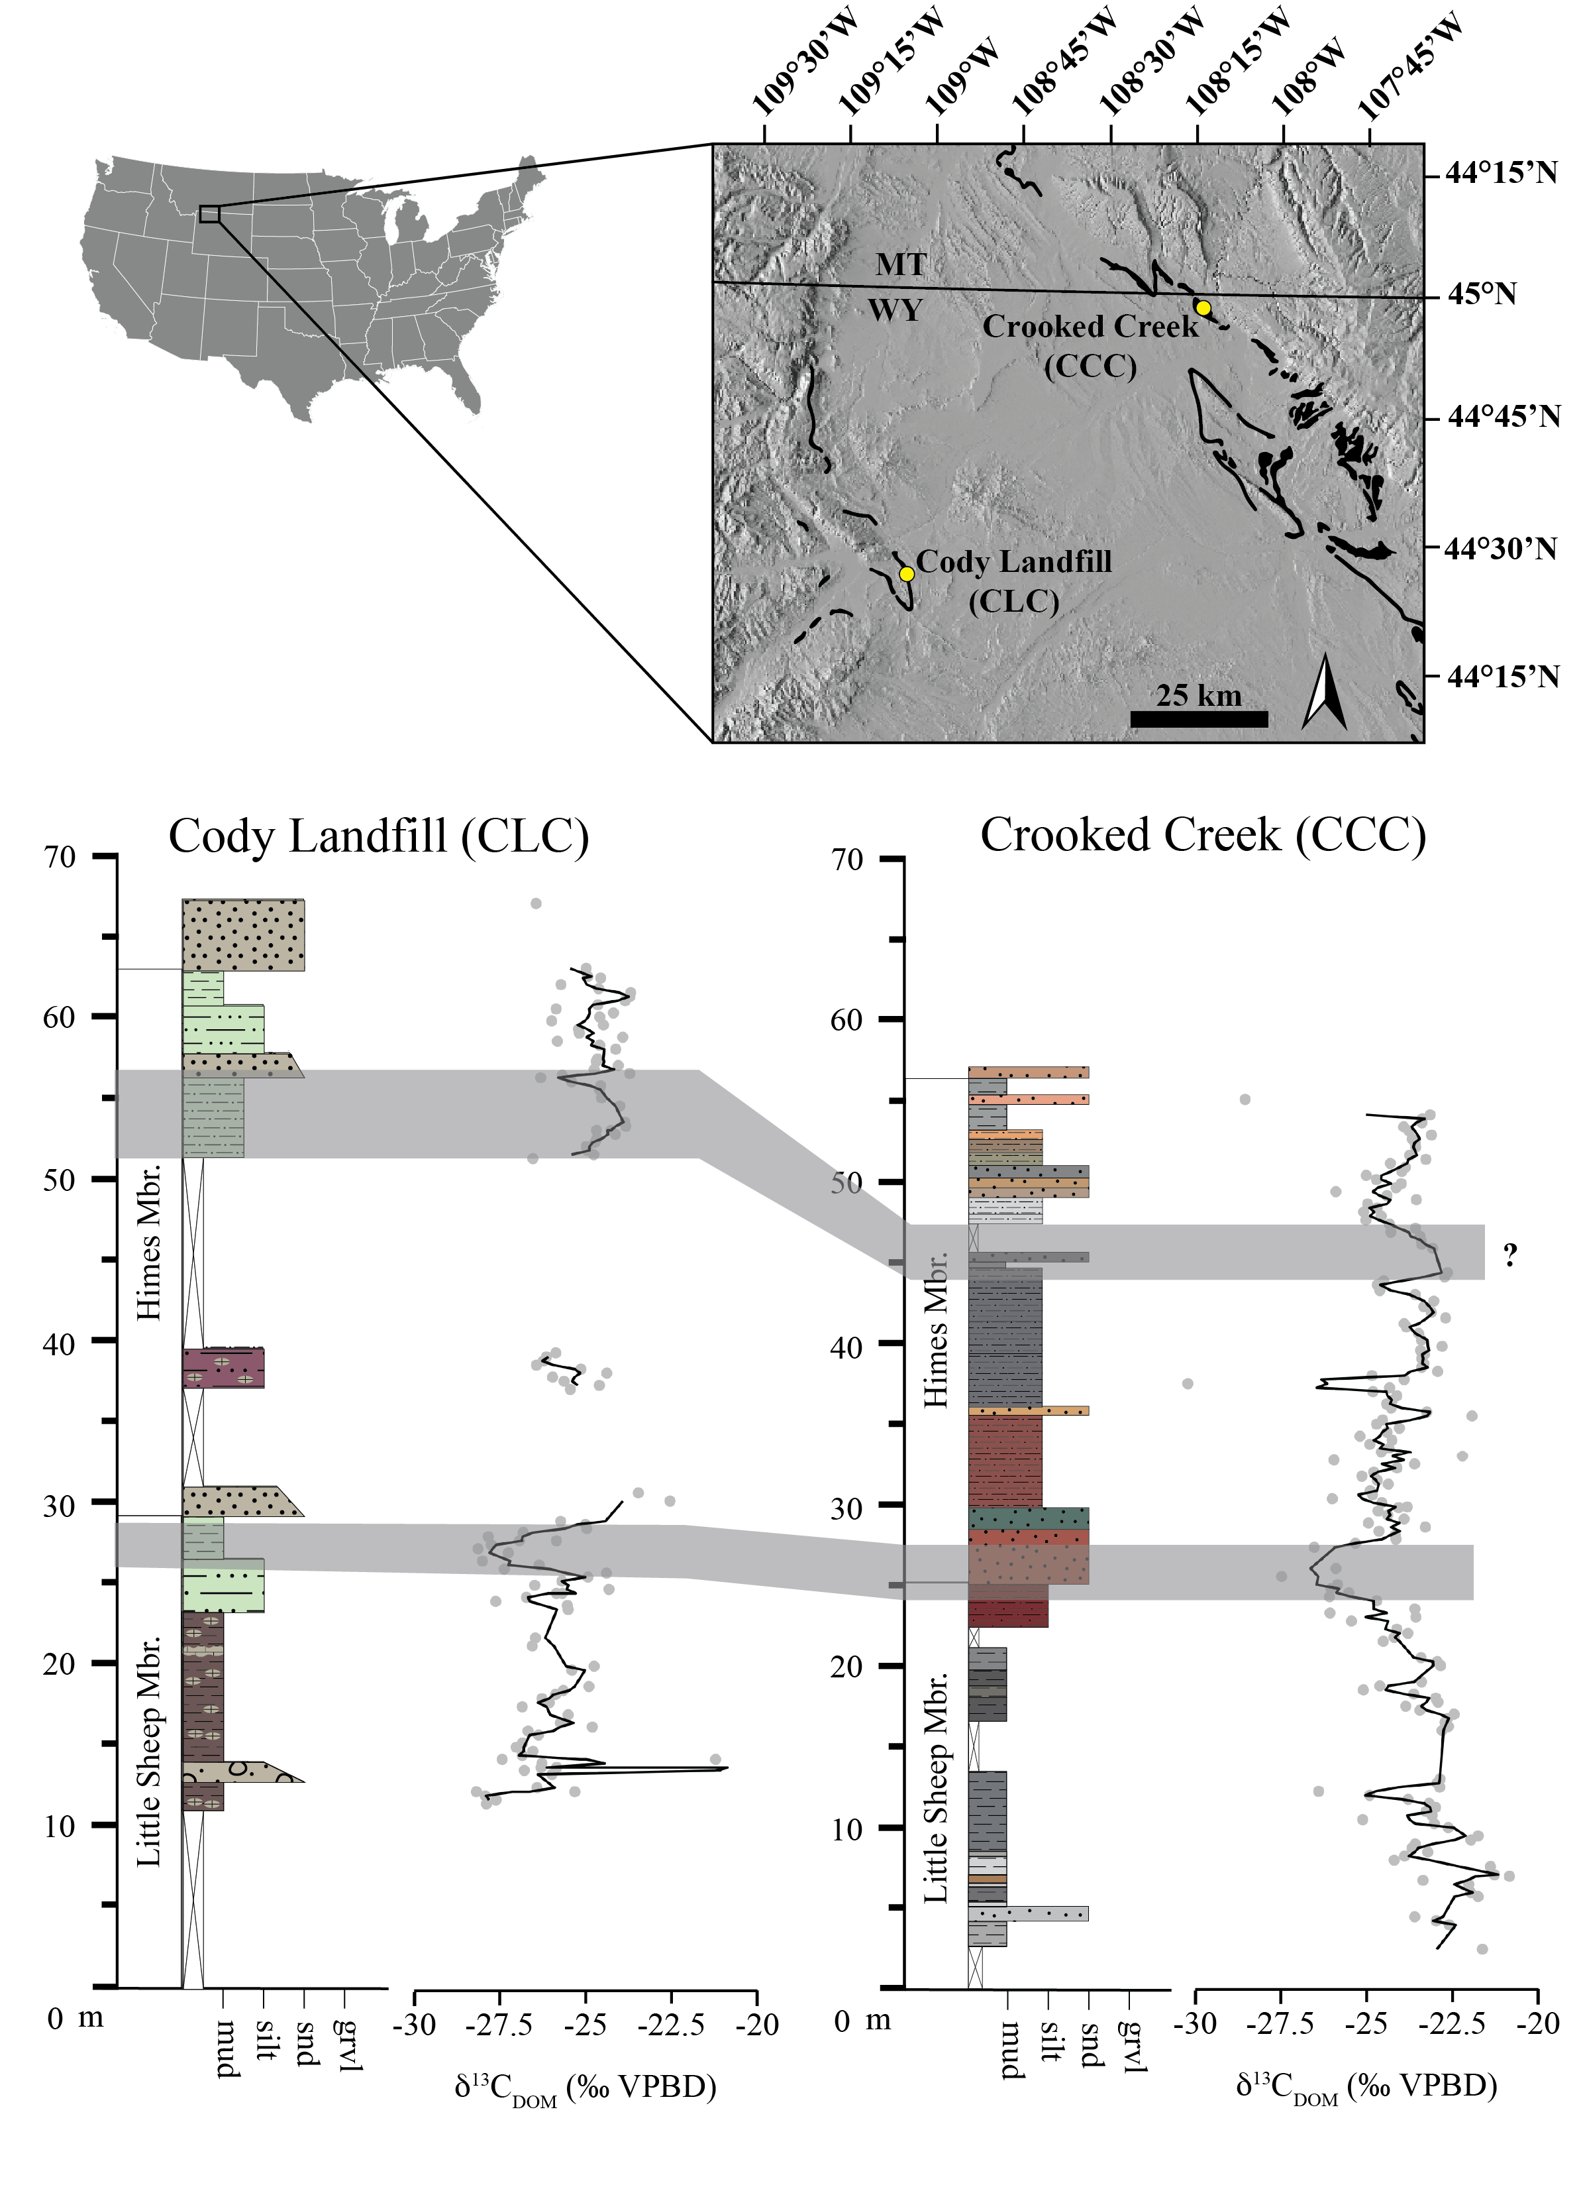

**2.2 Stratigraphic Context**

The Cloverly Formation is a series of fluviolacustrine deposits in the Bighorn and Wind River Basins in northwestern Wyoming and southeastern Montana that have been dated to the mid-Cretaceous. The Wind River and Bighorn basins are sub-basins in the broader Western Interior Basin (WIB). The WIB was a retroarc foreland basin formed east of the Sevier Thrust Belt, which developed as the Farallon plate began to subduct beneath the North American plate during the Late Jurassic and continued into the Late Cretaceous (CITE). WIB Jurassic nonmarine deposits (i.e. Morrison Formation) are often separated from overlying Cretaceous deposits by a major unconformity. Overlying Cretaceous deposits thin eastward, reflecting classic retroarc foreland basin geometry (CITE).

As with the age of the Cloverly Formation in general, much work has been done in the past to place the Cloverly deposits into a detailed chronostratigraphic framework (for a detailed review, see D’Emic et al., 2019). Only with recent developments in zircon U/Pb geochronology and nonmarine sequence stratigraphy has a more accurate and precise history of Cloverly deposition begun to reveal itself (D’Emic et al., 2019; Orchard, 2024). The progression of lithofacies in the Cloverly from amalgamated conglomeratic fluvial channels, to floodplain paleosols and shallow palustro-lacustrine deposits, to paralic wetlands before burial by marginal marine deposits and ultimately offshore black shales in the Sykes Mountain Formation and the Thermopolis Shale are consistent with synorogenic deposition and active evolution of the Sevier foreland basin (Foreman et al., 2022). The accompanying shifts in the balance between sediment supply and accommodation space imparted a strong control on depositional patterns in the Cloverly and the paleoecological records that it preserved (Orchard, 2024; Foreman et al., 2022). Early Cloverly deposition, including the Pryor Conglomerate and the interfingering basal Little Sheep mudstones represent deposition during a time when sediment supply outpaced the creation of accommodation space, representing a Low Accommodation Systems Tract (LAST) coinciding with a phase of basin overfill. Fluvial braidplains shed gravel from the uplifting Sevier highlands to the west. Widespread deposition of Little Sheep mudstones followed, as sedimentation was outpaced by subsidence during a broader under-filled phase in the Sevier foreland basin and a High Accommodation Systems Tract (HAST) in the Cloverly region. Deposition during this interval was dominated by fluvial overbank and avulsion deposits overprinted with well-developed paleosols. Isolated channel sands occurring throughout. Ostrom’s (1970) Unit VI, an interval with multi-story amalgamated channel sands that locally occur at the top of the Little Sheep Mudstone Member, seems to represent a temporary LAST, likely an authigenic overprint of the broader continuation of the underfilled phase of Sevier foreland deposition. This transient HAST was broadly followed by the development of coastal plains associated with a marine Transgressive Systems Tract (TST).

Like other Lower Cretaceous nonmarine WIB deposits, the Cloverly’s stratigraphy is spatially complex (D’Emic et al., 2019; Ostrom, 1970). The Cloverly overlies the nonmarine Late Jurassic Morrison Formation and is overlain by the marginal marine Sykes Mountain Formation (D’Emic et al., 2019; Moberly, 1960; Ostrom, 1970). A major unconformity separates the Cloverly from the underlying Late Jurassic deposits across much of its area. Resumption of Sevier orogenesis to the west is recorded in the Cloverly as basal conglomerates shed from the Sevier highlands and deposited by broad east-flowing braided river networks (Elliot et al., 2007; Foreman et al., 2022). These conglomerates interfinger with and underlie fine-grained deposits comprised mostly of bentonitic mudstones with interspersed channel sands. Lower Cloverly mudstones are generally more chromatic but less variegated than mudstones in the upper part of the formation. Moberly (1960) proposed three formal stratigraphic members based on the differences between the three intervals. These are the Pryor Conglomerate, Little Sheep Mudstone, and Himes Mudstone Members, in order of deposition. Ostrom (1970) also recognized this general pattern across the Bighorn Basin but proposed an alternative nomenclature that included the Jurassic Morrison Formation, four units within the Cloverly Formation, and the Sykes Mountain Formation. These two frameworks are generally similar, differing only in that Ostrom (1970) formally recognized a sand body (“Unit VI”) which is present at some sites. Subsequent studies of the Cloverly have primarily used these two stratigraphic nomenclatures (Fig. 2). D’Emic et al. (2019) proposed a facies-based stratigraphic model which integrates the observations of Moberly (1960) and Ostrom (1970) (Fig. 2). This model recognizes Moberly’s (1960) formal members but also addresses the spatial variability within the members. D’Emic et al. (2019) propose that sand bodies occurring in the Little Sheep and Himes intervals represent isolated channel deposits. This model implies that a channel sand near the Little Sheep and Himes boundary at any given locality may be diachronous with channel sands occurring near the boundary at other sites. Historically, Cloverly fossil localities have been reported from Ostrom’s (1970) Units V, VI, and VII, which generally correspond with the Little Sheep Mudstone and Himes Mudstone intervals (D’Emic et al., 2019). D’Emic et al., (2019) suggested that “Unit VI” sands are not necessarily directly age-equivalent to “Unit VI” sands at other sites. This interpretation also implies that a unit VII mudstone may interfinger and stratigraphically underly a unit VI sand in some instances. Discordant but similar radiometric dates reported from “Unit VI” sands at different sites in the Bighorn Basin support this (Carrano et al., 2022; D’Emic et al., 2019). Disentangling the roles of tectonics, climate, and biology in shaping the paleoenvironmental and paleobiological evolution of Cloverly ecosystems and the geologic record of those processes requires an integrated understanding of how those factors interacted.

Figure 2: Lithostratigraphy of the study sections

Caption. I think this figure will NOT include the carbon isotope profiles

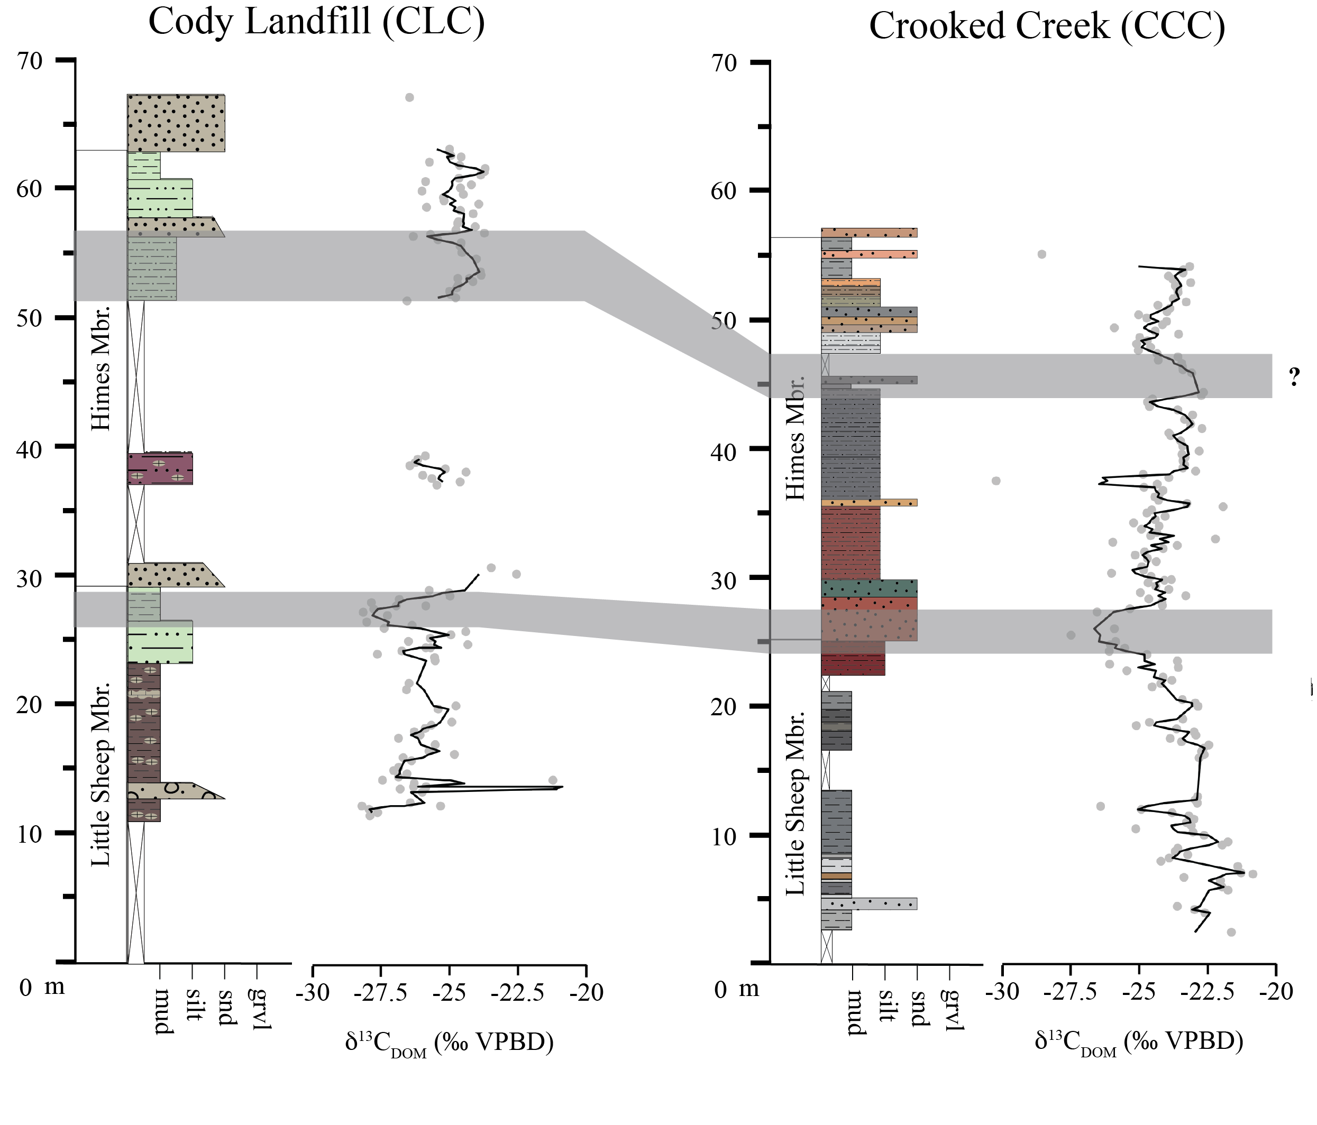

2. Materials and Methods

2.1. Zircon U/Pb Geochronology

2.1.1. Sampling Methods

2.1.2. Sample Preparation

2.1.3. CA-TIMS Analyses

2.1.4. LA-ICP-MS Analyses

2.1.5 Depth-Age Modelling

2.2. Carbon Isotope Stratigraphy

2.2.1. Sampling Methods

We collected bulk rock hand samples at 25 to 100 cm intervals from the Little Sheep and Himes members at CCC and CLC. To access fresh rock we removed surficial weathered surface material using hand tools (small picks and shovels).

2.2.2. Sample Preparation

Samples were prepared at the University of Arkansas Stable Isotope Laboratory (UASIL) and the NSF-Keck Paleoenvironment and Stable Isotope Laboratory (KPESIL) at the University of Kansas. We powdered the samples using mortar and pestle. Samples were then treated with 0.5 M hydrochloric acid to remove carbonate. Samples were rinsed, dried, and weighed into tin capsules.

2.2.2. Isotope Ratio Mass Spectrometry

Mass of weighed samples varied from ~ 1-10mg depending on color as a proxy for total organic carbon (TOC) by weight. Target sample weights by color were determined through pilot analyses. Sample analysis occurred at the University of Arkansas Stable Isotope Lab and combusted via IsoLink Elemental Analyzer coupled to a Delta V Plus isotope ratio mass spectrometer. Values were corrected to the VPBD scale using internal and international standards (sandy soil, White River trout, corn maize, benzoic acid, ANU sucrose). Reproducibility was reported at s = 0.18 ‰.

2.2.3. Chemostratigraphic Correlation

We used a combination of manual correlation (i.e. “wiggle-matching”) and quantitative correlation methods. We used our geochronological age models to predict the age of each sample and plotted our carbon isotope data against stratigraphic height and then against age. We compared d13C-depth curves and d13C-age curves between the Crooked Creek and Cody Landfill section.

We then used cross-correlation and dynamic time warping (DTW) to quantify the likelihood of correlations between carbon isotope curves. CHATGPT recommended these statistical methods, helped generate the R code, and helped with interpretation of the results. This can be reproduced using the script “script_name.R” in the R Project “Cloverly_chemostrat.Rproj” in Supplementary file XYZ.

3. Results

3.1. Lithofacies Characterization

The Cody Landfill (CLC) and Crooked Creek (CCC) sections record a succession of fluvial channel, crevasse splay, and overbank deposits. Multistory channel sandstones—equivalent to Ostrom’s (1970) “Unit VI”—are present only at CCC near the base of the Himes Member, where they form thick, massive beds with ripples and mud rip-up clasts at their base. Crevasse splay sandstones are thin (<2 m), upward-fining beds that are locally cemented with carbonate, and occur in both the Little Sheep and Himes members at both sites.

Fine-grained overbank deposits comprise both non-pedogenic and pedogenic facies. Non-pedogenic laminated silts and muds, which occur mainly in the upper Himes Member, are interpreted as paralic deposits and contain woody plant debris, leaves, and material that appears to be either charcoal or gelified wood. The distinction between the two could not be confidently determined in the field. These paralic deposits represent only a small proportion of the measured sections. The majority of overbank deposits are pedogenically altered and can be classified as well-drained (red–purple) or poorly drained (drab) paleosols. Both paleosol types show mottling, bioturbation, and localized shrink-swell (vertic) features, though vertic characteristics are more continuous at CLC than at CCC.

Carbonates occur most abundantly in well-drained paleosols at CLC, commonly as nodules or semi-continuous beds, and less frequently at CCC, where they are restricted to one interval of poorly drained paleosols in the Little Sheep Member. Ostracods were identified in this interval at both sites, suggesting episodes of standing water. Some of these deposits may reflect shallow lacustrine or palustrine environments (cf. Orchard, 2024), but the scarcity of sedimentary structures and diagnostic minerals (e.g., chalcedony, gypsum) makes such interpretations uncertain.

3.1. LA-ICP-MS

Insert text for LA-ICP-MS results, reference Table 3.1… Lorem ipsum dolor sit amet, consectetur adipiscing elit, sed do eiusmod tempor incididunt ut labore et dolore magna aliqua. Ut enim ad minim veniam, quis nostrud exercitation ullamco laboris nisi ut aliquip ex ea commodo consequat. Duis aute irure dolor in reprehenderit in voluptate velit esse cillum dolore eu fugiat nulla pariatur. Excepteur sint occaecat cupidatat non proident, sunt in culpa qui officia deserunt mollit anim id est laborum.

**Table 3.1.** LA-ICP-MS data.

|  |  |  |
| --- | --- | --- |
| **Title 1** | **Title 2** | **Title 3** |
| entry 1 | data | data |
| entry 2 | data | data |

3.2. CA-TIMS

Insert text for CA_TIMS results, reference Table 3.2… Lorem ipsum dolor sit amet, consectetur adipiscing elit, sed do eiusmod tempor incididunt ut labore et dolore magna aliqua. Ut enim ad minim veniam, quis nostrud exercitation ullamco laboris nisi ut aliquip ex ea commodo consequat. Duis aute irure dolor in reprehenderit in voluptate velit esse cillum dolore eu fugiat nulla pariatur. Excepteur sint occaecat cupidatat non proident, sunt in culpa qui officia deserunt mollit anim id est laborum.

**Table 3.2.** CA-TIMS data.

|  |  |  |
| --- | --- | --- |
| **Title 1** | **Title 2** | **Title 3** |
| entry 1 | data | data |
| entry 2 | data | data |

3.3 Depth-Age Models

Insert text for age model results, reference figure 3.3… Lorem ipsum dolor sit amet, consectetur adipiscing elit, sed do eiusmod tempor incididunt ut labore et dolore magna aliqua. Ut enim ad minim veniam, quis nostrud exercitation ullamco laboris nisi ut aliquip ex ea commodo consequat. Duis aute irure dolor in reprehenderit in voluptate velit esse cillum dolore eu fugiat nulla pariatur. Excepteur sint occaecat cupidatat non proident, sunt in culpa qui officia deserunt mollit anim id est laborum.

Figure 3.3: Depth-age models

Caption (this plot will include both age models)

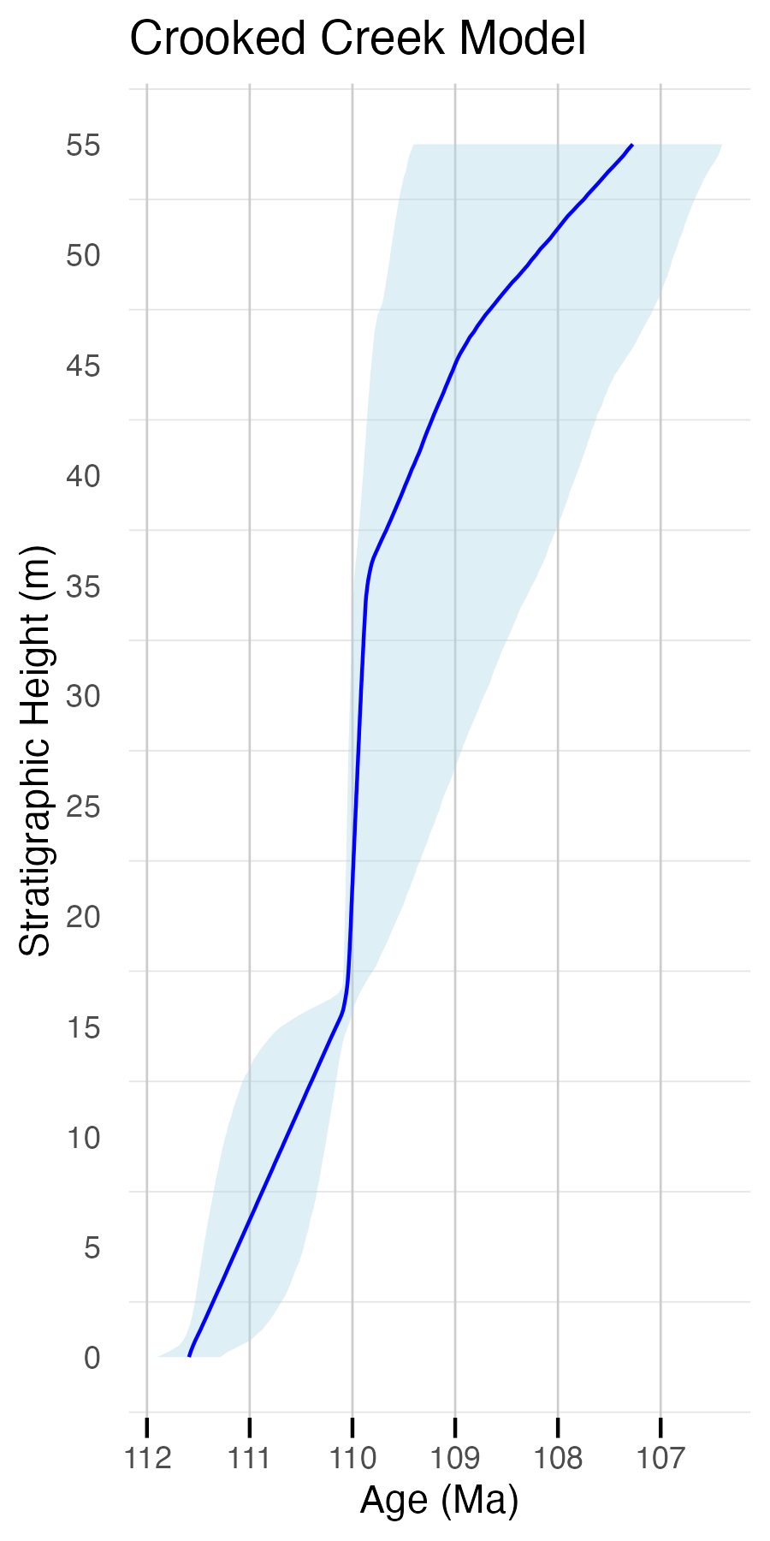

3.4 Bulk Organic Carbon IRMS

At Crooked Creek, bulk organic matter carbon isotope values (d13CBOM) range from –30.1‰ to –21.0‰, with an average of –23.97‰. The curve was divided into seven intervals based on consistent trends in the smoothed, three-point average data. The lowest interval exhibits a positive carbon isotope excursion (PCIE) beginning in the Pryor Conglomerate and peaking in the lower Little Sheep Member at –20.88‰ near 15 m. This is followed by a gradual negative shift to –26.41‰ at 20.25 m, then a rapid rebound to –22.9‰ by 20.5 m. A sustained positive trend follows, with values averaging –23.25‰ over a 7.5 m interval. This is succeeded by a pronounced negative excursion reaching –27.48‰ at 33.5 m in the lower Himes Member (Unit VI), followed by a positive excursion that peaks at –23.32‰ at 36.55 m, primarily within the bone bed of Unit VI. Above this, d13CBOM values in the upper Himes Member (Unit VII) show a more gradual positive trend, punctuated by alternating negative shifts, continuing into the overlying Sykes Mountain Formation.

Figure 3.4: Carbon isotope values by stratigraphic height for Crooked Creek and Cody Landfill sections.

Caption. I won’t have these erroneous correlations annotated.

At Cody Landfill, d13CBOM values range from –28.2‰ to –22.6‰, with an average of –25.6‰. The first ~10 m above the Pryor Conglomerate–Little Sheep contact was not sampled due to surface cover, and six intervals were identified in the remaining section. The first sampled interval records a gradual ~3‰ positive shift from ~–28‰ to ~–25‰ between ~11.5 m and ~25 m. This is followed by a ~2‰ decline to ~–27‰ near 24 m, and then a more complex interval marked by a sharp increase of ~2‰, a rapid drop of ~3‰, and a rebound of ~4‰, with values exceeding –24‰ by 30 m. A ~7 m sampling gap follows. Above the gap, values decrease from ~–24.5‰ to ~–26.5‰ between ~37 m and ~40 m, followed by another gap extending to ~51 m. In the upper part of the section, values rise from ~–26.5‰ to ~–24‰ and then fall back to ~–26.5‰ by ~62 m, defining a well-resolved feature in the upper Himes Member. Above this point, values fluctuate between –24‰ and –26‰ with no clear trend, ending below the Rusty Beds sandstone unit of the Sykes Mountain Formation. A single sample from the top of that unit yielded a value of –26.5‰.

3.5 Chemostratigraphic Correlation Analyses

Correlation between the CCC and CLC d¹³C profiles in the age domain is weak overall. Zero-lag Pearson correlation is negative and non-significant (r = −0.193, 95% CI −0.503–0.161, p = 0.283, n = 33). A 1 Myr sliding-window analysis identified a localized peak correlation of r = 0.667 centered at ~108.62 Ma. However, radiometric dates at CLC indicate a major unconformity immediately beneath this interval, limiting the reliability of any cross-sectional correlation in that interval. Additionally, relatively lower sedimentation rates at CLC result in the nominal 25 cm sampling interval producing a much coarser effective temporal resolution compared to CCC, further constraining resolution in the age domain. Dynamic Time Warping (DTW) yielded a distance of 107.568, indicating only moderate similarity in curve shape after allowing non-linear alignment. Phase alignment, magnitude, and absolute values of d¹³C vary considerably between the two sections, suggesting local environmental or diagenetic influences.

Manual and quantitative correlation analyses between the Cloverly profiles and global reference sections further suggest strong correlation between the Crooked Creek profile and a profile from the Marnes Bleues Formation in the Vocontian Basin of France, whereas correlation is very weak between the CLC and Marnes Bleues profiles. Taken together, the results indicate that the Cody Landfill d¹³C profile cannot be robustly correlated with the Crooked Creek profile or with any tested global reference section.

Figure 3.5: Make figure that is panel of key correlation attempts: CCC-CLC by age, CCC-France by age, CCC - Axel Heiberg Island by age.

Caption. Placeholder image

4. Discussion

4.1. Interpretation and key findings

Depth–age models derived from zircon geochronology indicate that the Crooked Creek (CCC) and Cody Landfill (CLC) sections are largely diachronous. Of the ~30 Myr encompassed by Cloverly deposition, only about 1.5 Myr of overlap occurs between these two sections. Most of the mudstone interval in the Cloverly appears to have been deposited over a relatively short period (~110–104 Ma), although locally preserved Aptian strata are present in the lower Little Sheep Mudstone. Radiometric ages of 126 Ma and 120 Ma from the Horse Center Anticline near Cody, WY, suggest that the lowermost mudstones overlying the Pryor Conglomerate there were deposited ~10 Myr before the basin-wide onset of Little Sheep and Himes deposition. In contrast, ages from the middle Little Sheep interval across the basin indicate more stable depositional patterns after ~110 Ma.

We observe an apparent correlation between the carbon isotope excursion (CIE) at ~25 m in the CCC section and the “l’Arboudeyesse” CIE recorded in global marine reference sections (Herrle et al., 2015; Gale et al., 2011). However, carbon isotope data from the CLC section do not show strong correspondence with either the CCC profile or time-equivalent marine records. Although a more stratigraphically complete CLC profile might improve alignment, our current dataset provides little evidence for correlation between CLC and CCC. This mismatch may reflect one or more of the following: (a) analytical bias or contamination in the CLC dataset; (b) inaccuracies in the CLC age model; or (c) autocyclic modification of regional or global carbon isotope signals by local heterogeneity in soil carbon pool mixing and depositional processes.

4.2 Implications for Cloverly chronostratigraphy

The upper Little Sheep Member is likely Albian in age throughout the basin, while the lower Little Sheep appears to be older in some parts of the basin where it is separated from the upper interval by a local unconformity. New zircon geochronology from the western flank of the Horse Center Anticline supports the interpretation of a significant unconformity (~120–112 Ma) approximately 14 meters above the Pryor Conglomerate at HCA as suggested by previous data from the Cody Landfill site (D’Emic et al., 2019). We are unable to recognize a lithostratigraphic indication of a significant erosional unconformity or extensive (105-107 years) period of non-deposition at CLC. There is no unconformable, sharp contact, and there is no notable change in the degree of pedogenesis expected to accompany a landscape that is stable for millions of years. Still, the geochronological evidence for a hiatus here is robust. The Himes Member is also likely entirely Albian, with no evidence supporting the presence of Cenomanian deposits within the Cloverly Formation as suspected by D’Emic et al. (2009).

High-resolution, correlative carbon isotope records from key fossil-bearing sections of the Cloverly Formation have the potential to establish a high-precision spatiotemporal framework for fossil occurrences and paleoenvironmental records, which is essential for detailed paleoecological reconstruction. Our results warrant caution in using carbon isotope stratigraphy for this purpose in the Cloverly. Local heterogeneity in depositional and environmental conditions appears to have overwhelmed any regional or global influence on the carbon isotope composition of soil organic matter at the Cody Landfill site. This interpretation assumes that our geochronology-based age model for the CLC section is as accurate and precise as reported. While initial analyses of our data suggested a possible correlation between carbon isotope excursions in both the Crooked Creek and Cody Landfill sections, our age models indicate that these features are diachronous between the sections. Our results suggest that in some cases, Cloverly carbon isotope records may capture regional or global signals which can be used to align stratigraphic sections within the Cloverly. However, it appears that local heterogeneity in soil carbon pools, as well as highly variable depositional and erosional histories, may confound these signals in some Cloverly sections. Additionally, analyses of additional sections may reveal that the apparent correlation of the l’Arboudeyesse CIE to the CCC section may be erroneous.

Our zircon geochronology and facies relationships indicate substantial heterogeneity in accommodation space and sedimentation rates across the basin during early Cloverly deposition. As a result, local sections may not correlate neatly even within the same lithostratigraphic “member,”. Ultimately, this means that the lower Little Sheep Mudstone interval is likely time transgressive, but the upper Little Sheep and the Himes

4.3 Implications for stratigraphy of the mid-Cretaceous Western Interior Basin

Our radiometric dates, combined with existing chronostratigraphic data, indicate that the Cloverly mudstone interval is predominantly mid-Albian in age (~110–104 Ma; FIGURE?). This suggests that the fossil assemblages from this interval, which host the majority of documented Cloverly fossil occurrences, are largely diachronous with the Antlers and Cedar Mountain biotas. This finding supports the conclusion of D’Emic et al. (2019) that these assemblages are not strictly time equivalent and challenges previous interpretations that made direct faunal comparisons across these units.

Interfingering of well-developed paleosols (lower “Little Sheep” mudstones) with coarse channel conglomerates (“Pryor” Member) in the lower Cloverly Formation suggests that some of the mudstones in the lower Little Sheep were deposited during the “over-filled” phase of Sevier foreland basin evolution that preceded the tectonically quiescent “under-filled” phase which deposited upper Cloverly mudstones. This is supported by our zircon ages, which indicate that the lowermost mudstones overlying the Pryor Conglomerate at the Cody Landfill site were likely deposited prior to 120 Ma. This suggests that there was spatial heterogeneity in accommodation space and sedimentation rates within the Cloverly depositional area. This also suggests that the Cloverly mudstones may not neatly fit into the two member (Little Sheep and Himes) nomenclatural framework that has predominantly been used in the Cloverly. Orchard (2024) also noted a lithologic change that often occurs within the lower mudstone interval (“Little Sheep” mudstones) overlying the Pryor Conglomerate in the northeastern area of the Bighorn Basin, suggesting that this either reflects a shift in depositional setting or a climatic shift from dry to wet. Perhaps paleosols in the lowermost Cloverly are simply better developed due to stable floodplains.

4.4 Implications for terrestrial carbon isotope stratigraphy as a chronostratigraphic tool

Well, I guess my main thoughts here are that based on (Baczinsky et al., 2013?; others!)and our data here, you really need substantial CIE’s to overwhelm local carbon variations in floodplain paleosols. If your section doesn’t happen to encompass such an interval that has significant CIE’s, you might not be able to resolve regional or global signals in your floodplain paleosol records. And, as I suggested above, maybe this is particularly a concern in heterogeneous landscapes and in nonmarine low-accommodation systems tracts.

This work also underscores that caution must be taken to avoid overcorrelating terrestrial d13C profiles visually. We were convinced that the isotope excursions occurring at ~25 m in both sections must be correlative until we received additional radiometric data that further indicated diachroneity.

Previous works have found that carbon isotopes of ancient soil organic matter are potentially subject to processes that confound the use of carbon isotope stratigraphy as a high-precision, broadly applicable, correlative tool (Baczinsky et al., 2013?; others!). Among the factors that may influence the Cloverly carbon isotope compositions are reworking of older, allochtonous organic carbon into younger deposits, mixing carbon pools and changing the mean d13C of organic carbon in the floodplain deposits. This reworking is a likely possibility in the Cloverly, given the evidence that the Cloverly mudstones were deposited during a low-accommodation systems tract where erosion and sediment bypass are the predominant processes (Foreman et al.., 2022; this study). Another key local influence likely at play in the Cloverly floodplain paleosols is variation in soil drainage and therefore microbial respiration (Baczinsky et al., 2013?; others!).

5. Conclusions

This section is not mandatory but can be added to the manuscript if the discussion is unusually long or complex.

**Supplementary Materials:** The following supporting information can be downloaded at: https://www.mdpi.com/article/doi/s1, Figure S1: title; Table S1: title; Video S1: title.

**Author Contributions:** For research articles with several authors, a short paragraph specifying their individual contributions must be provided. The following statements should be used “Conceptualization, X.X. and Y.Y.; methodology, X.X.; software, X.X.; validation, X.X., Y.Y. and Z.Z.; formal analysis, X.X.; investigation, X.X.; resources, X.X.; data curation, X.X.; writing—original draft preparation, X.X.; writing—review and editing, X.X.; visualization, X.X.; supervision, X.X.; project administration, X.X.; funding acquisition, Y.Y. All authors have read and agreed to the published version of the manuscript.” Please turn to the [CRediT taxonomy](https://img.mdpi.org/data/contributor-role-instruction.pdf) for the term explanation. Authorship must be limited to those who have contributed substantially to the work reported.

**Funding:**

This research was largely funded by the National Science Foundation, grant number XXX. Funding was also provided by a Student Research Grant from the Society for Sedimentary Geology (SEPM). The APC was funded by XXX.

**Data Availability Statement:** Suggested Data Availability Statements are available in section “MDPI Research Data Policies” at <https://www.mdpi.com/ethics>. Code and data will be available on Github. Data will also be available on EarthChem.

**Acknowledgments:** In this section, you can acknowledge any support given which is not covered by the author contribution or funding sections. This may include administrative and technical support, or donations in kind (e.g., materials used for experiments). Where GenAI has been used for purposes such as generating text, data, or graphics, or for study design, data collection, analysis, or interpretation of data, please add “During the preparation of this manuscript/study, the author(s) used [tool name, version information] for the purposes of [description of use]. The authors have reviewed and edited the output and take full responsibility for the content of this publication.”

**Conflicts of Interest:** The authors declare no conflicts of interest. The funders had no role in the design of the study; in the collection, analyses, or interpretation of data; in the writing of the manuscript; or in the decision to publish the results.

Abbreviations

The following abbreviations are used in this manuscript:

|  |  |
| --- | --- |
| MDPI | Multidisciplinary Digital Publishing Institute |
| DOAJ | Directory of open access journals |
| TLA | Three letter acronym |

References

References must be numbered in order of appearance in the text (including citations in tables and legends) and listed individually at the end of the manuscript. We recommend preparing the references with a bibliography software package, such as EndNote, ReferenceManager or Zotero to avoid typing mistakes and duplicated references. Include the digital object identifier (DOI) for all references where available.

Citations and references in the Supplementary Materials are permitted provided that they also appear in the reference list here.

In the text, reference numbers should be placed in square brackets [ ] and placed before the punctuation; for example [1], [1–3] or [1,3]. For embedded citations in the text with pagination, use both parentheses and brackets to indicate the reference number and page numbers; for example [5] (p. 10), or [6] (pp. 101–105).

1. Author 1, A.B.; Author 2, C.D. Title of the article. *Abbreviated Journal Name* **Year**, *Volume*, page range.
2. Author 1, A.; Author 2, B. Title of the chapter. In *Book Title*, 2nd ed.; Editor 1, A., Editor 2, B., Eds.; Publisher: Publisher Location, Country, 2007; Volume 3, pp. 154–196.
3. Author 1, A.; Author 2, B. *Book Title*, 3rd ed.; Publisher: Publisher Location, Country, 2008; pp. 154–196.
4. Author 1, A.B.; Author 2, C. Title of Unpublished Work. *Abbreviated Journal Name* year, *phrase indicating stage of publication (submitted; accepted; in press)*.
5. Author 1, A.B. (University, City, State, Country); Author 2, C. (Institute, City, State, Country). Personal communication, 2012.
6. Author 1, A.B.; Author 2, C.D.; Author 3, E.F. Title of Presentation. In Proceedings of the Name of the Conference, Location of Conference, Country, Date of Conference (Day Month Year).
7. Author 1, A.B. Title of Thesis. Level of Thesis, Degree-Granting University, Location of University, Date of Completion.
8. Title of Site. Available online: URL (accessed on Day Month Year).

**Disclaimer/Publisher’s Note:** The statements, opinions and data contained in all publications are solely those of the individual author(s) and contributor(s) and not of MDPI and/or the editor(s). MDPI and/or the editor(s) disclaim responsibility for any injury to people or property resulting from any ideas, methods, instructions or products referred to in the content.

|  |  |
| --- | --- |
| C:\Users\martin\Downloads\testFigure.tif | C:\Users\martin\Downloads\testFigure.tif |
| (**a**) | (**b**) |

**Figure 2.** This is a figure. Schemes follow another format. If there are multiple panels, they should be listed as: (**a**) Description of what is contained in the first panel; (**b**) Description of what is contained in the second panel. Figures should be placed in the main text near to the first time they are cited.

Appendix A

What to include:

-Geochron results/plots (concordance, etc?)

-Correlation analysis results/plots

-Replicate-level carbon isotope data

Appendix A.1

The appendix is an optional section that can contain details and data supplemental to the main text—for example, explanations of experimental details that would disrupt the flow of the main text but nonetheless remain crucial to understanding and reproducing the research shown; figures of replicates for experiments of which representative data is shown in the main text can be added here if brief, or as Supplementary data. Mathematical proofs of results not central to the paper can be added as an appendix.

**Table A1.** This is a table caption.

|  |  |  |
| --- | --- | --- |
| **Title 1** | **Title 2** | **Title 3** |
| entry 1 | data | data |
| entry 2 | data | data |

Appendix B

All appendix sections must be cited in the main text. In the appendices, Figures, Tables, etc. should be labeled starting with “A”—e.g., Figure A1, Figure A2, etc.