Gene expression and byssal thread mechanics in paired animals
Foot and gill association analysis, gene-mechanics-correlation module, PSMFC Mytilus byssus pilot
Generated 16 September 2026 from mattgeorgephd/PSMFC-mytilus-byssus-pilot at commit 60ab1d3, with scripts 20 to 23 parameterised by tissue and run for foot and gill through the new driver 24. Every number is read from a file under gene-mechanics-correlation/03_analyses/ or thread-strength/03_analyses/; nothing is retyped.

1. Summary
This analysis asks whether day-3 gene expression in the same animal covaries with the mechanical performance of the byssal threads it made under exposure. It now runs on the complete thread dataset, with the day-3 control arm included, in both tissues: foot n = 44 (control 10, OA 12, OW 12, DO 10; 42 with baselines) and gill n = 45 (43 with baselines). The earlier version ran on 31 foot animals with no control arm.
- Day-3 levels of force, area, adhesion and extension carry no expression signal in either tissue. Best foot candidate on peak force q = 0.67, permutation p = 0.44; on plaque area q = 0.78, permutation p = 0.50. Gill is the same (permutation p = 0.41 and 0.33). Nothing in either DEG union passes q < 0.10 on any metric.
- The change in adhesion from each animal's own baseline carries one borderline signal, in the foot, in the collagen machinery. Collagen alpha-1(V) chain: q = 0.034 (weighted regression), the first candidate-set association in this project to pass BH. Collagen alpha-2(IV) q = 0.064; the byssal-collagen module q = 0.052. Higher collagen expression goes with a larger fall in adhesion and a larger rise in plaque area, not with a change in force.
- It is foot-specific and borderline. The permutation-corrected p for the best foot change-in-adhesion hit, across the 57-gene search, is 0.054. Without the control arm it keeps its sign and rank (slope −0.43, p = 0.004) but not its BH significance (q = 0.21). In the gill the same metric shows nothing (best q = 0.78, permutation p = 0.88). Tissue specificity in the byssus-producing organ is what a real signal would look like; it is not proof of one.
- Two apparent hits are detection-floor artifacts and should be discounted: Byssal peroxidase-like protein 2 against plaque area (41% of foot samples at the VST floor) and Peroxiredoxin-5 against extension (q = 0.084, driven by two animals at the floor; visible in Figure 2).
- The gill's weak leads are oxidative and hypoxia modules against force level (oxidative_detox q = 0.072, HIF_hypoxia q = 0.096), consistent with a systemic-state readout rather than a thread-building mechanism. Neither survives permutation.
Treat all of this as hypothesis-strengthening at n = 44. The one concrete, testable statement it produces is in section 11.

2. Design and data
Tag-seq sampling was destructive, so expression and day-3 threads come from the same animal at the same time; this is contemporaneous association, not prediction. Every animal in the paired set has foot (or gill) RNA, at least one day-3 thread with a plaque measurement, and a Tag-seq arm assignment that agrees with the thread key. Most also have pre-exposure baseline threads, which is what makes the change metrics possible.
 | Foot | Gill
Paired animals | 44 | 45
control | 10 | 10
OA | 12 | 12
OW | 12 | 12
DO | 10 | 11
With baseline threads | 42 | 43
Candidate genes tested | 57 | 63
DEG-union genes tested | 523 | 1009
Table 1. Paired sets by tissue. Gill has two animals (T047, T051) with no foot library. T047 also lacks a foot treatmentinfo row and is excluded from the foot set for that reason. One further gill animal in the treatmentinfo file has no count-matrix column and is dropped with a message.

Mechanical metrics
On the full thread dataset the stressor effect sits in peak force and plaque area separately, not in their ratio: adhesion (kPa) falls ~20% in every arm including control (arm × timepoint p = 0.55) while force (p = 0.0005) and area (p < 0.0001) split warming and hypoxia from control and acidification. Force and area are therefore the primary targets here and adhesion is retained as the material-strength readout. Each metric is tested as a day-3 level (per-animal mean of its plaques) and, where baselines exist, as a change: log(day-3 / baseline). On the log scale the change in adhesion equals the change in force minus the change in area.
Metric | Type | Foot mean: control / OA / OW / DO | Gill mean: control / OA / OW / DO
Peak force | level | 0.218 / 0.206 / 0.154 / 0.125 | 0.218 / 0.206 / 0.154 / 0.119
Plaque area | level | 3.2 / 3.2 / 2.9 / 2.5 | 3.2 / 3.2 / 2.9 / 2.4
Adhesion | level | 71.3 / 63.8 / 59.3 / 57.7 | 71.3 / 63.8 / 59.3 / 56.6
Extension | level | 0.137 / 0.125 / 0.140 / 0.125 | 0.137 / 0.125 / 0.140 / 0.133
Δlog force | change | -0.16 / -0.08 / -0.53 / -0.59 | -0.16 / -0.08 / -0.53 / -0.69
Δlog area | change | 0.11 / 0.12 / -0.27 / -0.38 | 0.11 / 0.12 / -0.27 / -0.46
Δlog adhesion | change | -0.25 / -0.21 / -0.24 / -0.17 | -0.25 / -0.21 / -0.24 / -0.19
Table 2. Arm means of each metric in the paired sets (paired_sample_manifest_F/G.csv). Units: N, mm², kPa, mm; the change metrics are log ratios.

Per-animal response classification
Thread-strength script 4 classifies every paired animal by whether its own threads got weaker or stronger between baseline and day 3, on each metric, and by a composite of force and adhesion. The class is joined into the paired manifest and is available as a covariate or stratifier.
Arm | Paired | Weaker | Stronger | Mixed | Force fell | Area fell | Adhesion fell
control | 10 | 5 | 1 | 4 | 6 | 4 | 8
OA | 11 | 7 | 2 | 2 | 8 | 3 | 8
OW | 12 | 8 | 2 | 2 | 10 | 9 | 8
DO | 12 | 7 | 2 | 3 | 10 | 11 | 7
Table 3. Response classification of the 45 paired thread animals (mussel_response_classification.csv). Counts are animals whose per-animal mean decreased.
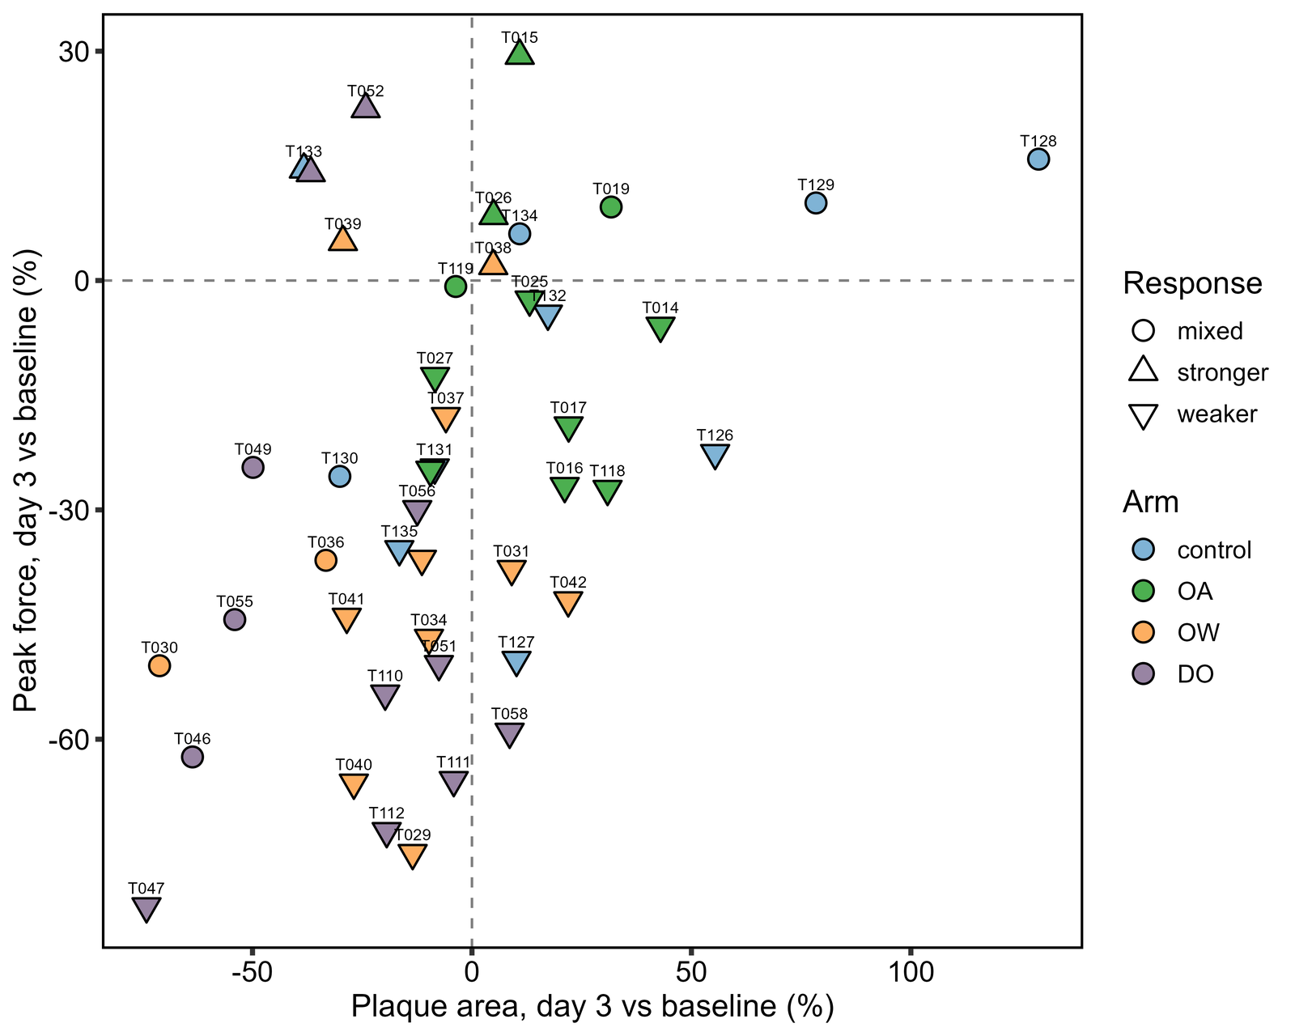
Figure 1. Every paired animal: change in peak force against change in plaque area, day 3 versus baseline, coloured by arm and shaped by response class. Warming and hypoxia animals occupy the lower-left quadrant; control and acidification animals spread across the top and right. Filled from thread-strength/03_analyses/decompose-adhesion/.

3. Methods
Expression. Counts for the chosen tissue are variance-stabilised with DESeq2 across all samples of that tissue, then subset to the paired animals. Genes are kept if count > 5 in at least a third of paired samples. Two gene universes: a keyword-defined candidate set (byssal and adhesive proteins, collagens, curing and cross-linking enzymes, heat-shock and chaperone, hypoxia signalling, aminoacyl-tRNA synthetases, oxidative-stress enzymes) and the data-driven union of significant DEGs from the tissue's three stressor contrasts. The candidate set is the defensible test; the DEG union is screening.
Association, script 20. For each gene and metric, lm(metric ~ expression + arm), with the animal's baseline as a covariate for the level metrics (ANCOVA). Partial Spearman on the same animals. BH within each gene set × metric.
Refinements, script 21. A thread-level mixed model with a random intercept per animal for the level metrics, so animals with more plaques weigh more; a per-animal weighted regression (weight = plaque count, or the smaller of the two counts for a change metric), which is the reported test for the change metrics and the engine for the permutation; five pathway modules scored as the first principal component of their members; a permutation null that shuffles expression among animals within arm and records the minimum p across the candidate set, for peak force, plaque area and the change in adhesion; detection-floor and influence diagnostics.
Why the control arm is in. The ten day-3 control animals have RNA, day-3 threads and baselines. Their own ~20% decline in adhesion is the null trajectory a stress-specific expression signal must beat, and an association that holds within the control arm too is about attachment biology rather than the stress response. INCLUDE_CONTROL_ARM = FALSE restores the stressor-only set.
Tissue. Scripts 20 to 23 take a knit parameter, tissue = "F" or "G"; driver 24 renders them for both in separate R processes. The gill treatmentinfo codes the day-3 control arm as control_3 and is normalised. All outputs are tissue-suffixed.

4. Foot

4.1 Best candidate gene per metric
Metric | n | Best candidate gene | Slope | p | q (BH within metric)
Peak force | 44 | Hypoxia-inducible factor 1-alpha (HIF-1-alpha) (HIF… | -0.052 | 0.013 | 0.672
Plaque area | 44 | Byssal peroxidase-like protein 2 | -0.225 | 0.016 | 0.782
Adhesion | 44 | Heat shock 70 kDa protein 12B (Heat shock protein f… | -28.720 | 0.0051 | 0.211
Extension | 44 | Peroxiredoxin-5, mitochondrial (EC 1.11.1.24) (Alu … | -0.019 | 0.0015 | 0.084
Δlog force | 42 | Collagen alpha-1(V) chain | -0.205 | 0.025 | 0.578
Δlog area | 42 | Collagen alpha-2(IV) chain | 0.245 | 0.016 | 0.517
Δlog adhesion | 42 | Collagen alpha-1(V) chain | -0.383 | 0.0006 | 0.034
Table 4. Foot, weighted per-animal regression (assoc_candidate_WLS_F.csv), the top gene for each metric. The plaque-area and extension rows are detection-floor artifacts; see section 7.
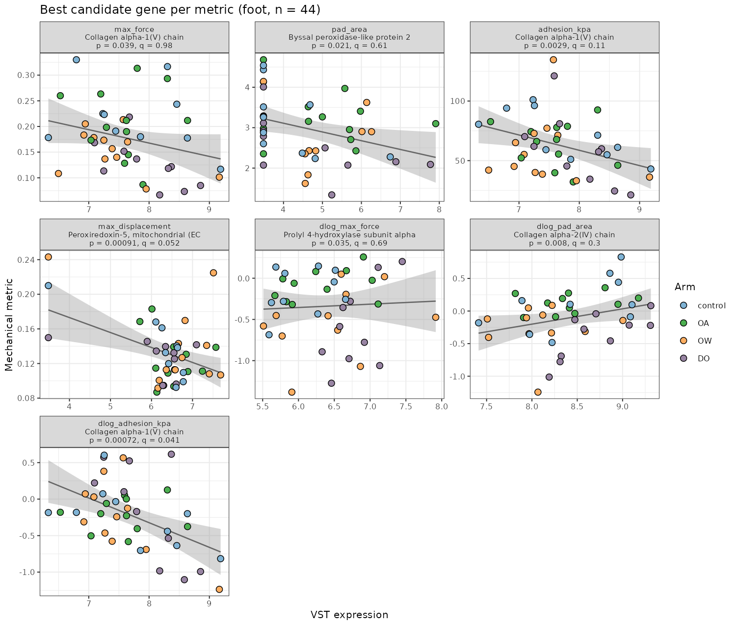
Figure 2. Foot: the best candidate gene for each metric, VST expression against the metric, coloured by arm, pooled linear fit with 95% band (best_hit_per_metric_scatter_F.png). The collagen V association with the change in adhesion (bottom left) runs through every arm, including control. The plaque-area and extension panels show the detection-floor pile-ups at VST ≈ 3.5 that drive those two fits.

4.2 Hits passing q < 0.15
Metric | n | Gene | Slope | p | q
Δlog adhesion | 42 | Collagen alpha-1(V) chain | -0.383 | 0.0006 | 0.034
Extension | 44 | Peroxiredoxin-5, mitochondrial (EC 1.11.1.24) (Alu … | -0.019 | 0.0015 | 0.084
Δlog adhesion | 42 | Collagen alpha-2(IV) chain | -0.512 | 0.0022 | 0.064
Table 5. Foot candidate-set associations with q < 0.15 across all seven metrics. Peroxiredoxin-5 against extension depends on two animals at the detection floor.
The sign matters. Collagen V and collagen IV expression are negatively associated with the change in adhesion and positively with the change in plaque area (collagen IV vs Δlog area: slope +0.30, p = 0.008, q = 0.30), with almost no relation to the change in force (q = 0.58). Animals investing more in collagen built larger plaques that did not hold proportionally more. That is the same dichotomy the thread analysis found at the arm level, force and area moving apart, now visible at the level of individual animals and their transcriptomes.

4.3 Modules
Module | Metric | Model | n | Genes | Slope | p | q
HIF_hypoxia | Δlog area | wls | 42 | 5 | 0.107 | 0.010 | 0.051
byssal_collagen | Δlog adhesion | wls | 42 | 11 | -0.134 | 0.010 | 0.052
HIF_hypoxia | Adhesion | mixed | 44 | 5 | -8.615 | 0.016 | 0.081
byssal_collagen | Δlog area | wls | 42 | 11 | 0.068 | 0.032 | 0.080
HIF_hypoxia | Δlog adhesion | wls | 42 | 5 | -0.151 | 0.034 | 0.085
byssal_collagen | Adhesion | mixed | 44 | 11 | -5.293 | 0.034 | 0.085
tRNA_translation | Adhesion | mixed | 44 | 11 | 2.981 | 0.087 | 0.144
Table 6. Foot module associations with q < 0.20 (module_associations_F.csv). Five modules × seven metrics, BH within metric. "mixed" = thread-level mixed model; "wls" = weighted per-animal regression.
The collagen module against the change in adhesion (q = 0.052) is the module-level version of the gene hit. The HIF_hypoxia module against the change in plaque area (q = 0.051) has a positive slope: higher HIF-module expression, larger plaque growth. The register's earlier directional hypothesis was that foot HIF-1α is inversely associated with plaque area; on the full data, in the change frame, the sign is the other way. That framing needs re-examining before it is written up.

4.4 Search-corrected significance
Metric | n | Genes searched | Observed min p | Permutation p
Peak force | 44 | 57 | 0.013 | 0.436
Plaque area | 44 | 57 | 0.016 | 0.503
Δlog adhesion | 42 | 57 | 0.0006 | 0.054
Table 7. Foot permutation null (permutation_best_hit_F.csv): expression shuffled among animals within arm, 1000 permutations, minimum p across the candidate set recorded each time. The permutation p is the fraction of shuffles producing a minimum at least as small as observed.

4.5 Sensitivity to the control arm
Re-running script 20 with INCLUDE_CONTROL_ARM = FALSE (n = 34, 32 with baselines) leaves Collagen alpha-1(V) as the top gene for the change in adhesion with the same sign and a similar slope (−0.43 against −0.37; p = 0.004) but q = 0.21, and Collagen alpha-2(IV) second (p = 0.010). The direction and rank are stable across specifications; the BH-level significance depends on the ten control animals.

5. Gill
Metric | n | Best candidate gene | Slope | p | q
Peak force | 45 | Glutathione S-transferase 1 (EC 2.5.1.18) (GST clas… | -0.057 | 0.013 | 0.512
Plaque area | 45 | Byssal HSP-like protein 1 | -0.585 | 0.0094 | 0.313
Adhesion | 45 | Peroxiredoxin-1 (EC 1.11.1.24) (Thioredoxin-depende… | -42.261 | 0.0015 | 0.093
Extension | 45 | Alanine--tRNA ligase, cytoplasmic (EC 6.1.1.7) (Ala… | -0.049 | 0.0063 | 0.310
Δlog force | 43 | Byssal peroxidase-like protein 2 | -0.141 | 0.010 | 0.482
Δlog area | 43 | Byssal peroxidase-like protein 2 | -0.112 | 0.0085 | 0.536
Δlog adhesion | 43 | Collagen alpha-1(XXII) chain | -0.370 | 0.035 | 0.777
Table 8. Gill, weighted per-animal regression (assoc_candidate_WLS_G.csv), the top gene for each metric.
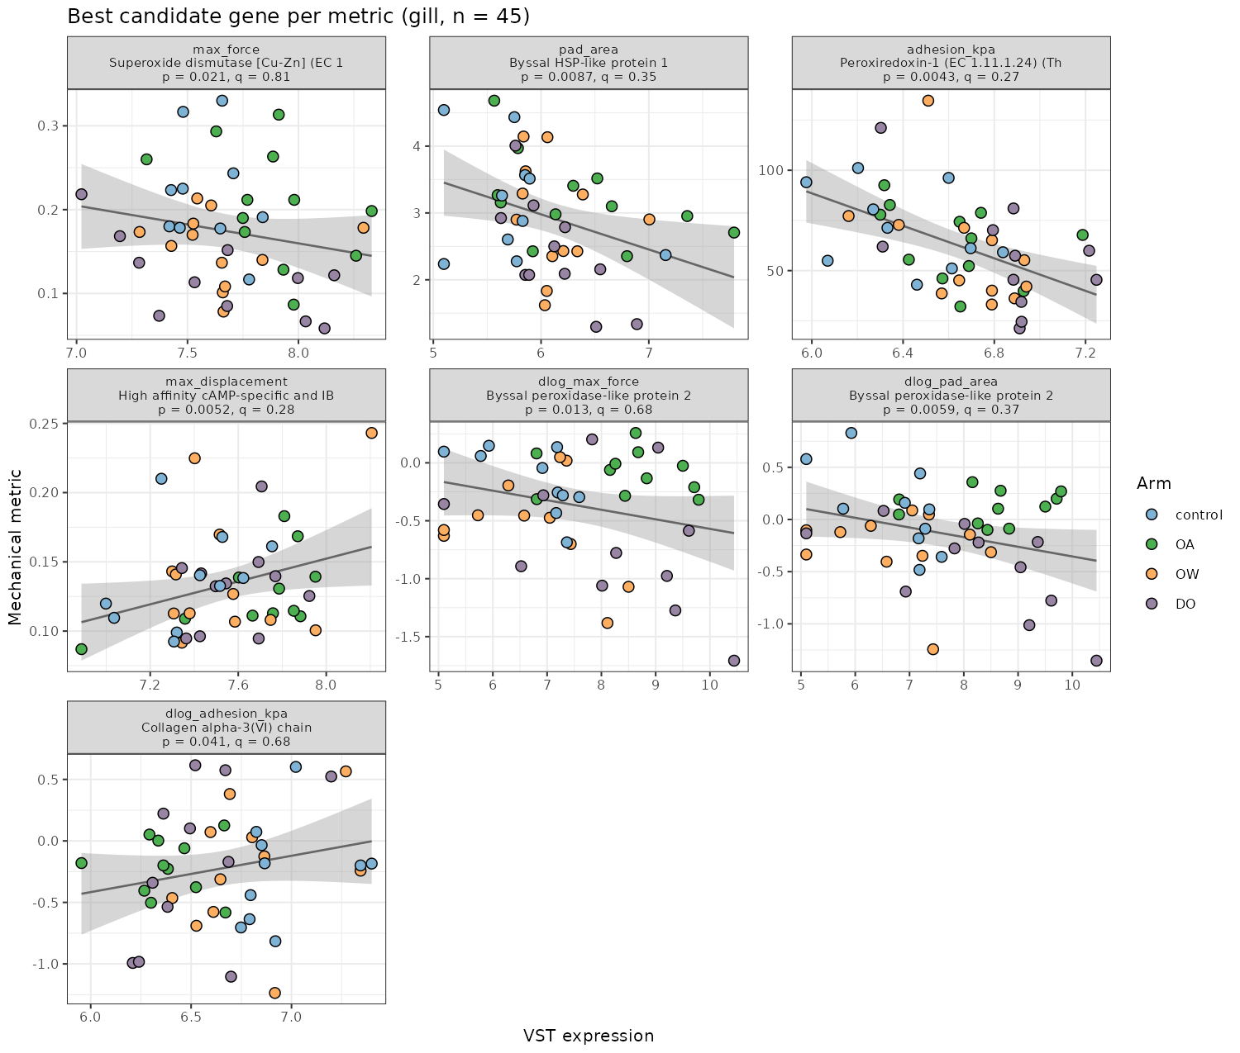
Figure 3. Gill: the best candidate gene for each metric, as Figure 2. No panel shows the within-arm trend the foot collagen panel does.
Module | Metric | Model | n | Slope | p | q
oxidative_detox | Peak force | mixed | 45 | -0.014 | 0.014 | 0.072
HIF_hypoxia | Δlog force | wls | 43 | -0.135 | 0.025 | 0.125
HIF_hypoxia | Peak force | mixed | 45 | -0.016 | 0.038 | 0.096
Table 9. Gill module associations with q < 0.20 (module_associations_G.csv).
Metric | n | Genes searched | Observed min p | Permutation p
Peak force | 45 | 63 | 0.013 | 0.413
Plaque area | 45 | 63 | 0.0094 | 0.333
Δlog adhesion | 43 | 63 | 0.035 | 0.875
Table 10. Gill permutation null (permutation_best_hit_G.csv).
Gill is the systemic tissue, not the one that builds the thread. Its best single-gene association is Peroxiredoxin-1 against adhesion level (q = 0.093), and its modules point the same way: oxidative_detox and HIF_hypoxia against peak force level, both negative. None of it survives the permutation null. The change-in-adhesion metric that carries the foot's collagen signal shows nothing in gill (best q = 0.78). The gill DEG union is larger (1009 genes against 523) and its minimum q is 0.10.

6. Foot against gill
Gene | Metric | Foot slope | Foot q | Gill slope | Gill q
Peroxiredoxin-5, mitochondrial (EC 1.11… | Extension | -0.019 | 0.084 | -0.000 | 0.996
Collagen alpha-1(V) chain | Δlog adhesion | -0.383 | 0.034 | 0.035 | 0.970
Collagen alpha-2(IV) chain | Δlog adhesion | -0.512 | 0.064 | -0.031 | 0.970
Table 11. The foot hits with q < 0.15, looked up in the gill results for the same gene and metric. "not tested" means the gene did not pass the expression filter in gill.
Module | Metric | Foot slope | Foot q | Gill slope | Gill q
HIF_hypoxia | Peak force | -0.015 | 0.326 | -0.016 | 0.096
HIF_hypoxia | Adhesion | -8.615 | 0.081 | -4.483 | 0.302
HIF_hypoxia | Δlog force | -0.025 | 0.834 | -0.135 | 0.125
HIF_hypoxia | Δlog area | 0.107 | 0.051 | -0.020 | 0.996
HIF_hypoxia | Δlog adhesion | -0.151 | 0.085 | -0.126 | 0.352
byssal_collagen | Adhesion | -5.293 | 0.085 | 4.043 | 0.302
byssal_collagen | Δlog area | 0.068 | 0.080 | 0.000 | 0.996
byssal_collagen | Δlog adhesion | -0.134 | 0.052 | 0.041 | 0.538
oxidative_detox | Peak force | -0.001 | 0.814 | -0.014 | 0.072
tRNA_translation | Adhesion | 2.981 | 0.144 | 0.734 | 0.705
Table 12. Module associations reaching q < 0.20 in either tissue, side by side.
The two tissues do not share a signal. The foot's collagen association with the change in adhesion has no counterpart in gill; the gill's oxidative and hypoxia modules against force level are not seen in foot at q < 0.20. That pattern, a thread-building signal confined to the thread-building organ and a general-stress signal in the systemic tissue, is coherent, and it is what would be expected if the foot result were real. It is also what would be expected from two independent sets of noise. The permutation p of 0.054 in foot and the sensitivity in section 4.5 are the honest measures.

7. Diagnostics
Detection floor. A gene with many paired samples at the minimum VST value is effectively unexpressed in those animals, and any correlation it shows is driven by presence/absence, not level. Candidate genes with more than 20% of samples at the floor: foot, Multidrug resistance-associated protein 1 (48%), Byssal peroxidase-like protein 2 (41%), Glyoxalase 3 (36%), ACDC/Byssal EP-like protein 1 (27%), Glutathione S-transferase 1 (25%), mitochondrial Phe-tRNA ligase (23%); gill, Dual oxidase maturation factor 1 (31%), Collagen alpha-1(XXII) chain (31%). The foot plaque-area "hit" (Byssal peroxidase-like protein 2) is one of these. Collagen alpha-1(V) and alpha-2(IV) are not.
Influence. The extension association with Peroxiredoxin-5 (foot, q = 0.084) rests on two animals at the floor with high extension, visible in Figure 2. Script 21 reports the most influential animal per top hit by Cook's distance; the collagen V fit is not dominated by any single animal.
Two DESeq2 runs for gill hypoxia. The register notes that GDO_TC_siggene_apeglm.csv (307 genes) is not a subset of GDO_TC_apeglm.csv. The gill DEG union here uses the siggene file, as the foot does. That inconsistency in the differential-expression module is unresolved and bears on the gill DEG-union results.

8. Byssus and foot gene list, script 23
Category | Foot genes | Foot stress-responsive | Gill genes | Gill stress-responsive
byssal_accessory | 6 | 1 | 4 | 0
byssal_structural | 16 | 0 | 10 | 3
collagen | 26 | 0 | 29 | 7
collagen_biosynth | 18 | 2 | 14 | 3
crosslink_curing | 17 | 1 | 17 | 2
ecm_adhesion | 38 | 3 | 65 | 7
Table 13. The narrowed byssus/foot gene list by category, expressed in the thread-tested animals (byssus_gene_expression_F/G.csv): 121 genes in foot, 139 in gill. "Stress-responsive" = differentially expressed in at least one stressor contrast.
The pattern the register recorded still holds on the current tables: the canonical structural byssal proteins are not differentially expressed under any stressor in foot; the stress signal sits in the curing and biosynthesis machinery. Those tables are the per-gene, per-animal reference for confirming that statement and are not repeated here.

9. Coverage, script 22
 | Foot | Gill
RNA-sequenced animals | 59 | 59
with curated day-3 threads | 45 | 45
with curated baseline threads | 45 | 45
Sequenced at day 3, no day-3 trace | T136, T137 | T136, T137
Table 14. RNA × thread manifest (rna_thread_manifest_F/G.csv). Every extracted trace is curated; the only gap is the two day-3 control animals, T136 and T137, that were never pulled.

10. Evaluation and caveats
- Power. n = 44 (foot) and 45 (gill), 10 to 12 per arm. Within-arm correlations are not interpretable; the pooled-with-covariate model borrows strength across arms but cannot separate arm-level expression shifts from arm-level attachment differences.
- Multiplicity. 57 candidate genes × 7 metrics in foot. The permutation null is the search-corrected number: 0.054 for the best change-in-adhesion hit, 0.44 and 0.50 for force and area. The DEG union (523 foot, 1009 gill) is screening only and produced nothing.
- Design confounds inherited from the thread module. One tank per arm; baseline and day-3 threads differ in age and re-attachment history; the control arm started ~15 kPa higher; no curation exclusions have been applied. The collagen association is with the change metric, which removes fixed between-animal differences but not any of these.
- Destructive sampling. Expression and threads are contemporaneous. A gene whose expression tracks plaque growth may be responding to it as easily as driving it.
- The metric that carries the signal is a ratio of the two that do not. Collagen expression relates to the change in adhesion because it relates to the change in area, not force. Reporting it as an "adhesion" gene would obscure that; reporting it as a plaque-size gene is closer to what the data say.
- The register's directional hypothesis is not supported in the change frame. HIF module expression is positively, not inversely, associated with the change in plaque area (q = 0.051). The level-frame association with adhesion is negative (q = 0.081). The two frames are answering different questions and the earlier framing should be revisited with both in view.

11. What this points to
- State one testable hypothesis, not a result. "In the foot, higher expression of fibrillar-collagen genes (alpha-1(V), alpha-2(IV)) and prolyl 4-hydroxylase alpha-2 at day 3 is associated with greater plaque growth from baseline and a proportionally smaller gain in holding force." That is what q = 0.034 / permutation 0.054 / gill-null supports, and no more.
- The powered follow-up the register already calls for should target plaque area and force separately, with a qPCR panel on the collagen and P4H genes plus the HIF and oxidative modules, on 60 to 90 paired animals with baselines and replicate tanks. The change metrics need the baseline pull; design it in.
- Apply the curation step and re-run. The thread table currently includes every run. Excluding the technician-noted retries and T090_01, then re-running 20 to 21, is the cheapest robustness check available and should be done before anything is written.
- Run the level and change frames as a pair in any write-up. Where they disagree (HIF vs area), say so rather than picking one.
- Resolve the two gill hypoxia DESeq2 runs before the gill DEG-union results are cited anywhere.

12. Reproducibility
Open gene-mechanics-correlation.Rproj and knit 01_code/24-run_gene_mechanics_by_tissue.Rmd; it renders 20 → 21 → 22 → 23 for foot and gill in separate R processes and writes the HTML reports and a run log to 03_analyses/knit_html/. Any single script can also be knitted alone with the tissue parameter set in its YAML header, or run chunk by chunk in RStudio, where it defaults to foot. Requires thread-strength scripts 1 to 4 to have been run first. Outputs are tissue-suffixed under 03_analyses/gene_mechanics/, expr_tables/ and byssus_genes/; annotation_map.csv is shared. gene-mechanics-pipeline_DOC.md in 01_code/ documents inputs, options and outputs.

Appendix. Candidate-gene correlation heatmaps
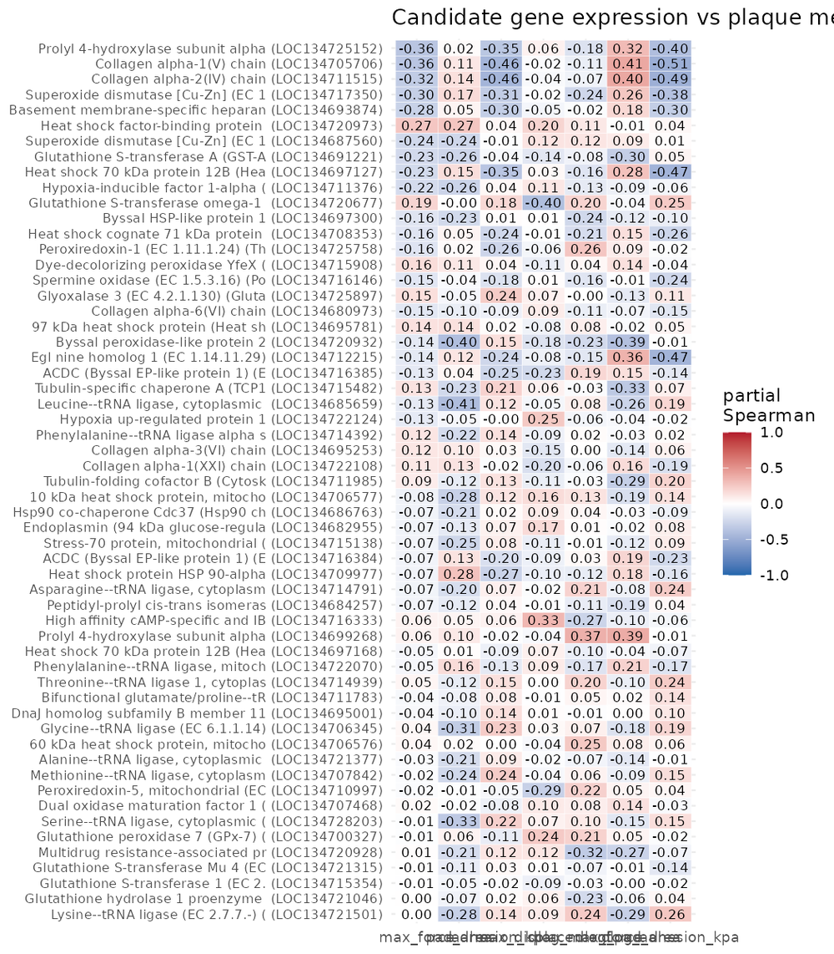
Figure A1. Foot: treatment-partialled Spearman correlation of every candidate gene against every metric (candidate_heatmap_F.png).

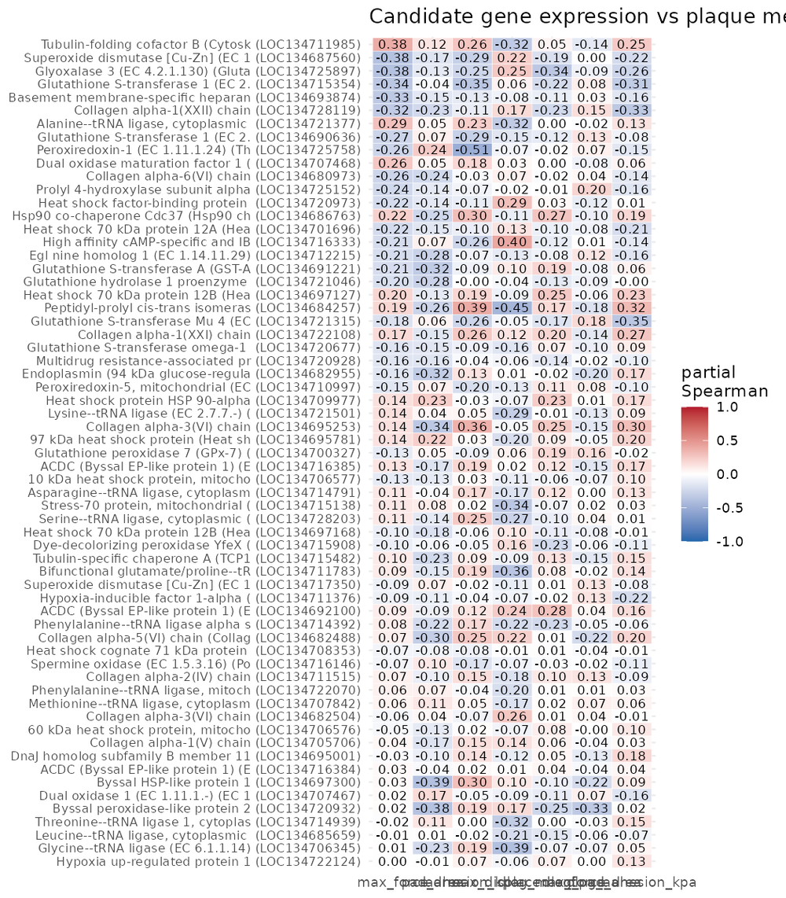
Figure A2. Gill: as Figure A1 (candidate_heatmap_G.png).

