Byssal thread mechanics before and after a 3-day stress exposure
Results of the thread-strength module, PSMFC Mytilus byssus pilot
Generated 16 September 2026 from mattgeorgephd/PSMFC-mytilus-byssus-pilot at commit 0182455. Every number in this report is read from a file under thread-strength/03_analyses/ produced by scripts 1 to 4; nothing is retyped.

1. Summary
The complete dataset is now in play: 375 threads from 86 Mytilus trossulus, every one with a plaque measurement, and the day-3 control arm paired to its own baselines for the first time (10 of 10 animals). The findings below supersede every earlier version of this analysis, all of which ran on a 299-thread subset with an unpaired control arm and a baseline pool contaminated by lab-reference animals.
- Adhesion (kPa) falls by about a fifth in every arm between baseline and day 3, including control. Mixed model: timepoint F = 18.7, p < 0.0001; arm × timepoint interaction F = 0.71, p = 0.548. On adhesion alone, no stressor arm differs from control.
- That null hides a real dichotomy. Peak force and plaque area, modelled separately, both carry a strong arm × timepoint interaction (force p = 0.0005; area p < 0.0001). Warming and hypoxia animals build plaques 19% and 37% smaller that hold with 44% and 51% less force. Control and acidification animals build slightly larger plaques that hold with slightly less force. The two changes divide out to a similar fall in kPa, which is why the ratio shows nothing.
- Acidification is not distinguishable from control on any mechanical metric. Its paired adhesion decline is the only stressor-arm paired test that reaches p < 0.05 (p = 0.011, n = 11), but its magnitude (-16.5 kPa) is smaller than the control arm's own decline (-19.5 kPa, p = 0.077, n = 10).
- The earlier "significant interaction" (p = 0.045) was an artifact. It arose from a rank-deficient design in which the control arm had no baseline cell. With the control baselines curated, the interaction on adhesion is p = 0.548.
- Failure-mode composition shifts with treatment at day 3 (Fisher's exact p = 0.044). Peeling failures hold at roughly 55 kPa against 80 kPa for cohesive failures, and hypoxia has the highest peeling fraction (49%).
Data provenance items that need your confirmation before any of this is written up: nine previously committed plaque areas changed value in the latest data file, seven of them by an exact integer; the 76 newly added plaque measurements cannot be checked against images in the repository; and the curated table currently applies no exclusions at all. Details in section 6.

2. Data and pipeline
Raw tensometer traces are organised in six subfolders under 02_data/tensometer_output/. The subfolder is the only place the thread treatment is recorded, so the pipeline reads it into three columns: thread_trt (what the thread was built in), phase (lab, pre or post) and, by joining the mussel key, mussel_trt (the arm the animal was assigned to). The distinction matters because mussel_trt is a destiny label: a baseline thread from an animal later exposed to acidification is not an acidification thread.
Pipeline: script 1 extracts every trace (peak force, area under the force curve, extension) and writes the QC plots; script 2 joins the hand-measured plaque areas and writes a curation candidate; the curated table is 03_analyses/thread-summary.xlsx; script 3 models adhesion; script 4 models its components.
Folder | Thread treatment | Phase | Day | Traces | Mussels | Threads / mussel
00_baseline | baseline | pre | 1 | 158 | 60 | 1 to 4
00_laboratory_control | lab_control | lab | 0 | 38 | 12 | 3 to 5
01_treatment_control | treatment_control | post | 3 | 33 | 10 | 3 to 5
02_OA_treatment | OA | post | 3 | 37 | 13 | 1 to 3
03_OW_treatment | OW | post | 3 | 68 | 22 | 2 to 5
04_DO_treatment | DO | post | 3 | 41 | 14 | 2 to 3
Table 1. Trace coverage by tensometer subfolder. 375 traces, 86 mussels. Forty-five animals appear in both a pre and a post folder.
Three groups deserve a word. The lab-reference animals (T001 to T012) were pulled on day 0 and never entered the experimental system; they are a descriptive reference and are excluded from every before/after model. The pre-exposure baselines (day 1, shared holding) are the reference pool for every within-animal contrast. The day-3 control arm (T126 to T135) is the common-garden control; it is the correct comparison for the stressor arms at day 3, and it is now paired to its own baselines.

3. Adhesion, script 3

3.1 Thread-level summary
Thread treatment | Threads | Mussels | Peak force (N) | Plaque area (mm²) | Adhesion (kPa) | Extension (mm)
lab reference | 38 | 12 | 0.228 ± 0.101 | 3.01 ± 0.90 | 78.2 ± 37.2 | 0.189
baseline (pre) | 158 | 60 | 0.241 ± 0.102 | 3.29 ± 0.95 | 76.3 ± 32.9 | 0.142
control (day 3) | 33 | 10 | 0.215 ± 0.088 | 3.17 ± 0.93 | 70.2 ± 28.1 | 0.138
OA | 37 | 13 | 0.202 ± 0.114 | 3.18 ± 0.94 | 62.5 ± 28.8 | 0.124
OW | 68 | 22 | 0.150 ± 0.074 | 2.86 ± 0.85 | 56.1 ± 31.0 | 0.147
DO | 41 | 14 | 0.131 ± 0.086 | 2.41 ± 1.02 | 63.4 ± 43.3 | 0.131
Table 2. Mean ± SD across threads, by the condition the thread was built in. Adhesion = peak force / plaque area × 1000.
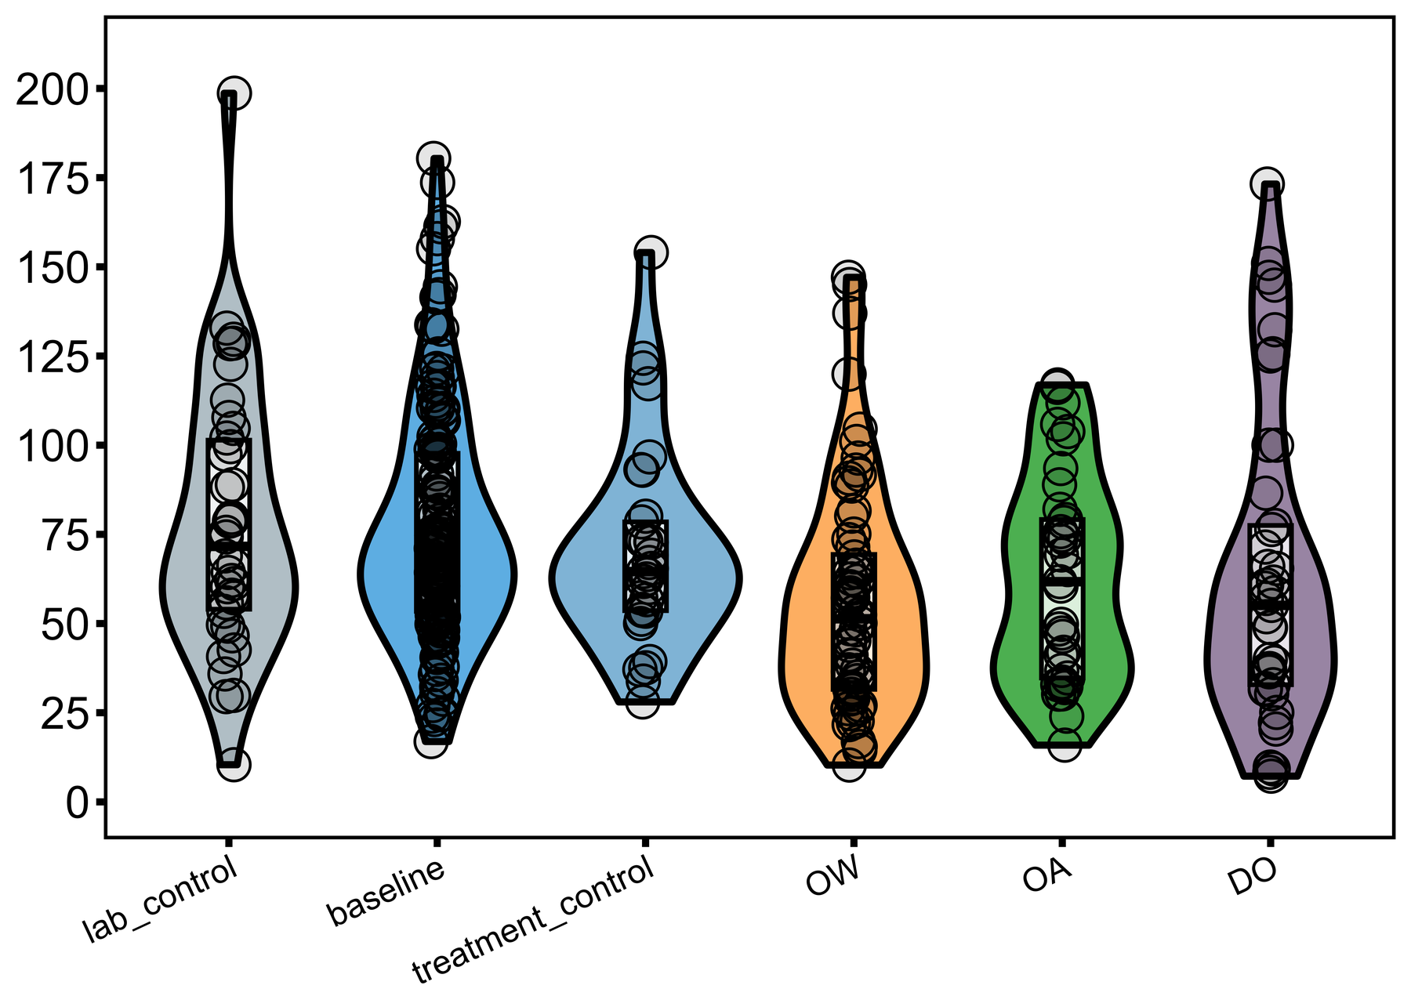
Figure 1. Adhesion of every thread by thread treatment. Violin, box (coef = 0) and jittered points. Each bar is one condition a thread was actually built in; baseline and the day-3 control arm are separate bars.

3.2 Within-animal change, by arm
One value per animal per timepoint (the mean of its threads). The paired test uses only animals measured at both timepoints; the two-sample test compares an arm's day-3 animals against the full pre-exposure pool of 60 animals. The two-sample test conflates the time effect with the treatment effect and is reported for continuity with earlier versions, not as evidence of a stressor effect.
Arm | Pairs | Δ adhesion (kPa) | Paired t p | Wilcoxon p | Day-3 n | Welch p vs pool | Mann-Whitney p
control (day 3) | 10 | -19.5 | 0.077 | 0.065 | 10 | 0.432 | 0.397
OA | 11 | -16.5 | 0.011 | 0.019 | 13 | 0.024 | 0.028
OW | 12 | -15.0 | 0.179 | 0.151 | 22 | 0.0010 | 0.0003
DO | 12 | -11.6 | 0.252 | 0.233 | 14 | 0.174 | 0.061
Table 3. Within-arm before/after on per-animal means (STATS_within_arm_beforeafter.csv). The baseline pool is pre-exposure animals only (INCLUDE_LAB_REFERENCE = FALSE).
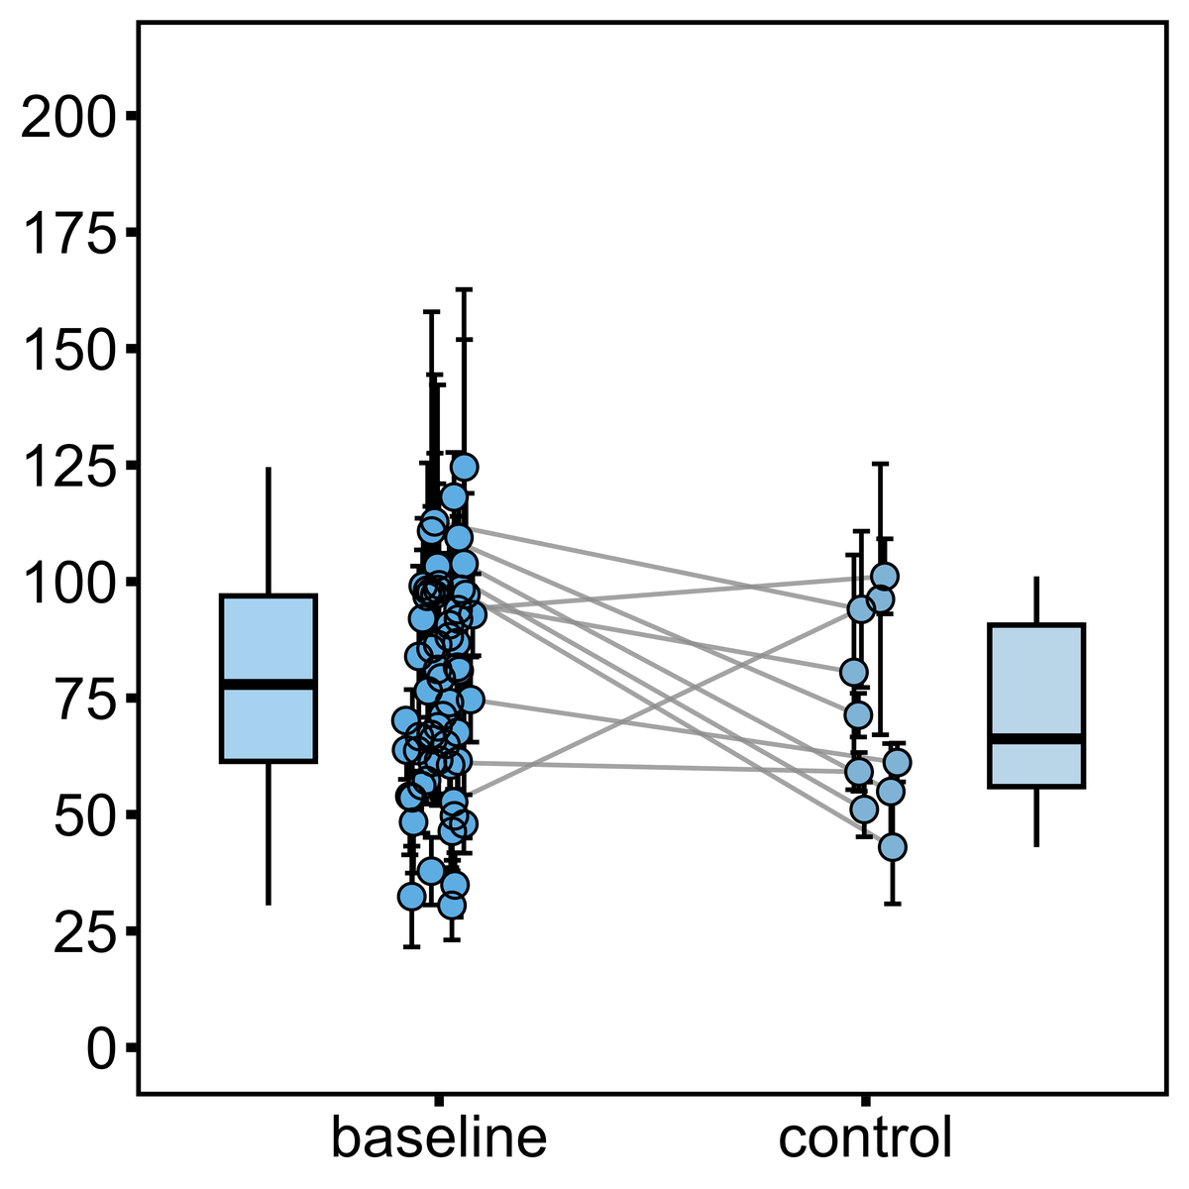 | 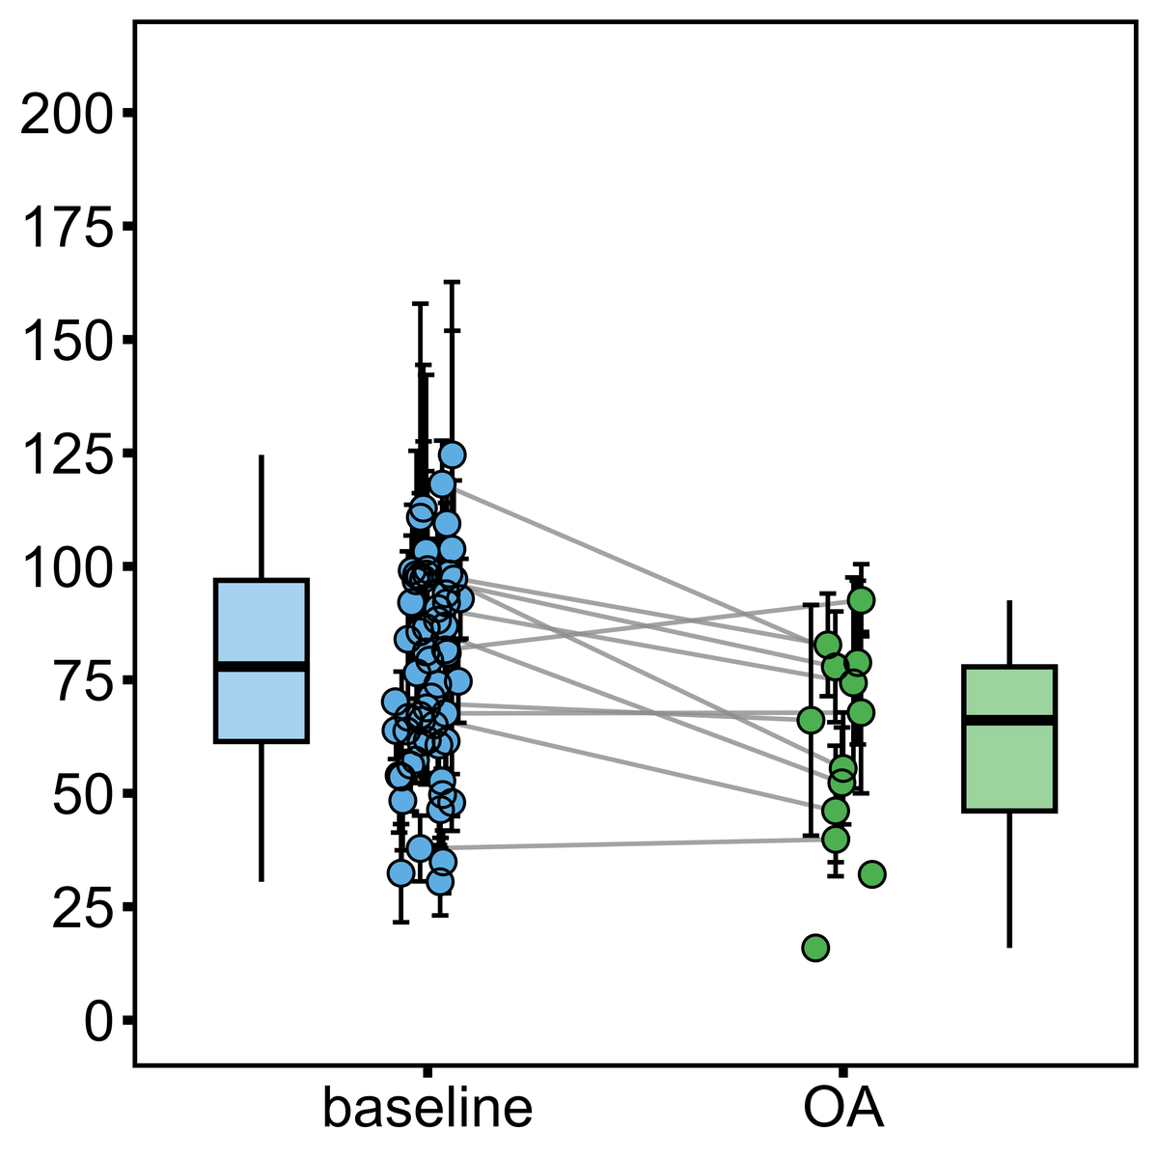
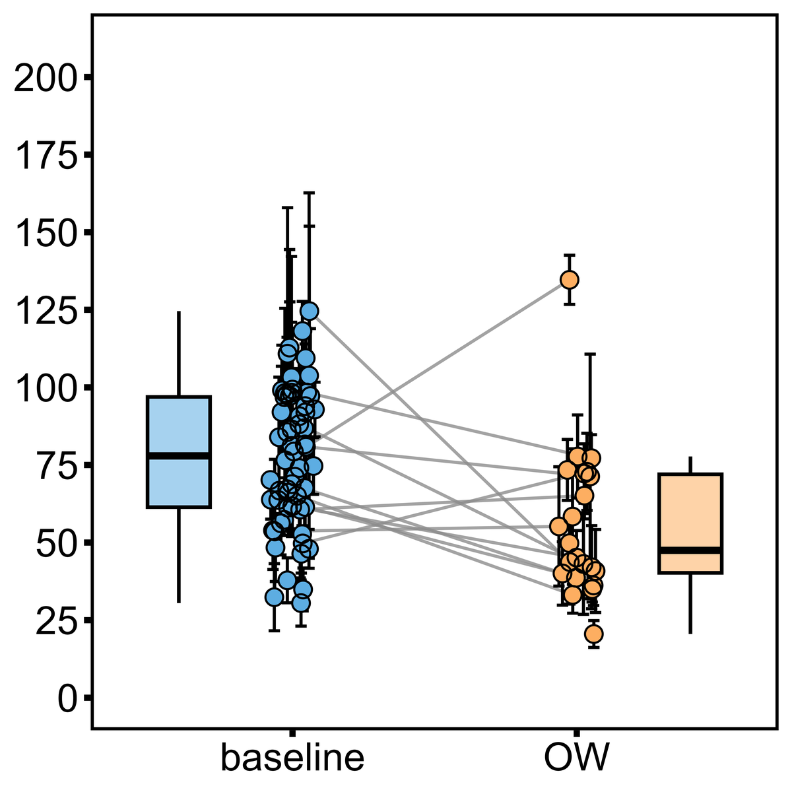 | 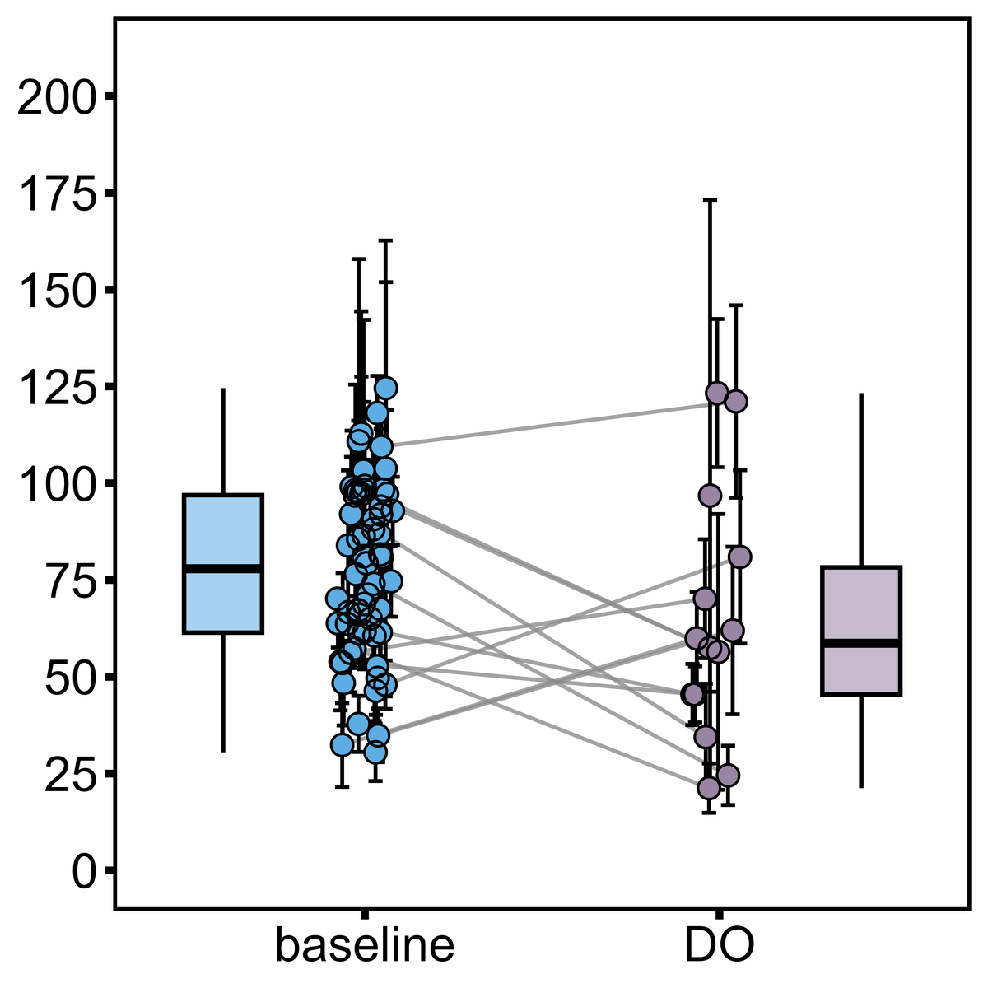
Figure 2. Per-animal mean adhesion (± SE across threads) at baseline and at day 3 for the control arm (top left), acidification (top right), warming (bottom left) and hypoxia (bottom right). The left cluster is the same 60 pre-exposure animals on every panel; a grey line connects an animal measured at both timepoints. Boxes summarise the per-animal means.

3.3 Mixed model on all threads
lmer(adhesion_kpa ~ mussel_trt × timepoint + (1 | mussel)) on 337 threads from 74 animals (phase pre and post; lab-reference animals excluded). The interaction is the scientific target: does the baseline-to-day-3 change differ by arm?
Model | Term | NumDF | DenDF | F | p
adhesion_kpa | mussel_trt | 3 | 63.1 | 1.64 | 0.189
adhesion_kpa | timepoint | 1 | 314.5 | 18.67 | < 0.0001
adhesion_kpa | mussel_trt:timepoint | 3 | 314.3 | 0.71 | 0.548
log(adhesion_kpa) | mussel_trt | 3 | 59.8 | 2.15 | 0.104
log(adhesion_kpa) | timepoint | 1 | 313.4 | 23.70 | < 0.0001
log(adhesion_kpa) | mussel_trt:timepoint | 3 | 313.2 | 0.29 | 0.834
Table 4. Type III ANOVA, Satterthwaite df (STATS_lmer_typeIII_ANOVA.csv). The log model is the robustness check for right-skewed residuals.
Arm | Baseline (kPa) | Day 3 (kPa) | Change baseline → post | SE | p
control | 90.6 [76, 105] | 70.6 [57, 84] | -20.0 | 8.3 | 0.016
OA | 75.2 [64, 86] | 59.9 [48, 72] | -15.3 | 6.9 | 0.028
OW | 75.2 [63, 87] | 55.8 [47, 65] | -19.4 | 6.6 | 0.0035
DO | 72.0 [61, 83] | 64.7 [53, 76] | -7.2 | 6.8 | 0.292
Table 5. Estimated marginal means [95% CI] and the within-arm change from the adhesion model (STATS_lmer_marginal_means.csv, STATS_lmer_within_arm_change.csv). Note the control arm's higher baseline.

3.4 Between arms at day 3
One-way ANOVA on per-animal day-3 means: F(3, 55) = 0.94, p = 0.429. Kruskal-Wallis: χ² = 3.98, p = 0.264. No pairwise Tukey contrast approaches significance.
Contrast | Difference (kPa) | 95% CI | Adjusted p
OW-control | -15.5 | [-41.1, 10.1] | 0.385
OA-control | -11.1 | [-39.4, 17.2] | 0.726
DO-control | -7.0 | [-34.8, 20.8] | 0.908
OA-OW | 4.4 | [-19.1, 27.9] | 0.960
DO-OW | 8.5 | [-14.5, 31.5] | 0.762
DO-OA | 4.1 | [-21.8, 30.0] | 0.975
Table 6. Tukey HSD on day-3 per-animal means (STATS_between_arm_day3_TukeyHSD.csv).

4. Decomposing adhesion, script 4
Adhesion is a ratio, and on the log scale the decomposition is exact: log(adhesion) = log(force) − log(area). Script 4 fits the same mixed model to each component and to extension at break. The interaction term, null on the ratio, is strong on both components.
Response | Scale | Arm p | Timepoint p | Arm × timepoint p
Adhesion | log | 0.104 | < 0.0001 | 0.834
Peak force | log | 0.059 | < 0.0001 | 0.0005
Plaque area | log | 0.359 | 0.0001 | < 0.0001
Extension at break | none | 0.208 | 0.090 | 0.0026
Table 7. Type III ANOVA p-values for each response (STATS_decomp_typeIII_ANOVA.csv).
Response | Control | OA | OW | DO
Adhesion | -22% (p = 0.059) | -21% (p = 0.029) | -31% (p = 0.0006) | -23% (p = 0.019)
Peak force | -12% (p = 0.331) | -18% (p = 0.071) | -44% (p < 0.0001) | -51% (p < 0.0001)
Plaque area | 12% (p = 0.105) | 7% (p = 0.285) | -19% (p = 0.0003) | -37% (p < 0.0001)
Extension (mm) | -0.034 (p = 0.0037) | -0.018 (p = 0.057) | +0.017 (p = 0.059) | +0.001 (p = 0.919)
Table 8. Model-estimated change from baseline to day 3 within each arm. For the logged responses the entry is the post/baseline ratio expressed as a percentage change; extension is a raw difference (STATS_decomp_within_arm_change.csv).
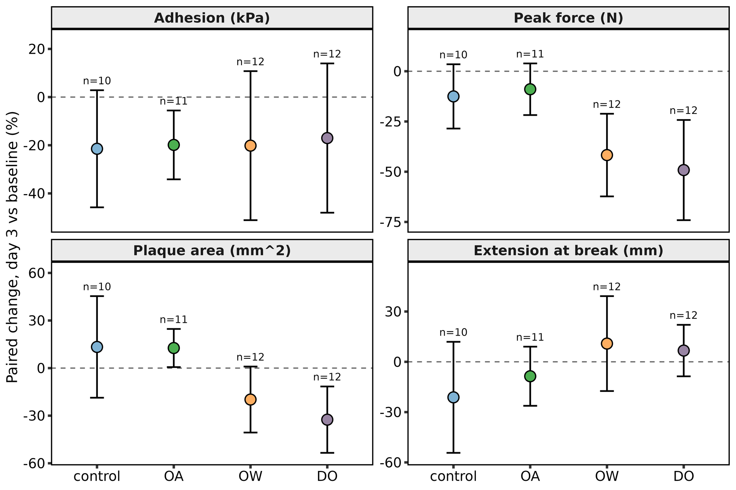
Figure 3. Paired per-animal change from baseline to day 3, mean and 95% CI, by arm and response (STATS_decomp_paired_by_arm.csv). Adhesion falls similarly everywhere; peak force and plaque area separate the warming and hypoxia arms from control and acidification.
The reading is consistent across the model-based and the paired per-animal estimates. Warming and hypoxia animals lose roughly half their peak holding force and build plaques a fifth to a third smaller. Control and acidification animals lose a tenth to a fifth of their force and build plaques that are, if anything, larger. This is the finding the earlier top-line summary reached on the partial dataset ("warming is the most mechanically damaging stressor; stress acts on plaque size"), now with a paired control arm to anchor it, and with hypoxia joining warming.

4.1 Failure mode
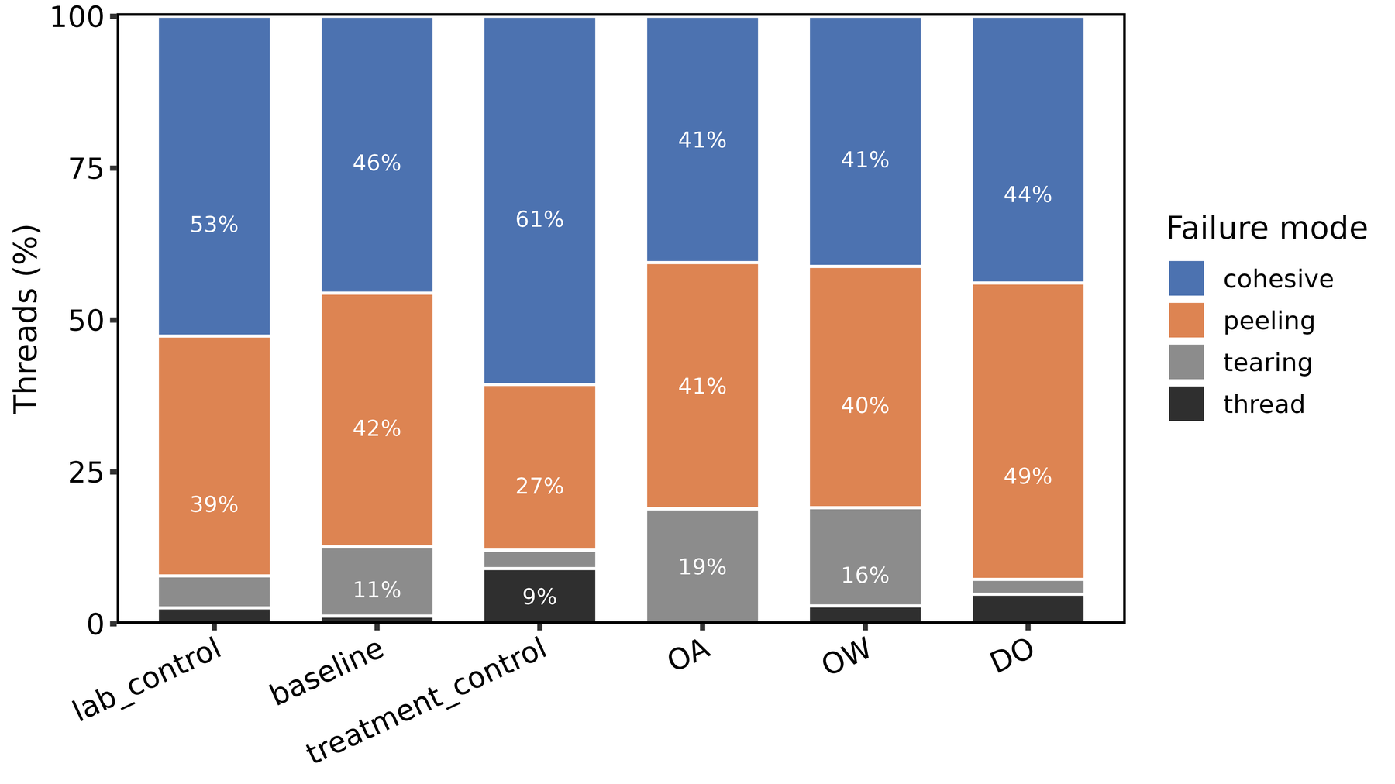
Figure 4. Failure-mode composition by thread treatment. Among the four day-3 arms: χ² = 16.6, df = 9, p = 0.056; Fisher's exact (simulated) p = 0.044.
Failure mode | Threads | Mean adhesion (kPa) | Median adhesion (kPa)
cohesive | 173 | 80.1 | 73.9
peeling | 152 | 55.0 | 51.7
tearing | 40 | 75.6 | 67.0
thread | 10 | 82.3 | 75.0
Table 9. Adhesion by failure mode, all threads. Peeling is the weak mode; a shift toward peeling is a shift toward weaker attachment.

5. Evaluation

What is robust
- The decline in adhesion from baseline to day 3 is large, present in every arm, and agrees across the paired tests, the raw mixed model and the log mixed model. It is the one result every specification supports.
- The force/area dichotomy is supported by two independent routes to the same numbers: model-based ratios and paired per-animal means. The interaction p-values on the components are small enough (0.0005 and < 0.0001) that they would survive any reasonable multiplicity correction across the four responses.
- The control arm is now a genuine within-subject control. Its decline is the calibration for everything else, and it removes the rank deficiency that made the previous interaction estimate unstable.

What is not
- Sample size. Ten to twelve pairs per arm. The paired adhesion CIs in Figure 3 span roughly 50 percentage points. Nothing here is confirmatory.
- Baseline imbalance. The control arm started higher (model baseline mean 91 kPa against 75 to 72 kPa for the stressor arms). The arm main effect is not significant (p = 0.189), but with n = 10 a 15 kPa gap is not nothing, and it means the control arm had further to fall. This is a randomisation check that should be reported.
- Two clocks. Baseline threads were built over roughly one day in shared holding; day-3 threads over roughly two days in the treatment tanks. Thread age at the pull, and the number of threads an animal had already built, differ between timepoints in ways the design cannot separate from the exposure. The uniform decline may be partly a thread-age or re-attachment effect.
- Single tanks. One tank per arm. Arm and tank are confounded, and no reanalysis can lift that.
- Curation. The curated table is the script 2 candidate verbatim: 375 rows in, 375 rows out. No thread has been excluded on QC grounds, and the technician notes and the three earlier force disagreements have not been reviewed against the QC plots. Until that review happens, every number here includes every run.

What changed against the earlier analysis, and why
The previous run (299 threads, control arm unpaired, lab-reference animals in the baseline pool) reported a significant arm × timepoint interaction on adhesion (p = 0.045) and per-arm mixed-model contrasts that disagreed with the paired tests. Three things fixed that: the control baselines entered the data, the lab-reference animals left the reference pool, and the pad-area file was completed. The paired-versus-mixed disagreement is gone; both now say the same thing. The stressor signal moved from the adhesion ratio to its components, where it is larger and cleaner than anything the earlier analysis reported.

6. Data provenance items to confirm
- Nine previously committed plaque areas changed value. T014_3, T015_1, T017_3, T038_2, T041_1, T041_2, T051_1, T090_1 and T090_4. The earlier values matched the retired Google Sheet export; the new ones do not, and seven of the nine differ by an exact integer (1, 2, 3 or 4 mm²), the signature of a corrected leading-digit typo. T051_1 doubled (2.42 to 4.85). If the new values came from the original measurement records, that is the right fix and worth a sentence in the methods; if not, they need a second look.
- The 76 newly added plaque measurements cannot be checked against the repository. Only 5 of those 76 threads have a microscope image under 02_data/pictures/; every one of the 299 previously measured threads does. The 71 images are presumably on your own storage. Committing them closes the provenance gap and lets the measurements be re-done if a value is ever questioned.
- No exclusions have been applied. thread-summary.xlsx is byte-identical to the script 2 candidate. The intended manual step, dropping bad runs against the QC plots, has not happened. One trace (T090_01, warming) was previously flagged as a different trace from the one behind its curated force value; it is included here at its freshly extracted value.
- Day-3 traces for T136 and T137 are still missing (morphometrics lists twelve day-3 control animals; ten have post traces). Fourteen animals have day-3 traces but no pre-exposure trace, and thirteen day-1 animals were pulled at baseline only by design. The pairing sheet in pad-area-worklist.xlsx lists every case.

7. Role of thread-strength in the overall analysis
The thread-strength module produces the mechanical phenotype of the study. It feeds two things: manuscript section 3.2 (thread mechanics), which is currently empty and can now be written from sections 3 and 4 of this report, and the gene-mechanics correlation (gene-mechanics-correlation/01_code/, scripts 20 to 23), which uses per-animal post-stress thread metrics as the response that gene expression is tested against.
The gene-mechanics pipeline is currently broken on its thread input. Scripts 20, 22 and 23 read thread-strength/02_data/thread-summary-trossulus-clean.xlsx, which was deleted in commit 91dea50, and they filter on a treatment column whose "control" value meant baseline threads. The fix is small: point THREAD_FILE at 03_analyses/thread-summary.xlsx, accept mussel_ID for mussel, take post-stress rows as thread_trt %in% c("OA", "OW", "DO") and baseline rows as phase == "pre". It is not included in this patch because the thread mechanics numbers have changed materially (375 threads, corrected areas, a paired control arm), so the correlation results will change and deserve their own pass rather than a side-effect of this one.
Two implications for that downstream analysis follow directly from section 4. First, max_force and pad_area should be the primary correlation targets, not adhesion_kpa: the stressor signal lives in the components, and a gene associated with plaque size would be invisible against the ratio. Script 20 already runs all three metrics, so this is a matter of which one is reported as primary. Second, the baseline-adjusted specification (ADJUST_FOR_BASELINE) is now available for the control arm too, and the control animals' own change from baseline is the natural null against which a stressor-specific expression signal should be judged.

8. Recommended further thread-level analyses
In priority order. The first three are cheap and change how the results are framed; the rest add information the current tables do not carry.
- Report force and area as the primary responses, with adhesion as the derived ratio. Script 4 already produces the tables. The manuscript framing should follow the components: warming and hypoxia reduce both plaque size and holding force; acidification does neither beyond what the control arm shows.
- Add thread production as a fourth mechanical response. The morphometrics workbook carries thread_count_before and thread_count_after per animal. An animal that builds fewer, smaller, weaker threads under hypoxia is a different biological story from one that builds the same number of weaker threads. This is a per-animal count model (Poisson or negative binomial with the same arm × timepoint structure) and needs no new data.
- Fit a joint force-area model or a plaque-weighted adhesion. Force and area co-vary within a thread. A bivariate mixed model, or force with log(area) as a covariate, separates "less force per unit plaque" from "less plaque". The current per-response models cannot tell whether the warming animals' force loss is entirely explained by their smaller plaques.
- Model failure mode as a response. A multinomial or, more simply, a binomial mixed model on peeling versus not, with the same arm × timepoint structure and a random intercept for animal. The chi-square in section 4.1 ignores the clustering of threads within animals and is therefore anti-conservative.
- Use the trace shape, not only its peak. Script 1 now exports extension at break and the force-time integral, and every QC plot shows a load-extension curve. Stiffness (initial slope), work to failure (integral of force over extension rather than time), and the shape of the post-peak tail all discriminate plaque-limited from thread-limited failure and are standard in the byssus mechanics literature. The integral currently exported is force over time, an impulse, and should not be reported as work.
- Add a covariate for thread number within the pull sequence. Threads 1 to 5 from the same animal are not exchangeable if the first pull disturbs the rest. A thread-order term in the mixed model is a one-line check.
- Report the randomisation check and the baseline correlation. Baseline adhesion by assigned arm (Table 5) and the correlation between an animal's baseline and day-3 values. The latter tells you how much of the day-3 variance is individual quality rather than treatment, which bears directly on how much power a follow-up needs.
- Sensitivity analysis on curation. Re-run scripts 3 and 4 with the technician-noted retries and the T090_01 trace excluded, and with INCLUDE_LAB_REFERENCE = TRUE. If the force/area dichotomy survives all three, say so; it is the strongest robustness statement available at this n.

9. Reproducibility
Open thread-strength.Rproj, then knit scripts 0 to 4 in order. Script 1 reads 02_data/tensometer_output/ and writes 03_analyses/extract-tensometer-data/; script 2 joins 02_data/pad_area_measurements.xlsx and writes 03_analyses/assemble-thread-summary/; the candidate is saved as 03_analyses/thread-summary.xlsx after curation; scripts 3 and 4 write 03_analyses/analyze-thread-strength/ and 03_analyses/decompose-adhesion/. Each output folder carries a RUN_provenance.txt with the timestamp, the configuration and the n at each step. Every script has a companion _DOC.md.
Provenance for this report: generated : 2026-09-15 21:03:47; input : 03_analyses/thread-summary.xlsx; INCLUDE_LAB_REFERENCE : FALSE; threads analysed: 375; threads dropped (no pad_area): 0; baseline pool : 60 mussels; lmer data : 337 threads, 74 mussels

Appendix. Residual diagnostics
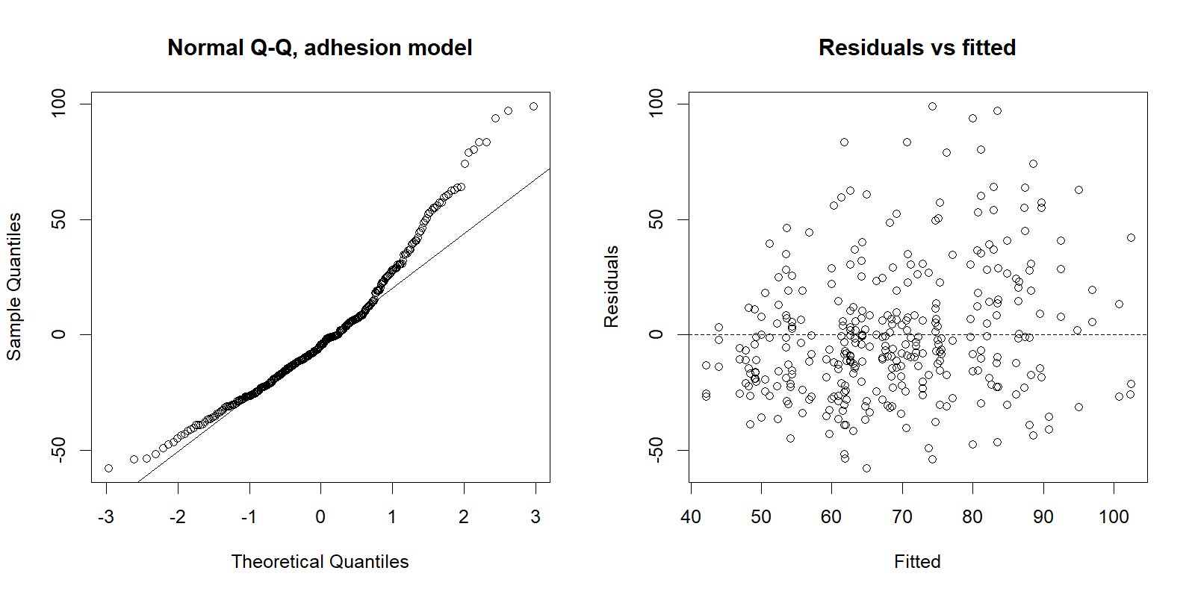
Figure A1. Normal Q-Q and residuals against fitted values for the adhesion mixed model (raw scale). The right tail motivates the log model reported alongside it; both give the same conclusions.

