**Semi-Annual Report**

**Development of Genomic Markers for Environmental Resilience in Mussels**

**Reporting Period: 05/1/2021 – 10/31/2021**

**(A) Project Summary**

Our project seeks to support the sustainable expansion of the shellfish aquaculture industry by investigating the downstream impact of common environmental stressors on the survival and successful cultivation of marine bivalves.

Our research objective is to describe the response of commercially relevant species of marine mussels to environmental fluctuations commonly experienced within nearshore environments, including ocean acidification (OA) and ocean warming (OW), utilizing cutting-edge molecular technologies to identify genetic markers that confer resilience to environmental change.

The measure of success for this proposal will be the identification of genetic markers that, when used as selection criteria for mussel broodstock, will produce adults with robust attachment to aquaculture lines under near-future OA and OW. By defining these gene-environment interactions, our results stand to support commercial growers in the development of selective breeding programs to ensure the efficient, sustainable, and profitable production of mussels within the United States.

**(B) Summary of Progress and Results**

During the reporting period, we completed the first phase of our proposed project – laboratory stressor trials. Using indoor mesocosms filled within filtered seawater, we successfully exposed two mussel species (*Mytilus galloprovincialis, Mytilus trossulus*) used within local aquaculture but from different ancestral geographic origin to acute ocean acidification (OA), ocean warming (OW), hypoxia, and desiccation stress (see Table 1 for treatment conditions). From these experiments, we collected:

(1) mantle, gill, and foot tissue for genomic analysis,

(2) byssal threads for mechanical analysis,

(3) respirometry measurements,

(4) thread production measurements, and

(5) condition and reproductive status measurements.

These measurements were taken from mussels before and after stress exposure, using the same individual when possible (see Figure 1 for experimental design). To date, we have completed the analysis of the thread production, respirometry, and condition/reproductive status datasets. In summary, the metabolic­ rate of mussels was impacted by OA, OW, and hypoxia exposure, with species level differences observed under OA and OW (Figure 2, 3). Thread production increased within both species under OA exposure, but decreased under hypoxia (*M. galloprovincialis* did not make any threads). Contrasting trends in thread production were observed under OW, with *M. galloprovincialis* increasing thread production, while *M. trossulus* produced fewer threads (Figure 4, 5). The physiological condition of *M. trossulus* throughout the experiment was greater than that of *M. galloprovincialis*, but no evidence of a laboratory of treatment-level effect on condition index or gonad index (reproductive condition) was observed in either species over the course of the experiment (Figure 6, 7).

Our goal going forward will be to:

(1) Extract DNA and RNA from tissues samples,

(2) Sequence RNA samples to quantify gene expression,

(3) Determine the attachment strength of byssal threads using mechanical analysis, and

(4) Sequence DNA from a subset of animals that exhibit resilience/susceptibility to weakened attachment.

Included with this report is a summary of the Materials and Methods used within laboratory studies and our preliminary results (see Tables and Figures).

**(C) Challenges**

Experiments were planned so as to not coincide with months wherein farmers see large spawning events (spring) and seawater temperatures had not previously stressed animals (summer). However, mesocosm experiments were delayed due to an outbreak of paralytic shellfish poisoning (PSP) within Penn Cove, pushing our start date by three weeks into October rather than September. Measurements of physiological condition and reproductive status did not indicate any prior stress or spawning, and limited mortality was observed over the course of 3 weeks in the laboratory. For these reasons, we are confident that tissue collected within theses assays will yield reliable transcriptomic results that are not confounded by other physiological processes that are occurring during to prior stress exposure or reproduction.

**Materials and Methods**

*Experimental Design*

200 Mediterranean Mussels (*Mytilus galloprovincialis*) and 200 Bay Mussels (*Mytilus trossulus*) were collected from Penn Cove Shellfish’s farms, located at Totten Inlet (47°09'N 122°59'24.0"W) and Penn Cove (48°13'N 122°42'W), Washington, respectively. Animals were transported to the laboratory on ice and placed within experimental mesocosms filled with recirculating, 0.2 µm filtered seawater and held at 12°C; seawater in tanks was exchanged every 3-4 d. Upon arrival, all mussels were labeled by gluing a numbered wire tag to the right shell valve, and shell measurements (shell length, width, and height) were recorded.

To assess their physiological condition, tissue from a subset of mussels within each species was resected and the somatic and gonad tissue was separately weighed after drying at 60°C for 5d. This process was completed with cohorts of mussels upon arrival in the laboratory and after the completion of stress exposures; tissue measurements were used to calculate the condition index (CI = total dry tissue weight × shell length-3) and gonad index (GI = total dry gonad weight ÷ total dry tissue weight), measures of physiological and reproductive status, respectively.

After a 1-week acclimation period, mussels were fastened to mica plates with rubber bands and allowed to make threads for 3 d. The number of threads that each mussel produced was counted (thread number) before cutting threads at the shell interface. Mica plates with attached threads were removed and aged within aerated, filtered seawater for 9 d before being dried and stored for later mechanical testing. As mussels (and collected threads) were labeled, these initial thread samples will constitute the ‘baseline’ conditions for both thread production and thread strength.

After thread removal, mussels were placed into one of five treatments: control (pH=8.0, T=12°C, dissolved oxygen = 10 mg L-1), ocean acidification (pH = 7.0), ocean warming (T = 20°C), hypoxia (dissolved oxygen = 4 mg L-1), or desiccation (27°C aerial exposure for 24 h), as diagramed within Figure 1A. Treatments were generated using a temperature-, pH-, or oxygen-stat system that continually monitored and controlled each parameter to a desired setpoint using a controller that regulated the activity of a tank heater or the flow of either CO2 or N2 into chambers (for a full description see our previous work [1]). A list of the conditions within each treatment are listed in Table 1. After 3 d of stress exposure, individual mussels within each treatment were collected, the byssus was carefully removed, and mussels were again aggregated into beds on mica plates, and returned to their respective stress treatments.

After 24 h, the number of threads that mussels produced were counted and sampled as previously described. Tissue from the mantle, gill, and foot of mussels that made threads (before and after stress exposure when possible) was resected, flash frozen in liquid nitrogen, and stored at -80°C for later genomic analysis.

*Respirometry*

The respiration rate of mussels within each treatment using an OXY-10 ST multi-channel oxygen meter fitted with DP-PSt7 oxygen dipping probes with temperature and salinity compensation (PreSens Precision Sensing, Regensburg, Germany). Baseline measurements for a subset of labeled mussels within each stress treatment was taken after a one-week laboratory acclimation period, followed by another measurement on the same individuals after 3 d of stress exposure (in all cases except desiccation). The rate of oxygen uptake (ṀO2) of individual oysters was determined by closed-system respirometry wherein animals were placed in 1.2 L plastic chambers filled with filtered seawater (with properties that matched treatment conditions), partially submerged in a recirculating water bath. For each measurement, a single mussel was placed within a chamber and allowed to recover from handling stress for at least 15 min; chambers were then closed, shielded from light, and the decline in O2 concentration (µmol O2) was recorded for 30 min. The water bath temperature during each run was made to reflect treatment conditions. The oxygen concentration of a blank chamber was used as an internal control. The standard respiration rate (SMR, mg O2 h-1 l-1) was calculated using the following equation:

where m is the oxygen uptake rate of the linear portion of the oxygen concentration curve (umol min-1), b is the oxygen uptake rate of a blank chamber (µmol min-1), 44.66 serves as a conversion factor from µmol to mg O2, and S is shell length (cm).

**Tables and Figures**

Table 1. Summary of treatment conditions (mean ± SD).

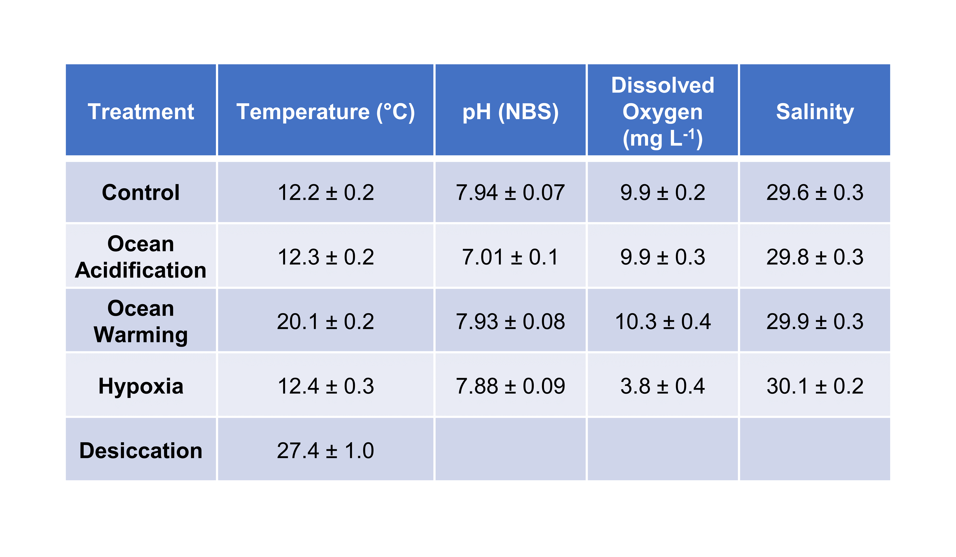

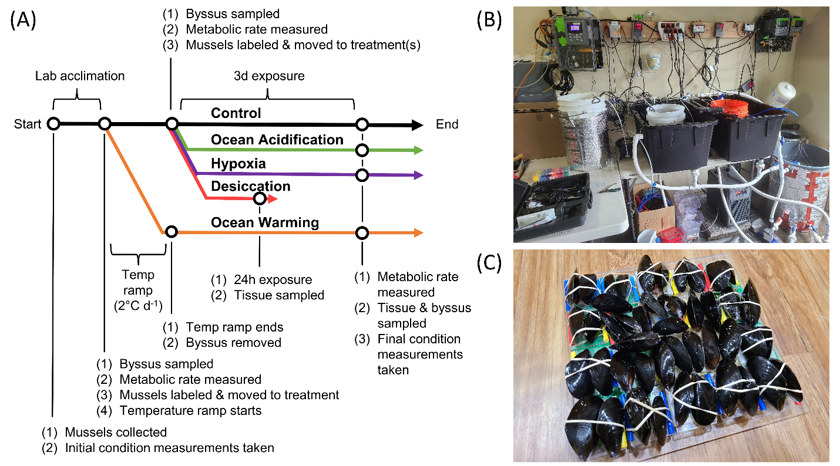

Figure 1. (A) Conceptual diagram detailing the experimental design used in thread experiments. (B) Laboratory mesocosm setup used in thread experiments. (C) Artificial mussel beds used to collect threads produced within treatments.

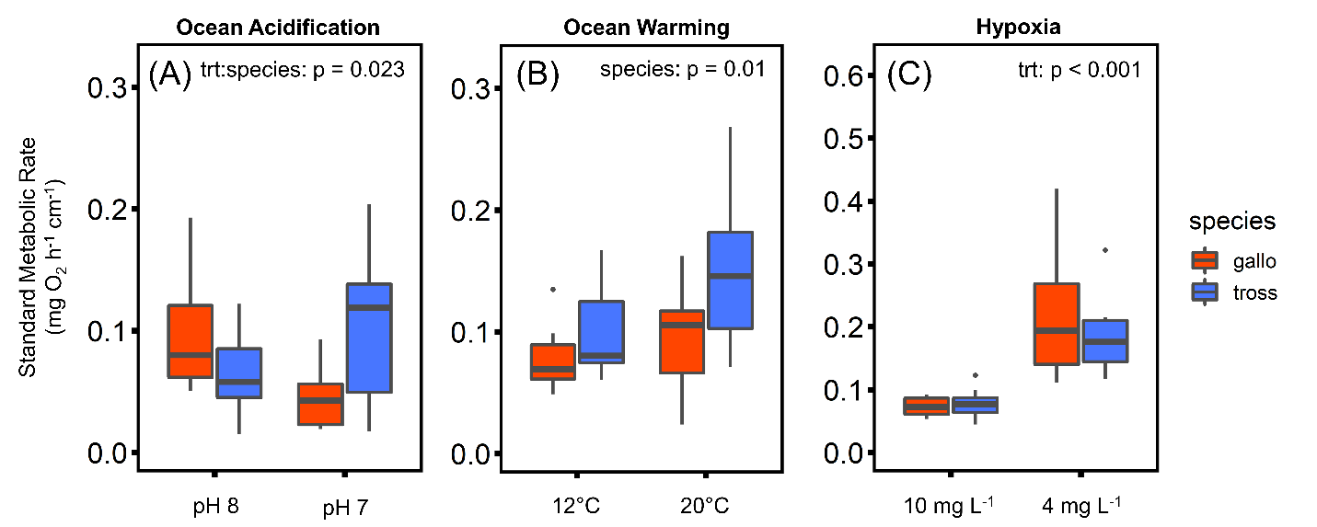

Figure 2. The standard metabolic rate (SMR) of mussels before and after exposure to (A) ocean acidification, (B) ocean warming, or (C) hypoxia.

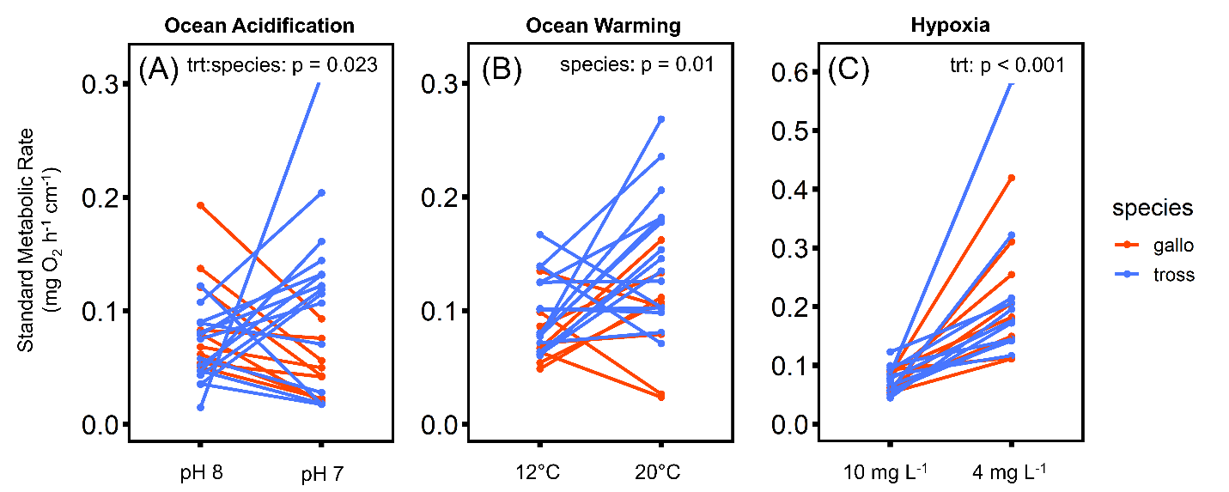

Figure 3. The standard metabolic rate (SMR) of mussels before and after exposure to (A) ocean acidification, (B) ocean warming, or (C) hypoxia. Lines represent paired measurements from a single mussel.

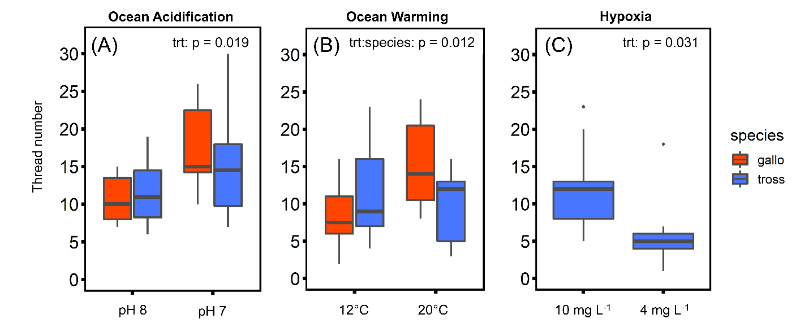

Figure 4. Thread production of mussels before and after exposure to (A) ocean acidification, (B) ocean warming, or (C) hypoxia. *Mytilus galloprovincialis* did not produce threads under hypoxic conditions.

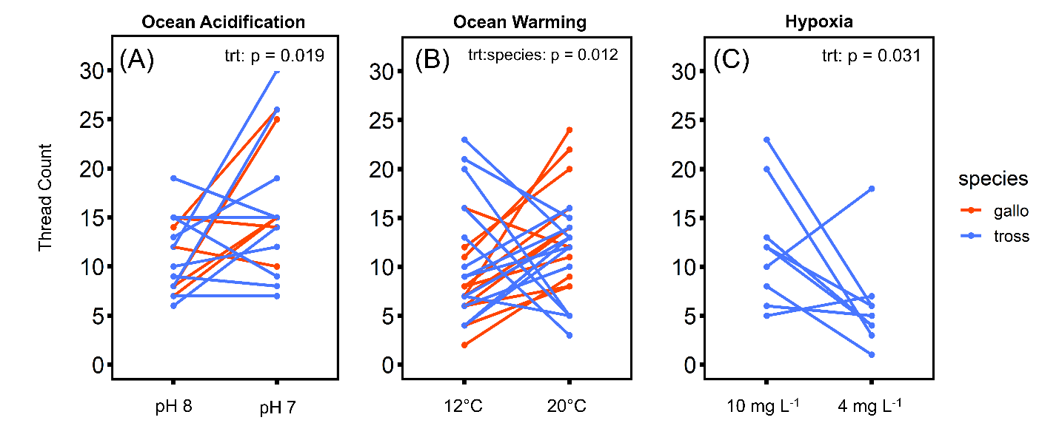

Figure 5. Thread production of mussels before and after exposure to (A) ocean acidification, (B) ocean warming, or (C) hypoxia. Lines represent paired measurements from a single mussel. *Mytilus galloprovincialis* did not produce threads under hypoxic conditions.

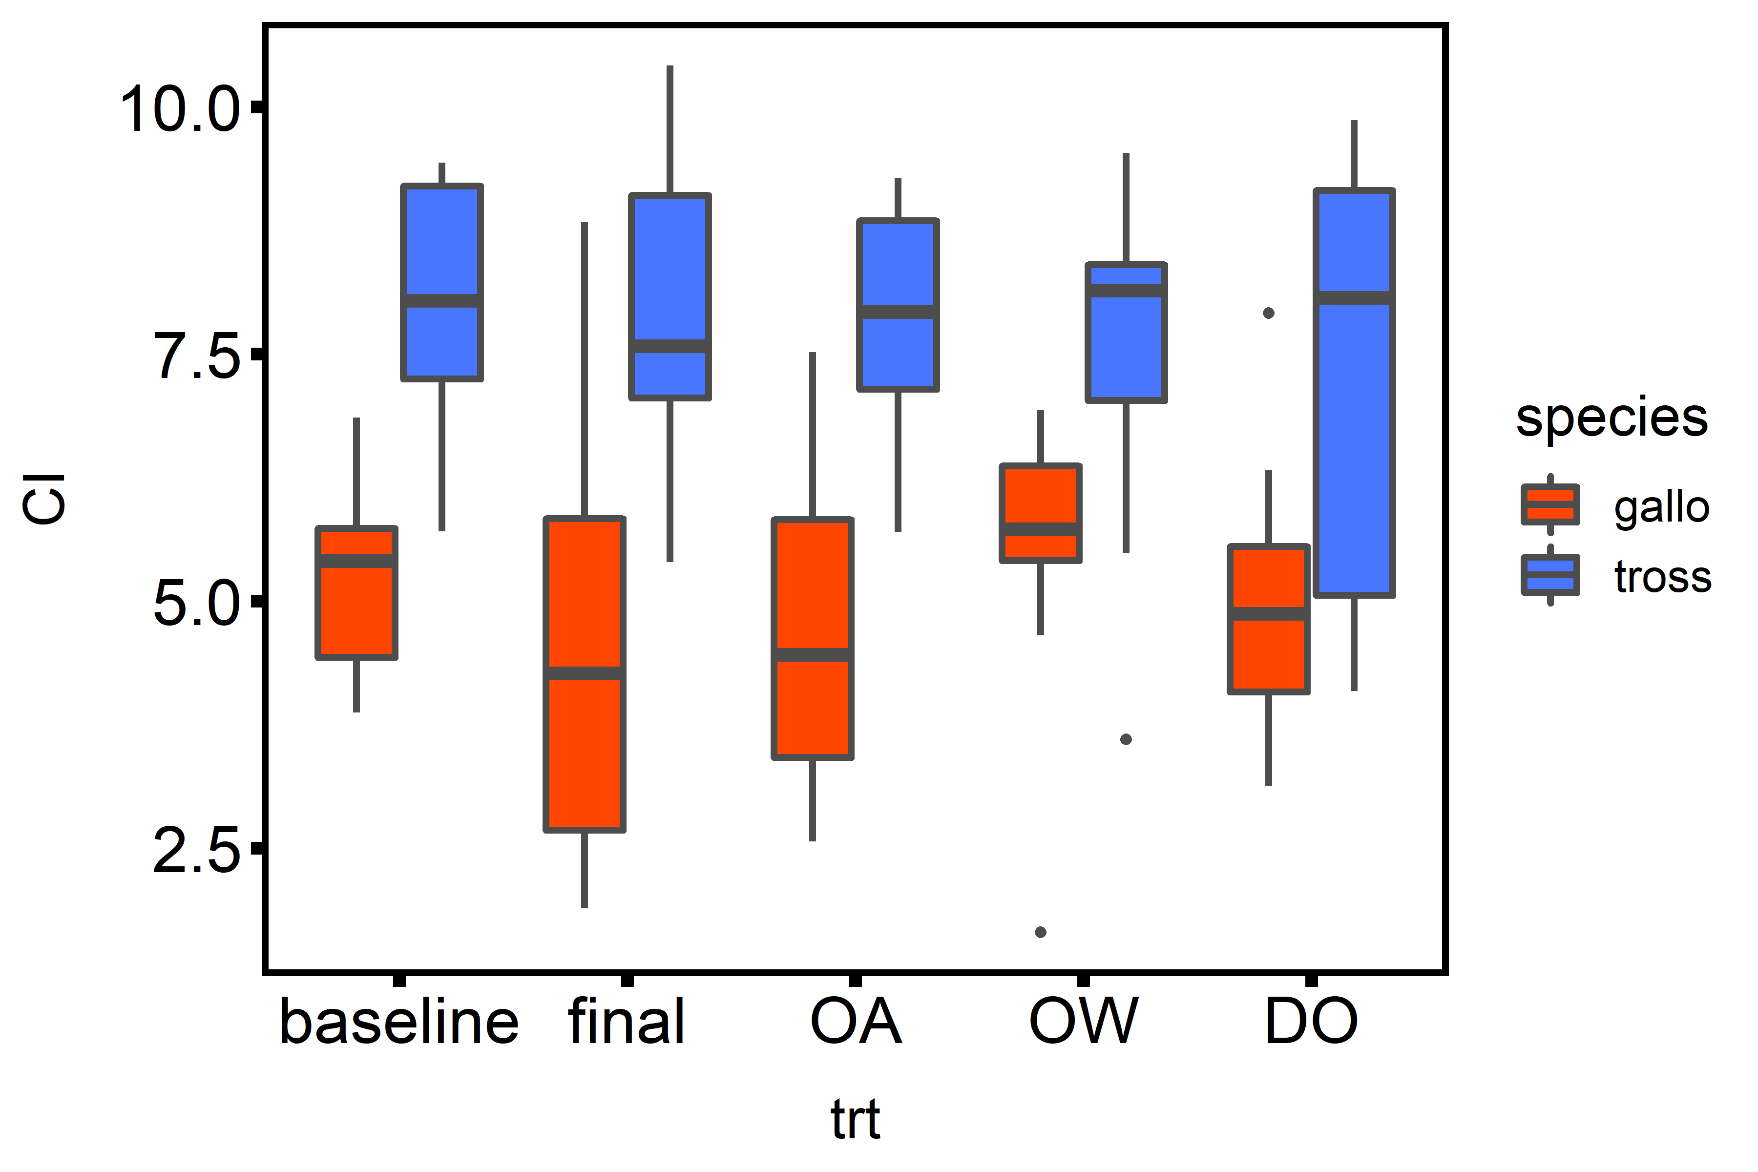

Figure 6. The physiological condition (condition index, CI) of mussels before and after exposure to laboratory (baseline, final) and treatment (ocean acidification, OA; ocean warming, OW; or hypoxia, DO) conditions.

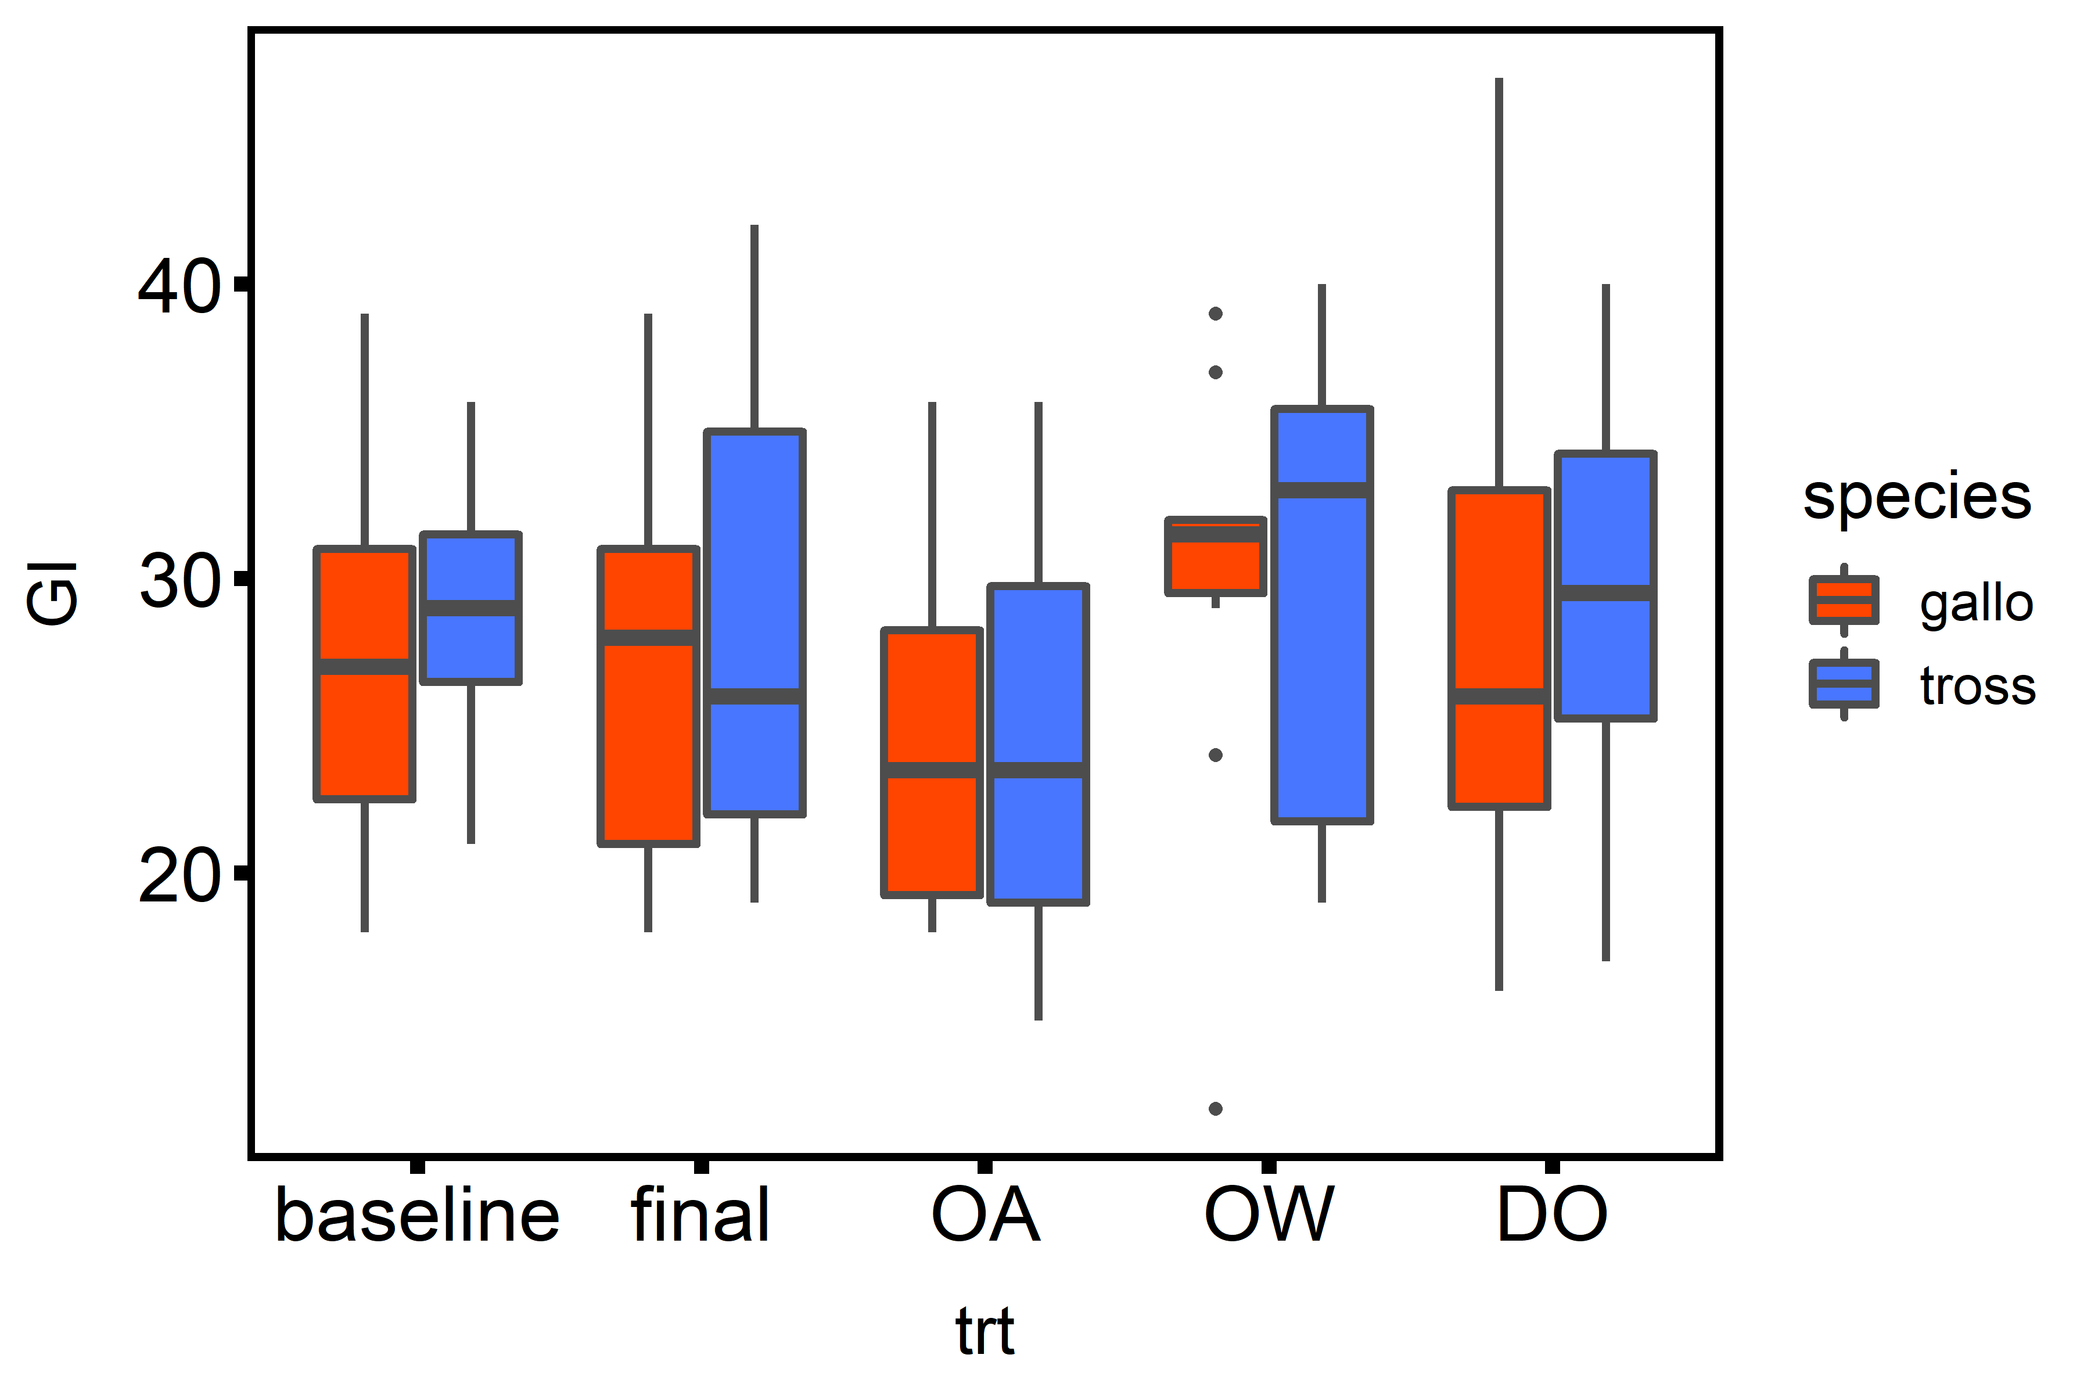

Figure 7. The reproductive condition (gonad index, GI) of mussels before and after exposure to laboratory (baseline, final) and treatment (ocean acidification, OA; ocean warming, OW; or hypoxia, DO) conditions.

References

1. George, M.N., et al., *Microscale pH and dissolved oxygen fluctuations within mussel aggregations and their implications for mussel attachment and raft aquaculture.* Journal of Shellfish Research, 2019. **38**(3): p. 795-809.