**Semi-Annual Report**

**Development of Genomic Markers for Environmental Resilience in Mussels**

**Reporting Period: 11/01/2022 – 04/30/2023**

**(A) Project Summary**

Our project seeks to support the sustainable expansion of the shellfish aquaculture industry by investigating the downstream impact of common environmental stressors on the survival and cultivation of marine bivalves.

Our research objective is to describe the response of commercially relevant species of marine mussels to environmental fluctuations commonly experienced within nearshore environments, including ocean acidification (OA) and ocean warming (OW), utilizing cutting-edge molecular technologies to identify genetic markers that confer resilience to environmental change.

The measure of success for this proposal will be the identification of genetic markers that, when used as selection criteria for mussel broodstock, will produce adults with robust attachment to aquaculture lines under near-future OA and OW. By defining these gene-environment interactions, our results stand to support commercial growers in the development of selective breeding programs to ensure the efficient, sustainable, and profitable production of mussels within the United States.

**(B) Summary of Progress and Results**

As detailed in previous reports, we have made substantial progress on the first (laboratory experiments) and second (genomic analyses) phases of the project. The first phase constituted laboratory stressor trials wherein mussels (*Mytilus trossulus*) underwent acute exposure to ocean acidification (OA), ocean warming (OW), and hypoxia (DO). The number of byssal threads produced by individual mussels was determined before and after exposure to stressors, as was their metabolic and mortality rate. These results were presented in previous reports. Additionally, byssal threads were saved following stressor trials for later mechanical analysis. The mechanical testing of byssal threads was completed during the current reporting period with the assistance of two undergraduate research assistants. A preliminary analysis of results suggest that mussels produced weaker byssal threads following acute exposure to ocean warming and hypoxia, but not ocean acidification (Figure 1). Repeated measurements from individually labeled mussels increased our confidence in this finding (Figure 2). Further analysis of the impact of stressors on other aspects of thread morphology that may impact adhesion are ongoing, including any impact of environmental treatment on the size of the attachment plaque. When this analysis is concluded, phase one of this project will be complete and ready for publication.

**(C) Challenges**

During the second phase, RNA was extracted from flash frozen gill (ctenidia) and foot tissue samples collected from mussels before and after exposure to climate stressors and submitted to the Genomic Sequencing and Analysis Facility (GSAF) at University of Texas at Austin for 3′-end Tag-Sequencing (Tag-Seq) and library preparation. The goal of genomic analysis is to determine how the expression of key genes involved in thread production are impacted by climate stressors and correlate these results with physiological measurements and thread attachment strength. As detailed in our last report, the sequencing data we received from the GSAF has been trimmed and determined to be of good quality, but gene expression analysis is not possible without a genome assembly for *M. trossulus*. To develop a genomic resource against which we could align our sequencing data, we previously developed a *de novo* transcriptome assembly using all the publicly available sequence read archives (SRA) available on the National Center for Biotechnology Information (NCBI) website. However, the majority of our samples achieved a poor alignment rate of ~35%. Given this challenge, we have submitted pooled gill and foot RNA extracted from all individuals included in our experiments for additional sequencing at the University of Washington PacBio sequencing facility. Sequencing and library prep is currently underway on the Iso-Seq Express platform and will generate approximately 3 million tissue-specific reads per SMRT cell. The Iso-seq platform should address the issues we encountered using publicly available SRA data by generating full-length transcript sequences of 10kb or longer from animals used in our experiments; this approach will maximize the probability that any transcriptome assembly generated achieves a high alignment rate with our tag-seq data while also capturing rare (low expression level) transcripts that are uniquely expressed (no present in SRA data) following environmental stress exposure. After a delay in sample processing due to sample backlogs over the holiday break and technical issues with their Iso-seq platform, UW PacBio assured us on 4/26/2023 that they will be able to provide us with our sequencing results before the end of May. We look forward to receiving this data and completing phase two of the project.

**Figures:**

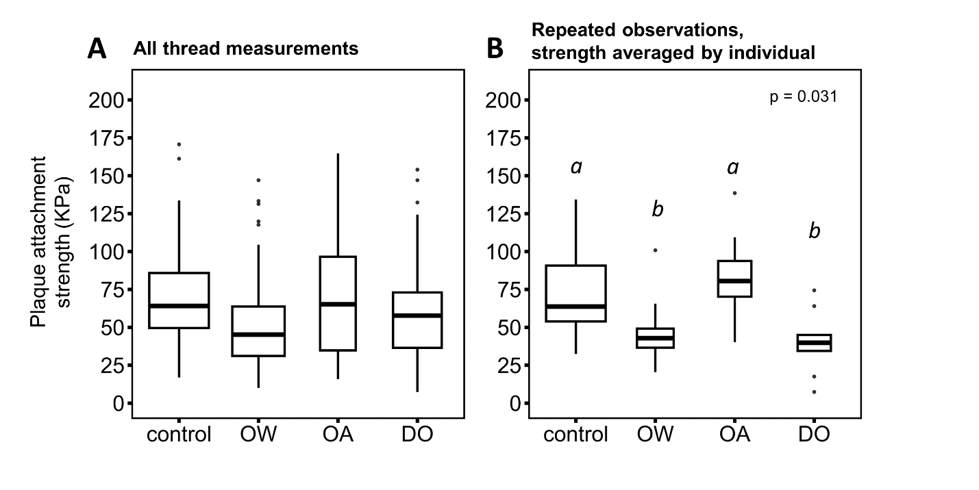

Figure 1. Byssal thread plaque attachment strength of mussels measured before (control; pH = 8.0, T = 12°C, O2 = 10 mg L-1) and after a three day exposure to ocean acidification (OA; pH = 7.0, T = 12°C, O2 = 10 mg L-1), ocean warming (OW; pH = 8.0, T = 20°C, O2 = 10 mg L-1), or hypoxia (DO; pH = 8.0, T = 12°C, O2 = 4 mg L-1). Measurements are presented for all threads (A) and for individuals for which repeated observations were available, averaged by individual (B).

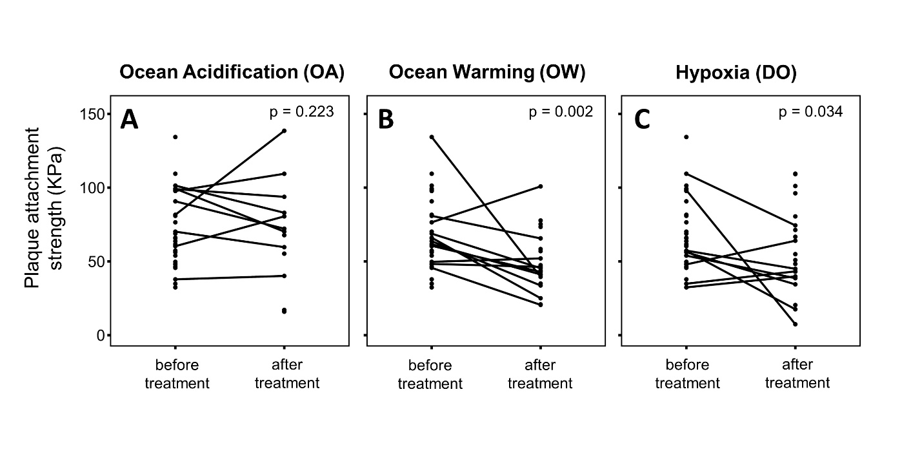

Figure 2. Line graphs displaying the byssal thread plaque attachment strength of individual mussels before and after exposure to ocean acidification (OA; A), ocean warming (OW; B), or hypoxia (DO; C).