**Semi-Annual Report**

**Development of Genomic Markers for Environmental Resilience in Mussels**

**Reporting Period: 05/01/2023 – 10/31/2023**

**(A) Project Summary**

Our project seeks to support the sustainable expansion of the shellfish aquaculture industry by investigating the downstream impact of common environmental stressors on the survival and cultivation of marine bivalves.

Our research objective is to describe the response of commercially relevant species of marine mussels to environmental fluctuations commonly experienced within nearshore environments, including ocean acidification (OA) and ocean warming (OW), utilizing cutting-edge molecular technologies to identify genetic markers that confer resilience to environmental change.

The measure of success for this proposal will be the identification of genetic markers that, when used as selection criteria for mussel broodstock, will produce adults with robust attachment to aquaculture lines under near-future OA and OW. By defining these gene-environment interactions, our results stand to support commercial growers in the development of selective breeding programs to ensure the efficient, sustainable, and profitable production of mussels within the United States.

**(B) Summary of Progress and Results**

As detailed in previous reports, we have made substantial progress on the first (laboratory experiments) and second (genomic analyses) phases of the project.

First Phase: Evaluate the impact of environmental stressors on byssal thread mechanics.

Mussels (*Mytilus trossulus*) underwent acute exposure to ocean acidification (OA), ocean warming (OW), and hypoxia (DO) in a series of laboratory trials. The number of byssal threads produced by each mussel was determined before and after exposure to stressors, as was their metabolic and mortality rate; these results were presented in previous reports. Additionally, byssal threads were saved for mechanical testing. Mechanical testing was completed, and preliminary results were generated during the last reporting period. During the current reporting period, two undergraduate research assistants completed a quality assessment of the thread mechanics dataset, removed outliers, and conducted a statistical evaluation of the impact of each environment factor on plaque adhesion strength, work of adhesion, and plaque failure mode. Results are currently being summarized in a draft manuscript, marking the completion of the first phase.

Second Phase: Identify genes associated with robust attachment following climate stress.

RNA was extracted from flash frozen gill (ctenidia) and foot tissue samples collected from mussels before and after exposure to climate stressors and submitted to the Genomic Sequencing and Analysis Facility (GSAF) at University of Texas at Austin for 3′-end Tag-Sequencing (Tag-Seq) and library preparation. The goal of genomic analysis is to determine how the expression of key genes involved in thread production are impacted by climate stressors and correlate these results with physiological measurements and thread attachment strength. As detailed in our last report, the sequencing data we received from the GSAF has been trimmed and determined to be of good quality. During the previous reporting period, we submitted pooled gill and foot RNA samples for Iso-seq sequencing at the University of Washington’s (UW) PacBio facility to address an issue were encountered when trying to use publicly available data to align our tag-seq reads. During this reporting period, we received the Iso-seq results and use it to generate a *de novo* transcriptome assembly for *M. trossulus*. Publicly available data from the uniport database was used to annotate the transcriptome. With the help of a graduate student, we aligned our tag-seq reads to the annotated transcriptome and generated a transcript count matrix. The count matrix is currently being used to perform gene-level analysis using DESeq2. When this is complete, this will mark the end of the second phase of the project. When the gene-level analysis is completed and figures are generated, they will be added to the publication that is currently under development.

**(C) Challenges**

There are currently no challenges to report.

**Figures:**

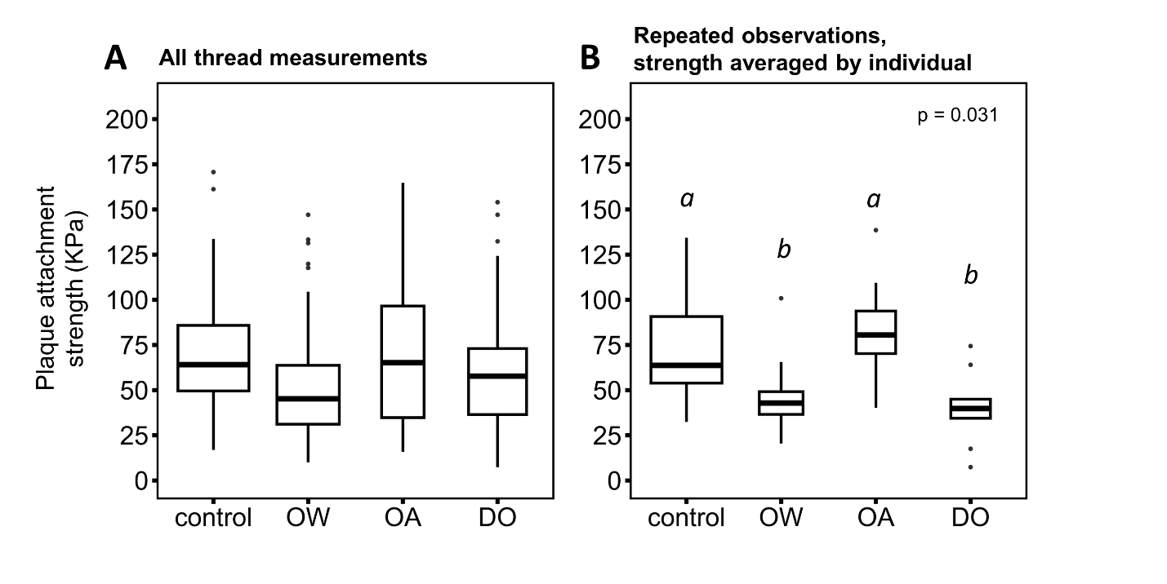

Figure 1. Byssal thread plaque attachment strength of mussels measured before (control; pH = 8.0, T = 12°C, O2 = 10 mg L-1) and after a three day exposure to ocean acidification (OA; pH = 7.0, T = 12°C, O2 = 10 mg L-1), ocean warming (OW; pH = 8.0, T = 20°C, O2 = 10 mg L-1), or hypoxia (DO; pH = 8.0, T = 12°C, O2 = 4 mg L-1). Measurements are presented for all threads (A) and for individuals for which repeated observations were available, averaged by individual (B).

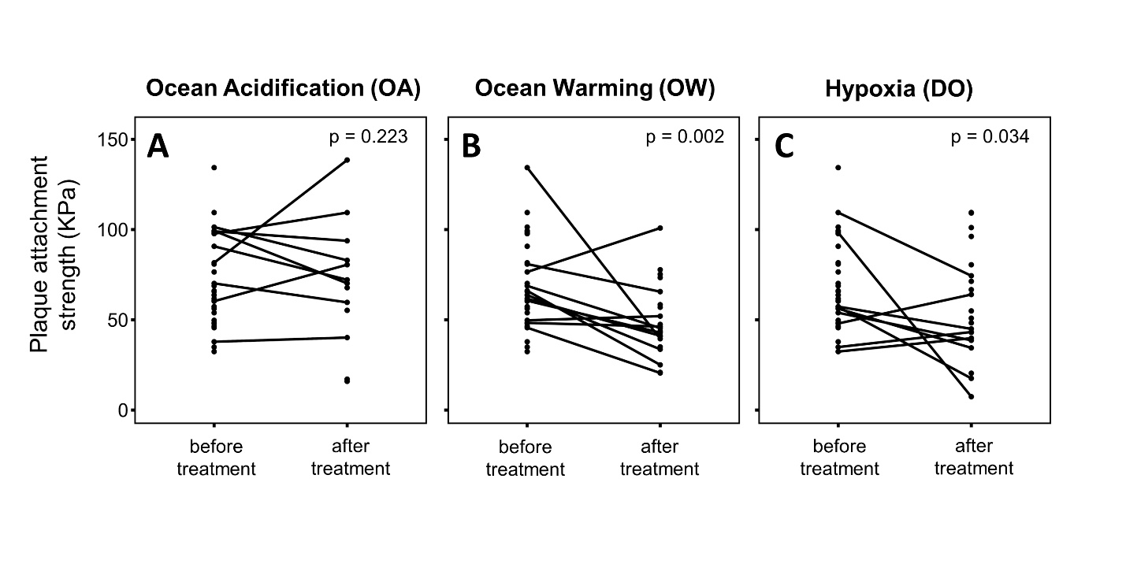

Figure 2. Line graphs displaying the byssal thread plaque attachment strength of individual mussels before and after exposure to ocean acidification (OA; A), ocean warming (OW; B), or hypoxia (DO; C).