

College of Agriculture & Life Sciences
Department of Applied Ecology

appliedecology.cals.ncsu.edu
Campus Box 7617, 127 David Clark Labs
100 Eugene Brooks Avenue
Raleigh, NC 27695-7617
P: 919.515.4662
F: 919.515.5327

28 February 2022
Re: NRSP-8 Small Funding Possibilities for US Aquaculture Groups

Dear Matthew George, Mackenzie Gavery, and Steven Roberts:

Congratulations on being selected to receive a $10,000 funding award to conduct pioneering and preliminary research aimed to promote the objectives of the NRSP-8 National Animal Genome Program! Your project entitled “Identifying genomic architecture features that contribute to critical phenotypes in shellfish” has been selected among those submitted in 2021 for funding in 2022. We also appreciate your patience through the 2021 COVID-19 pandemic—our intention was to disperse these funds for projects at a time when we could be sure that all of the awardees could complete the research amidst institutional closures and restrictions across the country.

Please remit this letter, along with your attached project description as a plan of work. The sponsored programs or grant managing division of your institution should create an invoice for submission to North Carolina State University in the amount of $10,000. This letter serves as the award notice for this funding opportunity. All of those documents should be emailed to the following contacts: Greg Lewis jglewis@ncsu.edu, Dawn Newkirk dnewkirk@ncsu.edu, and Ben Reading bjreadin@ncsu.edu.

Once your funding is approved for transfer to your institution, that will commence the beginning of the project. Indirect costs are not allowed on these funds. Please note that final reports for the research are due 12 months after the award is made; no cost extensions are not allowed for these funds or these projects. Final reports are to be submitted to Ben Reading bjreadin@ncsu.edu. As such, please plan on completing your research and submitting your report by end of April of 2023.

We appreciate your dedication to the NRSP-8 and thank you for conducting this important line of research along our priority areas. We look forward to the exciting progress over the next year and hope to see you at the International Plant and Animal Genome Conference in 2023, if you can attend. Please do not hesitate to contact me if any further information is required.

Sincerely yours,
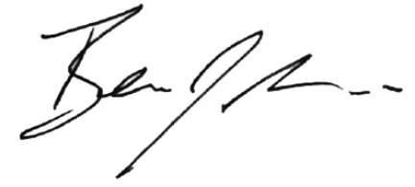

Dr. Benjamin J. Reading

Associate Professor and University Faculty Scholar
Aquaculture Co-Coordinator USDA NRSP-8 National Animal Genome Program

127 David Clark Labs
Department of Applied Ecology
North Carolina State University
Phone: (206) 658-5149
bjreadin@ncsu.edu

