Washington Department of Fish and Wildlife | Coastal Shellfish Unit
Recreational Razor Clam Harvest Estimation
Methodology, History, Uncertainty, and Sampling Design
Version 5 | 2026 program review
Scope. A consolidated technical reference for how WDFW produces the coastal recreational razor clam harvest estimate: the field data collected, the equations applied, how the correction factor is derived, how the method and the seasons have changed over time, the uncertainty that remains, and how many days per tide series must be counted to meet a stated precision standard. It supersedes and expands the prior WDFW Razor Clam Harvest Estimation Methodology / Field Data Collection note, whose content is retained and corrected herein.
Status. Working reference. The estimation chain in section 4 has been reimplemented from the five raw database tables and reproduces the database's own stored outputs on 13,651 of 13,653 joinable rows. The imputation rule of section 4.5 has been validated by leave-one-out cross validation on 2,889 paired beach-days (section 10.2). The correction factor of section 5 has been given a between-survey variance by resampling the egress surveys behind each expansion table (section 10.3). Section 11 states a defensible answer to the question of how many beach-days per tide series must be counted. Version 5 restores the 2017-18 season from its FINAL printout and establishes that the 2022-23 published season total omits an entire tide series. Items that could not be confirmed are flagged as open.
Beaches covered. Long Beach, Twin Harbors, Copalis, and Mocrocks (the four expansion-table beaches). Kalaloch is assessed separately by Olympic National Park staff and is treated as a special case (section 7.5).
What is new in version 5
- The 2017-18 season is restored. Version 4 excluded it from several analyses because its Effort tab holds only 10 of 27 dig days. The FINAL printout in the repository is the complete season record, and it reconciles to the harvest database beach-day by beach-day: 66 of its 67 open beach-days carry a census, 65 of those 66 agree to within rounding, and the database backs 99.97 percent of the printout's coastwide effort. 2017-18 was the most completely sampled season on record, and it is the last season before the collapse in coverage. It is now in Table 1 and Figures 4 and 12, and section 6.2 carries the full reconciliation as Table 5.
- The 2022-23 season is worse than version 4 said, and in a different way. Its Effort tab is not a mid-season snapshot: it runs to 25 April 2023 and then stops. The 4 to 14 May 2023 tide series, 33 open beach-days on the program's own schedule, appears nowhere in the workbook. The harvest database holds 22 of those beach-days, worth 61,959 digger trips, or 26.1 percent of the workbook's coastwide total. The published 2022-23 season totals, 237,419 digger trips and 3,570,881 clams including wastage, are not season totals.
- The 2023-24 season is not truncated. The workbook now in the repository holds all 100 dig days to 12 May 2024. Version 4's statement that it ends on 18 November 2023 described a superseded snapshot. The dig-day register and the corrected-estimates workbook already used the complete file; the recompute workbook's coverage sheet did not, and its 2023-24 rows are stale.
- The 2017-18 published wastage, 109,381 clams, has no traceable source. The four Wastage sheets in the 2017-18 workbook are empty, its wastage-rate cell is blank, and the harvest database holds wastage surveys for only Mocrocks and Twin Harbors that season, totalling 12,764 clams. Wastage cannot be recomputed for that season from either source.
- Four 2017-18 beach-days do not reconcile and need a records check. Copalis on 2 November 2017 and 21 April 2018 differ in effort by 10.3 and 5.2 percent. Long Beach on 31 December 2017 and Mocrocks on 21 April 2018 carry printout catch rates of 10.2 and 10.1 clams per digger trip against database rates of 12.14 and 14.68. Those four days, less the single imputed Twin Harbors beach-day, account exactly for the 42,732-clam coastwide harvest difference.
Carried over from version 4
- Fourteen figures and twenty-two numbered tables. Every figure and table is generated directly from the data products in the repository, so all of them are reproducible.
- Section 5.6: the complete egress survey record behind every expansion table, with per-table provenance, verification status, and the fifteen defects found in that record.
- Section 6.3 quantifies what the post-2013 table refinements did. The same Long Beach count expands to 33.1 percent more digger trips under the current table than under the 2013 table.
- Section 11: a sampling design recommendation built against two published precision standards, with the number of days per tide series required, the day-selection rule, the irreducible floor set by the correction factor, and the crew-day arithmetic showing the reallocation is cost-neutral.
- Section 10.4: the intervals are strongly right-skewed, because effort scales with the reciprocal of the correction factor. Reporting them as plus or minus a percentage understates the upper tail.
- Disagreements between companion work products, and two probable citation errors in the sampling-design workbook, are flagged rather than silently reconciled (sections 10.2, 10.4, 11.1).

Contents

The fishery in historical perspective
The Pacific razor clam, Siliqua patula, lives on Washington's high-energy ocean beaches, buried in clean, surf-washed sand from the mid-intertidal out past the lowest tides. It is a fast-growing, short-lived, highly fecund animal. A spawning female releases on the order of six to ten million eggs; fertilization is external; and the larvae drift for roughly six to eight weeks, through trochophore, straight-hinge, and umbo stages, before settling and burrowing into the beach in deeper or shallower water depending on currents. Clams reach roughly four to four and a half inches and sexual maturity within about two to three years, so a single strong year class can dominate the harvestable stock and the fishery can recover quickly from a poor stretch. WDFW manages the resource as five beaches spanning about 58 miles of coast: from south to north, Long Beach (Cape Disappointment to Leadbetter Point), Twin Harbors (Cape Shoalwater to the Grays Harbor south jetty), Copalis (the Grays Harbor north jetty to the Copalis River), Mocrocks (the Copalis River to the Quinault Indian Nation boundary), and Kalaloch (within Olympic National Park). Three quarter-mile reserves, on Copalis, Twin Harbors, and Long Beach, are permanently closed to digging.
Razor clams have been eaten on this coast since the earliest times, and a commercial canning fishery developed from about 1902 that, at its height, employed several thousand people in the Grays Harbor and Willapa Harbor districts. That fishery drove the first conservation concern. After a long, unbroken decline in the commercial catch from 1927 to 1934, the Department of Fisheries commissioned the first scientific assessment of the stocks, published by Milner B. Schaefer in 1939 as Biological Report 37B. Schaefer's central methodological contribution was to measure abundance not by total landings but by the catch per unit of effort, specifically the catch per man-tide (one digger working one tide), reasoning that average catch rate tracks relative abundance more faithfully than raw production, which can be propped up by ever-increasing effort. That logic, that effort-standardized catch rate is the honest index of a clam population, is the direct conceptual ancestor of the clams-per-digger term (CPUE) in today's recreational estimate (section 4.1), even though the modern method counts diggers and interviews harvesters rather than auditing cannery records.
State regulation of personal-use digging began in 1929 with a 36-clam daily limit and a three-and-one-half-inch minimum size; the first fixed season, March 1 to September 30, followed in 1943. Over the following decades the commercial fishery dwindled while the recreational fishery grew into one of the largest shellfish fisheries in the state, and management priority shifted accordingly. Today the resource is managed primarily for recreational use, with only a minor separate commercial fishery on detached spits of Willapa Bay, under Fish and Wildlife Commission Policy C3009 (section 7.7). The long-run record of that recreational fishery is shown in Figures 1 and 2.
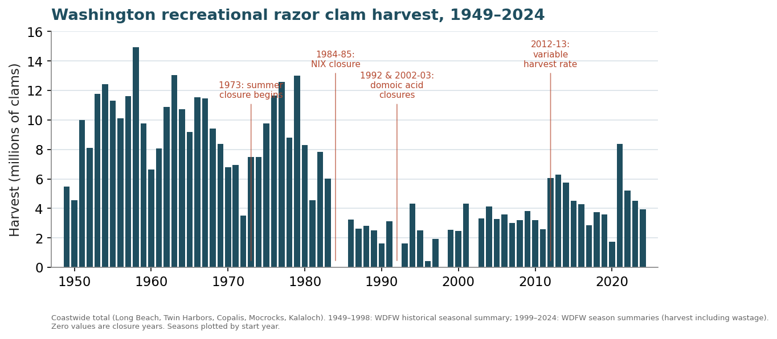
Figure 1. Coastwide recreational razor clam harvest, 1949 to 2024 (millions of clams, including wastage from 1999). Harvest peaked near 14.9 million clams in 1958. Sources: WDFW historical seasonal summary (1949 to 1998) and WDFW season summaries (1999 to 2024). Zero values are closure years; seasons are plotted by start year.
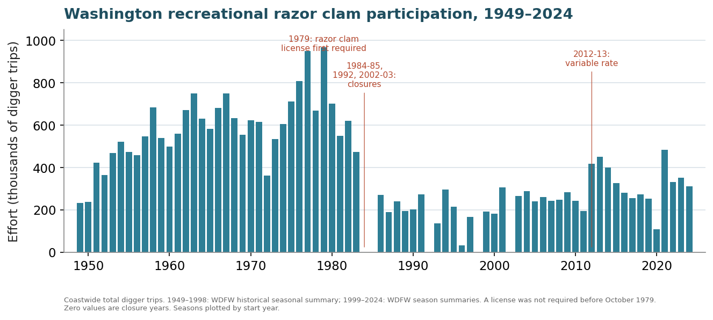
Figure 2. Coastwide recreational razor clam participation, 1949 to 2024 (thousands of digger trips). Effort peaked near 967,000 digger trips in 1979, the year a razor clam license was first required. Sources as in Figure 1.
Two features of these series matter for interpreting any single season. First, the fishery is volatile by nature: effort and harvest swing widely with clam abundance, tide quality, weather, and regulation, and the swings in the early decades were larger still. Second, the deepest drops are management and environmental events, not estimation artifacts. Digging was closed over the summer beginning in 1973; the entire fishery was closed in 1984 and 1985 by a NIX parasite mortality event; and since domoic acid was first detected in razor clam tissue in 1992, marine-toxin closures have removed about a quarter of all planned digging opportunities, including the season-long closures visible as zeros in 1992, 1998, and 2002 to 2003. The management history behind these patterns is summarized in Figure 3 and revisited in sections 7.6 and 7.7.
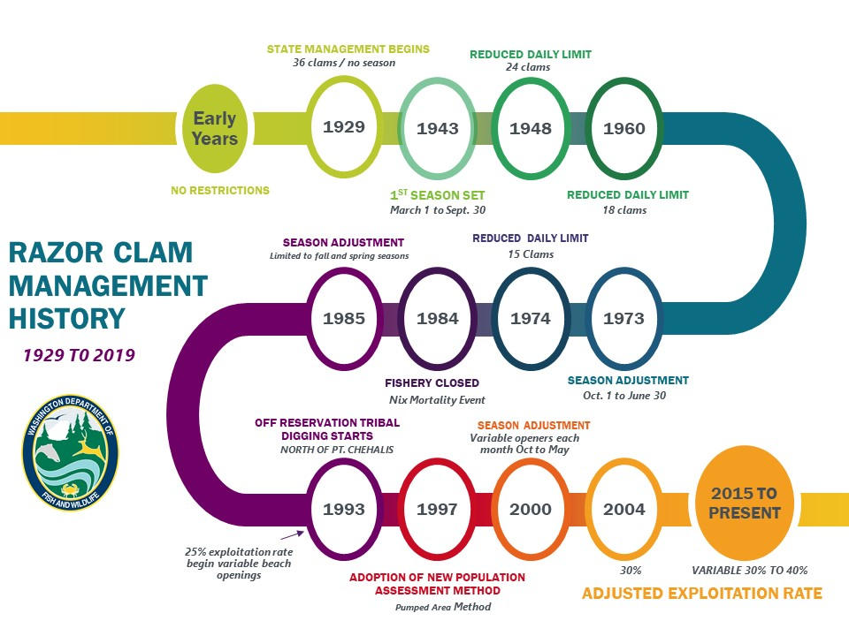
Figure 3. Milestones in Washington razor clam management, 1929 to present (WDFW). Key transitions include state management and the first size and bag limits (1929), the first fixed season (1943), progressive bag-limit reductions (1948, 1960, 1974), the start of the summer closure (1973), the NIX closure (1984 to 1985), independent beach management (1987), the start of off-reservation tribal digging and variable beach openings (1993), adoption of the Pumped Area Method for population assessment (1997), and the shift to a variable 30 to 40 percent exploitation rate (2004 to present).
The remainder of this document concerns the recreational harvest estimate specifically: the data WDFW collects on each open day, the equations that turn those data into a season total, how the correction factor at the center of the method is derived, how the method and the seasons have changed, what uncertainty remains, and what sampling effort would be needed to reduce it.

1. Purpose and scope
This document describes how the recreational razor clam harvest is estimated on Washington's coastal beaches, why the method is built the way it is, and how both the method and the fishery have changed over roughly three decades. It is intended to serve three audiences at once: an analyst reproducing or auditing the estimate, a manager interpreting season results, and a future staff member reconstructing the program's history.
The estimate rests on two distinct data streams that are easy to confuse and are documented separately in companion data dictionaries. The first is the recreational-harvest (creel) stream: instantaneous beach counts of diggers, paired with harvester interviews, stored in the harvest database. The second is the egress-survey stream: vehicle on/off counts collected across the tidal cycle, stored in the ingress/egress database and in a set of scattered workbooks, from which the beach-specific expansion tables (and therefore the correction factor) are built. The harvest estimate is a product of both: counts and interviews supply effort and catch rate, while the egress surveys supply the factor that scales an instantaneous count to a full day.

2. Summary of the estimation approach
Digging is concentrated around low tide. The beds generally become available about two hours before low water and are covered again about two hours after; most effort and harvest fall between two hours before and roughly thirty minutes after low water, because digging an incoming tide is harder than an outgoing one. The estimate exploits this regularity: a single well-timed count near the effort peak, expanded by a factor that encodes the shape of the effort curve, recovers the day's total.
For one beach on one open day the steps are:
- Count. A roving crew counts diggers along the beach about one hour before low water (or counts lights, called lanterns, or cars on dark tides).
- Adjust for non-diggers. The head count is reduced to diggers using the fraction of interviewed people who were actually digging.
- Expand to the full day. The instantaneous digger count is divided by the correction factor, the fraction of the day's effort present during the count, to estimate total digger trips.
- Apply catch rate. Total digger trips are multiplied by CPUE (clams per digger) from the interviews to get clams harvested.
- Add wastage. A wastage proportion from hole surveys is added.
Daily beach estimates are summed to season totals per beach and compared to the Total Allowable Catch (TAC). When no crew counts a beach, that day is filled in from the beaches that were counted (section 4.5). That filling-in is a distinct estimation layer, and it now carries a substantial share of the published estimate.

3. Field data collection
WDFW assigns staff, as available, to each of the open management beaches on a dig day. The data below are collected per beach per day; egress surveys are run less frequently.

3.1 Beach (digger) counts
About one hour before low water a crew (generally two people) drives the length of the assigned beach and counts every person observed harvesting razor clams, or preparing to or finishing. In daylight, people are counted directly. In the dark, crews count lights on the beach, or cars parked along it, instead. Depending on crowd size a count takes thirty minutes to an hour. Recorded: start and end time, people by geographic section, direction of count, staff names, and weather observations.

3.2 Harvester interviews (creel)
Before and after the count, staff intercept randomly selected groups who have finished their trips and record: number of people in the group, number who harvested, total clams harvested, total lights used (if a light count was done), and total cars used (if a car count was done). These interviews supply CPUE and the ratios that convert head counts and car or light counts into diggers.

3.3 Egress (ingress/egress) surveys
On an annual basis, or as staffing allows, an egress survey is run to measure what share of the day's effort is present through the opener. Staff at beach access points count vehicles driving on and off the beach in fifteen-minute intervals from three hours before to two hours after low water, a six-hour window. A roving crew simultaneously runs a standard beach count. Group interviews are taken as usual. The on/off counts are the raw material for the expansion tables (section 5). In practice these surveys are rare: twenty-seven distinct surveys exist across thirty-three years and four beaches, and none at all between 2012 and 2021 (section 5.6).

3.4 Wastage surveys
Wastage is clams harvested but not retained, usually broken or undersized. Because birds quickly remove surface clams, WDFW samples wasted clams left in dig holes. Before the incoming tide, crews randomly select areas with many holes that have not been swept by the tide, examine at least one hundred holes, and record holes sampled and clams (mortalities) found. Night tides and low-effort tides often make wastage sampling impossible.

3.5 Shell-length sampling
When practical, harvested shells are measured. Length data exist for only a minority of dig events (about one sixth in the harvest database) and do not enter the harvest estimate; they support size structure and the separate stock assessment.

3.6 Conditions and tidal context
Each survey records sky, precipitation, surf, and wind, plus the predicted low-tide time and height. Tide time relative to sunrise and sunset determines whether the dig is a daylight or a near-dark (evening) tide, which in turn selects the expansion table used (section 5.2). Surf, precipitation, and wind determine whether a good-weather or poor-weather table applies.

4. The estimation equations
The equations below are the form actually implemented in the harvest database and validated against its stored daily results; they are the post-2013 corrected method (section 6.2). They are stated at three grains: per-event creel rates, per-count expansion, and roll-ups. A note on one symbol convention: CF here is the mean fraction of the day's effort present during the count, R_t, a number near 0.5; effort is recovered by dividing the count by it.

4.1 Per-event creel rates (pooled over a beach-day's interviews)
CPUE_e = Σ clams_i / Σ diggers_i
(1 − p)_e = Σ diggers_i / Σ people_i
ppc_e = mean( people-per-car_i ) dpl_e = Σ diggers_i / Σ lanterns_i
where the sum is over interviews i in event e. CPUE is catch per digger; (1 − p) is the digging fraction; ppc is people per car; dpl is diggers per lantern (night tides).
Field-semantics note. In the harvest database the interview field that feeds ppc stores people per car, not a vehicle count; its long-run average is the basis of the 2.67 fallback constant below.

4.2 People present at each count (hierarchical)
A count records people directly when possible; otherwise people are inferred from whatever secondary count was taken, using the event's own ratios, in this order:
CalcPeople = NPeople, else NCars × ppc_e, else NLanterns × dpl_e, else NCars × 2.67
The terminal constant 2.67 is the historical interview-derived average people-per-car, used only when a count has cars but no people or lantern count and the event has no creel-derived people-per-car.

4.3 Expansion to effort and harvest (per count, then summed)
E_total = E_t (1 − p) / CF Harvest = E_total × CPUE
where, for each count: E_t is the diggers present at the count, equal to CalcPeople × (1 − p); E_total is the estimated total digger trips for the beach-day; and CF is the correction factor, equal to R_t, the mean fraction of the day's effort present during the count window (section 5), a number near 0.5. Counts at the segment grain are expanded independently and summed to the event; events are summed to beach and season.

4.4 Wastage, sampling intensity, and roll-ups
WastageRate_e = Σ mortalities / Σ holes H_w = Harvest_e × WastageRate_e
H_total = Harvest_e + H_w % interviewed = Σ people / E_total
Wastage is applied per beach as a cumulative proportion of harvest. Percent interviewed is a sampling-intensity diagnostic, not an input. Its median across the series is 3.4 percent of estimated digger trips.

4.5 Days without a count: the imputation layer
WDFW does not staff every open beach on every dig day. When no crew counts a beach, that beach-day carries no census, no interviews, and therefore no correction factor and no CPUE of its own. Its effort is instead borrowed: the workbook takes the ratio of the unmonitored beach to a monitored donor beach on a recent day when both were counted, and applies that ratio to the donor's effort today. For target beach X, donor D, dig day t and reference day r:
X_t = X_r × D_t / D_r
Where more than one beach was counted, the donors are summed before the ratio is formed:
X_t = X_r × (D1_t + D2_t) / (D1_r + D2_r)
Harvest on such a day is then the imputed effort multiplied by a CPUE that is itself borrowed, so the entire beach-day estimate is a function of other beach-days. This is a distinct estimation layer, not a rounding detail, and it has never been documented as one.
Who borrows from whom. Across the 19 seasons 2007-08 to 2025-26 the in-season workbooks contain 838 borrowing links: 660 across beaches and 178 within Long Beach. Of the 660 cross-beach links, Copalis or Mocrocks is the sole donor in 473 and a joint donor in a further 53. They are almost never the recipients: since 2015-16 neither has more than 0.5 percent of its season effort imputed in any season. Long Beach and Twin Harbors are the recipients. This follows from the schedule, since Copalis and Mocrocks open on alternating days and are counted whenever they are open.
How much of the estimate this layer carries. The share of coastwide effort that is a direct expansion of a count was 96 percent in 2012-13 and 2013-14 and 99.7 percent in 2017-18, and is 58 percent in 2025-26. Long Beach adds a second imputation of its own (section 5.4). In 2025-26, 13.8 percent of the Long Beach effort estimate is a direct expansion of a full beach count, 29.2 percent is a within-beach section imputation, and 57.0 percent is borrowed from another beach. Twin Harbors in the same season is 42.5 percent borrowed. This is the single largest source of unquantified error in the published estimate, though not, as section 10.1 shows, the largest source of variance in a season total.
Table 1. Composition of the coastwide effort estimate, by season. Percentages are of coastwide digger trips.
Season | Direct expansion of a count | Long Beach section ratio | Borrowed from another beach
2012-13 | 96% | 0% | 4%
2013-14 | 94% | 0% | 6%
2016-17 | 92% | 0% | 8%
2017-18 | 99.7% | 0% | 0.3%
2019-20 | 54% | 9% | 36%
2021-22 | 60% | 20% | 20%
2022-23 | 67% | 14% | 20%
2023-24 | 64% | 11% | 25%
2024-25 | 60% | 11% | 29%
2025-26 | 58% | 10% | 32%
The 2017-18 row is computed from the FINAL printout and the harvest database, because the 2017-18 Effort tab is a mid-season snapshot holding 10 of 27 dig days (section 6.2). Its single borrowed beach-day is Twin Harbors on 4 December 2017, 692 of 257,003 coastwide digger trips. The 2022-23 row is computed on the 62 dig days the workbook holds; the workbook omits the May 2023 tide series entirely, so the row describes part of a season (section 9).
The same collapse can be measured a second, independent way: by asking what share of each season's Effort-tab total the harvest database's own censuses actually support. That statistic does not depend on how a workbook cell was written. It is plotted in Figure 4 and gives the same answer. Two of its points had to be rebuilt for this version: 2017-18, whose Effort tab is a snapshot, is computed against the FINAL printout; and 2022-23 and 2023-24, whose database beach-days do not all appear in their Effort tabs, are computed on the beach-days the two sources share.
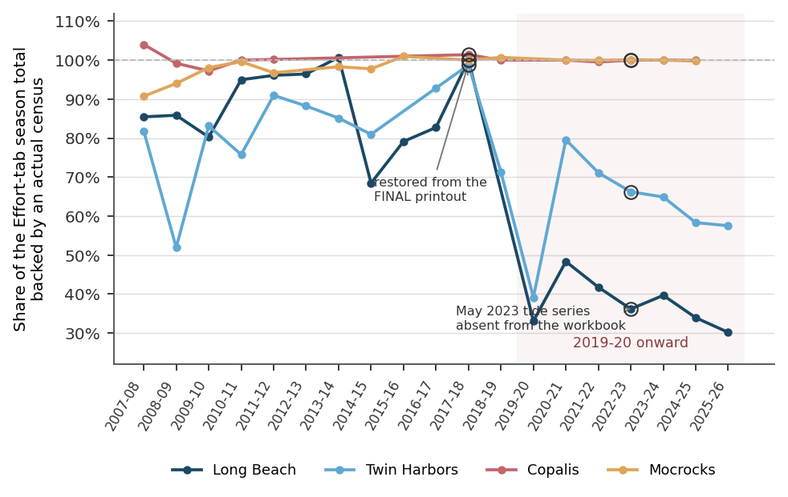
Figure 4. Share of each season's Effort-tab season total that is backed by an actual census in the harvest database, by beach. Copalis and Mocrocks sit at 100 percent throughout because they open on alternating days and are counted whenever they are open. Long Beach falls to 30.2 percent and Twin Harbors to 57.5 percent by 2025-26. Values slightly above 100 percent occur where the database expansion of a counted day exceeds the value the workbook typed. Circled points are the two seasons rebuilt for version 5: 2017-18 against the FINAL printout, where 66 of 67 open beach-days carry a census; and 2022-23, where the share is computed only on the part of the season the workbook holds, since the May 2023 tide series is absent from it.
Three properties of this layer that should be recorded. First, 28 of the 1,071 reference-day links point at a beach-day that was itself estimated, so a minority of estimates are chained. Second, on ten beach-days a census exists in the harvest database and the workbook estimated anyway, discarding a real count; two of them, Long Beach on 26 and 27 March 2016, have a complete seven-segment count. Third, twelve beach-days carry a borrowing formula but no asterisk, so the workbook's own flag understates how much of the series is imputed.
Estimated beach-days are flagged with an asterisk in the season workbooks and must be carried as estimates, not as measurements. The companion dig-day register lists every one of them with its donor, its reference day, and the exact formula used.
The rule now has an error model, and a bias correction. Leave-one-out cross validation on 2,889 paired beach-days (section 10.2) shows the rule is unbiased in the median for a single day but carries a standard deviation of the log error of 0.541 and a mean absolute percentage error of 47 percent. It regresses to the mean: conditioned on the imputed value, the mean ratio of actual to imputed is 1.46 in the bottom third of imputed values, 1.12 in the middle third and 0.91 in the top third. Because the beach-days that go uncounted are the small ones, the in-season estimate is systematically low. Applying the empirical multipliers raises Long Beach season effort by 9.0 percent in 2025-26 and 8.6 percent in 2024-25, and Twin Harbors by 3.8 and 3.7 percent. Copalis and Mocrocks are unchanged, because almost nothing of theirs is imputed.
CPUE on an estimated beach-day is typed by hand. Effort is imputed by formula, but the catch rate is not. On 507 of the 660 cross-beach estimated beach-days the CPUE cell holds a number typed in by the analyst, and 15.8 percent of those are exactly 15, the daily bag limit. Nothing in the workbook records where the number came from. The minimum defensible change is to use the donor beach's same-day CPUE, which was measured from interviews. Doing so raises Long Beach harvest by 5.5 percent in 2025-26 and 7.2 percent in 2024-25, and moves Mocrocks by less than 2 percent. The error of that substitution is measurable: the log ratio of a donor's CPUE to a target's on days both were counted has a standard deviation of 0.448 over 3,430 paired beach-days.

4.6 Notation
Table 2. Notation used throughout this document.
Symbol | Meaning
CPUE | Clams per digger, from interviews (catch per unit effort)
1 − p | Digging fraction: interviewed people who were actually digging
ppc, dpl | People per car; diggers per lantern (event-level interview ratios)
CalcPeople | People present at a count (direct, or inferred from cars or lanterns)
E_t | Diggers present at the count = CalcPeople × (1 − p)
CF = R_t | Mean fraction of the day's effort present during the count window (approximately 0.5)
E_total | Estimated total digger trips for a beach-day
H_total | Total clams harvested including wastage
H_w | Estimated wasted clams
W | Wastage proportion (mortalities / holes)
u | Share of a season's harvest that is imputed rather than expanded from a count
n, m | Open days in a tide series; days of that series on which a count was taken

5. The correction factor in depth

5.1 From egress survey to the percent-available curve
An egress survey yields, for each fifteen-minute interval relative to low water, the number of vehicles that drove on and off the beach. Accumulating arrivals and departures gives the number of vehicles on the beach at each interval; dividing by the day's total arrivals gives the share of the day's effort present at that interval, the percent available for beach count. Plotted against time, this is the effort curve. The correction factor for an actual count is the mean of this curve over the fifteen-minute bins the count spanned:
CF = R_t = mean of (percent available) over the count's bins
A beach-and-condition expansion table is built by pooling the on and off counts across the relevant surveys before computing the curve. This derivation is exact and reproducible: pooling the survey records reproduces the published 2010 and 2011 cumulative-ingress tables to three decimals, and all thirteen located tables reproduce exactly from the surveys named for them (section 5.6). The four curves currently embedded in the harvest database are shown in Figure 5.
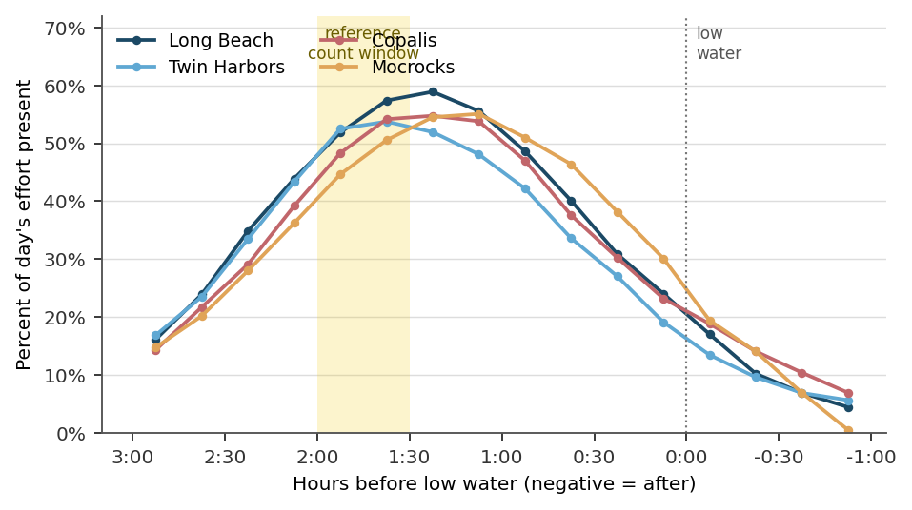
Figure 5. The four operational expansion tables, extracted from the Correction Factor form of the harvest database. Each curve is the percent of a day's effort present on the beach at each fifteen-minute interval relative to low water. The shaded band is the reference count window, roughly two hours to one and a half hours before low water. Kalaloch has no curve. The correction factor for a given count is the mean of the curve over the bins the count spanned; effort is the count divided by that number.

5.2 Condition-specific tables and how the condition is chosen
The correction factor is not a single number per beach. Separate tables exist by light condition and by weather, because the effort curve differs between them. Two independent dimensions select the table:
- Light. Daylight versus near-dark (evening), set by the low-tide time relative to sunset and last light. Fall evening tide series use the near-dark table; spring morning series use the daylight table.
- Weather. Good versus poor, set by the recorded surf, precipitation, and wind. High surf, moderate or heavier rain, or strong wind select a poor-weather table where one exists.
Night and weather conditions raise the share of effort captured by a single count, so their tables carry higher values than the daylight, good-weather table. In current day-to-day operation, however, the harvest database carries a single reference table per beach (embedded in the Correction Factor form, section 6.3), which staff apply with manual judgement for unusual conditions, for example assigning a fixed higher factor on small, slow-digging crowds, rather than switching among separate condition tables. The condition-specific tables are best understood as the historical derivation artifacts behind that single working table. A consolidated lookup accompanies this document; it holds the current operational tables together with the archived 2012 and 2013 condition tables, by beach, condition, and bin, and records which historical condition tables were never located: Long Beach and Twin Harbors have no daylight table of any vintage, and no poor-weather table exists for Long Beach, Twin Harbors, Copalis, or Kalaloch.
That gap is not cosmetic. Long Beach and Twin Harbors have four daylight egress surveys each, and every spring morning opener at those beaches is nonetheless expanded with an evening table or with an undocumented factor.

5.3 Reference count time and timing sensitivity
The standard count is run about one hour before low water at peak effort; a count takes roughly twenty-six to thirty-one minutes, so the correction factor typically averages two adjacent bins. The corrected (divide-by-R_t) method is sensitive to count timing: a count begun earlier than the peak captures a smaller share of effort and therefore expands more. The 2013 re-estimation found many historical counts begun earlier than the normal peak with no documented reason; where no reason was recorded, the expansion was left unadjusted, which can overstate effort, and where an early peak was documented, the factor was adjusted.
Timing matters for a second, less obvious reason. The correction factor is estimated from a handful of surveys, and the surveys disagree most where the curve is steep. Resampling the surveys behind each table (section 10.3) shows the sampling error of the correction factor is minimised near the peak and rises sharply away from it, exceeding 20 percent at Long Beach for windows more than two and a half hours before low water or less than an hour before it. Holding the count at the reference time is therefore not only a bias control; it is the single cheapest variance control available in the field (Figure 6).
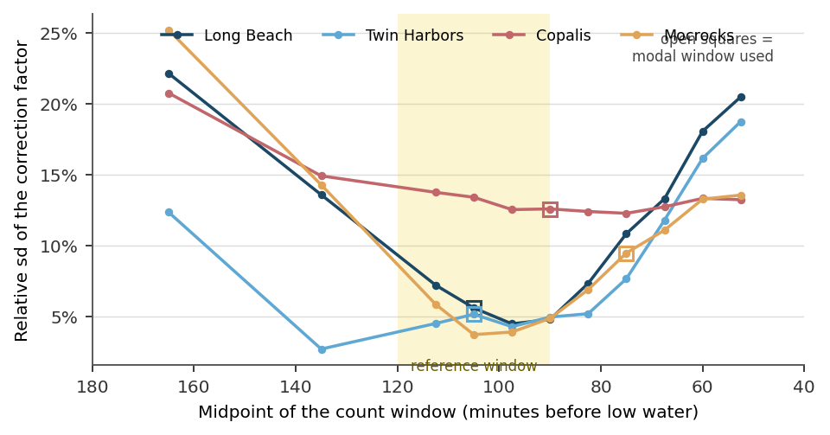
Figure 6. Relative standard deviation of the correction factor as a function of where the count window sits, from resampling the egress surveys behind each beach's expansion table. Open squares mark the modal window actually used. The error is smallest near the effort peak and rises steeply on either side. Copalis is high everywhere because its table rests on three surveys that disagree with one another. Windows are the contiguous bin runs of the table; the horizontal position is the window midpoint.

5.4 Long Beach: two counts, two correction factors, and a second imputation
Long Beach is 7 of the 28 segments in the beach lookup, numbered 11101 to 12600. It is not walked as one unit. From the 2019-20 season it is walked as a four-segment count (11101, 11104, 11200, 12300) and a three-segment count (12400, 12500, 12600), entered in the harvest database as two separate events on the same date, each with its own correction factor. Any roll-up to the beach-day must sum the two events. Treating them as duplicate records, which a naive deduplication on beach and date would do, deletes roughly 40 percent of recent Long Beach effort.
On many days only one half is walked. The workbook then scales the unwalked half by the ratio of the two halves on a reference day when both were walked. With a and b the two halves' expanded effort on the reference day and X the half walked today, the cell computes:
LB_t = (a / b) × X + X
This has been verified against the database. In the 2024-25 workbook the constants 492.628869212425 and 659.953914314618 are the expanded effort of EventID 2353 (492.628871) and EventID 2354 (659.953918) on 16 October 2024, the day both halves were walked. On 19 October 2024 only EventID 2365 exists, expanded effort 1154.586123, which is the X in that day's cell. The cell as written on that date is missing its multiplication operator, and overstates Long Beach by 293.5 digger trips (section 9).
The consequence is that Long Beach carries two imputation layers, one within the beach and one across beaches. In 2025-26 only 13.8 percent of its effort estimate rests on a full beach count. The within-beach rule is the better of the two, with a standard deviation of log error of 0.281 against 0.541, but it exists only because the beach is walked in halves. Section 11 recommends retiring it.

5.5 Recovering the count window from the correction factor
The count time is not recorded anywhere in the harvest database. It can nevertheless be recovered, because the correction factor is by construction the mean of the percent-available values over the contiguous fifteen-minute bins spanning the count window. Enumerating every contiguous bin run of every known expansion table gives 1,015 distinct table-and-window combinations and their means. A stored correction factor equal to one of those means identifies both the table that was used and the window the count occupied.
Applied to the 2,672 events that carry a correction factor, this matches 61.4 percent overall: 70.6 percent from June 2013 onward and 35.8 percent before. The pre-2013 gap is expected, since those events were computed under the pre-correction arithmetic (section 6.2) and against earlier table vintages. The residual gap after 2013 corresponds to the Long Beach, Copalis and Mocrocks tables that were refined after 2013 and whose derivation surveys have not been located (section 6.3). Kalaloch matches none of its 16 events, consistent with it having no expansion table of its own (section 7.5).
Two by-products are worth recording. The correction factor identifies the assumed count window, so it can be checked against the reference count time of roughly one hour before low water. And the spread of correction factors within a season, which is a direct measure of how much discretion the analyst exercised, drops sharply when the standardized logging rule begins in 2023-24.
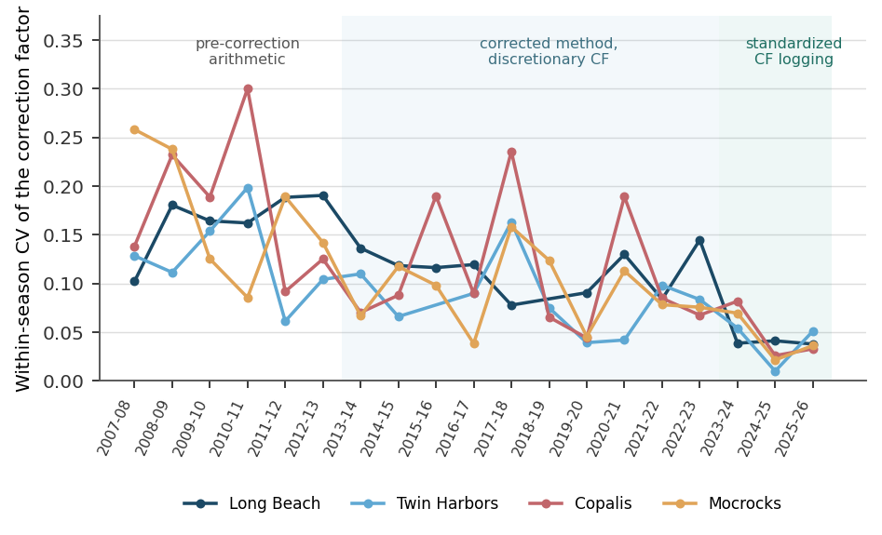
Figure 7. Within-season coefficient of variation of the stored correction factor, by beach. Computed from the recomputed event table over the four expansion-table beaches, on events whose correction factor lies in (0, 1]. Beach-seasons with fewer than five such events are omitted. Pooling the four beaches within a season, the coefficient of variation runs 0.150 to 0.214 before 2013-14, 0.065 to 0.178 from 2013-14 to 2022-23, and 0.035 to 0.065 from 2023-24 onward.
A note on an inconsistency with version 3. Version 3 of this document reported this spread as 0.17 to 0.28 before the 2013 correction, 0.10 to 0.13 from 2013-14 to 2022-23, and 0.039 to 0.052 from 2023-24 onward. Those numbers cannot be reproduced from the recomputed event table on any stated basis, and the basis was not stated. The values in Figure 7 and in the paragraph above are computed as described in the caption and are reproducible from the companion pipeline output. The qualitative conclusion, that standardized logging roughly halved the within-season spread, is unchanged.
The correction factor also has a sampling error, and it is the largest single term in the budget. Each operational evening table is pooled from three egress surveys, four at Mocrocks. Resampling those surveys with replacement, re-pooling the raw car counts, recomputing the percent-available curve and taking its mean over the count window gives the sampling distribution of the correction factor. Over the five central count windows actually used, the relative standard deviation is 4.5 to 7.3 percent at Long Beach, 4.3 to 5.2 percent at Twin Harbors, 3.7 to 6.9 percent at Mocrocks, and 12.4 to 13.7 percent at Copalis. It rises above 20 percent for windows far from the effort peak (Figure 6). Effort is proportional to the reciprocal of the correction factor, so this translates directly into effort, and it is systematic: every beach-day expanded with the same table moves together.

5.6 The survey record behind the tables
The expansion tables are the load-bearing element of the whole method, and they rest on a survey record that is far thinner than the tables' apparent precision suggests. Every ingress and egress source in the project file set, together with the ingress/egress Access database, has been consolidated into a single workbook. It contains 44 survey records covering 27 distinct surveys across 33 years: six at Long Beach, seven at Twin Harbors, six at Copalis, eight at Mocrocks, and none at Kalaloch. There are no surveys at all between 2012 and 2021, yet all four evening tables were revised in that window.
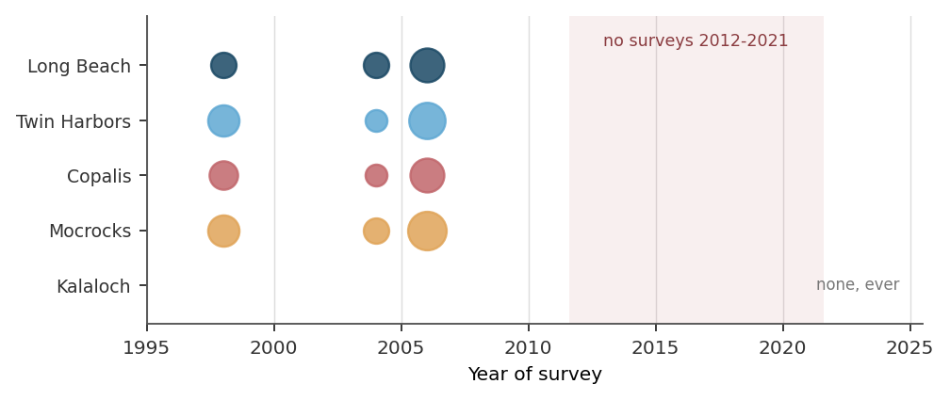
Figure 8. Every located egress survey, by beach and year. Marker area is proportional to the number of surveys in that beach-year. Kalaloch has never been surveyed; the table labelled Kalaloch is the Mocrocks survey of 1 April 1998. No survey exists between 2012 and 2021, yet the Long Beach, Copalis and Mocrocks evening tables were all refined in that period.
Table 3. The located egress survey record, by beach. Counts are distinct surveys flagged for pooling.
Beach | Surveys | Daylight | Evening | Years surveyed | Surveys behind the operational evening table
Long Beach | 6 | 3 | 3 | 1998, 2004 (2), 2009, 2011 (2) | 3
Twin Harbors | 7 | 5 | 2 | 1998, 2004, 2010, 2011 (4) | 3
Copalis | 6 | 4 | 2 | 2004, 2008, 2010, 2011, 2022, 2023 | 3
Mocrocks | 8 | 5 | 3 | 1998, 2004, 2006, 2008, 2010, 2011, 2022, 2023 | 4
Kalaloch | 0 | 0 | 0 | none | none; the table is a Mocrocks survey
The 1990 Long Beach record is excluded because its counts are identical, value for value, to the 1998 record (section 9, defects in the egress survey record, issue 6).
Every published table reproduces exactly from the surveys named for it, which is a real and reassuring result: the derivation is not folklore. Four evening surveys that exist in no file can be recovered bin by bin by differencing successive published tables, and every bin-wise difference is non-negative, which is what pure accumulation predicts and smoothing would not.
Table 4. Provenance and verification of every located expansion table.
Beach | Table | Component surveys | Verification
Long Beach | 2011-01-25 | 2011-01-21 PM + 2009-01-10 PM | Exact. All 23 bins reproduce. Totals 1,252 on / 1,217 off.
Long Beach | 2013-02-11 | 2011-01-25 table + one unlocated evening survey | Partly verified. Residual non-negative in every bin: 585 on, 555 off.
Twin Harbors | 2011-01-25 | 2011-01-22 PM alone | Exact. Single survey. Totals 245 on / 219 off.
Twin Harbors | 2013-09-24 | 2011-01-22 + 2011-02-17 + one unlocated survey | Partly verified. Priors summed, not folded. Residual non-negative.
Copalis | 2010-11-03 | 2008-11-13 PM + 2010-10-08 PM | Exact, but only if the 2008 prior-to-start (16 on) is folded into the 3:15 to 3:00 bin.
Copalis | 2012-12-19 | 2010-11-03 table + one unlocated evening survey | Partly verified. Residual non-negative: 142 on, 137 off.
Mocrocks | 2010-11-03 | 2006-11-04 + 2008-11-13 + 2010-10-09 PM | Exact. Also recovers the 2010 survey's true three-bin split, which the database collapsed into one cell.
Mocrocks | 2013-09-18 | 2010-11-03 table + one unlocated evening survey | Partly verified. Residual non-negative: 119 on, 106 off.
Copalis | Master_Tables daylight | 2004-04-23 alone | 18 of 19 bins match to 1e-9. One hand-appended value has no survey behind it.
Copalis | Master_Tables near dark | 2008-11-13 alone | All 17 bins match to 1e-9.
Mocrocks | Master_Tables daylight | 2004-04-24 alone | 17 bins match to 1e-9. Four hand-appended tail values have no survey behind them.
Mocrocks | Master_Tables poor weather | 2006-11-04 alone | All 17 bins match. That survey's low water was 27 minutes after sunset and the database flags it Evening.
Kalaloch | Master_Tables daylight | Mocrocks 1998-04-01 | All 13 values equal the Mocrocks percent-available column to 16 significant figures. There is no Kalaloch survey.

The defect that matters most. A pooled table sums raw car counts across surveys with different counting windows. The Long Beach survey added between the 2011 and 2013 tables recorded nothing after the bin ending at low water: its window stopped there. It nonetheless contributes 585 cars, 32 percent of the pooled total of 1,837, to the denominator of every bin, while supplying no egress observation for any of the eight post-low bins, and its 30 unreleased cars are carried forward as a constant. Twin Harbors, Copalis and Mocrocks carry the same defect at smaller scale. The post-low bins of a pooled table therefore rest on fewer surveys than the pre-low bins, and nothing in the published table records how many. A beach count that starts late, and therefore draws its correction factor from the post-low bins, is expanded on the thinnest evidence in the table. Publishing a per-bin count of contributing surveys alongside each table would close this immediately.

6. Historical evolution of the methodology

6.1 Origins
The expansion approach traces to 1987 razor clam harvest estimation instructions written by former (now retired) WDF staff, and to an ingress survey program formalized by the late 1990s (a 1998 ingress plan and associated Quattro Pro workbooks survive). The fundamental idea, scaling a peak count by the share of effort present, has been constant since; what changed is the arithmetic of the scaling and the data behind the tables.

6.2 The May 2013 correction (the central event)
In May 2013 WDFW discovered that the longtime expansion arithmetic was wrong. The 1987 method computed CF = 1.0 + (1 − R_t) and multiplied the count by it. The corrected method sets CF = R_t and divides. For a count taken when about 60 percent of effort is present, the old method expanded a thousand diggers to 1,330 and the corrected method to 1,583, an underestimate of about 16 percent under the old method. WDFW re-estimated Copalis and Mocrocks day by day back to the 1997-98 season (sixteen seasons), the period with a solid tribal-harvest record and pumped-area-method population estimates. The stored correction factors in the harvest database, and the equations in section 4 of this document, are the corrected form.
Documentation reconciliation. The prior methodology note expressed the effort equation as E_total = E_t (1 − p)(CF) with CF = 1 − R_t, a multiplicative form that is inconsistent with the corrected divide-by-R_t method and with the database calculation that reproduces the published harvest. The equations here are reconciled to that validated implementation. Primary source: Ayres, D.L., Re-estimate of State Razor Clam Harvest Totals, WDFW memorandum, 29 August 2013, with the accompanying re-estimation workbook.
Reimplementation and validation (2026 review). The chain in section 4 has been reimplemented from the five raw tables and reproduces the database's own stored working table on 13,651 of 13,653 joinable rows for CalcPeople, expanded effort and harvest, and on 13,653 of 13,653 for CPUE. Two details are load-bearing. The correction factor is stored as an Access Single; it must be cast to 32-bit precision before division or the reproduction fails on rounding alone. And the digging fraction is pooled at the event grain, not the segment grain: pooling by segment matches only 3,394 of 13,664 rows.
The independent check: the 2017-18 season, beach-day by beach-day. The strongest available validation is an external one, against a document the pipeline never sees. The 2017-18 FINAL printout, held in the repository, is the complete season record: 27 dig days, 67 open beach-days, per-beach daily effort, harvest, catch rate, tide-series subtotals, wastage, and percent of TAC. It is not derived from the database, and the in-season workbook that produced it does not survive. Reconciling the two:
- 66 of the 67 open beach-days carry a census in the database. The single exception is Twin Harbors on 4 December 2017, 692 digger trips, which the workbook imputed.
- On 65 of those 66 matched beach-days, the database expansion and the printout agree to within rounding. The median absolute difference is 0.3 digger trips, which is what rounding to whole trips produces.
- Coastwide, the database backs 256,925 of the printout's 257,003 digger trips, 99.97 percent. Long Beach and Mocrocks reproduce to less than one digger trip.
- Two Copalis beach-days do not reconcile: 2 November 2017 (printout 1,464 digger trips, database 1,615, a difference of 10.3 percent) and 21 April 2018 (8,956 against 9,418, 5.2 percent).
- Harvest reconciles on 63 of 66 beach-days, and the coastwide harvest difference of 42,732 clams decomposes exactly into three anomalous days less the one imputed day: Long Beach 31 December 2017 (+19,821), Mocrocks 21 April 2018 (+26,277), Copalis 21 April 2018 (+4,665), and Twin Harbors 4 December 2017 (-8,031, the imputed beach-day). Two of the three anomalies are catch rate, not effort: the printout carries 10.2 and 10.1 clams per digger trip where the database's pooled interviews give 12.14 and 14.68.
- The printout is internally inconsistent by one digger trip: its four beach subtotals sum to 257,003 while its own coastwide total reads 257,004.
This is the closest thing the program has to an end-to-end external validation of the expansion chain, and it passes. It also identifies exactly four beach-days whose field records should be re-examined.
Table 5. The 2017-18 season: the FINAL printout against the harvest database, by beach.
Beach | Open beach-days | With a census | Effort: printout | Effort: database | Share | Harvest: printout | Harvest: database | Diff. | Wastage: printout | Wastage: database | % of TAC
Long Beach | 16 | 16 | 94,213 | 94,213 | 1.000 | 823,281 | 843,102 | +2.4% | 16,466 | 0 | 96.2%
Twin Harbors | 18 | 17 | 55,588 | 54,896 | 0.988 | 619,897 | 611,866 | -1.3% | 12,398 | 3,691 | 124.8%
Copalis | 13 | 13 | 43,987 | 44,601 | 1.014 | 543,238 | 547,903 | +0.9% | 33,952 | 0 | 97.6%
Mocrocks | 20 | 20 | 63,215 | 63,215 | 1.000 | 745,045 | 771,322 | +3.5% | 46,565 | 9,073 | 101.7%
Effort in digger trips, harvest and wastage in clams. Percent of TAC is the printout's own, computed on harvest including wastage. Twin Harbors exceeded its 2017-18 TAC by 24.8 percent and Mocrocks by 1.7 percent. The published wastage of 109,381 clams has no source: the workbook's four Wastage sheets are empty and the database holds 12,764 clams of surveyed wastage across two beaches (section 9).

6.3 Expansion-table version history
Because the tables are pooled from egress surveys, each table is a snapshot of the survey record at the time it was built, then frozen until re-derived. The available files show at least three vintages, and confirm the current tables are newer still.
Table 6. Expansion-table vintages and their status.
Vintage | What it is | Status
1998 origins | Earliest ingress workbooks (Quattro Pro) | Historical; not the working tables.
2010 to 2011 | Cumulative-ingress tables dated 11/2010 to 01/2011 | Reproduced exactly by pooling the named surveys.
2013 | Tables dated 02/2013 to 09/2013 | Re-derived with surveys collected 2011 to 2013; differ from the 2010 to 2011 vintage in the peak window.
Current | One reference table per beach embedded in the harvest database Correction Factor form (Kalaloch has none) | Extracted and matched bin for bin to the 2023 to 2026 correction-factor logs. Twin Harbors is identical to its 2013 table; Long Beach, Copalis, and Mocrocks were refined after 2013, Long Beach substantially.

Where the current tables live. The operational expansion tables are not held in a queryable table; they are stored as fixed controls in the harvest database's Correction Factor form, one curve per beach, sixteen fifteen-minute bins from three hours before to one hour after low water. A plain table export therefore misses them. The four curves were recovered from the form and reconciled to the recent correction-factor logs: every logged value is a bin of these tables, for example Long Beach 0.519, 0.574, 0.589, 0.556, 0.486 and Copalis 0.538, 0.541, 0.547.
What the refinement actually did, and why it is not a footnote. Comparing the current curve with its 2012 or 2013 predecessor bin for bin (Figure 9) shows Twin Harbors unchanged, Copalis and Mocrocks adjusted modestly, and Long Beach changed substantially in the peak window. The consequence is arithmetic. Effort is the count divided by the correction factor, so a lower correction factor at the same count window means a larger expanded effort. Evaluated at the modal count window for each beach, the change is as follows.
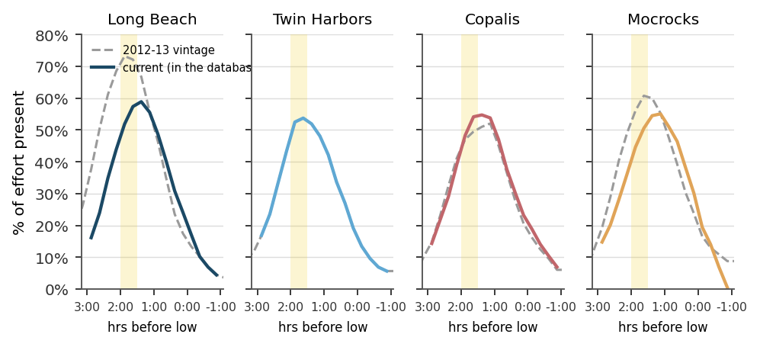
Figure 9. The operational expansion table (solid, coloured) against its 2012 or 2013 vintage predecessor (dashed grey), by beach. The shaded band is the reference count window. Twin Harbors is unchanged. Long Beach was substantially reshaped: its 2013 evening curve peaked above 73 percent, a level no current curve approaches, in part because one of its component surveys stopped counting at low water and contributed 585 cars to every bin's denominator while supplying no egress observations after low water.
Table 7. Effect of the post-2013 table refinement on the correction factor and on expanded effort, evaluated at each beach's modal count window.
Beach | Count window (minutes before low water) | CF, 2012 to 2013 table | CF, current table | Change in expanded effort for the same count
Long Beach | 120 to 90 | 0.727 | 0.546 | +33.1%
Twin Harbors | 120 to 90 | 0.531 | 0.531 | +0.0%
Copalis | 105 to 75 | 0.502 | 0.544 | -7.7%
Mocrocks | 90 to 60 | 0.576 | 0.548 | +5.2%
Modal windows are those recovered from the stored correction factors (section 5.5). A positive change means the current table expands the same count to more digger trips. Twin Harbors is unchanged because its current table is bin-for-bin identical to its 2013 table.
Long Beach is the beach whose effort estimate is now most heavily imputed, and it is also the beach whose expansion table moved the most. Any comparison of Long Beach effort across the table change is a comparison of two different measuring instruments. This has never been documented, and it should be, because a 33 percent step in the expansion of a counted day propagates directly into the ratios that the imputation rule uses to fill uncounted days.
Two residual points. First, the form curves carry no derivation note or date, and the egress surveys behind the post-2013 refinements are not all present in the available files, so the current tables cannot yet be independently re-derived or dated from raw surveys. Second, the ingress/egress database remains the authoritative method and early-data source but stops in 2011; it reproduces the 2010 and 2011 tables exactly and is the right tool for re-deriving and validating any future table version.

6.4 Exploitation-rate history and the move to a variable harvest rate
The rate at which the estimated harvestable population is converted into a TAC has itself changed over time, and because the harvest estimate is compared against that TAC, the history matters here. Through the mid-2000s the exploitation rate was 25 percent, derived from an assumed annual instantaneous natural mortality of M = 0.5 and a harvest strategy of F = 0.75 M under the Baranov equation, equivalent to the North Pacific Fishery Management Council (NPFMC) Tier 6 approach used when total legal-size biomass is unknown. The rate was raised to 30 percent in 2006, switching to F = M (NPFMC Tier 5, used when legal-size biomass is known). A 2006 to 2009 reserve-area growth study then re-estimated the von Bertalanffy growth constant at K of approximately 1 (Cheng and Kuk 2002 method, replacing the earlier Fabens estimate), which, under the working assumption that M = K, supports a higher maximum rate on the order of 40 to 43 percent (Cheng 2011).
Building on that work, the four main beaches moved from the fixed 30 percent rate to a variable, adaptive rate of up to about 40 percent. The rate is scaled by the ratio of the current spawning biomass (from the most recent stock assessment) to the highest spawning biomass on record for that beach, harvesting more when the stock is strong and automatically lowering the rate, under a 40-10 rebuilding rule keyed to pre-recruit and recruit densities, when the stock falls below 40 percent of that maximum, down to closure when it is severely depleted (Cheng 2011). The exact effective dates differ across the program's own records: the management-history figure (Figure 3) marks the 30 percent rate at 2004 and the variable rate at 2015, whereas the quantitative basis was set out in 2011 and the change is elsewhere dated to about 2012 or 2013. This conflict remains unresolved and should be settled against a definitive program source. Whichever dating is used, the variable rate changes the management target against which estimated harvest is compared, not the harvest estimate itself.

6.5 The 2023-24 standardized correction-factor practice
From the 2023-24 season, correction factors are logged per dig event with explicit reasoning. The dominant rule is to average the two largest applicable table bins, chosen by when the count occurred relative to peak effort. Documented exceptions: small, condensed, slow-digging crowds are assigned a fixed higher factor (0.600 or 0.700), because a single count then captures most of the day's effort; and occasionally same-day ingress/egress data are collected and used for that day's factor. This standardized practice, not any change to the tables, is what tightened the within-season spread of correction factors visible in Figure 7. It is a genuine improvement in reproducibility. It does not reduce the sampling error of the tables themselves, which is the term that dominates the season total.

7. How seasons have differed

7.1 Harvest-rate regime
A 25 percent exploitation rate through the mid-2000s, 30 percent from 2006, and a variable rate (up to about 40 percent) from the early-to-mid 2010s (section 6.4). The estimate's machinery is unchanged across these boundaries; only the TAC denominator for share of TAC harvested changes.

7.2 Closures and disruptions
Several recent seasons were shortened or partially closed, which truncates effort and harvest independently of stock status and should be remembered when comparing seasons:
- 2019-20 closed prematurely (COVID-19).
- 2020-21 partially closed (elevated domoic acid, a marine toxin).
- 2022-23 partially closed (elevated domoic acid).
Marine-toxin closures, and poor weather and surf, also routinely move days between beaches within a season.

7.3 Effort by season and beach
Digs offered per season vary widely by beach and year; recent program summaries report totals ranging from the low tens to over a hundred dig-days per beach per season, driven mainly by the TAC and by toxin closures. The per-season, per-beach dig-day tables in the program's annual summaries are the authoritative record for effort context. For scale, the 2024-25 season offered up to 109 days per beach and produced an estimated 312,716 digger trips and about 4.0 million clams coastwide, or 12.4 clams per trip. Applying the corrections of section 10 raises those to roughly 324,700 digger trips and 4.0 million clams before wastage. Season totals are compared against the TAC beach by beach, and the comparison is not always comfortable: in 2017-18 Twin Harbors took 124.8 percent of its TAC and Mocrocks 101.7 percent (Table 5), a fact recoverable only from the FINAL printout, because the workbook that produced it does not survive.

7.4 Tide series, evening versus morning, and night digs
Fall openers fall on evening low tides and spring openers on morning low tides, with winter night digs in between. Time-of-day restrictions follow the tide (for example, no digging before noon on fall evening lows, and a midnight-to-noon window on spring morning lows). On dark tides, crews count lights or cars rather than people, and the near-dark expansion table applies; these choices flow through CalcPeople (section 4.2) and table selection (section 5.2). A tide series is the natural sampling unit of the fishery: it is a run of three to seven consecutive open days on one low-tide sequence, and section 11 shows that it is also the natural unit at which to design the count schedule.

7.5 Kalaloch as a special case
Kalaloch is assessed by Olympic National Park staff and does not follow the four-beach expansion method. Three facts establish how weak its series is. It has no ingress/egress expansion table of its own: the table labelled Kalaloch in Master_Tables.xls is, to sixteen significant figures, the Mocrocks survey of 1 April 1998, and even the cars-left figure carries across. Its correction factors match no bin window of any known table, and three of its sixteen events carry a correction factor of exactly 1.000, meaning no expansion was applied at all. And the in-season workbooks carry 40 Kalaloch beach-days of typed effort against only 15 distinct Kalaloch beach-dates in the harvest database: all 17 beach-days in 2009-10 and all 6 in 2018-19 have no sampling event behind them anywhere. The Kalaloch effort and harvest series should not be treated as comparable to the other four beaches, and its provenance should be documented or the series retired.

7.6 Regulatory history: bag limit, legal size, and season structure
The estimate's machinery is recent, but the fishery it measures has a long regulatory history that shapes how seasons compare across decades.
Table 8. Daily bag limit, minimum legal size, and season structure since state management began in 1929.
Period | Daily bag limit | Legal size | Season structure
To 1929 | None | None | No closed season
1929 to 1942 | 36 clams | 3.5 in | No closed season
1943 to 1947 | 36 clams | None | Mar 1 to Sep 30
1948 to 1959 | 24 clams (18 in 1950) | None | Mar 1 to Sep 30
1960 to 1972 | 18 clams | None | Mar 1 to Sep 30
1973 to 1983 | 15 clams | None | Oct 1 to Jun 30; summer closure begins; several conservation closures
1984 to 1986 | 15 clams | None | 1984 closed (NIX); limited 1985 and 1986 openers
1987 to 1995 | 15 clams | None | Beaches opened and closed independently; spring a.m. and fall p.m. odd-day openers
1996 to present | 15 clams | None | Oct to May, selected days on the best low-tide series; beaches managed independently

Three transitions bear directly on season comparisons. The 1973 summer closure ended year-round digging and moved the fishery into the fall-through-spring window it still occupies. The 1984 and 1985 NIX closure, together with the conservation closures of the late 1970s and early 1980s (for example the four- and five-month small-clam closures of 1981-82 and 1982-83), interrupts the series. And from 1987 the beaches were opened and closed independently by abundance, size, and toxin level, which is why beach-by-beach effort and harvest diverge so strongly from that point onward.

7.7 Marine toxins and the Commission management policy
Two marine biotoxins constrain the modern fishery. Domoic acid, which causes amnesic shellfish poisoning, is produced by the diatom Pseudo-nitzschia and was first detected in Washington razor clam tissue in 1992; it has been the dominant cause of closures since, removing roughly 25 percent of all planned digging opportunities. Paralytic shellfish poisoning, caused by saxitoxin from the dinoflagellate Alexandrium, has historically been a smaller but recurring problem. A beach can open only after two sample collections, taken seven to ten days apart, both test below the action level (20 ppm for domoic acid), which is why openers are always announced as tentative. These closures truncate effort and harvest independently of stock status, and are the reason several seasons in Figures 1 and 2 fall to zero or near zero.
All of this operates under Fish and Wildlife Commission Policy C3009, which directs WDFW to manage the resource primarily for recreational use (with only a minor commercial fishery on detached Willapa Bay spits), protect public health and safety, maintain stable and healthy populations, maximize recreational opportunity, provide a quality recreational experience, and manage each of the five beaches independently while accounting for the pertinent interactions of seasons, effort, opportunity, and tribal allocations.

8. The supporting databases

8.1 Recreational-harvest (creel) database
A Microsoft Access database (ACE14) holds the counts, interviews, wastage, and lengths, with a parent events table keyed by EventID and children keyed by EventID and segment LocationID. It spans 13 October 1993 to 6 May 2026, sparsely before 2008 and densely after. It holds 2,682 events, 13,789 counts, and 53,511 interviews. Two structural points matter for any roll-up. The event grain is one beach on one date, except that Long Beach is entered as two events per dig day (section 5.4). And ten beach-dates carry two events whose census segments overlap, which are genuine duplicates; the segment sets distinguish them from the 53 Long Beach splits, which must be summed. The beach name field is not normalized and carries three spellings of Long Beach; grouping on it undercounts Long Beach events by about 36 percent.
The full extraction is now a first-class artifact. All 21 tables are exported verbatim with mdbtools, cleaned by a documented and audited layer, and recomputed to four grains by a single script. Nothing downstream requires Access.

8.2 Ingress/egress survey database
A separate, small Access database holds the egress surveys: an event table (beach, date, tide time, evening flag, conditions, sampler) and two tables of vehicle counts on and off the beach in fifteen-minute bins, plus lookups. It contains twenty surveys spanning 2004 to 2011 and is the raw source for the percent-available curve and the expansion tables. It records no beach approach at all, which matters because Long Beach was surveyed at two approaches whose totals differ by more than an order of magnitude, and because the 1998 Twin Harbors and Mocrocks surveys each pool several approaches. Pooling across approaches without recording which is a hidden stratification. Four defects in this database are documented in section 9.

8.3 Why aggregates are recomputed from raw tables
The stored summary tables in the harvest database carry inflated sum columns: the summary-build query joins interviews to counts, so every interview sum is multiplied by the number of count rows in the event. The ratios (CPUE, digging fraction) survive this, which is why the harvest chain still validates, but the totals do not. The stored working table is also stale: for 476 events its own expanded-effort value does not equal that same row's CalcPeople times digging fraction divided by correction factor. Recompute all aggregates from the five raw tables and treat the derived tables as cached output, never as data.

9. Data quality and known issues
The following are confirmed in the data and should be handled before any recompute. They are documented in full, with counts and evidence, in the harvest-database data dictionary, the effort-expansion protocol, and the Data_Issues sheets of the companion workbooks.
Table 9. Confirmed defects in the harvest database and the in-season workbooks.
Issue | Effect and handling
Beach-name spellings | Three spellings of Long Beach undercount it by about 36 percent if grouped raw; normalize to the canonical beach before grouping.
Duplicate count rows | Exact-duplicate count rows (whole events entered twice) double-count effort; for example they overstate Twin Harbors 2022-23 by about 16 percent. Remove exact duplicates unconditionally (82 rows).
Mis-entered count rows | A few per-group records were typed into the count table (cars at least twice people). Remove them; EventIDs 469, 509, 2590.
People-per-car field | The interview cars field stores people per car, not a vehicle count; misreading it corrupts effort.
Impossible values | A handful of interviews carry impossible clam or people counts. Cap or nullify the offending value, not the whole interview.
Stored summary inflation | Stored summary sums are inflated by the count-row join (section 8.3); recompute from raw.
No per-count time | Count rows carry no time field, so genuine replicate counts cannot be distinguished from duplicates except by value, nor matched to the correction-factor reference time. Add a count-time field.
Correction factor out of range | One event carries CF = 2.100 and six are below 0.25. CF is a fraction of the day's effort present at the count, so any value outside (0, 1] is an error. Set out-of-range values to the beach preset and log the change.
Duplicate events versus the Long Beach split | Ten beach-dates carry two events with overlapping census segments and are duplicates. Fifty-three carry two events with disjoint segments and are the Long Beach halves. Distinguish by segment set, never by beach and date alone.
Stored working and summary tables are stale | For 476 events the stored expanded effort does not equal its own inputs. Recompute from the raw tables.
Recomputed CPUE exceeds the daily bag limit | CPUE recomputes to 16.5 to 17.2 clams per digger trip at all four beaches in 2021-22, 15.0 in 2020-21, and 20.1 at Long Beach in 2016-17. A catch rate above the 15-clam limit is not possible. Interview records for those seasons need review before any harvest series is published from them.
The 2017-18 Effort tab is a mid-season snapshot | It holds 10 of 27 dig days and ends 4 Dec 2017. It carries no wastage. The season record is the FINAL printout, which is in the repository and reconciles to the database on 66 of 67 open beach-days (Table 5). Use the printout, not the tab.
The 2022-23 workbook omits an entire tide series | The Effort tab ends 25 Apr 2023. The 4 to 14 May 2023 series, 33 open beach-days on the program's own sample schedule, appears nowhere in the workbook. The database holds 22 of those beach-days, worth 61,959 digger trips, 26.1 percent of the workbook's coastwide total of 237,419. The remaining 11, at Long Beach and Twin Harbors, were never counted and must be imputed. The published 2022-23 season totals are not season totals.
The 2023-24 workbook is complete; an earlier snapshot is not | The file in the repository holds all 100 dig days to 12 May 2024. A superseded snapshot ending 18 Nov 2023 is the basis of the coverage sheet in the recompute workbook, whose 2023-24 rows are therefore stale (section 10.2).
The 2017-18 published wastage has no source | The printout reports 109,381 clams of wastage. The workbook's four Wastage sheets are empty, its ESTIMATED WASTAGE RATE cell is blank, and the database holds wastage surveys only for Mocrocks (5 rows) and Twin Harbors (2 rows), together 12,764 clams. The published figure cannot be reproduced from any surviving record.
Stale labels and SUM ranges in the 2017-18 workbook | Its season-total row is labelled FALL 2014 - SPRING 2015, its harvest-rate row Fall 2016 / Spring 2017, and its Kalaloch total reads SUM(N3:N53) against data to row 86. Its Day column carries October 2016 dates on the first two rows.
Seven dig days dated a year early | Rows for 14 to 20 January in the 2021-22 workbook carry 2021 dates and belong to 2022. Proven by the weekday column and by the presence of events on those dates in 2022 and their absence in 2021.
Arithmetic errors in the in-season workbooks | Long Beach 19 October 2024 is overstated by 293.5 digger trips (14.6 percent) by a section-ratio formula missing its multiplication operator. The 2016-17 per-beach season totals double count twenty April dig days by summing across an interior subtotal row, inflating them by 48 to 92 percent. Mocrocks season totals for 2011-12, 2012-13, 2017-18 and 2018-19 omit the first dig day because the SUM range starts one row late.
2007-08 season totals contradict their own daily rows | The SEASON TOTALS row holds typed pre-revision numbers while the daily rows below it hold the 2013-revised values, 13 to 30 percent higher. The published effort series carries the pre-revision values for 2007-08 through 2011-12.
Kalaloch has no expansion table and few events | See section 7.5. Forty beach-days of typed effort against fifteen database beach-dates, and a correction-factor table that is a Mocrocks survey.

Two further defect classes were found while building the companion data products and have not previously been recorded anywhere. Both bear on whether the sampled-versus-estimated distinction in the effort series can be trusted at all.
Table 10. Flag symbols used in the in-season Effort tabs, and what they actually mean.
Symbol | Legend as printed | What it means for sampling status
* | Estimate based on comparison of other beaches | The beach was not counted.
** (2013-14, 2014-15) | Seahawks play in Superbowl. Low attendance. | A note on attendance. The beach WAS counted. On 2 Feb 2014 Mocrocks is EventID 914 with six census rows and four interviews.
** (2015-16 onward) | No beach count. Used data from another day. | The beach was not counted.
+ | No harvest due to very heavy surf and storm warnings | A note on conditions. Says nothing about sampling.
# | Tide is not low enough for decent digging opportunity | A note on conditions. Says nothing about sampling.
(no flag) |  | Ambiguous. Twelve beach-days carry a derivation formula with no flag, and 63 flagged beach-days hold a typed number with no derivation.
The same symbol changed meaning in 2015-16. Each beach has its own flag column, not a single shared one. Sampling status must therefore be derived from the cell contents, not from the flag. Doing so agrees with the harvest database on 97.0 percent of days labelled sampled and 98.5 percent of days labelled estimated. Where the workbook is complete the agreement is exact: in 2022-23 all 17 flagged Long Beach beach-days and all 20 flagged Twin Harbors beach-days are precisely those with no census, and in 2023-24 all 44 and all 28 likewise.
Table 11. Defects in the egress survey record, the data behind every correction factor.
# | Severity | Issue | Effect
1 | High | The Kalaloch expansion table is the Mocrocks survey of 1 April 1998 | Every Kalaloch harvest estimate has been expanded on Mocrocks effort behaviour. Direction and magnitude of bias unknown.
2 | High | The ingress database collapses three bins into one for the Mocrocks 9 Oct 2010 survey | Curves pooled straight from the database mis-place 40 cars-on into a single early bin, distorting the leading edge of the Mocrocks evening curve.
3 | High | Probable transcription error in the Mocrocks 21 Apr 2011 cars-on | The stored 3 should almost certainly be 23. The Mocrocks daylight curve is understated by up to 3.7 percentage points from 1:00 to 0:45 onward.
4 | Medium | The database stores the Mocrocks prior-to-start values in the wrong column | Any query reading prior-to-start, or reporting the survey window, is wrong for every Mocrocks event.
5 | Medium | Duplicate prior-to-start inflates the Long Beach 2004 south survey by 3.7 percent
6 | High | Identical counts filed under two dates eight years apart (27 Mar 1998 and 11 May 1990) | This is the single largest Long Beach survey on record, 2,344 cars. Pooling both files double-counts it.
7 | Medium | Inconsistent pooling convention for prior-to-start | Copalis folds the earlier survey's prior into the first common bin; Twin Harbors simply sums the priors. The bin that anchors the whole cumulative curve is treated differently on different beaches.
8 | Medium | The 1998 per-approach sheets under-record prior-to-start | Cumulative cars-off exceed cars-on on four approach sheets, giving negative cars on beach. The per-approach sheets cannot be used; the summaries are sound.
9 | Low | The 1998 summaries divide percent available by the wrong denominator | Percent available overstated by 0.47 percent at Long Beach and 0.14 percent at Twin Harbors throughout those curves.
11 | Medium | Ingress_Egress_review.xls is misaligned and mislabelled | Its Copalis 2011 PM column pools a daylight survey into an evening curve. If this sheet was ever used to justify a table revision, the justification is unsound.
12 | Low | Long Beach and Twin Harbors have no daylight expansion table | Daylight openers at those beaches are expanded with an evening table or with an undocumented factor, despite four daylight surveys existing at each.
13 | Low | Hand-appended tail values with no survey behind them | Five values in the Copalis and Mocrocks daylight tables extend past the last bin any survey recorded. The Mocrocks tail implies effort dropping from 20.5 to 1.2 percent in one hour, steeper than any observed survey.
15 | Medium | Pooled tables mix surveys with different window lengths, and do not say so | The post-low bins of a pooled table rest on fewer surveys than the pre-low bins. Nothing in the table records how many.
Numbering follows the Data_Issues sheet of the consolidated ingress/egress workbook; issues 10 and 14 are cosmetic and are omitted here.

10. Where the error enters: a step-by-step budget
The published harvest estimate is a point estimate produced by a chain of nine steps. Each step substitutes a modelled or sampled quantity for one that was not observed. Table 12 names the step, the substitution it makes, the error that substitution introduces, whether that error is currently quantified, and the experiment or calculation that would quantify it. The steps are ordered as the calculation runs, not by importance.
Table 12. The nine-step error budget of the recreational harvest estimate.
Step | What is estimated | Error introduced | Quantified today | What would quantify it
1. Beach count | People present on each segment at one instant | Observer miscount; segments missed; the count takes 26 to 31 minutes, so it is not instantaneous | No | Replicate counts by independent observers on a subset of dig days
2. Digging fraction | Share of people present who are digging | Interview sampling error; interviewed groups may not represent the beach | Yes, by interview bootstrap | Done
3. People from cars or lanterns | People when the crew counted vehicles or lights, not people | Model error in people-per-car and diggers-per-lantern, and in the 2.67 fallback constant | No | Paired counts of people and cars on the same segment
4. Correction factor | Share of the day's effort present during the count window | Table vintage; condition assignment; count window placement; the tables pool three or four surveys and carry no per-bin survey count | Yes (section 10.3). Between-survey relative sd 4.5 to 7.3 percent at Long Beach, 4.3 to 5.2 at Twin Harbors, 3.7 to 6.9 at Mocrocks, 12.4 to 13.7 at Copalis. Systematic, so it does not average down | Locate the post-2013 tables and recover the 2012 to 2021 surveys to shrink it; publish a per-bin survey count with every table
5. CPUE | Clams per digger trip | Interview sampling error; impossible values (section 9); interviews are a median 3.4 percent of estimated digger trips. On estimated beach-days CPUE is typed by hand: 507 of 660 cells, 15.8 percent of them exactly 15 | Yes for counted days. For estimated days the transfer error has sd of log ratio 0.448 | Substitute the donor's measured CPUE
6. Imputation for unmonitored beach-days | Effort and harvest on a beach nobody counted | Assumes the donor-to-target ratio is stable between the reference day and the dig day. Carries 32 percent of coastwide effort in 2025-26, and 57 percent of Long Beach effort | Yes (section 10.2) | Apply the multiplier correction; it raises Long Beach 2025-26 effort by 9.0 percent
7. Long Beach section ratio | The half of Long Beach that was not walked | Same class of error as step 6, within the beach, but half the magnitude: sd of log error 0.281. Carries a further 29 percent of Long Beach effort in 2025-26 | Yes (section 10.2), on 96 paired days | Walk all seven segments on any counted Long Beach day
8. Wastage | Clams dug and not retained | A flat proportion from a subset of events, absent on many night and low-effort tides | No | Bootstrap hole surveys; report coverage
9. Roll-up and transcription | Season totals per beach | Formula and range errors in the in-season workbooks (section 9); truncated workbooks; a season total that does not equal the sum of its own daily rows | Yes, and correctable | Generate the season workbook from the database rather than maintaining it by hand

Reading the budget. Steps 1 to 5 are the classical creel-survey error terms. Steps 6 and 7 do not add noise to a measurement; they replace the measurement entirely, and in 2025-26 they account for 42 percent of coastwide digger trips and 86 percent of Long Beach digger trips. That makes step 6 the largest error on any single beach-day. It does not make it the largest error on a season total, and section 10.1 explains why.

10.1 What dominates a season total, and why it is not what it looks like
Two of the sources in the budget have now been quantified, and the result reverses the intuition above. The reason is correlation, not magnitude.
Imputation error (steps 6 and 7) is large but idiosyncratic. Residuals within a tide series are strongly negatively autocorrelated, with a lag-1 autocorrelation of -0.68, so a tide-series sum has a log-error standard deviation of 0.219 against 0.541 for a single day, and a season sum is better still. It averages down.
Correction-factor error (step 4) is smaller per beach-day but it does not average down at all. Every beach-day of a beach is expanded with the same table, so the error is common to all of them and scales the season total directly. Formally, in the imputation X_t = X_r × D_t / D_r the donor's correction factor cancels between D_t and D_r, while the target's survives in X_r. The whole season for a beach, counted days and imputed days alike, moves with one over that beach's correction factor.
Propagating both, together with interview error and the CPUE transfer error, gives the variance shares below, averaged over the seasons from 2019-20 onward.
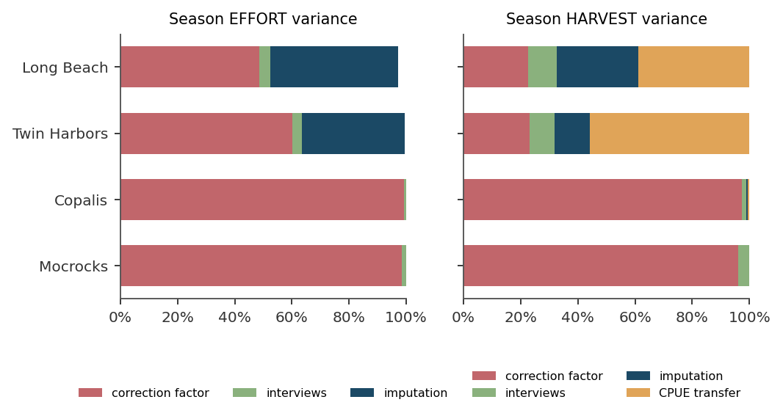
Figure 10. Share of each season total's variance attributable to each source, averaged over the seasons from 2019-20 onward, by leaving each source out in turn. Left: effort. Right: harvest. The correction factor dominates effort everywhere and dominates harvest at the two fully counted beaches. CPUE transfer, which exists only because catch rate must be borrowed on an uncounted day, dominates harvest at Long Beach and Twin Harbors.
Table 13. Variance shares of the season total by source, mean over 2019-20 onward.
Beach | EFFORT: correction factor | EFFORT: interviews | EFFORT: imputation | HARVEST: correction factor | HARVEST: interviews | HARVEST: imputation | HARVEST: CPUE transfer
Copalis | 99% | 1% | 0% | 97% | 2% | 0% | 1%
Long Beach | 49% | 4% | 45% | 23% | 10% | 28% | 39%
Mocrocks | 98% | 2% | 0% | 96% | 4% | 0% | 0%
Twin Harbors | 60% | 4% | 36% | 23% | 9% | 12% | 56%

The consequence is counter-intuitive and worth stating plainly. Copalis is counted on every open day it has. It also has the widest season effort interval of the four beaches, because its expansion table rests on three surveys that disagree with one another. Long Beach, 86 percent of whose 2025-26 effort is imputed, has a narrower interval, because its three surveys agree better and its imputation errors partly cancel. Counting more beach-days would not narrow the Copalis interval. Running more egress surveys would.
For harvest the picture flips again. Because the catch rate on an estimated beach-day must be borrowed, and the borrow error is large, CPUE transfer becomes the largest single source of harvest variance at Long Beach (39 percent) and Twin Harbors (56 percent). At Copalis and Mocrocks, where nothing is borrowed, the correction factor is still 96 to 97 percent of harvest variance.

10.2 The imputation experiment
For every beach-day on which the target and its donor were both counted, the workbook's own rule was applied as if the target had not been counted, using the workbook's own reference-day convention, and the result compared against the expansion of the count that was actually taken. Truth and prediction both come from the harvest database, recomputed from raw tables. The sample is 2,889 paired beach-days, of which 1,055 use the target and donor pairs the workbook actually uses, plus 96 paired days for the Long Beach section rule.
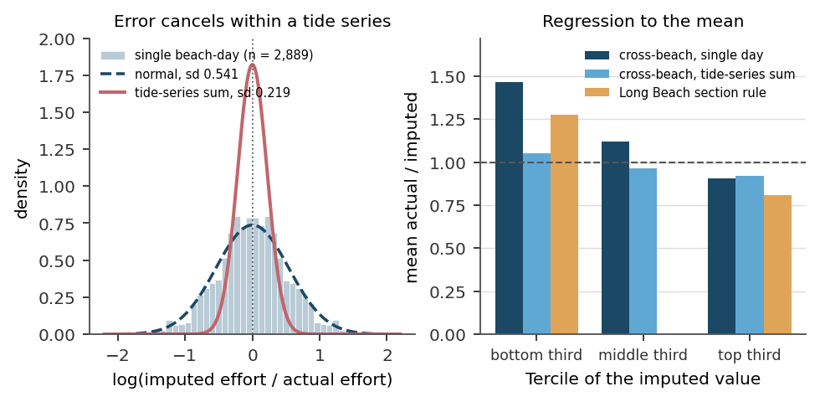
Figure 11. Left: the distribution of log(imputed / actual) over 2,889 paired beach-days, with a fitted normal (dashed) and, for comparison, the much narrower distribution of the same error summed over a tide series (solid). Residuals within a tide series have a lag-1 autocorrelation of -0.68, so the error largely cancels before it reaches a season total. Right: the mean ratio of actual to imputed effort, conditioned on the tercile of the imputed value. Every rule regresses to the mean, and the single-day cross-beach rule does so most.
Table 14. Leave-one-out imputation error by target and donor beach, single beach-days.
Target | Donor | Paired days | Median ratio (imputed / actual) | sd of log error | Mean absolute percentage error
Copalis | Long Beach | 186 | 1.011 | 0.615 | 55%
Copalis | Mocrocks | 156 | 0.959 | 0.476 | 39%
Copalis | Twin Harbors | 190 | 1.015 | 0.446 | 37%
Long Beach | Copalis | 186 | 0.989 | 0.615 | 57%
Long Beach | Copalis+Mocrocks | 97 | 0.985 | 0.425 | 37%
Long Beach | Mocrocks | 246 | 1.001 | 0.641 | 58%
Long Beach | Twin Harbors | 321 | 1.034 | 0.550 | 50%
Mocrocks | Copalis | 156 | 1.042 | 0.476 | 43%
Mocrocks | Long Beach | 246 | 0.999 | 0.641 | 55%
Mocrocks | Twin Harbors | 258 | 1.024 | 0.532 | 46%
Twin Harbors | Copalis | 190 | 0.985 | 0.446 | 37%
Twin Harbors | Copalis+Mocrocks | 78 | 1.016 | 0.368 | 30%
Twin Harbors | Long Beach | 321 | 0.967 | 0.550 | 46%
Twin Harbors | Mocrocks | 258 | 0.977 | 0.532 | 45%
The rule is unbiased in the median for every pair. The Copalis-plus-Mocrocks joint donor is the best single-day donor for both southern beaches; a single northern beach is the worst. The Long Beach section rule, not shown, has sd of log error 0.309 walking the north four segments and 0.253 walking the south three.
Table 15. How the imputation error behaves as it is aggregated, and the empirical bias multipliers.
Aggregation level | n | Median ratio | sd of log error | Mean absolute percentage error | Mean multiplier, bottom third | middle third | top third
Single beach-day, cross-beach | 2,889 | 1.000 | 0.541 | 47% | 1.463 | 1.120 | 0.905
Tide-series sum, 2 imputed days | 874 | 1.015 | 0.256 | 18.0% | 1.051 | 0.962 | 0.922
Tide-series sum, 3 to 4 imputed days | 308 | 1.031 | 0.207 | 16.4%
Tide-series sum, 5 or more imputed days | 26 | 1.066 | 0.153 | 12.8%
Long Beach section rule, single day | 96 | 1.000 | 0.281 | 23% | 1.273 |  | 0.809
The multiplier is the mean of (actual / imputed), conditioned on the tercile of the imputed value, which is observable at the time of imputation. Multiplying the imputed value by it removes the regression-to-the-mean bias. Note that the tide-series multipliers are close to one: most of the single-day bias is already gone by the time a series is summed.
Two limits apply, and they run in the same direction. The validation days are days that were counted, and the days that go uncounted are systematically smaller, with a median of 664 against 1,067 digger trips at Long Beach and Twin Harbors since 2019-20, and less often weekends. The measured error therefore probably understates the error on the days the rule is actually used. And on four beach-days the workbook estimated a beach the database shows was counted; the workbook-to-actual ratios are 2.72, 1.29, 0.95 and 3.28, two of which sit above the 93rd percentile of the validation distribution.
Error grows with the lag between the dig day and the reference day: the standard deviation of the log error is 0.493 at a lag of one day, 0.571 at two, 0.595 at three, and 0.742 at four to five. Reference days should be the nearest, not the most convenient.
Three disagreements between companion products, flagged rather than resolved. First, the correction workbook and the imputation workbook use different pools for the donor-to-target CPUE transfer error: 0.448 over 3,430 paired beach-days in the former, 0.461 over 1,906 paired days in the latter. The 0.448 figure is the operative one because it is the value the variance model actually draws from. Second, the two workbooks disagree on the bias-adjusted 2025-26 coastwide effort: 321,705 digger trips from the per-beach corrections, against 314,700 from the imputation-only calculation, a difference of 2.2 percent, because the latter does not apply the Long Beach section-rule multiplier. Third, and newly identified in version 5, the coverage sheet of the recompute workbook was built on a superseded 2023-24 snapshot and on whole-season database effort divided by partial-season workbook totals for 2017-18 and 2022-23. Its coverage shares for those three seasons are wrong by wide margins, for example 6.006 for Copalis in 2023-24 and 1.282 in 2022-23. The corrected shares are those in Figure 4. Nothing else in the workbook depends on that sheet, and no published estimate does.

10.3 The correction-factor experiment
Each operational evening expansion table is a pooling of named surveys: Long Beach from three, Twin Harbors from three, Copalis from three, Mocrocks from four. Resampling those surveys with replacement, re-pooling the raw car counts and recomputing the curve gives the sampling distribution of the correction factor at any count window. Because the count window is itself recoverable from the stored correction factor (section 5.5), this can be done per event.
Table 16. Bootstrap of the correction factor at each beach's modal count window.
Beach | Component surveys | Count window (min before low) | Correction factor | Bootstrap sd | Relative sd | 95 percent interval
Long Beach | 3 | 120 to 90 | 0.727 | 0.0406 | 5.6% | 0.577 to 0.781
Twin Harbors | 3 | 120 to 90 | 0.531 | 0.0273 | 5.1% | 0.459 to 0.574
Copalis | 3 | 105 to 75 | 0.502 | 0.0631 | 12.6% | 0.344 to 0.569
Mocrocks | 4 | 90 to 60 | 0.575 | 0.0543 | 9.5% | 0.473 to 0.671
The correction factors here are those of the 2012 to 2013 tables, because those are the tables whose component surveys are known. The relative standard deviation is what is transferred to the operational correction factors, not the level. Compare Table 7: the operational Long Beach factor at this window is 0.546, not 0.727.
Two assumptions are load-bearing. The operational tables for Long Beach, Copalis and Mocrocks were refined after 2013 and their component surveys have not been located (section 6.3), so the relative standard deviation measured on the 2013-vintage tables is transferred to the operational correction factors. If the current tables rest on more surveys, this overstates their error; if on the same three, it does not. And three surveys is a very small bootstrap: the central estimate of the relative standard deviation is usable, its tails are not. Both point the same way. Locating the current tables and recovering the 2012 to 2021 surveys is the highest-value data-recovery task in the program, because it is the only thing that would narrow the interval on a beach that is already fully counted.

10.4 What the interval covers, and what it does not
The delivered interval propagates correction-factor error, interview error, imputation error and CPUE transfer error, with the correlation structure above. It excludes beach-count observer error, which cannot be estimated because no beach has ever been counted twice on the same day by independent observers; the people-per-car and diggers-per-lantern fallbacks; and wastage. It is therefore a lower bound.
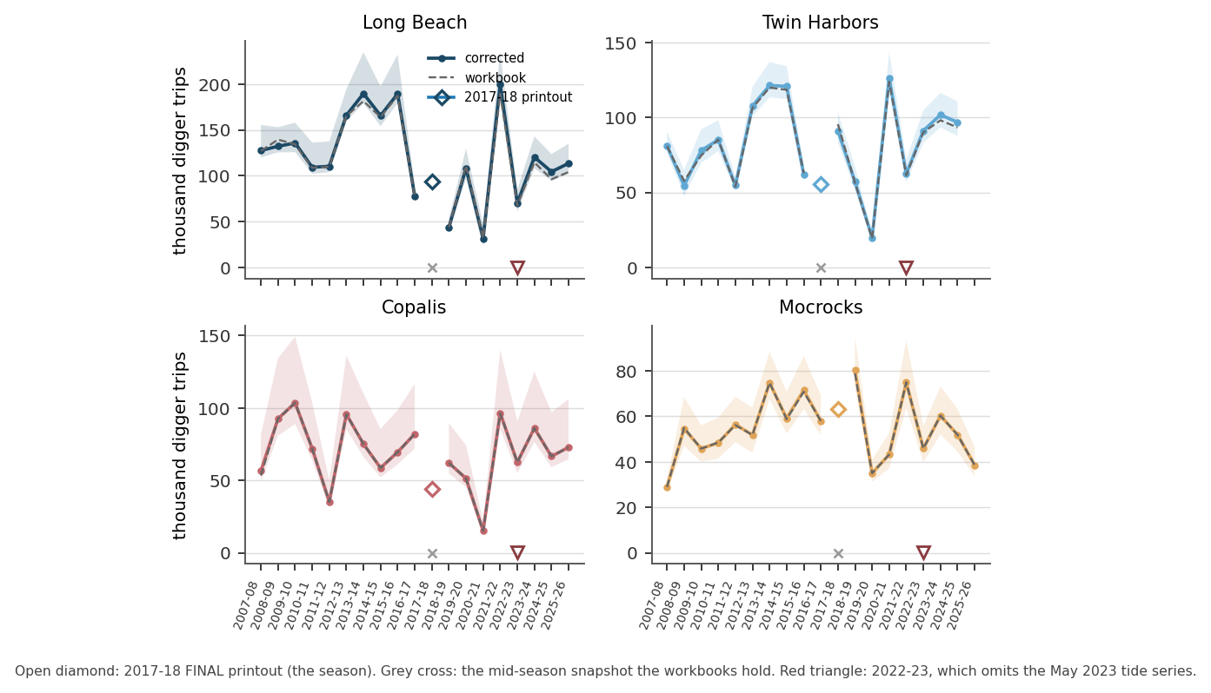
Figure 12. Season effort by beach, 2007-08 to 2025-26. The dashed grey line is the in-season workbook value; the coloured line is the value after the imputation bias correction; the band is the 95 percent interval from correction-factor, interview, imputation and CPUE-transfer error. Copalis and Mocrocks are unchanged by the bias correction because almost nothing of theirs is imputed, but they carry the widest bands, because their expansion tables rest on the most disagreeing surveys. Two seasons are marked. The open diamond at 2017-18 is the FINAL printout, the season of record; the grey cross beneath it is the mid-season snapshot that the workbooks and the uncertainty model actually used, and it understates the season by a factor of two to three. The inverted triangle at 2022-23 marks a season whose workbook omits the May 2023 tide series and therefore understates coastwide effort by at least 26 percent.
The intervals are right-skewed, and version 3 misstated this. Effort is the count divided by the correction factor. A bootstrap draw that lowers the correction factor raises effort without bound, while a draw that raises it can at most halve effort. The resulting interval is therefore asymmetric, and increasingly so as the relative standard deviation of the correction factor grows. For Copalis in 2025-26 the corrected effort is 72,870 digger trips with a 95 percent interval of 64,530 to 106,100, which is minus 11 percent and plus 46 percent, not plus or minus 14 percent. The coefficient of variation, 0.14, is the honest one-number summary; a symmetric plus-or-minus statement is not. The same caution applies to every interval in Table 17 and to every band in Figure 12.
Table 17. Corrected season estimates and 95 percent intervals, 2023-24 to 2025-26. Effort in digger trips; harvest in clams before wastage.
Season | Beach | Effort: workbook | Effort: corrected | Bias | Effort 95% interval | Effort CV | Harvest: corrected | Bias | Harvest CV
2023-24 | Copalis | 86,088 | 86,088 | -0.0% | 76,465 to 125,084 | 0.14 | 1,054,633 | -2.9% | 1523829.98
2023-24 | Long Beach | 114,614 | 120,321 | +5.0% | 108,141 to 142,913 | 0.07 | 1,531,375 | +5.7% | 2183953.46
2023-24 | Mocrocks | 60,278 | 60,278 | +0.0% | 52,039 to 73,045 | 0.09 | 767,090 | -0.1% | 934345.58
2023-24 | Twin Harbors | 90,082 | 91,147 | +1.2% | 83,126 to 104,777 | 0.06 | 1,126,946 | +1.2% | 1492625.50
2024-25 | Copalis | 66,628 | 66,647 | +0.0% | 59,131 to 97,103 | 0.14 | 791,289 | +0.0% | 1149524.97
2024-25 | Long Beach | 96,152 | 104,415 | +8.6% | 94,720 to 123,594 | 0.07 | 1,313,276 | +7.2% | 1761285.44
2024-25 | Mocrocks | 51,840 | 51,882 | +0.1% | 44,368 to 63,250 | 0.10 | 610,023 | -1.9% | 749267.08
2024-25 | Twin Harbors | 98,096 | 101,720 | +3.7% | 93,283 to 116,366 | 0.06 | 1,258,356 | +0.8% | 1519730.78
2025-26 | Copalis | 72,865 | 72,865 | -0.0% | 64,526 to 106,100 | 0.14 | 861,865 | -0.0% | 1248179.18
2025-26 | Long Beach | 104,090 | 113,483 | +9.0% | 102,369 to 134,882 | 0.07 | 1,402,956 | +5.5% | 2021832.09
2025-26 | Mocrocks | 38,563 | 38,563 | -0.0% | 33,678 to 46,517 | 0.09 | 411,195 | -0.1% | 497876.15
2025-26 | Twin Harbors | 93,256 | 96,794 | +3.8% | 87,739 to 110,644 | 0.06 | 1,176,111 | +0.6% | 1431747.68
Coastwide 2025-26: 308,774 digger trips in the workbooks against 321,705 corrected, and 3.77 million clams against 3.85 million, before wastage. Coastwide 2024-25: 312,716 against 324,665, and 3.89 against 3.97 million clams.
Season effort coefficients of variation for 2025-26 are 0.14 at Copalis, 0.09 at Mocrocks, 0.07 at Long Beach and 0.06 at Twin Harbors. Season harvest coefficients of variation are 0.14, 0.09, 0.14 and 0.10. Every one of these meets the NOAA MRIP publication threshold of a percent standard error at or below 30. Only Copalis fails a coefficient of variation of 0.10 on harvest, and it fails for a reason no amount of counting can fix.
Where the remaining effort should go. Three things, in order. Locate the current Long Beach, Copalis and Mocrocks expansion tables and recover the 2012 to 2021 egress surveys, because the correction factor is the largest term in the effort budget and the only one that a larger survey record would shrink. Replace the hand-typed CPUE on estimated beach-days with the donor's measured CPUE, because a measured quantity with a known error beats a typed one with none. And run a paired-observer beach count on a handful of dig days, because step 1 is the one term in the budget with no estimate at all and it sits underneath everything else.

11. How many days per tide series should be sampled
The preceding sections establish that the effort series rests on materially less direct observation than it used to, and that the resulting uncertainty is now measurable. The natural next question is not rhetorical: given a crew of finite size, how many beach-days per tide series must be counted, and which ones? This section answers that against a stated, published precision standard. It is new work and has not previously existed in any form in the program.

11.1 The standard used
There is no WDFW precision standard for this fishery, so two external ones are adopted, at two different scales.
- Design target, CV at or below 0.20. This is the conventional precision target in creel-survey design. It appears in the sample-size literature summarized in Lester et al. (1991) in American Fisheries Society Symposium 12, and is used as the comparison benchmark by McCormick and Meyer (2017), who note that a relative 95 percent confidence interval of about 40 percent corresponds approximately to a coefficient of variation of 0.20.
- Publication threshold, percent standard error at or below 30 (that is, CV at or below 0.30). NOAA Fisheries Recreational Fishing Survey and Data Standards, standard 7.2.2.1: the Marine Recreational Information Program presents a warning when the percent standard error for an estimate exceeds 30 percent, with the recommendation that it be used with caution. Standard 7.2.2.2: MRIP does not support the use of estimates when the percent standard error exceeds 50 percent. A later MRIP workshop found general agreement that data with a percent standard error at or below 40 percent provides valid input to stock assessment models, that 40 to 60 percent should be used with caution, and that 60 percent or above should be used only with extreme caution. That is a floor for usability, not a design target.
A citation correction. The companion sampling-design workbook attributes the CV of 0.20 convention to Bayley et al. (1991) and cites McCormick et al. (2017) at North American Journal of Fisheries Management 37:1074-1084. Neither could be confirmed. The relevant paper is McCormick, J.L., and K.A. Meyer, 2017, Sample Size Estimation for On-Site Creel Surveys, North American Journal of Fisheries Management 37(5):970-980, and it attributes the CV of 0.20 target to Lester et al. (1991), not Bayley et al. The workbook should be corrected.
The coefficient of variation is computed by Monte Carlo over 262 real tide series, using database truth for every counted day. Counted days carry interview bootstrap error. Uncounted days carry the leave-one-out imputation error of section 10.2 and the donor-to-target CPUE transfer error. The correction factor carries the between-survey error of its expansion table and is drawn once per beach, because it is systematic. Season totals use the measured correlation structure: imputation residuals cancel within and across tide series (within-season design effect 0.14), while the CPUE transfer error has an irreducible season-level component with a standard deviation of 0.137 in the log ratio (within-season design effect 3.44) that no amount of sampling removes. Beach-count observer error is not in the calculation, because it has never been measured. Every number in this section is therefore a lower bound.

11.2 The answer
For the in-season tide-series harvest estimate to meet a coefficient of variation of 0.20: count two of a four- or five-day series, and three of a six- or seven-day series. That is 40 to 50 percent of a beach's open days, and it should be read as 45 percent with a floor of two days. Counting one day per series never meets the design target: the tide-series harvest coefficient of variation at m = 1 runs from 0.206 (Twin Harbors, six-day series) to 0.305 (Mocrocks, four-day series), and the Mocrocks value sits just above the MRIP publication threshold as well. Percentages here are of a beach's open days, not of calendar dig days: Long Beach and Twin Harbors are open a median of five days per tide series, while Copalis and Mocrocks alternate and are open a median of 2.5 and 3 days.
One exception is worth stating, because it is the same exception that runs through the whole document. On a three-day tide series, two counted days meet the design target at Long Beach, Twin Harbors and Mocrocks, but not at Copalis, whose correction-factor floor of 0.126 leaves too little headroom above a series CV of 0.221. Copalis needs all three. The floor, not the sampling, is the binding constraint.
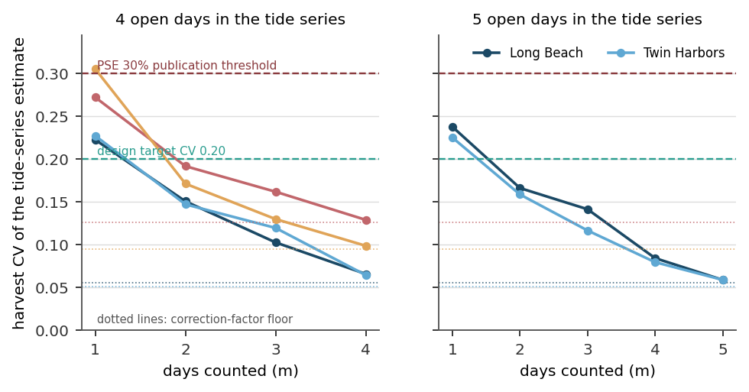
Figure 13. Harvest coefficient of variation of a single tide-series estimate as a function of how many of the series' open days are counted, for four-day and five-day series. The green dashed line is the CV = 0.20 design target; the dark red dashed line is the MRIP percent standard error of 30. The coloured dotted lines are each beach's correction-factor floor, the value the CV cannot go below no matter how many days are counted. Copalis has no five-day series because it opens on alternating days.
Table 18. Harvest coefficient of variation of a tide-series estimate, by beach, series length n, and days counted m.
Beach | Open days n | m = 1 | m = 2 | m = 3 | m = 4 | m = 5 | m = 6 | CF floor
Long Beach | 3 | 0.215 | 0.173 | 0.067 |  |  |  | 0.056
Long Beach | 4 | 0.223 | 0.151 | 0.103 | 0.066 |  |  | 0.056
Long Beach | 5 | 0.238 | 0.166 | 0.141 | 0.084 | 0.059 |  | 0.056
Long Beach | 6 | 0.294 | 0.216 | 0.172 | 0.139 | 0.092 | 0.057 | 0.056
Twin Harbors | 3 | 0.242 | 0.158 | 0.068 |  |  |  | 0.051
Twin Harbors | 4 | 0.227 | 0.147 | 0.119 | 0.064 |  |  | 0.051
Twin Harbors | 5 | 0.225 | 0.159 | 0.117 | 0.079 | 0.059 |  | 0.051
Twin Harbors | 6 | 0.206 | 0.165 | 0.115 | 0.088 | 0.074 | 0.058 | 0.051
Copalis | 3 | 0.277 | 0.221 | 0.130 |  |  |  | 0.126
Copalis | 4 | 0.272 | 0.192 | 0.162 | 0.129 |  |  | 0.126
Mocrocks | 3 | 0.222 | 0.191 | 0.099 |  |  |  | 0.095
Mocrocks | 4 | 0.305 | 0.171 | 0.130 | 0.099 |  |  | 0.095
Values at or below 0.20 meet the design target. Every value at m = 1 fails it at Long Beach, and Copalis fails it at m = 1 for either series length. The last column is the irreducible correction-factor floor from Table 16.

11.3 Which days to count
The largest-effort days. Selecting the m largest days of a tide series beats an evenly spread selection by 4 to 11 coefficient-of-variation points at every series length tested, and beats a random selection at every length but one. The bias penalty for doing so is small, 1 to 6 percent, and no worse than the penalty of the spread rule. This is what the program already does implicitly, by staffing the opening weekend and the biggest tides, and it is correct.
Table 19. Harvest coefficient of variation of a tide-series estimate under four day-selection rules.
Beach | n | m | Largest-effort days | Peak plus spread | Random | Evenly spread | Relative bias, largest-effort rule
Long Beach | 5 | 2 | 0.174 | 0.217 | 0.238 | 0.259 | +1.3%
Long Beach | 5 | 3 | 0.126 | 0.179 | 0.180 | 0.200 | +1.4%
Long Beach | 6 | 2 | 0.246 | 0.300 | 0.261 | 0.317 | +5.9%
Long Beach | 6 | 3 | 0.175 | 0.281 | 0.223 | 0.281 | +4.4%
Twin Harbors | 5 | 2 | 0.164 | 0.205 | 0.207 | 0.261 | +2.4%
Twin Harbors | 5 | 3 | 0.114 | 0.163 | 0.158 | 0.216 | +1.1%
Twin Harbors | 6 | 2 | 0.164 | 0.197 | 0.247 | 0.274 | -0.5%
Twin Harbors | 6 | 3 | 0.116 | 0.171 | 0.220 | 0.184 | +0.3%
The largest-effort rule is the best or tied-best on CV in every case tested. Its relative bias is between minus 0.5 and plus 5.9 percent, comparable to the other rules. Selecting the largest days requires knowing which days will be largest, which the schedule, the tide height, and the day of week predict well.

11.4 The floor that sampling cannot cross
No sampling design can take Copalis below a harvest coefficient of variation of 0.126, or Mocrocks below 0.095. That is the between-survey error of their expansion tables. It is systematic, it does not average down, and it is present on every beach-day of the season. Copalis is already counted on 100 percent of its open days and sits at a series CV of 0.129. A 10 percent target is infeasible at Copalis at any sampling rate. Only more egress surveys would move it.
At the season scale the same floor sets a ceiling on how much of a season may be imputed. Figure 14 traces the season harvest coefficient of variation as a function of u, the share of season harvest that is imputed.
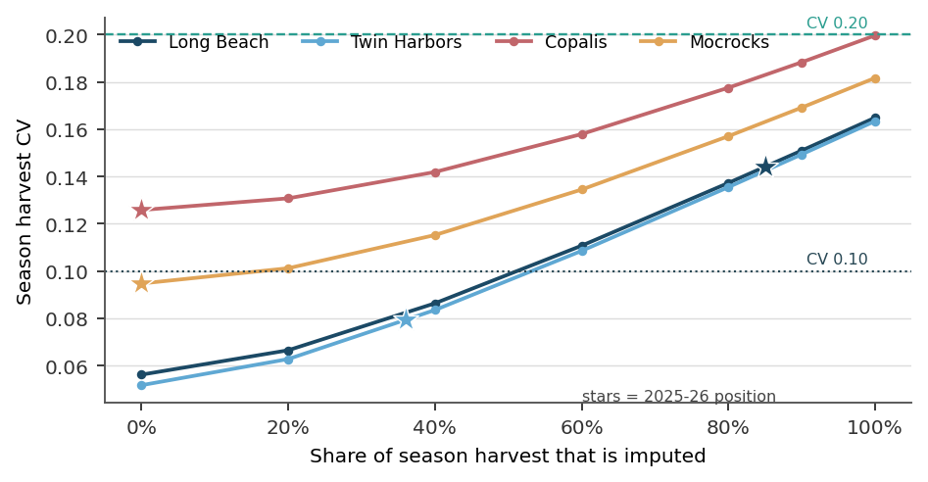
Figure 14. Season harvest coefficient of variation as a function of the share of season harvest that is imputed. Stars mark each beach's 2025-26 position: Long Beach 0.85, Twin Harbors 0.36, Copalis 0.00, Mocrocks 0.00. The intercept at zero imputation is the correction-factor floor. Long Beach and Twin Harbors, whose tables are well behaved, can tolerate a great deal of imputation before they reach a season CV of 0.20. Copalis cannot reach a season CV of 0.10 at any imputation rate, including zero.
Table 20. Maximum share of season harvest that may be imputed while still meeting each season-level CV target.
Beach | CV at or below 0.10 | CV at or below 0.15 | CV at or below 0.20 | CV at or below 0.30
Long Beach | 51% | 89% | 100% | 100%
Twin Harbors | 53% | 90% | 100% | 100%
Copalis | infeasible | 51% | 100% | 100%
Mocrocks | 17% | 74% | 100% | 100%
Current imputed share of season harvest, 2025-26: Long Beach 0.85, Twin Harbors 0.36, Copalis 0.00, Mocrocks 0.00. Every beach currently meets the 0.20 season target. Long Beach exceeds the share compatible with a 0.15 target only marginally, at 0.85 against a limit of 0.89.
This is the most useful result in the section, because it inverts the usual framing. The question is not how many days to count in the abstract; it is how much imputation each beach's expansion table can afford. A beach with a well-determined correction factor, like Twin Harbors, can be scaled off its neighbours for 90 percent of its season and still deliver a season harvest CV of 0.15. A beach with a poorly determined correction factor, like Copalis, cannot buy precision with crew days at all.

11.5 The crew-day arithmetic
Moving to a 45 percent sampling rate is not a request for more staff. A Long Beach full count is entered as two events, a four-segment walk and a three-segment walk, so it costs two crew-day units; every other beach-day costs one. Copalis and Mocrocks are currently counted on every open day, which is more than the design requires, while Long Beach is fully counted, meaning both segment groups walked, on only 9 of its 103 open days.
Table 21. Crew-day arithmetic for a 45 percent sampling rate, 2025-26 actuals.
Beach | Open days | Counted now | Percent now | Crew-day units now | Counted at 45% | Crew-day units at 45% | Series CV now | Series CV at 45%
Copalis | 51 | 51 | 100% | 51 | 23 | 23 | 0.129 | 0.192
Mocrocks | 52 | 52 | 100% | 52 | 23 | 23 | 0.099 | 0.171
Twin Harbors | 103 | 52 | 50% | 52 | 46 | 46 | 0.164 | 0.164
Long Beach | 103 | 9 | 9% | 48 | 46 | 92 | 0.294 | 0.175
TOTAL |  |  |  | 203 |  | 184
Net change: minus 19 crew-day units. The reallocation pays for itself. Long Beach at 45 percent assumes every counted day is a full seven-segment walk, which retires the half-beach section ratio and its 0.281 log-error standard deviation.
Long Beach's series coefficient of variation falls from 0.294 to 0.175, crossing the design target. Copalis and Mocrocks rise from 0.129 and 0.099 to 0.192 and 0.171, and both remain inside the target. Twin Harbors does not move. The coastwide effect is to convert nineteen surplus crew-day units on the two northern beaches into a Long Beach estimate that meets a published precision standard for the first time.

11.6 What this recommendation does not say
- It does not say that counting fewer days at Copalis and Mocrocks is free. Those two beaches are the donors for every cross-beach imputation. Reducing their coverage degrades the donor series, and the Monte Carlo does account for this through the imputation error, but it assumes the donor-to-target error structure measured on the historical record continues to hold. If Copalis is counted on half its days, the imputation rule will sometimes have to reach further back for a reference day, and error grows with lag (section 10.2).
- It does not include beach-count observer error. No beach has ever been counted twice on the same day by independent observers, so that term is absent from every coefficient of variation in this section. A paired-observer experiment on a handful of dig days would close it, and it is the cheapest unpurchased information in the program.
- It does not address wastage, the people-per-car fallback, or the diggers-per-lantern fallback.
- It assumes the correction-factor error measured on the 2012 and 2013 tables applies to the current tables (section 10.3). If the current tables rest on more surveys, the floors in Table 18 are too high and the sampling requirement is less demanding than stated.

12. Outstanding uncertainty and recommendations

12.1 Uncertainty that is not currently quantified
The published estimate is a point estimate. Five of the nine steps in section 10 now carry a variance and are propagated in the companion workbook, and a sixth is correctable rather than random. The rest do not. Ordered by how much of the estimate they carry:
- The beach count itself. Treated as exact. No beach has ever been counted twice on the same day by independent observers, so no estimate exists. It sits underneath every other term.
- People-per-car and diggers-per-lantern fallbacks. These substitute event ratios, or the 2.67 constant, whenever a count lacks a direct head count. The error is untracked.
- Wastage. A flat proportion from a subset of feasible surveys, absent on many night and low-effort tides.
- Table vintage and condition assignment. The bootstrap of section 10.3 measures between-survey error within one table. It does not measure the error of having chosen the wrong table, which section 6.3 shows can be a 33 percent effect at Long Beach.
Until these are closed, every interval in the companion workbook, and every coefficient of variation in section 11, should be read as a lower bound.

12.2 Open items on the correction-factor tables
- Document the derivation and effective date of each current form table, since the curves carry no provenance note, and confirm whether any separate condition-specific tables are still consulted alongside the single per-beach form table.
- Recover the egress surveys from roughly 2012 to 2021 so the post-2013 refinements at Long Beach, Copalis, and Mocrocks can be independently re-derived, validated, and dated.
- Move the form curves into a proper, versioned lookup table in the database, or an external controlled file, so they are queryable and auditable rather than embedded as form controls.
- Publish a per-bin count of contributing surveys alongside each pooled table, and adopt a single documented convention for the prior-to-start bin.
- Derive daylight expansion tables for Long Beach and Twin Harbors from the four daylight surveys that already exist at each, or document what is actually used on spring morning openers.
- Decide whether the Kalaloch series, which borrows the Mocrocks curve and has no census on most of its beach-days, should be documented as such or retired.

12.3 Open items on the data and method
- Add a per-count time field to the count table so replicate counts are distinguishable from duplicates and matchable to the correction-factor reference time.
- Resolve the recomputed CPUE values above the 15-clam bag limit in 2016-17, 2020-21, 2021-22 and 2022-23 before any harvest series is published from those seasons.
- Confirm the people-estimate precedence, that is, whether a recorded lantern count should ever outrank a recorded car count, and rename the people-per-car field in any new collection.
- Decide and document the policy for impossible values and out-of-range correction factors.
- Generate the in-season workbook from the database rather than maintaining it by hand, which removes an entire class of defect (Table 9) at a stroke.
- Resolve the dating conflict on the 30 percent and variable exploitation rates (section 6.4) against a definitive program source.
- Reconcile the companion products' disagreements on the coastwide bias-adjusted effort, on the CPUE-transfer error pool, and on the coverage shares for 2017-18, 2022-23 and 2023-24 (section 10.2).
- Restore the 4 to 14 May 2023 tide series to the 2022-23 workbook and re-derive that season's effort, harvest, wastage and percent of TAC. The database supplies 22 of the 33 open beach-days directly; the remaining 11, at Long Beach and Twin Harbors, must be imputed with the workbook's own rule.
- Rebuild the dig-day register, the coverage sheet, and the sampling-design Monte Carlo once 2017-18 and 2022-23 are complete. The register holds 50 rows for 2017-18, from 10 dig days, where the season has 27; and the Monte Carlo's 262 tide series omit both the 2017-18 season and the May 2023 series.
- Identify the source of the 2017-18 wastage figures, 109,381 clams, or record that the season's wastage is unsupported by any surviving workbook or database record.
- Re-examine the field records for four 2017-18 beach-days: Copalis on 2 November 2017 and 21 April 2018, where the printout and the database disagree on effort by 10.3 and 5.2 percent; and Long Beach on 31 December 2017 and Mocrocks on 21 April 2018, where they disagree on catch rate by 1.9 and 4.6 clams per digger trip.

12.4 Recommendations in priority order
Ordered by the ratio of what they buy to what they cost. The first two correct published numbers. The next four change the estimate. The rest change what can be said about it.
Table 22. Recommendations, in priority order.
# | Recommendation | What it buys | Cost
1 | Restore the 4 to 14 May 2023 tide series to the 2022-23 workbook and republish that season | Corrects a published season total that is understated by at least 61,959 digger trips, 26.1 percent of the figure now in the record | The database supplies 22 of the 33 open beach-days; 11 need imputing
2 | Adopt the 2017-18 FINAL printout as the season of record and rebuild the daily series from it | Restores the most completely sampled season in the series, 99.97 percent census-backed, to every coverage, imputation and sampling analysis that currently omits it | Transcription; the printout is in the repository and reconciles to the database
3 | Locate the current Long Beach, Copalis and Mocrocks expansion tables and recover the 2012 to 2021 egress surveys | The only lever on the dominant variance term. It is the sole route to a Copalis harvest CV below 0.126, and it would let the Long Beach vintage step be dated and audited | Archival search; no field work
4 | Run two or three egress surveys per beach, once, prioritising Copalis | Directly reduces the correction-factor bootstrap variance, which is 99 percent of Copalis effort variance and 96 percent of its harvest variance | Two to three crew-days per beach, once
5 | Replace the hand-typed CPUE on estimated beach-days with the donor beach's measured same-day CPUE | Replaces an unauditable number with a measured one whose error is known (sd of log ratio 0.448). Raises Long Beach harvest by 5.5 to 7.2 percent | Zero; a formula change
6 | Apply the imputation bias multipliers of Table 15 | Removes a known, measured, one-sided bias. Raises Long Beach season effort by about 9 percent | Zero; a lookup
7 | Reallocate counts to 45 percent of open days at every beach, with a floor of two per tide series, choosing the largest-effort days | Brings the Long Beach tide-series harvest CV from 0.294 to 0.175, meeting the design target for the first time | Minus 19 crew-day units. It pays for itself (Table 21)
8 | Walk all seven Long Beach segments on any counted Long Beach day | Retires the section-ratio imputation and its 0.281 log-error standard deviation | One extra crew-day unit per counted Long Beach day; already in the arithmetic of Table 21
9 | Run a paired-observer beach count on a handful of dig days | Closes the one term in the budget with no estimate at all. Until it is closed every interval is a lower bound | A few crew-days, once
10 | Add a count-time field, and generate the season workbook from the database | Removes the transcription defect class, including the two truncations found here, and makes the count window observable rather than inferred | Development time
11 | Publish a per-bin survey count with every expansion table and adopt one prior-to-start convention | Makes the thinnest evidence in the table visible, and makes future tables comparable | Zero
12 | Document or retire the Kalaloch series, and resolve the source of the 2017-18 wastage | Two series of numbers currently rest on no surviving record | Zero

13. References and companion documents
Primary sources
- Ayres, D.L. Re-estimate of State Razor Clam Harvest Totals. WDFW memorandum, Region Six / Coastal Shellfish, 29 August 2013 (with re-estimation workbook). Primary source for the 2013 correction and the corrected expansion equation.
- Schaefer, M.B. 1939. The Present Status of the Razor Clam Stocks in the State of Washington. Washington Department of Fisheries, Biological Report 37B. Primary historical source for the commercial fishery and the catch-per-man-tide abundance method, the conceptual precursor of CPUE.
- Cheng, Y.W. 2011. Review of the drafted report on Razor Clam Growth and Natural Mortality Models (second draft, September 2011). WDFW quantitative review. Primary source for the 25 percent, 30 percent, and variable exploitation-rate history, their derivation from natural- and fishing-mortality assumptions (Baranov equation; NPFMC Tier 5 and Tier 6), the 2006 to 2009 growth-constant re-estimate, and the spawning-biomass-scaled rebuilding framework.
- Berry-Powell, Z., et al. 2023. Pacific razor clam stock assessment by the pumped-area method. Journal of Shellfish Research 42(1):91-98. DOI 10.2983/035.042.0109. Companion population and TAC method.
- Cochran, W.G. 1977. Sampling Techniques, 3rd edition. Wiley. Chapter 10, two-stage sampling, is the appropriate reference for the variance of the pumped-area estimator and for any future two-stage treatment of the beach count.
- Fish and Wildlife Commission Policy C3009, Razor Clam Management.
- 2017 Fall - 2018 Spring Harvest.FINAL.pdf (WDFW, printed 17 July 2018). The complete 2017-18 season record, and the only surviving source for that season's daily effort, harvest, catch rate, wastage and percent of TAC. Basis of Table 5.
- WDFW razor clam sample and harvest schedules, by season. The MAY 04 sheet of the 2022-23 schedule establishes that 33 beach-days were open from 4 to 14 May 2023, that 21 were assigned a count, and that Long Beach and Twin Harbors were each open 11 days and counted 5. It is the evidence that the 2022-23 workbook omits a whole tide series.
Precision standards cited in section 11
- NOAA Fisheries. Recreational Fishing Survey and Data Standards, standards 7.2.2.1 and 7.2.2.2. MRIP warns that estimates with a percent standard error above 30 should be used with caution and does not support estimates above 50.
- NOAA Fisheries. Proceedings of the Workshop on Percent Standard Error (PSE) of Recreational Fishing Data. General agreement that data with a percent standard error at or below 40 provide valid input to stock assessment models.
- McCormick, J.L., and K.A. Meyer. 2017. Sample Size Estimation for On-Site Creel Surveys. North American Journal of Fisheries Management 37(5):970-980. DOI 10.1080/02755947.2017.1342723. Source for the correspondence between a relative 95 percent confidence interval of 40 percent and a coefficient of variation of 0.20.
- Lester, N.P., et al. 1991, in Guthrie, D., et al. (editors), Creel and Angler Surveys in Fisheries Management. American Fisheries Society Symposium 12. Cited by McCormick and Meyer (2017) as the source of the CV of 0.20 design convention. The companion sampling-design workbook attributes this to Bayley et al. (1991); that attribution could not be confirmed and should be corrected.
WDFW program documents
- WDFW. Washington Recreational Razor Clam Management Update (Region 6, Coastal Shellfish). Source for the 1999-2000 through 2024-25 seasonal series, the five-beach and 58-mile framing, Commission Policy C3009, the marine-toxin history, and the 2024-25 totals.
- Razor Clam Recreational Fishery Historical Season Information (bag limit, legal size, and season, 1929 to 2015); Seasonal Summary of Razor Clam Sport Digging on the Ocean Beaches, 1949 to 1995; Razor Clam Management History timeline (1929 to present); razor clam beach descriptions and location map; and the razor clam life-history sheet.
- WDFW historical seasonal recreational harvest and effort series (1949 to 2010), the coastwide source underlying Figures 1 and 2.
Companion data products (this project, 2026 review)
- RazorClam_HarvestDB_Extract_and_Pipeline: all 21 raw tables, the audited cleaning layer, the audit log, and the validated recompute script. Nothing in it requires Access.
- WDFW_RazorClam_HarvestDB_Recompute_and_Reconciliation.xlsx: validation against the stored tables, topline by season, coverage and imputation share, beach-day reconciliation, and eighteen issue verdicts.
- WDFW_RazorClam_DigDay_Register_2007_2026.xlsx: every dig day across 19 seasons, with tide series, monitoring status, donor links, reference days, verbatim estimation formulas, and reverse-matched correction-factor windows.
- WDFW_RazorClam_Sampled_Effort_2007_2026.xlsx: every beach-day in every Effort tab, classified sampled, partial, or estimated from the cell contents rather than the flag; with season reconciliation and fourteen numbered defects.
- 1993-2026_Ingress_Egress_Consolidated.xlsx: every located egress survey, in long form, with per-table provenance, four reconstructed surveys, and fifteen numbered defects. Source for Figure 8 and Tables 3, 4 and 11.
- RazorClam_CF_ExpansionTable_Lookup.xlsx: the four operational tables extracted from the harvest database form, the archived 2012 and 2013 condition tables, and the condition-selection rules. Source for Figures 5 and 9 and Tables 6 and 7.
- WDFW_RazorClam_Imputation_Error_2007_2026.xlsx: the leave-one-out validation of the imputation rule, multiplier pools, and season intervals from the imputation step. Source for Figure 11 and Tables 14 and 15.
- WDFW_RazorClam_Corrected_Estimates_and_Uncertainty.xlsx: bias-corrected effort and harvest, the survey bootstrap of every correction factor, the full variance decomposition, and the CPUE replacement day by day. Source for Figures 10 and 12 and Tables 13, 16 and 17.
- WDFW_RazorClam_Sampling_Design_Recommendation.xlsx: the Monte Carlo behind section 11. Source for Figures 13 and 14 and Tables 18 to 21.
- 02_data/harvest_inseason_records: the in-season workbook for every season from 2007-08, plus the 2017-18 FINAL printout. Section 6.2 and section 9 rest on these files directly.
- Companion working documents: harvest-database data dictionary; ingress/egress database data dictionary; effort-expansion protocol.
Compiled as a working reference. Equations validated against the harvest-database implementation; historical and table-version statements are drawn from the program documents and survey records cited above. Every figure and table is generated directly from the companion data products and is reproducible from them. Items marked open could not be confirmed from the records available at the time of writing.

