Modelling the growth of razor clam (Siliqua patula) in Washington State coast

Summary
We propose a method for fitting growth curves to capture and recapture data of razor clam (RC)(Siliqua patula) when the age at first capture is unknown. 75 and 97 RCs were capture and recapture from the Copalis and Long Beach in Washington State coast between year 2005 to 2007. The shell length and width of RCs were measured during capture and recapture(s). A comparison of linear and nonlinear relationship between shell length and width of RCs with Akaike information Criteria is performed. The von Bertalanffy growth curve is used to model the growth. To account for individual variability, the unknown age in square transformation of a RC at first recapture, and the individual growth coefficient of its shell length or width are modeled as random effects with a bivariate normal distribution. A comparison between this model and the Fabens growth equation is given. The proposed new model results with better statistical properties compared with Fabens model. It provides consistent, robust results for both shell length and width of capture and recapture(s) data. Moreover, the fitting of model is amenable to existing software. The proposed method is a flexible method and can be applied to fit different growth equations when the age at first capture is unknown.

Introduction
The tens of thousands of visitors who are drawn to Washington State’s coastal communities to recreationally harvest razor clams continue to leave a significant economic contribution in their wake. This economic contribution is especially important during the quiet fall, winter and early spring months. As a result of input received at annual razor clam public meetings, WDFW has attempted over the last several years to allow more harvest during the October through March period than in previous years. This change in season setting was an attempt to specifically improve the economic impact of this fishery and has been very successful. A recent example was a turnout of 21,000 diggers on the evening of November 23, 2007, (part of a 4-day post-Thanksgiving holiday opener.

The razor clam fishery in Washington is not only a significant source of revenue for tourism-dependent businesses such as restaurants and motels, but also an important source of community identity and basis for tribal subsistence. Razor clam harvesting, cleaning, cooking, eating, and canning have been an important focus of family relationships and local culture in Washington coastal communities for many generations.

Numerous parametric models have been used to model growth of crustacean with the von Bertalanffy growth curve (von Bertalanffy, 1938) being the method most commonly used. The growth of razor clam (Panulirus cygnus) is modelled in this paper using the von Bertalanffy growth curve, which has the form:

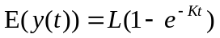, (1)
where y(t) is the shell length of RC at age t, L is the asymptotic size and K is the growth coefficient or constant. The advantage of the model is that it is simple with only two unknown parameters.

For most crustaceans such as clam, lobster, pearl oyster and abalone, it is difficult to estimate the age. There are two well-known methods for constructing growth curves where length data are available, but where those length data are of unknown age. These are the Walford plot (Walford, 1946) and the Fabens method (Fabens, 1965). Cruywagen (1997) used a generalized linear modeling approach (McCullagh and Nelder, 1989) to examine inter-annual differences in the growth increments of Jasus lalandii. He extended the Walford plot method to study inter-annual variation. However his model was only capable of handling observations that are equally spaced in time. The Fabens growth equation is

, (2)

where is the first recapture time and is the first capture time. This method is easy to model and has only two unknown parameters, but suffers from several disadvantages. Firstly, it ignores the individual variability in the growth curves and does not make efficient use of multiple measurements of individuals. Secondly, it is restricted to von Bertalanffy curves and its asymptotic behaviour is inconsistent (Maller and de Boer, 1988). Finally, James (1991) used estimating function techniques to produce an unbiased estimate of and  under the assumption that does not vary between animals. Lastly, the estimated standard errors for the two unknown growth parameters might be bias because the estimated standard errors of two unknown parameters from equation (1) might not be the equivalent to results from equation (2).

Methods
Beginning in February 2006, clams were planted along a total of four transects. Two transects were located in the Copalis Razor Clam Reserve, and two others in the Long Beach razor clam reserve. Clam were planted on each side of each transect (north and south). Each side of each transect was re-sampled every six-months (as weather and surf conditions allowed). This sampling was staggered so that one side was sampled and then three months later the other side was sampled.

A series of permanent steel posts were placed in a line perpendicular to the surf. These were used to re-locate the exact position of each transect.

Sampling was conducted using the WDFW standard razor clam sampling technique, the “pumped area method.” This involves using water pumped from the surf to liquidly the sand allowing the clams that are present to float to the surface and be sampled. At 50-foot intervals or elevations, starting at the top of the clam beds to the edge of the surf and perpendicular along each transect clams were sampled in six plots (each ½ square/meter in area). All razor clams were removed as they came to the surface. Each clam was measured for both length and width. Also recorded was the exact location the clam was taken from. This included transect, side (north or south), elevation (50, 100, 150, etc) and plot (1,2,3,4,5,6). The date was also recorded. The clams were then tagged. Of all clams over approximately 75 mm in length, 1/3 (every third clam encountered) were marked by attaching a PIT (passive integrate transponder) tag to the exterior of the shell. Of all clams over approximately 75 mm in length, approximately 2/3’s were marked by etching a unique identifier on the shell. Of all clams under approximately 75 mm in length, 100% were marked by attaching a PIT tag to the exterior of the shell. If possible, each PIT tagged clams were also etched with a light ‘T’ to assess rate of tag loss.

The PIT tag was attached using cyanoacrylate (CA) glue and an accelerator to speed the drying time. Etching will be accomplished using a battery operated Dremel ® drill with an etching disk attached.

Each plot was then “hardened’ by adding sand to the liquefied area using a standard garden shovel. The tagged clams were then replanted in the exact plot from which they were taken. Care was taken to position each clam correctly to assure their survival. Additional sand was then added over the top of each plot.

Data (Henry…do you want to add the additional data we’ve since collected??? We just finsished another round of field work last week (1.21.08) at Copalis and will have these new data to you very soon…Dan)
In Copalis, 75 RCs were recaptured and 9 of them were recaptured twice. In Long Beach, 97 RCs were recaptured and 8 of them were recaptured twice. The minimum duration between capture and recapture was 130 days and 142 days for Copalis and Long Beach.
The maximum duration between capture and recapture was 1.5 years for them. The minimum, mean and maximum shell length sizes of Copalis RC first capture were 31.0 mm, 93.67 mm, and 137.2 mm. The minimum, mean and maximum shell length sizes of Long Beach RC first capture were 39.0 mm, 105.10 mm, and 131.0 mm.

Shell length and width relationship
We assumed RC is with zero shell width when it is with zero shell length. The commonly used shell length (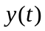) and width (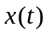) linear relationship is
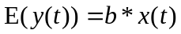, where was unknown to be determined.
In some cases, the linear relationship did not fit well when the RC was small. We proposed to fit the shell length and width relationship with nonlinear equation,
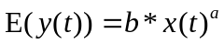, where and were unknown to be determined. We compared the fitted results by two above equations. Due to the difference in the number of unknown parameters to be estimated, we compared the fit of two equations by the estimated residual sum of squares and the Akaike Information Criteria (Akaike, 1974).

Proposed model
Let denote the unknown age of the 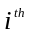 RC at first capture and be the time between the first recapture and the 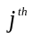capture. It follows that the age of the RC at the capture is 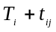. Upon substitution into the von Bertalanffy growth curve, we obtain the following model
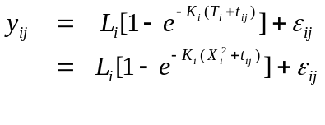, (3)
where 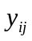is the shell or width length of RC at the 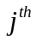capture, 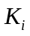 is the growth coefficient and 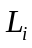 is the asymptotic size of RC . 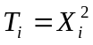 restricts 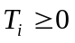. The estimated mean first capture age is 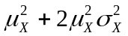, where 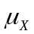 and 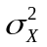are mean and variance of . We model (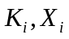) as a bivariate normal distribution with mean vector (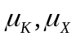) and variance-covariance matrix . By doing so, we allow the age 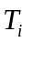 at the first capture to be correlated with the animal specific growth parameters . The error vectors 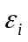 are assumed to be distributed as 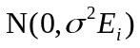. The choice 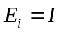, where is the identity matrix, corresponds to the case of no serial correlation. For comparison purpose, we also computed the estimates using Fabens equation.

Results
The estimated linear and nonlinear relationship between shell length and width of RC is listed Table 1. The Copalis and Long Beach results are similar in both linear and nonlinear fits. Their 95% confidence intervals (CIs) are overlapped each other. From residual sum of squares, AIC and observed fitted curve or line with observed data (Figures 1 and 2), the nonlinear relationship fit out-performs the linear relationship fit. The fitted lines underestimated the shell length when the width is small. The fitted curves fits well for all width measurements of RC in both Copalis and Long Beach.
From the nonlinear fit results, the estimated ratio of shell length and width decreased with width increase. This implied the rate of RC width grew faster than the rate of RC shell length with larger RC.
In Table 2, the results of the estimated asymptotic shell length of RC by Fabens, and Cheng and Kuk (2002, 2003) were listed with the estimated correlation (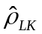) between and for both shell length and width in Copalis and Long Beach. It is well known that these two estimated parameters are highly negative correlated in von Bertalanffy growth equation construction. Its absolute value affects the speed and chance of success of convergence in nonlinear optimization. In addition, it affects precision of inference estimation in these parameters. The estimated s of new proposed model were with a lower absolute value compared the estimated s of Fabens model in all location and all measurements. This implies that the new proposed model has a better statistical properties than the Fabens model. In Copalis, the estimated asymptotic shell length and width, by Fabens model, were 2.1% and 2.6% less than the estimated shell length and width, by new proposed model.
The estimated standard errors of fixed effects
We can not observe any over or under trend of estimated standard errors of and 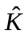
At present, there is no legal size limit for Washington State recreational RC fishery. The bag limit is 15 RCs and the anglers should keep first RCs regarding the sizes. From Table 4, Figures 2 and 3, it can be seen that there are high negative correlations, -0.94 to –0.96 between the growth coefficient, and of the shell length of RCs in both Copalis and Long Beach. This implies faster growing RCs tend to be caught at a younger age. This is very useful information for RC management because some of harvested RCs might be less than 1 year old.

Discussion
We propose an alternative model to Fabens model to estimate the expected asymptotic size and expected growth coefficient of RC when the initial first capture age is unknown. The proposed model is parsimonious and allows for unknown initial age and individual variability in the growth curves. This is an advantage as knowledge of variation in individual growth is very important in developing realistic models of growth in RC for harvesting strategies in fisheries. This model can apply to other crustaceans, eg. abalone, red sea urchin, lobster,…,etc, where direct aging is impossible.
Palmer et al. (1991) used simulated data of a mark-recapture experiment on rock (spiny) lobster (Panulirus cygnus) in Mexico to show the effectiveness of mixed effects model in estimating the population’s growth curve and variability in individual growth. They considered growth curves with random animal specific coefficients. The unknown initial age of a captured animal was also regarded as random and its distribution was approximated by a mixture of uniform distributions over 20 time intervals. Independence between the coefficients and the initial age of an animal was assumed, which might be unreasonable as animals with faster growth are likely to be caught earlier. Estimation is by means of the expectation and maximization (EM) algorithm (Dempster et al., 1977) but at present, there is no software available for fitting the model. Instead of finite mixtures, Cheng and Kuk (2002, 2003) assume the distribution of the unknown initial age to be log normal. Specifically, the unknown age at first capture, the asymptotic size and the growth coefficient of carapace length are modeled as random effects (Laird and Wares, 1982) with a trivariate normal distribution. The error structure within all the consecutive captures of each lobster are assumed to be first order autoregressive process AR(1) with unequally spaced time points. Most of lobsters were female with twice or more multiple recapture observations that allowed the estimation of trivariate random effects and the autoregressive errors within each lobster. Our RC data were limited to estimate bivariate random effects because most of data were limited to one single recapture. We chose to model () bivariate random effects instead of (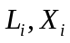) because the estimated coefficient of variation (CV) of was smaller than the CV of . In addition, we wanted to investigate the growth change or growth rate and the unknown age of first capture for individual RC.

In addition to the von Bertalanffy curve, there are other common growth curves such as logistic and Gompertz (Moreau, 1987). These curves can also be used with the method discussed in this paper so as to deal with the unknown age problem, whilst they cannot be with Fabens method.

 | Models |  |  | Sum of squares | AIC
Copalis (n=159) | Linear | 2.51 (0.01) |  | 4734.00 | 541.59
Copalis (n=159) | Nonlinear | 4.49(0.21) | 0.85 (0.01) | 2417.77 | 436.75
Long Beach (n=202) | Linear | 2.49 (0.01) |  | 5347.79 | 663.79
Long Beach (n=202) | Nonlinear | 4.93(0.30) | 0.82 (0.02) | 3350.88 | 571.36

Location | Models | (mm) |  | 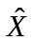(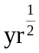) | 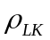
Copalis | Faben | 140.16 (2.43) | 1.14 (0.08) |  | -0.82
Copalis | Cheng and Kuk (2002) | 143.17 (1.78) | 1.00 (0.06) | 1.01 (0.05) | -0.69
Long Beach | Faben | 138.52 (1.96) | 1.16 (0.09) |  | -0.85
Long Beach | Cheng and Kuk (2002) | 141.67 (1.00) | 0.98 (0.04) | 1.16 (0.04) | 0.66
Table : Shell length

Location | Models | (mm) |  | ()
Copalis | Faben | 59.22 (1.49) | 0.97 (0.09) |  | -0.85
Copalis | Cheng and Kuk (2002) | 60.77 (1.54) | 0.89 (0.09) | 1.02 (0.06) | -0.80
Long Beach | Faben | 58.42 (1.03) | 0.98 (0.08) |  | -0.88
Long Beach | Cheng and Kuk (2002) | 57.52 (0.88) | 0.90 (0.08) | 1.23 (0.06) | -0.80
Table : Width length

Location | Measurement (mm)
 | Shell length | Width
Copalis | 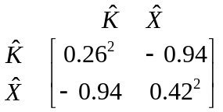 | 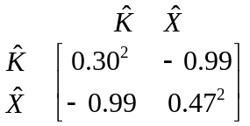
Long Beach | 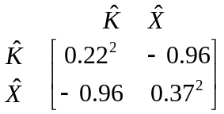 | 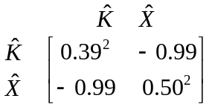
Table : A summary of the estimated the correlation matrix of random effects with different measurements
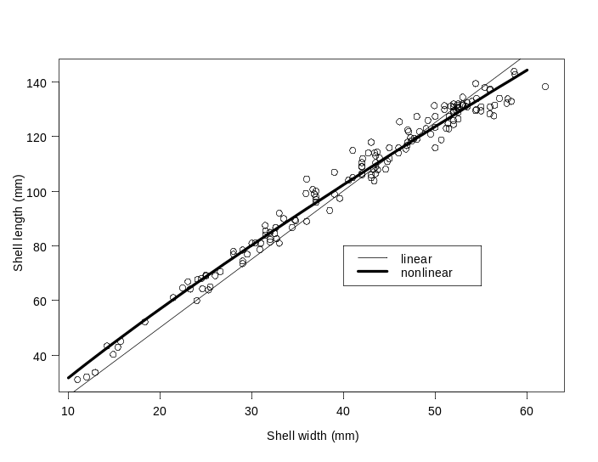
copalis
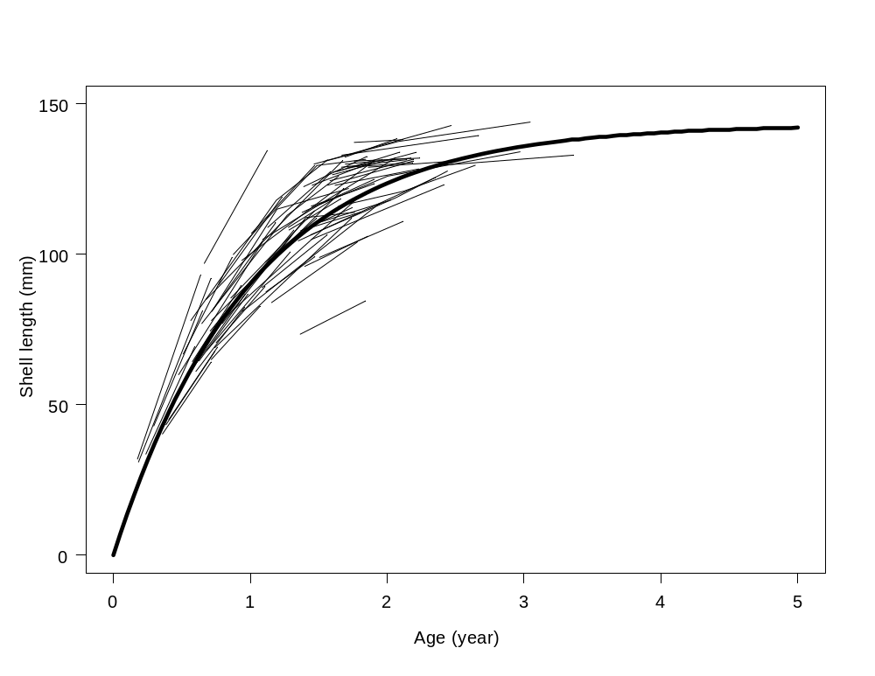
Figure 1: Figure 1: Plot of the expected growth curve of razor clam from Copalis beach, Washington State. Lines and polygons are individual razor clam longitudinal observations with the unknown age of first capture estimated from mixed effects model.

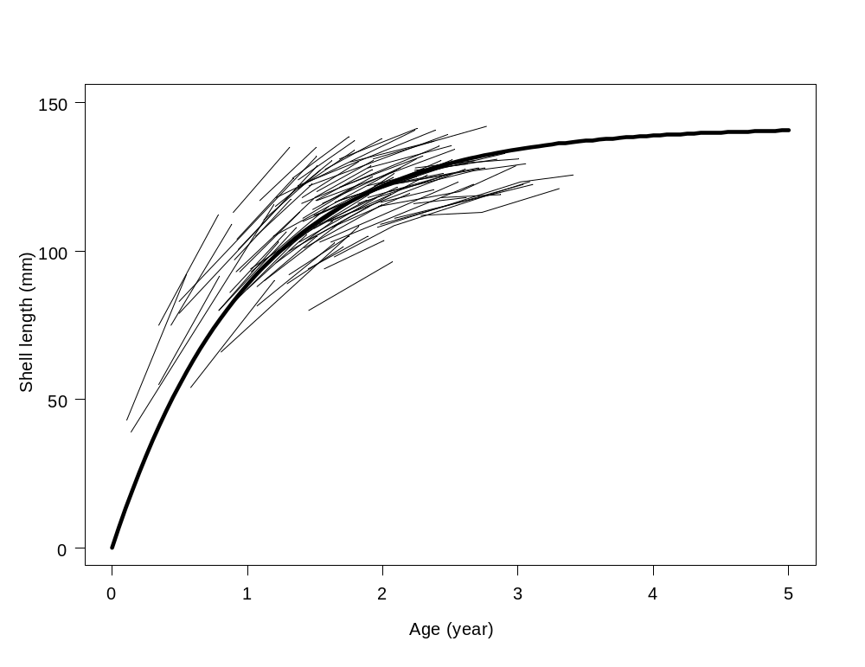
Figure 2: Plot of the expected growth curve of razor clam from Long Beach, Washington State. Lines and polygons are individual razor clam longitudinal observations with the unknown age of first capture estimated from mixed effects model.

