Matt Gmitro (scribe) 12:30p-2:00p

Josh Levine (scribe) 11:00a-12:30p

Daniel Martin (scribe) 11:00a-12:30p

**Project 1**

**1.1. What was it that prompted Brian Nosek to undertake the project described in the podcast?**

An academic psychology paper with evidence showing that ESP is real prompted Nosek to look into how scientific studies are conducted. The paper led to controversy as to whether scientific evidence was correct or not.

**1.2. What did the project designed by Brian Nosek consist of?**

Nosek set out to repeat a large number of studies.

**1.3. What is the (at least one) reason that scientists do not habitually repeat studies?**

It would take too much time and too many resources to habitually repeat studies. Additionally, it does not motivate graduate students because they wouldn’t get jobs or be able to publish unique studies.

**1.4. How many experiments did the volunteer scientists “do over”?**

He chose to repeat 100 experiments.

**1.5. What was the source of the chosen experiments? Were they obscure within the field?**

They were taken from 3 of the top psychology journals, so they were not obscure within the field.

**1.6. What is the “afternoon-treat hypothesis”?**

A sugar boost makes people engage in more effortful decision making.

**1.7. Did the project originator Brian Nosek keep constant track of how many of the experiments were successfully replicated? Or did he wait until the entire experiment experiment was completed?**

He did not keep track of the experiments during the project. He waited until there were 100 studies finished.

**1.8. How many original conclusions were confirmed?**

The result was 39 confirmations and 61 non-confirmations.

**1.9. Is the conclusion that the scientists are faking their data?**

No the conclusion is not about fraud. It is about how experiments are conducted.

**1.10. What experiment did the journalist conduct the morning of taping the podcast? What were the results?**

The journalist flipped a coin 10 times. The results were 9 heads, 1 tails.

**1.11. What is the file-drawer effect? What is its consequence in the field of psychology?**

Journals are more likely to publish positive results than negative results. 97% of results in psychology are positive. They put their negative findings “in their file drawer” because they're boring.

**1.12. Does the file-drawer effect completely explain the 39/100 ratio?**

Not completely, though it may have some partial effect on the ratio.

**1.13. Which example of a common mistake does Dr. Lindsey describe?**

A common mistake is performing extra tests because performing more tests increases the likelihood of chance affecting the study. The practitioner can test until they reach the desired conclusion and then stop.

**1.14. Which other disciplines are now trying to do the experiment experiment?**

Economics, ecology, and cancer biology are all fields trying to do the experiment experiment.

**1.15. What remedy does Brian Nosek propose?**

Before you do the study, write down how you're going to do it, how you're going to analyze your data, and what you expect to learn. Then you submit what you’ve written to an online registry and put your results in the registry.

**1.16. Is this idea already being implemented in a certain research field? Has this changed the frequency of positive results?**

Yes, in drug research. It has decreased the frequency of positive results. For one heart drug, the positive results went from 50% to 8%.

**1.17. Should we lose faith in scientific results?**

No but researchers need to understand the file-drawer effect and document their procedures so that they are accountable for their results. Some scientific studies are based on actually happening things or theoretical events, such as the Higgs-Boson example given in the podcast.

**1.2. Design and execute a simple experiment:**

We are going to flip a coin 10 times and analyze the proportion of heads to tails. We expect to learn the fairness of the coin. We hypothesize the coin will be fair, defined as an equal number of heads and tails flipped.

Results (T = Tails, H = Heads): T T T T T T T H T H

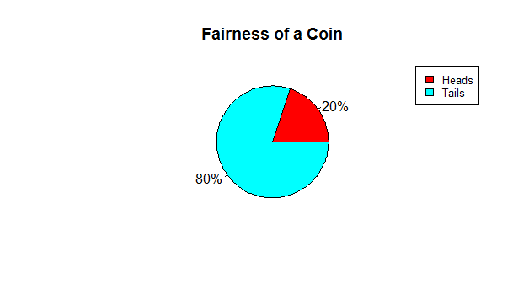

This implies the coin to be unfairly biased towards tails since 80% of trials came up tails. Therefore, the hypothesis was proven to be untrue. However, similar studies should be done to confirm this conclusion.

We are tempted to increase the number of tosses. We could keep going until we had an equal fairness and then stop, but this would fall to the bias Dr. Lindsey described in the podcast. Thus, we would need to keep tossing an arbitrarily large number of times to make a suitable difference in the study.