DA410_Project1_MattGraham
This is our first project, analyzing air pollution, mortality rates, and relevant parameters.

Getting imports for analysis
library(nnspat) # used for dist2full()
library("dplyr") # used to select numeric datatypes
library("ggplot2")
library(reshape) # used for melting matricies
airpol.full <- read.table("C:/mattgraham93.github.io/school/22_3_DA410/data/airpoll.txt", header=TRUE)
city.names <- as.character(airpol.full[1:16,1])
airpol.data.sub <- airpol.full[1:16,2:8]
airpol.data.sub
## Rainfall Education Popden Nonwhite NOX SO2 Mortality
## 1 36 11.4 3243 8.8 15 59 921.9
## 2 35 11.0 4281 3.5 10 39 997.9
## 3 44 9.8 4260 0.8 6 33 962.4
## 4 47 11.1 3125 27.1 8 24 982.3
## 5 43 9.6 6441 24.4 38 206 1071.0
## 6 53 10.2 3325 38.5 32 72 1030.0
## 7 43 12.1 4679 3.5 32 62 934.7
## 8 45 10.6 2140 5.3 4 4 899.5
## 9 36 10.5 6582 8.1 12 37 1002.0
## 10 36 10.7 4213 6.7 7 20 912.3
## 11 52 9.6 2302 22.2 8 27 1018.0
## 12 33 10.9 6122 16.3 63 278 1025.0
## 13 40 10.2 4101 13.0 26 146 970.5
## 14 35 11.1 3042 14.7 21 64 986.0
## 15 37 11.9 4259 13.1 9 15 958.8
## 16 35 11.8 1441 14.8 1 1 860.1

1 - Calculating covariance and correlation
Identify which pairs of variables seem to be strongly associated, and describe the nature (strength and direction) of the relationship between these variable pairs.

Covariance
my.S <- round(var(airpol.data.sub), digits=2)
melted.my.S <- melt(my.S)
ggplot(data = melted.my.S, aes(x=X1, y=X2, fill=value)) +
geom_tile() +
geom_text(aes(label = round(value, 1)))
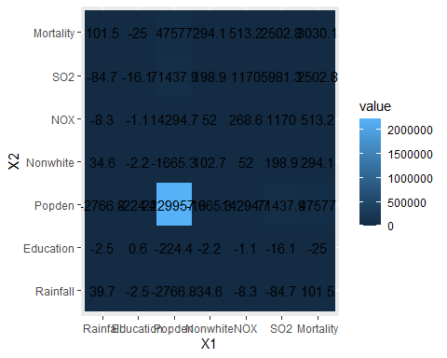

Correlation
my.R <- round(cor(airpol.data.sub), digits=2)
melted.my.R <- melt(my.R)
ggplot(data = melted.my.R, aes(x=X1, y=X2, fill=value)) +
geom_tile() +
geom_text(aes(label = round(value, 1)))
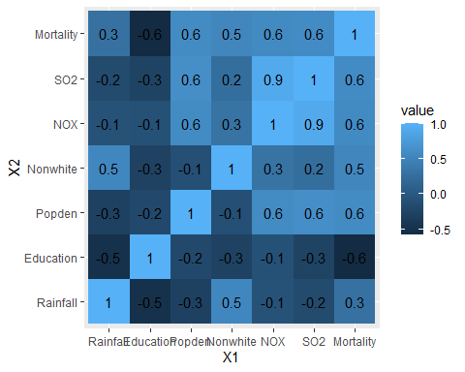

Covariance vs. Correlation
as.data.frame(cov2cor(my.S))
## Rainfall Education Popden Nonwhite NOX SO2
## Rainfall 1.0000000 -0.49976469 -0.2939816 0.5419172 -0.08035640 -0.1737525
## Education -0.4997647 1.00000000 -0.1924363 -0.2842847 -0.08906087 -0.2663758
## Popden -0.2939816 -0.19243630 1.0000000 -0.1100481 0.58408307 0.6185629
## Nonwhite 0.5419172 -0.28428472 -0.1100481 1.0000000 0.31286146 0.2537516
## NOX -0.0803564 -0.08906087 0.5840831 0.3128615 1.00000000 0.9230345
## SO2 -0.1737525 -0.26637581 0.6185629 0.2537516 0.92303455 1.0000000
## Mortality 0.2925457 -0.58057023 0.5787939 0.5271655 0.56885330 0.5879137
## Mortality
## Rainfall 0.2925457
## Education -0.5805702
## Popden 0.5787939
## Nonwhite 0.5271655
## NOX 0.5688533
## SO2 0.5879137
## Mortality 1.0000000
melted.my.cor2cov <- melt(cov2cor(my.S))
ggplot(data = melted.my.cor2cov, aes(x=X1, y=X2, fill=value)) +
geom_tile() +
geom_text(aes(label = round(value, 1)))
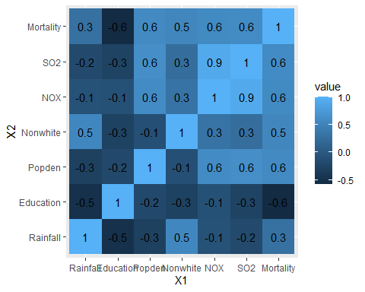

Covariance/correlation analysis
Looking at our correlation plots, a few things really stood out to me. The first being the negative correlation between education and rainfall. There is also a strong positive correlation between NOX and SO2. It would make sense for pollutanats to be holistically more present in places with more pollution versus those without.
We can also see the positive correlation between NOX and SO2 has on mortality rates! Theo only negative correlation is education, which is quite interesting.

2 - Calculating weighted distance
Describe some of the most similar pairs of cities and some of the most different pairs of cities, giving evidence from the distance matrix.
std <- sapply(airpol.data.sub, sd) # finding standard deviations of variables
airpol.data.std <- sweep(airpol.data.sub,2,std,FUN="/") # dividing each variable by its standard deviation
dis <- dist(airpol.data.std)
dis.matrix<-dist2full(dis)
rownames(dis.matrix) <- city.names
colnames(dis.matrix) <- city.names
my.melted.dist <- melt(round(dis.matrix,digits=2))
ggplot(data = my.melted.dist, aes(x=X1, y=X2, fill=value)) +
geom_tile() +
geom_text(aes(label = round(value, 1)))
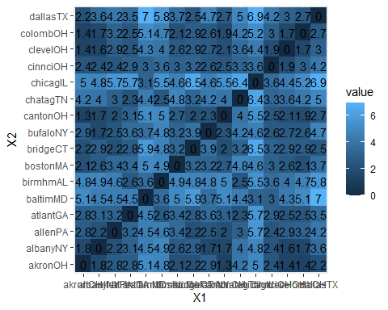

Distance analysis
We can see that some of the biggest differences are stemming from Chicago, IL. It differs most from other metro areas like Atlanta, GA and even Dallas, TX!
Some of the most similar are among the cities in Ohio - Akron, Canton, Cleveland, and Columbus.

3 - Determining multivariate normality
What is your conclusion based on the plot?
#Copy the chisplot function into R
chisplot <- function(x) {
if (!is.matrix(x)) stop("x is not a matrix")
### determine dimensions
n <- nrow(x)
p <- ncol(x)
xbar <- apply(x, 2, mean)
S <- var(x)
S <- solve(S)
index <- (1:n)/(n+1)
xcent <- t(t(x) - xbar)
di <- apply(xcent, 1, function(x,S) x %*% S %*% x,S)
quant <- qchisq(index,p)
plot(quant, sort(di), ylab = "Ordered distances",
xlab = "Chi-square quantile", lwd=2,pch=1)
}
# Note: You must check if airpol.full has non-numerical columns or not. Use only numerical columns for plot!
chisplot(as.matrix(select_if(airpol.full, is.numeric)))
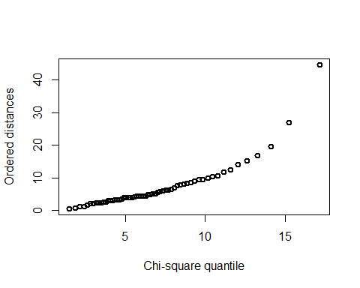

Normality analysis
Given the quantile plot above, we can see an exponentially increase in distance from our mean expected value. This implies that mortality is not normal across the United States in cities that were measured!

