DA410_Exam2_MattGraham
library(nnspat) # used for dist2full()
library("dplyr") # used to select numeric datatypes
library("ggplot2")
library(reshape) # used for melting matricies
library(klaR)
library(ggvis)
library(class)
library(gmodels)
library(MASS)
library(readxl)
library(psych)
library(corrplot)
## Warning: package 'corrplot' was built under R version 4.2.2
library(lavaan)
## Warning: package 'lavaan' was built under R version 4.2.2
library(semPlot)
## Warning: package 'semPlot' was built under R version 4.2.2
library(semTable)
## Warning: package 'semTable' was built under R version 4.2.2
library(kutils)
## Warning: package 'kutils' was built under R version 4.2.2

Problem 1
Get data
cov.mat <- data.frame(c(5, 0, 0), c(0, 9,0), c(0,0,9))
cov.mat
## c.5..0..0. c.0..9..0. c.0..0..9.
## 1 5 0 0
## 2 0 9 0
## 3 0 0 9

A) Find eigenvalues and vectors
cov.mat.vals <- eigen(cov.mat)$values
cov.mat.vals
## [1] 9 9 5
cov.mat.vects <- eigen(cov.mat)$vectors
cov.mat.vects
## [,1] [,2] [,3]
## [1,] 0 0 1
## [2,] 0 1 0
## [3,] 1 0 0

B) Find variance explained
for (r in cov.mat.vals) {
print(r/sum(cov.mat.vals))
}
## [1] 0.3913043
## [1] 0.3913043
## [1] 0.2173913
We can see that of our eigen values, ~80% of our variance is explained with 2 dimensions, while ~20% is explained with 1 dimension. This can be seen below.

Plot
plot(cov.mat.vals/sum(cov.mat.vals), xlab = 'Number of components', ylab='Eigen size', main='Plot of dimension variance')
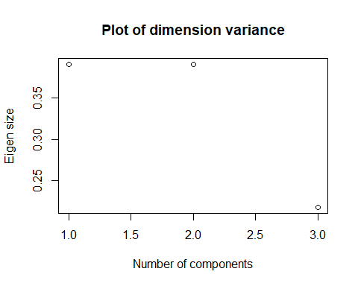
###C) Decision Ultimately, we will want to select 2 components in our analysis.

Problem 2
Assumption check:
Variables used should be metric. Dummy variables can also be considered, but only in special cases. -> check
Sample size: Sample size should be more than 200. -> check
Homogeneous sample: A sample should be homogenous. Violation of this assumption increases the sample size as the number of variables increases. Reliability analysis is conducted to check the homogeneity between variables.
Correlation: At least 0.30 correlations are required between the research variables.
french <- c(1, .44, .41, .29, .33, .25)
english <- c(.44, 1, .35, .35, .32, .33)
history <- c(.41, .35, 1, .16, .19, .18)
arithmetic <- c(.29, .35, .16, 1, .59, .47)
algebra <- c(.33, .32, .19, .59, 1, .46)
geometry <- c(.25, .33, .18, .47, .46, 1)
subject.cor <- cbind(french, english, history, arithmetic, algebra, geometry)
row.names(subject.cor) <- c('french', 'english', 'history', 'arithmetic', 'algebra', 'geometry')
as.data.frame(subject.cor)
## french english history arithmetic algebra geometry
## french 1.00 0.44 0.41 0.29 0.33 0.25
## english 0.44 1.00 0.35 0.35 0.32 0.33
## history 0.41 0.35 1.00 0.16 0.19 0.18
## arithmetic 0.29 0.35 0.16 1.00 0.59 0.47
## algebra 0.33 0.32 0.19 0.59 1.00 0.46
## geometry 0.25 0.33 0.18 0.47 0.46 1.00
We have a few correlations that are unable to be compared, and will be noted through analysis
Since we do not have a raw dataset, we assume there are no outliers.

Running fa
solution <- fa(r = subject.cor, nfactors = 2, rotate = "oblimin", fm="pa")
## Loading required namespace: GPArotation
## Warning in fac(r = r, nfactors = nfactors, n.obs = n.obs, rotate = rotate, : I
## am sorry, to do these rotations requires the GPArotation package to be installed
solution
## Factor Analysis using method = pa
## Call: fa(r = subject.cor, nfactors = 2, rotate = "oblimin", fm = "pa")
## Standardized loadings (pattern matrix) based upon correlation matrix
## PA1 PA2 h2 u2 com
## french 0.59 0.37 0.49 0.51 1.7
## english 0.59 0.23 0.41 0.59 1.3
## history 0.43 0.41 0.36 0.64 2.0
## arithmetic 0.71 -0.34 0.62 0.38 1.4
## algebra 0.70 -0.27 0.56 0.44 1.3
## geometry 0.58 -0.18 0.38 0.62 1.2
##
## PA1 PA2
## SS loadings 2.22 0.59
## Proportion Var 0.37 0.10
## Cumulative Var 0.37 0.47
## Proportion Explained 0.79 0.21
## Cumulative Proportion 0.79 1.00
##
## Mean item complexity = 1.5
## Test of the hypothesis that 2 factors are sufficient.
##
## The degrees of freedom for the null model are 15 and the objective function was 1.43
## The degrees of freedom for the model are 4 and the objective function was 0.01
##
## The root mean square of the residuals (RMSR) is 0.01
## The df corrected root mean square of the residuals is 0.03
##
## Fit based upon off diagonal values = 1
## Measures of factor score adequacy
## PA1 PA2
## Correlation of (regression) scores with factors 0.90 0.73
## Multiple R square of scores with factors 0.82 0.53
## Minimum correlation of possible factor scores 0.63 0.06
Overall, our model does a great job explaining ~90% of variation when using 2 factors. Our most-ideal values to model from would be arithmetic and algebra. We can also see in our console output that hypothesis tests with 2 factors are sufficient. Neither of these have correlations below .30.

Problem 3
Get data
food.stuff <- read.table("C:/mattgraham93.github.io/school/22_3_DA410/data/foodstuff.dat", header=TRUE)
food.stuff <- food.stuff[-1]
food.stuff
## Energy Protein Fat Calcium Iron
## 1 340 20 28 9 2.6
## 2 245 21 17 9 2.7
## 3 420 15 39 7 2.0
## 4 375 19 32 9 2.5
## 5 180 22 10 17 3.7
## 6 115 20 3 8 1.4
## 7 170 25 7 12 1.5
## 8 160 26 5 14 5.9
## 9 265 20 20 9 2.6
## 10 300 18 25 9 2.3
## 11 340 20 28 9 2.5
## 12 340 19 29 9 2.5
## 13 355 19 30 9 2.4
## 14 205 18 14 7 2.5
## 15 185 23 9 9 2.7
## 16 135 22 4 25 0.6
## 17 70 11 1 82 6.0
## 18 45 7 1 74 5.4
## 19 90 14 2 38 0.8
## 20 135 16 5 15 0.5
## 21 200 19 13 5 1.0
## 22 155 16 9 157 1.8
## 23 195 16 11 14 1.3
## 24 120 17 5 159 0.7
## 25 180 22 9 367 2.5
## 26 170 25 7 7 1.2
## 27 110 23 1 98 2.6

a. Determine factors to use
library(factoextra)
## Warning: package 'factoextra' was built under R version 4.2.2
## Welcome! Want to learn more? See two factoextra-related books at https://goo.gl/ve3WBa
food.stuff.pca <- prcomp(food.stuff)
fviz_eig(food.stuff.pca)
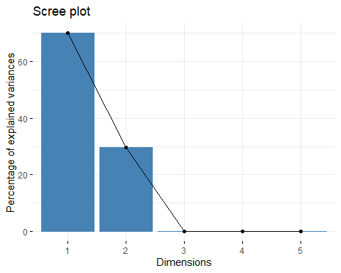
We will ultimately use 2 dimensions when concluding our analysis.

B - obtaining loadings
S <- cov(food.stuff)
R <- cor(food.stuff)
S
as.data.frame(S)
## Energy Protein Fat Calcium Iron
## Energy 10243.01994 74.807692 1124.5655271 -2530.292023 -14.7521368
## Protein 74.80769 18.076923 1.1923077 -28.230769 -1.0846154
## Fat 1124.56553 1.192308 126.7207977 -270.673789 -0.9965812
## Calcium -2530.29202 -28.230769 -270.6737892 6089.344729 5.0491453
## Iron -14.75214 -1.084615 -0.9965812 5.049145 2.1341026
R
as.data.frame(R)
## Energy Protein Fat Calcium Iron
## Energy 1.00000000 0.17384812 0.98706740 -0.32038440 -0.09977765
## Protein 0.17384812 1.00000000 0.02491163 -0.08508934 -0.17462478
## Fat 0.98706740 0.02491163 1.00000000 -0.30813212 -0.06060118
## Calcium -0.32038440 -0.08508934 -0.30813212 1.00000000 0.04429196
## Iron -0.09977765 -0.17462478 -0.06060118 0.04429196 1.00000000
Get eigenvalues and eigenvectors of S and R
eig.S <- eigen(S)
eig.R <- eigen(R)
Eigen S
eig.S
## eigen() decomposition
## $values
## [1] 1.155253e+04 4.903923e+03 2.042503e+01 2.066907e+00 3.516836e-01
##
## $vectors
## [,1] [,2] [,3] [,4] [,5]
## [1,] 0.901061141 0.4195897978 -0.034918237 -0.0089992248 0.1035999595
## [2,] 0.006887716 0.0011983568 -0.924379029 0.1023111641 -0.3674329322
## [3,] 0.098689332 0.0474125325 0.374781853 0.0877224332 -0.9164364709
## [4,] -0.422255831 0.9064738840 -0.002194532 -0.0001874493 0.0005097596
## [5,] -0.001344580 -0.0003389534 0.061950579 0.9908361011 0.1200167645
Eigen R
eig.R
## eigen() decomposition
## $values
## [1] 2.197777619 1.144204758 0.848574671 0.807842783 0.001600169
##
## $vectors
## [,1] [,2] [,3] [,4] [,5]
## [1,] -0.6539155 0.08725829 -0.1490040 0.1985936 0.709322816
## [2,] -0.1511882 -0.69052953 0.4629211 0.5245825 -0.104059181
## [3,] -0.6394332 0.20196122 -0.2157528 0.1336768 -0.697078234
## [4,] 0.3546581 -0.00633049 -0.6521357 0.6699900 0.003161132
## [5,] 0.1219811 0.68900403 0.5400663 0.4675657 0.010235855

c. Obtain scores
for (r in eig.R$values) {
print(r/sum(eig.R$values))
}
## [1] 0.4395555
## [1] 0.228841
## [1] 0.1697149
## [1] 0.1615686
## [1] 0.0003200338
We can see that of our eigen values, ~65% of our variance is explained with just two dimensions, and inerestingly enough going with all 5 shows almost no meaningful value. We can see this below.

Plot
plot(eig.R$values/sum(eig.R$values), xlab = 'Number of components', ylab='Eigen size', main='Plot of dimension variance')
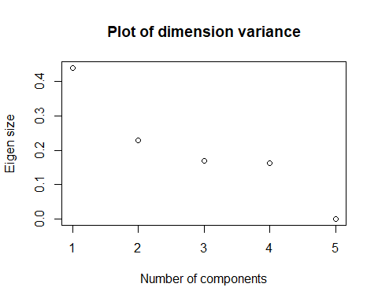

e. Interpretation
Over the impact of foods’ macros pertaining to total energy, as we model our data, we can conclude that most of our variation happens within the first 2 measures compared to subsequent ones. This makes sense as protein and fat are our primary determinate for overall macro tracking and impact caloric intake.

Problem 4
scores <- read.table("C:/mattgraham93.github.io/school/22_3_DA410/data/test_score.dat", header=TRUE)
scores <- scores[-1]
scores
## math reading sex
## 1 83.16 79.67 boy
## 2 102.51 101.13 boy
## 3 81.63 80.53 boy
## 4 88.25 84.58 boy
## 5 81.47 76.52 boy
## 6 87.19 84.70 boy
## 7 88.66 85.86 boy
## 8 79.35 81.03 boy
## 9 83.35 80.44 boy
## 10 86.58 84.67 boy
## 11 81.73 80.71 boy
## 12 85.00 81.32 boy
## 13 85.23 81.31 boy
## 14 80.30 79.37 boy
## 15 81.18 79.65 boy
## 16 88.41 85.85 boy
## 17 90.80 88.81 boy
## 18 81.68 79.71 boy
## 19 82.22 79.81 boy
## 20 78.21 74.20 boy
## 21 72.64 69.13 boy
## 22 84.61 83.05 boy
## 23 82.06 82.12 boy
## 24 87.01 84.62 boy
## 25 86.25 85.45 boy
## 26 77.05 74.03 boy
## 27 90.76 87.13 boy
## 28 81.39 78.53 boy
## 29 81.20 79.73 boy
## 30 83.07 79.94 boy
## 31 76.99 75.74 girl
## 32 83.32 81.40 girl
## 33 75.37 78.26 girl
## 34 84.81 83.93 girl
## 35 81.61 79.58 girl
## 36 76.08 78.18 girl
## 37 84.43 86.48 girl
## 38 82.29 83.16 girl
## 39 81.91 81.88 girl
## 40 97.85 97.01 girl
## 41 75.96 75.72 girl
## 42 82.47 80.84 girl
## 43 78.43 75.01 girl
## 44 82.89 82.92 girl
## 45 86.26 84.84 girl
## 46 88.48 87.90 girl
## 47 82.47 82.29 girl
## 48 87.24 87.45 girl
## 49 79.72 79.75 girl
## 50 87.52 85.44 girl
## 51 84.73 82.24 girl
## 52 77.15 77.63 girl
## 53 85.33 81.96 girl
## 54 80.58 81.67 girl
## 55 88.70 87.57 girl
## 56 79.20 77.14 girl
## 57 91.84 91.55 girl
## 58 81.07 77.01 girl
## 59 88.15 88.16 girl
## 60 76.98 75.65 girl
## 61 79.27 80.33 girl
## 62 85.70 84.27 girl

Hotelling’s test
summary(manova(cbind(math, reading) ~sex, data=scores), test="Hotelling")
## Df Hotelling-Lawley approx F num Df den Df Pr(>F)
## sex 1 0.30593 9.0249 2 59 0.0003805 ***
## Residuals 60
## ---
## Signif. codes: 0 '***' 0.001 '**' 0.01 '*' 0.05 '.' 0.1 ' ' 1

Hotelling’s Analysis
At alpha = 0.05 and p-value < 0.05, we can conclude there is sufficient evidence to state there are differences between mean math and reading scores between the recorded sexes.

Problem 5
Get data
glucose <- read.table("C:/mattgraham93.github.io/school/22_3_DA410/data/T3_5_DIABETES.DAT", header=FALSE)[1:34,]
glucose <- glucose[-1]
colnames(glucose) <- c('rel_wt', 'fst_pls_glu', 'gl_int', 'ins_resp', 'ins_resist')
ys <- glucose[1:2]
xs <- glucose[3:5]
glucose
## rel_wt fst_pls_glu gl_int ins_resp ins_resist
## 1 0.81 80 356 124 55
## 2 0.95 97 289 117 76
## 3 0.94 105 319 143 105
## 4 1.04 90 356 199 108
## 5 1.00 90 323 240 143
## 6 0.76 86 381 157 165
## 7 0.91 100 350 221 119
## 8 1.10 85 301 186 105
## 9 0.99 97 379 142 98
## 10 0.78 97 296 131 94
## 11 0.90 91 353 221 53
## 12 0.73 87 306 178 66
## 13 0.96 78 290 136 142
## 14 0.84 90 371 200 93
## 15 0.74 86 312 208 68
## 16 0.98 80 393 202 102
## 17 1.10 90 364 152 76
## 18 0.85 99 359 185 37
## 19 0.83 85 296 116 60
## 20 0.93 90 345 123 50
## 21 0.95 90 378 136 47
## 22 0.74 88 304 134 50
## 23 0.95 95 347 184 91
## 24 0.97 90 327 192 124
## 25 0.72 92 386 279 74
## 26 1.11 74 365 228 235
## 27 1.20 98 365 145 158
## 28 1.13 100 352 172 140
## 29 1.00 86 325 179 145
## 30 0.78 98 321 222 99
## 31 1.00 70 360 134 90
## 32 1.00 99 336 143 105
## 33 0.71 75 352 169 32
## 34 0.76 90 353 263 165
Find means
x.bar <- colMeans(xs)
x.bar
## gl_int ins_resp ins_resist
## 341.47059 175.32353 99.11765
y.bar <- colMeans(ys)
y.bar
## rel_wt fst_pls_glu
## 0.9164706 89.6470588

a - Find canonical correlations
cancor2<-function(x,y,dec=4){
#Canonical Correlation Analysis to mimic SAS PROC CANCOR output.
#Basic formulas can be found in Chapter 10 of Mardia, Kent, and Bibby (1979).
# The approximate F statistic is exercise 3.7.6b.
x<-as.matrix(x)
y<-as.matrix(y)
n<-dim(x)[1]
q1<-dim(x)[2]
q2<-dim(y)[2]
q<-min(q1,q2)
S11<-cov(x)
S12<-cov(x,y)
S21<-t(S12)
S22<-cov(y)
E1<-eigen(solve(S11)%*%S12%*%solve(S22)%*%S21)
E2<-eigen(solve(S22)%*%S21%*%solve(S11)%*%S12)
rsquared<-as.double(E1$values[1:q])
LR<-NULL;pp<-NULL;qq<-NULL;tt<-NULL
for (i in 1:q){
LR<-c(LR,prod(1-rsquared[i:q]))
pp<-c(pp,q1-i+1)
qq<-c(qq,q2-i+1)
tt<-c(tt,n-1-i+1)}
m<-tt-0.5*(pp+qq+1);lambda<-(1/4)*(pp*qq-2);s<-sqrt((pp^2*qq^2-4)/(pp^2+qq^2-5))
F<-((m*s-2*lambda)/(pp*qq))*((1-LR^(1/s))/LR^(1/s))
df1<-pp*qq;df2<-(m*s-2*lambda)
pval<-1-pf(F,df1,df2)
outmat<-round(cbind(sqrt(rsquared),rsquared,LR,F,df1,df2,pval),dec)
colnames(outmat) <- list("R","RSquared","LR","ApproxF","NumDF","DenDF","pvalue")
rownames(outmat) <- as.character(1:q)
xrels<-round(cor(x,x%*%E1$vectors)[,1:q],dec)
colnames(xrels)<-apply(cbind(rep("U",q),as.character(1:q)),1,paste,collapse="")
yrels<-round(cor(y,y%*%E2$vectors)[,1:q],dec)
colnames(yrels)<- apply(cbind(rep("V",q),as.character(1:q)),1,paste,collapse="")
list(Summary=outmat,
a.Coefficients=E1$vectors,
b.Coefficients=E2$vectors,
XUCorrelations=xrels,YVCorrelations=yrels
)
}
## END FUNCTION
#################################################

b - Find standard coefficients
For canonical variables
Fasting coefficients
before.coefficients <- cancor2(xs, ys)$a.Coefficients
after.coefficients <- cancor2(xs, ys)$b.Coefficients
diag(before.coefficients)
## [1] 0.42680635 0.07577154 0.27703237
Post-consumption coefficients
diag(after.coefficients)
## [1] 0.99999176 0.09433123

c - Test significance for reach canonical correlation
cancor2(xs, ys)
## $Summary
## R RSquared LR ApproxF NumDF DenDF pvalue
## 1 0.6024 0.3628 0.6353 2.4616 6 58 0.0345
## 2 0.0546 0.0030 0.9970 NaN 2 NaN NaN
##
## $a.Coefficients
## [,1] [,2] [,3]
## [1,] 0.4268063 -0.96431194 0.06551464
## [2,] -0.5231307 0.07577154 0.95862448
## [3,] 0.7376792 0.25369501 0.27703237
##
## $b.Coefficients
## [,1] [,2]
## [1,] 0.999991761 0.99554087
## [2,] -0.004059221 0.09433123
##
## $XUCorrelations
## U1 U2
## gl_int 0.2754 -0.9065
## ins_resp -0.2448 -0.0518
## ins_resist 0.7781 0.3186
##
## $YVCorrelations
## V1 V2
## rel_wt 0.9691 0.2465
## fst_pls_glu -0.1661 0.9861
# It produces two other pieces of information: An F-test for the
# significance of each canonical correlation, and the correlations between
# the original variables and the corresponding canonical variates.

Interpretation
Given all our p-values < 0.05, there is enough evidence to conclude that there is at least one non-zero canonical correlation between relative weight and plasma glucose across glucose intolerance, insulin response to oral glucose, and insulin resistance.This means our subjects had different responses to ingesting glucose. This makes sense as diabetes and insulin are directly correlated.

Problem 6
hematology <- read.csv('C:/mattgraham93.github.io/school/22_3_DA410/data/hematology.csv', header=TRUE)
hematology
## Observation.number X..1 X..2 X..3 X..4 X..5 X..6
## 1 1 13.4 39 4100 14 25 17
## 2 2 14.6 46 5000 15 30 20
## 3 3 13.5 42 4500 19 21 18
## 4 4 15.0 46 4600 23 16 18
## 5 5 14.6 44 5100 17 31 19
## 6 6 14.0 44 4900 20 24 19
## 7 7 16.4 49 4300 21 17 18
## 8 8 14.8 44 4400 16 26 29
## 9 9 15.2 46 4100 27 13 27
## 10 10 15.5 48 8400 34 42 36
## 11 11 15.2 47 5600 26 27 22
## 12 12 16.9 50 5100 28 17 23
## 13 13 14.8 44 4700 24 20 23
## 14 14 16.2 45 5600 26 25 19
## 15 15 14.7 43 4000 23 13 17
pairs(hematology[-1])
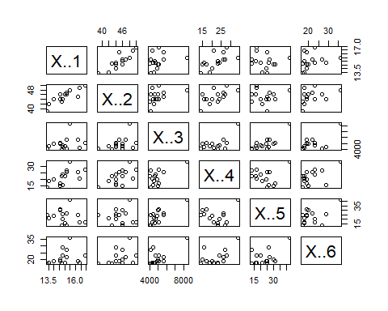
Normalizing
z <- hematology[,-c(1,1)]
means <- apply(z,2,mean)
sds <- apply(z,2,sd)
nor <- scale(z,center=means,scale=sds)
distance = dist(nor)
Plotting
mydata.hclust = hclust(distance)
plot(mydata.hclust)
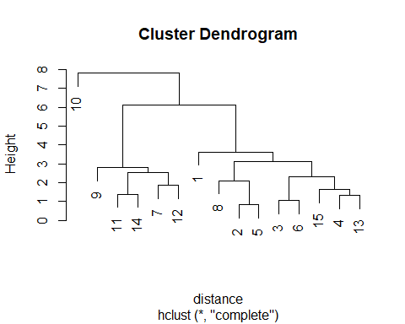
plot(mydata.hclust,labels=hematology$Observation.number,main='Default from hclust')
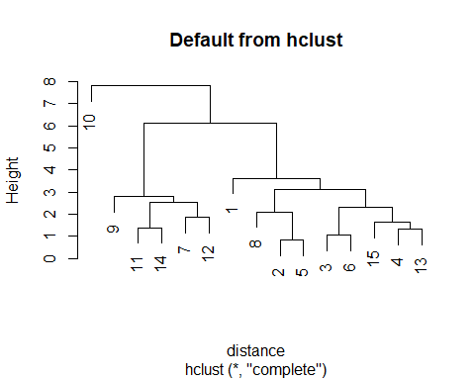
plot(mydata.hclust,hang=-1, labels=hematology$Observation.number,main='Default from hclust')
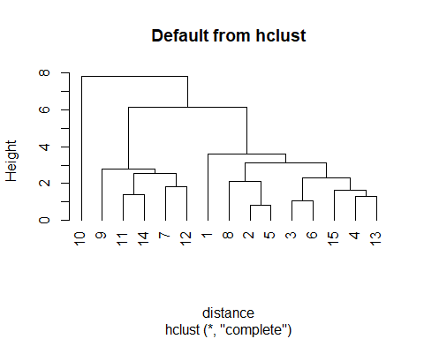
Average linkage
mydata.hclust<-hclust(distance,method="average")
plot(mydata.hclust,hang=-1)
