DA420_Project 6_MattGraham
Steps needed to get working: 1) Uninstall all versions of R newer than 4.0.5 2) Install R v4.0.5 3) Install RTools 400 4) Install packages; Rstem takes forever. Expect a full 20-30 minutes
# install.packages("Rstem", repos = "http://www.omegahat.net/R", type = "source")
# install.packages("devtools")
# install.packages("wordcloud")
# install.packages("SnowballC")
# install.packages("plyr")
# install.packages("ggplot2")
# install.packages("RColorBrewer")
# install.packages("tm")
# require(devtools)
# install_url("https://cran.r-project.org/src/contrib/Archive/sentiment/sentiment_0.1.tar.gz")
# install_url("https://cran.r-project.org/src/contrib/Archive/sentiment/sentiment_0.2.tar.gz")

Import libraries
library(plyr)
library(ggplot2)
library(wordcloud)
library(RColorBrewer)
library(tm)
library(SnowballC)
library(sentiment)

Getting the data
###Get the data
data <- readLines("http://www.r-bloggers.com/wp-content/uploads/2016/01/vent.txt")
# from: http://www.wvgazettemail.com/
df <- data.frame(data)
textdata <- df$data

Remove non-essential characters
textdata = gsub("[[:punct:]]", "", textdata)
textdata = gsub("[[:digit:]]", "", textdata)
textdata = gsub("http\\w+", "", textdata)
textdata = gsub("[ \t]{2,}", "", textdata)
textdata = gsub("^\\s+|\\s+$", "", textdata)
try.error = function(x)
{
y = NA
try_error = tryCatch(tolower(x), error=function(e) e)
if (!inherits(try_error, "error"))
y = tolower(x)
return(y)
}
textdata = sapply(textdata, try.error)
textdata = textdata[!is.na(textdata)]
names(textdata) = NULL

Perform sentiment analysis
class_emo = classify_emotion(textdata, algorithm="bayes", prior=1.0)
## Warning in TermDocumentMatrix.SimpleCorpus(x, control): custom functions are
## ignored
emotion = class_emo[,7]
emotion[is.na(emotion)] = "unknown"
class_pol = classify_polarity(textdata, algorithm="bayes")
## Warning in TermDocumentMatrix.SimpleCorpus(x, control): custom functions are
## ignored
polarity = class_pol[,4]
sent_df = data.frame(text=textdata, emotion=emotion,
polarity=polarity, stringsAsFactors=FALSE)
sent_df = within(sent_df,
emotion <- factor(emotion, levels=names(sort(table(emotion),
decreasing=TRUE))))
sent_df$polarity
## [1] "positive" "negative" "negative" "negative" "neutral" "negative"
## [7] "negative" "positive" "positive" "negative" "positive" "positive"
## [13] "neutral" "negative" "positive" "negative" "positive" "positive"
## [19] "positive" "positive" "positive" "positive" "neutral" "positive"
## [25] "positive" "negative" "positive" "neutral" "positive" "positive"
## [31] "positive" "negative" "negative" "positive" "negative" "negative"
## [37] "positive" "neutral" "negative" "negative" "positive" "neutral"
## [43] "positive" "neutral" "neutral" "negative" "neutral" "positive"
## [49] "positive" "negative" "positive" "positive" "positive" "negative"
## [55] "negative" "negative" "positive" "positive" "positive" "negative"
## [61] "positive" "positive" "negative" "negative" "positive" "positive"
## [67] "negative" "positive" "negative" "negative" "positive" "neutral"
## [73] "negative" "positive" "positive" "positive" "negative" "negative"
## [79] "negative" "neutral" "positive" "positive" "positive"
sent_df$emotion
## [1] unknown unknown anger unknown unknown unknown joy joy
## [9] joy unknown unknown unknown unknown unknown unknown sadness
## [17] unknown unknown unknown joy unknown unknown unknown unknown
## [25] unknown sadness surprise joy unknown joy joy sadness
## [33] unknown unknown sadness joy surprise fear unknown unknown
## [41] unknown anger unknown unknown unknown anger unknown unknown
## [49] unknown unknown joy joy joy anger unknown unknown
## [57] unknown unknown unknown fear unknown unknown joy joy
## [65] unknown unknown joy unknown joy joy unknown unknown
## [73] unknown unknown joy unknown unknown unknown sadness joy
## [81] joy joy unknown
## Levels: unknown joy sadness anger fear surprise

Plotting our results

Emotion category plot
ggplot(sent_df, aes(x=emotion)) +
geom_bar(aes(y=..count.., fill=emotion)) +
scale_fill_brewer(palette="Dark2") +
labs(x="emotion categories", y="")
## Warning: The dot-dot notation (`..count..`) was deprecated in ggplot2 3.4.0.
## i Please use `after_stat(count)` instead.
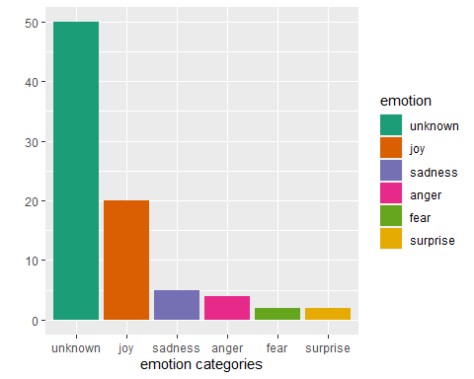

Polarity plot
ggplot(sent_df, aes(x=polarity)) +
geom_bar(aes(y=..count.., fill=polarity)) +
scale_fill_brewer(palette="RdGy") +
labs(x="polarity categories", y="")
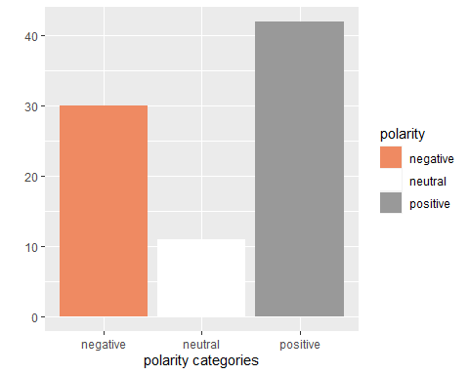

Word cloud
emos = levels(factor(sent_df$emotion))
nemo = length(emos)
emo.docs = rep("", nemo)
for (i in 1:nemo)
{
tmp = textdata[emotion == emos[i]]
emo.docs[i] = paste(tmp, collapse=" ")
}
emo.docs = removeWords(emo.docs, stopwords("english"))
corpus = Corpus(VectorSource(emo.docs))
tdm = TermDocumentMatrix(corpus)
tdm = as.matrix(tdm)
colnames(tdm) = emos
comparison.cloud(tdm, colors = brewer.pal(nemo, "Dark2"),
scale = c(3,.5), random.order = FALSE,
title.size = 1.5)
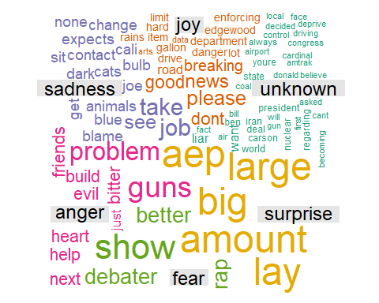

Analysis
It took a bit to get this working, but I’m so glad I got it right! I left the steps above in case other people experience this problem in the future.
Most comments are neutral, and a majority are neutral or positive. Relating this to our word cloud, we can see the proportion of positive/negative reflected with negative relating to anger and sadness. surprise and joy are likely attributed with happy, and fear/unknown being neutral.
We can see many words are filed under, “unknown”. This can be something addressed and excluded in future visualizations. Or, ideally, revisited and look at things as phrases. Something like, “around” isn’t a word of surprise to me. Heart under anger makes no sense either.
It would be helpful improving the bucketing algorithm. I would like to know why holiday is under surprise and not joy. Why is “aep” part of surprise? Why is it so prominent? “Don’t” under joy is also a bit strange.

