library(readxl)
library(strucchange) # for chow test
## Loading required package: zoo
##
## Attaching package: 'zoo'
## The following objects are masked from 'package:base':
##
## as.Date, as.Date.numeric
## Loading required package: sandwich
library(quantreg) # for LAD regression (rq)
## Loading required package: SparseM
##
## Attaching package: 'SparseM'
## The following object is masked from 'package:base':
##
## backsolve
library(stargazer)
##
## Please cite as:
## Hlavac, Marek (2022). stargazer: Well-Formatted Regression and Summary Statistics Tables.
## R package version 5.2.3. https://CRAN.R-project.org/package=stargazer
library(L1pack) # more LAD regression (lad)
## Loading required package: fastmatrix
library(plyr)
library(reshape2)
library(ggplot2)
library(ggrepel) # https://www.statology.org/label-scatterplot-points-r/
library(car)
## Loading required package: carData
library(sandwich)
library(tinytex)
library(rjson)
library(censusapi)
##
## Attaching package: 'censusapi'
## The following object is masked from 'package:methods':
##
## getFunction
library(dplyr)
##
## Attaching package: 'dplyr'
## The following object is masked from 'package:car':
##
## recode
## The following objects are masked from 'package:plyr':
##
## arrange, count, desc, failwith, id, mutate, rename, summarise,
## summarize
## The following objects are masked from 'package:stats':
##
## filter, lag
## The following objects are masked from 'package:base':
##
## intersect, setdiff, setequal, union
library(devtools)
## Loading required package: usethis
library(blsAPI)
library(car)
library(dynlm)
library(lmtest)
library(jtools)
library(sjPlot) # https://cran.r-project.org/web/packages/sjPlot/vignettes/plot_interactions.html
## Registered S3 methods overwritten by 'broom':
## method from
## tidy.glht jtools
## tidy.summary.glht jtools
## Learn more about sjPlot with 'browseVignettes("sjPlot")'.
library(sjmisc) # https://cran.r-project.org/web/packages/sjPlot/vignettes/plot_interactions.html
## Learn more about sjmisc with 'browseVignettes("sjmisc")'.
##
## Attaching package: 'sjmisc'
## The following objects are masked from 'package:jtools':
##
## %nin%, center
library(fastDummies)
library(corrplot)
## corrplot 0.92 loaded
library(RColorBrewer)
library(ggstatsplot)
## Warning: package 'ggstatsplot' was built under R version 4.3.1
## You can cite this package as:
## Patil, I. (2021). Visualizations with statistical details: The 'ggstatsplot' approach.
## Journal of Open Source Software, 6(61), 3167, doi:10.21105/joss.03167
library (BSDA)
## Warning: package 'BSDA' was built under R version 4.3.1
## Loading required package: lattice
##
## Attaching package: 'BSDA'
## The following objects are masked from 'package:carData':
##
## Vocab, Wool
## The following object is masked from 'package:datasets':
##
## Orange

Getting data
cps <- read.csv("cps_00002.csv")
cps <- subset(cps, INCTOT >= 12000 & INCTOT <= 500000)
cps$SEX<- mapvalues(cps$SEX, from = c(1, 2), to = c(0, 1))
cps$LOG_INCTOT <- log(cps$INCTOT)
cps <- cps %>% select(c('YEAR', 'AGE':'RACE', 'INCTOT':'LOG_INCTOT'))
head(cps)
## YEAR AGE SEX RACE INCTOT LOG_INCTOT
## 1 2000 51 1 100 78644 11.272687
## 3 2000 77 1 100 26049 10.167735
## 4 2000 22 0 100 12031 9.395242
## 5 2000 48 1 100 20010 9.903987
## 6 2000 43 1 100 42755 10.663241
## 7 2000 16 1 100 13300 9.495519
M <- cor(cps)
corrplot(M, type="upper", order="hclust",
col=brewer.pal(n=8, name="RdYlBu"))
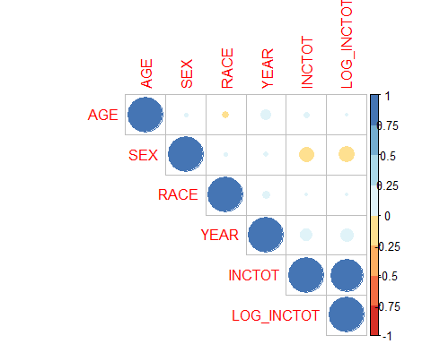

Data exploration and transformation
cps.race.codes <- read_excel("cps_race_codes.xlsx")
head(cps.race.codes)
## # A tibble: 6 × 2
## RACE RACE_LABEL
## <dbl> <chr>
## 1 100 White
## 2 200 Black
## 3 300 American Indian/Aleut/Eskimo
## 4 650 Asian or Pacific Islander
## 5 651 Asian only
## 6 652 Asian or Pacific Islander
cps <- merge(x = cps, y = cps.race.codes, by = "RACE")
cps$RACE_HL <- ifelse(cps$RACE_LABEL=="White", "White", "Non-white")
cps$SEX_LABEL <- ifelse(cps$SEX == 1, "Woman", "Man")
head(cps)
## RACE YEAR AGE SEX INCTOT LOG_INCTOT RACE_LABEL RACE_HL SEX_LABEL
## 1 100 2000 51 1 78644 11.272687 White White Woman
## 2 100 2000 77 1 26049 10.167735 White White Woman
## 3 100 2000 22 0 12031 9.395242 White White Man
## 4 100 2000 48 1 20010 9.903987 White White Woman
## 5 100 2000 43 1 42755 10.663241 White White Woman
## 6 100 2000 16 1 13300 9.495519 White White Woman
summary(cps)
## RACE YEAR AGE SEX
## Min. :100.0 Min. :2000 Min. :15.00 Min. :0.0000
## 1st Qu.:100.0 1st Qu.:2005 1st Qu.:34.00 1st Qu.:0.0000
## Median :100.0 Median :2011 Median :45.00 Median :0.0000
## Mean :156.2 Mean :2011 Mean :46.81 Mean :0.4628
## 3rd Qu.:100.0 3rd Qu.:2017 3rd Qu.:58.00 3rd Qu.:1.0000
## Max. :830.0 Max. :2022 Max. :90.00 Max. :1.0000
## INCTOT LOG_INCTOT RACE_LABEL RACE_HL
## Min. : 12000 Min. : 9.393 Length:2265001 Length:2265001
## 1st Qu.: 22041 1st Qu.:10.001 Class :character Class :character
## Median : 36000 Median :10.491 Mode :character Mode :character
## Mean : 49771 Mean :10.544
## 3rd Qu.: 60000 3rd Qu.:11.002
## Max. :500000 Max. :13.122
## SEX_LABEL
## Length:2265001
## Class :character
## Mode :character
##
##
##
hist(cps$LOG_INCTOT)
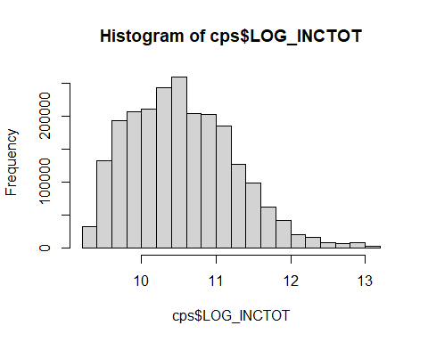
ggplot(data = cps) +
geom_histogram(aes(x=LOG_INCTOT), bins = 4) +
facet_wrap(~ RACE_HL)
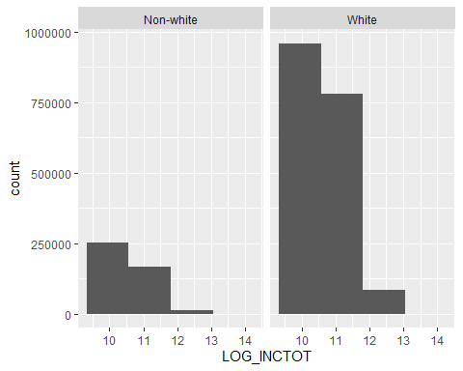
ggplot(data = cps) +
geom_histogram(aes(x=LOG_INCTOT), bins = 4) +
facet_wrap(~ SEX_LABEL)
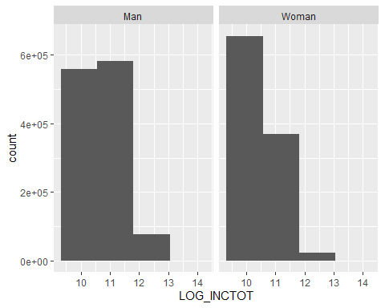
boxplot(cps$LOG_INCTOT)
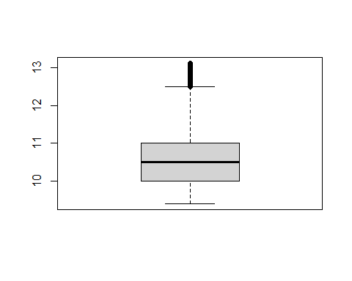 ## Removing outliers
iqr <- IQR(cps$LOG_INCTOT)
Q <- quantile(cps$LOG_INCTOT, probs = c(.25, .75), na.rm = FALSE)
up <- Q[2] + (1.5*iqr)
low <- Q[1] - (1.5 * iqr)
outliers_rm <- subset(cps, cps$LOG_INCTOT > low & cps$LOG_INCTOT < up )
head(outliers_rm)
## RACE YEAR AGE SEX INCTOT LOG_INCTOT RACE_LABEL RACE_HL SEX_LABEL
## 1 100 2000 51 1 78644 11.272687 White White Woman
## 2 100 2000 77 1 26049 10.167735 White White Woman
## 3 100 2000 22 0 12031 9.395242 White White Man
## 4 100 2000 48 1 20010 9.903987 White White Woman
## 5 100 2000 43 1 42755 10.663241 White White Woman
## 6 100 2000 16 1 13300 9.495519 White White Woman
iqr <- IQR(cps$AGE)
Q <- quantile(outliers_rm$AGE, probs = c(.25, .75), na.rm = FALSE)
up <- Q[2] + (1.5*iqr)
low <- Q[1] - (1.5 * iqr)
print(low)
## 25%
## -2
print(up)
## 75%
## 94
outliers_rm <- subset(outliers_rm, outliers_rm$AGE > low & outliers_rm$AGE < up )
head(outliers_rm)
## RACE YEAR AGE SEX INCTOT LOG_INCTOT RACE_LABEL RACE_HL SEX_LABEL
## 1 100 2000 51 1 78644 11.272687 White White Woman
## 2 100 2000 77 1 26049 10.167735 White White Woman
## 3 100 2000 22 0 12031 9.395242 White White Man
## 4 100 2000 48 1 20010 9.903987 White White Woman
## 5 100 2000 43 1 42755 10.663241 White White Woman
## 6 100 2000 16 1 13300 9.495519 White White Woman

Racial differences
outliers_rm %>%
group_by(RACE_HL) %>%
summarize(min_inctot = exp(min(LOG_INCTOT)), max_inctot = exp(max(LOG_INCTOT)), med_inctot = exp(median(LOG_INCTOT)),
mean_inctot = exp(mean(LOG_INCTOT)), var_inctot = exp(var(LOG_INCTOT))
)
## # A tibble: 2 × 6
## RACE_HL min_inctot max_inctot med_inctot mean_inctot var_inctot
## <chr> <dbl> <dbl> <dbl> <dbl> <dbl>
## 1 Non-white 12000 269251 33000. 34925. 1.53
## 2 White 12000 269473 36100 37767. 1.56
w_df <- subset(outliers_rm, RACE_HL == "White")
ggplot(data = w_df) +
geom_histogram(aes(x=LOG_INCTOT), bins = 4) +
facet_wrap(~ SEX_LABEL)
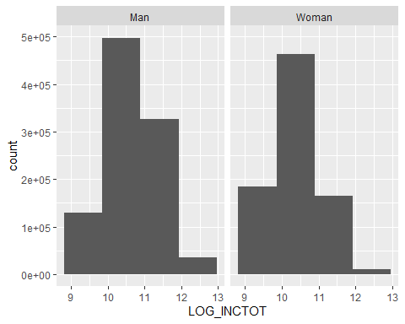
nw_df <- subset(outliers_rm, RACE_HL == "Non-white")
ggplot(data = nw_df) +
geom_histogram(aes(x=LOG_INCTOT), bins = 4) +
facet_wrap(~ SEX_LABEL)
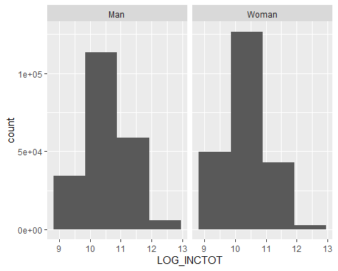
ggplot(data = outliers_rm) +
geom_histogram(aes(x=LOG_INCTOT), bins = 4) +
facet_wrap(~ RACE_HL)
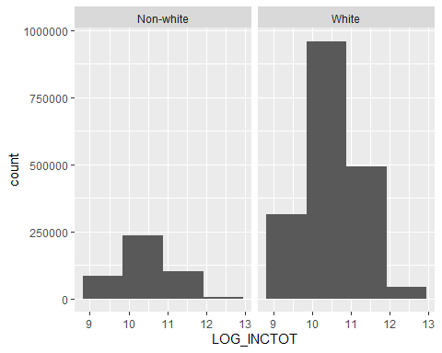
ggplot(data = outliers_rm) +
geom_histogram(aes(x=LOG_INCTOT), bins = 4) +
facet_wrap(~ SEX_LABEL)
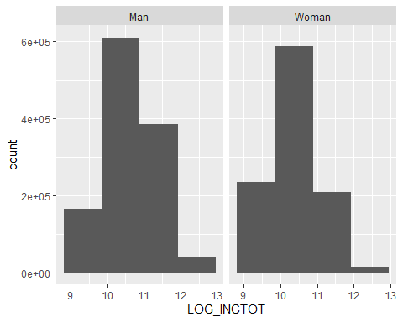

Creating dummy variables
cps <- dummy_cols(outliers_rm, select_columns = 'RACE_LABEL', remove_selected_columns = TRUE)
head(cps)
## RACE YEAR AGE SEX INCTOT LOG_INCTOT RACE_HL SEX_LABEL
## 1 100 2000 51 1 78644 11.272687 White Woman
## 2 100 2000 77 1 26049 10.167735 White Woman
## 3 100 2000 22 0 12031 9.395242 White Man
## 4 100 2000 48 1 20010 9.903987 White Woman
## 5 100 2000 43 1 42755 10.663241 White Woman
## 6 100 2000 16 1 13300 9.495519 White Woman
## RACE_LABEL_American Indian/Aleut/Eskimo RACE_LABEL_Asian only
## 1 0 0
## 2 0 0
## 3 0 0
## 4 0 0
## 5 0 0
## 6 0 0
## RACE_LABEL_Asian or Pacific Islander RACE_LABEL_Asian-Mixed RACE_LABEL_Black
## 1 0 0 0
## 2 0 0 0
## 3 0 0 0
## 4 0 0 0
## 5 0 0 0
## 6 0 0 0
## RACE_LABEL_Black-Mixed RACE_LABEL_Four or five races, unspecified
## 1 0 0
## 2 0 0
## 3 0 0
## 4 0 0
## 5 0 0
## 6 0 0
## RACE_LABEL_Two or three races, unspecified RACE_LABEL_White
## 1 0 1
## 2 0 1
## 3 0 1
## 4 0 1
## 5 0 1
## 6 0 1
## RACE_LABEL_White-Mixed
## 1 0
## 2 0
## 3 0
## 4 0
## 5 0
## 6 0
summary(cps)
## RACE YEAR AGE SEX
## Min. :100.0 Min. :2000 Min. :15.0 Min. :0.0000
## 1st Qu.:100.0 1st Qu.:2005 1st Qu.:34.0 1st Qu.:0.0000
## Median :100.0 Median :2011 Median :45.0 Median :0.0000
## Mean :156.3 Mean :2011 Mean :46.8 Mean :0.4653
## 3rd Qu.:100.0 3rd Qu.:2017 3rd Qu.:58.0 3rd Qu.:1.0000
## Max. :830.0 Max. :2022 Max. :90.0 Max. :1.0000
## INCTOT LOG_INCTOT RACE_HL SEX_LABEL
## Min. : 12000 Min. : 9.393 Length:2245138 Length:2245138
## 1st Qu.: 22000 1st Qu.: 9.999 Class :character Class :character
## Median : 35500 Median :10.477 Mode :character Mode :character
## Mean : 46947 Mean :10.524
## 3rd Qu.: 59280 3rd Qu.:10.990
## Max. :269473 Max. :12.504
## RACE_LABEL_American Indian/Aleut/Eskimo RACE_LABEL_Asian only
## Min. :0.00000 Min. :0.0000
## 1st Qu.:0.00000 1st Qu.:0.0000
## Median :0.00000 Median :0.0000
## Mean :0.01177 Mean :0.0481
## 3rd Qu.:0.00000 3rd Qu.:0.0000
## Max. :1.00000 Max. :1.0000
## RACE_LABEL_Asian or Pacific Islander RACE_LABEL_Asian-Mixed RACE_LABEL_Black
## Min. :0.000000 Min. :0.000000 Min. :0.0000
## 1st Qu.:0.000000 1st Qu.:0.000000 1st Qu.:0.0000
## Median :0.000000 Median :0.000000 Median :0.0000
## Mean :0.009246 Mean :0.000832 Mean :0.1078
## 3rd Qu.:0.000000 3rd Qu.:0.000000 3rd Qu.:0.0000
## Max. :1.000000 Max. :1.000000 Max. :1.0000
## RACE_LABEL_Black-Mixed RACE_LABEL_Four or five races, unspecified
## Min. :0.000000 Min. :0.0000000
## 1st Qu.:0.000000 1st Qu.:0.0000000
## Median :0.000000 Median :0.0000000
## Mean :0.001055 Mean :0.0007478
## 3rd Qu.:0.000000 3rd Qu.:0.0000000
## Max. :1.000000 Max. :1.0000000
## RACE_LABEL_Two or three races, unspecified RACE_LABEL_White
## Min. :0.0000000 Min. :0.0000
## 1st Qu.:0.0000000 1st Qu.:1.0000
## Median :0.0000000 Median :1.0000
## Mean :0.0006971 Mean :0.8067
## 3rd Qu.:0.0000000 3rd Qu.:1.0000
## Max. :1.0000000 Max. :1.0000
## RACE_LABEL_White-Mixed
## Min. :0.00000
## 1st Qu.:0.00000
## Median :0.00000
## Mean :0.01305
## 3rd Qu.:0.00000
## Max. :1.00000

Removing year from dummy model
cps_no_year <- cps %>% select(-'YEAR')
head(cps_no_year)
## RACE AGE SEX INCTOT LOG_INCTOT RACE_HL SEX_LABEL
## 1 100 51 1 78644 11.272687 White Woman
## 2 100 77 1 26049 10.167735 White Woman
## 3 100 22 0 12031 9.395242 White Man
## 4 100 48 1 20010 9.903987 White Woman
## 5 100 43 1 42755 10.663241 White Woman
## 6 100 16 1 13300 9.495519 White Woman
## RACE_LABEL_American Indian/Aleut/Eskimo RACE_LABEL_Asian only
## 1 0 0
## 2 0 0
## 3 0 0
## 4 0 0
## 5 0 0
## 6 0 0
## RACE_LABEL_Asian or Pacific Islander RACE_LABEL_Asian-Mixed RACE_LABEL_Black
## 1 0 0 0
## 2 0 0 0
## 3 0 0 0
## 4 0 0 0
## 5 0 0 0
## 6 0 0 0
## RACE_LABEL_Black-Mixed RACE_LABEL_Four or five races, unspecified
## 1 0 0
## 2 0 0
## 3 0 0
## 4 0 0
## 5 0 0
## 6 0 0
## RACE_LABEL_Two or three races, unspecified RACE_LABEL_White
## 1 0 1
## 2 0 1
## 3 0 1
## 4 0 1
## 5 0 1
## 6 0 1
## RACE_LABEL_White-Mixed
## 1 0
## 2 0
## 3 0
## 4 0
## 5 0
## 6 0

Modeling

Full model
cps_full <- lm(LOG_INCTOT ~ ., data = cps)
summary(cps_full)
##
## Call:
## lm(formula = LOG_INCTOT ~ ., data = cps)
##
## Residuals:
## Min 1Q Median 3Q Max
## -1.7457 -0.1586 0.0831 0.2107 0.3536
##
## Coefficients: (3 not defined because of singularities)
## Estimate Std. Error t value
## (Intercept) 5.417e+00 6.892e-01 7.859
## RACE 2.357e-03 8.589e-04 2.745
## YEAR 1.237e-03 2.779e-05 44.516
## AGE -9.340e-04 1.093e-05 -85.487
## SEX -3.972e-02 3.572e-04 -111.190
## INCTOT 1.655e-05 4.960e-09 3337.660
## RACE_HLWhite 1.672e+00 6.030e-01 2.772
## SEX_LABELWoman NA NA NA
## `RACE_LABEL_American Indian/Aleut/Eskimo` 1.163e+00 4.312e-01 2.697
## `RACE_LABEL_Asian only` 3.678e-01 1.298e-01 2.834
## `RACE_LABEL_Asian or Pacific Islander` 3.741e-01 1.299e-01 2.880
## `RACE_LABEL_Asian-Mixed` 9.870e-03 8.579e-03 1.151
## RACE_LABEL_Black 1.418e+00 5.171e-01 2.743
## `RACE_LABEL_Black-Mixed` -1.329e-02 6.220e-03 -2.136
## `RACE_LABEL_Four or five races, unspecified` -6.214e-03 1.257e-02 -0.494
## `RACE_LABEL_Two or three races, unspecified` -6.137e-03 1.064e-02 -0.577
## RACE_LABEL_White NA NA NA
## `RACE_LABEL_White-Mixed` NA NA NA
## Pr(>|t|)
## (Intercept) 3.88e-15 ***
## RACE 0.00605 **
## YEAR < 2e-16 ***
## AGE < 2e-16 ***
## SEX < 2e-16 ***
## INCTOT < 2e-16 ***
## RACE_HLWhite 0.00557 **
## SEX_LABELWoman NA
## `RACE_LABEL_American Indian/Aleut/Eskimo` 0.00699 **
## `RACE_LABEL_Asian only` 0.00460 **
## `RACE_LABEL_Asian or Pacific Islander` 0.00398 **
## `RACE_LABEL_Asian-Mixed` 0.24991
## RACE_LABEL_Black 0.00610 **
## `RACE_LABEL_Black-Mixed` 0.03265 *
## `RACE_LABEL_Four or five races, unspecified` 0.62108
## `RACE_LABEL_Two or three races, unspecified` 0.56400
## RACE_LABEL_White NA
## `RACE_LABEL_White-Mixed` NA
## ---
## Signif. codes: 0 '***' 0.001 '**' 0.01 '*' 0.05 '.' 0.1 ' ' 1
##
## Residual standard error: 0.2621 on 2245123 degrees of freedom
## Multiple R-squared: 0.8438, Adjusted R-squared: 0.8438
## F-statistic: 8.664e+05 on 14 and 2245123 DF, p-value: < 2.2e-16
Intercept assumes: non-white man
cps_mod <- lm(LOG_INCTOT ~ RACE + AGE + SEX + INCTOT + RACE_HL +
`RACE_LABEL_American Indian/Aleut/Eskimo` + `RACE_LABEL_Asian only` +
`RACE_LABEL_Asian or Pacific Islander` + `RACE_LABEL_Black-Mixed` +
RACE_LABEL_Black
, data = cps)
summary(cps_mod)
##
## Call:
## lm(formula = LOG_INCTOT ~ RACE + AGE + SEX + INCTOT + RACE_HL +
## `RACE_LABEL_American Indian/Aleut/Eskimo` + `RACE_LABEL_Asian only` +
## `RACE_LABEL_Asian or Pacific Islander` + `RACE_LABEL_Black-Mixed` +
## RACE_LABEL_Black, data = cps)
##
## Residuals:
## Min 1Q Median 3Q Max
## -1.73993 -0.15847 0.08286 0.21155 0.34955
##
## Coefficients:
## Estimate Std. Error t value
## (Intercept) 7.887e+00 2.936e-01 26.864
## RACE 2.376e-03 3.654e-04 6.504
## AGE -8.906e-04 1.089e-05 -81.806
## SEX -3.894e-02 3.569e-04 -109.102
## INCTOT 1.659e-05 4.897e-09 3387.695
## RACE_HLWhite 1.683e+00 2.571e-01 6.547
## `RACE_LABEL_American Indian/Aleut/Eskimo` 1.172e+00 1.840e-01 6.369
## `RACE_LABEL_Asian only` 3.713e-01 5.575e-02 6.659
## `RACE_LABEL_Asian or Pacific Islander` 3.697e-01 5.582e-02 6.624
## `RACE_LABEL_Black-Mixed` -1.321e-02 5.606e-03 -2.357
## RACE_LABEL_Black 1.428e+00 2.205e-01 6.478
## Pr(>|t|)
## (Intercept) < 2e-16 ***
## RACE 7.81e-11 ***
## AGE < 2e-16 ***
## SEX < 2e-16 ***
## INCTOT < 2e-16 ***
## RACE_HLWhite 5.88e-11 ***
## `RACE_LABEL_American Indian/Aleut/Eskimo` 1.90e-10 ***
## `RACE_LABEL_Asian only` 2.75e-11 ***
## `RACE_LABEL_Asian or Pacific Islander` 3.50e-11 ***
## `RACE_LABEL_Black-Mixed` 0.0184 *
## RACE_LABEL_Black 9.31e-11 ***
## ---
## Signif. codes: 0 '***' 0.001 '**' 0.01 '*' 0.05 '.' 0.1 ' ' 1
##
## Residual standard error: 0.2622 on 2245127 degrees of freedom
## Multiple R-squared: 0.8437, Adjusted R-squared: 0.8437
## F-statistic: 1.212e+06 on 10 and 2245127 DF, p-value: < 2.2e-16
plot_model(cps_mod, type="pred", terms = c("RACE", "SEX"))
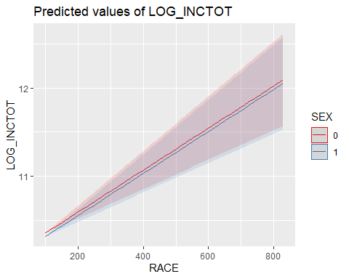
plot_model(cps_mod, type="pred", terms = c("AGE", "SEX"))
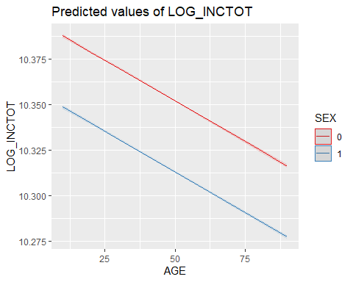
plot_model(cps_mod, type="pred", terms = c("AGE", "RACE"))
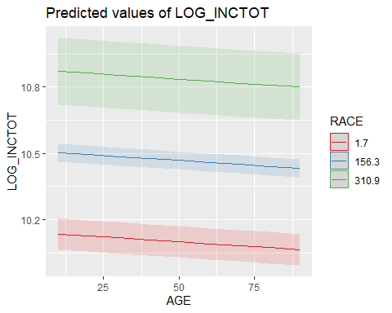
cps_mod_w_time <- lm(LOG_INCTOT ~ YEAR + RACE + AGE + SEX + INCTOT + RACE_HL +
`RACE_LABEL_American Indian/Aleut/Eskimo` + `RACE_LABEL_Asian only` +
`RACE_LABEL_Asian or Pacific Islander` + `RACE_LABEL_Black-Mixed` +
RACE_LABEL_Black
, data = cps)
summary(cps_mod_w_time)
##
## Call:
## lm(formula = LOG_INCTOT ~ YEAR + RACE + AGE + SEX + INCTOT +
## RACE_HL + `RACE_LABEL_American Indian/Aleut/Eskimo` + `RACE_LABEL_Asian only` +
## `RACE_LABEL_Asian or Pacific Islander` + `RACE_LABEL_Black-Mixed` +
## RACE_LABEL_Black, data = cps)
##
## Residuals:
## Min 1Q Median 3Q Max
## -1.7457 -0.1586 0.0831 0.2107 0.3536
##
## Coefficients:
## Estimate Std. Error t value
## (Intercept) 5.562e+00 2.981e-01 18.660
## YEAR 1.237e-03 2.778e-05 44.543
## RACE 2.176e-03 3.652e-04 5.958
## AGE -9.339e-04 1.093e-05 -85.480
## SEX -3.972e-02 3.572e-04 -111.187
## INCTOT 1.655e-05 4.960e-09 3337.663
## RACE_HLWhite 1.544e+00 2.570e-01 6.009
## `RACE_LABEL_American Indian/Aleut/Eskimo` 1.072e+00 1.839e-01 5.829
## `RACE_LABEL_Asian only` 3.402e-01 5.573e-02 6.105
## `RACE_LABEL_Asian or Pacific Islander` 3.465e-01 5.580e-02 6.210
## `RACE_LABEL_Black-Mixed` -1.293e-02 5.603e-03 -2.307
## RACE_LABEL_Black 1.309e+00 2.204e-01 5.938
## Pr(>|t|)
## (Intercept) < 2e-16 ***
## YEAR < 2e-16 ***
## RACE 2.55e-09 ***
## AGE < 2e-16 ***
## SEX < 2e-16 ***
## INCTOT < 2e-16 ***
## RACE_HLWhite 1.86e-09 ***
## `RACE_LABEL_American Indian/Aleut/Eskimo` 5.57e-09 ***
## `RACE_LABEL_Asian only` 1.03e-09 ***
## `RACE_LABEL_Asian or Pacific Islander` 5.29e-10 ***
## `RACE_LABEL_Black-Mixed` 0.0211 *
## RACE_LABEL_Black 2.89e-09 ***
## ---
## Signif. codes: 0 '***' 0.001 '**' 0.01 '*' 0.05 '.' 0.1 ' ' 1
##
## Residual standard error: 0.2621 on 2245126 degrees of freedom
## Multiple R-squared: 0.8438, Adjusted R-squared: 0.8438
## F-statistic: 1.103e+06 on 11 and 2245126 DF, p-value: < 2.2e-16
cps_mod_int_r <- lm(LOG_INCTOT ~ RACE * AGE * SEX, data = cps)
summary(cps_mod_int_r)
##
## Call:
## lm(formula = LOG_INCTOT ~ RACE * AGE * SEX, data = cps)
##
## Residuals:
## Min 1Q Median 3Q Max
## -1.33433 -0.49855 -0.03763 0.44342 2.15298
##
## Coefficients:
## Estimate Std. Error t value Pr(>|t|)
## (Intercept) 1.055e+01 2.586e-03 4077.841 < 2e-16 ***
## RACE 7.323e-05 1.171e-05 6.252 4.05e-10 ***
## AGE 2.106e-03 5.297e-05 39.759 < 2e-16 ***
## SEX -1.368e-01 3.784e-03 -36.142 < 2e-16 ***
## RACE:AGE -1.718e-06 2.476e-07 -6.937 4.00e-12 ***
## RACE:SEX 9.550e-05 1.700e-05 5.616 1.95e-08 ***
## AGE:SEX -2.928e-03 7.689e-05 -38.081 < 2e-16 ***
## RACE:AGE:SEX 4.656e-07 3.565e-07 1.306 0.191
## ---
## Signif. codes: 0 '***' 0.001 '**' 0.01 '*' 0.05 '.' 0.1 ' ' 1
##
## Residual standard error: 0.6503 on 2245130 degrees of freedom
## Multiple R-squared: 0.03851, Adjusted R-squared: 0.03851
## F-statistic: 1.285e+04 on 7 and 2245130 DF, p-value: < 2.2e-16
plot_model(cps_mod_int_r, type="pred", terms = c("SEX", "RACE", "AGE"))
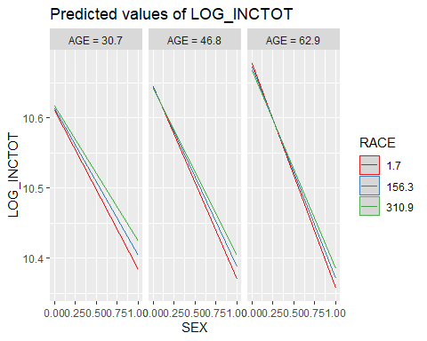
cps_mod_comp <- lm(LOG_INCTOT ~ YEAR + RACE + AGE + SEX + INCTOT + RACE_HL +
`RACE_LABEL_American Indian/Aleut/Eskimo` + `RACE_LABEL_Asian only` +
`RACE_LABEL_Asian or Pacific Islander` + `RACE_LABEL_Black-Mixed` +
RACE_LABEL_Black + (YEAR * RACE) + (YEAR * AGE) + (YEAR * SEX) + (AGE * SEX) + (YEAR * AGE * SEX)
, data = cps)
summary(cps_mod_comp)
##
## Call:
## lm(formula = LOG_INCTOT ~ YEAR + RACE + AGE + SEX + INCTOT +
## RACE_HL + `RACE_LABEL_American Indian/Aleut/Eskimo` + `RACE_LABEL_Asian only` +
## `RACE_LABEL_Asian or Pacific Islander` + `RACE_LABEL_Black-Mixed` +
## RACE_LABEL_Black + (YEAR * RACE) + (YEAR * AGE) + (YEAR *
## SEX) + (AGE * SEX) + (YEAR * AGE * SEX), data = cps)
##
## Residuals:
## Min 1Q Median 3Q Max
## -1.73495 -0.15808 0.08294 0.21082 0.36342
##
## Coefficients:
## Estimate Std. Error t value
## (Intercept) 3.382e+00 3.785e-01 8.935
## YEAR 2.244e-03 1.181e-04 19.008
## RACE 6.456e-03 5.425e-04 11.899
## AGE 1.010e-01 4.660e-03 21.675
## SEX -6.948e+00 3.343e-01 -20.784
## INCTOT 1.655e-05 4.957e-09 3338.933
## RACE_HLWhite 1.668e+00 2.568e-01 6.496
## `RACE_LABEL_American Indian/Aleut/Eskimo` 1.161e+00 1.838e-01 6.315
## `RACE_LABEL_Asian only` 3.682e-01 5.570e-02 6.610
## `RACE_LABEL_Asian or Pacific Islander` 3.687e-01 5.575e-02 6.613
## `RACE_LABEL_Black-Mixed` -1.318e-02 5.596e-03 -2.354
## RACE_LABEL_Black 1.416e+00 2.203e-01 6.425
## YEAR:RACE -2.039e-06 1.926e-07 -10.586
## YEAR:AGE -5.056e-05 2.317e-06 -21.821
## YEAR:SEX 3.447e-03 1.662e-04 20.741
## AGE:SEX -6.307e-03 6.766e-03 -0.932
## YEAR:AGE:SEX 2.875e-06 3.363e-06 0.855
## Pr(>|t|)
## (Intercept) < 2e-16 ***
## YEAR < 2e-16 ***
## RACE < 2e-16 ***
## AGE < 2e-16 ***
## SEX < 2e-16 ***
## INCTOT < 2e-16 ***
## RACE_HLWhite 8.23e-11 ***
## `RACE_LABEL_American Indian/Aleut/Eskimo` 2.70e-10 ***
## `RACE_LABEL_Asian only` 3.83e-11 ***
## `RACE_LABEL_Asian or Pacific Islander` 3.77e-11 ***
## `RACE_LABEL_Black-Mixed` 0.0186 *
## RACE_LABEL_Black 1.32e-10 ***
## YEAR:RACE < 2e-16 ***
## YEAR:AGE < 2e-16 ***
## YEAR:SEX < 2e-16 ***
## AGE:SEX 0.3512
## YEAR:AGE:SEX 0.3927
## ---
## Signif. codes: 0 '***' 0.001 '**' 0.01 '*' 0.05 '.' 0.1 ' ' 1
##
## Residual standard error: 0.2618 on 2245121 degrees of freedom
## Multiple R-squared: 0.8442, Adjusted R-squared: 0.8442
## F-statistic: 7.603e+05 on 16 and 2245121 DF, p-value: < 2.2e-16
cps_mod_final <- lm(LOG_INCTOT ~ YEAR + RACE + AGE + SEX + INCTOT + RACE_HL +
`RACE_LABEL_American Indian/Aleut/Eskimo` + `RACE_LABEL_Asian only` +
`RACE_LABEL_Asian or Pacific Islander` + `RACE_LABEL_Black-Mixed` +
RACE_LABEL_Black + (YEAR * RACE) + (YEAR * AGE) + (YEAR * SEX)
, data = cps)
summary(cps_mod_final)
##
## Call:
## lm(formula = LOG_INCTOT ~ YEAR + RACE + AGE + SEX + INCTOT +
## RACE_HL + `RACE_LABEL_American Indian/Aleut/Eskimo` + `RACE_LABEL_Asian only` +
## `RACE_LABEL_Asian or Pacific Islander` + `RACE_LABEL_Black-Mixed` +
## RACE_LABEL_Black + (YEAR * RACE) + (YEAR * AGE) + (YEAR *
## SEX), data = cps)
##
## Residuals:
## Min 1Q Median 3Q Max
## -1.73902 -0.15784 0.08298 0.21046 0.35469
##
## Coefficients:
## Estimate Std. Error t value
## (Intercept) 3.324e+00 3.481e-01 9.547
## YEAR 2.281e-03 9.193e-05 24.815
## RACE 6.468e-03 5.426e-04 11.921
## AGE 1.002e-01 3.381e-03 29.642
## SEX -6.998e+00 1.093e-01 -64.007
## INCTOT 1.656e-05 4.955e-09 3341.394
## RACE_HLWhite 1.664e+00 2.569e-01 6.480
## `RACE_LABEL_American Indian/Aleut/Eskimo` 1.158e+00 1.838e-01 6.299
## `RACE_LABEL_Asian only` 3.673e-01 5.571e-02 6.592
## `RACE_LABEL_Asian or Pacific Islander` 3.677e-01 5.576e-02 6.595
## `RACE_LABEL_Black-Mixed` -1.319e-02 5.597e-03 -2.357
## RACE_LABEL_Black 1.412e+00 2.204e-01 6.409
## YEAR:RACE -2.048e-06 1.927e-07 -10.631
## YEAR:AGE -5.028e-05 1.681e-06 -29.921
## YEAR:SEX 3.460e-03 5.437e-05 63.644
## Pr(>|t|)
## (Intercept) < 2e-16 ***
## YEAR < 2e-16 ***
## RACE < 2e-16 ***
## AGE < 2e-16 ***
## SEX < 2e-16 ***
## INCTOT < 2e-16 ***
## RACE_HLWhite 9.17e-11 ***
## `RACE_LABEL_American Indian/Aleut/Eskimo` 3.00e-10 ***
## `RACE_LABEL_Asian only` 4.33e-11 ***
## `RACE_LABEL_Asian or Pacific Islander` 4.26e-11 ***
## `RACE_LABEL_Black-Mixed` 0.0184 *
## RACE_LABEL_Black 1.46e-10 ***
## YEAR:RACE < 2e-16 ***
## YEAR:AGE < 2e-16 ***
## YEAR:SEX < 2e-16 ***
## ---
## Signif. codes: 0 '***' 0.001 '**' 0.01 '*' 0.05 '.' 0.1 ' ' 1
##
## Residual standard error: 0.2618 on 2245123 degrees of freedom
## Multiple R-squared: 0.8442, Adjusted R-squared: 0.8442
## F-statistic: 8.686e+05 on 14 and 2245123 DF, p-value: < 2.2e-16
stargazer(cps_full,
cps_mod,
cps_mod_w_time,
cps_mod_final,
title="Displaying results for multiple response variables",
type = "text",
float = FALSE,
report = "vcs*",
no.space = FALSE,
header=FALSE,
font.size = "small",
intercept.bottom = F,
column.labels = c("Full model", "Reduced without", "Reduced with Time", "Reduced with Time and interaction"),
column.separate = c(1, 1, 1, 1),
digits = 4,
t.auto = F,
p.auto = F,
notes.align = "l",
notes = c("lm() function with Robust SE"),
notes.append = TRUE
)
##
## ============================================================================================================================================================================================
## Dependent variable:
## -----------------------------------------------------------------------------------------------------------------------------------------------
## LOG_INCTOT
## Full model Reduced without Reduced with Time Reduced with Time and interaction
## (1) (2) (3) (4)
## --------------------------------------------------------------------------------------------------------------------------------------------------------------------------------------------
## Constant 5.4166 7.8871 5.5619 3.3239
## (0.6892)*** (0.2936)*** (0.2981)*** (0.3481)***
##
## RACE 0.0024 0.0024 0.0022 0.0065
## (0.0009)*** (0.0004)*** (0.0004)*** (0.0005)***
##
## YEAR 0.0012 0.0012 0.0023
## (0.00003)*** (0.00003)*** (0.0001)***
##
## AGE -0.0009 -0.0009 -0.0009 0.1002
## (0.00001)*** (0.00001)*** (0.00001)*** (0.0034)***
##
## SEX -0.0397 -0.0389 -0.0397 -6.9982
## (0.0004)*** (0.0004)*** (0.0004)*** (0.1093)***
##
## INCTOT 0.00002 0.00002 0.00002 0.00002
## (0.0000)*** (0.0000)*** (0.0000)*** (0.0000)***
##
## RACE_HLWhite 1.6715 1.6829 1.5441 1.6645
## (0.6030)*** (0.2571)*** (0.2570)*** (0.2569)***
##
## SEX_LABELWoman
##
##
## `RACE_LABEL_American Indian/Aleut/Eskimo` 1.1633 1.1718 1.0721 1.1580
## (0.4312)*** (0.1840)*** (0.1839)*** (0.1838)***
##
## `RACE_LABEL_Asian only` 0.3678 0.3713 0.3402 0.3673
## (0.1298)*** (0.0557)*** (0.0557)*** (0.0557)***
##
## `RACE_LABEL_Asian or Pacific Islander` 0.3741 0.3697 0.3465 0.3677
## (0.1299)*** (0.0558)*** (0.0558)*** (0.0558)***
##
## `RACE_LABEL_Asian-Mixed` 0.0099
## (0.0086)
##
## RACE_LABEL_Black 1.4182 1.4285 1.3089 1.4123
## (0.5171)*** (0.2205)*** (0.2204)*** (0.2204)***
##
## YEAR:RACE -0.000002
## (0.000000)***
##
## YEAR:AGE -0.0001
## (0.000002)***
##
## YEAR:SEX 0.0035
## (0.0001)***
##
## `RACE_LABEL_Black-Mixed` -0.0133 -0.0132 -0.0129 -0.0132
## (0.0062)** (0.0056)** (0.0056)** (0.0056)**
##
## `RACE_LABEL_Four or five races, unspecified` -0.0062
## (0.0126)
##
## `RACE_LABEL_Two or three races, unspecified` -0.0061
## (0.0106)
##
## RACE_LABEL_White
##
##
## `RACE_LABEL_White-Mixed`
##
##
## --------------------------------------------------------------------------------------------------------------------------------------------------------------------------------------------
## Observations 2,245,138 2,245,138 2,245,138 2,245,138
## R2 0.8438 0.8437 0.8438 0.8442
## Adjusted R2 0.8438 0.8437 0.8438 0.8442
## Residual Std. Error 0.2621 (df = 2245123) 0.2622 (df = 2245127) 0.2621 (df = 2245126) 0.2618 (df = 2245123)
## F Statistic 866,365.9000*** (df = 14; 2245123) 1,211,643.0000*** (df = 10; 2245127) 1,102,647.0000*** (df = 11; 2245126) 868,629.5000*** (df = 14; 2245123)
## ============================================================================================================================================================================================
## Note: *p<0.1; **p<0.05; ***p<0.01
## lm() function with Robust SE

Testing our final model
vif(cps_mod_final, type = 'predictor' )
## GVIFs computed for predictors
## GVIF Df GVIF^(1/(2*Df))
## YEAR 1.245192e+05 7 2.311774
## RACE 1.182938e+06 3 10.283959
## AGE 3.010284e+00 3 1.201622
## SEX 1.117096e+01 3 1.495140
## INCTOT 1.070229e+00 1 1.034519
## RACE_HL 3.370531e+05 1 580.562765
## RACE_LABEL_American Indian/Aleut/Eskimo 1.334925e+21 0 Inf
## RACE_LABEL_Asian only 1.334925e+21 0 Inf
## RACE_LABEL_Asian or Pacific Islander 1.334925e+21 0 Inf
## RACE_LABEL_Black-Mixed 1.334925e+21 0 Inf
## RACE_LABEL_Black 1.530029e+05 1 391.155890
## Interacts With
## YEAR RACE, AGE, SEX
## RACE YEAR
## AGE YEAR
## SEX YEAR
## INCTOT --
## RACE_HL --
## RACE_LABEL_American Indian/Aleut/Eskimo --
## RACE_LABEL_Asian only --
## RACE_LABEL_Asian or Pacific Islander --
## RACE_LABEL_Black-Mixed --
## RACE_LABEL_Black --
## Other Predictors
## YEAR INCTOT, RACE_HL, RACE_LABEL_American Indian/Aleut/Eskimo, RACE_LABEL_Asian only, RACE_LABEL_Asian or Pacific Islander, RACE_LABEL_Black-Mixed, RACE_LABEL_Black
## RACE AGE, SEX, INCTOT, RACE_HL, RACE_LABEL_American Indian/Aleut/Eskimo, RACE_LABEL_Asian only, RACE_LABEL_Asian or Pacific Islander, RACE_LABEL_Black-Mixed, RACE_LABEL_Black
## AGE RACE, SEX, INCTOT, RACE_HL, RACE_LABEL_American Indian/Aleut/Eskimo, RACE_LABEL_Asian only, RACE_LABEL_Asian or Pacific Islander, RACE_LABEL_Black-Mixed, RACE_LABEL_Black
## SEX RACE, AGE, INCTOT, RACE_HL, RACE_LABEL_American Indian/Aleut/Eskimo, RACE_LABEL_Asian only, RACE_LABEL_Asian or Pacific Islander, RACE_LABEL_Black-Mixed, RACE_LABEL_Black
## INCTOT YEAR, RACE, AGE, SEX, RACE_HL, RACE_LABEL_American Indian/Aleut/Eskimo, RACE_LABEL_Asian only, RACE_LABEL_Asian or Pacific Islander, RACE_LABEL_Black-Mixed, RACE_LABEL_Black
## RACE_HL YEAR, RACE, AGE, SEX, INCTOT, RACE_LABEL_American Indian/Aleut/Eskimo, RACE_LABEL_Asian only, RACE_LABEL_Asian or Pacific Islander, RACE_LABEL_Black-Mixed, RACE_LABEL_Black
## RACE_LABEL_American Indian/Aleut/Eskimo YEAR, RACE, AGE, SEX, INCTOT, RACE_HL, RACE_LABEL_American Indian/Aleut/Eskimo, RACE_LABEL_Asian only, RACE_LABEL_Asian or Pacific Islander, RACE_LABEL_Black-Mixed, RACE_LABEL_Black
## RACE_LABEL_Asian only YEAR, RACE, AGE, SEX, INCTOT, RACE_HL, RACE_LABEL_American Indian/Aleut/Eskimo, RACE_LABEL_Asian only, RACE_LABEL_Asian or Pacific Islander, RACE_LABEL_Black-Mixed, RACE_LABEL_Black
## RACE_LABEL_Asian or Pacific Islander YEAR, RACE, AGE, SEX, INCTOT, RACE_HL, RACE_LABEL_American Indian/Aleut/Eskimo, RACE_LABEL_Asian only, RACE_LABEL_Asian or Pacific Islander, RACE_LABEL_Black-Mixed, RACE_LABEL_Black
## RACE_LABEL_Black-Mixed YEAR, RACE, AGE, SEX, INCTOT, RACE_HL, RACE_LABEL_American Indian/Aleut/Eskimo, RACE_LABEL_Asian only, RACE_LABEL_Asian or Pacific Islander, RACE_LABEL_Black-Mixed, RACE_LABEL_Black
## RACE_LABEL_Black YEAR, RACE, AGE, SEX, INCTOT, RACE_HL, RACE_LABEL_American Indian/Aleut/Eskimo, RACE_LABEL_Asian only, RACE_LABEL_Asian or Pacific Islander, RACE_LABEL_Black-Mixed
coeftest(cps_mod_final)
##
## t test of coefficients:
##
## Estimate Std. Error t value
## (Intercept) 3.3239e+00 3.4815e-01 9.5473
## YEAR 2.2812e-03 9.1928e-05 24.8155
## RACE 6.4684e-03 5.4261e-04 11.9210
## AGE 1.0021e-01 3.3806e-03 29.6424
## SEX -6.9982e+00 1.0933e-01 -64.0068
## INCTOT 1.6556e-05 4.9550e-09 3341.3941
## RACE_HLWhite 1.6645e+00 2.5686e-01 6.4800
## `RACE_LABEL_American Indian/Aleut/Eskimo` 1.1580e+00 1.8385e-01 6.2987
## `RACE_LABEL_Asian only` 3.6728e-01 5.5712e-02 6.5925
## `RACE_LABEL_Asian or Pacific Islander` 3.6770e-01 5.5756e-02 6.5948
## `RACE_LABEL_Black-Mixed` -1.3190e-02 5.5972e-03 -2.3566
## RACE_LABEL_Black 1.4123e+00 2.2035e-01 6.4091
## YEAR:RACE -2.0484e-06 1.9267e-07 -10.6314
## YEAR:AGE -5.0283e-05 1.6805e-06 -29.9210
## YEAR:SEX 3.4602e-03 5.4368e-05 63.6443
## Pr(>|t|)
## (Intercept) < 2.2e-16 ***
## YEAR < 2.2e-16 ***
## RACE < 2.2e-16 ***
## AGE < 2.2e-16 ***
## SEX < 2.2e-16 ***
## INCTOT < 2.2e-16 ***
## RACE_HLWhite 9.171e-11 ***
## `RACE_LABEL_American Indian/Aleut/Eskimo` 3.001e-10 ***
## `RACE_LABEL_Asian only` 4.327e-11 ***
## `RACE_LABEL_Asian or Pacific Islander` 4.260e-11 ***
## `RACE_LABEL_Black-Mixed` 0.01845 *
## RACE_LABEL_Black 1.464e-10 ***
## YEAR:RACE < 2.2e-16 ***
## YEAR:AGE < 2.2e-16 ***
## YEAR:SEX < 2.2e-16 ***
## ---
## Signif. codes: 0 '***' 0.001 '**' 0.01 '*' 0.05 '.' 0.1 ' ' 1
F tests
anova(cps_mod_final)
## Analysis of Variance Table
##
## Response: LOG_INCTOT
## Df Sum Sq Mean Sq F value
## YEAR 1 23206 23206 3.3859e+05
## RACE 1 0 0 1.2100e-01
## AGE 1 41 41 6.0302e+02
## SEX 1 37693 37693 5.4995e+05
## INCTOT 1 772111 772111 1.1265e+07
## RACE_HL 1 70 70 1.0176e+03
## `RACE_LABEL_American Indian/Aleut/Eskimo` 1 12 12 1.7097e+02
## `RACE_LABEL_Asian only` 1 2 2 2.5244e+01
## `RACE_LABEL_Asian or Pacific Islander` 1 4 4 5.7468e+01
## `RACE_LABEL_Black-Mixed` 1 0 0 2.7343e+00
## RACE_LABEL_Black 1 2 2 3.5337e+01
## YEAR:RACE 1 5 5 7.3807e+01
## YEAR:AGE 1 57 57 8.2964e+02
## YEAR:SEX 1 278 278 4.0506e+03
## Residuals 2245123 153877 0
## Pr(>F)
## YEAR < 2.2e-16 ***
## RACE 0.72797
## AGE < 2.2e-16 ***
## SEX < 2.2e-16 ***
## INCTOT < 2.2e-16 ***
## RACE_HL < 2.2e-16 ***
## `RACE_LABEL_American Indian/Aleut/Eskimo` < 2.2e-16 ***
## `RACE_LABEL_Asian only` 5.051e-07 ***
## `RACE_LABEL_Asian or Pacific Islander` 3.436e-14 ***
## `RACE_LABEL_Black-Mixed` 0.09822 .
## RACE_LABEL_Black 2.773e-09 ***
## YEAR:RACE < 2.2e-16 ***
## YEAR:AGE < 2.2e-16 ***
## YEAR:SEX < 2.2e-16 ***
## Residuals
## ---
## Signif. codes: 0 '***' 0.001 '**' 0.01 '*' 0.05 '.' 0.1 ' ' 1
HSK
bptest(cps_mod_final, ~ fitted(cps_mod_final) + I(fitted(cps_mod_final)^2) )
##
## studentized Breusch-Pagan test
##
## data: cps_mod_final
## BP = 1663715, df = 2, p-value < 2.2e-16
HSK is present
u <- resid(cps_mod_final)
logu2 <- log(u^2)
varreg<-lm(logu2 ~ YEAR + RACE + AGE + SEX + INCTOT + RACE_HL +
`RACE_LABEL_American Indian/Aleut/Eskimo` + `RACE_LABEL_Asian only` +
`RACE_LABEL_Asian or Pacific Islander` + `RACE_LABEL_Black-Mixed` +
RACE_LABEL_Black + (YEAR * RACE) + (YEAR * AGE) + (YEAR * SEX)
, data=cps)
# summary(varreg)
w <- 1/exp(fitted(varreg))
fgls <- lm(LOG_INCTOT ~ YEAR + RACE + AGE + SEX + INCTOT + RACE_HL +
`RACE_LABEL_American Indian/Aleut/Eskimo` + `RACE_LABEL_Asian only` +
`RACE_LABEL_Asian or Pacific Islander` + `RACE_LABEL_Black-Mixed` +
RACE_LABEL_Black + (YEAR * RACE) + (YEAR * AGE) + (YEAR * SEX)
, data = cps, weight=w)
# summary(fgls)
stargazer(varreg, fgls, type="text")
##
## ======================================================================
## Dependent variable:
## ----------------------------
## logu2 LOG_INCTOT
## (1) (2)
## ----------------------------------------------------------------------
## YEAR -0.005*** 0.001***
## (0.001) (0.0001)
##
## RACE -0.023*** 0.005***
## (0.004) (0.0005)
##
## AGE -0.232*** 0.071***
## (0.025) (0.003)
##
## SEX 14.065*** -4.823***
## (0.796) (0.096)
##
## INCTOT 0.00001*** 0.00002***
## (0.00000) (0.000)
##
## RACE_HLWhite -6.264*** 1.300***
## (1.869) (0.212)
##
## `RACE_LABEL_American Indian/Aleut/Eskimo` -4.388*** 0.908***
## (1.338) (0.152)
##
## `RACE_LABEL_Asian only` -1.408*** 0.281***
## (0.405) (0.046)
##
## `RACE_LABEL_Asian or Pacific Islander` -1.416*** 0.287***
## (0.406) (0.046)
##
## `RACE_LABEL_Black-Mixed` 0.104** -0.010**
## (0.041) (0.005)
##
## RACE_LABEL_Black -5.314*** 1.106***
## (1.604) (0.182)
##
## YEAR:RACE 0.00001*** -0.00000***
## (0.00000) (0.00000)
##
## YEAR:AGE 0.0001*** -0.00004***
## (0.00001) (0.00000)
##
## YEAR:SEX -0.007*** 0.002***
## (0.0004) (0.00005)
##
## Constant 13.123*** 5.259***
## (2.534) (0.289)
##
## ----------------------------------------------------------------------
## Observations 2,245,138 2,245,138
## R2 0.023 0.857
## Adjusted R2 0.023 0.857
## Residual Std. Error (df = 2245123) 1.905 1.518
## F Statistic (df = 14; 2245123) 3,723.912*** 958,083.500***
## ======================================================================
## Note: *p<0.1; **p<0.05; ***p<0.01
WLS (2) is exceptionally better. We can see how much less reliant the model is on the constant and more on the actual variables of interest.
tsdata <- ts(cps, start = 2000)
res <- dynlm(LOG_INCTOT ~ YEAR + RACE + AGE + SEX + INCTOT + RACE_HL +
`RACE_LABEL_American Indian/Aleut/Eskimo` + `RACE_LABEL_Asian only` +
`RACE_LABEL_Asian or Pacific Islander` + `RACE_LABEL_Black-Mixed` +
RACE_LABEL_Black + (YEAR * RACE) + (YEAR * AGE) + (YEAR * SEX)
, data = tsdata)
# summary(res)
res_trend <- dynlm(LOG_INCTOT ~ YEAR + RACE + AGE + SEX + INCTOT + RACE_HL +
`RACE_LABEL_American Indian/Aleut/Eskimo` + `RACE_LABEL_Asian only` +
`RACE_LABEL_Asian or Pacific Islander` + `RACE_LABEL_Black-Mixed` +
RACE_LABEL_Black + (YEAR * RACE) + (YEAR * AGE) + (YEAR * SEX) +
trend(tsdata), data = tsdata)
# summary(res_trend)
stargazer(res,res_trend, type="text")
##
## =============================================================================================================
## Dependent variable:
## -------------------------------------------------------------------
## LOG_INCTOT
## (1) (2)
## -------------------------------------------------------------------------------------------------------------
## YEAR 0.002*** 0.003***
## (0.0001) (0.0001)
##
## RACE 0.006*** 0.008***
## (0.001) (0.001)
##
## AGE 0.100*** 0.100***
## (0.003) (0.003)
##
## SEX -6.998*** -6.971***
## (0.109) (0.109)
##
## INCTOT 0.00002*** 0.00002***
## (0.000) (0.000)
##
## RACE_HL 1.664*** 1.678***
## (0.257) (0.257)
##
## `RACE_LABEL_American Indian/Aleut/Eskimo` 1.158*** 1.172***
## (0.184) (0.184)
##
## `RACE_LABEL_Asian only` 0.367*** 0.371***
## (0.056) (0.056)
##
## `RACE_LABEL_Asian or Pacific Islander` 0.368*** 0.371***
## (0.056) (0.056)
##
## `RACE_LABEL_Black-Mixed` -0.013** -0.013**
## (0.006) (0.006)
##
## RACE_LABEL_Black 1.412*** 1.429***
## (0.220) (0.220)
##
## trend(tsdata) -0.000***
## (0.000)
##
## YEAR:RACE -0.00000*** -0.00000***
## (0.00000) (0.00000)
##
## YEAR:AGE -0.0001*** -0.0001***
## (0.00000) (0.00000)
##
## YEAR:SEX 0.003*** 0.003***
## (0.0001) (0.0001)
##
## Constant 1.659*** 0.515
## (0.582) (0.601)
##
## -------------------------------------------------------------------------------------------------------------
## Observations 2,245,138 2,245,138
## R2 0.844 0.844
## Adjusted R2 0.844 0.844
## Residual Std. Error 0.262 (df = 2245123) 0.262 (df = 2245122)
## F Statistic 868,629.500*** (df = 14; 2245123) 810,745.400*** (df = 15; 2245122)
## =============================================================================================================
## Note: *p<0.1; **p<0.05; ***p<0.01
linearHypothesis(res, matchCoefs(res, c("SEX","RACE")))
## Warning in grep(pattern, names, value = TRUE): argument 'pattern' has length >
## 1 and only the first element will be used
## Linear hypothesis test
##
## Hypothesis:
## SEX = 0
## YEAR:SEX = 0
##
## Model 1: restricted model
## Model 2: LOG_INCTOT ~ YEAR + RACE + AGE + SEX + INCTOT + RACE_HL + `RACE_LABEL_American Indian/Aleut/Eskimo` +
## `RACE_LABEL_Asian only` + `RACE_LABEL_Asian or Pacific Islander` +
## `RACE_LABEL_Black-Mixed` + RACE_LABEL_Black + (YEAR * RACE) +
## (YEAR * AGE) + (YEAR * SEX)
##
## Res.Df RSS Df Sum of Sq F Pr(>F)
## 1 2245125 155001
## 2 2245123 153877 2 1124.6 8204.3 < 2.2e-16 ***
## ---
## Signif. codes: 0 '***' 0.001 '**' 0.01 '*' 0.05 '.' 0.1 ' ' 1
b <- coef(res)
b["SEX"] + b["RACE"] + b["`RACE_LABEL_American Indian/Aleut/Eskimo`"] + b["`RACE_LABEL_Asian only`"] +
+ b["`RACE_LABEL_Asian or Pacific Islander`"] + b["RACE_LABEL_Black"] + b["`RACE_LABEL_Black-Mixed`"] + b["YEAR:RACE"] +
b["YEAR:AGE"] + b["YEAR:SEX"]
## SEX
## -3.696223

