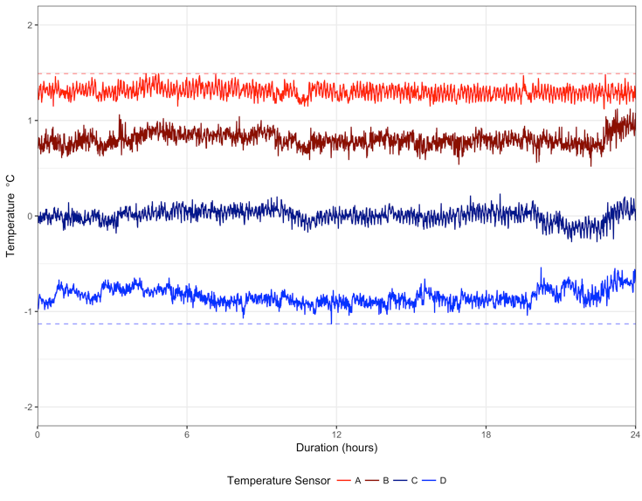

**Figure 1** - Recorded temperature in the thermal gradient tank over a period of 24hrs, with four temperature sensors located 107cm apart starting from the warm to the cold end of the tank. The dashed red and blue lines indicate the maximum upper and lower minimum temperature limits of the thermal gradient tank, which will be used in subsequent graphs to demark the testing limits of the thermal gradient tank.

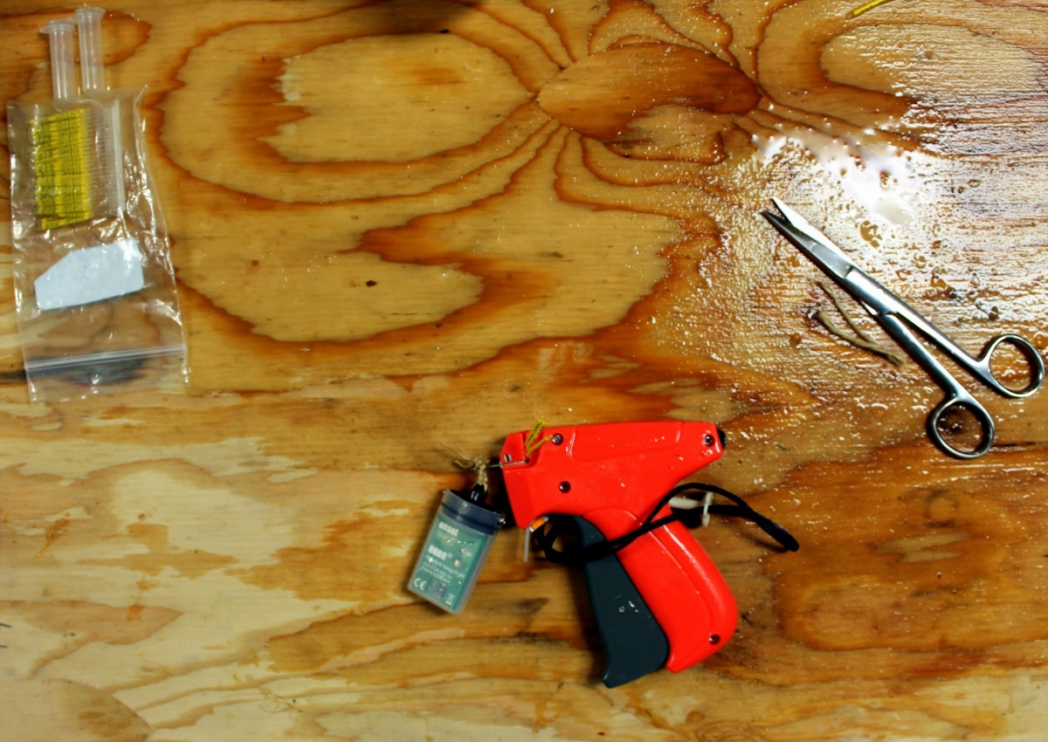

**Figure 2** - Tagging gun with the temperature logger ready to be attached onto a fish.

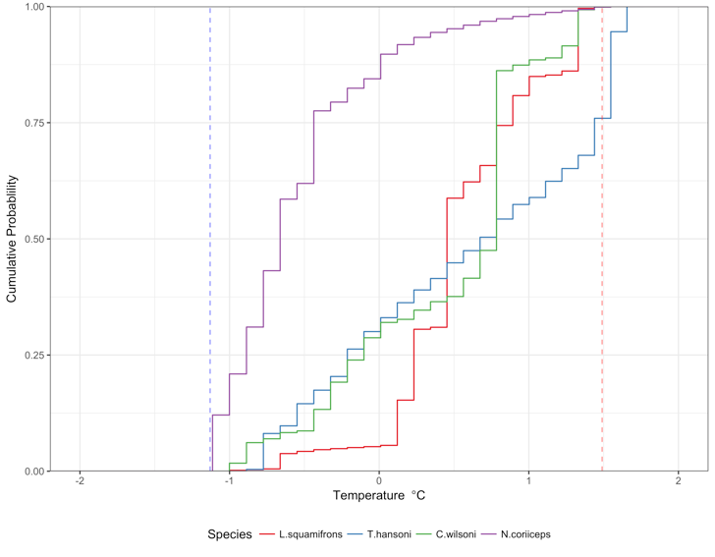

**Figure 4** – EDF plot of each species pooled time series data. The dashed red and blue lines indicate the maximum upper and lower minimum temperature limits of the thermal gradient tank.

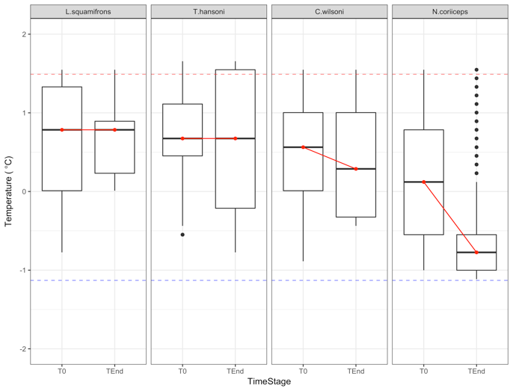

**Figure 5** - T0 and Tend distributions for each species. The dashed red and blue lines indicate the maximum upper and lower minimum temperature limits of the thermal gradient tank.

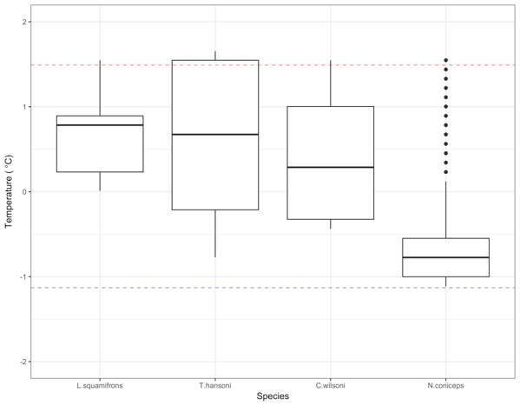

**Figure 6** - Tend distributions used to determine the thermal preference for each species. The dashed red and blue lines indicate the maximum upper and lower minimum temperature limits of the thermal gradient tank.

**Figure 1** - Onsite XBT temperature profile of the water column at locations where L. squamifrons was caught. Location coordinates for each measurement: Bismark Strait (-64 52.45801, -63 39.5166) Dallman Bay (-63 55.85107 -62 48.50049), Gerlache Strait (-64 43.35596, -63 1.41016).

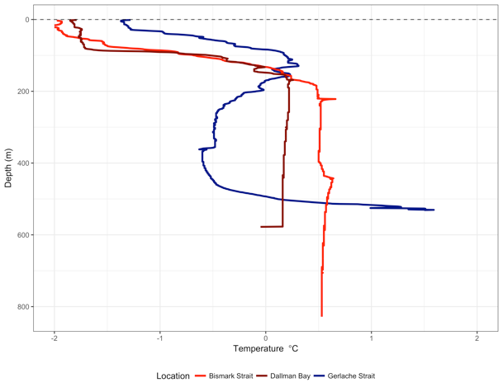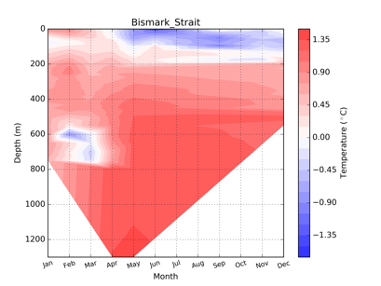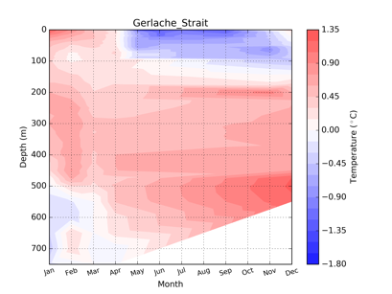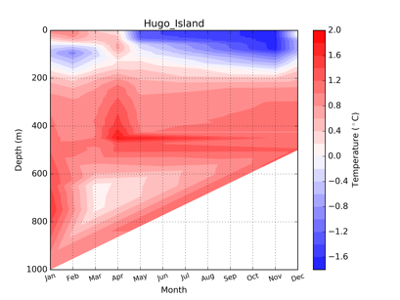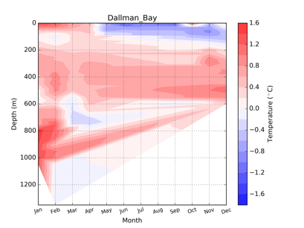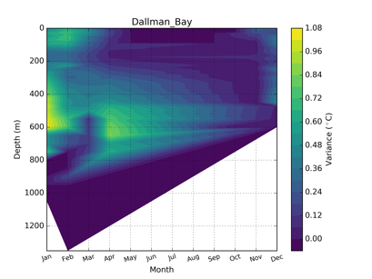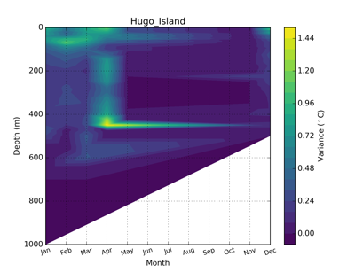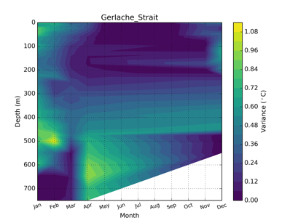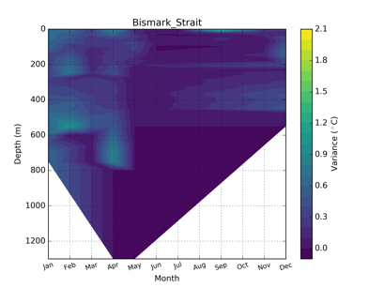

**Figure 7** – (Top row) Year round water column thermal profile (C) generated from historical data within 1 decimal degree radius of catch site locations. (Bottom row) Variance of year round water column thermal profile data for each site.