Assignment 3:

Task 1:

Task 2:

Task 3:

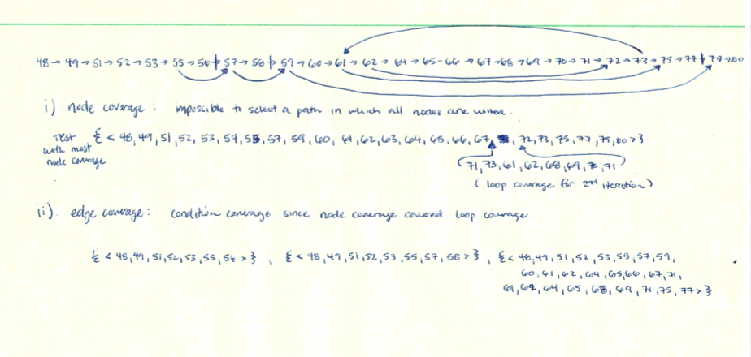

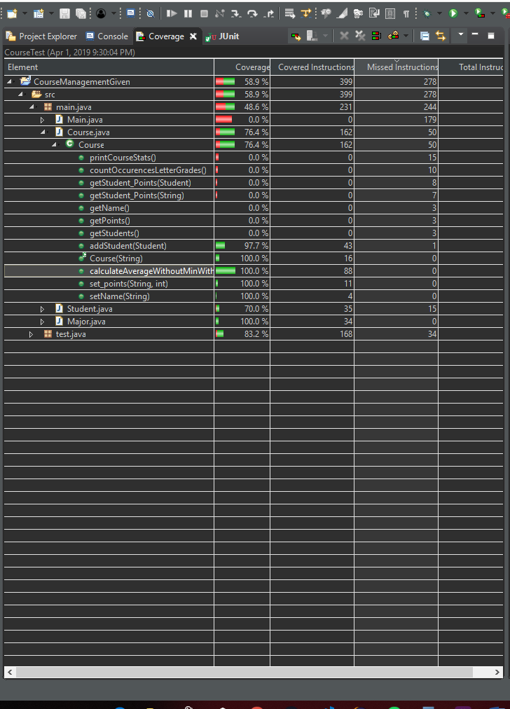

7. c)  
 ii). Overall Code Coverage: 53.9%  
 iii). Coverage for Course.java: 76.4%  
 v). 97%, 100%, 100% for the 3 methods.

Task 4:

