Assignment 4: Static Analysis  
  
Task 1: Style Checking using Checkstyle

#10

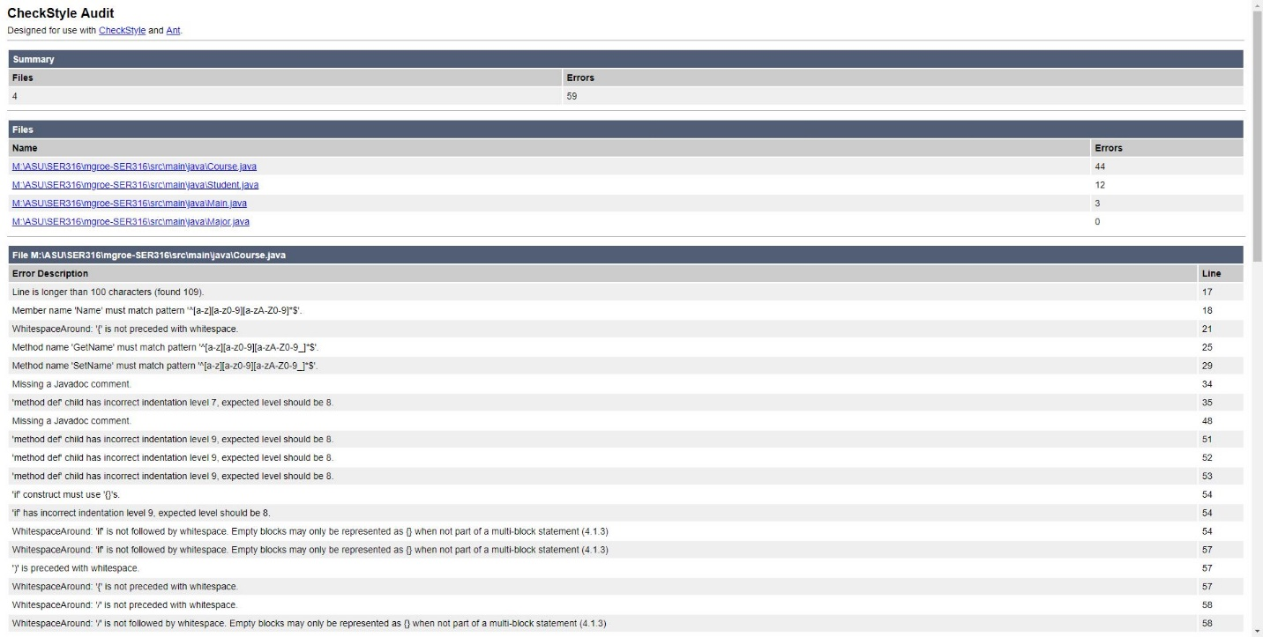

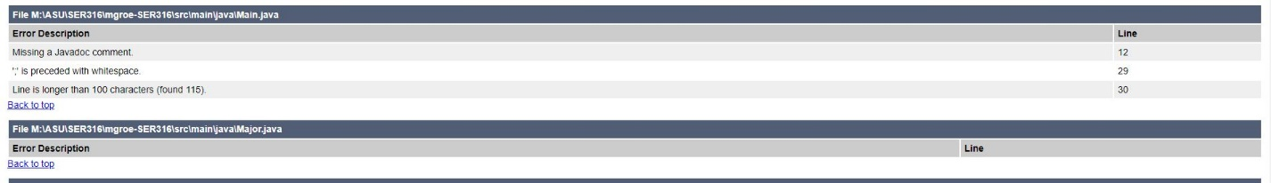

#11

The amount of errors within the Main section of the Checkstyle report was 59. There are 0 errors in Test based on the gradle report.

#12

There were 13 less errors in the Checkstyle test after changing from tabs to spacing in eclipse.

#15

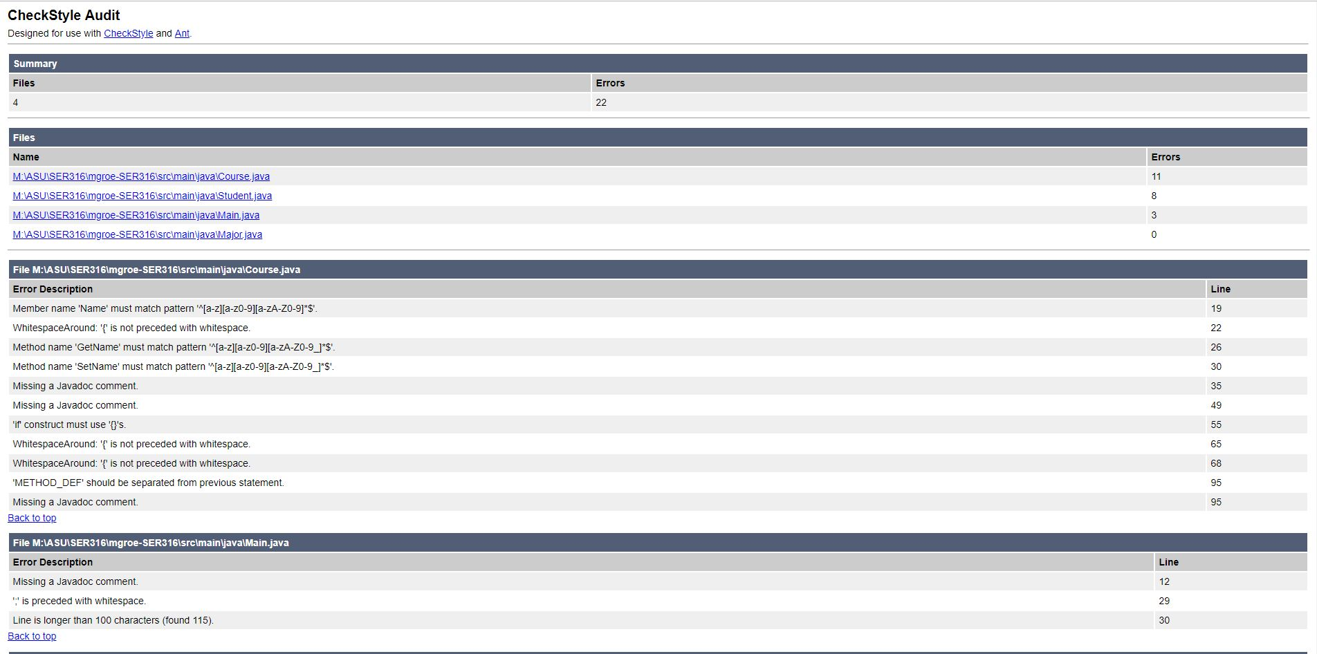

#16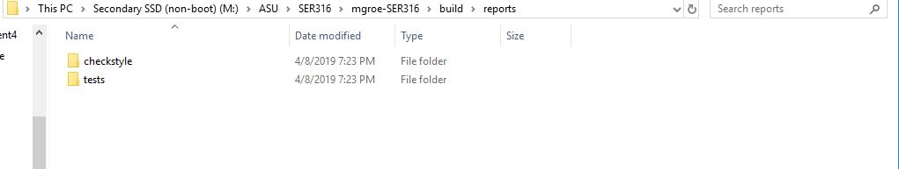

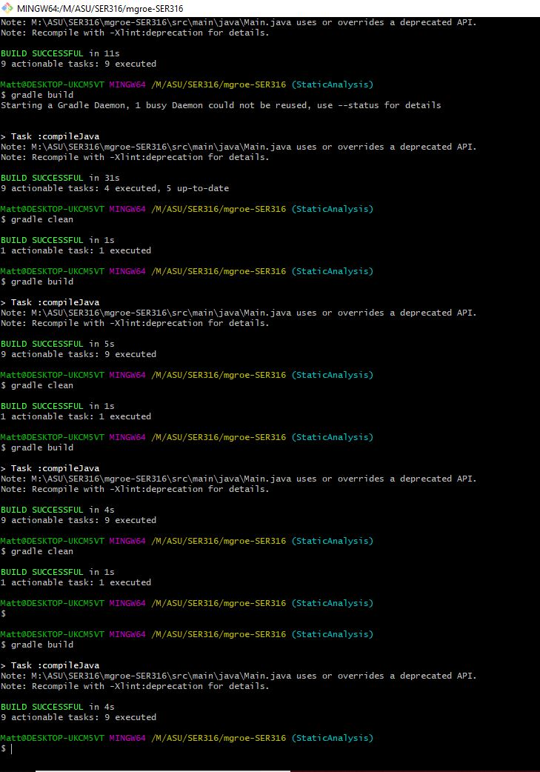

Task 2: Static Analysis using Spotbugs  
Task 2.1:

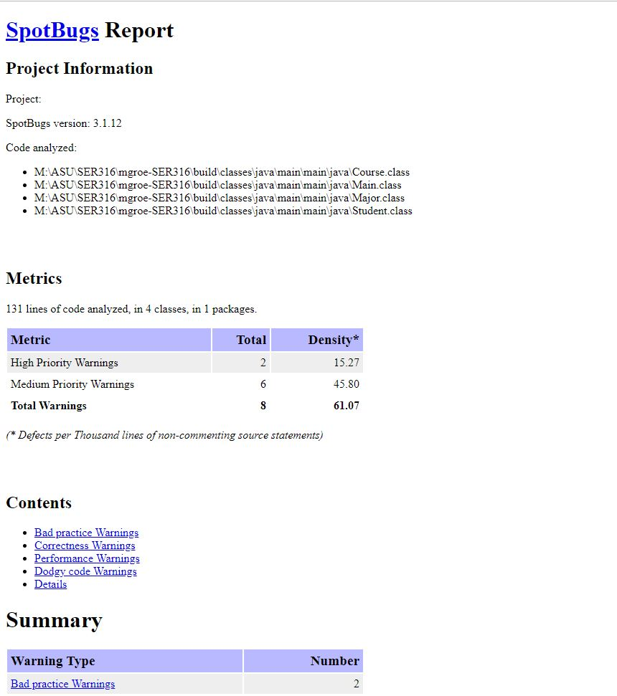

Task 2.2:

