Thrust Modelling:
Using a motor thrust stand from the flight lab, we measured the thrust output force of our motor and propeller combination for different PWM values as shown below.

Frequency = 5000
PWM Value | % | Thrust (g) | Current (amps)
13 | 5 | 6 | 0.22
26 | 10 | 14 | 0.47
51 | 20 | 30 | 0.86
77 | 30 | 40 | 1.16
102 | 40 | 48 | 1.38
127 | 50 | 50 | 1.55
153 | 60 | 52 | 1.71
179 | 70 | 53 | 1.83
204 | 80 | 54 | 1.86
230 | 90 | 56 | 1.78
255 | 100 | 56 | 1.8

We also tested with different values for frequency, but they were all within general margin of error.

The graph of the data shown in the table above is shown below.

Comparing:
Looking at other group’s data, we see that they had more linear response with the thrust versus the PWM value/percentage. We think that this could be due to different capacitances on our board since we tried to get them as close to the original schematic values as possible and other groups just used the recommended replacement/substitute values. For C1 we used 5 parallel 10uF to get close to 47uF whereas we believe other groups used the suggested 10uF instead, and for C2 we found the 47nF capacitance while we think that other groups most likely used the suggested 0.1uF capacitance. For the 2.2uF capacitors we did use 1uF capacitors as replacements as suggested.
Konrad team:
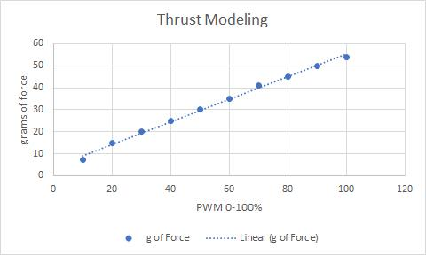
(They used PWM values 0-1023)

Clinton’s team:
