**CSCE 4523: Database Management Project: Report**

**Authors: Matthew Hartstein & Sai Sirigineedi**

**Date: 4/20/20**

Introduction:

The goal of this project is to practice creating a database back end with a web front end by using any technologies we prefer. We decided to use mysql on Turing as our DBMS and implemented our database from there (STUDENT table, COURSE table, and ENROLLMENT table). For our web server, we decided to use Apache running on Turing. As you can see, our website has been implemented along with six functions that all lead back to the home page; press the ‘Home’ button at the top. Lastly, we successfully completed this assignment by utilizing Java, HTML, PHP, and mySQL languages. The link to our home page is located below, as well as several screenshots that show the functionality of our website.

Home Page Links:

**csce.uark.edu/~mshartst/project_java/home.php**

**csce.uark.edu/~sssirigi/project_java/home.php**

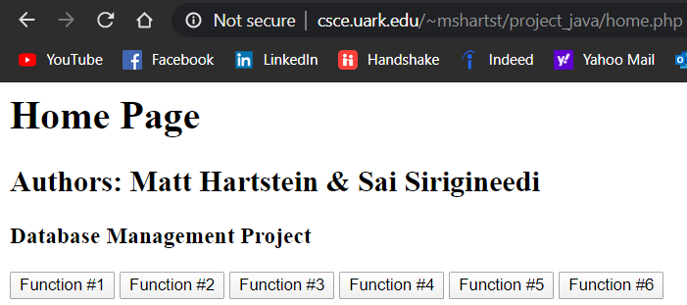

**Home Page (/home.php)**

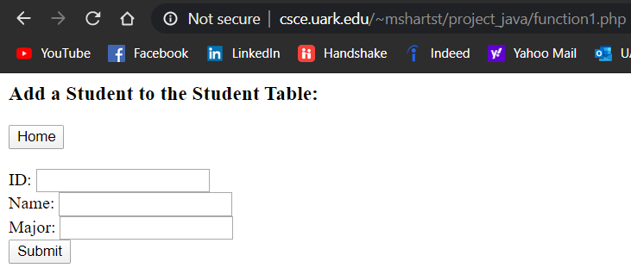

**Function #1 before Submit (/function1.php)**

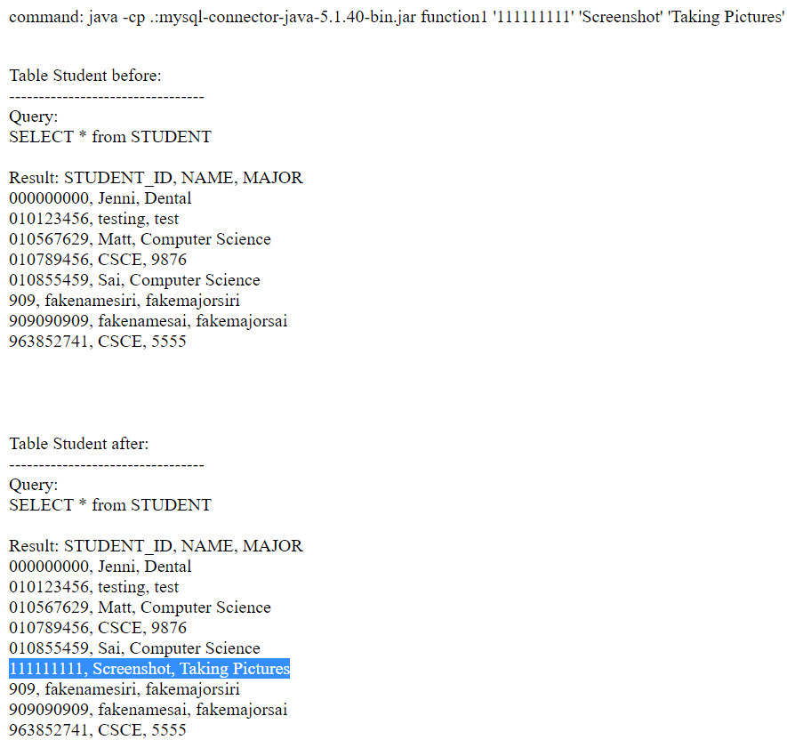

**Function #1 after Submit (/function1.php)**

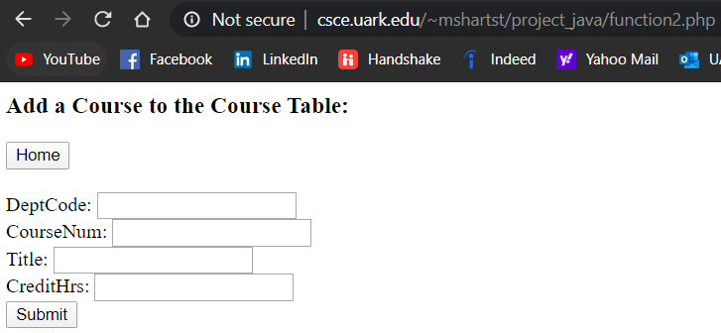

**Function #2 before Submit (/function2.php)**

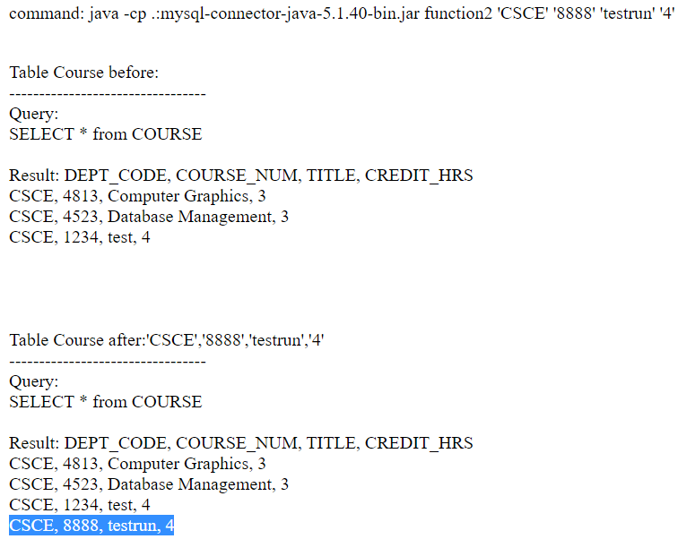

**Function #2 after Submit (/function2.php)**

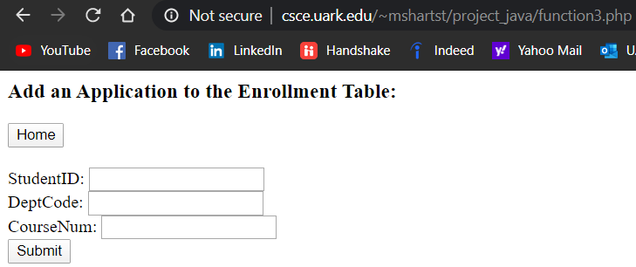

**Function #3 before Submit (/function3.php)**

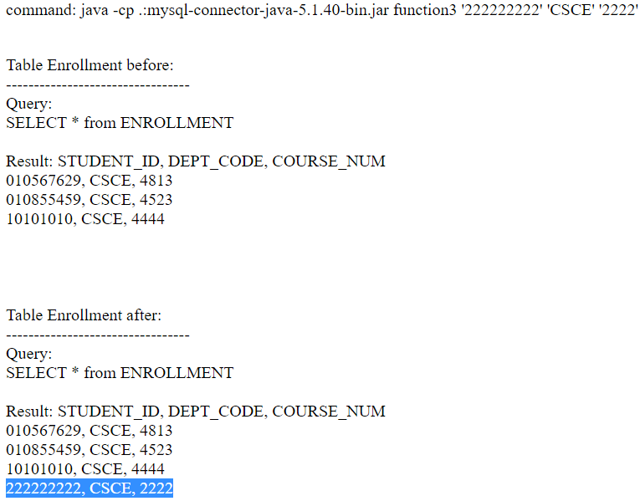

**Function #3 after Submit (/function3.php)**

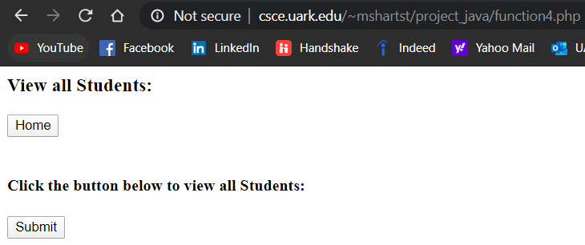

**Function #4 before Submit (/function4.php)**

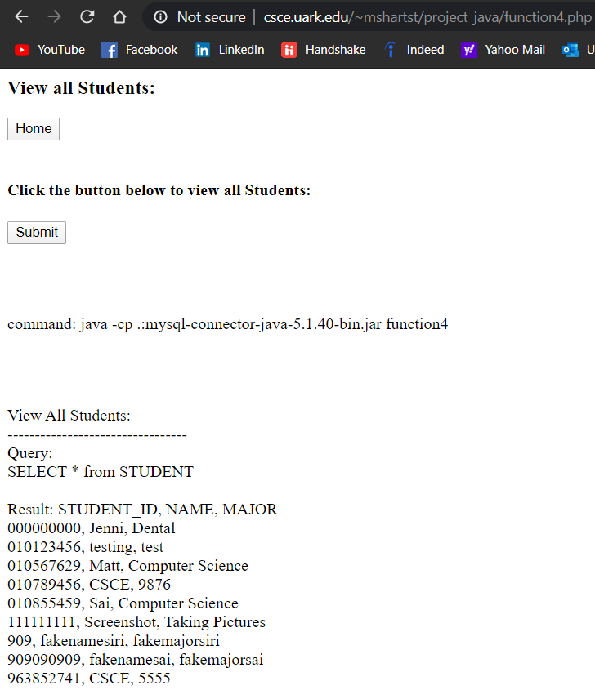

**Function #4 after Submit (/function4.php)**

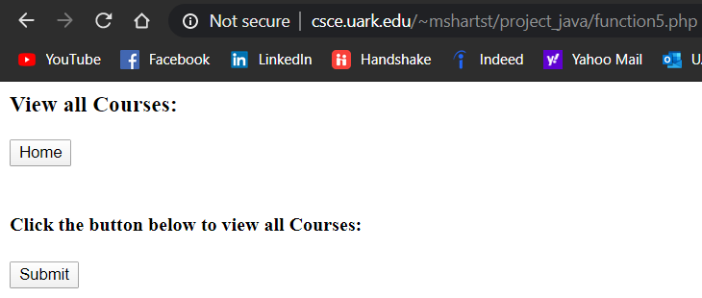

**Function #5 before Submit (/function5.php)**

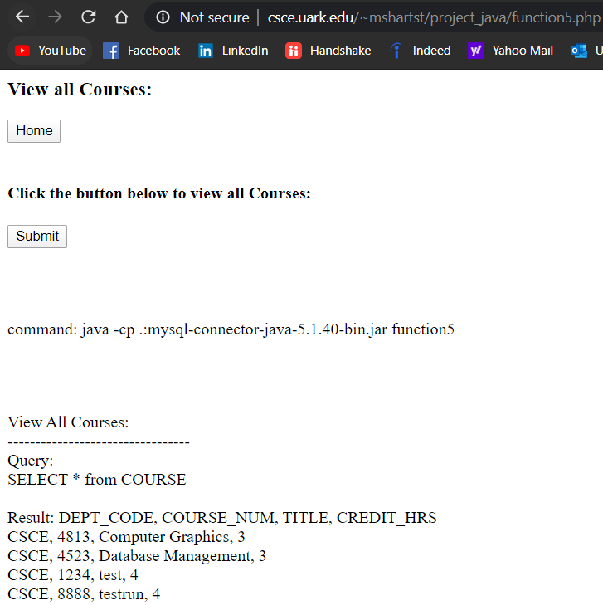

**Function #5 after Submit (/function5.php)**

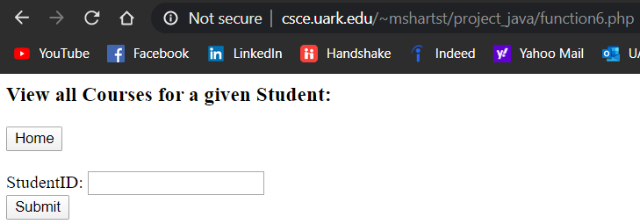

**Function #6 before Submit (/function6.php)**

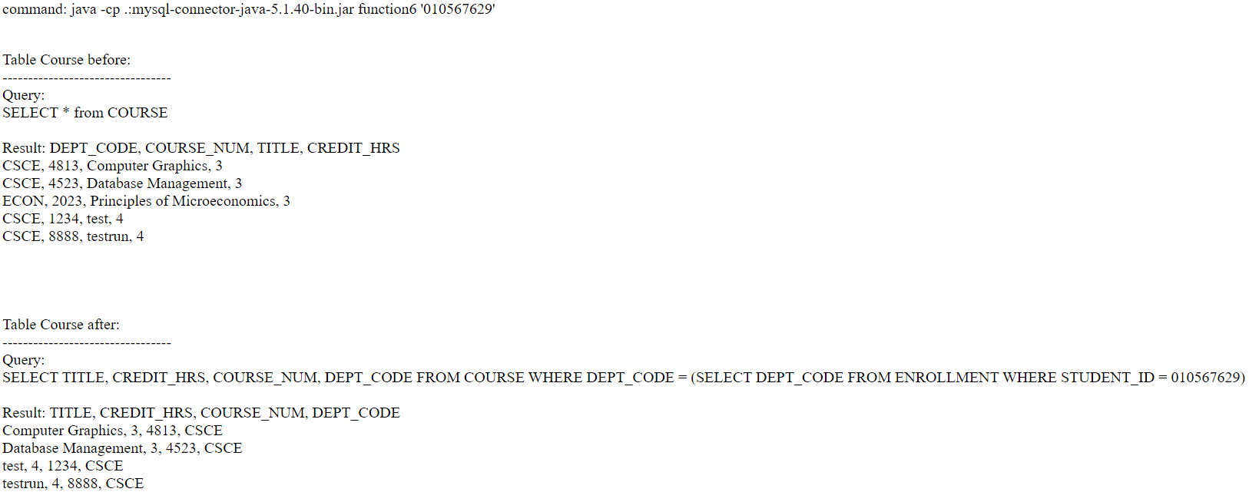

**Figure #6 after Submit (/function6.php)**

**Figure #6 Example 2 before Submit (/function6.php)**



**Figure #6 Example 2 after Submit (/function6.php)**

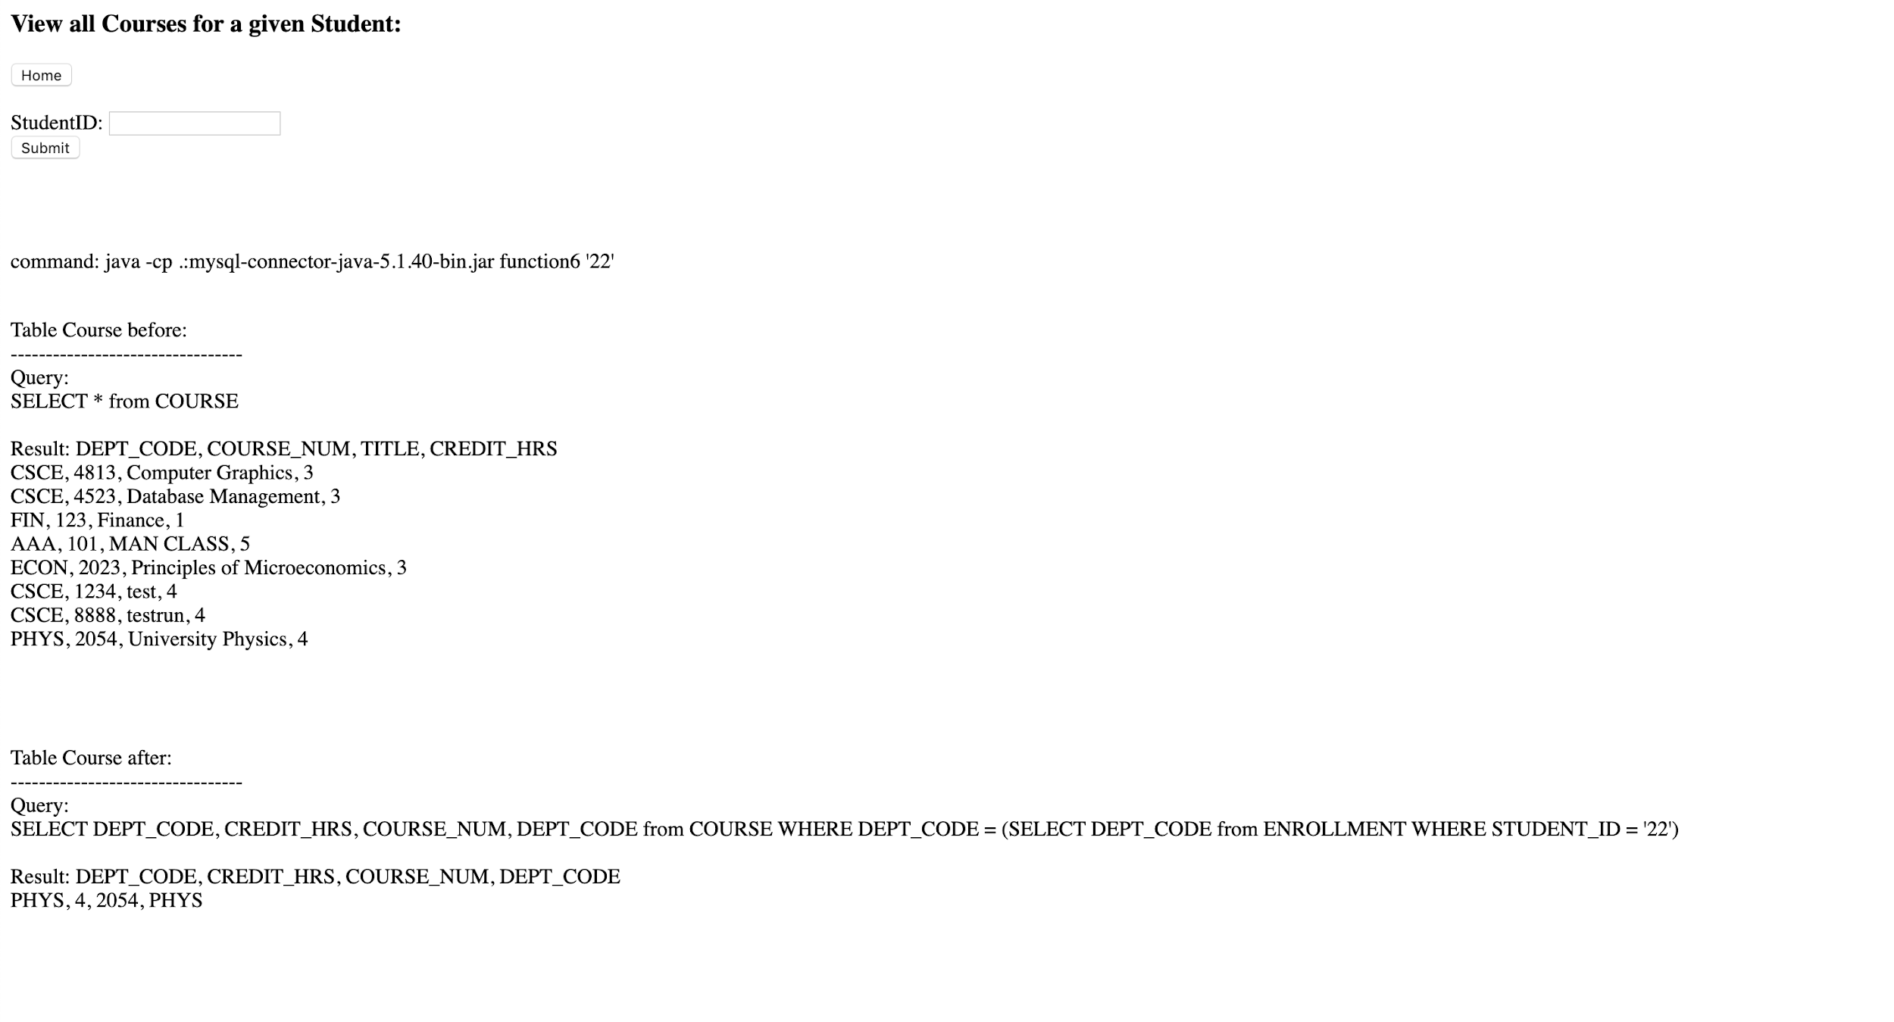

Conclusion:

Overall, we were able to finish the mySQL database, website design/hosting, and ⅚ required functions for this project. Regarding the last function, for some reason that we couldn’t work out, it only works when you create a new student and a new course and enroll it in the same session. We are both very satisfied with the final result and thought it was very applicable to our future careers. Matt worked on the web design, mySQL database implementation, Apache hosting via Turing, and functions 1, 2, 3, and 5. Sai worked on the mySQL database, web design, Apache hosting via Turing, and functions 4 and 6. In total, it took us around 8 hours to complete this assignment and we are extremely happy with the final result.