**Database Management Systems**

**Homework #4**

**Matthew S. Hartstein & Sailesh Sai Sirigineedi**

**Objectives:**

The goal of this assignment is to understand and practice using a high-level language (C++ or Java) to interact with a database via ODBC or JDBC; we decided to use JDBC and Java for this assignment.The primary goal is to write a program that runs from the command line. It interacts with an end-user to insert, delete, and update records, as well as handle queries on the data. This interface is fairly similar to Homework 1 and the database managed is the same as Homework 3.

**Approach:**

To begin, we decided to use Java and JDBC to implement this homework assignment by integrating it with a mySQL database via Turing. Our strategy was to keep it as simple as possible, as well as to have clean and organized code that is very easy to comprehend. Our design involves a singular Java class that acts as an extension to the “Sample Java Code” source code that was provided to us on our class website.

First, we connected Java to the JDBC Library by using a mySQL connector, which was provided to us on our class website. After successfully connecting/linking our mySQL database to our Java application, we started the implementation process for the Menu of Operations. This step was fairly simple as we used a Switch Statement to perform certain tasks, given by the user’s input. Acceptable inputs are as follows: 1, 2, 3, 4, 5, 6. A number that doesn’t fall within this range and/or if there’s an incorrect data type, such as a String or Char, the program will return an error message, followed by a termination. Therefore, it is important the user correctly enters an acceptable input in order for the program to work as expected.

Focusing on the Menu of Operations, we were instructed to implement the following actions: (1) Find all agents and clients in a given city, (2) Add a new client, then purchase an available policy from a particular agent, (3) List all policies sold by a particular agent, (4) Cancel a policy, (5) Add a new agent to a city, and (6) to quit. As you will tell, we were only able to implement options 1, 3, 5, and 6 for this assignment due to the ongoing COVID virus that blindsided our society.

Overall, it was very important for us to implement our program in a professional way by including comments, classes, functions/methods, proper indentation, white space management, as well as mnemonic variable names. We were careful to implement each function one at a time and then tested each of them to ensure proper functionality. On another note, we have collected several test cases (as screenshots) that clearly show that the majority of our program works as expected, per the problem statement. In the next section, we will discuss how we managed error handling techniques, what worked well and what didn’t, as well as the roles of each member.

**Results:**

As previously mentioned, plenty of error handling was used throughout the implementation process associated with this homework assignment. As instructed, each function/method was carefully implemented, then checked and verified by using numerous error handling techniques, such as simple “cout” statements, comparing expectations to actual results, as well as proper queue handling to avoid abnormal errors.

As an optimist, I will first discuss what went well with this assignment. After some trial and error, we easily were able to connect Java to our mySQL Database via Turing by using the files Dr. Gauch provided to us on our class website. The T.A.’s did a phenomenal job at simplifying this process for the both of us. Once we connected our Java Application to mySQL via Turing, the tables from the last homework assignment became available for us to use and manipulate for this homework assignment. Constant communication and source sharing via GitHub was utilized to stay organized and up-to-date. The overall program was organized in a way that each task had its own method and would revert back to the menu to make it more organized. Displaying the tuples that were requested by the SQL query also went well. The program was easily able to display the name, type, and commission percentage of all the policies that were sold by the specified agent. As for what went wrong, we were only able to finish 5/6 Menu Options.

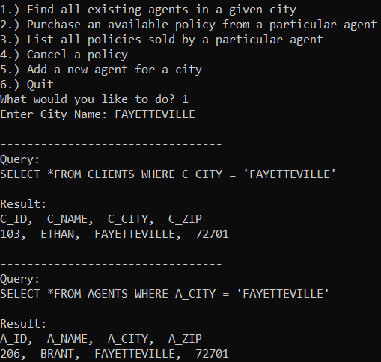

**Option #1: Find all existing agents in a given city.**

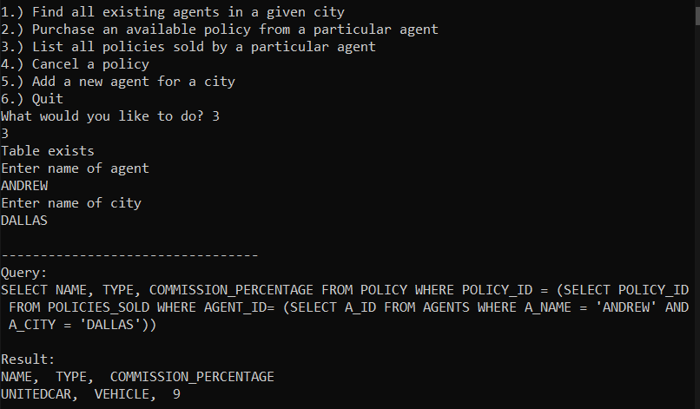

**Option #3: List all policies sold by a particular agent.**

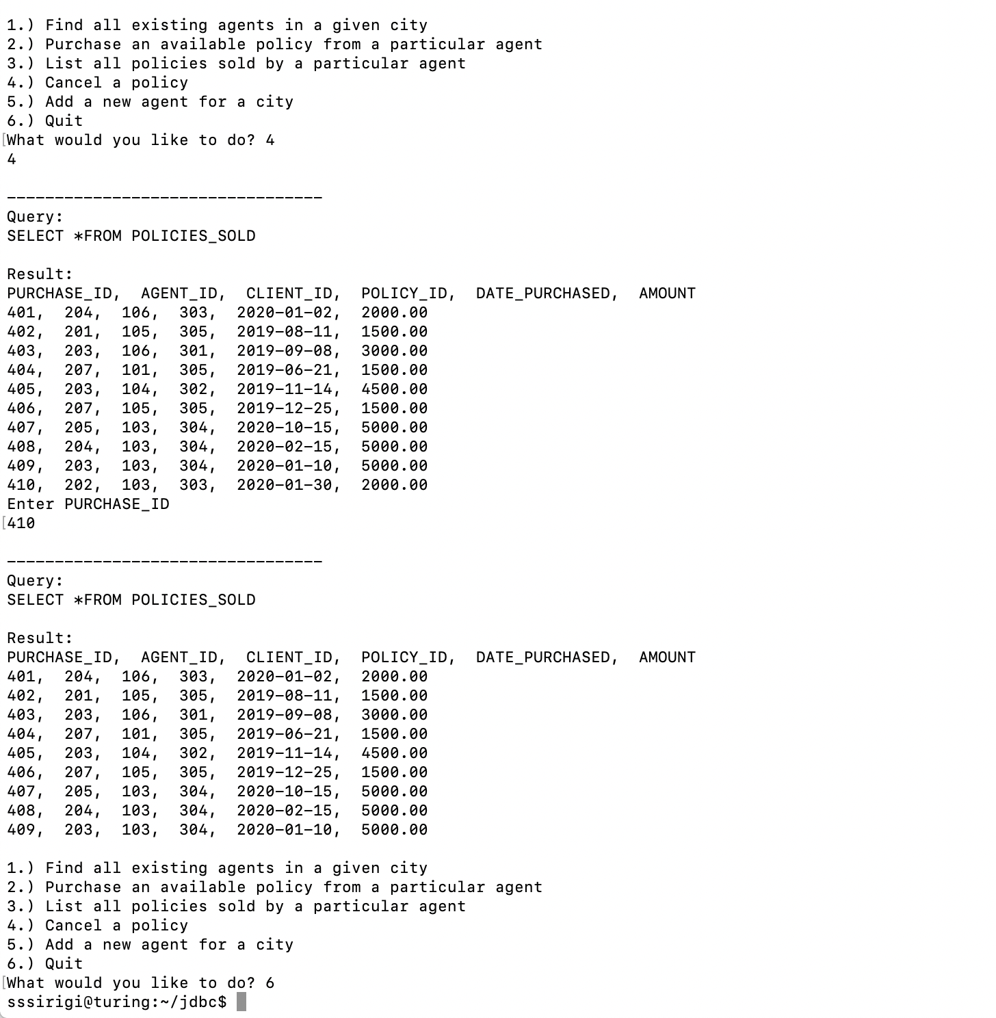

**Option #4: Cancel a policy.**

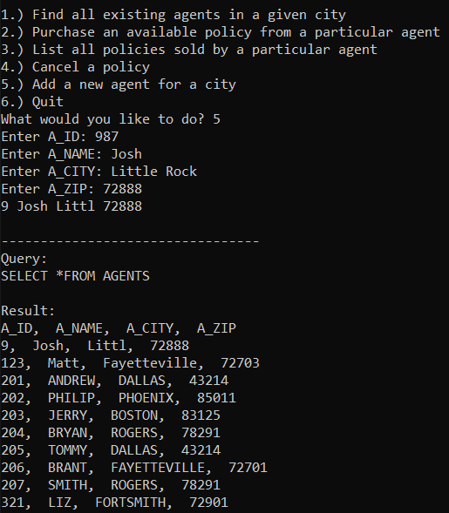

**Option #5: Add a new agent for a city.**

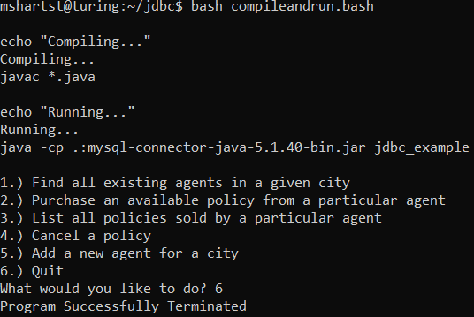

**Option #6: Quit (Also disconnects as expected).**

**Conclusion:**

The overall result of this assignment involves 5/6 properly working Menu of Operation functionalities with screenshots that prove our program works as expected. Due to the ongoing Coronavirus plus Spring Break, we were very limited on available resources to fully complete this assignment. With that being said, we tried our absolute best and wish we had a little more time to fully-finish this assignment. Overall, we both agree that the assignment was a success and deserves a passing grade.

If we were to restart this assignment, some things we would have done differently include modeling our workflow, which was taught in Software Engineering. I believe a SCRUM Agile Method would have worked extremely well (as it has before with previous assignments). Despite this, each team member properly and consistently communicated with each other to ensure a quality product. GitHub was used to share private repositories that contained our source code, updates, and comparisons. Visually mapping out Object-Oriented Programming (classes) would have been extremely helpful if we had decided to use multiple classes. But, as mentioned, for the sake of simplicity, we decided to stick with one class for this homework assignment. In total, it took us roughly 20 hours to complete this assignment and we both feel very accomplished and proud of our work, as well as getting the chance to apply the information that we’ve learned in this class thus far to a real-world, applicable database management system integrated with Java.