Understanding Your Retirement Plan
A plain-English guide to every concept, setting and result in the Retirement Planner
From the big picture of lifetime money management to the individual settings that drive it
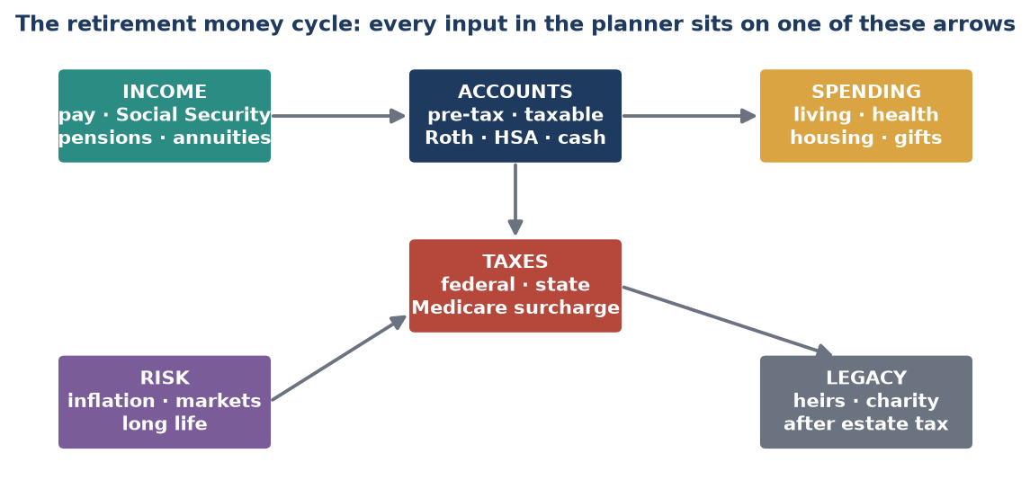
Figure 1. The whole system on one page.

Prepared from the planner's own inputs, calculations and screens. Rates and thresholds shown are illustrative; the planner uses the figures in your tax and economic assumptions.

Contents

How to use this guide
Part 1. The big picture
What a retirement plan actually answers
The three buckets
The ages that matter
How the planner runs each year
Tax brackets in one picture
Social Security timing
Probability, not prediction
Scoring a plan
Five rules of thumb the planner makes visible
Part 2. Concepts, settings and results
1. Household & Timeline
2. Economy & Assumptions
3. Income
4. Spending & Healthcare
5. Housing & Real Estate
6. Accounts, Holdings & Allocation
7. Withdrawals & Cash Flow
8. Taxes
9. RMDs & Roth Conversions
10. Charitable Giving
11. Insurance, Care & Special Situations
12. Estate & Legacy
13. Risk, Stress Tests & Probability
14. Decision Scores & Scenarios
Appendix. Acronym and term index

(To add page numbers, right-click the list in Word and choose Update Field.)

How to use this guide
This guide has two layers. Part 1 is the macro view: why retirement planning is hard and how the pieces fit. Part 2 is the micro view: every concept and setting in the planner, grouped by topic, with a plain-English explanation, the other settings it works with, and where to find it on screen.

How each entry is laid out
Term  A short description in under ten words.  A plain-English explanation, using everyday comparisons and a small example where useful.  Works with: the other settings that move when this one moves.  Find it: the screen and the label shown beside the field in the app. [Name] stands for a household member's first name, and “the Survivor fields” means every field whose label begins with Survivor. | Reading tips  - Start with the chapter's 'Big idea' box, then read the entries that matter to you.  - 'Works with' shows cause and effect: change one setting and watch the others.  - Where several versions exist (member 1 and 2, extra spending lines 1-5) they appear once.  - Acronyms are explained where first used and again in the index at the back.

Not financial advice. The planner is a modeling tool. This guide explains how it works so you can ask better questions of yourself and of your advisers.

Part 1. The big picture

What a retirement plan actually answers
Retirement planning is four questions asked over and over for 30+ years:
- Will the money last? Spending, inflation, returns and how long you live.
- What will I owe in tax? Which bucket you draw from decides the tax bill.
- What if things go badly? Bad markets, high inflation, big medical costs, early death of a spouse.
- What will be left? What heirs and charities receive after taxes.
Big idea: Money is only worth what you can spend after tax. Planning is mostly about choosing the order and timing of withdrawals so less goes to tax, and the plan survives bad luck.

The three buckets
Where savings sit matters as much as how much there is. Each bucket is taxed differently, and the planner decides which to draw from each year.
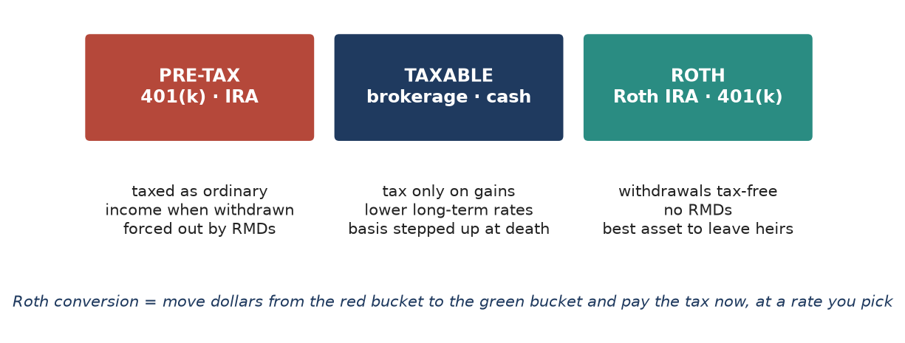
Figure 2. Three account types, three tax treatments.

The ages that matter
Most rules switch on at particular ages. The planner tracks each person's age separately and uses their birth year and month.
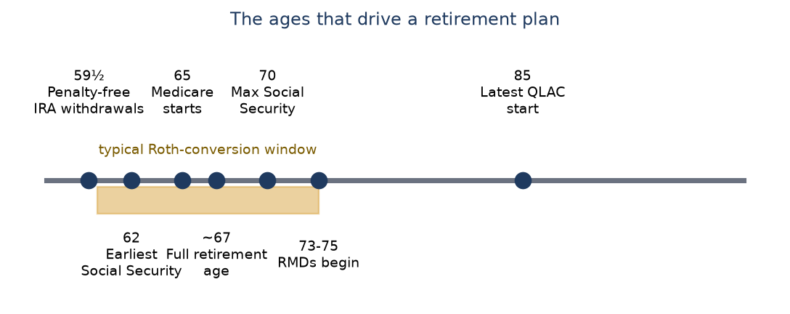
Figure 3. Key ages (thresholds are current law and are set in the planner's reference data).

How the planner runs each year
For every year of the plan, the engine repeats the same sequence. Knowing it helps you understand why a change in one setting ripples into others.
1. Age everyone and apply events - Retirement, death, home sale, divorce and other dated events happen.
2. Bring in income - Pay, Social Security, pensions, annuities, rent and required distributions (RMDs).
3. Set spending - Core budget grown by inflation, plus healthcare, housing and one-off items.
4. Decide conversions and deductions - Roth conversions, charitable gifts, standard versus itemized deduction.
5. Compute tax - Federal, state, payroll, investment surtax and Medicare surcharges.
6. Fund the gap - Draw from accounts in the chosen order; keep the cash reserve.
7. Grow balances - Apply returns to what remains; update net worth, liabilities and legacy.
Why it matters: Because tax in step 5 depends on income in steps 2 and 4, and step 6 depends on tax, the engine repeats parts of the sequence until the answer stops changing (a 'fixed point').

Tax brackets in one picture
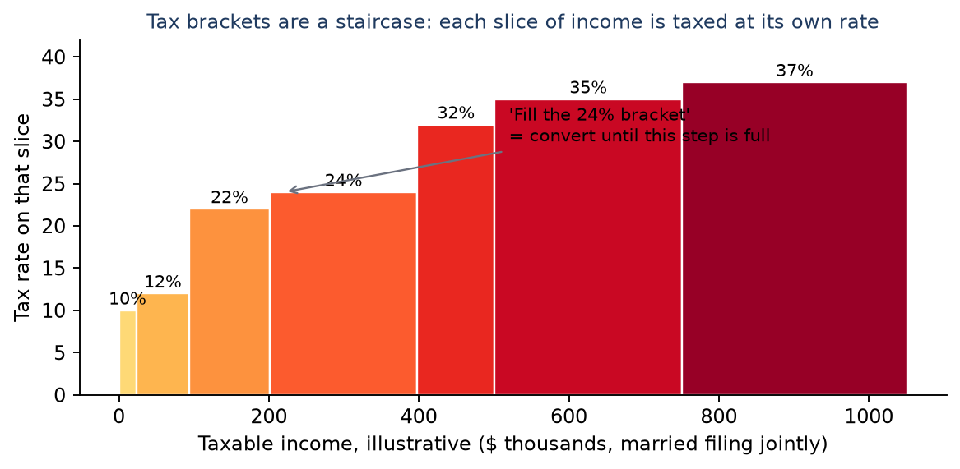
Figure 4. A staircase of rates - illustrative values, not current law.

Social Security timing
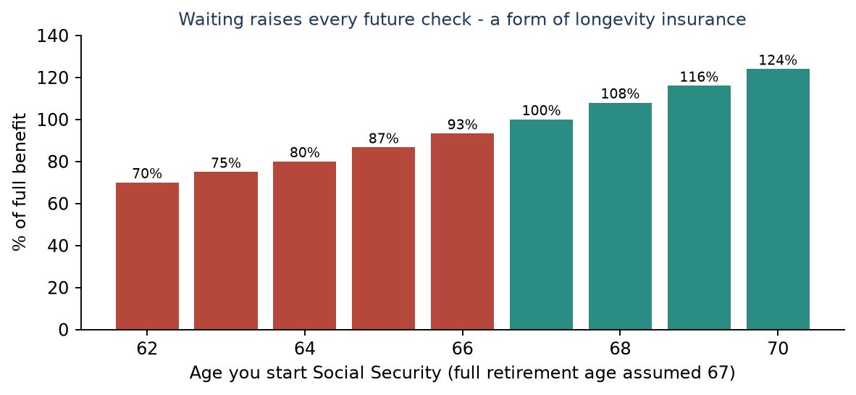
Figure 5. Claiming age versus benefit size.

Probability, not prediction
A single projection assumes average returns every year, which never happens. The Monte Carlo stress test runs hundreds or thousands of random futures and reports what share succeed.
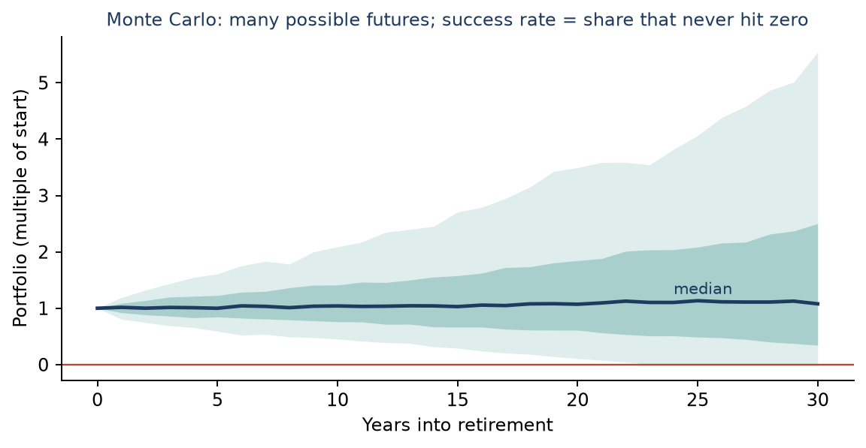
Figure 6. Each shaded band is a range of outcomes; the line is the middle path.

Scoring a plan
To compare strategies the planner uses one headline score that combines enjoyment and legacy. Taxes, medical costs and estate tax reduce both sides, which is why tax strategies show up as a higher score.
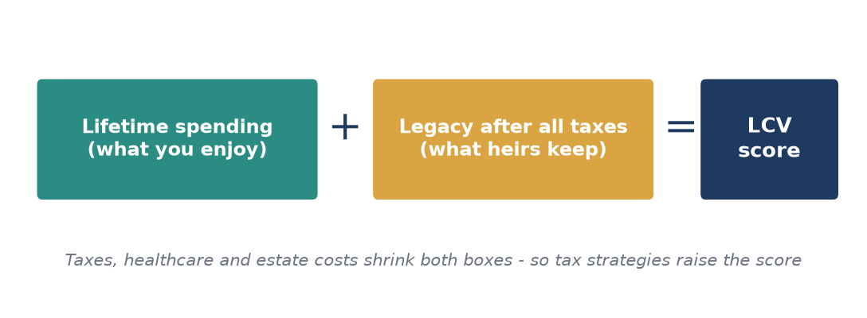
Figure 7. LCV, the Lifetime Consumption-and-Transfer Value.

Five rules of thumb the planner makes visible
- Spending matters most. A 10% cut usually beats a 1% extra return.
- Taxes are about timing. Paying tax at 12-24% in early retirement can avoid 32%+ later.
- Guaranteed income reduces fear. Social Security and annuities cover essentials so investments can take risk.
- Keep cash for bad years. A reserve avoids selling stocks at a low.
- Plan for the survivor. One person, one tax return with narrower brackets, and less household income.

Part 2. Concepts, settings and results
Each chapter opens with a one-paragraph overview, then lists its concepts and settings. Entries are deduplicated: one entry covers every version of a setting.

1. Household & Timeline
Who is in the plan and when things happen. Every other calculation hangs off these dates and ages.
Big idea: Think of this as the calendar on the wall: birthdays, retirement days, and how long the plan must last.
Plan members (member 1 / member 2) The one or two people the plan covers.
The planner models up to two adults. Almost every input comes in a 'member 1' and 'member 2' version (retirement date, claim age, RMD start). Names and nicknames are only labels.
Works with: Everything: ages, filing status, Social Security, RMDs. Find it: Household & People | [Name 1] and [Name 2] fields
Date of birth Starting point for every age-based rule.
Age decides when Social Security can start, when Medicare begins, when withdrawals become mandatory, and which senior tax breaks apply. The model uses the birth year and month, so a December birthday behaves differently from a January one.
Works with: Retirement date, claim age, RMD start age, Medicare, senior deduction. Find it: Household & People | [Name] DOB
Retirement date When paychecks stop and the drawdown begins.
Earned income ends here. From this point the plan must fund spending from savings, Social Security, pensions and annuities.
Works with: Work income, spending, Roth conversion window, healthcare bridge (ACA/COBRA). Find it: Household & People | [Name] Retirement Date
Planning horizon (mortality age) The age the plan is stress-tested to.
Nobody knows how long they will live, so you pick a conservative age (often 90-100). The plan is considered funded only if money lasts that long. Choosing a later age is safer but more expensive.
Works with: Spending, success probability, estate size, survivor assumptions. Find it: Household & People | [Name] Mortality Age
State of residence Which state taxes and rules apply.
States tax income, estates and retirement withdrawals very differently. Moving from a high-tax to a no-tax state can be worth six figures over a retirement. The State Comparison feature quantifies it.
Works with: State income tax, estate tax, housing costs, state-residency comparison. Find it: Household & People | Residence State; State Comparison
Filing status How the household files its tax return.
Married filing jointly, single, head of household, or married filing separately. It sets the size of every tax bracket and deduction. After the first spouse dies the survivor usually becomes 'single', which narrows the brackets (the 'widow's penalty').
Works with: Tax brackets, standard deduction, IRMAA, NIIT, survivor filing status. Find it: Household & People | Filing Status, Survivor Filing Status, Survivor Has Dependent
Survivor assumptions What the household looks like after one death.
When one spouse dies, some income stops, expenses fall only partly, and the tax return becomes single. A surviving spouse with a dependent child can keep joint brackets for two years (QSS).
Works with: Filing status, Social Security survivor benefit, annuity survivor options, estate. Find it: Household & People; Stress Test > Survivor | the Survivor fields

2. Economy & Assumptions
The 'weather forecast' for the plan: inflation, investment returns and how rules change over time.
Big idea: These numbers are guesses about the future. Small changes compound over 30 years, which is why the planner lets you stress them.
General inflation Yearly rise in everyday prices.
At 3% inflation, $100 of groceries today costs about $243 in 30 years. The planner raises spending by this rate each year so you can see money in both today's and future dollars.
Works with: Spending growth, Social Security COLA, tax bracket indexing, real vs nominal reporting. Find it: Economic & Tax Assumptions | General CPI Inflation
Nominal portfolio return Expected yearly growth before inflation.
The average yearly gain assumed on investments, before subtracting inflation. 'Real' return is nominal minus inflation, and is what actually increases buying power.
Works with: Allocation, Monte Carlo (average), account growth. Find it: Economic & Tax Assumptions | Portfolio Nominal Return
Social Security COLA Yearly raise applied to Social Security checks.
Cost-of-living adjustment: Social Security benefits rise with inflation, so this normally tracks inflation.
Works with: Social Security income, inflation. Find it: Economic & Tax Assumptions | Social Security COLA
Medicare premium inflation Yearly rise in Part B and Part D premiums.
Medicare premiums have historically grown faster than general prices, so they have their own rate.
Works with: Healthcare spending, IRMAA surcharges. Find it: Economic & Tax Assumptions | Medicare Part B Inflation, Medicare Part D Inflation
Tax bracket inflator How fast tax brackets widen each year.
Federal brackets and deductions are raised yearly with inflation. This sets that pace beyond the years the law already specifies.
Works with: All taxes, Roth conversion room, standard deduction. Find it: Economic & Tax Assumptions | Fed Tax Bracket Inflator
Social Security taxable fraction Share of Social Security counted as taxable.
Up to 85% of benefits can be taxed depending on other income. This is a simplifying setting used where the full formula is not applied.
Works with: Taxable income, AGI, Social Security income. Find it: Economic & Tax Assumptions | Social Security Taxable Fraction
Cash yield Interest earned on cash balances.
Cash earns little but is safe. This is the rate applied to the cash reserve and cash holdings.
Works with: Liquidity buffer, cash holdings. Find it: Economic & Tax Assumptions | Cash Yield Rate
Real-dollar reporting Show results in today's purchasing power.
A million dollars in 2056 buys much less than today. Real reporting divides future values by cumulative inflation so results feel comparable.
Works with: Inflation, all result tables. Find it: Settings / Reporting | Real Dollar Reporting Enabled
Annuity default dividend rate Assumed yearly dividend on participating annuities.
Some annuities pay a variable dividend on top of the guaranteed income. This is the default used until you enter a carrier illustration.
Works with: Annuity income, PDIA scenarios. Find it: Economic & Tax Assumptions | Annuity Default Dividend Rate, Annuity Default Additional Income

3. Income
All money coming in: pay, business profit, Social Security, pensions and annuities.
Big idea: Income is the faucet. In retirement the faucet narrows, so the plan decides which buckets of savings to open to replace it.
Earned income Salary or self-employment pay until retirement.
Pay stops at the retirement date or last-year setting. It is taxed, may be reduced by 401(k) deferrals, and drives Social Security credits.
Works with: Retirement date, payroll tax, 401(k) contributions, taxable income. Find it: Work Income | Annual Earned Income, Earned Income Start Year, Earned Income Last Year, Earned Income Annual Increase
Business entity & QBI How a business is taxed and its 20% deduction.
Sole proprietors, LLCs and S-corporations are taxed differently. Qualified business income (QBI) allows up to a 20% deduction on pass-through profit, with income limits.
Works with: Self-employment tax, payroll tax, taxable income. Find it: Work Income | Entity Type, QBI Eligible, QBI Phaseout Applies, Reasonable Salary Annual, Business Expenses Annual
Self-employment health insurance Deduction for health premiums paid by the owner.
Self-employed people can deduct health premiums, lowering income tax (not payroll tax).
Works with: Taxable income, S-corp wages. Find it: Work Income | Health Insurance Premiums Annual, SEHI Added To W-2
401(k) contribution Pre-tax savings from your paycheck.
Money put into a 401(k) is not taxed now but is taxed when withdrawn. It lowers today's tax bill and grows the pre-tax bucket.
Works with: Taxable income, pre-tax balance, RMDs, contribution limits. Find it: Work Income | Monthly 401(k) Contribution, Annual 401(k) Limit Base Year, Index 401(k) Limit
Payroll tax Social Security and Medicare tax on wages.
Taken from each paycheck (about 7.65% employee share) and doubled for the self-employed. Extra Medicare tax applies at high incomes.
Works with: Earned income, self-employment income. Find it: Economic & Tax Assumptions | SS Employee Rate, Medicare Employee Rate, SS Wage Base Base Year, Additional Medicare Rate, SE Net Earnings Factor
Social Security claim age Age at which benefits start.
Claiming at 62 gives about 70% of the full benefit; waiting until 70 gives about 124%. Waiting costs years of checks but increases every later check, which acts like longevity insurance.
Works with: Full retirement age, PIA, survivor benefit, taxes, Social Security timing analysis. Find it: SS, Pensions & Annuities | Claim Age, FRA Age
Primary Insurance Amount (PIA) Your base monthly benefit at full retirement age.
Your lifetime earnings are converted into this one figure. Early claiming reduces it and late claiming increases it. It is entered in today's dollars and grows with COLA.
Works with: Claim age, COLA, spousal and survivor benefits. Find it: SS, Pensions & Annuities | Monthly at FRA, Benefit at 62 through Benefit at 70
Spousal and survivor benefits Social Security paid on a spouse's record.
A lower earner can receive up to half of the higher earner's benefit, and a survivor keeps the larger of the two checks. The survivor percentage and claim-age rule decide how much.
Works with: Claim age, death year, filing status. Find it: SS, Pensions & Annuities | Spousal Benefits Enabled, Survivor % of Higher Benefit, Survivor Benefit Uses Deceased Claim Age
Social Security funding haircut Possible future benefit cut.
The trust fund is projected to run short; this lets you assume a percentage cut starting in a chosen year to test dependence on the program.
Works with: Social Security income, stress tests. Find it: SS, Pensions & Annuities | Discount Starts, Benefit Reduction
Pension / annuity income stream A fixed payment for life or a term.
Annuities convert a lump sum into guaranteed income. Inputs define when it starts, whether it grows, what share is taxable, and what a surviving spouse receives.
Works with: Taxable income, survivor options, spending coverage, estate. Find it: SS, Pensions & Annuities; Insurance | First Payment, Payout Type, Qualified, Joint-and-Survivor Percentage, Cumulative At Death
Annuity reserve factor & exclusion ratio Price-and-tax rules inside an annuity.
The reserve factor estimates what an annuity is worth today (its reserve). The exclusion ratio splits each payment into tax-free return of your own money and taxable earnings.
Works with: Annuity value in net worth, taxable income. Find it: Insurance | Reserve Factor, Exclusion Ratio, Deferral Dampening, Principal Recovery Age
Participating deferred income annuity (PDIA) Annuity that starts later and shares in dividends.
You pay now and income starts years later, usually boosted by dividends. Useful to protect against living very long.
Works with: Dividend rate, deferral years, QLAC, spending coverage. Find it: Insurance | Dividend Rate, Additional Income, Deferral Years, Pay In Cash
Note receivable Money someone owes you on a schedule.
A loan you made (for example to a family business) pays principal and interest over time, which counts as income and as an asset.
Works with: Net worth, taxable interest, legacy. Find it: Other Assets and Liabilities | Face Value, First Payment, Last Payment

4. Spending & Healthcare
Money going out: everyday living, one-off events and healthcare.
Big idea: Spending is the single biggest driver of whether a plan works. A plan that cuts spending 10% usually improves more than one that raises returns by 1%.
Annual spending (base year) Core living costs in today's dollars.
The starting yearly budget before inflation. The plan grows it each year with inflation or a manual growth rate, and can slow it with age.
Works with: Inflation, spending multiplier, withdrawals, taxes. Find it: Spending Model | Core Spending Base, Core Spending Increase Method, Manual Core Spending Increase
Spending multiplier Scale spending up or down in a scenario.
1.10 means spend 10% more. Used in what-if scenarios and stress tests.
Works with: Scenarios, success probability. Find it: Scenarios | Spend Multiplier
Spending freeze year Year after which spending stops rising.
Real-life spending often flattens in the late years. This setting stops growth at the chosen year.
Works with: Spending growth, longevity. Find it: Spending Model | Core Spending Increase Stops
Extra spending events One-off or time-limited expenses.
Weddings, cars, travel years, gifts. Each has a type, amount, year or a start and end year.
Works with: Withdrawals, taxes (to raise cash). Find it: Spending Model | Extra Spending Type, Extra Spending Amount, Extra Spending Year, Extra Spending Start Year, Extra Spending End Year
Healthcare costs (wellness) Premiums plus out-of-pocket medical spending.
Includes Medicare Part B and Part D, supplemental (Medigap) premiums, and a yearly out-of-pocket estimate with a utilization percentage. This estimate is a planning reference; the detailed medical, dental, vision and pharmacy budget lines are what is actually spent.
Works with: Medicare inflation, IRMAA, medical tax deduction, HSA. Find it: Spending Model > Wellness | Annual Premium Base Year, Monthly Medicare Part B, Part D and Part G, Annual Household Medical OOP Cap, OOP Utilization, Annual Medical Out-of-Pocket, Annual Dental Out-of-Pocket, Annual Vision Out-of-Pocket, Annual Pharmacy Out-of-Pocket
ACA marketplace subsidy Premium help before Medicare starts.
People retiring before 65 can buy marketplace insurance. Subsidies depend on income relative to the poverty level, so higher withdrawals or Roth conversions can reduce the subsidy.
Works with: MAGI, Roth conversions, household size. Find it: Economic & Tax Assumptions (ACA); Spending Model | Household Size, Federal Poverty Level Base Year, Benchmark Silver Premium Annual, Applicable Cap, Enhanced Subsidies Through Year
COBRA bridge Employer coverage kept after leaving work.
A temporary monthly cost that fills the gap until other coverage starts.
Works with: Retirement date, healthcare costs. Find it: Scenarios | COBRA Monthly, COBRA End Year
Healthcare cost shocks Random big medical bills in simulations.
Monte Carlo can add occasional large medical costs with a yearly probability and an average cost.
Works with: Monte Carlo, success probability. Find it: Stress Test > Monte Carlo | Wellness Cost Shocks, Wellness Shock Annual Prob, Wellness Shock Mean Cost
Actual spending (year to date) This year's real transactions.
Imported transactions are compared to the budget. The 'blend' option mixes actual year-to-date with a projected remainder for the current year.
Works with: Annual spending, current-year taxes, net worth. Find it: Actual Spending | YTD Blend Enabled, YTD Remainder Spending Override

5. Housing & Real Estate
Where you live, what it costs, and property you rent out or sell.
Big idea: A home is both a place to live and a large asset. The model tracks it as spending and as equity that can be tapped or sold.
Home value & appreciation Current worth and expected growth.
Value today grows by an appreciation rate. Home equity counts in net worth but is not spendable until sold or borrowed against.
Works with: Net worth, home sale, HELOC, estate. Find it: Other Assets and Liabilities | Home Value, Appreciation Rate
Mortgage Loan balance, rate and payment on the home.
Each payment is part interest (potentially tax-deductible) and part principal. Balance falls over time, raising equity.
Works with: Spending, itemized deductions, net worth, liabilities. Find it: Spending Model > Housing | Current Monthly Mortgage Payment, Current Loan Amount, Interest Rate, Last Payment Date
Property tax, insurance, upkeep Ongoing home ownership costs.
Real estate tax, insurance, HOA, utilities and maintenance are separate lines and are all part of total housing cost. Property tax may also be deductible, within the SALT cap.
Works with: SALT deduction, total spending. Find it: Spending Model > Housing | Annual Real Estate Taxes, Homeowners Insurance Annual, HOA Annual Fee, Utilities Annual, Home Maintenance Annual
Home sale (downsize) Selling the house in a chosen year.
Sale price less selling costs less mortgage (and HELOC) becomes cash in a chosen account. Part of the gain may be tax-free under the Section 121 rule.
Works with: Sec. 121 exclusion, basis, selling cost, rent after sale, mortgage payoff. Find it: Other Assets and Liabilities; Scenarios | Home Sale Year, Home Sale Price, Home Basis, Commission %, Home Sale Proceeds Account, Monthly Rent Post Sale
Section 121 exclusion Tax-free gain on selling a main home.
Up to $500,000 of gain for a couple ($250,000 single) is excluded if the home was lived in for 2 of the last 5 years.
Works with: Home basis, sale price, taxes. Find it: Other Assets and Liabilities | Section 121 Exclusion MFJ
Cost basis What you originally paid, including improvements.
Gain equals sale price minus basis. Higher basis means less tax. For inherited assets, basis resets to the value at death (step-up).
Works with: Capital gains tax, step-up, estate. Find it: Other Assets and Liabilities; Investment Holdings | Home Basis, Basis, Cost Basis
Next housing move Compare buying, renting or relocating.
Tests purchase price, down payment, mortgage rate, rent, taxes and moving year for a future home and ranks candidate ZIP codes.
Works with: Home sale, mortgage, spending, state tax. Find it: Optimize > Next Housing Move | Purchase Price, Down Payment, Mortgage Rate, Monthly Rent, RE Tax Rate, HOA Fee %, Start Year, End Year
Rental property Real estate that produces rent.
Rent minus expenses, mortgage interest and depreciation gives taxable income or a loss. Depreciation lowers tax now but is partly recaptured at sale. Passive-loss rules limit how much loss can offset other income.
Works with: Taxable income, passive loss limits, sale taxes, net worth. Find it: Rental Properties | Value, Sale Year, Sale Price, Basis, Depreciation Per Year, Depreciation Years, Land Share
HELOC (home equity line) Borrowing against the home for large needs.
A credit line used to bridge big costs without selling investments. It carries a variable interest rate and must be repaid within a set period.
Works with: Withdrawal order, mortgage, net worth (liability). Find it: Home Equity Line | HELOC Enabled, HELOC Credit Limit, HELOC Draw End Year, HELOC Initial Rate, HELOC Rate Drift bps Yr, HELOC Repayment Years

6. Accounts, Holdings & Allocation
What you own, where it is held, and how it is invested.
Big idea: Think of three buckets with different tax flavors: pre-tax (taxed when withdrawn), taxable (taxed on gains) and Roth (tax-free).
Account types Pre-tax, taxable, Roth, HSA and cash.
The type decides when tax is due. Pre-tax IRAs and 401(k)s are taxed as ordinary income on withdrawal. Taxable brokerage pays capital-gains tax on growth. Roth withdrawals are tax-free. HSA is tax-free for medical costs.
Works with: Withdrawal order, RMDs, Roth conversions, taxes. Find it: Investment Holdings; Accounts & Sources
Tax lot (holding) One purchase of a security.
Each purchase has its own date, shares and cost basis, so selling a specific lot changes the tax. Lots held over a year get lower long-term rates.
Works with: Capital gains, tax-loss harvesting, basis. Find it: Investment Holdings | Ticker, Shares, Purchase Date, Basis
Prior-year-end balance Account value at the end of last year.
The starting point for measuring this year's growth and contributions. Header shows the actual year (for example 2025 year-end balance).
Works with: Current value, year-to-date growth. Find it: Accounts & Sources | Prior Year End Balance
Cash reserve (liquidity buffer) Cash kept untouched to avoid forced sales.
A set number of years of expenses held in cash so you never need to sell stocks in a crash.
Works with: Sequence-of-returns risk, withdrawals, cash yield. Find it: Reserve Requirements | Years Of Expenses, Start Year, End Year, Reserve Account
Asset allocation Mix of stocks, bonds, cash and other assets.
Higher stock share means higher expected return and larger swings. The planner can use your target mix or an optimizer's recommendation.
Works with: Portfolio return, Monte Carlo volatility, risk tolerance. Find it: Optimize > Asset Allocation | Target, Allocation Selection Mode, Equity, Cash, Commodity, Risk Tolerance, Glide Path
Holding-period and real-loss controls Settings that limit loss at the time you need money.
Bonds and cash are favored for money needed soon, and the optimizer is penalized for outcomes that lose buying power.
Works with: Allocation, retirement horizon. Find it: Optimize > Asset Allocation | Holding Period Allocation Enabled, Holding Period Floor Strength, Real Loss Aware Risk Aversion
Concentration risk Too much in one thing.
Large positions in employer stock, real estate or a business can dominate outcomes; these inputs let the optimizer diversify around them.
Works with: Allocation, equity compensation, business. Find it: Optimize > Asset Allocation | Concentration Employer Stock, Concentration Real Estate, Concentration Business
Capital market assumptions Expected returns and risk by asset class.
Long-run estimates for stocks, bonds and others used by the optimizer, with a chosen time horizon.
Works with: Allocation optimizer, Sharpe ratio. Find it: Optimize > Asset Allocation | Capital Market Assumption Preset, Horizon Years
Reinvest dividends Use dividends to buy more shares.
When on, dividends stay invested. When off, they become cash available for spending.
Works with: Portfolio growth, taxable income. Find it: Economic & Tax Assumptions; Account Policy | Reinvest Dividends
Net worth Everything owned minus everything owed.
Investments, home equity, other assets and annuity value, less mortgage, HELOC, credit cards and loans. Each liability is subtracted once.
Works with: Liabilities, home value, all accounts. Find it: Build & Results; Balance Sheet
Liabilities Money you owe.
Credit cards, car loans, student loans, HELOC and other debt. Each can have a payoff month and year or be carried at zero going forward.
Works with: Net worth, spending, interest. Find it: Other Assets and Liabilities | Liability Balance, Payoff Date

7. Withdrawals & Cash Flow
The order in which money is taken from accounts to fund the year.
Big idea: Each year the planner asks: how much do we need, what arrives automatically, and which bucket do we draw from?
Spending gap Need minus automatic income.
Spending plus taxes, less Social Security, pensions and RMDs, equals the amount that must be drawn from savings.
Works with: Withdrawal order, taxes, funding tolerance. Find it: Build & Results; Optimize > Withdrawal Sequencing
Withdrawal order Which account is tapped first.
RMDs come first by law, then HSA, elective IRA withdrawals, taxable trust, Roth and finally home equity. The order changes lifetime tax.
Works with: Taxes, RMD, Roth conversion, HELOC. Find it: Optimize > Withdrawal Sequencing | RMD, HSA, IRA (elective), Trust, Roth, Home equity tap
Annual funding tolerance Small shortfall treated as met.
Allows rounding-size gaps without calling the plan underfunded.
Works with: Success definition. Find it: Optimize > Withdrawal Sequencing | Annual Funding Tolerance
Forced actions A withdrawal or conversion you require.
Overrides the automatic rule: take $X from account Y in year Z. Forced conversions are combined with automatic ones.
Works with: Roth conversion, taxes. Find it: Optimize | Source Account, Year, Amount
HSA withdrawal policy How and when to use the HSA.
Health savings accounts can reimburse medical costs tax-free. A reimbursed expense cannot also be deducted.
Works with: Medical deduction, withdrawal order. Find it: Optimize > HSA Drawdown | HSA Withdrawal Mode, HSA Annual Spend, HSA Withdrawal Start Year, HSA Withdrawal End Year, Catchup Eligible, Requires HDHP
Tax-loss harvesting (TLH) Selling losers to cut tax.
Realized losses offset gains and some ordinary income. The policy sets minimum loss, annual ceiling and transaction cost.
Works with: Capital gains, basis, taxable lots. Find it: Optimize > Harvesting | Policy, Minimum Loss ($), Minimum Loss (%), Annual Ceiling, Transaction Cost (bps)
Gain harvesting Realizing gains when tax is 0%.
In low-income years, gains up to a threshold are taxed at 0%, resetting basis upward at no cost.
Works with: Long-term capital gain brackets, taxable income. Find it: Optimize > Harvesting | 0% LTCG Bracket Top (MFJ), 15% LTCG Bracket Top (MFJ)

8. Taxes
How income is measured and taxed: federal, state, payroll and Medicare surcharges.
Big idea: Taxes are applied in layers: first decide what counts as income, subtract deductions, then apply the bracket staircase.
Gross income vs AGI Total income vs income after adjustments.
Adjusted Gross Income (AGI) is the model's income line after above-the-line adjustments such as half of self-employment tax. In this planner 'gross income' is a simplified AGI, not total receipts.
Works with: Deductions, IRMAA, NIIT, ACA. Find it: Build & Results
MAGI AGI with some items added back.
The version of income used for Medicare surcharges, ACA subsidies, NIIT and Roth eligibility.
Works with: IRMAA, ACA, NIIT, senior deduction phase-out. Find it: Build & Results
Standard vs itemized deduction The amount subtracted before tax.
The standard deduction is a flat amount; itemizing uses actual state/local tax (capped), mortgage interest, charity and medical costs above a threshold. The planner takes the larger.
Works with: Filing status, charitable giving, medical costs, SALT cap. Find it: Build & Results
Senior bonus deduction Extra deduction for age 65+ (2025-2028).
A temporary extra deduction per person aged 65+, reduced above an income threshold. It is added once to the deduction, whether you take the standard or itemize.
Works with: MAGI, filing status, age. Find it: Build & Results | Senior Bonus Deduction
SALT cap Limit on state and local tax deduction.
Income plus property tax can be deducted only up to a cap that changes by year and shrinks at high income.
Works with: Itemized deduction, property tax, state tax. Find it: Build & Results | SALT Gross, Property Tax for SALT
Tax brackets Rates rise in steps as income rises.
Only the dollars within each step are taxed at that step's rate; the marginal rate is the rate on your next dollar.
Works with: Taxable income, Roth conversions, bracket inflator. Find it: Economic & Tax Assumptions (Tax Assumptions table)
Marginal vs effective rate Rate on next dollar vs average rate.
Marginal drives decisions (should I convert more?). Effective (total tax / income) describes the overall burden.
Works with: Tax brackets, ELTR. Find it: Build & Results
Long-term capital gains tax Lower rates on assets held over a year.
0%, 15% or 20% depending on income, stacked on top of ordinary income.
Works with: Taxable lots, basis, home sale, rental sale. Find it: Economic & Tax Assumptions
NIIT (3.8%) Surtax on investment income at high income.
Applies to the smaller of investment income or the amount MAGI exceeds a threshold. Never negative.
Works with: MAGI, capital gains, rental income. Find it: Model Constants | NIIT MAGI Threshold MFJ
IRMAA Medicare premium surcharge for higher income.
Medicare Part B and D cost more when income from two years earlier exceeds set tiers. Crossing a tier by $1 triggers the whole surcharge, so guardrails exist.
Works with: MAGI, Roth conversions, healthcare cost. Find it: Roth Conversion | IRMAA Guardrail Behavior, Roth IRMAA Cap, Medicare IRMAA Tier Ceiling
State income tax Tax levied by the state.
Some states exempt Social Security or retirement income; others tax it fully.
Works with: State of residence, state comparison. Find it: Economic & Tax Assumptions | State Tax Rate
Tax law scenario Which tax rules to assume.
For example whether today's lower brackets continue or revert to older law. Used to test sensitivity.
Works with: All taxes, Roth conversion decisions. Find it: Economic & Tax Assumptions | Tax Law Scenario
Stochastic taxes Random tax-law changes in simulation.
Optionally varies brackets and IRMAA tiers across Monte Carlo paths to model policy risk.
Works with: Monte Carlo. Find it: Stress Test > Monte Carlo | Stochastic Tax Brackets, Stochastic IRMAA

9. RMDs & Roth Conversions
Taking pre-tax money out on your own terms before the government forces you to.
Big idea: Pre-tax accounts have a hidden partner: the tax collector. Roth conversions pay that tax early, at rates you choose, to avoid bigger bills later.
Required Minimum Distribution (RMD) Forced yearly withdrawal from pre-tax accounts.
Starting at age 73 or 75 (depending on birth year) you must withdraw a percentage of the prior year-end balance. It is taxed as ordinary income whether or not you need it.
Works with: Pre-tax balance, QCD, taxes, IRMAA. Find it: Model Constants | [Name 1] RMD Start Age, [Name 2] RMD Start Age
Roth conversion Move money from pre-tax to Roth, paying tax now.
Converted dollars become taxable income this year but later grow and are withdrawn tax-free, with no RMDs. Best done in low-bracket years, such as between retirement and RMD age.
Works with: Brackets, IRMAA, ACA, RMDs, legacy. Find it: Roth Conversion | Roth Conversion Policy, Roth Bracket Strategy
Conversion target bracket The bracket you fill up to.
Instead of a dollar amount, 'fill the 24% bracket' converts only as much as stays at or under that rate. The base year defines which year's bracket table is used.
Works with: Brackets, bracket inflator. Find it: Roth Conversion | Roth Tax-Bracket Ceiling, Roth Conversion Target Bracket Base Year, Roth Headroom Usage
Conversion window & limits When and how much you convert.
The window ends a number of years after a reference point; limits cap the share of the IRA converted each year and the number of years.
Works with: RMD start, Social Security start. Find it: Roth Conversion | Max Annual Conversion Of Traditional IRA, Max Conversion Years, Roth Conv Window End Offset
Phased conversion Different brackets in different stages.
Convert up to one rate in early years, another later.
Works with: Target bracket, window. Find it: Roth Conversion | Roth Phase Count, Roth Phase 1, 2 and 3 Bracket Rate
Conversion objective weights What the optimizer cares about.
Weights balance lifetime tax, after-tax inheritance, survivor tax risk and future tax-rate risk. The terminal-pretax tax rate estimates tax heirs will pay.
Works with: LCV, legacy, survivor penalty. Find it: Roth Conversion | Roth Objective Mode, Roth Optimize Terminal Weight, Roth Optimize Lifetime Tax Weight, Future Tax Risk Weight, Survivor Tax Risk Weight
Pre-tax bequest penalty / Roth bonus Adjusts how heirs value account types.
Heirs pay income tax on inherited pre-tax money, so it is worth less to them than Roth. These percentages express that.
Works with: Legacy score, conversion decision. Find it: Roth Conversion | Pre Tax Bequest Penalty, Roth Bequest Preference Bonus, Heir Ordinary Tax Rate Assumption
Roth discount rate Value of money today vs later.
A dollar of tax paid now is weighed against a dollar saved later using this rate.
Works with: Present value, conversion objective. Find it: Roth Conversion | Roth Tax Discount Rate
Secure 2.0 529-to-Roth rollover Move unused 529 money to a Roth IRA.
A limited rollover from an education account to a beneficiary's Roth IRA; this switch lets the model allow it.
Works with: Education funding, Roth. Find it: Education & Equity Comp | Allow Secure 2 Roth Rollover
Spousal rollover Survivor treats the deceased's IRA as their own.
Defers RMDs to the survivor's own age.
Works with: Death year, RMD, survivor filing. Find it: Optimize > Withdrawal Sequencing | Decedent Balances Pass To Survivor

10. Charitable Giving
Gifts to charity and how they reduce tax.
Big idea: Giving can cost less than it looks if the right account and tax rules are used.
Annual charitable giving Yearly gifts, low and high.
Total giving amount used for budgeting and for the itemized deduction (after a floor of 0.5% of AGI).
Works with: Itemized deduction, QCD, DAF. Find it: Work Income / Charitable Giving | Annual Charitable Giving Low, Annual Charitable Giving High
Qualified Charitable Distribution (QCD) IRA money sent straight to charity.
Satisfies the RMD without being taxed, so it is better than deducting a gift. In this model the QCD is capped at that person's RMD and a yearly limit, and QCD dollars are not deducted again.
Works with: RMD, itemized deduction, AGI. Find it: Charitable Giving | QCD Enabled, QCD Annual Amount, Start Year and End Year
Donor-advised fund (DAF) Give now, deduct now, grant later.
You contribute a lump sum (deductible in the contribution year) and recommend grants over later years. The deduction comes from the contribution, not from the grants.
Works with: Itemized deduction, taxable lots, grant years. Find it: Charitable Giving | Enabled, Contribution Amount, Contribution Year, Annual Grant Amount, Grant Start Year, Grant End Year

11. Insurance, Care & Special Situations
Protection against events that are unlikely but expensive.
Big idea: Insurance converts big unpredictable costs into small predictable ones.
Life insurance in force Existing policies and their value.
Face amount is paid at death; cash value is a living asset. Policies held in an irrevocable trust (ILIT) stay out of the taxable estate.
Works with: Estate, legacy, premiums. Find it: Insurance | Policy Type, Face Amount, Cash Value Today, Annual Premium, Term End Year, Owned By ILIT
Long-term care (LTC) stress Cost of extended care.
Tests care onset ages, duration and cost for home care, memory care and facility care, offset by insurance.
Works with: Spending, estate, hybrid LTC. Find it: Stress Test > Long-Term Care | the Onset Age fields
Hybrid LTC policy Life insurance with care benefit.
Pays for care if needed or a death benefit if not.
Works with: LTC stress, premiums. Find it: Other Assets > Hybrid LTC | Face Value, Annual Premium, Start Year, Insured
Disability income insurance Replaces pay if you cannot work.
Monthly benefit after an elimination period and for a benefit period.
Works with: Earned income, retirement date. Find it: Insurance | Monthly Benefit, Elimination Days, Benefit Period Years, Simulate Disability Year
Umbrella liability Extra liability coverage.
Recommended coverage is expressed as a multiple of net worth.
Works with: Net worth. Find it: Insurance | Umbrella Target Multiple Of Net Worth, Coverage Limit, Deductible
Equity compensation Stock options and grants.
Options can trigger tax at exercise and at sale, and alternative minimum tax. Grant type, exercise price and fair market value decide the bill.
Works with: AMT, capital gains, concentration risk. Find it: Education & Equity Comp | Grant Type, Exercise Price, FMV Per Share Today, Planned Exercise Year, Planned Sale Year, FMV Growth Rate
Education funding (529) Savings for education.
Balances grow tax-free for qualified education costs and may earn a state deduction.
Works with: Cash flow, state tax, Secure 2.0 rollover. Find it: Education & Equity Comp | Balance Today, Monthly Contribution, Growth Rate, Annual Cost Today, Cost Inflation Rate, State Deduction Eligible
Business succession Plan for transferring a business.
Valuation, ownership share, buy-sell agreement and funding vehicle determine what the family or partner receives.
Works with: Estate value, key-person coverage. Find it: Estate Inputs | Valuation Today, Valuation Growth Rate, Ownership, Buy Sell Type, Transfer Year
Special-needs planning Support for a dependent with a disability.
Trusts and ABLE accounts protect benefits such as SSI and Medicaid while funding extra support.
Works with: Estate, legacy floor. Find it: Estate Inputs | Annual Support Today, SSI Monthly, SSDI Monthly, Medicaid Enrolled
Divorce and QDRO Overlay for dividing assets.
A divorce year, new filing status and transfers of accounts by a court order (QDRO) are modeled.
Works with: Filing status, accounts. Find it: Stress Test > Divorce Planning | Divorce Year, Filing Status After Divorce, Transfer, Transfer Amount

12. Estate & Legacy
What is left, who gets it, and how much tax it costs.
Big idea: Legacy planning asks: after taxes, how much reaches the people and causes you care about?
Estate tax exemption Amount of estate shielded from federal tax.
Estates below the exemption owe no federal estate tax. Many states have lower thresholds. Portability lets a surviving spouse reuse the first spouse's unused exemption.
Works with: State estate tax, credit-shelter trust, gifts. Find it: Estate Inputs | Exemption MFJ, State Estate Exemption, Portability Enabled
Credit-shelter trust (CST) Trust that uses the first spouse's exemption.
Assets placed in it are not counted in the survivor's estate.
Works with: Estate tax, net worth, estate value. Find it: Estate Inputs | Trust Type, Funding Amount
Step-up in basis Heirs' cost basis resets at death.
Appreciated non-retirement assets pass to heirs with basis equal to the value at death, erasing built-in gain.
Works with: Capital gains, legacy. Find it: Estate Inputs | Basis Step Up At Death
Annual gift exclusion Tax-free yearly gift per recipient.
Gifts up to this amount per person each year do not use up the lifetime exemption.
Works with: Gifting schedule, estate tax. Find it: Estate Inputs | Annual Exclusion Per Donee
Legacy floor Minimum amount to leave.
A target inheritance that the plan tries to protect.
Works with: Success, optimizer. Find it: Estate Inputs | Legacy Floor
Post-tax inheritance (PTI) What heirs actually receive.
Estimated after income, capital-gain and estate taxes.
Works with: Estate value, Roth/pre-tax mix. Find it: Build & Results

13. Risk, Stress Tests & Probability
How the plan behaves when the future is not average.
Big idea: A single forecast is one possible future. Monte Carlo runs thousands of futures and counts how many survive.
Monte Carlo simulation Thousands of random future paths.
Each run draws random yearly returns, optionally inflation and tax changes. The success rate is the share of runs that did not run out of money. 'Exact' mode re-runs the whole model; 'quick' mode uses a faster approximation.
Works with: Return, volatility, inflation, sequence risk. Find it: Stress Test > Monte Carlo | Monte Carlo Simulations, Monte Carlo Engine, Monte Carlo Portfolio Sigma, Monte Carlo Sensitivity Simulations
Volatility (sigma) How much returns bounce.
Higher sigma gives wider results: more great outcomes and more bad ones.
Works with: Allocation, success rate. Find it: Stress Test > Monte Carlo | Monte Carlo Portfolio Sigma, Inflation Sigma
Success rate Share of paths that stayed funded.
A path succeeds only if no spending goes unfunded and liquid assets stay above the floor every year, including the end. A displayed range uses a Wilson confidence interval so small samples are not overstated.
Works with: Liquid floor, home-equity contingency. Find it: Stress Test > Monte Carlo | Success Liquid Floor
Home-equity contingency Count home equity as a last resort.
A second success rate that allows selling or borrowing on the home, after a haircut and delay.
Works with: Success rate, home value. Find it: Stress Test > Monte Carlo | Monte Carlo Home Equity Contingency, Monte Carlo Home Equity Haircut, Monte Carlo Home Equity Access Lag Years
Return correlations & serial correlation How returns relate to each other.
Stocks and inflation may move together; a bad year may follow a bad year. These settings model that.
Works with: Inflation, asset classes. Find it: Stress Test > Monte Carlo | Return Inflation Correlation, Return Serial Correlation, Use Asset Class Covariance, Stochastic Inflation
Sequence-of-returns risk Bad returns early hurt most.
Poor early years combined with withdrawals shrink the base that later growth acts on. The cash reserve and glide path reduce this.
Works with: Cash reserve, allocation, success rate. Find it: Stress Test
Percentile band Typical vs bad vs great outcomes.
The 10th percentile means 90% of paths did better. Charts show a band of percentiles.
Works with: Monte Carlo. Find it: Stress Test results
Market-luck stress test A fixed adverse return sequence.
Tests a specific bad start rather than random paths.
Works with: Returns, withdrawals. Find it: Stress Test
Survivor stress test One spouse dies early.
Tests mortality ages, income reduction and filing changes.
Works with: Survivor assumptions, taxes. Find it: Stress Test > Survivor

14. Decision Scores & Scenarios
How plans are compared and which levers you can pull.
Big idea: Scores turn many outcomes (spending, tax, legacy) into one comparable number; scenarios let you test 'what if'.
LCV (Lifetime Consumption-and-Transfer Value) Spending plus after-tax legacy.
The headline score: everything you spend over the plan plus what heirs keep after taxes. Higher is better. Baseline values are in nominal dollars; optimizer versions may be discounted, so compare like with like.
Works with: Spending, taxes, estate, discounting. Find it: Workbench
ELTR / EFTR Lifetime vs future effective tax rate.
Total taxes as a share of total cash flow, for the whole plan (ELTR) or from today onward (EFTR). Lower is better.
Works with: All taxes. Find it: Workbench
NPV of future taxes Taxes still to pay in today's dollars.
Future taxes discounted to today so large late-life taxes are weighted appropriately.
Works with: Discount rate, Roth conversions. Find it: Workbench
Scenario change set A named bundle of changes.
Overrides such as inflation, return, salary, retirement year, home sale year, or care onset, compared against the baseline.
Works with: Baseline, workbench. Find it: Scenarios | Inflation Override, Portfolio Return Override, Salary Override, [Name 1] Retire Year, the Include fields
Plan features (module toggles) Switches that turn analyses on or off.
Each optional analysis (Roth conversion, TLH, estate, Monte Carlo, ...) can be turned off to keep the plan simple. A 'plan tier' sets how many are shown by default.
Works with: Navigation, build time. Find it: Plan Features | Optional Functions, Plan Tier
Third-party data auto-import Daily import of transactions and balances.
When enabled, a scheduled job reads files another tool has produced (transactions, account balances) from a folder and updates the plan. Account Reconciliation matches those accounts to the plan.
Works with: Actual spending, accounts, net worth. Find it: Plan Features; Data & Maintenance

Appendix. Acronym and term index
Term | In brief
ABLE | Achieving a Better Life Experience (a tax-advantaged savings account for disability-related expenses)
ACA | Affordable Care Act
AGI | Adjusted Gross Income
Basis | The original cost of an asset, used to figure capital gain or loss when...
COLA | Cost-of-living adjustment
CPI | Consumer Price Index
Credit-Shelter Trust | A trust designed to use a decedent's estate tax exemption, sheltering assets from tax...
CST | Credit-Shelter Trust
DAF | Donor Advised Fund
DOB | Date of birth
EFTR | Effective Future Tax Rate
ELTR | Effective Lifetime Tax Rate
ETF | Exchange-traded fund
FCV | Future Consumption Value
FRA | Full Retirement Age
HELOC | Home equity line of credit
HSA | Health savings account
ILIT | Irrevocable Life Insurance Trust
IRA | Individual retirement account
IRMAA | Income-Related Monthly Adjustment Amount
Joint-and-Survivor | An annuity or pension feature (J&S) that pays a reduced benefit to a surviving...
LCV | Lifetime Consumption-and-Transfer Value
LTC | Long-term care
LTCG | Long-Term Capital Gain
MAGI | Modified Adjusted Gross Income
MFJ | Married filing jointly
Monte Carlo | Statistical simulation using repeated random scenarios to model a range of outcomes
NIIT | Net Investment Income Tax
NPV of Future Taxes | Net present value of future taxes
OOP | Out-of-pocket
PCT | Percent
PDIA | Participating deferred income annuity
Percentile Band | The value at or below which a given share of Monte Carlo simulation results...
PIA | Primary Insurance Amount
PTI | Post-tax inheritance
PV | Present value
QBI | Qualified business income
QCD | Qualified Charitable Distribution
QDRO | Qualified Domestic Relations Order
QLAC | Qualified Longevity Annuity Contract
QSS | Qualifying Surviving Spouse
QTIP | Qualified Terminable Interest Property trust
REIT | Real estate investment trust
REITs | Real estate investment trusts
RMD | Required Minimum Distribution
Roth | Roth retirement account
Roth Conversion | Transfer from a pre-tax IRA to a Roth IRA, triggering ordinary income tax in...
S-Corp | S corporation
SDI | State disability insurance
Sec. 121 Exclusion | Up to $500,000 (MFJ) of home-sale gain excluded from federal income tax
SEHI | Self-employed health insurance
Sequence-of-Returns Risk | The risk that poor investment returns early in retirement permanently impair a portfolio, even...
Sharpe | Sharpe ratio
Spousal Rollover | A surviving spouse's option to inherit a deceased spouse's IRA as their own, deferring...
SS | Social Security
SSDI | Social Security Disability Insurance
SSI | Supplemental Security Income
Standard Deduction | The tax-reference-year MFJ base plus over-65 add-ons; inflated annually
Step-Up in Basis | Reset of an asset's cost basis to fair market value at death for non-retirement...
tangency | Tangency portfolio
TIPS | Treasury Inflation-Protected Securities
TLH | Tax-Loss Harvesting
W-2 | Wage and Tax Statement

