Christopher Akuna
Hieu Nyugen
CSC/MATH 870
10/24/05
Final Project Proposal

Visibility Graph Algorithm Comparison

THESIS
The performance of visibility graphs algorithms versus heuristic techniques depend not only upon the heuristics used in path determination but also the specific geometry of the path itself. In determining the dependencies of the various geometric parameters on performance we propose analyzing the metrics derived from a wide range of possible effects in an attempt to obtain a faster path finding algorithm and determining when a given algorithm is superior to another. One of the problems of employing heuristic technique in this way is one of finding a provably optimal path. If this stipulation is relaxed it should be possible to develop a significantly faster algorithm. Clearly the heuristic should find the optimal path within a given percentage of the time. This leads to yet another measurable parameter—that of comparing optimality against time performance.

MOTIVATION
In programming nearly any video game one encounters the problem of trying to move game pieces from one end of the game field to the other in a coherent and desirable fashion. The optimality of that path generally need not be precise but developing an algorithm that does not take wildly sub-optimal paths nor gets confused easily is highly desirable. In the course of moving game pieces across a playing field one must also consider that there are generally other pieces moving simultaneously. These other pieces move along their own player controlled random trajectories. As a result, one cannot find an optimal path (or even a preferred one) by projecting the trajectories of all the moving pieces and calculating a set path. It seems more desirable to be able to recalculate paths in real-time every few game-cycle iterations. In order to accomplish this task one needs a very, very fast path finding algorithm.

ALGORITHMS COMPARED
We have decided to compare three different algorithms. The first, perhaps due to its accessibility, is the visibility graph algorithm presented in the textbook. The Lee algorithm, while not optimal, should provide a nice baseline to compare the other algorithms. The second algorithm we have chosen is the Hershberger and Suri algorithm that operates in optimal, O(n log n) time. This should clearly provide better results. The last algorithm we will be comparing is a heuristic that we will be developing.

DESIGN DECISIONS
There were many simplification decisions that were necessary in creating an application to compare these algorithms. It was first decided that the playing piece moved across the field should be point sized. This was decision was made since the algorithm needed to move a larger piece would be so similar that it was not worth exploring at this time. We also decided to use a fixed map size. Originally the map sizes were going to be user defined but for simplicity we elected to go with a 250 by 250 square. It fit easily on the screen and allowed side-by-side comparisons between the algorithms. We elected to not include turning radii in determining the piece’s path since it would further convolute the vast amounts of data that we would already be obtaining. The geometric variables that we will be testing performance against will be the number of edges on the map (obviously), the path distance, the map density (the number of obstacles divided by the map area), the obstacle sizes, and the number of edges contained within the derived path. For future work, it might be desirable to include the concept of moving many objects at the same time.

USER INTERFACE SPECIFICATIONS
We intend on creating an application that allows the user to change each of the many variables tested against and view a side-by-side comparison of each algorithm.

The GUI will look rough like this:
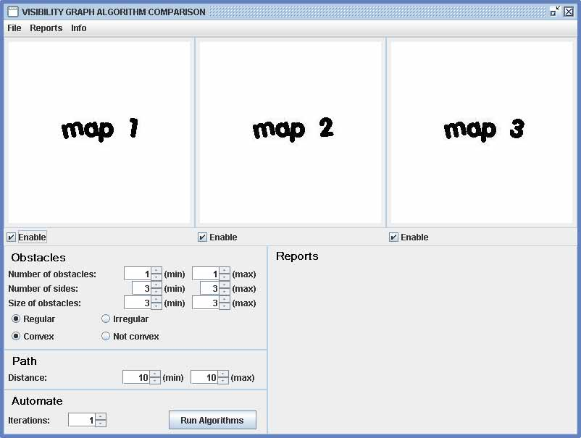

The report section would provide information about the maps and paths used. Under the report menu lays many different graphing options to provide the user with whatever comparisons are of interest.

CHALLENGES
Besides the obvious challenge of creating a faster algorithm to provide path information (and researching the plethora of algorithms currently used), there also is the difficulty of determining its ability to yield optimal results. Additionally, one problem that isn’t immediately obvious will simply be the creation of the maps. Although map creation isn’t a metric that we wish to generate, its impact on the convenient running of our application will be. Creating fast polygons in random locations on the fly may prove difficult. Once all the data is collected by the program, the analysis of that data and trying to draw concrete dependency relations may also prove challenging.

