Computational Convexity
Introduction
The subject of Computational Convexity is a result of discrete mathematics and convex geometry. It is also directly related to operations research and computer science, among other applied areas. Computational Convexity also covers subjects such as Linear Programming, Polyhedral Combinatorics, and the Algorithmic Theory of Polytopes and Convex Bodies. The emphasis in Computational Convexity is on convex geometry of normed vector spaces of finite but not restricted dimensions.
I plan to concentrate on a geometric property of convex Polytopes called Volume. One of the basic problems in mathematics is the computation or approximation of the volumes of convex bodies. Polytopes may be V-presented or H-presented. But convex bodies that are not polytopes require a different approach. A convenient way for such bodies is to assume that the convex body is given by an algorithm called an oracle that answers certain questions about the body.
Glossary
Automorphism group: the group of order-preserving permutations of the polytope P.
Affine hull of a set S: the smallest affine space of 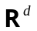 containing S
G: a subgroup of all affine automorphisms of
Dissection of an n-polytope P into n-polytopes 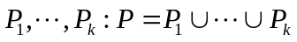, where the polytopes have pairwise disjoint interiors.
Interior int(P) is the set of all points 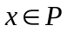 such that for some 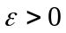, the ε-ball around x is contained in P.
Polytopes 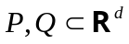 are G-equidissectable: For some k there exists dissections of P and Q and elements g of G, such that 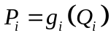 for all i.
Polytopes are G-equicomplementable: There are polytopes 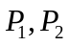 and 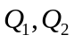 such that 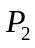 is dissected into P and , 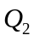 is dissected into Q and 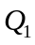, and are G-equidissectable, and and are G-equidissectable.
Decomposition of a set S: 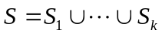, where the sets are pairwise disjoint.
Sets S, T are G-equidecomposable: For some k there are decompositions of S and of T, and elements of G, such that 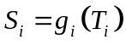 for all i.
Valuation on a family S of subsets of : A functional φ with the property that
G-invariant valuation φ: 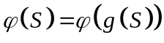 for all S and 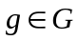.
Simple valuation φ: 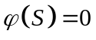 whenever S is contained in a hyperplane.
Monotone valuation φ: 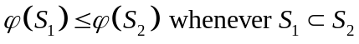
Class P of H-polytopes is near-simplicial: There is a nonnegative integer σ such that 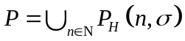 where 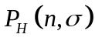 is the family of all n-dimensional H-polytopes P in 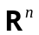 such that each facet of P has at most n + 1 + σ vertices.
Class P of V-polytopes is near-simple: There is a nonnegative integer σ such that 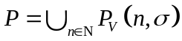 where 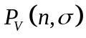 is the family of all n-dimensional V-polytopes P in such that each vertex of P has at most n + σ edges.
V: The functional that associates with a convex body K its volume.
H-VOLUME: For a given H-polytope P and a nonnegative rational v, decide whether 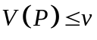.
V-VOLUME: For a given V-polytope P and a nonnegative rational v, decide whether .
Classical Background
In the following, D is the group of isometries.
- Two polytopes are G-equidissectable if and only if they are G-equicomplementable.
- Two polytopes P and Q are G-equidissectable if and only if 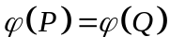 for all G-invariant simple valuations of 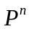.
- Two plane polygons are of equal area if and only if they are D-equidissectable.
- If one agrees that an a-by-b rectangle should have are ab, and also agrees that the area function should be a D-invariant simple valuation, it then follows from the preceding result that the area of any plane polygon P ca be determined by finding a rectangle R to which P is equidissectable. The third problem of Hilbert asked, in effect, whether such a result extends to 3-polytopes. Later on Dehn showed that that a regular tetrahedron and a cube of the same volume are not D-equidissectable, thus providing a counterexample.
- Two plane polygons are of equal area if and only if they are D-equidecomposable.
- If X and Y are bounded subsets of with d > 2, and each set has nonempty interior, then X and Y are D-equidecomposable. This is the famous Banach-Tarski paradox.
- Under the group of all volume-preserving affinities of , two d-polytopes are equidissectable if and only if the are of equal volume.
Calculating Volumes
Since calculating the volumes of simplices are relatively easy, one way to try calculating the volume of a polytope is to triangulate it, then add up the volumes of the resulting simplices. Therefore, if the dimension n is fixed, the volume of polytopes can be computed in polynomial time.
Another method is to dissect the polytope into pyramids with common apex over its facets. The volume of the pyramid is 1/n times the product of its height and the (n – 1)-volume of its base.
A third approach for computing the volume is to use the technique of sweep-plane, that is, to sweep a hyperplane through a polytope.

