Computing Characteristic Polynomials of Hyperplane Arrangements

Eric Etu, Vanessa Hutchison and Alex Plotitsa
October 17, 2005

Background
The first study of arrangements can be linked back to a paper written by Jacob Steiner in 1826. Steiner was attempting to count the number of regions dissected by an arrangement in R² or R³. Since then, work has been done to solve this problem and has only recently been solved for hyperplane intersections by Thomas Zaslavsky, in 1975. He was able to prove that, given a hyperplane arrangement H, once the characteristic polynomial, χ(λ), is known, the number of regions dissected by the arrangement is equal to χ(-1) and the number of bounded regions is equal to χ(1). Determining the number of regions and bounded regions that resulting from a hyperplane arrangement is one of the primary reasons for determining the characteristic polynomial.

Terminology

A linear hyper plane, H, is an (d-1) dimensional subspace of R^{d}, i.e.

In order to determine the characteristic polynomial of a hyperplane arrangement, a meet-semilattice L must be defined. The meet-semilattice is determined by, first, finding the intersection lattice of the hyperplane arrangement, and, then, ordering it by reverse inclusion. R^{d} becomes the unique minimal element of the resulting meet-semilattice. The formal definition of a meet-semilattice L of a hyperspace arrangement H is:

Ordered by reverse inclusion
For all elements x and y of the set L(H), the greatest lower bound (meet) of the set exists.

The Möbius function, formally introduced by August Möbius in 1831, for determining the characteristic polynomial of a hyperspace arrangement is listed below:
 | { | 0 | If r > s,
 | { | 1 | If r = s,
 | { |  | If r < s.

Resulting characteristic polynomial of the hyperplane arrangement H:

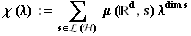

An Example in R²

A simple example for deriving a Characteristic Polynomial for a Hyperplane Arrangement in R²:

Let’s say we have 3 lines intersecting in 3 points:

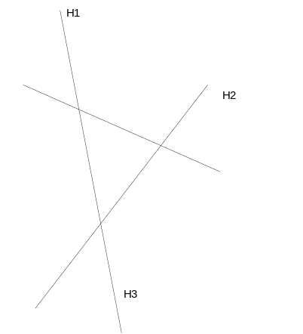

To derive a Characteristic Polynomial for this Hyperplane Arrangement, we produce the
following meet-semi lattice:
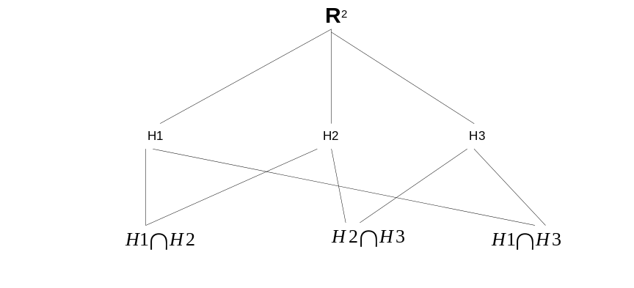
To arrive at coefficients for the polynomial, assign 1 to the coefficient corresponding to the element of the highest power (2). The path from higher dimension to lower dimension must add up to zero, so coefficients for H1, H2 and H3 are (-1). Going down one dimension, to the level containing the intersections, the paths also have to sum up to zeros. So the coefficients for the intersection elements are each 1:

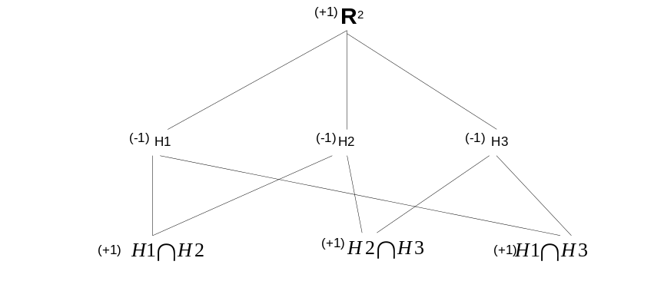

Now, summing up all of the coefficients for each dimension, we get the polynomial.
(+1)t² + (-3)t¹ + (+3)t⁰

Incidentally, if you plug t = (-1), into the polynomial, you get 7, which is the number
of regions created by the intersecting lines. And t = (+1) gives you 1, which is a number
of bounded regions created by this intersection.

Implementation

We aim to devise an efficient algorithm for computing the characteristic polynomial for a given hyperplane arrangement. Our software should support arrangements in any (reasonable-sized) dimension. As outlined here, our algorithm will follow approximately the same process one would use for computing a characteristic polynomial by hand:

Our algorithm will take as inputs:
- The space (e.g. 3-space).
- A series of hyperplane equations in that space.

We expect our algorithm to (approximately) follow these steps:
- Determine the intersection properties of the arrangement.
- Form a “lattice” structure of the objects in the space (e.g. which hyperplanes are supersets of which lines, which lines are supersets of which points, etc.)
- Recursively compute and label each of these objects in the “lattice” with their Möbius values.
- Use these values to generate the characteristic polynomial for the arrangement.
- Use the characteristic polynomial to determine the number of regions, and the number of bounded regions, in the arrangement.

Our algorithm will output:
- The characteristic polynomial of the arrangement.
- The number of regions in the arrangement.
- The number of bounded regions in the arrangement.

We will focus our efforts on the pure computational aspects of this problem and less on usability. Our product will likely take the form of a command-line application.

Once written, we intend to test our algorithm by running it against some of the problems we have solved by hand as well as against some classic combinatorial problems.

References

¹J. Steiner, Einige Gesetze ¨uber die Theilung der Ebene und des Raumes. J. reine angew. Math. 1 (1826), 349–364.
²Matthias Beck, Thomas Zaslavsky, “Inside-out polytopes & a tale of seven polynomials” (UC Davis Combinatorics & Representation Theory Seminar, 2/18/05; University of Kentucky Algebraic Combinatorics Seminar, 4/4/05

