Final Project Overview
CSC/MATH 870
Tracie Hong, Jun Murakawa, Nicolay Postarnakevich
Introduction to Proximity Graphs
Proximity graphs are graphs which represent neighbor relationships between objects, for example, points on a Euclidean plane. Proximity graphs have many different uses in the real world; they can be used in neighborhood/city planning, data mining, and location finding. There are many different types of proximity graphs, and for this project, we will be focusing on five different types of graphs, Nearest Neighbor Graphs (NNG), Minimum Spanning Trees (MST), Relative Neighborhood Graphs (RNG), Gabriel Graphs (GG), and Delaney Triangulations (DT). In this paper we will first give a brief overview of each of these five graphs, discuss the relationships between them, and finally provide an overview of what our final application will include.

Graph Overview
Nearest Neighbor Graphs
The Nearest Neighbor Graph is one of the first graphs we will be studying since it is a subset of the other neighborhood graphs we will be covering. The Nearest Neighbor Graph of a point set V, denoted by NNG(V), is a set containing all points V, and edges E, such that an edge e from a point a to a point b is in E if b is the nearest neighbor of a. NNG can be generalized to include more than one neighbor. The K Nearest Neighbor Graph is a generalized NNG where K represents the number of edges from any vertex to k nearest neighbors.

NNG is a subset of a Minimum Spanning Tree. As such, it is possible to construct an NNG(V) from an MST(V). First construct the MST(V), then prune out all edges that don’t belong in NNG(V) by keeping the shortest edge emanating from each point. Hence, two results immediately follow; NNG is a directed graph, and NNG may be unconnected.

Some of the other, somewhat obvious, properties of the NNG include:
- Along any directed path, the edges have non increasing length.
- The only cycles in NNG(V) are 2-cycles.
- For V in 2-dimentions, NNG(V) is a planar graph, and two edges incident at a vertex must meet at an angle of at least 60o, Hence degree of a vertex is at most 6.

MST
NNG

Minimum Spanning Trees
A Minimum Spanning Tree is a weighted, acyclic, connected, undirected subgraph that contains all the vertices in a graph G such that the weight of the resulting tree contains the minimum weight of G. Because edges of a graph could contain the same weight, any particular graph G could have multiple Minimum Spanning Trees. An example of a MST is provided below.
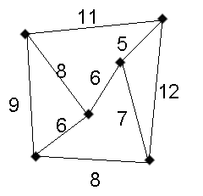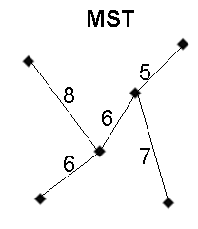

There are two algorithms that are regularly used to create an MST which will be discussed. The first algorithm which can be used to create an MST is Prim’s algorithm. This algorithm can be used to create an MST in θ(n²) time and goes as follows:
- Start with an empty subset of edges F and a subset of vertices Y initialized to contain an arbitrary vertex. Initialize Y to {v1}.
- A vertex nearest to Y is a vertex in V-Y that is connected to a vertex in Y by an edge of minimum weight. This vertex is added to Y and the edge is added to F.
- Ties are broken arbitrarily and the process is repeated until Y=V.

The second algorithm, known as Kruskal’s algorithm, on average may perform more efficiently than Prim’s algorithm, however, its worst-case performs in θ(n²lgn) time, which is worse. To create an MST using Kruskal’s algorithm, the following actions are performed:
- Start by creating disjoint subsets of V, one for each vertex and containing only that vertex.
- Next inspect the edges according to non-decreasing weight (ties are broken arbitrarily).
- If an edge connects two vertices in disjoint subsets, the edge is added and the subsets are merged into one set.
- The process is repeated until all the subsets are merged into one set.

Relative Neighborhood Graphs
The next graph we will be looking at is the Relative Neighborhood Graph of a point set V, denoted by RNG(V). RNGs were studied in detail by Toussaint, and many of the details regarding this graph we obtained from his papers. An RNG of a point set V contains an edge e(u,v) between points u and v if for all points w in V, d(u,v) ≤ max{d(u,w), d(v,w)}.
An edge e(u,v) exists between vertices u and v if the distance between them, d(u,v) is not strictly the largest side in any triangle uvw for every common neighbor w of u,v. In other words, in the RNG, two points, p and r are adjacent if there is no point that is simultaneously closer to both points than they are to one another.

There is also another geometric way of viewing the RNG. For an edge (u,v) to be included, the intersection of two circles centered at points u and v and diameter uv should not contain any other vertex.
v
u
w

Toussaint proved several properties of RNG: RNG is a connected graph, and is a planar graph. MST(V)RNG(V)DT(V). This leads to the fact that in 2-dimentional space |MST(V)| ≤ |RNG(V)| ≤ |DT(V)| so if n=|V| we have in Lp that
n-1 ≤ |RNG(V)| ≤ 3n-6.

Gabriel Graphs
A Gabriel Graph is similar to its subgraph RNG except that instead of using lunes to determine edges of the graph, disks are used. In other words, a Gabriel Graph (GG) is a graph which contains an edge between points x and y if a disk with diameter xy contains no other point.

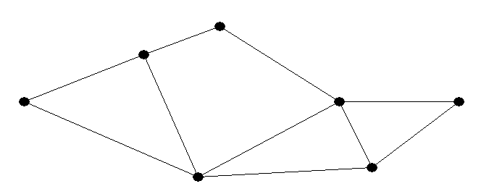
Disk

The formal definition of a Gabriel Graph is as follows:

A Gabriel Graph can be created in O(nlgn) time by first finding the Delaunay Triangulation and Voronoi Diagram for the set of points. Then, for each edge in the triangulation, if the edge intersects its Voronoi edge, it is added as an edge to the GG.

Delaunay Triangulations
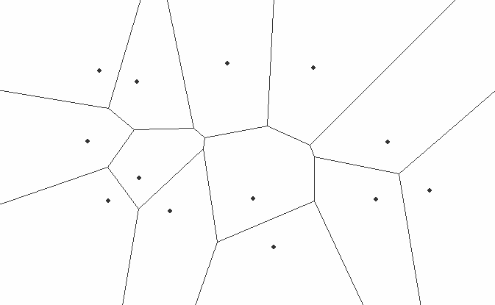
A triangulation T is called a Delaunay Triangulation (DT) if and only if a circle which contains any triangle of T, whose vertices fall on the circle’s edge, does not contain any other points in its interior.
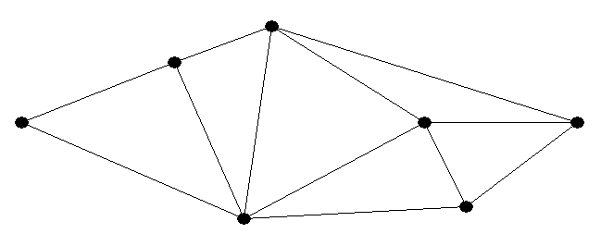

There are a few interesting properties involving Delaunay Triangulations:
- The Delaunay graph of a planar point set is a plane graph.
- Any angle-optimal triangulation of a point set P is a DT.
- Any DT of P maximizes the minimum angle over all triangulations of P.
- A DT is also a dual graph of the Voronoi diagram. It has an edge between any two Voronoi cells which share a Volonoi edge.

Using this last property, it can be very simple to create a Delaunay Triangulation of any point set P by first creating the Voronoi Diagram of P, then creating the dual graph of this diagram.

An alternative way to create a DT would be to use a randomized incremental algorithm whose complexity is O(nlogn). This algorithm begins with a large initial triangle and adds incrementally adds each point while maintaining the DT properties. The high level steps of this algorithm are as follows.

- Begin with an initial large triangle which covers all points in set P.
- Incrementally insert all points one by one while maintaining the DT properties outlined above.
  - Insert a point into an already legalized DT.
  - Triangulate by adding 2 or 3 edges from this point.
  - Legalize all possibly illegal edges recursively.
  - Repeat steps until all points in set P have been triangulated.
- Remove the initial large triangle

Relationship Between Graphs
As previously mentioned, it can be shown that each proximity graph is a subgraph of its next, more complex proximity graph. This is, in many cases, obvious when one considers algorithms that require the pruning of a more complex proximity graph in order to create a lower, less complex graph. For example, a Nearest Neighbor Graph can be created using a Minimum Spanning Tree, and a Gabriel Graph is created by first determining the point sets Delaunay Triangulation.

Mathematically speaking, the relationship between the five graphs discussed above, can be shown as follows:

NNG(V)MST(V)RNG(V)GG(V)DT(V).
Project Application
The overall goal of this project will be to implement an application which allows a user to specify random point sets and view the various proximity graphs of their point set. In order to accomplish this, the first step we will need to complete in our application will be the algorithm implementation of each type of proximity graph mentioned previously. Once the algorithms that will be implemented are determined, we will also attempt to prove the graph relationship mentioned. Since many of the algorithms discussed have already been analyzed in regards to their complexity and efficiency, what we will attempt to do is to verify the complexity of these algorithms by testing these various algorithms with increasingly complex point sets and analyzing the results. Finally, we would like to study these different proximity graphs in multi-dimensional space, particularly 3 dimensions and expand our application to visualize these graphs in 3D.

