Introduction
One of the earliest problems in graph matching is the so-called “marriage problem.” In this setting, a bipartite graph is constructed such that the vertices x_{i}, i = 1, …, n represent the men and the vertices y_{j}, j = 1, …, m represent the women. An edge (x_{i}, y_{j}) exists is y_{j} is the girlfriend of x_{i}. The marriage problem equals finding in the graph a set of edges such that no two have a common vertex and each xi is a vertex of one of these edges. More contemporary problems in graph matching recall matching a set of point of lines, that is graphs, for pattern recognition. The old techniques used in graph matching are used in the newer field of pattern recognition. Graph matching is also important in the study of matching similar molecules, notably called similarity searching in chemical databases. Similarity searching is used to find the nearest neighbors to a specific molecule. The graph matching that needs to be accomplished must take connectivity into consideration. This means that how a molecule is connected is modeled by the graph and its matched partner. Thus, effective graph matching is critical to many contemporary scientific problems.

Define a simple graph to be an unweighted, undirected graph having no multiple edges or graph loops. A single edge represents the bond between two atoms; each vertex is an atom. Each edge has its own signature indicating whether it is a single, double or triple bond. Each vertex has its own signature representing an atom’s attributes. An atom’s attributes may include mass, valence, partial charge, physical coordinates relative to other atoms, and any number of other chemical and physical atomic properties. Suppose that for two simple graphs, G and H have two vertex sets V_{G} and V_{H}, and two edge sets, E_{G} and E_{H}, respectively. Then a graph isomorphism between G and H is defined to be a bijection f:V_{G} → V_{H} such that [u,v] belongs to E_{G} implies [f(u), f(v)] belongs to E_{H}. The edge between the two graphs has to be the same. The edge set is what defines the connectivity. Sub-graph matching is also taken into consideration, especially given the situation in which two graphs have a nonequivalent number of vertices. This problem commonly arises when matching two molecules. Thus, it is of great interest to be able to make conclusions regarding graph and sub-graph matching.

Determining graph isomorphism is an NP-Complete problem and may even be an NP-Hard problem. The sub-graph matching problem is known to be NP-complete [1]. If sub-graph matching is NP-complete, it is fair to consider that isomorphic graph matching is NP-hard. For example, consider the two graphs on the next page.

They are isomorphic but nontrivially so.

Another application of graph matching besides molecular similarity is the use of region adjacency graphs in pattern recognition [2].

Major research efforts have tried to improve the performances of matching algorithms, with respect to computer memory and computational time. Both imposing topological constraints and pruning algorithms have been tried to solve this NP-complete problem.

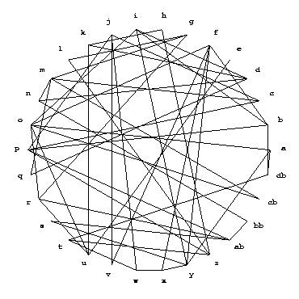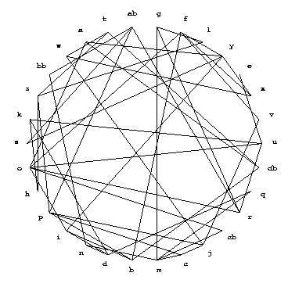

Ullmann’s algorithm takes the approach of reducing the search base by backtracking. This algorithm works for both graph isomorphism and sub-graph isomorphism. The VF algorithm which is one of the newest attempts to the problem, uses a depth-first search which contains some rules to trim the search tree [3].

In our work, we will implement two new algorithms as described by two papers [4-5]. Haili Chui and Anand Rangarajan’s work promises to yield a pose or mapping between two sets of points and a correspondence matrix between the two sets of points. We will modify this algorithm to incorporate a measure or metric between these sets of points because we are not only matching points but we are measuring similarity between two different sets of points using a metric. For details of the metric, see [6]. To recall what sets of points with which we are concerned is to recall the set of points that are the set of vertices of a graph that model a molecular structure.

Chui and Rangarajan’s work use sophisticated reasoning originating from combinatorial optimization for the use in computer vision and we will take full advantage of their techniques by carefully querying and implementing each step of their algorithm which employs deterministic annealing and the algorithm softassign to establish the correspondence. One of the main features of softassign is the use of a doubly substochastic matrix which is used as a continuous approximation to a permutation matrix. Then, using a thin-plate spline which is a two-dimensional analog of a cubic spline, a non-rigid mapping is accomplished.
Gori, Maggini and Sarti propose an algorithm for exact and inexact graph matching using random walks. To accomplish their goal, they use a new class of graphs called the Markovian spectrally distinguishable graphs. They also use a permutation matrix to formulate their matching. We desire to place a metric into their algorithm to measure similarity as before and their algorithm more easily permits this.

Ideally, the two algorithms would have a common meeting point and we could then use a combination of both algorithms to do our graph matching but this would be most likely future work.

References

1. H.G. Barrow and R.M. Burstall, “Sub-graph Isomorphism, Matching Relational Structures and Maximal Cliques,” Information Processing Letters, 4(4), 83-84, 1976.
2. Rahul Singh, Course notes, Multimedia Systems, 2005.
3. P. Foggia, C. Sansone, M. Vento, A Performance Comparison of Five Algorithms
for Graph Isomorphism, http://amalfi.dis.unina.it/graph/db/papers/benchmark.pdf

4. Haili Chui and Anand Rangarajan, A New Algorithm for Non-Rigid Point Matching, IEEE Conference on Computer Vision and Pattern Recognition, 2000, 2, 44-51.

5. Marco Gori, Marco Maggini, and Lorenzo Sarti, Exact and Approximate Graph Matching Using Random Walks, IEEE Transactions on Pattern Analysis and Machine Intelligence, 27 (7), 1100-1111. July, 2005.

6. Elinor Velasquez, Emmanuel R. Year, and Rahul Singh, Computing Graph-based Molecular Similarity using a Generalized Riemannian Metric, preprint. 2005.

