Steps

1. Create new class
2. Extend Topology Loader (TopFile.TopFileLoader)

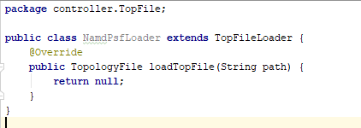

1. Implement loader…

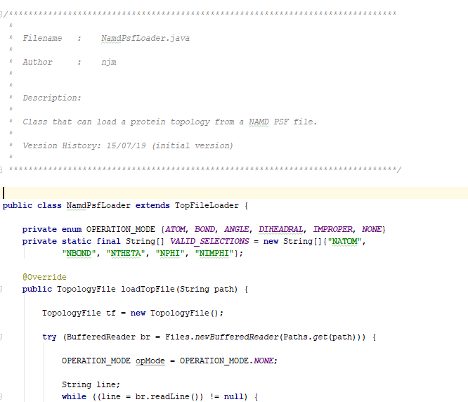

1. Add extension to TOP_FORMAT enum in ConsoleController



1. Add loader type to “loadTopologyFile” in the HaptimolPreProcessor

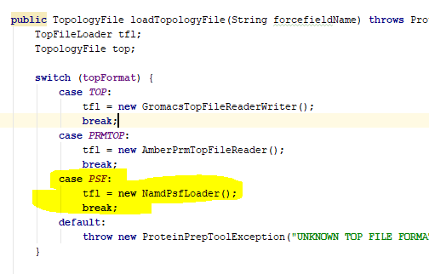

1. Add any required extensions to the String[] at the top of MainGUI.java

