CS 142

Prasidha Timsina, Nana Nimako, Andres Salcedo

Assignment: Final Project

TSN Industries Website

Version <1.0>

Table Of Contents

Time Log 3

Introduction 4

Purpose 4

Definitions, acronyms, and abbreviations 4

Overall Description 4

Story Board 5

Specific requirements 9

|  |  |  |  |
| --- | --- | --- | --- |
| Time Log | | | |
| Estimated time to complete assignment => | | | 6-100 Hours |
| Date | Time Spent  (in hours) | Description | Author |
| 04/03/19 | 1 (each) | Brainstormed ideas at davis center, we each came up with a few ideas and narrowed it down. | Prasidha, Nana, Andres |
| 04/05/19 | 2 (each) | We each sketched out different pages and different layouts before choosing one to focus on and mock up digitally | Prasidha, Nana, Andres |
| 04/06/19 | 2 | Mocked up our main idea digitally and talked to the group about simple changes before diving into refining it. | Prasidha |
| 04/12/19 | 1 (each) | Met at davis and finalized the different sections of the website. Decided to wait till next week to start building from mockup. | Prasidha, Nana, Andres |
| 04/18/19 | 6 (each) | Everyone coded a page that we wanted to work on. Prasidha worked on the About-us and started the index page. Andres worked on making things mobile responsive. Nana added some backend components for our website (we are thinking of adding a feature where our clients can signup and login) | Prasidha, Nana, Andres |
| O4/21/19 | 2 (each) | Met together at davis to discuss the pages. | Prasidha, Nana, Andres |
| 04/21/19 | 2 | Nana Made the different parts of the site more mobile responsive. | Nana |
| 04/24/19 | 3 | Nana created the database and did the backend coding for our website. | Nana |
| 04/26/19 | 5 (each) | Met together at davis to work together on the project. Nana shared the database and backend code with us so we could all have the db access and admin access. Prasidha and Andres worked on designing a page and creating the css and content for it. | Prasidha, Nana, Andres |
| 05/03/19 | 5 (each) | Prasidha worked on the CSS for index, Nana worked on the portfolio and Andres worked on the Content for our script and such for usability tests and getting people for the tests. | Prasidha, Nana, Andres |
| 05/04/19 | 6 (each) | Prasidha Worked on finishing index and migrating database over to other server, Nana worked on the css for the blog. Andres and Nana both worked on usability tests. | Prasidha, Nana, Andres |
| 05/05/19 | 3 (each) | We all met at Davis center to do finishing touches for the website and fill up the content so its not just all dummy text. | Prasidha, Nana, Andres |
| 05/05/19 | 3(each) | Prasidha did some extra styling for the form and content of the website. Nana worked on making sure the website passes css and html validation and Andres did more web usability testing. | Prasidha, Nana, Andres |
|  |  |  |  |
|  |  |  |  |
|  |  |  |  |
|  |  |  |  |
|  |  |  |  |
|  |  |  |  |
|  |  |  |  |
|  |  |  |  |
|  | 109 | <=Total Time Spent |  |
|  |  |  |  |

# Introduction

### Purpose

The purpose of this document is to describe the requirement specification for the web site TSN Industries.

The intended audience for this document is our Project Stakeholder, Robert Erickson. This project spec document will outline our website process from start to finish and all the steps we took to finish it. It lets our Project Stakeholder know what we worked on and that we spent our hours on so we can reliably get funding.

### Definitions, acronyms, and abbreviations

*Sample for the client:*

W3 Validation – refers to both Html and CSS validation tool provided by the W3c.org. the html validator is located at:

<http://validator.w3.org/>

with the CSS validator located at:

<http://jigsaw.w3.org/css-validator/>

Data Science – Data science is the use of data, algorithms, and other processes to collect data and present it in a way to help an organization improve.

Mobile Responsive – The ability of a website to adapt itself to be usable on a mobile device.

# Overall Description

TSN Industries is a web agency company founded by Prasidha, Nana, Andres to deliver modern websites and mobile applications. Our website lets clients contact us and view our portfolios and learn more about us.

# Story Board

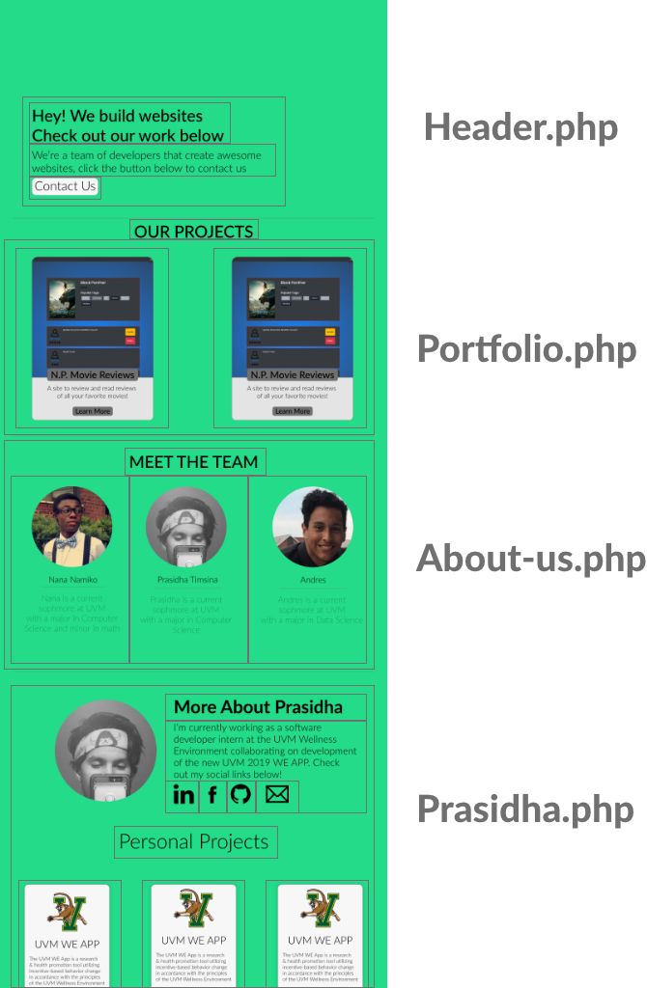

# Specific requirements

1. Index.php
   1. Header with image, header title, button to contact us, and companies we’ve worked with.
   2. Reasons to choose TSN industries – 3 reasons
   3. Section about responsive design
   4. Small sample of portfolio with link to full portfolio
   5. Small sample of blog with link to full blog page
2. Portfolio.php
   1. Links to projects we’ve worked on.
3. About.php
   1. Section for all founders and a small description for each of them.
4. Blog.php
   1. Able to show video posts and read more about them.
   2. Able to show written posts as well.
5. Contact-us
   1. Form fully works and sends to a backend database
   2. User should be able to see all the comments / questions via an admin dashboard
6. FAQs
   1. List of FAQ s and able to see them all quickly and not have too much to distract users.