Requirements to run

In order to run these files, you will need python installed aswell as installing the logging extension by running 'pip install logging'. If you wish to use the version with the html gui you will also need to install flask,
which can be done through 'pip install flask'.

which zip to download

If you wish to play 2 -player in the command line
- Download stage 1.zip and extract
- There should be 2 files componants.py and game_engine.py
- run the game by opening the command prompt in the directory where the 2 python files are and running python game_engine.py
- play the game using the command prompt window

If you wish to play 2 player with a gui
- Download stage2.zip and extract
- There should be 3 files: componants.py,flask_game_engine.py and game_engine.py aswell as a folder called templates which contains index.html
- to play run flask_game_engine.py using python flask_game_engine.py or by using an ide such as vscode
- to interact with the gui open a web browser and go to the address http://127.0.0.1:5000 which is where its hosted
- To exit the game either close the tab or enter CTRL+C in the terminal

If you wish to play against an ai opponant

- Download stage3.zip and extract
- There should be 3 files: componants.py,flask_game_engine.py and game_engine.py aswell as a folder called templates which contains index.html
- to play run flask_game_engine.py using python flask_game_engine.py or by using an ide such as vscode
- to interact with the gui open a web browser and go to the address http://127.0.0.1:5000 which is where its hosted
- To exit the game either close the tab or enter CTRL+C in the terminal

How the API works

There are several endpoints for the GUI to interact with the flask

/

/ is the default endpoint and is used to render the template. It is passed the game board as an argument
/move

/move is the endpoint to complete a user move. The endpoint expects a request with 2 arguments x and y which are the users coordinate inputs. There are 3 types of responses, success,failure and finished. For success and failure
the response has a status which is either 'success'. If success the board will be sent within "board" aswell as the colour of the playerr whos turn it is under "player". If it is returning a fail an error message is provided under "message"

If it is a response to say that the game has finished, then it will have 2 arguments. The first is "finished" and the value of "finished" will be a message which has the reason for the game ending, the number of each colour counter and who won/draw

/save

/save is the endpoint to save the current state of the game to the user. The endpoint expects the request to be in plaintext and the body of the request to be the name the user wants to save the file as. The endpoint will return a response
with the format of "status" which will be success or fail depending on the outcome and a "message" which will either be conformation of the saves completion or an error message of what went wrong.

/load

/load is the endpoint to load a previously saved game. Like /save tthe /load endpoint expects the request to be in plaintext and the body of the request to be the name of the file the user wants to load. The endpoint will return a response
with the arguments "status" which will be success or fail depending on if the file was succesfully loaded or not, aswell as a "message" which will be confirmation of a succesful game load or an error message of what went wrong

Testing

To start a new game has been created

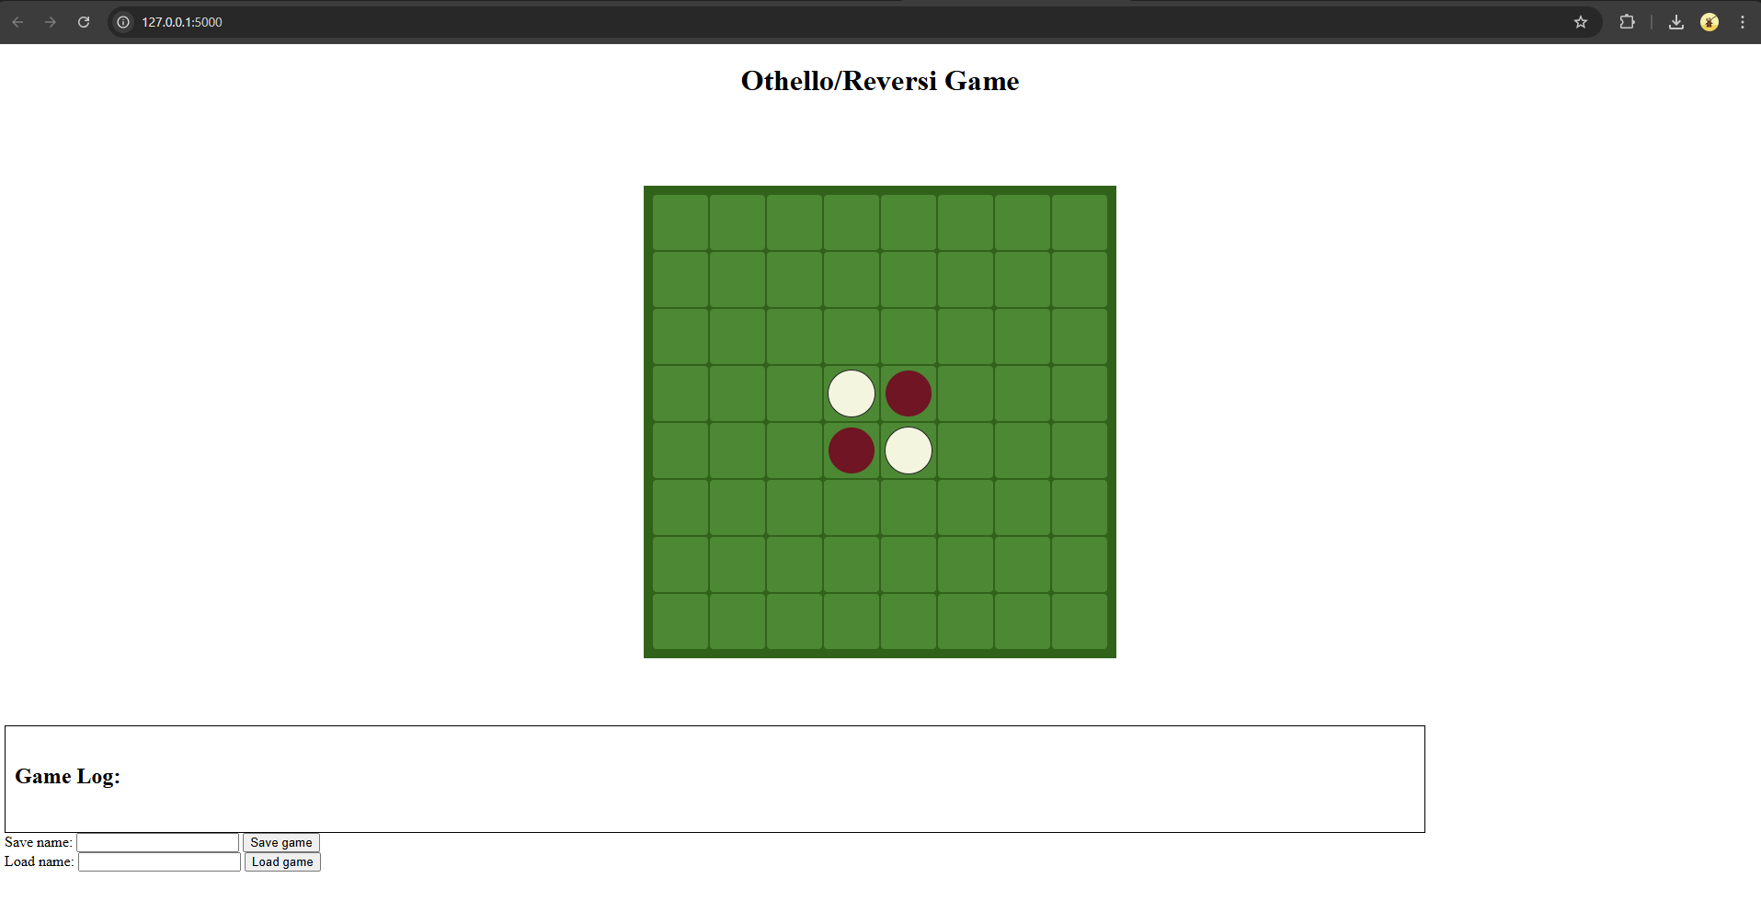

I will attempt to place a dark counter in the cell, 4,4 with the top left cell being 1,1.
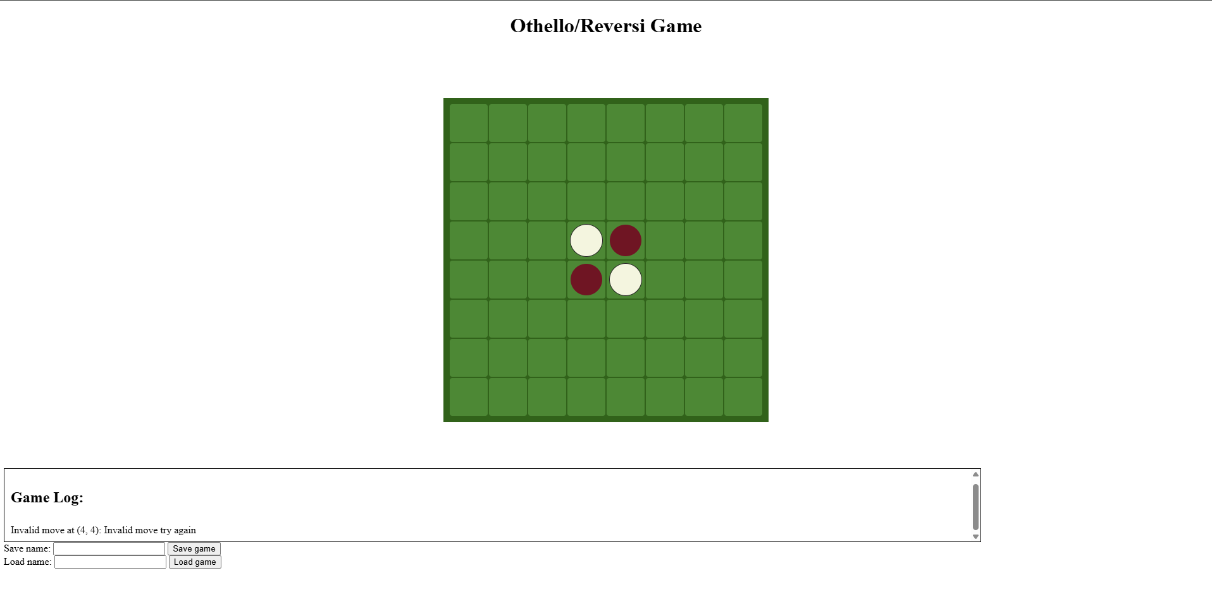

The game log correctly tells me that the move (4,4) is invalid.

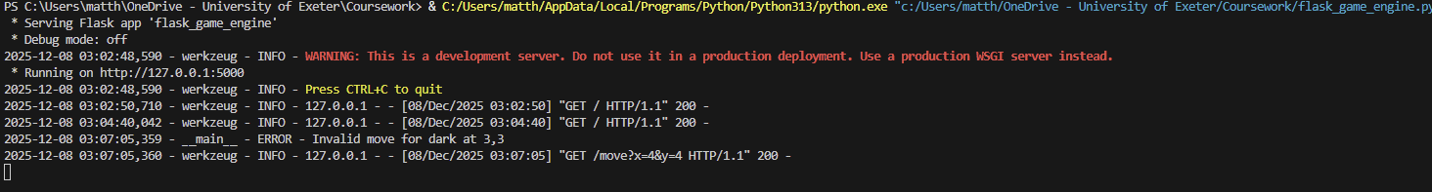

The command line also documents that an invalid move was attempted at (3,3) as python indexes list at 0 not 1

Next I will attempt to play a move in 3,5 and it should also alert me that it is an invalid move

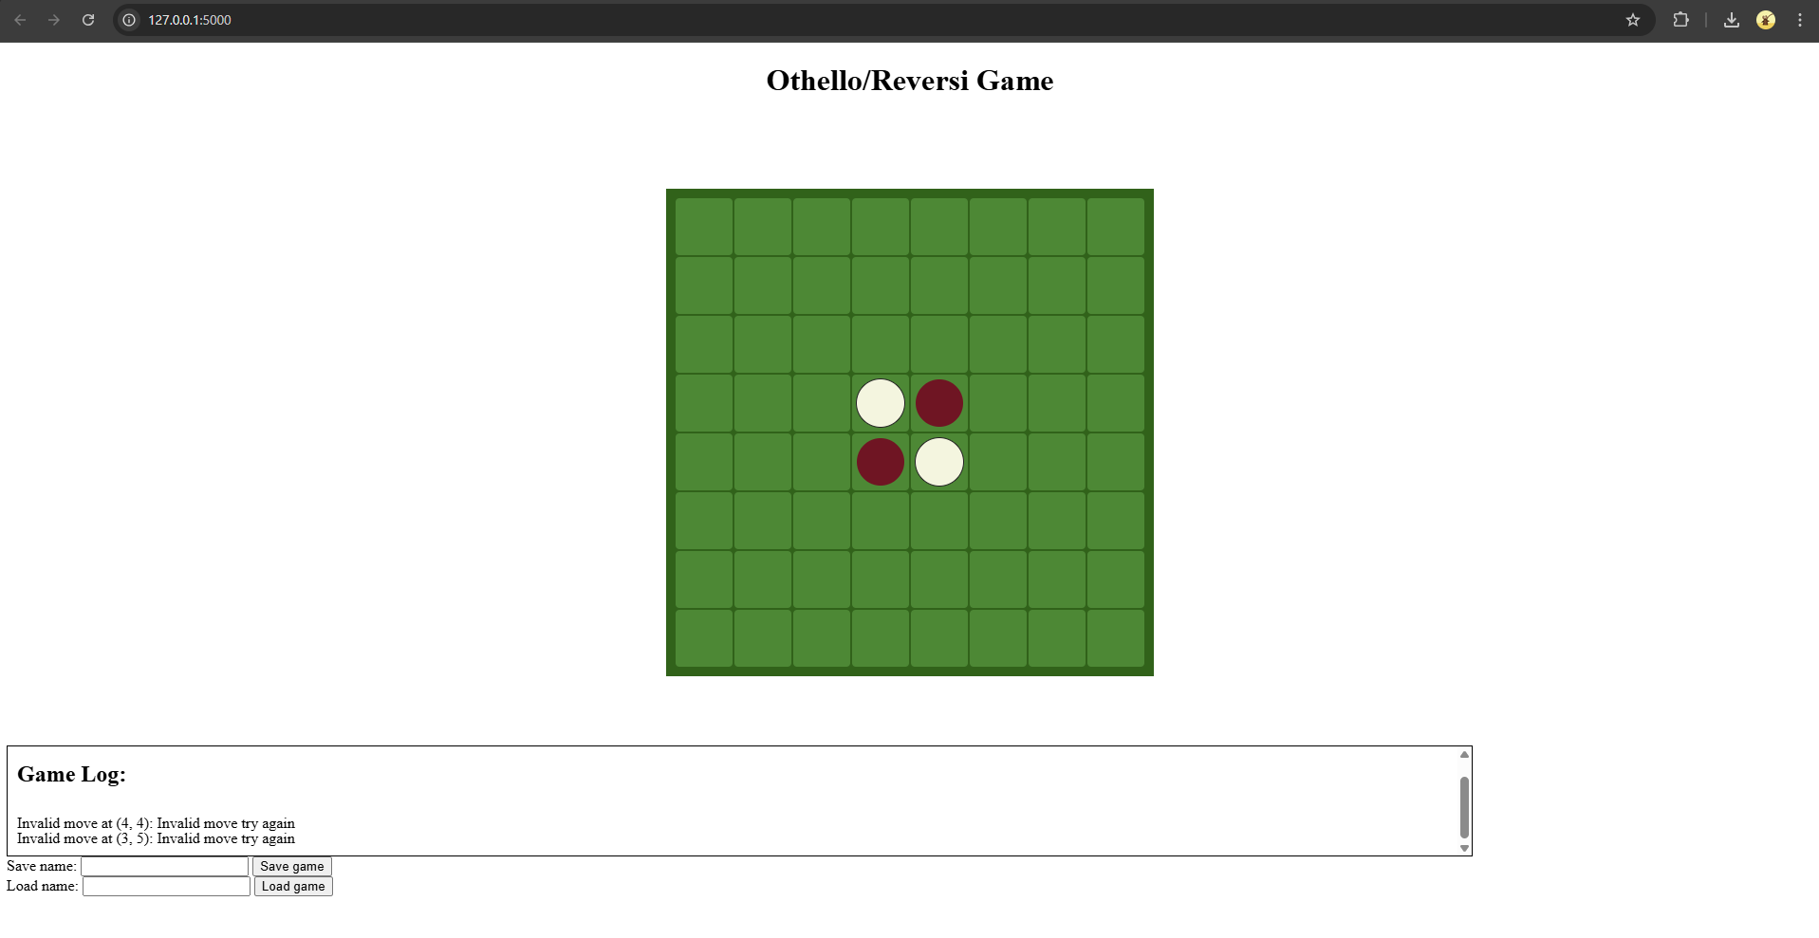

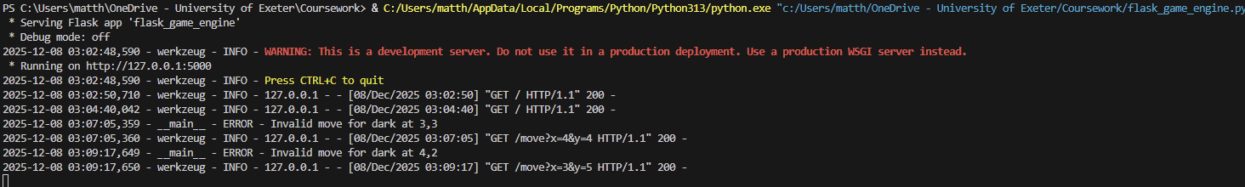

I will now test that it accepts the valid move of (3,4)

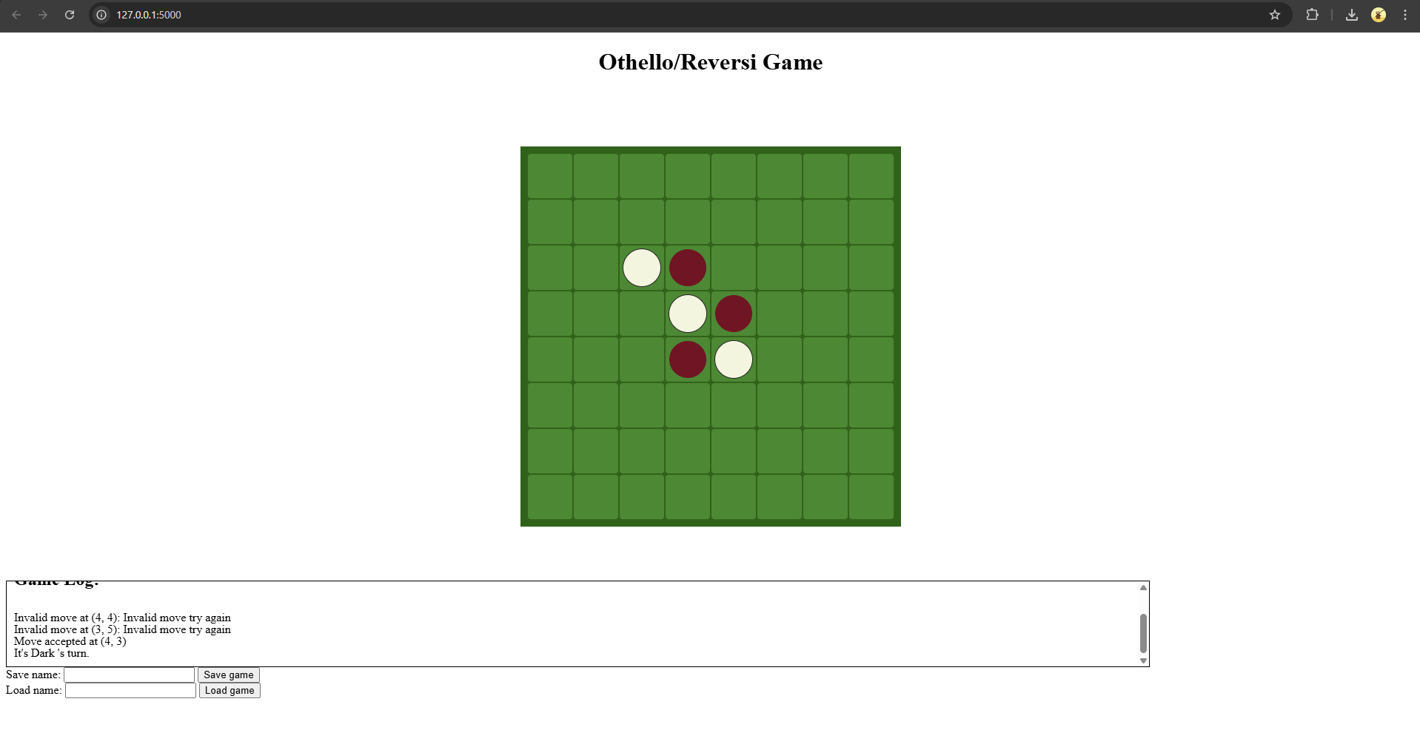

The move was accepted at (3,4) and a message was sent to the game log to confirm this. The ai also successfully made the move (2,2) or (3,3) on the game board and the number of moves left were successfully reduced to 58

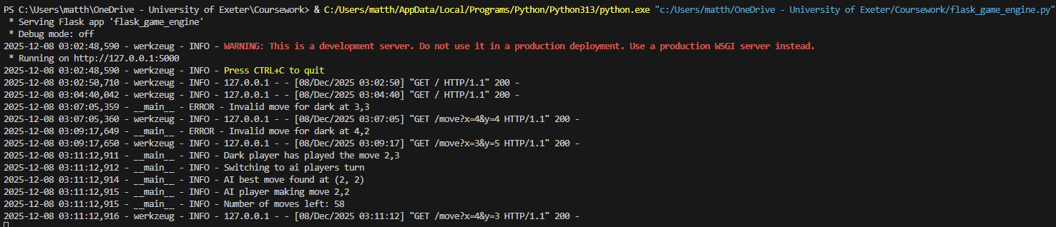

After playing a few more moves I will now save the game as Othello test game.

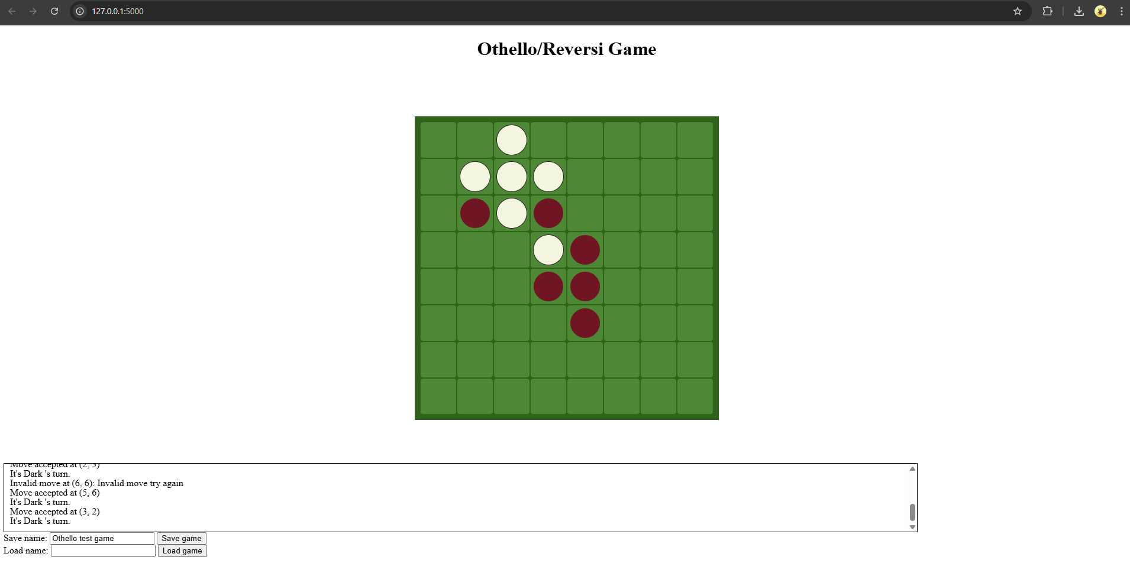
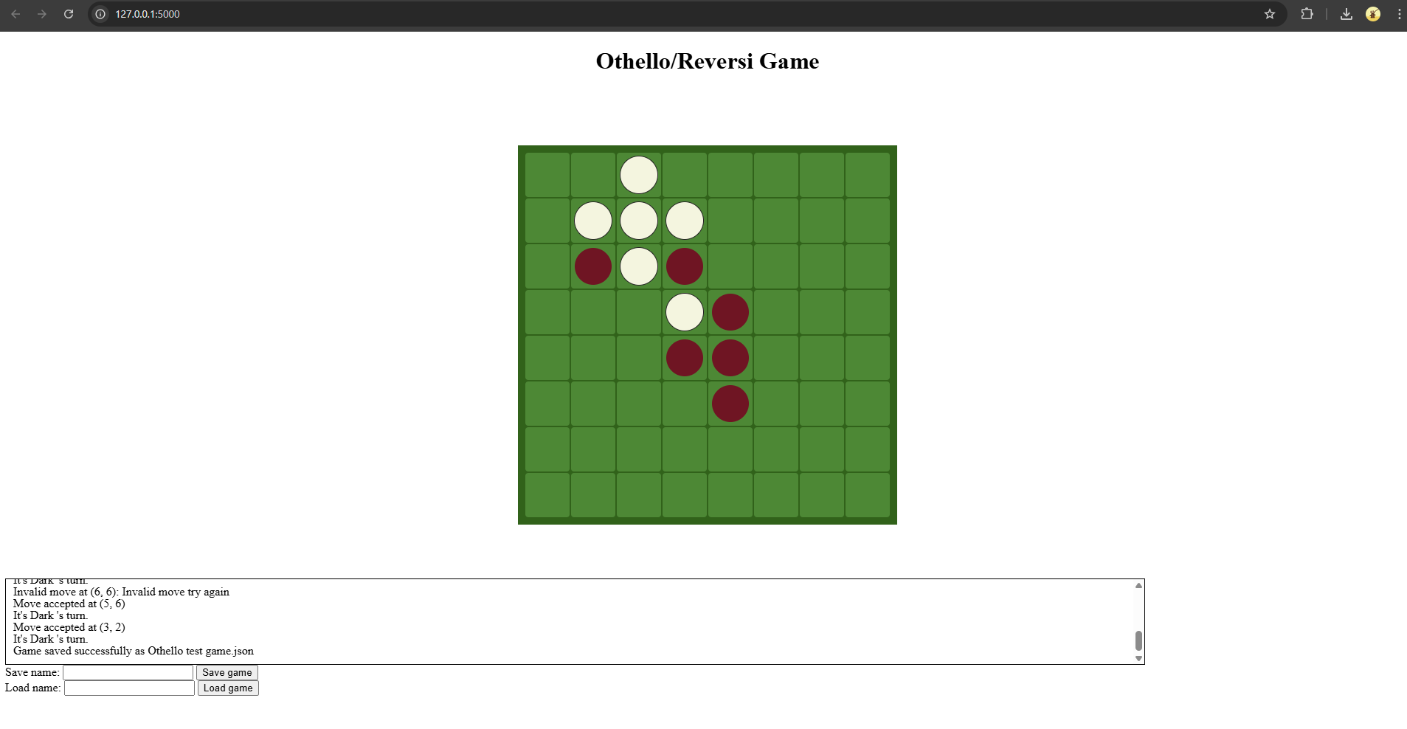

A message in the game log confirms that the game was saved successfully, and so does the command line. The file also appears in the same directory as the code
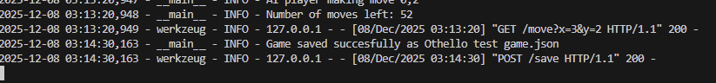
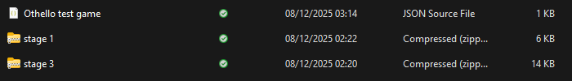

If I try to save a game without entering a name I get a warning that it must be filled in

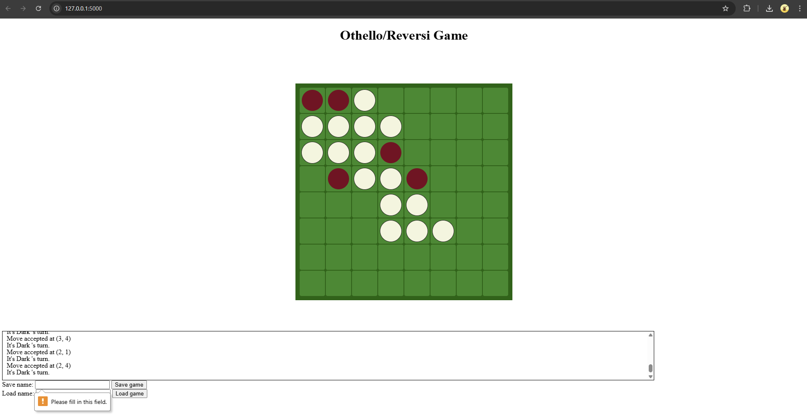

If I now try load the game, but I input a filename that doesn’t exist I should get an error message

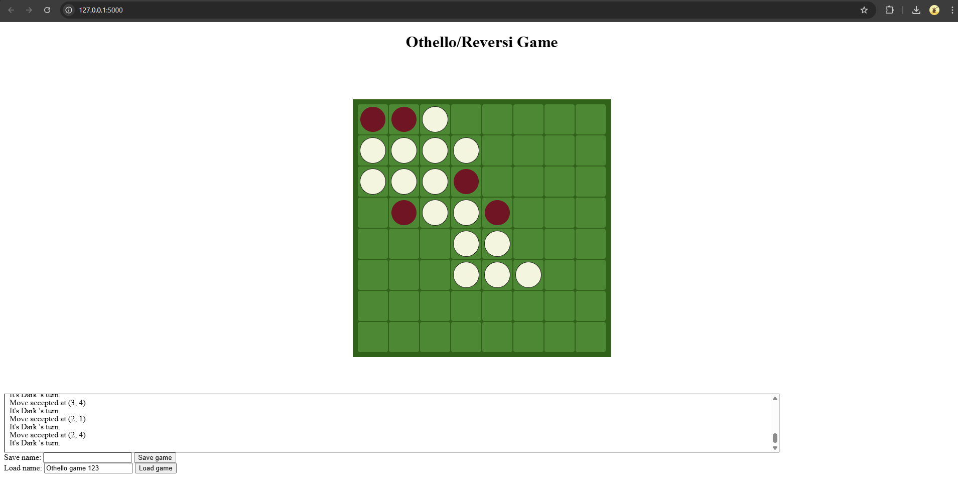

I successfully get an error message that the game Othello game 123.json cannot be found in the fame log and also the command line logs

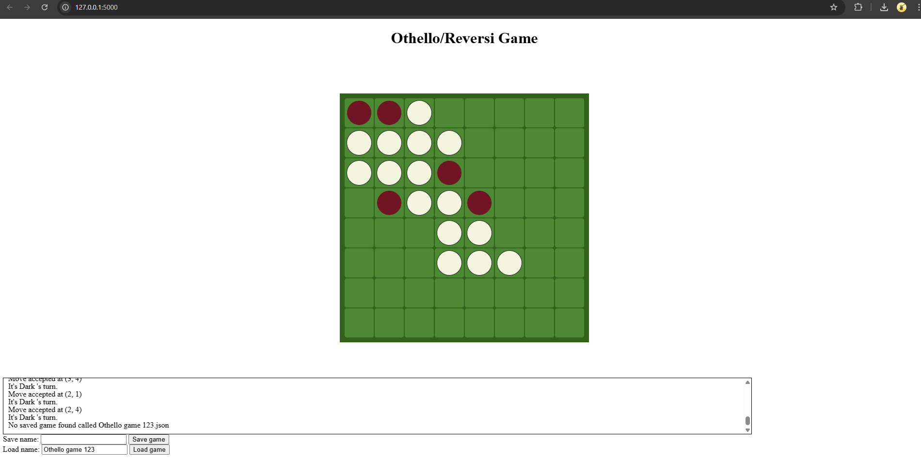

If instead I try load the game Othello test game from earlier it should return the game to that state

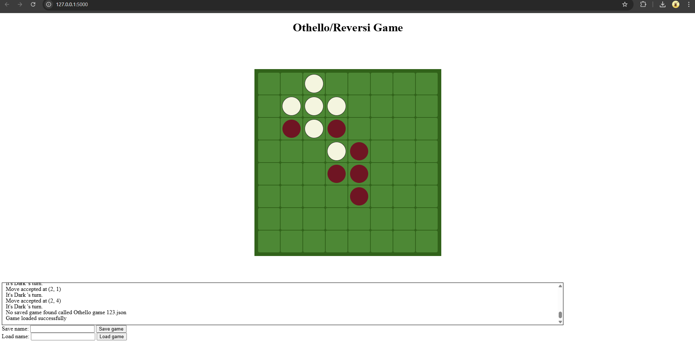

I get success messages in both the game log and the command line logs. The number of moves left also successfully increases from 44 to 50 after the game was loaded and the board reverted back to its original state

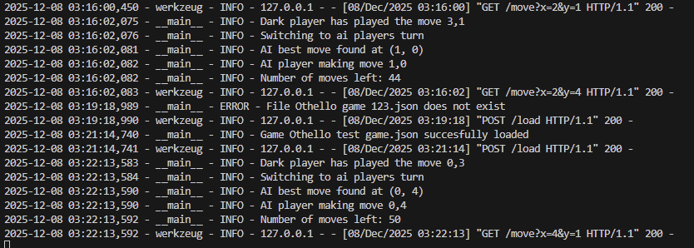

When the ai has no valid moves the code successfully skips the ais turn and allows the user to place if they have a legal move

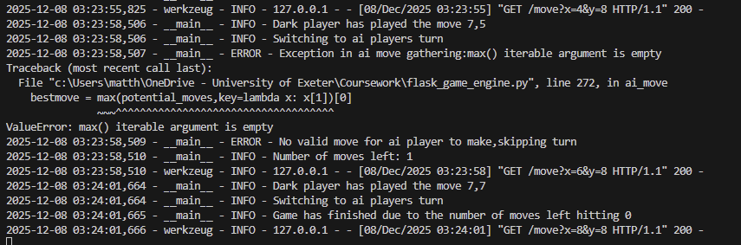

If the game finishes with all counters being places, a message pops up with the reason for the game finish, number of counters for each player as well as who won

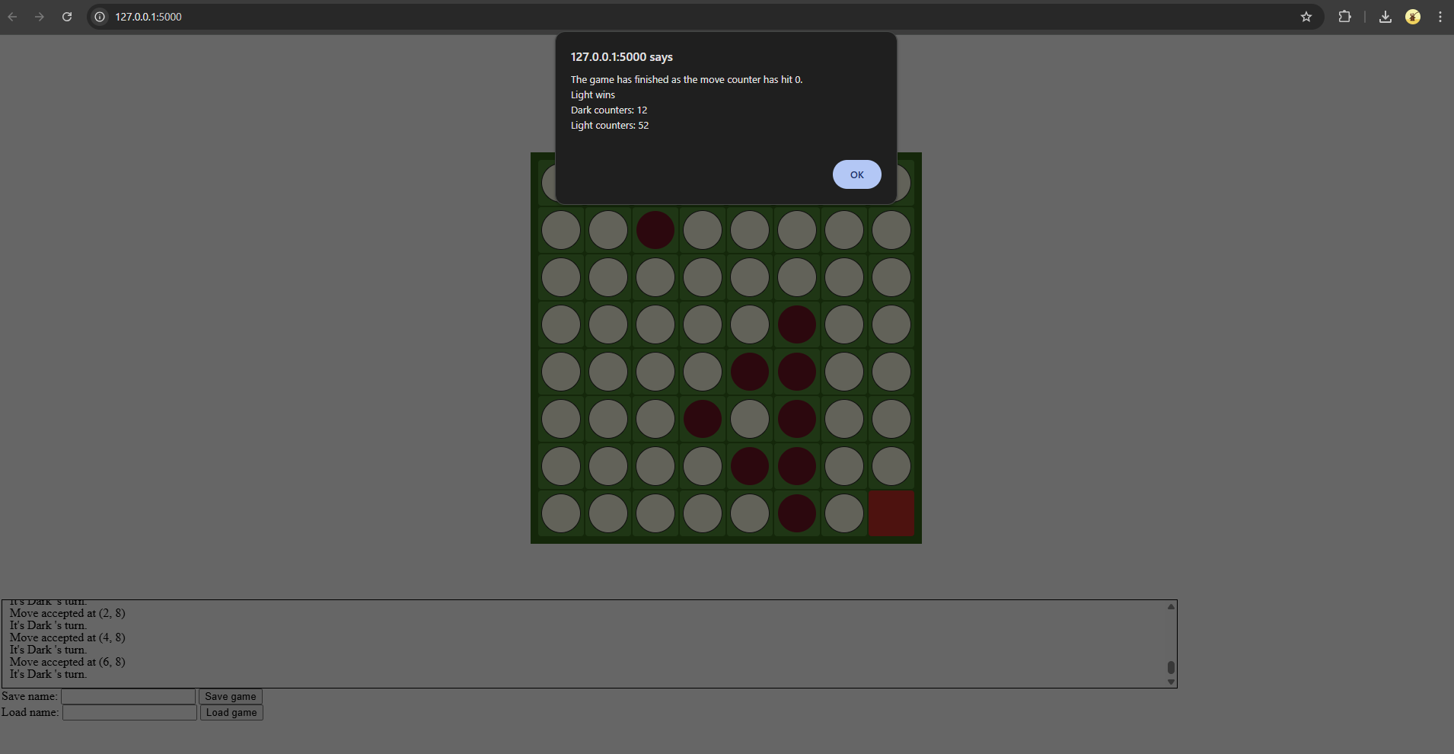

After pressing ok on the popup message the game resets to a new game

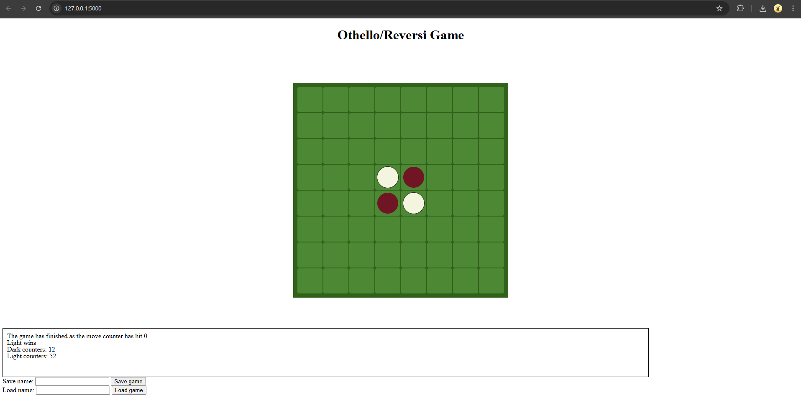

When in this position the user playing the move (2,5) should end the game as white will play (2,2)and leave neither player any legal moves.

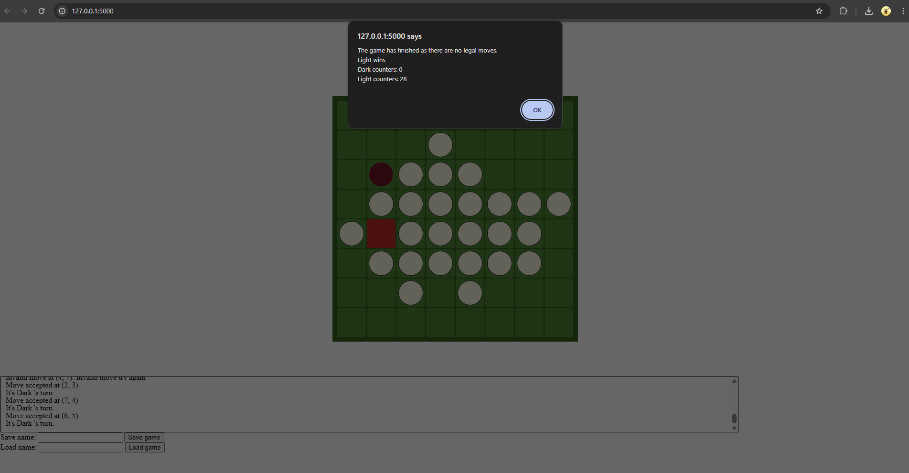

The game successfully calculates that there are no legal moves left for the player or the ai so ends the game.

