Group 2 Project: SHA-1 Implementation on a SoC FPGA

Appendix A - Simulation

Software simulation was done on a Gnome Desktop, Red Hat, Linux system running Xilinx version 14.6 ISE and ModelSIM. To launch the simulation use an emulator in bash mode and browse to the pcores/glue_v1_00_a/devl/projnav folder in the files provided. From here source the setup.sh file and then launch the ISE with the command ise glue.xise
You should have a screen as shown below [Figure A-1]:
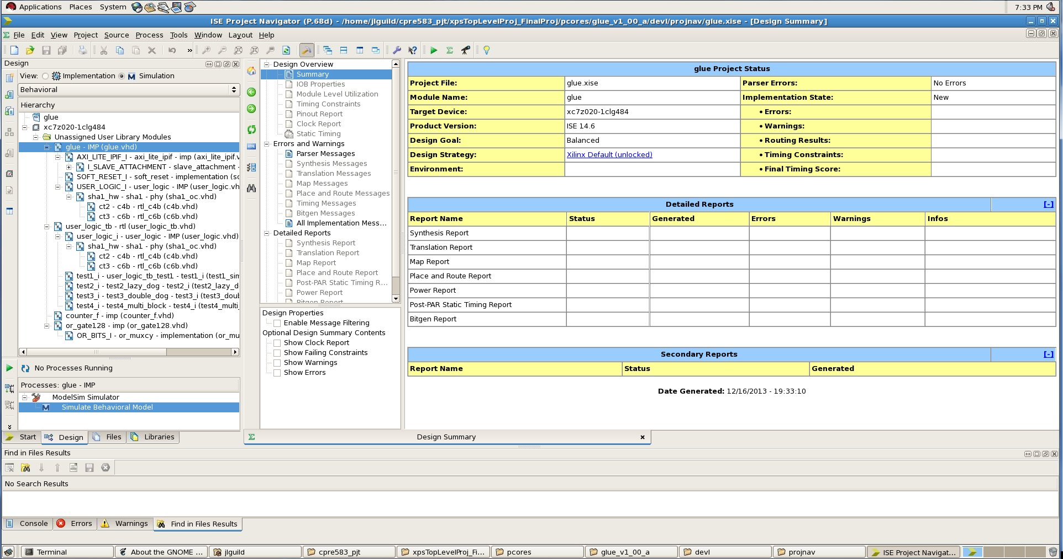
Figure A-1: ISE Project Explorer
Verify all items are listed and have no conflicts.
To run the simulation and observe results select the simulation radio button and highlight the source labeled user_logic_tb - rtl (user_logic_tb.vhd) [Figure A-2]. Then double-click the Simulate Behavioral Model in the Processes listing
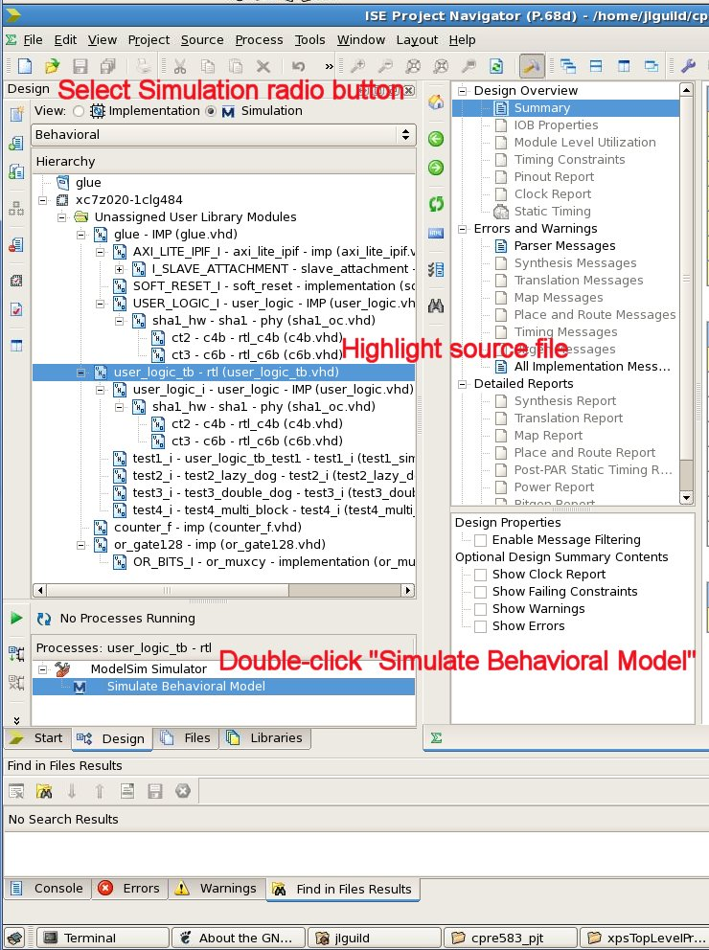
Figure A-2: Running Simulation
Here the simulation will run and give the signal wave results similar to this [Figure A-3]:
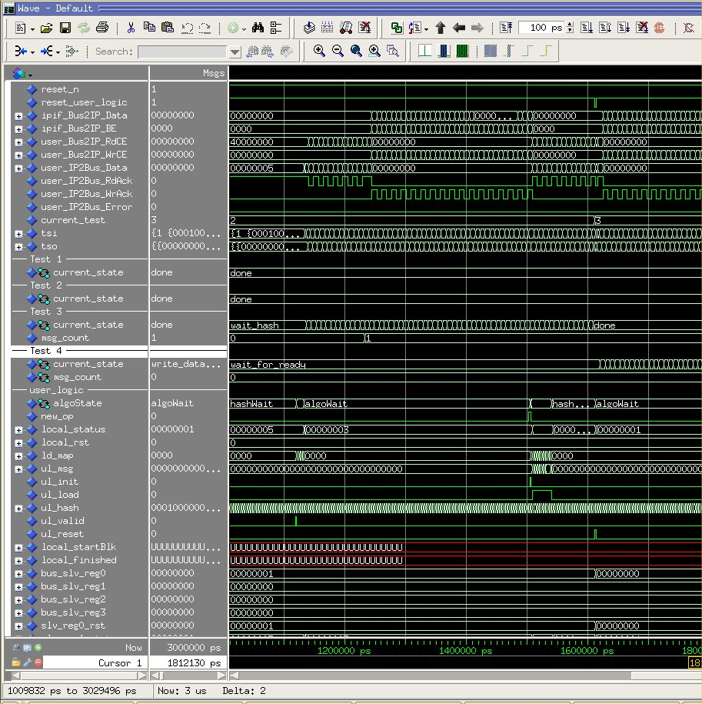
Figure A-3: Initial Waveform
This waveform will have the initial setup of the architecture as well as all four tests . It runs for a total of 3 microseconds and contains all data registers and signals. The IP bus sends data back and forth from the micro to the FPGA doing the SHA1 encryption, current_test tracks the test being run at any given time -1, and the current_state under each test label signals where in the state machine the current test is. The user_logic maintains the local micro signals and registers with data being written for each test to the slv_reg9 through slv_reg25 registers. The resulting hash calculation is written to registers slv_reg4_h0 through slv_reg8_h4 and compared to the independently calculated hash to verify correctness. The independently calculated hash was done using the Linux command-line tool ‘sha1sum’.
Once the hash is validated the simulation starts the next test and resets the micro.
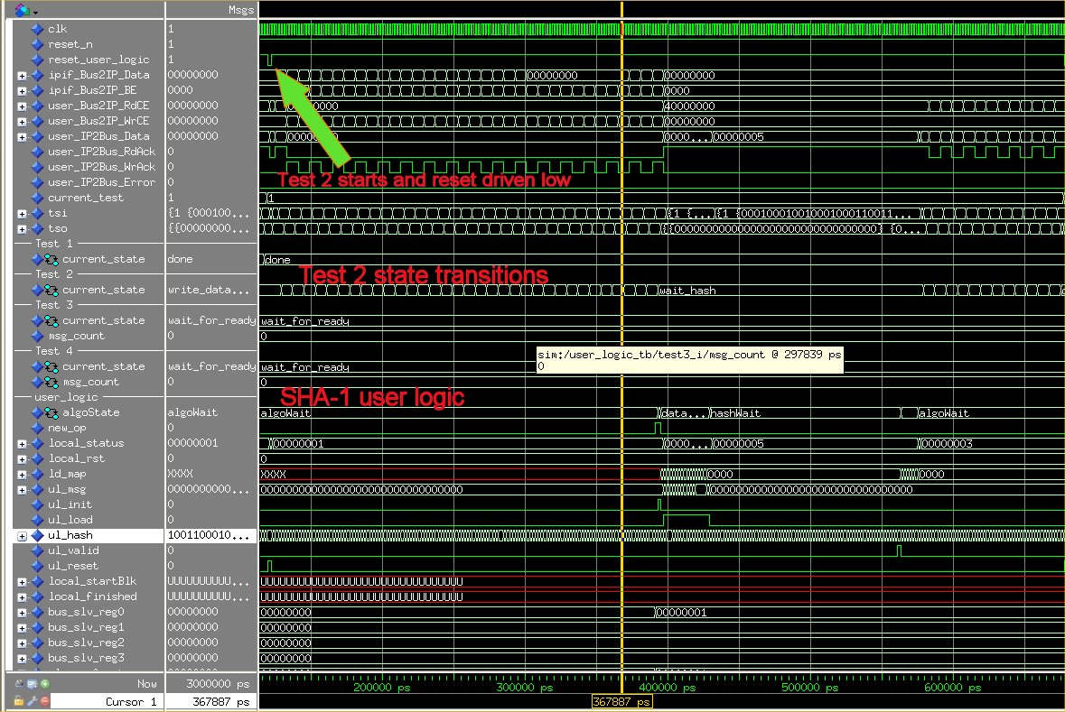
Figure A-4: Test State Signals
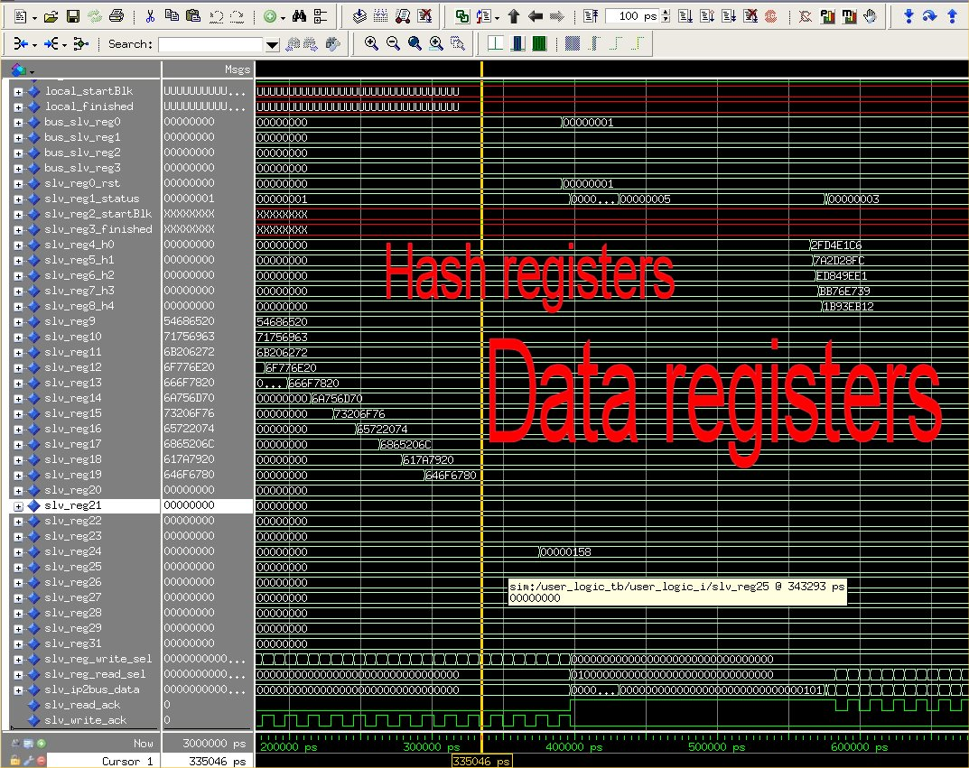
Figure A-5: Registers
Measurements for process time were taken at the test state transitions for metrics. Some tests revisited a state and the time for both periods were added together for the data sets. [Table A-1]

 | Test 1 | Test 2 | Test 3 | Test 4
Test Type | Word Write | Single Chunk (4bit) | Single Chunk(6bit)x2 | Multi-Chunk (6bit)
String Length (Bytes) | 4 | 44 | 44 | 88
Process Start (ns) | 101 | 119 | 677 | 1611
Process End (ns) | 118 | 676 | 1610 | 2476
Process Length (ns) | 17 | 557 | 933 | 865
Process Length (ns)/ 4 Bytes | 17 | 50.64 | 42.41 | 39.32
Bandwidth (MB/s) | 235.29 | 78.99 | 94.32 | 101.73
Reset start (ns) |  | 120 | 678 | 1612
Rest end (ns) |  | 129 | 687 | 1621
Reset Length (ns) |  | 9 | 9 | 9
% Process time |  | 1.62 | 0.96 | 1.04
Start write (ns) | 101 | 129 | 687 | 1621
End write (ns) | 109 | 385 | 943 | 1877
Start write (ns)(2) |  |  | 1241 | 1927
End write (ns)(2) |  |  | 1497 | 2183
Write Length (ns) | 8 | 256 | 512 | 512
Write Length (ns)/ 4 Bytes | 8 | 23.27 | 46.55 | 23.27
% Process time | 47.06 | 45.96 | 54.88 | 59.19
Begin hash (ns) |  | 385 | 943 | 1877
End hash (ns) |  | 579 | 1137 | 1927
Begin hash (ns)(2) |  |  | 1497 | 2183
End hash (ns)(2) |  |  | 1513 | 2379
Hash Length (ns) |  | 194 | 210 | 246
Hash Length (ns)/ 4 Bytes |  | 17.64 | 19.09 | 22.36
% Process time |  | 34.83 | 22.51 | 28.44
Start validate (ns) | 109 | 587 | 1145 | 2387
End validate (ns) | 117 | 675 | 1233 | 2475
Start validate (ns)(2) |  |  | 1521
End validate (ns)(2) |  |  | 1609
Validate Length (ns) | 8 | 88 | 176 | 88
Validate Length (ns)/ 4 Bytes | 8 | 8 | 16 | 4
% Process time | 47.06 | 15.80 | 18.86 | 10.17
Added overhead/4 Bytes (ns) | 0.000 | 33.636 | 25.409 | 22.318
% increase process time | 0 | 198 | 149 | 131

Table A-1: Metric Data Analysis

Appendix B - Chipscope

The initial chipscope setup involve connecting the JTAG to the target hardware and scanning for chipscope monitors. In this case we have a AXI bus monitor added to our design.

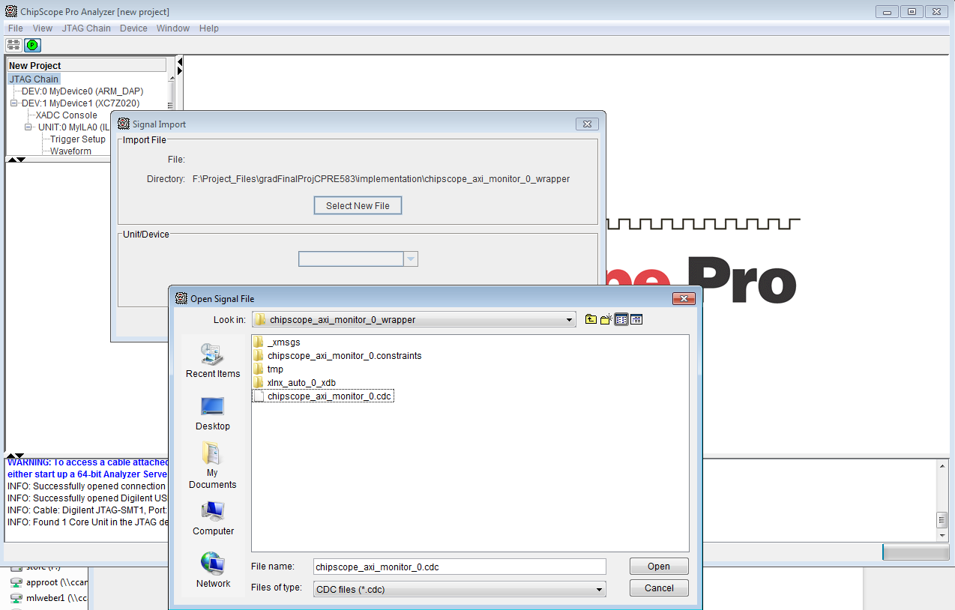
Figure B-1 : Chipscope signal setup

The cdc file referenced in Figure B-1 is provided in the <git repo>/chipscope/ folder. A .cpj file is also checked in with the cdc and includes the signal renaming captured in the other screenshots.
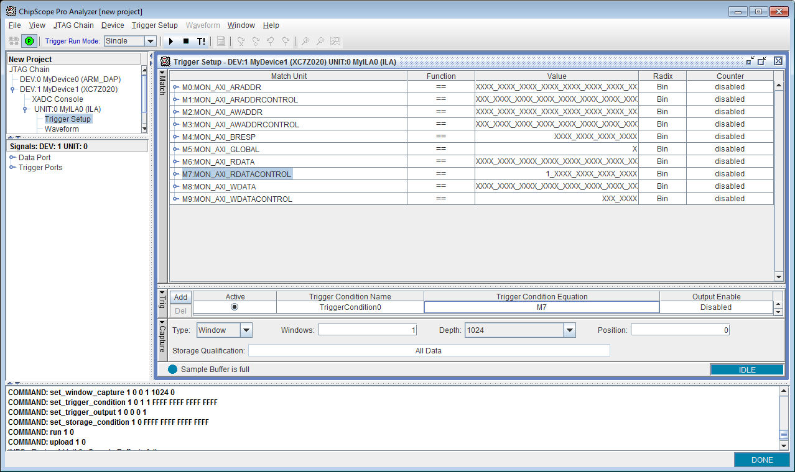
Figure B-2 : Chipscope trigger setup on read valid signal

The first step after scanning the bus and loading the signal names, is to configure the trigger signals (Figure B-2). To capture our start scenario the read valid worked to trigger on the initial software read of the userlogic status register.

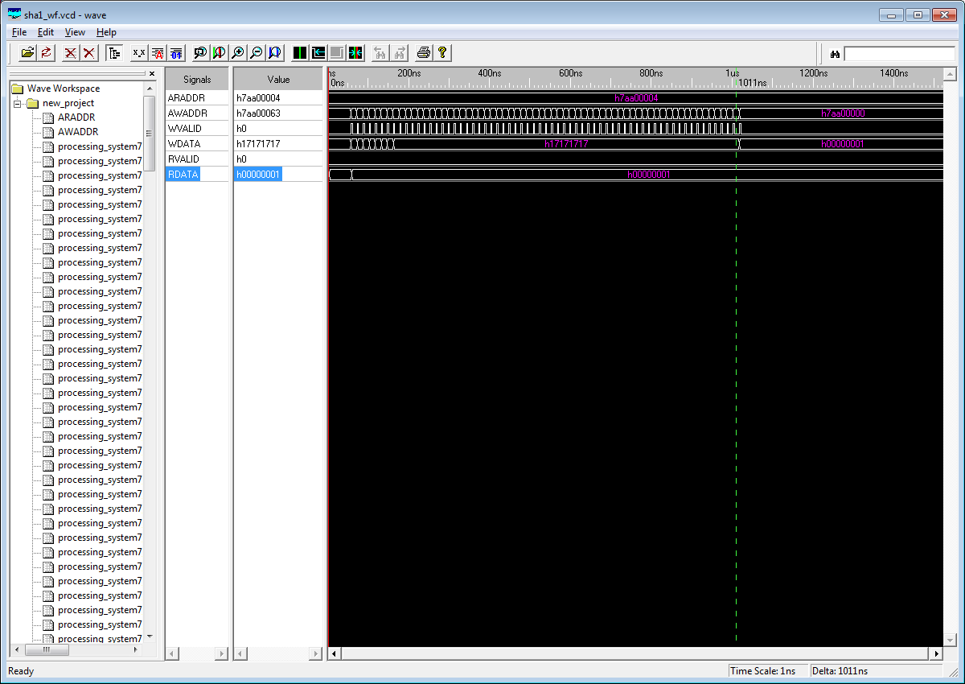
Figure B-3: Post analysis software

For any post signal analysis we used wavevcd viewer (
http://www.iss-us.com/wavevcd/Wave_msi.zip). The vcd files are included in our project submission/chipscope or <git repo>/chipscope folder. Figure B-3 shows the initial software status read and then the write of 64bytes (a block) of msg data to be hashed. Another view of the same sequence (in chipscope) is found in Figure B-4. The spacing between blocks was larger than our chipscope window so the end of the hash sequence was captured in another sequence (Figure B-5).

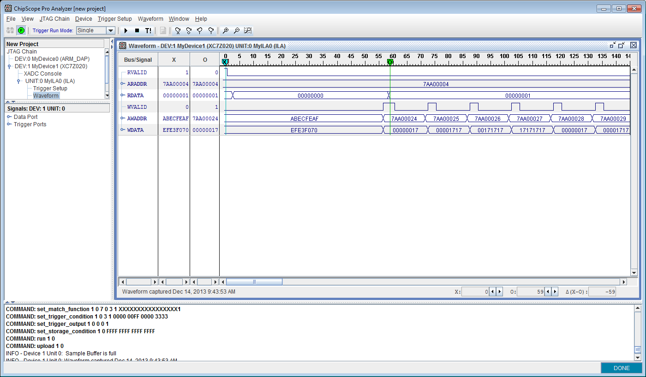
Figure B-4: Chipscope trigger on start of a new hash msg

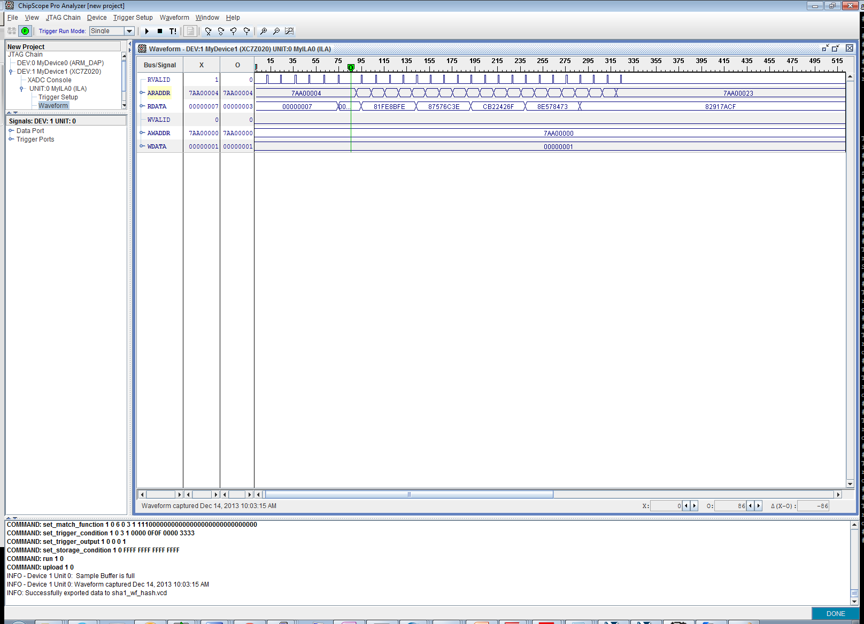
Figure B-5: Chipscope trigger on the end of a hash sequence when hash is ready

The end of a data msg hash sequence results in the software waiting for a status signaling hash complete. This is shown in Figure B-5 where the trigger was a read value of 0x7 signaling the software should start reading out the hash value (5 words).

In all the chipscope captures it’s fairly obvious that the amount of bus time the software spends checking status could definitely be optimized by utilizing interrupts to request the software to read status when there’s a update/change.

Appendix C - Extra Reference Material

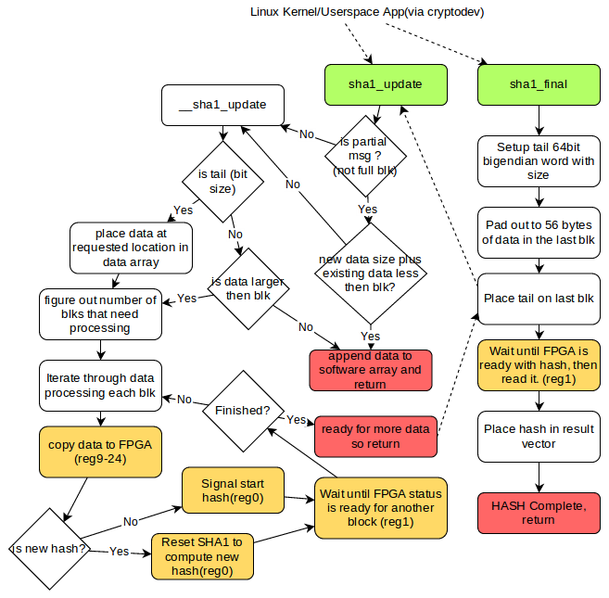
Figure C-1: SHA1 State Machine

Figure C-1 describes the overall operation of SHA1 PL design. All flow starts from the (top) userspace application running on the ARM. The boxes in green are the kernel function calls that implement the custom SHA1 interfacing to the PL (sha1_update/final as discussed in Section: “PL SHA1 Interface Module”). The boxes in yellow are interactions with the PL register map (FSM). The boxes in red are return/final states. Bringing this all together, the diagram shows the software control access and PL status interactions, as well as the data load and hash retrieval steps.

Address | Name | Reset Value | Notes
0x7AA00000 | ZYNQ_SHA1_RST | 0x0 | Controls: start has of new msg (0x2), continue current hash(0x1)
0x7AA00004 | ZYNQ_SHA1_STATUS | 0x0 | Status of userlogic FSM: ready for data input (0x1), Hash ready (0x2), hash busy (0x4)
0x7AA00010 | ZYNQ_SHA1_H0 | 0x0 | First word of 20 byte hash
0x7AA00014 | ZYNQ_SHA1_H1 | 0x0
0x7AA00018 | ZYNQ_SHA1_H2 | 0x0
0x7AA0001C | ZYNQ_SHA1_H3 | 0x0
0x7AA00020 | ZYNQ_SHA1_H4 | 0x0 | Last work of 20byte hash
0x7AA00024 | ZYNQ_SHA1_D0 | 0x0 | First word of 64byte block
0x7AA00028 | ZYNQ_SHA1_D1 | 0x0
0x7AA0002C | ZYNQ_SHA1_D2 | 0x0
0x7AA00030 | ZYNQ_SHA1_D3 | 0x0
0x7AA00034 | ZYNQ_SHA1_D4 | 0x0
0x7AA00038 | ZYNQ_SHA1_D5 | 0x0
0x7AA0003C | ZYNQ_SHA1_D6 | 0x0
0x7AA00040 | ZYNQ_SHA1_D7 | 0x0
0x7AA00044 | ZYNQ_SHA1_D8 | 0x0
0x7AA00048 | ZYNQ_SHA1_D9 | 0x0
0x7AA0004C | ZYNQ_SHA1_D10 | 0x0
0x7AA00050 | ZYNQ_SHA1_D11 | 0x0
0x7AA00054 | ZYNQ_SHA1_D12 | 0x0
0x7AA00058 | ZYNQ_SHA1_D13 | 0x0
0x7AA0005C | ZYNQ_SHA1_D14 | 0x0
0x7AA00060 | ZYNQ_SHA1_D15 | 0x0 | Last word of 64byte block
Table C-1: Control/status/data registers

Resource Links:

Notes on SHA1 - Overview of padding and tail format
http://www.itl.nist.gov/fipspubs/fip180-1.htm

Crypto dev sha testing example
http://lists.freebsd.org/pipermail/freebsd-security/2013-August/007115.html

Notes on using cryptodev-linux
https://github.com/nmav/cryptodev-linux/blob/master/INSTALL

Notes on zynq fabric loading
http://xlnx.lithium.com/t5/Embedded-Linux/download-bitfile-to-dev-xdevcfg-timeout/m-p/322419#M6137
http://forums.xilinx.com/t5/Embedded-Linux/Zynq-Loading-bitfile-into-FPGA-from-Linux-xdevcfg/td-p/237850/page/3

