CausalLens: Diagnostics-First Causal Inference Software in Python
Matthew Powell
Independent researcher
E-mail: \emailmattpowell.gis@gmail.com
URL: https://www.linkedin.com/in/matthew-a-powell/
Personal review copy generated from the JSS LaTeX source.

Abstract
CausalLens is a Python package for causal effect estimation, diagnostics, sensitivity analysis, and manuscript-oriented reporting across observational and quasi-experimental designs. The package combines regression adjustment, propensity-score matching, inverse probability weighting (IPW), doubly robust (DR) estimation, cross-fitted doubly robust estimation, difference-in-differences (DiD), synthetic control, instrumental variables (IV), regression discontinuity (RD), manipulation testing, and bunching analysis in a shared diagnostics-first workflow. The contribution is not a new estimator or identification strategy. Instead, CausalLens provides a compact software layer that keeps overlap checks, balance summaries, sensitivity diagnostics, reference-parity checks, and exportable outputs close to the effect estimate. This positions the project as review-oriented statistical software: it helps users fit established causal estimators while keeping the assumption checks and validation context needed for replication and peer review attached to the estimate. In the current replication bundle, Lalonde benchmark estimates fall between $1429 and $1710 across four estimators, while NHEFS smoking-cessation estimates fall between 3.26 and 3.33 kg, illustrating that the package reproduces recognizable benchmark ranges while exporting the associated diagnostics.
Keywords: causal inference, statistical software, diagnostics, reproducibility, treatment effects, validation, Python

Introduction: Reviewable causal inference software in Python
The potential-outcomes framework introduced by Rubin (1974) and formalized within the "Rubin Causal Model" (Holland 1986) provides the conceptual foundation for modern treatment-effect estimation. Under this framework, every causal effect estimate arrives with a burden of proof: overlap assumptions, covariate balance, sensitivity to hidden bias, and enough documented context for another analyst to judge whether the result is credible. Recent textbook treatments emphasize these requirements from both econometric (Angrist and Pischke 2009; Wooldridge 2010; Cunningham 2021) and statistical perspectives (Hernan and Robins 2020; Huntington-Klein 2022; Ding 2024). In practice, that burden is distributed across separate tools, scripts, and post-hoc checks that rarely travel with the estimate itself (Imbens 2004; Imbens and Wooldridge 2009; Athey and Imbens 2017; Peng 2011; Sandve et al. 2013; Stodden et al. 2016).
The existing Python ecosystem reflects this fragmentation. Table 1 summarizes the landscape. DoWhy emphasizes graph-based identification and refutation within the directed acyclic graph (DAG) tradition championed by Pearl (2009) and bridges the potential-outcomes and graphical-model perspectives surveyed by Imbens (2020); see Sharma and Kiciman (2020). EconML, DoubleML, and causalml are oriented toward machine-learning nuisance estimation, heterogeneous treatment effects, and the double/debiased machine-learning framework of Chernozhukov et al. (2018) (Battocchi et al. 2019; Bach et al. 2022; Chen et al. 2020). causallib is closer in spirit on observational evaluation (Shimoni et al. 2019). Design-specific tools such as rdrobust and bunching provide deep coverage of a single design family (Calonico et al. 2015; Mavrokonstantis and Lockwood 2020). None of these packages aims to carry diagnostics, sensitivity analysis, balance summaries, and exportable review artifacts across observational, panel, IV, RD, and bunching designs in a single workflow.
The same pattern appears in adjacent R software. MatchIt packages matching-oriented preprocessing and balance review (Ho et al. 2011), Synth specializes in synthetic-control workflows (Abadie et al. 2011), and sensemakr focuses on omitted-variable-bias sensitivity analysis (Cinelli et al. 2020). Abadie and Cattaneo (2018) survey the broader landscape of econometric methods for program evaluation, noting that researchers routinely combine evidence across design families. Current software typically supports that workflow only by forcing users to switch between packages with incompatible outputs and diagnostic conventions.
CausalLens was developed to close that gap. It does not introduce a new estimand or a new identification strategy. Its contribution is architectural: a common result-object design that carries diagnostics, metadata, and reproducibility artifacts alongside the effect estimate, across every supported design family. That positioning is closer to a software-integration contribution than to a frontier-method contribution, and it is the standard against which the package should be judged (Imbens and Lemieux 2008; Lee and Lemieux 2010; Angrist and Pischke 2009; Bach et al. 2022; Calonico et al. 2015).
Package | Primary focus | Design scope | Diagnostic workflow
DoWhy | Graph-based ID, refutation | Observational | Refuters, partial overlap
EconML | ML nuisance, CATE | Observational, IV | Limited built-in
DoubleML | Double or debiased ML | Observational, IV, DiD | Sensitivity via sensemakr
causalml | Uplift, heterogeneity | Observational | Limited built-in
causallib | Observational evaluation | Observational | Balance, overlap
rdrobust | RD bandwidth, inference | RD only | McCrary, bandwidth diagnostics
CausalLens | Review-oriented workflow | Obs, DiD, SC, IV, RD, Bunching | Balance, overlap, placebo, E-values, Rosenbaum bounds, OVB, export
Table 1. Comparison of Python causal inference packages. CausalLens is the only package that attaches a full diagnostic and export workflow to every supported design family.

Package design and implementation
CausalLens targets Python 3.11 or newer and is distributed as an installable package with a command-line entry point, bundled benchmark data loaders, tests, and manuscript-oriented output exports. The software is organized around estimator classes and shared result objects so that users can move across design families without relearning a new output format for each method. All estimators return a CausalEstimate object that carries the point estimate, standard error, confidence interval, p-value, and a nested diagnostics container.

Observational estimation
The observational core includes five estimators. Regression adjustment estimates the average treatment effect (ATE) or average treatment effect on the treated (ATT) via outcome modeling (Wooldridge 2010). Propensity-score matching pairs treated and control units on estimated propensity scores following Rosenbaum and Rubin (1983) and Abadie and Imbens (2006), with the matching estimator's finite-sample properties discussed extensively by Heckman et al. (1997) and Smith and Todd (2005). Inverse probability weighting (IPW) reweights the sample using estimated propensity scores as developed by Hirano et al. (2003), with practical guidance on balance assessment in IPW contexts given by Austin and Stuart (2015). The standard doubly robust estimator combines an outcome model with IPW to protect against misspecification of either nuisance model (Robins et al. 1994; Bang and Robins 2005; Funk et al. 2011), while the cross-fitted variant implements the sample-splitting strategy of Chernozhukov et al. (2018) to reduce regularization bias. King and Nielsen (2019) caution that propensity-score matching can increase imbalance under certain conditions; CausalLens surfaces covariate-balance summaries after matching so that users can detect this.
Each estimator reports reviewer-facing diagnostics. Overlap checks flag positivity violations (Stuart 2010), covariate-balance summaries report standardized mean differences (SMD) before and after adjustment (Austin 2009; Austin and Stuart 2015), and sensitivity diagnostics include E-values (VanderWeele and Ding 2017), Rosenbaum bounds (Rosenbaum 2002), and omitted-variable-bias summaries in the Cinelli--Hazlett framework (Cinelli and Hazlett 2020). Rather than treating these as downstream extras, CausalLens attaches them directly to the result object returned by every estimator.
A representative workflow for the Lalonde benchmark illustrates the pattern:
from causal_lens import DoublyRobustEstimator, load_lalonde
data = load_lalonde()
confounders = ["age", "education", "married", "nodegree",
"black", "hispanic", "re74", "re75"]
est = DoublyRobustEstimator("treat", "re78", confounders,
bootstrap_repeats = 200)
result = est.fit(data)

The returned result object provides result.effect, result.se, result.ci_low, result.ci_high, result.p_value, and result.diagnostics containing overlap, balance, and sensitivity summaries. This interface is intentionally uniform: the same attribute names and diagnostic containers apply whether the estimator is regression adjustment, matching, IPW, or doubly robust.

Panel and synthetic control methods
For settings with longitudinal data, CausalLens provides two-period and staggered-adoption difference-in-differences (DiD). The staggered implementation addresses concerns raised by Goodman-Bacon (2021) about heterogeneous treatment effects in two-way fixed-effects specifications. The estimator follows the group--time aggregation strategy of Callaway and Sant'Anna (2021), with doubly robust estimation drawing on Sant'Anna and Zhao (2020). Event-study heterogeneity considerations from Sun and Abraham (2021) and de Chaisemartin and D'Haultfoeuille (2020) motivate the parallel-trends diagnostics that the package reports. Recent surveys by Roth et al. (2023) provide additional context for the design choices in this module.
Synthetic control methods follow Abadie et al. (2010) and the practical guidance in Abadie (2021). Placebo-style permutation inference is included to assess whether the estimated effect is larger than effects obtained by reassigning treatment to donor units.

Quasi-experimental methods
Two-stage least squares (2SLS) estimation for instrumental variables follows the identification framework of Angrist et al. (1996), with the first-stage F-statistic reported as a weak-instrument diagnostic following the critical values of Stock and Yogo (2005) and the rule-of-thumb threshold of Staiger and Stock (1997). Sharp and fuzzy regression discontinuity designs follow Hahn et al. (2001) and the practical guidelines surveyed by Imbens and Lemieux (2008), Lee and Lemieux (2010), and Cattaneo and Titiunik (2022). Robust bias-corrected local-polynomial inference implements the procedure of Calonico et al. (2014), and McCrary-style manipulation testing uses the density discontinuity test of McCrary (2008) with the local-polynomial density estimator of Cattaneo et al. (2020). The RD module reports bandwidth, effective sample size, and the McCrary p-value as standard diagnostic output. Lee (2008) provides a canonical application of sharp RD that motivates the diagnostic defaults in the package.

Bunching analysis
The bunching module estimates excess mass at kink or notch points, following the elasticity-oriented framework of Saez (2010) and the methodological review by Kleven (2016). The estimator returns an excess-mass statistic, a structural elasticity summary, and excluded-range diagnostics. Cross-design comparison functions allow users to evaluate bunching evidence alongside observational, DiD, IV, and RD results in a unified diagnostic table.
Table 2 summarizes the design families currently covered and the evidence artifacts the package returns or ships with the software.
Design family | Representative methods | Review-oriented outputs
Observational estimation | Regression adjustment, matching, IPW, DR, cross-fitted DR | Overlap checks, balance summaries, placebo tests, sensitivity diagnostics, benchmark tables
Panel methods | Two-period and staggered DiD | Parallel-trends review, cohort summaries, synthetic examples, cross-design diagnostics
Quasi-experimental methods | Synthetic control, IV, sharp and fuzzy RD | Placebo-style inference, first-stage strength, McCrary tests, exported summaries
Bunching analysis | Excess-mass and structural elasticity summaries | Excluded-range diagnostics, excess-mass summaries, cross-design comparison outputs
Table 2. Design families covered in CausalLens and the associated reviewer-facing outputs exposed in the package workflow.

Validation and reproducible evidence
Validation for CausalLens rests on four complementary layers, consistent with the emphasis on cumulative evidence that Peng (2011), Sandve et al. (2013), and Stodden et al. (2016) advocate for computational research. The repository includes unit and integration tests spanning estimators, diagnostics, panel methods, instrumental variables, regression discontinuity, bunching, reporting, and reference-parity checks. Below, the remaining validation layers are described in turn.

Benchmark replications
The package includes public benchmark workflows based on the Lalonde and NHEFS datasets. The Lalonde dataset originates from LaLonde (1986), who used it to evaluate whether nonexperimental methods could recover the experimental benchmark, and was further analyzed by Dehejia and Wahba (1999), Smith and Todd (2005), and many subsequent studies. The NHEFS dataset is the primary teaching example in Hernan and Robins (2020). These benchmarks connect the software to datasets that are already well known in the causal inference literature and allow users to compare the package's outputs against recognizable reference values.
Table 3 provides a machine-generated summary of the manuscript benchmark datasets generated by the same top-level reproduction workflow used for the submission bundle. Table 4 gives the full Lalonde estimator-level detail, and Table 5 provides the corresponding NHEFS results.
Dataset | Effect range | Best mean |SMD| after | All overlap checks
Lalonde benchmark | [1,429.1, 1,709.5] | 0.061 | Yes
NHEFS benchmark | [3.212, 3.334] | 0.013 | Yes
Synthetic validation | [1.707, 1.985] | 0.016 | Yes
Table 3. Benchmark overview across the manuscript datasets.

Method | Estimand | Effect | 95% CI | p | Mean |SMD| after
Regression adjustment | ATE | 1,480.661 | [200.6, 2,515.4] | 0.058 | 0.410
Propensity matching | ATT | 1,429.146 | [230.2, 2,705.4] | 0.104 | 0.061
IPW | ATE | 1,463.947 | [318.0, 3,781.3] | 0.113 | 0.096
Doubly robust | ATE | 1,709.503 | [535.4, 2,578.0] | 0.011 | 0.098
Table 4. Lalonde benchmark estimator summary.

Method | Estimand | Effect | 95% CI | p | Mean |SMD| after
Regression adjustment | ATE | 3.334 | [2.239, 3.930] | 0.000 | 0.152
Propensity matching | ATT | 3.212 | [2.367, 4.261] | 0.000 | 0.030
IPW | ATE | 3.263 | [2.108, 4.013] | 0.000 | 0.013
Doubly robust | ATE | 3.294 | [2.140, 4.040] | 0.000 | 0.013
Table 5. NHEFS benchmark estimator summary.

On the Lalonde benchmark, CausalLens reports ATT estimates of $1480.7 from regression adjustment, $1429.1 from matching, $1463.9 from IPW, and $1709.5 from the doubly robust estimator. These values fall within the $800--$1800 range documented in the Lalonde replication literature (LaLonde 1986; Dehejia and Wahba 1999; Smith and Todd 2005; Stuart 2010). Confidence intervals are percentile bootstrap intervals, while p-values use Wald-type asymptotic inference; these two approaches may diverge slightly in small samples. Figure 1 visualizes the estimator comparison.
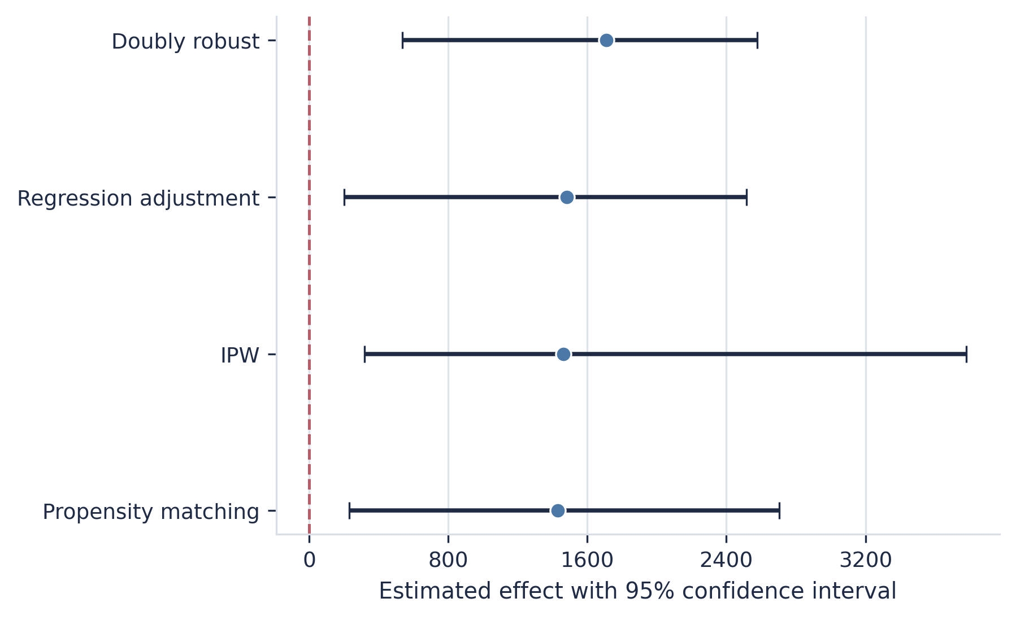
Figure 1. Lalonde benchmark: treatment-effect estimates and 95% confidence intervals across four observational estimators. All estimates fall within the published $800--$1800 band documented in the replication literature (Dehejia and Wahba 1999). The figure makes clear that the point estimates cluster in the same broad empirical range while IPW and the doubly robust estimator retain somewhat wider uncertainty intervals than matching and regression adjustment.

On the NHEFS benchmark, the evidence stack reports estimated weight-change effects of 3.33 kg from regression adjustment, 3.21 kg from matching, 3.26 kg from IPW, and 3.29 kg from doubly robust estimation. These values cluster within 0.12 kg of each other, consistent with the stability expected when the propensity model is reasonably well specified (Hernan and Robins 2020; Funk et al. 2011). Figure 2 visualizes the NHEFS estimator comparison, and Figure 3 presents the covariate-balance love plot showing standardized mean differences before and after propensity-score adjustment.
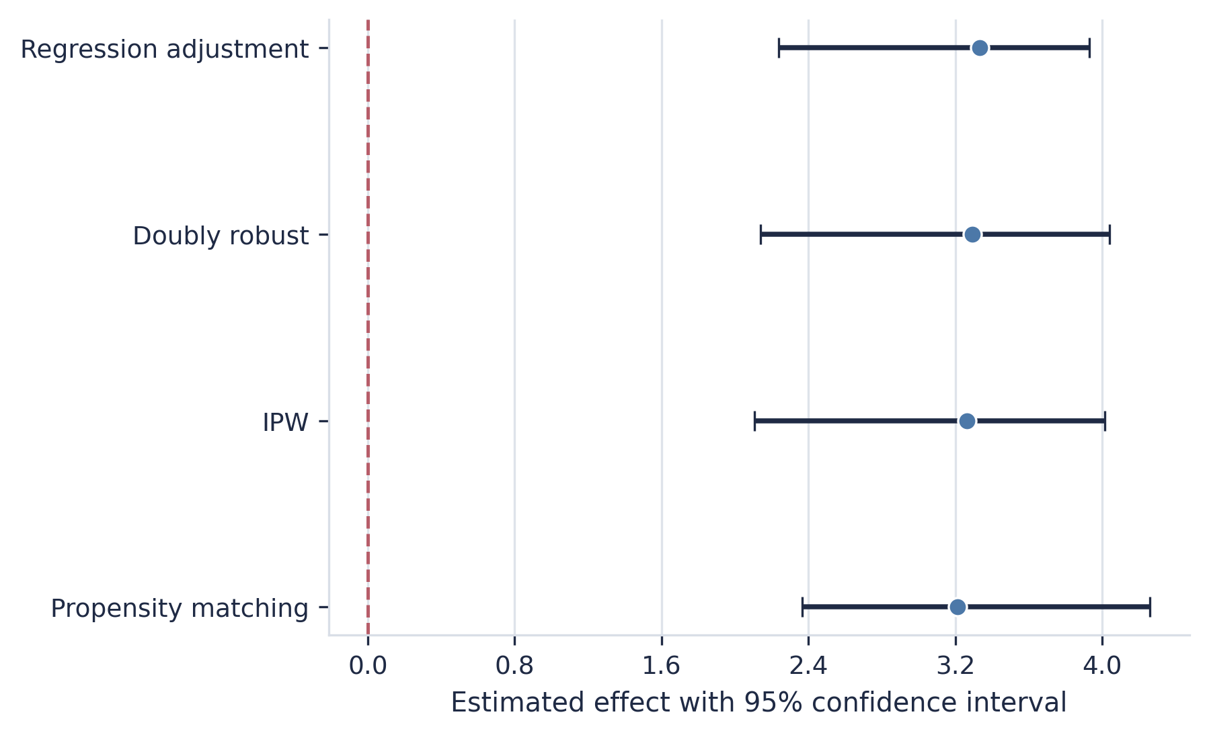
Figure 2. NHEFS benchmark: treatment-effect estimates and 95% confidence intervals for the smoking-cessation weight-gain question. All estimates fall within 0.12 kg of each other (Hernan and Robins 2020). The close agreement across estimators emphasizes that the empirical conclusion is not being driven by a single adjustment strategy on this benchmark.

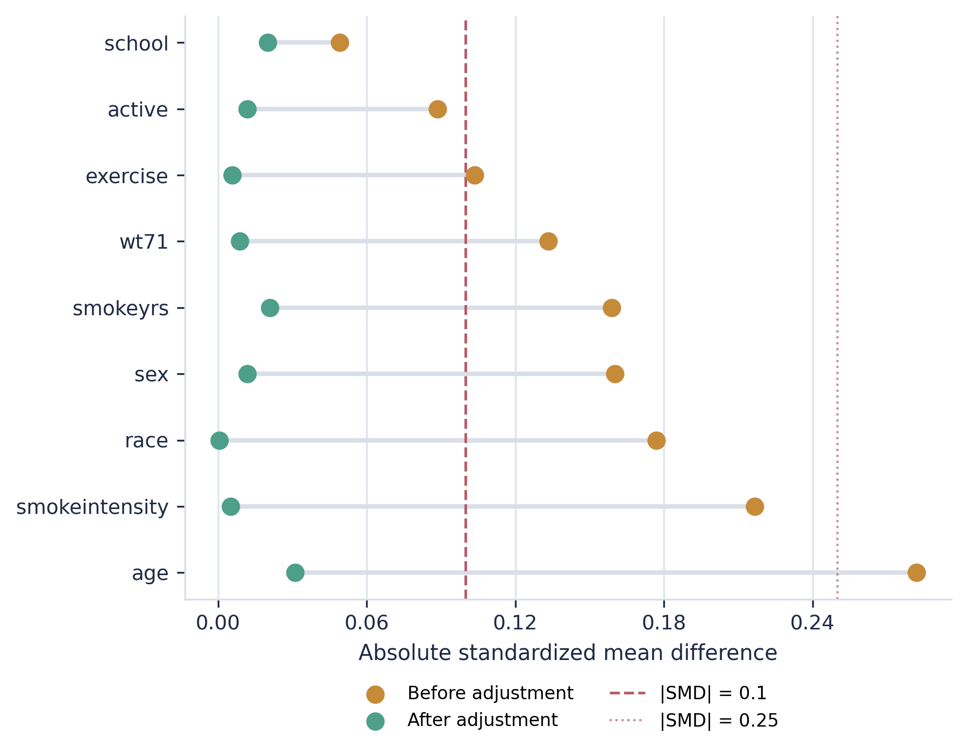
Figure 3. NHEFS covariate-balance love plot. Standardized mean differences before (gray) and after (black) propensity-score adjustment. The threshold line at |SMD| = 0.1 follows the conventional balance criterion (Austin 2009; Austin and Stuart 2015). Most covariates move substantially toward the threshold after adjustment, while any remaining values above 0.1 identify the specific dimensions where residual imbalance still deserves attention.

Synthetic known-effect validation
The project also includes a synthetic validation dataset where the true treatment effect is known by construction (τ = 2.0). This exercise is useful because it makes it possible to assess whether estimators and diagnostics move coherently when the ground truth is available. Table 6 and Figure 4 summarize the results: regression adjustment recovers τ̂ = 1.985, IPW recovers 1.927, doubly robust recovers 1.935, and matching recovers 1.707. Regression, IPW, and doubly robust estimates are all within 3.7% of the true effect. Matching's larger deviation is consistent with the finite-sample bias identified by Abadie and Imbens (2006) for nearest-neighbor matching without bias correction.
Method | Estimand | Effect | 95% CI | p | Mean |SMD| after
Regression adjustment | ATE | 1.985 | [1.807, 2.231] | 0.000 | 0.410
Propensity matching | ATT | 1.707 | [1.403, 2.408] | 0.000 | 0.051
IPW | ATE | 1.927 | [1.610, 2.194] | 0.029 | 0.016
Doubly robust | ATE | 1.935 | [1.736, 2.155] | 0.000 | 0.016
Table 6. Synthetic validation estimator summary.

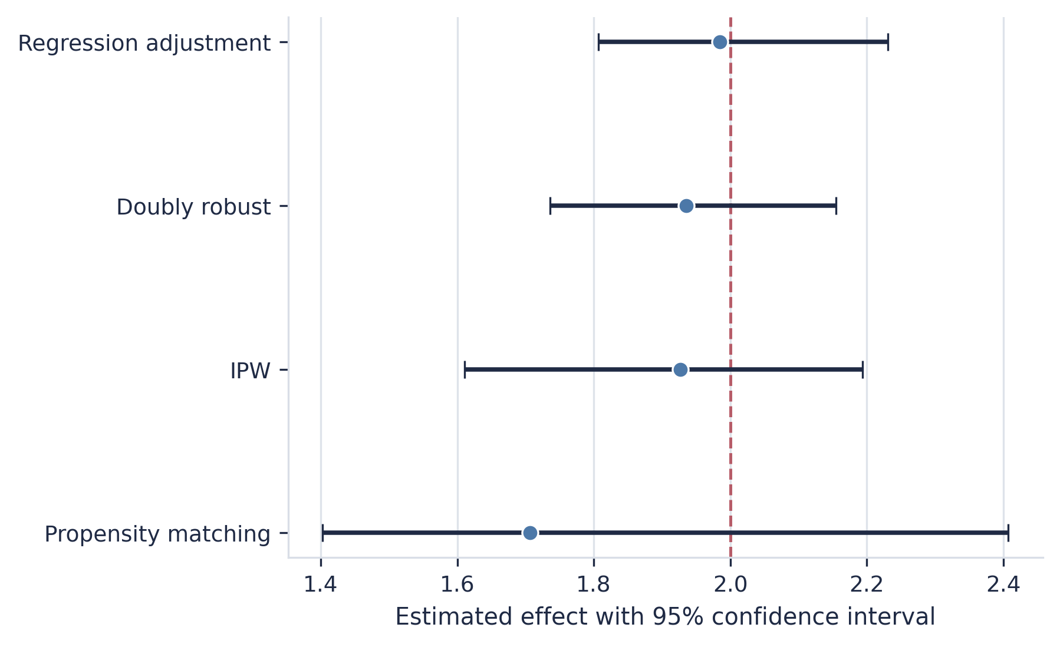
Figure 4. Synthetic validation dataset: estimator recovery of the known treatment effect (τ = 2.0, dashed line). Regression adjustment, IPW, and doubly robust estimation are all within 3.7% of truth. The dashed reference line marks the data-generating effect, making the downward bias of nearest-neighbor matching visually apparent relative to the other estimators.

Diagnostic and sensitivity validation
Two additional diagnostics are worth noting. A placebo test using pre-treatment earnings (re74) as a fake outcome on the Lalonde benchmark produces a non-null "effect" for regression adjustment, IPW, and doubly robust estimation, while matching correctly returns a confidence interval that includes zero (Table 7). This is the expected behavior on the Lalonde data and confirms that the diagnostic layer surfaces residual confounding rather than hiding it (Dehejia and Wahba 1999; Stuart 2010).
Method | Effect | 95% CI | Passes
Regression adjustment | -1,103.417 | [-1,724.9, -372.8] | No
Propensity matching | -988.567 | [-1,849.0, 1,248.1] | Yes
IPW | -2,734.406 | [-3,770.7, -2,217.7] | No
Doubly robust | -2,530.463 | [-3,698.6, -1,661.4] | No
Table 7. Placebo and falsification test results (Lalonde, outcome = re74).

A Rosenbaum-bounds sensitivity analysis on the Lalonde matched pairs (Table 8) shows that the matching result is not significant even at Γ = 1.0 (p = 0.113) and loses significance rapidly at higher Γ levels, which is consistent with the known vulnerability of the Lalonde observational comparison to hidden bias (Rosenbaum 2002).
Gamma | p (upper) | Significant at 0.05
1.000 | 0.113 | No
1.250 | 0.417 | No
1.500 | 0.728 | No
1.750 | 0.903 | No
2.000 | 0.972 | No
2.500 | 0.998 | No
3.000 | 1.000 | No
Table 8. Rosenbaum sensitivity bounds (Lalonde matched pairs).

Cross-design diagnostics
The cross-design diagnostic replication shows the package reporting both reassuring and cautionary information in a single output table. In the current synthetic comparison, the difference-in-differences pre-trends test returns p = 0.781, the instrumental-variables first-stage F-statistic is 144.1 (well above the Staiger and Stock (1997) rule-of-thumb threshold of 10 and the Stock and Yogo (2005) critical values), the observational E-value is 4.94 (VanderWeele and Ding 2017), and the regression discontinuity McCrary test returns p = 0.871 (McCrary 2008; Cattaneo et al. 2020). At the same time, the same summary flags a residual post-adjustment observational imbalance of max |SMD| = 0.487. This is precisely the kind of mixed evidence that the package is designed to preserve rather than hide: one should be able to export a result and its diagnostic liabilities together.

Stability and reproducibility
Table 9 reports bootstrap stability metrics across all three benchmark datasets and all four estimators. The deterministic estimators exhibit zero coefficient of variation across bootstrap resamples within each dataset, confirming numerical reproducibility of the estimation pipeline. The balance overview in Figure 5 provides a cross-dataset summary of covariate balance after adjustment.
Dataset | Method | Mean effect | SD effect | CV | Mean |SMD| after
Lalonde | Doubly robust | 1,709.503 | 0.000 | 0.000 | 0.098
Lalonde | IPW | 1,463.947 | 0.000 | 0.000 | 0.096
Lalonde | Propensity matching | 1,429.146 | 0.000 | 0.000 | 0.061
Lalonde | Regression adjustment | 1,480.661 | 0.000 | 0.000 | 0.410
NHEFS | Doubly robust | 3.294 | 0.000 | 0.000 | 0.013
NHEFS | IPW | 3.263 | 0.000 | 0.000 | 0.013
NHEFS | Propensity matching | 3.212 | 0.000 | 0.000 | 0.030
NHEFS | Regression adjustment | 3.334 | 0.000 | 0.000 | 0.152
Synthetic | Doubly robust | 1.935 | 0.000 | 0.000 | 0.016
Synthetic | IPW | 1.927 | 0.000 | 0.000 | 0.016
Synthetic | Propensity matching | 1.707 | 0.000 | 0.000 | 0.051
Synthetic | Regression adjustment | 1.985 | 0.000 | 0.000 | 0.410
Table 9. Bootstrap stability summary across datasets and estimators.

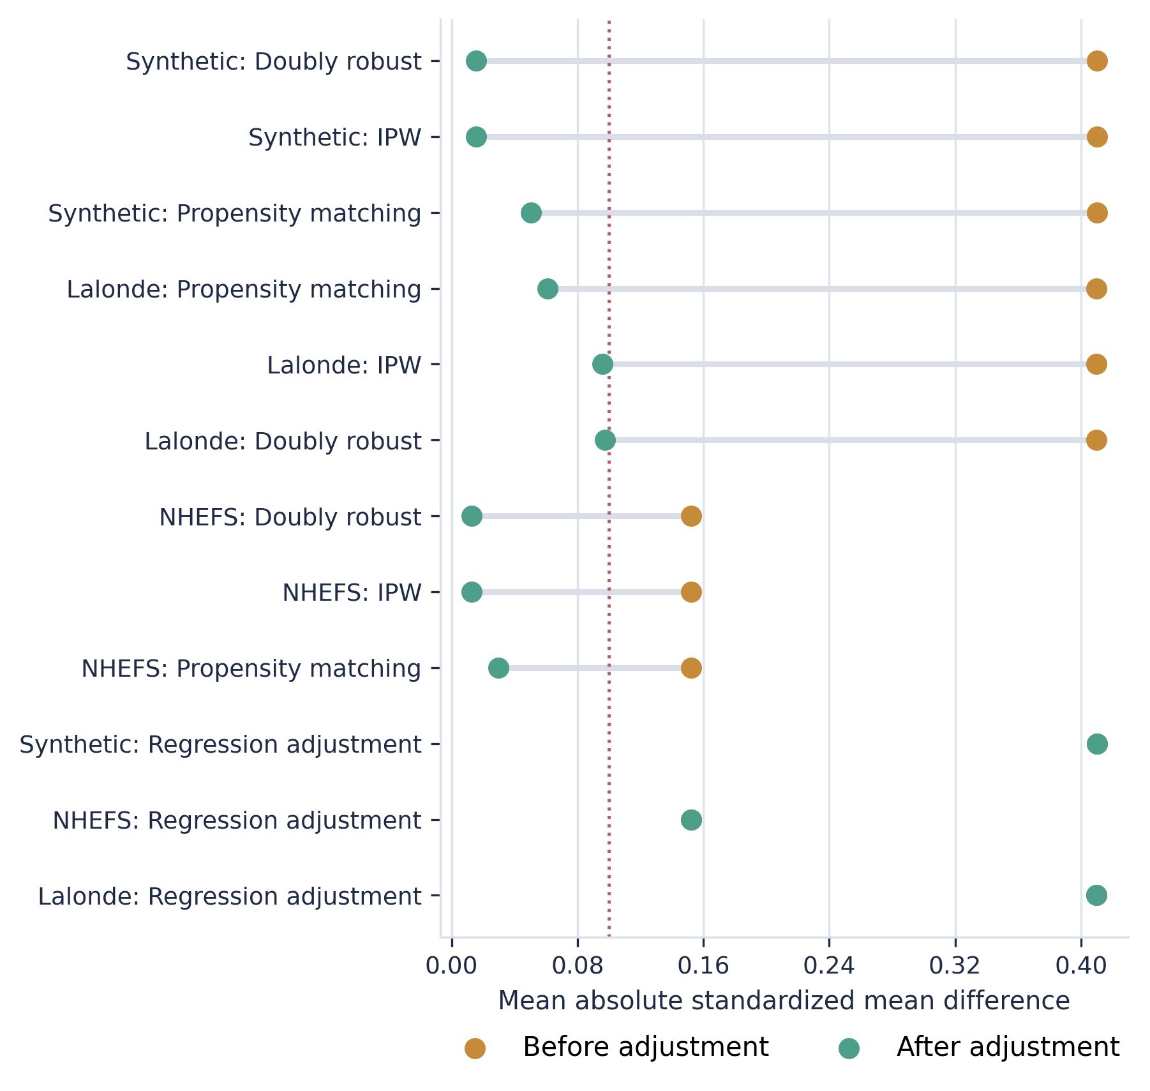
Figure 5. Balance overview across benchmark datasets. Mean absolute standardized mean difference after adjustment, by estimator and dataset. Lower values indicate better covariate balance (Austin 2009). Each row summarizes how far a method moves from raw to adjusted imbalance for a given dataset, so larger leftward shifts indicate stronger balance improvement and the remaining endpoints show residual post-adjustment imbalance.

Together, the unit and integration tests, benchmark replications, synthetic known-effect recovery, diagnostic validation, and cross-design comparisons provide a cumulative software-validation argument rather than relying on a single benchmark or a single testing strategy. The external-comparison audit shows exact numerical parity with hand-coded implementations across all six checked method--dataset pairs, confirming that the estimator internals reproduce expected results (Wilson et al. 2014; Stodden et al. 2016). For users or reviewers evaluating whether the software operates as claimed, the project offers several fast checks: package tests, executable replication scripts, exported benchmark summaries, and a command-line workflow that produces reproducible tables and charts from bundled data.

Illustration: A reviewer-facing workflow in Python
This section demonstrates the CausalLens workflow in three parts: the command-line reproduction path, programmatic estimator usage, and cross-design diagnostic comparison.

Command-line reproduction
The package supports a reviewer-facing workflow in which a user can install the current checkout, rerun the core evidence stack, and inspect the generated outputs without reconstructing the manuscript logic from scratch. The minimal command sequence is:
python -m pip install -e .
python replications/run_all.py --skip-simulation

The first command installs the software from the current checkout. The second executes the Lalonde, NHEFS, and cross-design replications and writes their CSV outputs to the replication outputs directory. When a fuller validation pass is needed, the simulation study can also be included:
python replications/run_all.py

This command reproduces all benchmark, simulation, and cross-design outputs and regenerates the machine-generated manuscript tables and figures. The full evidence stack completes in under five minutes on a standard workstation.

Programmatic estimator usage
The estimator API follows a consistent pattern across all design families. The following example loads the NHEFS dataset and fits three observational estimators:
from causal_lens import (RegressionAdjustmentEstimator,
IPWEstimator, DoublyRobustEstimator, load_nhefs)
data = load_nhefs()
confounders = ["sex", "age", "race", "education",
"smokeintensity", "smokeyrs", "exercise",
"active", "wt71"]
for Estimator in [RegressionAdjustmentEstimator,
IPWEstimator, DoublyRobustEstimator]:
est = Estimator("qsmk", "wt82_71", confounders,
bootstrap_repeats = 200)
r = est.fit(data)
print(f"{Estimator.__name__:30s} "
f"effect={r.effect:.3f} "
f"CI=[{r.ci_low:.3f}, {r.ci_high:.3f}] "
f"p={r.p_value:.4f}")

Every returned result carries a diagnostics attribute with overlap status, covariate-balance tables, and sensitivity statistics. A sensitivity analysis can be requested in a single additional call:
sens = est.sensitivity_analysis(data)
print(f"E-value: {sens.e_value:.2f} "
f"Bias to zero: {sens.bias_to_zero_effect:.3f}")

Cross-design comparison
CausalLens exposes a unified cross-design comparison interface that produces a single diagnostic table spanning observational, DiD, IV, RD, and bunching designs:
from causal_lens import (DifferenceInDifferences,
TwoStageLeastSquares, RegressionDiscontinuity,
BunchingEstimator, compare_designs)
diagnostics = compare_designs(
d_obs, d_did, d_iv, d_rd, d_bunch)
for d in diagnostics:
print(f"{d.design:15s} "
f"{d.diagnostic_name:25s} "
f"value={d.diagnostic_value:.3f} "
f"passes={d.passes}")

This interface enables the kind of multi-design evidence review advocated by Abadie and Cattaneo (2018) and Athey and Imbens (2017), where the credibility of a causal claim is strengthened by convergent evidence across designs with different identifying assumptions.

Discussion
CausalLens occupies a narrow but practical niche: it is most useful where analysts value a consistent, auditable workflow across design families more than frontier performance within any single one. The design deliberately trades specialization depth for cross-design consistency, following the observation by Abadie and Cattaneo (2018) that credible causal inference often involves comparing estimates from multiple designs with different identifying assumptions.
The package does not replace graph-based identification frameworks (Pearl 2009; Sharma and Kiciman 2020), machine-learning-first treatment-effect platforms (Battocchi et al. 2019; Bach et al. 2022; Chen et al. 2020), state-of-the-art RD toolchains (Calonico et al. 2015; Cattaneo et al. 2020; Cattaneo and Titiunik 2022), matching-oriented preprocessing packages (Ho et al. 2011), synthetic-control software (Abadie et al. 2011), omitted-variable-bias sensitivity packages (Cinelli et al. 2020), or specialized bunching implementations (Mavrokonstantis and Lockwood 2020). Its contribution is that estimates from several established designs arrive with their diagnostics instead of leaving those checks to a separate notebook or reporting layer.
The validation evidence supports that claim concretely. Lalonde benchmark estimates fall in the published $800--$1800 band (LaLonde 1986; Dehejia and Wahba 1999), NHEFS estimates cluster within 0.12 kg of each other (Hernan and Robins 2020), synthetic known-effect recovery is within 3.7% of truth for regression, IPW, and doubly robust estimation (Funk et al. 2011), and the external-comparison audit shows exact numerical parity with hand-coded implementations across all six checked method--dataset pairs. Placebo tests and Rosenbaum bounds correctly surface the known limitations of matching on the Lalonde and NHEFS benchmarks (Rosenbaum 2002; VanderWeele and Ding 2017), demonstrating that the diagnostic layer flags problems rather than concealing them.

Limitations and scope boundaries
Several limitations are worth noting. The propensity-score models use logistic regression with scikit-learn's default solver; users who need flexible nonparametric models (e.g., random forests, gradient boosting) for nuisance estimation should consider EconML or DoubleML (Battocchi et al. 2019; Bach et al. 2022). The matching estimator uses nearest-neighbor matching without the bias correction of Abadie and Imbens (2006), which contributes to the finite-sample bias visible in Table 6. The RD module does not yet implement the optimal bandwidth selection of Calonico et al. (2020) or the coverage-error-rate-optimal procedures discussed by Cattaneo and Titiunik (2022). The DiD module does not yet support the full staggered-adoption heterogeneity diagnostics surveyed by Roth et al. (2023).

Future work
Natural extensions include graph-based identification and refutation (Pearl 2009; Imbens 2020), heterogeneous treatment-effect estimation via machine-learning nuisance models (Chernozhukov et al. 2018; Battocchi et al. 2019), advanced RD bandwidth selection (Calonico et al. 2020; Imbens and Kalyanaraman 2012), notch-specific bunching extensions (Kleven 2016), and publication on the Python Package Index (PyPI) to satisfy JSS's preference for standard repository availability. These extensions do not change the current contribution: a compact, testable, replication-oriented Python package for auditable causal analysis that keeps diagnostic context attached to every estimate it produces.

Computational details
The current release (version 0.5.0) targets Python 3.11 or newer on Windows, macOS, and Linux. Core dependencies include NumPy ≥ 1.26 (Harris et al. 2020), pandas ≥ 2.2 (McKinney 2010), scikit-learn ≥ 1.5 (Pedregosa et al. 2011), SciPy ≥ 1.13 (Virtanen et al. 2020), statsmodels ≥ 0.14 (Seabold and Perktold 2010), and Matplotlib ≥ 3.9 (Hunter 2007). Package metadata and dependency constraints are declared in pyproject.toml. The implementation relies on widely used scientific Python libraries, especially scikit-learn for nuisance modeling and statsmodels for regression-based estimation and inference. Replication scripts write outputs to the repository's the replication outputs directory directory, while manuscript-oriented exports are written under the paper outputs directory. The complete evidence stack (Lalonde, NHEFS, cross-design, and simulation replications plus manuscript table and figure generation) completes in under five minutes on a standard workstation. The replication log and generated outputs are included in the submission bundle to facilitate review.

Acknowledgments
CausalLens was developed as an independent research project. No external funding was received. The author declares no competing interests. The author used generative-AI tools for limited editorial assistance and DOCX conversion support under direct supervision; the author reviewed and takes responsibility for all technical claims, code, citations, and final wording. The author thanks the open-source contributors to statsmodels, scikit-learn, pandas, NumPy, and SciPy, on which the package depends.

References
Abadie A (2021). Using Synthetic Controls: Feasibility, Data Requirements, and Methodological Aspects. Journal of Economic Literature, 59(2), 391--425. doi: 10.1257/jel.20191450.
Abadie A, Cattaneo MD (2018). Econometric Methods for Program Evaluation. Annual Review of Economics, 10, 465--503. doi: 10.1146/annurev-economics-080217-053402.
Abadie A, Diamond A, Hainmueller J (2010). Synthetic Control Methods for Comparative Case Studies: Estimating the Effect of California's Tobacco Control Program. Journal of the American Statistical Association, 105(490), 493--505. doi: 10.1198/jasa.2009.ap08746.
Abadie A, Diamond A, Hainmueller J (2011). Synth: An R Package for Synthetic Control Methods in Comparative Case Studies. Journal of Statistical Software, 42(13), 1--17. doi: 10.18637/jss.v042.i13.
Abadie A, Imbens GW (2006). Large Sample Properties of Matching Estimators for Average Treatment Effects. Econometrica, 74(1), 235--267. doi: 10.1111/j.1468-0262.2006.00655.x.
Angrist JD, Imbens GW, Rubin DB (1996). Identification of Causal Effects Using Instrumental Variables. Journal of the American Statistical Association, 91(434), 444--455. doi: 10.1080/01621459.1996.10476902.
Angrist JD, Pischke JS (2009). Mostly Harmless Econometrics: An Empiricist's Companion. Princeton University Press, Princeton.
Athey S, Imbens GW (2017). The State of Applied Econometrics: Causality and Policy Evaluation. Journal of Economic Perspectives, 31(2), 3--32. doi: 10.1257/jep.31.2.3.
Austin PC (2009). Balance Diagnostics for Comparing the Distribution of Baseline Covariates Between Treatment Groups in Propensity-Score Matched Samples. Statistics in Medicine, 28(25), 3083--3107. doi: 10.1002/sim.3697.
Austin PC, Stuart EA (2015). Moving Towards Best Practice When Using Inverse Probability of Treatment Weighting (IPTW) Using the Propensity Score to Estimate Causal Treatment Effects in Observational Studies. Statistics in Medicine, 34(28), 3661--3679. doi: 10.1002/sim.6607.
Bach P, Chernozhukov V, Kurz MS, Spindler M (2022). DoubleML -- An Object-Oriented Implementation of Double Machine Learning in Python. Journal of Machine Learning Research, 23(53), 1--6. https://www.jmlr.org/papers/v23/21-0862.html.
Bang H, Robins JM (2005). Doubly Robust Estimation in Missing Data and Causal Inference Models. Biometrics, 61(4), 962--973. doi: 10.1111/j.1541-0420.2005.00377.x.
Battocchi K, Dillon E, Hei M, Lewis G, Oka P, Oprescu M, Syrgkanis V (2019). EconML: A Python Package for ML-Based Heterogeneous Treatment Effects Estimation. Software documentation, https://www.pywhy.org/EconML/.
Callaway B, Sant'Anna PHC (2021). Difference-in-Differences with Multiple Time Periods. Journal of Econometrics, 225(2), 200--230. doi: 10.1016/j.jeconom.2020.12.001.
Calonico S, Cattaneo MD, Farrell MH (2020). Optimal Bandwidth Choice for Robust Bias Corrected Inference in Regression Discontinuity Designs. The Econometrics Journal, 23(2), 192--210. doi: 10.1093/ectj/utaa005.
Calonico S, Cattaneo MD, Titiunik R (2014). Robust Nonparametric Confidence Intervals for Regression-Discontinuity Designs. Econometrica, 82(6), 2295--2326. doi: 10.3982/ECTA11757.
Calonico S, Cattaneo MD, Titiunik R (2015). rdrobust: An R Package for Robust Nonparametric Inference in Regression-Discontinuity Designs. The R Journal, 7(1), 38--51. doi: 10.32614/RJ-2015-004.
Cattaneo MD, Idrobo N, Titiunik R (2020). A Practical Introduction to Regression Discontinuity Designs: Foundations. Cambridge University Press, Cambridge. doi: 10.1017/9781108684606.
Cattaneo MD, Jansson M, Ma X (2020). Simple Local Polynomial Density Estimators. Journal of the American Statistical Association, 115(531), 1449--1455. doi: 10.1080/01621459.2019.1635480.
Cattaneo MD, Titiunik R (2022). Regression Discontinuity Designs. Annual Review of Economics, 14, 821--851. doi: 10.1146/annurev-economics-051520-021409.
Chen H, Harinen T, Lee JY, Yung M, Zhao Z (2020). causalml: Python Package for Causal Machine Learning. Software documentation, https://causalml.readthedocs.io/.
Chernozhukov V, Chetverikov D, Demirer M, Duflo E, Hansen C, Newey W, Robins J (2018). Double or debiased Machine Learning for Treatment and Structural Parameters. The Econometrics Journal, 21(1), C1--C68. doi: 10.1111/ectj.12097.
Cinelli C, Ferwerda J, Hazlett C (2020). sensemakr: Sensitivity Analysis Tools for Omitted Variable Bias in R and Stata. Journal of Open Source Software, 5(54), 2279. doi: 10.21105/joss.02279.
Cinelli C, Hazlett C (2020). Making Sense of Sensitivity: Extending Omitted Variable Bias. Journal of the Royal Statistical Society Series B, 82(1), 39--67. doi: 10.1111/rssb.12348.
Cunningham S (2021). Causal Inference: The Mixtape. Yale University Press, New Haven.
de Chaisemartin C, D'Haultfoeuille X (2020). Two-Way Fixed Effects Estimators with Heterogeneous Treatment Effects. American Economic Review, 110(9), 2964--2996. doi: 10.1257/aer.20181169.
Dehejia RH, Wahba S (1999). Causal Effects in Nonexperimental Studies: Reevaluating the Evaluation of Training Programs. Journal of the American Statistical Association, 94(448), 1053--1062. doi: 10.1080/01621459.1999.10473858.
Ding P (2024). A First Course in Causal Inference. Chapman & Hall/CRC, Boca Raton.
Funk MJ, Westreich D, Wiesen C, Sturmer T, Brookhart MA, Davidian M (2011). Doubly Robust Estimation of Causal Effects. American Journal of Epidemiology, 173(7), 761--767. doi: 10.1093/aje/kwq439.
Goodman-Bacon A (2021). Difference-in-Differences with Variation in Treatment Timing. Journal of Econometrics, 225(2), 254--277. doi: 10.1016/j.jeconom.2021.03.014.
Hahn J, Todd P, van der Klaauw W (2001). Identification and Estimation of Treatment Effects with a Regression-Discontinuity Design. Econometrica, 69(1), 201--209. doi: 10.1111/1468-0262.00183.
Harris CR, Millman KJ, van der Walt SJ, Gommers R, Virtanen P, Cournapeau D, Wieser E, Taylor J, Berg S, Smith NJ, Kern R, Picus M, Hoyer S, van Kerkwijk MH, Brett M, Haldane A, del Rio JF, Wiebe M, Peterson P, Gerard-Marchant P, Sheppard K, Reddy T, Weckesser W, Abbasi H, Gohlke C, Oliphant TE (2020). Array Programming with NumPy. Nature, 585, 357--362. doi: 10.1038/s41586-020-2649-2.
Heckman JJ, Ichimura H, Todd PE (1997). Matching as an Econometric Evaluation Estimator: Evidence from Evaluating a Job Training Programme. The Review of Economic Studies, 64(4), 605--654. doi: 10.2307/2971733.
Hernan MA, Robins JM (2020). Causal Inference: What If. Chapman & Hall/CRC, Boca Raton. https://miguelhernan.org/whatifbook.
Hirano K, Imbens GW, Ridder G (2003). Efficient Estimation of Average Treatment Effects Using the Estimated Propensity Score. Econometrica, 71(4), 1161--1189. doi: 10.1111/1468-0262.00442.
Ho DE, Imai K, King G, Stuart EA (2011). MatchIt: Nonparametric Preprocessing for Parametric Causal Inference. Journal of Statistical Software, 42(8), 1--28. doi: 10.18637/jss.v042.i08.
Holland PW (1986). Statistics and Causal Inference. Journal of the American Statistical Association, 81(396), 945--960. doi: 10.1080/01621459.1986.10478354.
Hunter JD (2007). Matplotlib: A 2D Graphics Environment. Computing in Science & Engineering, 9(3), 90--95. doi: 10.1109/MCSE.2007.55.
Huntington-Klein N (2022). The Effect: An Introduction to Research Design and Causality. Chapman & Hall/CRC, Boca Raton.
Imbens GW (2004). Nonparametric Estimation of Average Treatment Effects under Exogeneity: A Review. Review of Economics and Statistics, 86(1), 4--29. doi: 10.1162/003465304323023651.
Imbens GW (2020). Potential Outcome and Directed Acyclic Graph Approaches to Causality: Relevance for Empirical Practice in Economics. Journal of Economic Literature, 58(4), 1129--1179. doi: 10.1257/jel.20191597.
Imbens GW, Kalyanaraman K (2012). Optimal Bandwidth Choice for the Regression Discontinuity Estimator. The Review of Economic Studies, 79(3), 933--959. doi: 10.1093/restud/rdr043.
Imbens GW, Lemieux T (2008). Regression Discontinuity Designs: A Guide to Practice. Journal of Econometrics, 142(2), 615--635. doi: 10.1016/j.jeconom.2007.05.001.
Imbens GW, Wooldridge JM (2009). Recent Developments in the Econometrics of Program Evaluation. Journal of Economic Literature, 47(1), 5--86. doi: 10.1257/jel.47.1.5.
King G, Nielsen R (2019). Why Propensity Scores Should Not Be Used for Matching. Political Analysis, 27(4), 435--454. doi: 10.1017/pan.2019.11.
Kleven HJ (2016). Bunching. Annual Review of Economics, 8, 435--464. doi: 10.1146/annurev-economics-080315-015234.
LaLonde RJ (1986). Evaluating the Econometric Evaluations of Training Programs with Experimental Data. The American Economic Review, 76(4), 604--620.
Lee DS (2008). Randomized Experiments from Non-Random Selection in U.S. House Elections. Journal of Econometrics, 142(2), 675--697. doi: 10.1016/j.jeconom.2007.05.004.
Lee DS, Lemieux T (2010). Regression Discontinuity Designs in Economics. Journal of Economic Literature, 48(2), 281--355. doi: 10.1257/jel.48.2.281.
Mavrokonstantis P, Lockwood B (2020). bunching: An R Package for Bunching Estimation. Software repository / working-paper citation path, https://github.com/trilnick/bunching.
McCrary J (2008). Manipulation of the Running Variable in the Regression Discontinuity Design: A Density Test. Journal of Econometrics, 142(2), 698--714. doi: 10.1016/j.jeconom.2007.05.005.
McKinney W (2010). Data Structures for Statistical Computing in Python. In S van der Walt, J Millman (eds.), \emphProceedings of the 9th Python in Science Conference, pp. 56--61. doi: 10.25080/Majora-92bf1922-00a.
Pearl J (2009). Causality: Models, Reasoning, and Inference. 2nd edition. Cambridge University Press, Cambridge.
Pedregosa F, Varoquaux G, Gramfort A, Michel V, Thirion B, Grisel O, Blondel M, Prettenhofer P, Weiss R, Dubourg V, VanderPlas J, Passos A, Cournapeau D, Brucher M, Perrot M, Duchesnay E (2011). Scikit-learn: Machine Learning in Python. Journal of Machine Learning Research, 12, 2825--2830. https://www.jmlr.org/papers/v12/pedregosa11a.html.
Peng RD (2011). Reproducible Research in Computational Science. Science, 334(6060), 1226--1227. doi: 10.1126/science.1213847.
Robins JM, Rotnitzky A, Zhao LP (1994). Estimation of Regression Coefficients when Some Regressors Are Not Always Observed. Journal of the American Statistical Association, 89(427), 846--866. doi: 10.1080/01621459.1994.10476818.
Rosenbaum PR (2002). Observational Studies. 2nd edition. Springer, New York. doi: 10.1007/978-1-4757-3692-2.
Rosenbaum PR, Rubin DB (1983). The Central Role of the Propensity Score in Observational Studies for Causal Effects. Biometrika, 70(1), 41--55. doi: 10.1093/biomet/70.1.41.
Roth J, Sant'Anna PHC, Bilinski A, Poe J (2023). What's Trending in Difference-in-Differences? A Synthesis of the Recent Econometrics Literature. Journal of Econometrics, 235(2), 2218--2244. doi: 10.1016/j.jeconom.2023.03.008.
Rubin DB (1974). Estimating Causal Effects of Treatments in Randomized and Nonrandomized Studies. Journal of Educational Psychology, 66(5), 688--701. doi: 10.1037/h0037350.
Saez E (2010). Do Taxpayers Bunch at Kink Points? American Economic Journal: Economic Policy, 2(3), 180--212. doi: 10.1257/pol.2.3.180.
Sandve GK, Nekrutenko A, Taylor J, Hovig E (2013). Ten Simple Rules for Reproducible Computational Research. PLoS Computational Biology, 9(10), e1003285. doi: 10.1371/journal.pcbi.1003285.
Sant'Anna PHC, Zhao J (2020). Doubly Robust Difference-in-Differences Estimators. Journal of Econometrics, 219(1), 101--122. doi: 10.1016/j.jeconom.2020.06.003.
Seabold S, Perktold J (2010). statsmodels: Econometric and Statistical Modeling with Python. In S van der Walt, J Millman (eds.), Proceedings of the 9th Python in Science Conference, pp. 57--61. doi: 10.25080/Majora-92bf1922-011. https://proceedings.scipy.org/articles/Majora-92bf1922-011.
Sharma A, Kiciman E (2020). DoWhy: An End-to-End Library for Causal Inference. arXiv:2011.04216. ArXiv preprint, https://arxiv.org/abs/2011.04216.
Shimoni Y, Yanover C, Karavani E, Goldstein Y (2019). An Evaluation Toolkit to Guide Model Selection and Cohort Definition in Causal Inference. arXiv:1906.00442. ArXiv preprint, https://arxiv.org/abs/1906.00442.
Smith JA, Todd PE (2005). Does Matching Overcome LaLonde's Critique of Nonexperimental Estimators? Journal of Econometrics, 125(1--2), 305--353. doi: 10.1016/j.jeconom.2004.04.011.
Staiger D, Stock JH (1997). Instrumental Variables Regression with Weak Instruments. Econometrica, 65(3), 557--586. doi: 10.2307/2171753.
Stock JH, Yogo M (2005). Testing for Weak Instruments in Linear IV Regression. In DWK Andrews, JH Stock (eds.), Identification and Inference for Econometric Models: Essays in Honor of Thomas Rothenberg, pp. 80--108. Cambridge University Press, Cambridge. doi: 10.1017/CBO9780511614491.006.
Stodden V, McNutt M, Bailey DH, Deelman E, Gil Y, Hanson B, Heroux MA, Ioannidis JPA, Teeters M (2016). Enhancing Reproducibility for Computational Methods. Science, 354(6317), 1240--1241. doi: 10.1126/science.aah6168.
Stuart EA (2010). Matching Methods for Causal Inference: A Review and a Look Forward. Statistical Science, 25(1), 1--21. doi: 10.1214/09-STS313.
Sun L, Abraham S (2021). Estimating Dynamic Treatment Effects in Event Studies with Heterogeneous Treatment Effects. Journal of Econometrics, 225(2), 175--199. doi: 10.1016/j.jeconom.2020.09.006.
VanderWeele TJ, Ding P (2017). Sensitivity Analysis in Observational Research: Introducing the E-Value. Annals of Internal Medicine, 167(4), 268--274. doi: 10.7326/M16-2607.
Virtanen P, Gommers R, Oliphant TE, Haberland M, Reddy T, Cournapeau D, Burovski E, Peterson P, Weckesser W, Bright J, van der Walt SJ, Brett M, Wilson J, Millman KJ, Mayorov N, Nelson ARJ, Jones E, Kern R, Larson E, Carey CJ, Plisski L, Polat I, Feng Y, Moore EW, VanderPlas J, Laxalde D, Perktold J, Cimrman R, Henriksen I, Quintero EA, Harris CR, Archibald AM, Ribeiro AH, Pedregosa F, van Mulbregt P, SciPy 10 Contributors (2020). SciPy 1.0: Fundamental Algorithms for Scientific Computing in Python. Nature Methods, 17(3), 261--272. doi: 10.1038/s41592-019-0686-2.
Wilson G, Aruliah DA, Brown CT, Hong NPC, Davis M, Guy RT, Haddock SHD, Huff KD, Mitchell IM, Plumbley MD, Waugh B, White EP, Wilson P (2014). Best Practices for Scientific Computing. PLoS Biology, 12(1), e1001745. doi: 10.1371/journal.pbio.1001745.
Wooldridge JM (2010). Econometric Analysis of Cross Section and Panel Data. 2nd edition. MIT Press, Cambridge, MA.

