Task

Based on the data please create output according to the below table shells (one table and one figure). Please also present some (or all) of the programming code developed for doing the output. The data presentation (output) can be done as tables (e.g. in Word, pdf, PowerPoint), interactive or other modalities that serves the purpose and are easiest for you.

Introduction to and description of data

Outline of trial design. Subjects are screened prior to randomisation into treatemnet groups (A and B). Timing of assesments is indicated in the lower part of the figure (HbA1c: Haemoglobin A1c; FPG: Fasting Plasman Glucose).
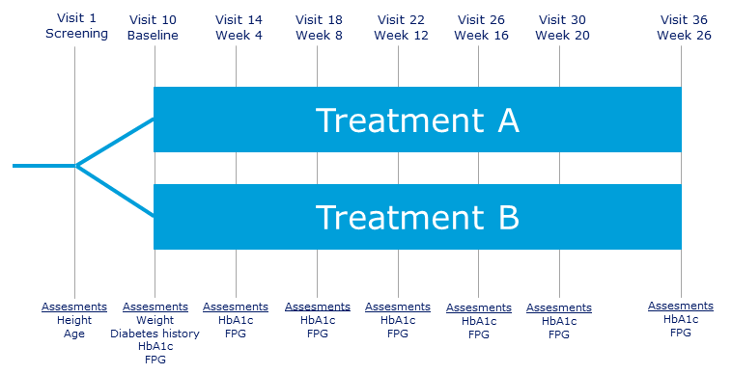

Data can be forund in Excel format in the file: data.xslx. Please note that the Excel workbook contain two sheets, with separate datasets:

ADSL: Subject level dataset (unique identifyer: SUBJID). Each subject has one single row of data and the following variables:
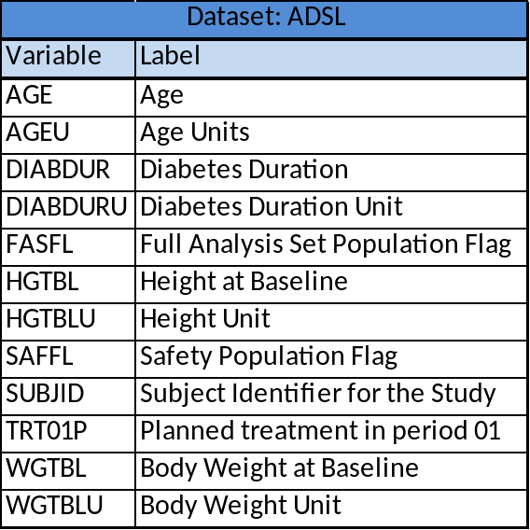

ADLB: Laboratory data (identifyers: SUBJID, PARAM, VISITNUM). The Laboratory dataset hold the following variables:
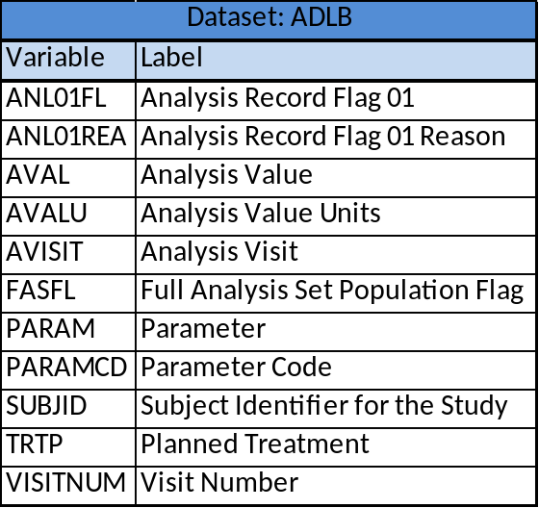

Table shells

Table 1 - Baseline and diabetes characteristics – summary - full analysis set

Treat A Treat B Total

Number of Subjects xxxx xxxx xxxxx

Age (yrs)
N xxxx xxxx xxxxx
Mean (SD) xx.x (xx.x) xx.x (xx.x) xx.x (xx.x)
Median xx.x xx.x xx.x
Min ; Max xx ; xx xx ; xx xx ; xx

Height (m)
N xxxx xxxx xxxxx
Mean (SD) x.xx (x.xx) x.xx (x.xx) x.xx (x.xx)
Median x.xx x.xx x.xx
Min ; Max x.xx ; x.xx x.xx ; x.xx x.xx ; x.xx

Body Weight (kg)
N xxxx xxxx xxxxx
Mean (SD) xx.x (xx.x) xx.x (xx.x) xx.x (xx.x)
Median xx.x xx.x xx.x
Min ; Max xx.x ; xxx.x xx.x ; xxx.x xx.x ; xxx.x

Duration of Diabetes (yrs)
N xxxx xxxx xxxxx
Mean (SD) xx.x (xx.x) xx.x (xx.x) xx.x (xx.x)
Median xx.x xx.x xx.x
Min ; Max xx.x ; xx.x xx.x ; xx.x xx.x ; xx.x

HbA_{1c} (%)
N xxxx xxxx xxxxx
Mean (SD) xx.x (xx.x) xx.x (xx.x) xx.x (xx.x)
Median xx.x xx.x xx.x
Min ; Max xx.x ; xx.x xx.x ; xx.x xx.x ; xx.x

N: Number of subjects, SD: Standard Deviation, Min: Minimum, Max: Maximum, yrs: Years, m: Meter, kg: Kilogram.

Notes:
- Data source: ADSL and ADLB (where PARAMCD=’C64849B’ and VISITNUM=10)
- Population: Full analysis set (FASFL=”Y”).
- Demographic information is obtained at baseline.

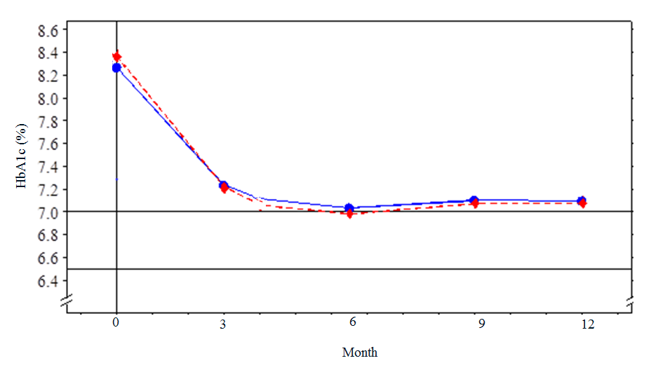
Figure 1 – Mean plot of HbA_{1c} by time - full analysis set

Notes:
- Data source: ADLB (where PARAMCD=’C64849B’)
- Population: Full analysis set (FASFL=”Y”).
- Analysis data: Analysis data 01 only (ANL01FL=’Y’)
- X-axis label: Weeks (i.e. not Months as in the template)
- Y-axis label: HbA1c (%)
- Reference lines: HbA1c = 7.0 % and HbA1c = 6.5 %
- Based on observed values at scheduled visits.

