Cable loop resistance and inductance calculations
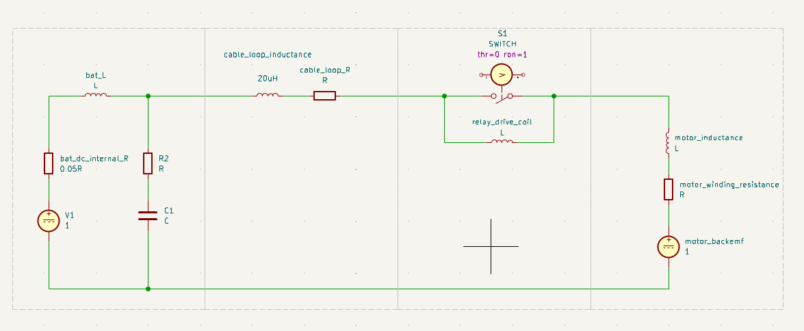
Two conductors loosely bound inside ~30 mm conduit, the loop inductance will be a bit higher than if they were tightly cable-tied together.
For 35 mm² copper, 10 m out + 10 m back = 20 m loop length:

Loop resistance
At 20°C:
Rloop​=ρAL​ mRloop​≈9.85 mΩ
So:
- Loop resistance ≈ 9.85 mΩ at 20°C
- Per metre of loop ≈ 0.492 mΩ/m
At higher conductor temperature:
- ~12.0 mΩ at 75°C
- ~13.1 mΩ at 105°C

Loop inductance
For a two-wire loop, inductance depends mostly on centre-to-centre spacing between the positive and negative conductors.
A 35 mm² conductor has a bare copper diameter of about:
mmd≈6.7 mm
Inside a 30 mm conduit, if the two insulated singles are loose, the conductor-centre spacing is likely somewhere around 16 to 24 mm, depending on insulation thickness and how they sit in the conduit.
Using that range:
- 16 mm spacing → 0.727 µH/m
- 20 mm spacing → 0.816 µH/m
- 24 mm spacing → 0.889 µH/m
For your 20 m total loop:
- 16 mm spacing → 14.5 µH
- 20 mm spacing → 16.3 µH
- 24 mm spacing → 17.8 µH

Practical estimate

Loop inductance ≈ 15 to 18 µH
and a reasonable single-value estimate is:

~16 µH loop inductance
with

~9.85 mΩ loop resistance at 20°C
or about

What that means for transients
The inductive voltage is roughly:
V=Ldtdi
So if current is interrupted quickly, even 16 µH can generate a noticeable spike. For example:
- 100 A interrupted in 10 µs:
V=16×10−6×10×10−6100≈160V
- 200 A interrupted in 10 µs:
V≈320 V

