1.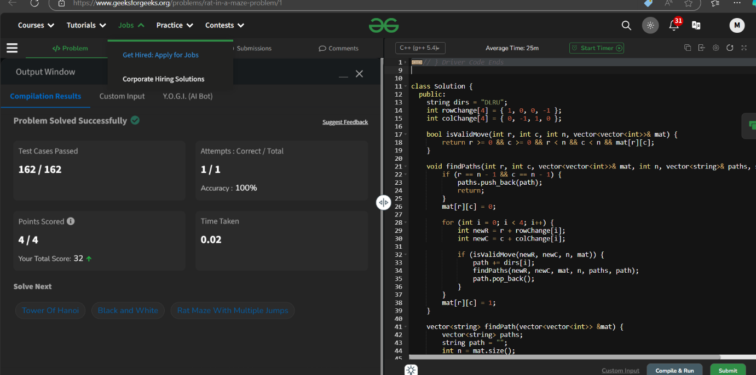

**Time Complexity--🡪O(3^(m*n))**

**2.**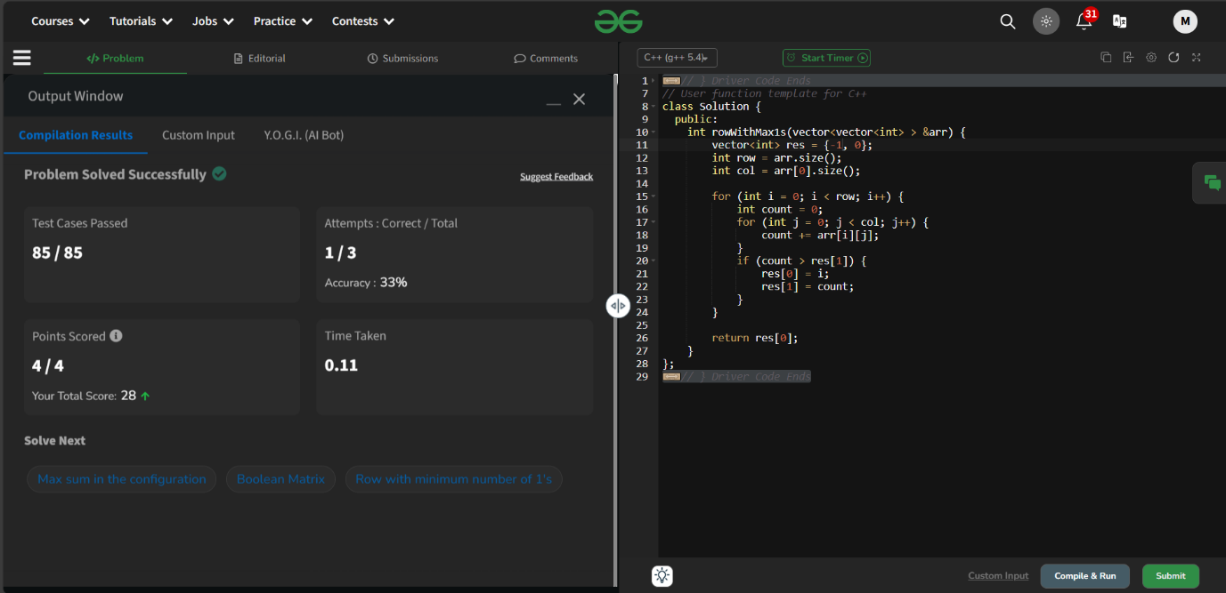

**Time Complexity--🡪O(m*n)**

3.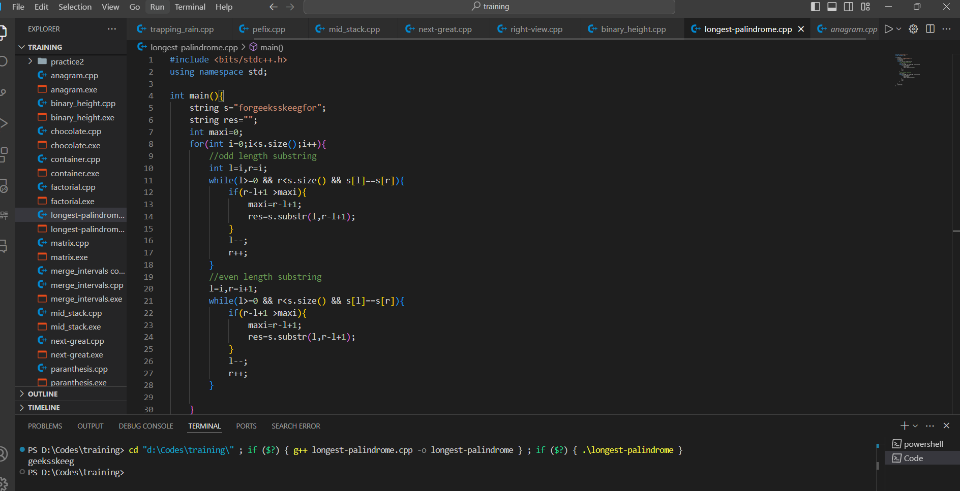

Time Complexity: O(N^2)

4.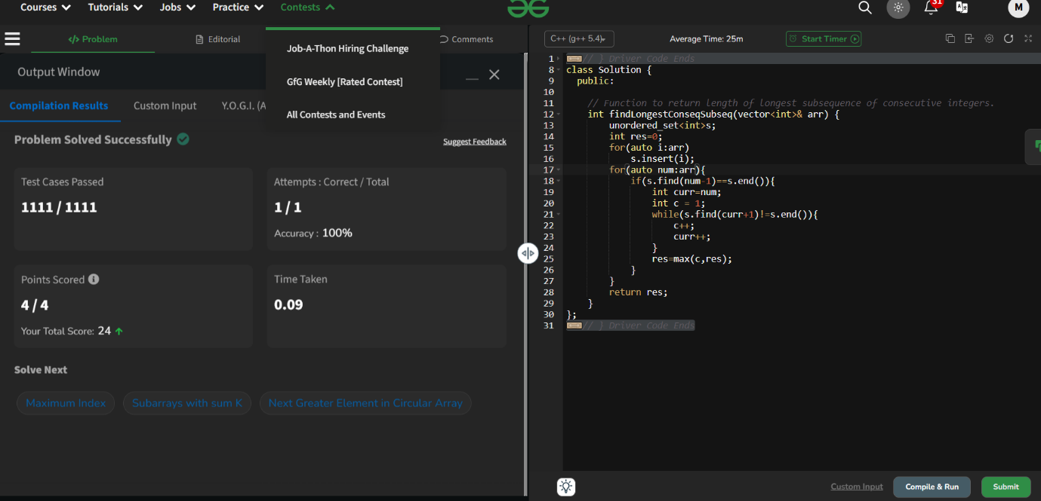

Time Complexity: O(N^2)

5.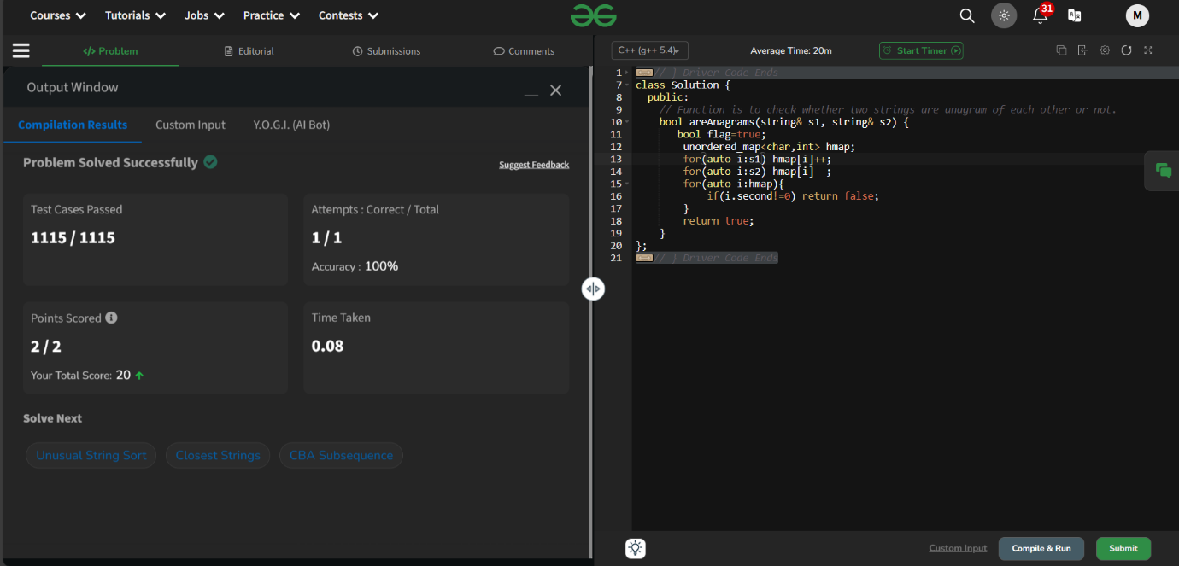

Time Complexity: O(N)