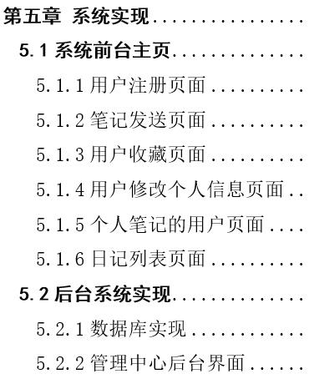

//用户注册

public function reg(Request $request)

{

$req = $request->post();

$user = new User();

$user->nick_name = $req["nickName"];

$user->pwd = $req["password"];

$user->signature = 'noting';

$result = $user->save();

if ($result) {

return json("success");

} else {

return json("error");

}

}

/**

* 新增日记

* @param Request $request

* @param Response $response

* @return msg

*/

public function addition(Request $request, Response $response)

{

$post = $request->post();

//标题

$title = $post['title'];

//内容

$content = $post['code'];

//封面base64

$file = $post['file'];

$fileKey = str_replace('.', '', uniqid('', true)) . '.html';

sleep(0.01);

$contentKey = str_replace('.', '', uniqid('', true)) . '.html';

$cos = new CosUtil();

$cos->uploadString($fileKey, $file);

$cos->uploadString($contentKey, $content);

$article = new Article();

$article->customer_id = Session::get("id");

$article->content = $contentKey;

$article->cover = $fileKey;

$article->title = $title;

$article->issuing_time = date('Y-m-d H:i:s', time());

$article->review_status = '2';

$result = $article->save();

if ($result) {

return $this->success('success');

} else {

return $this->error("error");

}

}

//收藏文章

public function collectArt()

{

$obj=controller("index/common/Base");

$obj->_initialize();

$collect = new Collect();

$collect->article_id = input()['id'];

$collect->customer_id = Session::get("id");

$result = $collect->save();

if ($result) {

return json('success');

} else {

return json('error');

}

}

//修改个人资料

public function setPerson(Request $request)

{

$req = $request->post();

$id = Session::get("id");

$nick_name = $req["nickname"];

$signature = $req["signature"];

$pwd = $req["password"];

if ($req["file"] != '0') {

$photo = $req["file"];

$fileKey = str_replace('.', '', uniqid('', true)) . '.html';

sleep(0.01);$cos = new CosUtil();

$cos->uploadString($fileKey, $photo);

$result = Db::table("user")->where("id",$id)

->setField(["nick_name"=>$nick_name,"signature"=>$signature,"pwd"=>$pwd,"photo"=>$fileKey]);

} else {

$result = Db::table("user")->where("id",$id)

->setField(["nick_name"=>$nick_name,"signature"=>$signature,"pwd"=>$pwd]);

}

if ($result){

return $this->success("success");

} else {

return $this->error("error");

}

}

//获取不同类型的文章列表 1为日期降序排序，2为收藏量与日期降序排序

public function getArtList()

{

if (input()['type'] == '1')

{

$article = Db::table('article')->where('review_status','1')

->order('issuing_time desc')->limit(12)->select();

} else {

$article = Db::query(

'SELECT

a.title,

a.id,

a.cover,

a.content,

a.issuing_time,

u.nick_name,

COUNT( c.article_id ) AS collectNum

FROM

article AS a

LEFT JOIN collect AS c ON a.id = c.article_id

LEFT JOIN `user` AS u ON a.customer_id = u.id

WHERE

a.review_status = 1

GROUP BY

a.id

ORDER BY

issuing_time DESC,

collectNum DESC

LIMIT 12');

}

$id = Session::get("id");

$user = Base::getUser($id)[0];

$userArt = Base::getUserArt($id);

$userCollectArt = Base::getUserCollectArt($id);

$this->assign("user", $user);

$this->assign('userArt',$userArt);

$this->assign('userCollect',$userCollectArt);

$this->assign('article',$article);

return view('artList/artList');

}