Game Theory: The Use of Artificial Intelligence in Chess

Alunni
Brock University
Computer Science
St. Catharines, Ontario, Canada
ma15uq@brocku.ca, 5865647

Abstract—In developing a chess application, it is crucial that a deep understanding of the game is developed. This includes the special cases of chess, including castling, en passant, and pawn promotion. As well, a deep understanding of how and where the chess pieces can move is essential. When designing any application, it is important to note the development environment. In the current case, a deep analysis of the environment of chess playing was completed, and the environment of chess playing was determined to be fully observable, deterministic (strategic), sequential, static, discrete, and multi-agent [5]. As well, a deep understanding of the alpha beta pruning, and the minimax algorithm is essential, as this is the core logic. Lastly, careful design configurations were chosen in order to complete the application. The most important part of this experiment, was the pruning, as the program was very heavy on memory and speed. Pruning significantly reduces runtime within the application.
Keywords—Chess, Castling, En Passant, Pawn Promotion, Environment, Decision Tree, Minimax, Alpha-Beta Pruning

Introduction
In computer science, games are challenge which can be rather difficult to handle. Games are a form of a multi-agent environment, where the intelligence cannot predict the opponents next move. Thus, the intelligence embodies a strategy to win, instead of just the next best move. A multi-agent environment is an environment by which there are multiple interacting intelligent agents. These agents cannot fully change the environment, but they can greatly influence it [1]. In a game of chess, where a person is playing against a computer, the person, as well as the intelligence would both be considered agents, thus, chess is a multi-agent environment. Throughout this experiment, developing a deep understanding of the game of chess was crucial. Learning about special cases within the game such as checkmate, stalemate, castling, and en passant, were also very important in the completion of this experiment. The main algorithm that was used in this was a minimax algorithm, and it was used for decision making.

Learning to Play the Game
When faced with any problem, it is essential to form a deep understanding of your task, and to fully understand all of the aspects and possibilities that one could be faced with. This meant learning the game of chess. For this experiment, to ensure a proper understanding, and to avoid any previous biases or incorrect thoughts of the game, it was decided that as a developer, I would assume no knowledge of the game, and learn everything from scratch.
Chess is played on a board, that is made up of eight by eight squares. In any given row, squares have alternating colours. This means that if you are looking at a square of colour A, then all of the squares directly touching it (up, down, left, right), are made up of colour B.

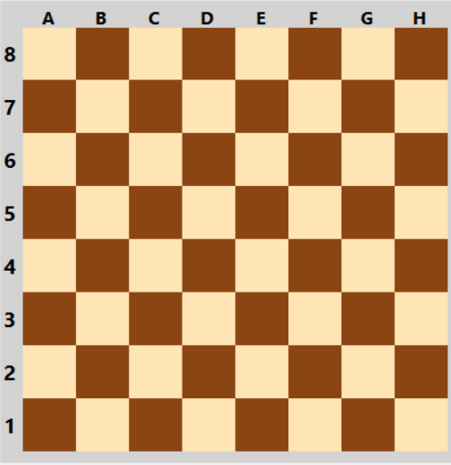

At the beginning of every game, the chess board is always laid out in the same way. The second row in front of each player, is filled with eight pawns [2]. Then, in the first row in front of each player, the rooks go in the corner, followed by the knights, and then the bishops [2]. The queen will always go onto her matching colour, so the white queen will go on the white square, and then the black queen will go on the black square [2]. Lastly, in the only square left in the first row, goes the king [2].

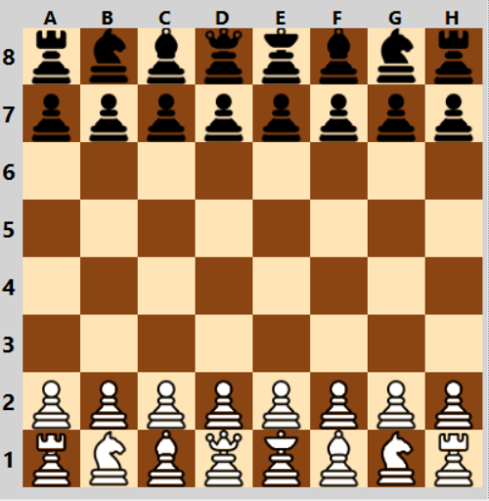
In chess, all six different pieces, have different movement. This means that the pawns move in a different way than the rooks, knights, bishops, kings, and queens do. Other than the knights, the pieces cannot move “through” each other [2]. The only pieces with somewhat of an exception to this rule, are the knights. The knights are able to “jump” over other pieces [2]. There can never be two pieces on a square. One piece can “capture” or “kill” a piece of another colour, and take its place on the board, however, there can never be two pieces on the same square [2].
In chess, the king is the most important piece. If an opponent captures the king, then they have won the game. For movement rules, the king can move one square in any direction, unless the king is putting itself into check. The terms check, checkmate, and stalemate are important when defining the movement of a king. In informal terms, check is when a king is in danger. Checkmate is when a king is in danger and cannot avoid being captured.
In chess, the queen is the most powerful piece, as the queen has the ability to move in any direction, and as far as she wants, as long as she does not move through any of her own pieces [2]. This means that the queen can move as far as she wants diagonally, forwards, backwards, left, or right. Like the king, or any of the other pieces for that matter, if the queen kills another piece, then the players turn is over, and the next player must make their move [2].
The next piece movement that will be examined is the rook. Like the queen, the rook is allowed to move as far as wants, as long as it is linearly up, down, left or right [2]. This means that the rook is unable to work diagonally. Like all of the other pieces, if the rook makes a kill, then that players turn is over, and the next player must resume the game. As well, the rook cannot move through pieces of its own colour.
We will now examine the movement of the bishops. Similar to the queen and the rooks, the bishops can move as far as they want, however, they can only move in a diagonal manner. If we look at the previous image, we can see where the rooks are placed on the board. Assuming we are white, then the bishops are placed on C1, and F1. If we look closer at the board, C1 is a dark tile, and F1 is a light tile. Then, by the rules that were previously stated, the bishop on C1 (dark tile) can only move on other dark tiles, and the bishop on F1 (light tile) can only move onto other light tiles. By this logic, the bishops can work very well together, as they cover up each others weakness [2].
Of all of the pieces, the knight’s movement was the most difficult to represent. A knight moves in an “L” shape. The knight can move two squares in any direction, and then must move one, in order to make the “L” at a 90-degree angle. The knight is also the only player in the game that can jump over other pieces. The image below is a helpful visualization of the knight’s movement.

Lastly, is the movement of the pawn. Similar to the knight, the pawn is another piece with very awkward movement. The pawns movement is awkward because it can only move forward, unless it is attacking. If it is attacking, then it can move diagonally [2]. Additionally, pawns can move two spaces forward instead of one if it is their first turn, otherwise, they can only move forward one space. Pawns cannot capture forward, they can only capture when there is an enemy diagonally in front of them. They cannot move backwards. If there is another piece directly in front of a pawn, then the pawn cannot move forward, and it is stuck until that piece moves [2].
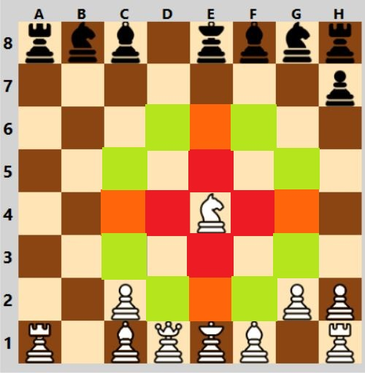

Special Cases in Chess
Upon further research, special cases within the game of chess were identified. The cases that were explored within the experiment were pawn promotion, castling, stalemate, and the en passant rule.
Pawn promotion occurs when a pawn of a player reaches the opposite end of the board. Consider the image above. If the pawn at C2 reaches the end of the board (position C8, perhaps), then the pawn can be promoted. Usually, in chess, a pawn is promoted to a queen [2].
Secondly, there is the rule of castling. Castling allows you to ideally get your king out of danger, and bring your rook into the center of the board, in a single move [2]. In castling, king is allowed to move two squares to one side, either left or right, and then the rook is allowed to move to the opposite side of the king. Essentially the rook switches to the opposite side of the king that it was originally on. The following two images will show the concept of castling visually [2]. Castling can only occur under certain conditions. Firstly, it must be the king’s very first move [2]. Next, it also must be the rooks very first move [2]. Thirdly, there cannot be any pieces between the rook and the king [2]. Lastly, the king must not be in check (in danger), or pass through check [2].
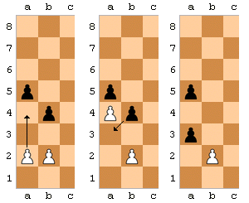
Thirdly, is the concept of stalemate. Stalemate is beneficial for the person who is losing. Stalemate is essentially a type of draw that occurs in chess [3]. Basically, if it is the current (losing) players turn, and they are not in check, and there are no other legal moves to be made, then the game ends in a draw, rather than a loss for the current player. The following is an image of stalemate [4].
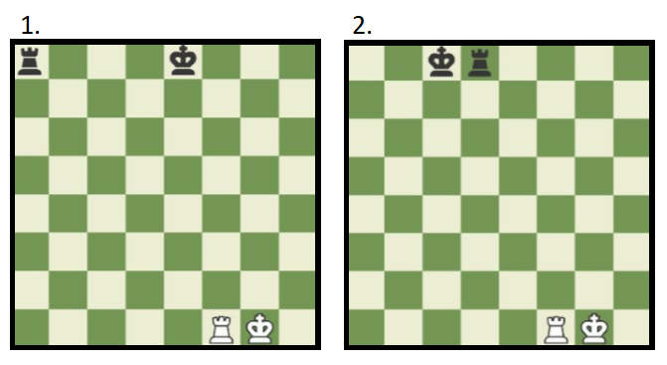
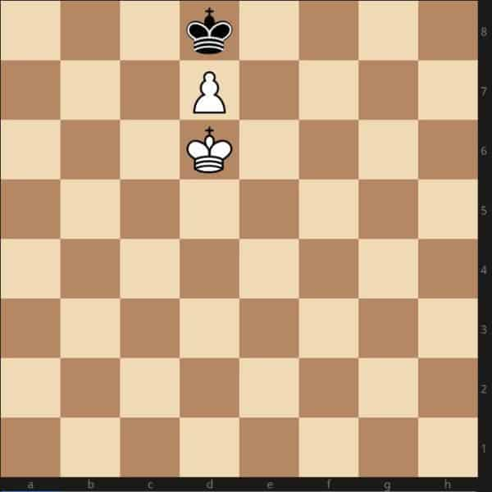
The final special case in chess, is called en passant. This rule concerns pawns. If a pawn moves two squares forward on its first move, and by doing so, lands directly beside another pawn, the other pawn has the option of capturing the pawn beside it as it passes by [2]. This move must be done immediately after the first pawn has moved past, otherwise the option to capture it is no longer available [2]. The image following displays a visualization of what happens when en passant occurs [5].

Environment of Chess Playing
The environment of chess playing was an important consideration in the application development, as with any artificial intelligent application. In chess playing, the environment is fully observable, deterministic (strategic), sequential, static, discrete, and multi-agent [5]. A fully-observable environment is an environment by which sensors can detect all aspects that are relevant to a choice of action. Chess is fully observable because when we make a decision, the agent (either the human, or the intelligence), has access to the full board. The environment of chess is also deterministic. A deterministic environment is one that is completely determined by the current state, and the action executed by the agent. Chess is also sequential. In a sequential environment, the current decision could affect all future decisions, and can have long-term or short-term consequences [5]. This is why a good approach at chess is creating a strategy, not just choosing the highest scoring move at each turn (greedy approach). The environment of chess is also static. A static environment is one that does not change while the agent is thinking [5]. Chess is a static environment because while one player is making their move, the other player is not allowed to make any changes to the board. If the chess is timed, meaning the player has to make their move within a specified time frame, then the environment is semi-dynamic. This is semi-dynamic because the agent has to keep the environment (the timer) in mind while deliberating. Chess takes place within a discrete environment. A discrete environment is one where there are only a finite number of actions that can be performed [1]. Chess is discrete because there are a set number of moves that can be made at all times. Lastly, chess is a multi-agent environment. This is because there are always two agents, or opponents, competing against each other. Even if a human is playing against some kind of artificial intelligence, then there is still a multi-agent environment. The chess player must take in information from their own choices, as well as their opponent’s choices/options when deliberating their next move.

The Minimax Algorithm With Alpha Beta Pruning
The minimax algorithm is a type of algorithm that is used in decision making and game theory to find the optimal move for a player, assuming that your opponent also plays optimally [7]. In a minimax algorithm, there are two players, a maximizer, and a minimizer. The maximizer tries to get the highest score possible, while the minimizer does the opposite [7]. In any given state, there is a value associated with the board; this means that if the maximizer is in the lead, then the board score is positive, and the opposite is true if the minimizer is in the lead [7]. The goal of minimax in the application of chess, is essentially to use the algorithm to search and look ahead at possible future positions, before the algorithm makes its move in the current position.
Alpha-Beta Pruning is an optimization technique for the minimax algorithm, which reduces computation time [8]. What the method of pruning allows us to do, is to potentially search faster, and into deeper levels of the game tree; it does this by cutting off branches within the game tree that do not need to be searched because there is already a better move which is available [8]. Minimax with Alpha Beta Pruning differs from regular minimax primarily in that it takes alpha and beta as parameters in the minimax function [8]. Alpha is the best value that the maximizer can guarantee at the current level or above, and beta is the best value that the minimizer currently can guarantee at the current level or above [8].
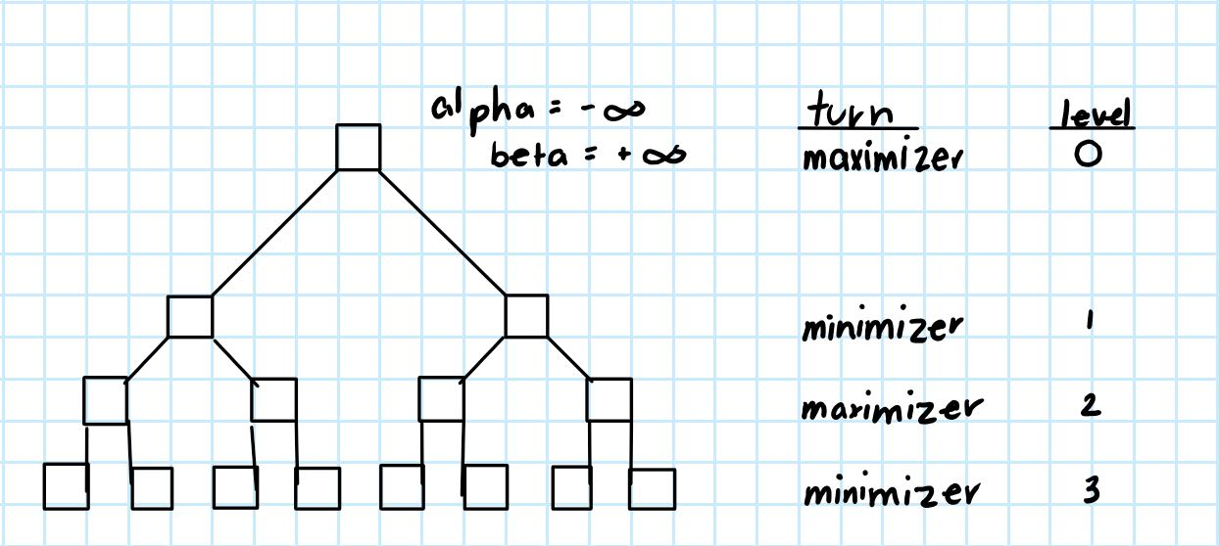
The above image is an example of a potential game tree. Initially, the algorithm begins at the root of the tree. The alpha value begins with the minimum integer value available, and the beta value begins with the maximum. In other words, these are the worst alpha and beta values possible.
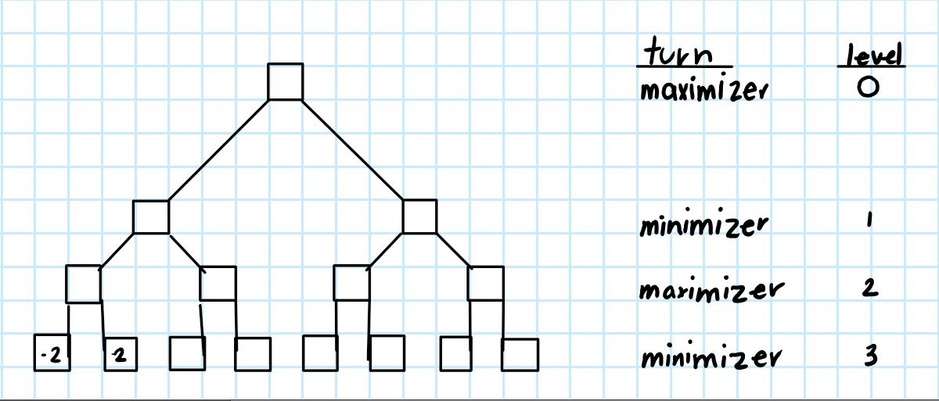
As we proceed through the algorithm, the initial poor scores are passed through the tree, until we arrive at the first leaf of the tree, which is shown above as the farthest left leaf (-2). Since -2 is greater than negative infinity, the alpha is updated to negative two. The traversal is then continued. Once we get to the next leaf (2), we can see that 2 is greater than our current alpha value, so alpha is updated to +2.
We now continue our traversal to the right side of the left subtree, where the leaf is equal to four. Since level one is the minimizers level, we know that the minimizer will most likely choose the left side of the left subtree (the node with 2), as the minimizer is trying to lower their beta value. Since we know that the minimizer is trying to lower their score, we do not even need to search the rest of the subtree, because in this case the minimizer would choose to follow the node valued with 2. Since we are eliminating this part of the path, we are not looking any further into that portion of the tree, so we have pruned a branch.
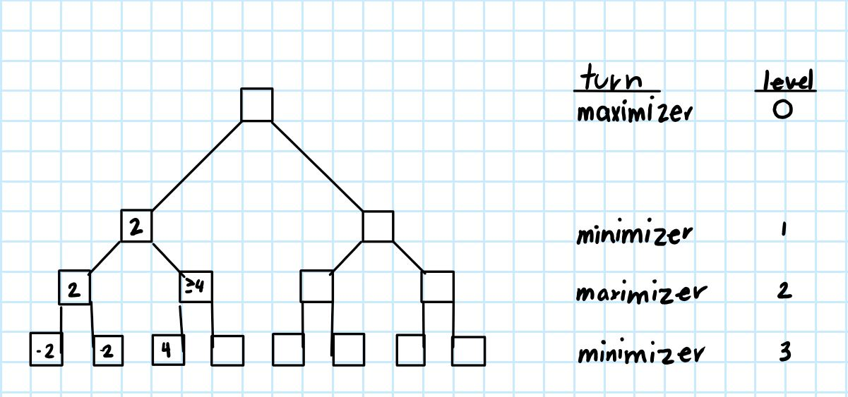
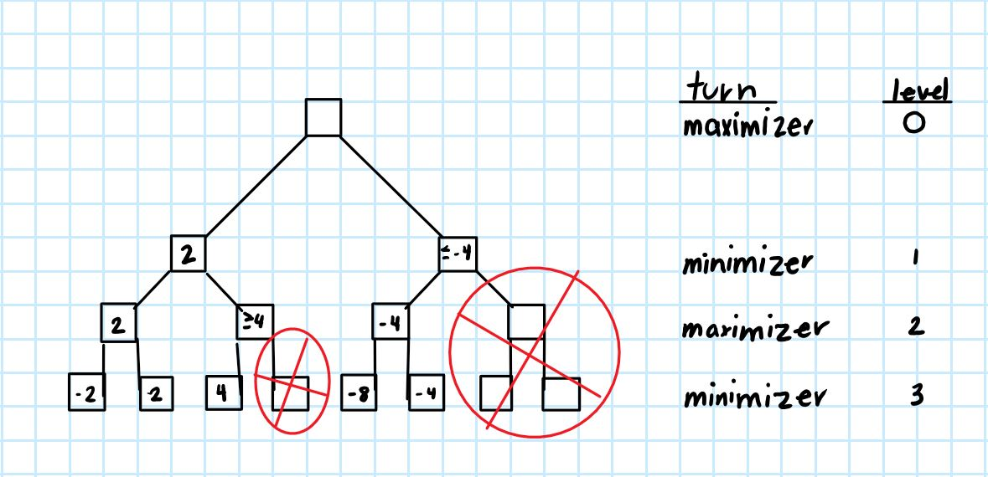
We now move to the right half of the tree as pictured above. As the traversal continues, we reach the first leaf of the right half of the subtree. It is -8. The level above (level two) is the maximizers move. This means that the maximizer updates alpha, which is currently negative infinity, to -8. The traversal is then continued. The next leaf is -4. Since -4 is greater than alpha, alpha is updated to -4. We now know that in level one, negative four is an option. Level one is the minimizers choice, so we can assume that that half of the subtree contains nodes less than or equal to negative four. Now we have both nodes filled in at level one, and we know that level zero is the maximizers turn. Since the maximizer aims to increase their score, we know they will choose the left half of the subtree, because 2 is greater than -4. Since we have discovered this, we no longer have to search the rest of the right half of the subtree, so we have pruned it.

Walkthrough of The Minimax Algorithm Developed
The minimax algorithm that has been created will be outlined step by step as follows. Firstly, the algorithm takes in the board, the player whose turn it currently is, the maximum depth, and the alpha and beta values. Next, there is a base case. What the base case does, is at the maximum depth of the game tree, returns the boards fitness. We then create a new list of boards. Following this step, the algorithm finds each available move/board state for the current player. For each piece on the board, a list is created for all of the allowed moves. For each possible move, a new board is created, and added to a list of chess boards.
Following this, begins the alpha-beta pruning part of the algorithm, which was detailed previously, however; in summary, the algorithm will not search branches of a search tree if there is a better path that already exists. This greatly reduces computation time.

New Concepts
Through the development of the application, there were several resources that were relatively new, which were used. Through trial and error, as well as some personal research, there were several concepts that needed to be researched. These new concepts include threading, multi-threading, cross threading, serializing, and deserializing. These concepts were used to solve errors and problems that needed newer solutions than what may have appeared in the beginning. These new concepts helped to make developing the application a smooth process.
The first concept that will be explained, is threading and multi-threading. “You can imagine multitasking as something that allows processes to run concurrently. While multithreading allows sub-processes to run concurrently [9].” Multithreading is defined as how a program or operating system manages its use by having one to many requests by the same user without having multiple copies of the program running [10]. In the application, the concept of parallel processing is used. Parallel processing refers to the utilization of multiple CPUs in a single computer system [11]. An example of when this concept is used, is in the calculate best move method, which allows iterations to run parallel to each other. This is meant to maximize computation time, allowing decisions to be made in a more efficient manner. The algorithm can think, while its opponent is making a decision.
Closely related is the concept of cross threading. Cross threading is an operation which accesses resources from a different thread. This was used in development when an error that reads as follows occurred. “"Cross-thread operation not valid: Control '' accessed from a thread other than the thread it was created on."” This is seen in the code where the “InvokeRequired” condition is tested. This checks to see if a thread called, then it invokes recursion.
The next concept that will be discussed, is serialization. Serialization is the process of converting state information of an instance of an object into a textual form to persist into storage [12]. A persistent object is one that continues to exist after the program is finished execution. An example of when serialization is used, is in the Chess class. Essentially, what this is used for is to save instances of objects when saving the chess information, that way it can be reloaded in the future. The purpose of this was to save the chess file to XML, so the game can be resumed in the future.
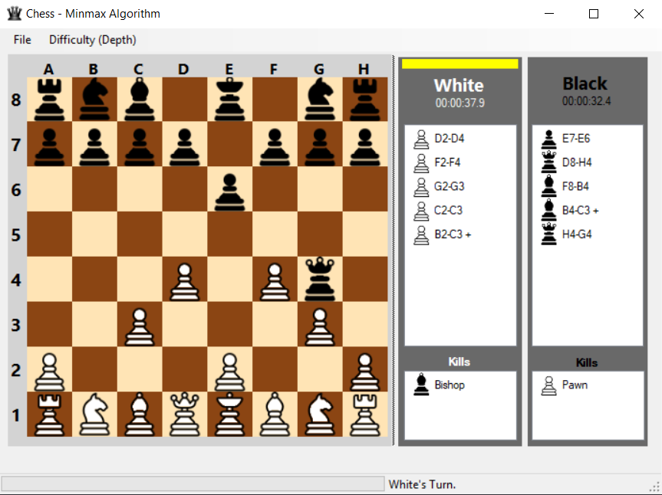
Deserialization was used when the XML file needed to be read to resume the game from file. This is basically turning the information that was created previously (through serialization), back into the form that they were originally, so that the information can be used again. Essentially the opposite of serialization.

Design
The classes that were used in this application are an “AllowedMovement” class, a “Board” class, a “Game” class, a “Chess” class, an interface called “IBoardView”, and a “MainForm” class.
Firstly, the “AllowedMovement” class will be examined. Important methods in the “AllowedMovement” class include the “IsCheck” method, the “Slide” method, and the “Move” method. The “IsCheck” method returns a Boolean value, that is true if the king is in check. The “Slide” method basically slides along a certain path until the algorithm hits something, and the move method actually updates the game state, and moves all of the pieces.
The “Board” class keeps track of both dead, and alive pieces. A very important function in this class is the fitness function. Other functions in this class are the “SetInitialPlacement” function, the “PlacePiece” function, and the “Initialize” function. Firstly, the “Initialize” function creates a blank board, and then fills it with empty spaces. Next, the “PlacePiece” function sets a piece onto the board, and finally, the “SetInitialPlacement” function uses the “PlacePiece” instruction to set up the beginning positions of the game. The fitness function is very important in execution of the program. It is calculated with the current player as a parameter, and is made up of two parts. Firstly, the fitness is calculated by the piece weights. In summary, it is the piece weights, subtracted by the difference between the number of the current player’s pieces and the oppositions pieces. Secondly, the number of potential moves that a player has is included in the fitness. This is calculated by halving the difference between the current player’s moves and the opposition’s moves.
The “Game” class is used to help notify the user interface that something has changed and needs to be refreshed, and deals with how pieces interact with each other. An example of when two pieces interact with each other, is in castling. In this class, there is also the methods that save the chess file, and load it. These methods are used to serialize and deserialize the information that was needed to pause a chess game, save a chess file, and later load a chess file, and resume the game.
Following this is the interface, “IBoardView”. This class defines the methods “SetBoard”, “LogMove”, “SetStatus”, “SetTurn”, and “LogKill” that any inheriting class must implement to render the game. The purpose of using this interface is to be able to take the logic, and isolate it from the view. The main form class implements this interface. Furthermore, the interface is what separates the presentation layer from the logic. That being said, if one wishes to display the chess logic within a web browser for example, they must simply inherit the interface and implement the methods defined.

Lastly, is the “MainForm” class, which is visually represented above. This is the class that interacts with the user. In the application, the user has the ability to choose an AI vs AI game, AI vs player game, or player vs player game. They can also end the current game, save the current game, or open up an old game. The user can also select the difficulty of the game. In this case, the difficulty is actually how many levels into the decision tree we are searching (the depth of the tree). This means that the user has the ability to choose the depth parameter of the search algorithm. This is why, if the user chooses to start a game on the beginner level, the game goes very quickly, and the opposition acts almost instantly. If the user chooses to start a game on the insane level, the time in between moves is significantly longer. This is because the algorithm has a larger decision tree to search, thus, taking more time. On the right side of the form, the user has the ability to see their move history, as well as the kill log, which is how many of the opposition’s pieces the current player has captured.

Conclusion
In game theory, artificial intelligence uses a game tree strategy to search through all of the possible moves in a tree. Although there is a finite amount of moves that can be made in chess, there is still a large number of moves. This experiment details a minimax algorithm with alpha beta pruning, in order to make searching the game tree more efficient. The greedy approach to chess is simply choosing the move that results in the best immediate fitness, however the minimax algorithm analyzes possibilities several moves ahead. The method of alpha beta pruning simply makes this process more efficient, as displayed in the application.

References
- W. Bourne, R. Gallimard and J. Tunnicliffe, "Environments", doc.ac.ic.uk, 2006. [Online]. Available: https://www.doc.ic.ac.uk/project/examples/2005/163/g0516302/environments/environments.html. [Accessed: 10- Jan- 2019].Trans. Roy. Soc. London, vol. A247, pp. 529–551, April 1955. (references)
- "How to Play Chess: Rules and Basics", Chess.com, 2019. [Online]. Available: https://www.chess.com/learn-how-to-play-chess. [Accessed: 09- Jan- 2019].
- C. (CHESScom), "What is Stalemate? | Chess Terms", Chess.com, 2019. [Online]. Available: https://www.chess.com/article/view/stalemate-chess. [Accessed: 09- Jan- 2019].
- "What is Stalemate in Chess? - The Ultimate Guide", iChess.net, 2019. [Online]. Available: https://www.ichess.net/blog/stalemate-in-chess/. [Accessed: 09- Jan- 2019].
- Wikipedia, Diagrama de ejemplo de la captura de peón "al paso". 2006.
- B. Ombuki-Berman, "COSC 3P71 Lecture Two", Brock University, 2018.
- A. L. Aradhya, "Minimax Algorithm in Game Theory | Set 1 (Introduction)", GeeksforGeeks, 2019. [Online]. Available: https://www.geeksforgeeks.org/minimax-algorithm-in-game-theory-set-1-introduction/. [Accessed: 10- Jan- 2019].
- A. L Aradhya, "Minimax Algorithm in Game Theory | Set 4 (Alpha-Beta Pruning)", GeeksforGeeks, 2019. [Online]. Available: https://www.geeksforgeeks.org/minimax-algorithm-in-game-theory-set-4-alpha-beta-pruning/. [Accessed: 10- Jan- 2019].
- "What is a Thread in an Operating System? - Definition from Techopedia", Techopedia.com, 2019. [Online]. Available: https://www.techopedia.com/definition/27857/thread-operating-systems. [Accessed: 10- Jan- 2019].
- M. Rouse, "What is multithreading? - Definition from WhatIs.com", WhatIs.com. [Online]. Available: https://whatis.techtarget.com/definition/multithreading. [Accessed: 10- Jan- 2019].
- H. Schildt, "Multithreading in java with examples", beginnersbook.com, 2019. [Online]. Available: https://beginnersbook.com/2013/03/multithreading-in-java/. [Accessed: 10- Jan- 2019].
[12] "What is Serialization? - Definition from Techopedia", Techopedia.com, 2019. [Online]. Available: https://www.techopedia.com/definition/867/serialization-net. [Accessed: 10- Jan- 2019].

