MGMT361 Fall 2025 Homework 2

Session time: ________________________________________

Student Name: .

**Do not round** **until the final answer.** Round *only* the final answers to two decimal places if necessary.

**Question 1 (4+4+4+2 = 14 points)**

Consider the following process. The processing time (sec/unit) is given for each worker.

M1

100 sec

M2

60 sec

M3

40 sec

|  |  |
| --- | --- |
| Designed CT for Stage 1 | sec / unit |
| Designed CT for Stage 2 | sec / unit |
| Bottleneck | Stage: _____ |
| Process Designed CT | sec / unit |
| Process Capacity | units / hour |

1. Calculate the following **design** parameters for this process:
2. Customers arrive to this Chipotle in the following way: At time 0, 120 sec, 240 sec, 360 sec, …, **two** customers arrive *together*, and M1 and M2 each takes a customer to serve. At time 60 sec, 180 sec, 300 sec, **one** customer arrive and M2 (the faster worker) serves him/her. Draw the Gantt chart from time 0 to time 300 sec. Each grid in the following chart represents 10 seconds. You can extend the below chart as needed.

**M1**

**M2**

**Bu**

**M3**

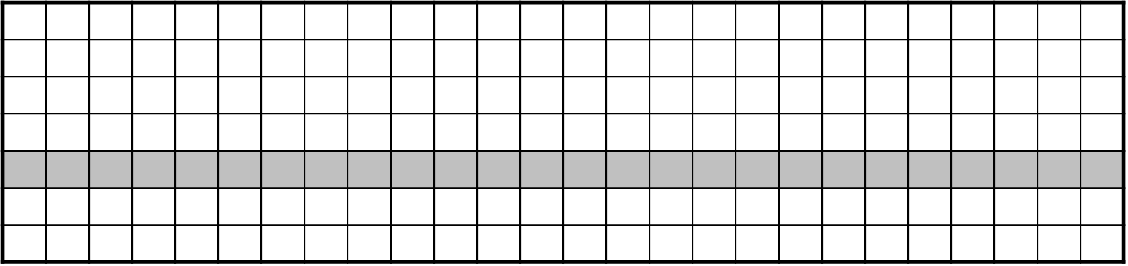

1. Under the arrival schedule given in (b), calculate the following **run-time** parameters:

|  |  |
| --- | --- |
| Demand Rate | units/hour |
| **Flow Rate** | units/hour |
| **Actual Cycle Time** | sec/unit |
| WIP for M1 | units |
| WIP for M2 | units |
| WIP for Buffer | units |
| WIP for M3 | units |
| **Total WIP** | units |
| **Flow time** | secs |

1. Use the total WIP and the flow time calculated in (c), then apply the Little’s formula to get the **flow rate** and the **actual CT**. Underline the correct answer:
   1. The **flow rate** calculated using the Little’s law is the same/more/less than the flow rate calculated in (c) using the Gantt chart.
   2. The **actual CT** calculated using the Little’s law is the same/more/less than the actual CT calculated in (c) using the Gantt chart.

**Question 2 (2+2+2+2=8 points)**

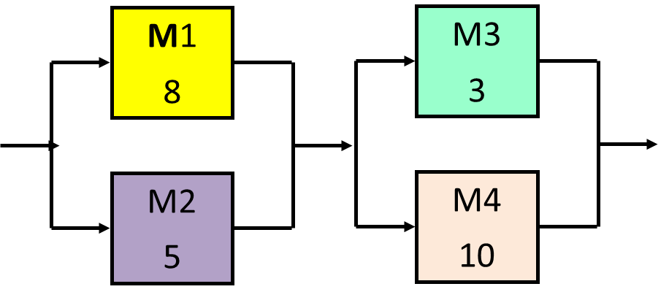We have a process as shown in the right figure. (M1-M4 are the names for four machines. The numbers are **activity times** in minutes). Consider the following schedule:

**10**

**4**

**6**

**2**

Schedule a job on M1 every 10 minutes, starting at time 0; schedule a job on M2 every 5 minutes starting at time 0. Jobs finished on M1 go to M3; jobs finished on M2 go to M4.

1. Plot this schedule for the first 6 jobs in the following Gantt chart. The first job and the 4th job start on M1. The second, third, 5th, and the 6th jobs start on M2. The first block of job 1-5 is plotted for you.

|  |  |  |  |  |  |  |  |  |  |  |  |  |  |  |  |  |  |  |  |  |  |  |  |  |  |  |  |  |
| --- | --- | --- | --- | --- | --- | --- | --- | --- | --- | --- | --- | --- | --- | --- | --- | --- | --- | --- | --- | --- | --- | --- | --- | --- | --- | --- | --- | --- |
|  | **1** | **2** | **3** | **4** | **5** | **6** | **7** | **8** | **9** | **10** | **11** | **12** | **13** | **14** | **15** | **16** | **17** | **18** | **19** | **20** | **21** | **22** | **23** | **24** | **25** | **26** | **27** | **28** |
| **M1** | **1** |  |  |  |  |  |  |  |  |  | **4** |  |  |  |  |  |  |  |  |  |  |  |  |  |  |  |  |  |
| **M2** | **2** |  |  |  |  | **3** |  |  |  |  | **5** |  |  |  |  |  |  |  |  |  |  |  |  |  |  |  |  |  |
| **M3** |  |  |  |  |  |  | **1** |  |  |  |  |  |  |  |  |  | **4** |  |  |  |  |  |  |  |  |  |  |  |
| **M4** |  |  | **2** |  |  |  |  | **3** |  |  |  |  | **5** |  |  |  |  |  |  |  |  |  |  |  |  |  |  |  |

You can extend the above chart as needed.

|  |  |
| --- | --- |
| Machine | WIP (units) |
| M1 |  |
| M2 |  |
| M3 |  |
| M4 |  |
| Total WIP |  |

1. Find the WIP on each machine and complete the below table.
2. What is the average throughput time, i.e., flow time [in mins]?

(*Hint: Every 10 minutes, 3 jobs come to the process (1 job to M1, 2 jobs to M2). To get the average throughput time (TPT), you need to calculate the TPT for each of the three jobs and then take the average. Do not round your answer.* )

1. Is the process demand- or supply-constrained? (Explain your answer)

**Question 3 (2+2+2+2 = 8 points)**

Use Little’s formula to answer the following two questions.

**Little’s formula: WIP = Flow rate × Flow time.**

1. A campus deli serves 400 customers over its busy lunch period from 11:00 am to 1:40 pm. A quick count of the number of customers waiting in line and being served by the sandwich makers shows that an average of 10 customers are in process at any point in time. What is the average amount of time that a customer spends in process?
2. Alpine Heights, a ski resort in the Alps, operates a triple-chair lift that transports 1,275 skiers per hour to the top of the slope. If the journey from the base to the summit takes 15 minutes, calculate the number of skiers on the lift at any given moment.
3. A retail company has an inventory turnover rate of 8 times per year and annual cost of goods sold amounting to $55.8 billion. Calculate the average inventory value held by the company in billion dollars.
4. A clinic operates from 9:00 AM to 1:00 PM. The following data shows the arrival and departure times of patients during this period:

|  |  |  |
| --- | --- | --- |
| **Patient** | **Arrival Time** | **Departure Time** |
| 1 | 9:00 AM | 9:20 AM |
| 2 | 9:15 AM | 10:15 AM |
| 3 | 10:30 AM | 11:00 AM |
| 4 | 10:45 AM | 12:00 PM |
| 5 | 11:30 AM | 1:00 PM |

Given these, how many patients on average are in the office?