TFEdit for .NET

A Lightweight Text Editing Component for the Microsoft .NET Runtime

TFEdit provides an easy to use lightweight text editing component for programs written for the Microsoft .NET runtime. You can add good text editing ability to you programs and, or, write a functional text file editing program with only a few lines of code.
TFEdit has the following features:
- Line numbers on and off.
- Show "invisible" character markers (end of line, tabs and spaces).
- Convert typed tabs to spaces as they are typed.
- Hide mouse cursor on and off when typing.
- Automatic bracket and brace matching pair highlighting when typing.
- Set a vertical line limit ruler on and off and change its position.
- Change the spacing of displayed tabs.
- Highlight the line with the caret
- No runtime licence required.
- Full source code is provided.
TFEdit uses code from the ICSharpCode.TextEditor.dll from the #Develop team; go to http://www.icsharpcode.net/OpenSource/SD/ for more on #Develop.
A Quick Tutorial
In this quick tutorial we are using Microsoft Visual C# 2008 Express Edition.
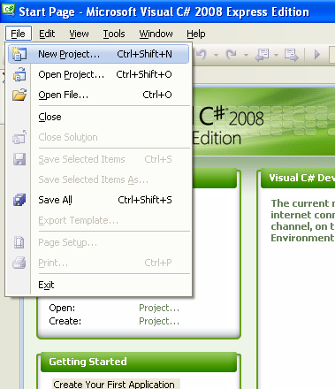
- Begin by creating a new project, or use one of you existing ones.
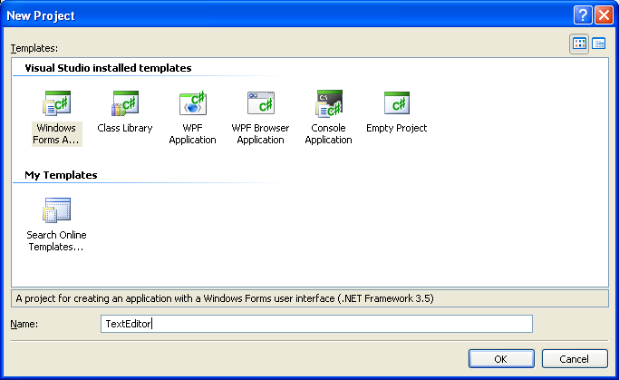
- The project is named.
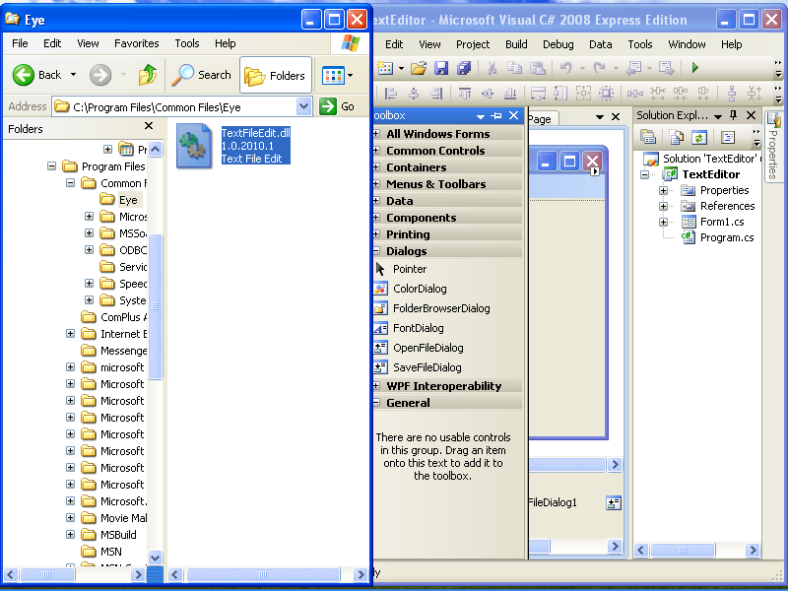
- Open the Toolbox and locate the TextFileEdit.dll that was extracted from the TFEdit zip file. Drag and drop the DLL onto the required Toolbox category.

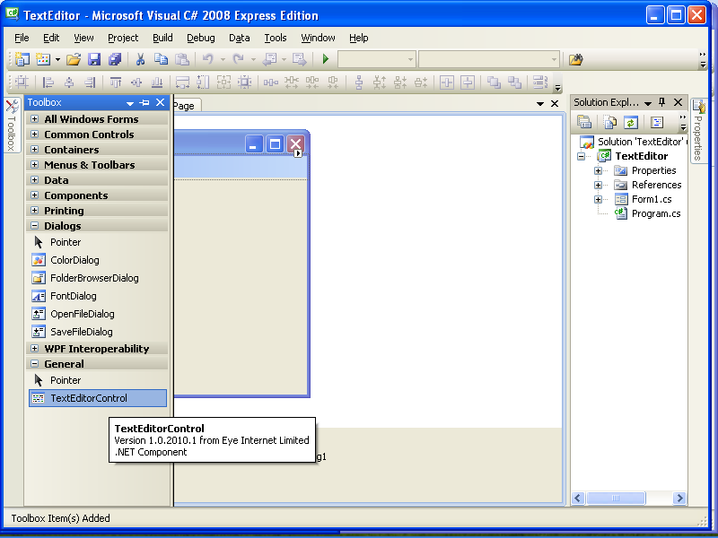
- Select the text edit component.

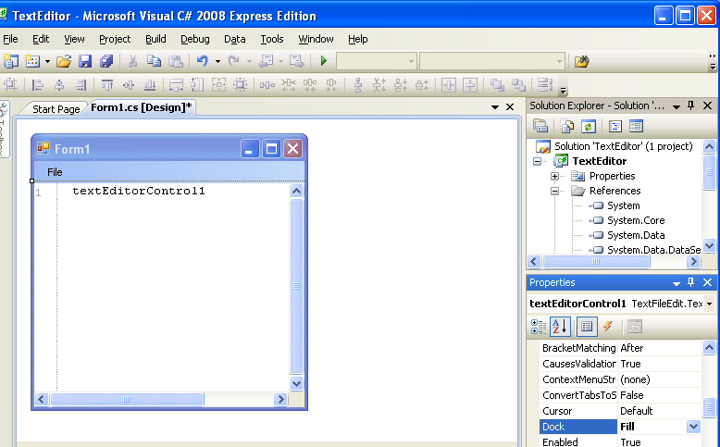

- Add it to a form (double click it in the Toolbox or drag and drop from the Toolbox to the form).
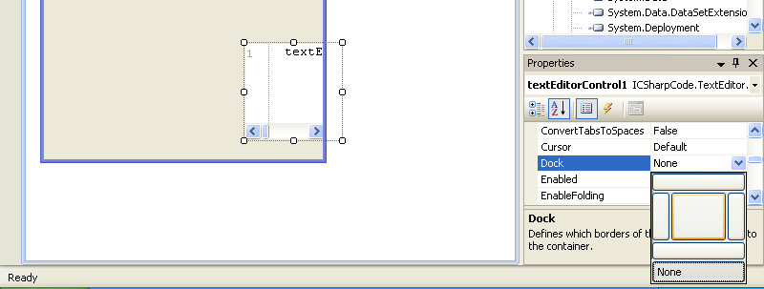

- Set the Dock property to “Fill”.
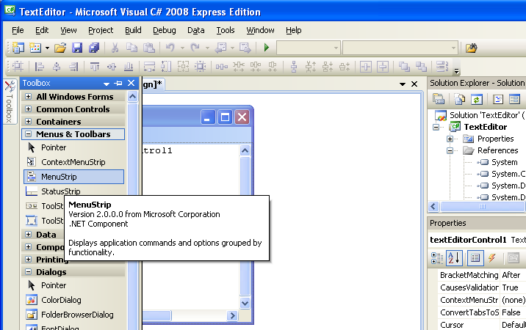

- Add a MenuStrip.

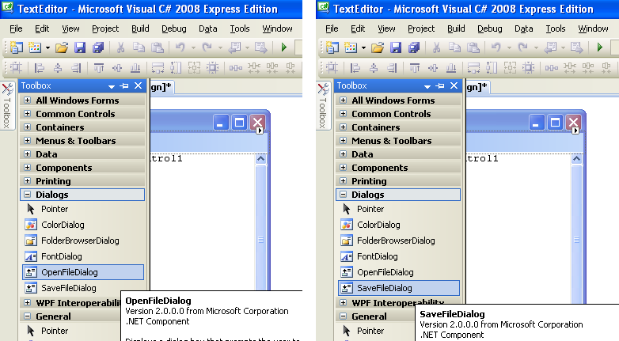

- Add the OpenFileDialog and SaveFileDialog.
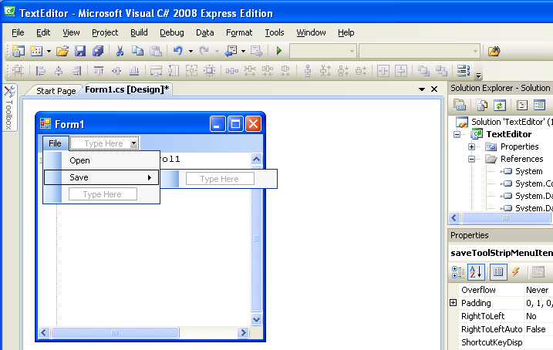

- Add the Open and Save menu text.

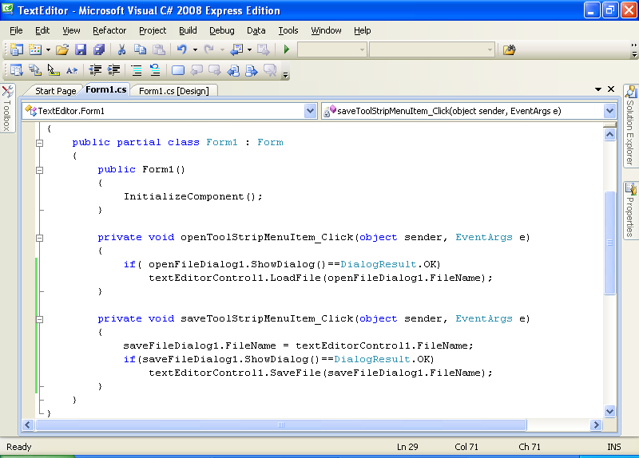

- Hook the Menus to the TextEditorControl (the only typed code so far and just five lines).
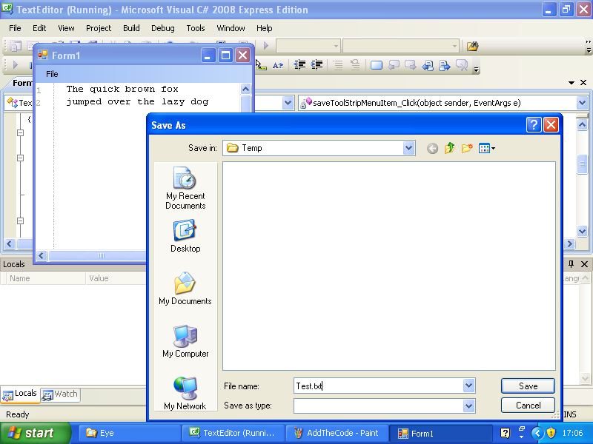
- Run!
Demonstration Program
The demonstration program (provide as a Microsoft Visual C# 2008 Express compiled solution) allows you to experiment with many of the controls properties.
