CIS 4618 – Expert Systems and Decision Support

Problem-solving and search methods

Search is a problem-solving technique that systematically explores a space of problem states, i.e., successive and alternative stages in the problem-solving process. Examples of problem states might include the different board configurations in a game or intermediate steps in a reasoning process. This space of alternative solutions is then searched to find an answer.

Search is inherent to the problems and methods of artificial intelligence (AI). That is because AI problems are intrinsically complex. Efforts to solve problems with computers which humans can routinely solve by employing innate cognitive abilities, pattern recognition, perception, and experience, invariably, must turn to considerations of search. All search methods essentially fall into one of two categories 1) exhaustive (blind) methods and 2) heuristic or informed methods.

Search Strategies
All search methods in computer science share in common three necessities: 1) a world model or database of facts based on a choice of representation providing the current state, as well as other possible states and a goal state, 2) a set of operators which defines possible transformations of states and 3) a control strategy which determines how transformations amongst states are to take place by applying operators. Reasoning from a current state in search of a state which is closer to a goal state is known as forward reasoning. Reasoning backward to a current state from a goal state is known as backward reasoning. As such, it is possible to make distinctions between bottom-up and top-down approaches to problem-solving. Bottom-up is often "goal-directed" -- that is reasoning backward from a goal state to solve intermediary sub-goal states. Top-down or data-driven reasoning is based on simply being able to get to a state which is defined as closer to a goal state than the current state. Often the application of operators to a problem state may not lead directly to a goal state, and some backtracking may be necessary before a goal state can be found.

Blind Search
A blind search (also called an uninformed search) is a search that has no information about its domain. The only thing that a blind search can do is distinguish a non-goal state from a goal state. While there are many blind search techniques, we will focus on two main search techniques: Depth-first search and Breadth-first search.

Depth First Search
The Depth First Search (DFS) is one of the most basic Blind Search Algorithms. It is for those who want to probe deeply down a potential solution path in the hope that solutions do not lie too deeply down the tree. That is DFS is a good idea when you are confident that all partial paths either reach dead ends or become complete paths after a reasonable number of steps. In contrast, DFS is a bad idea if there are long paths, even infinitely long paths, that neither reach dead ends nor become complete paths.

DFS goes through the tree branch by branch, going all the way down to the leaf nodes at the bottom of the tree before trying the next branch over. This strategy requires much less memory than a breadth-first search since it only needs to store a single path from the root of the tree down to the leaf node. However, it is potentially incomplete, since it will keep going on down one branch until it finds a dead-end, and it is nonoptimal -- if there's a solution at the fourth level in the first branch tried, and a solution at the second level in the next one over, the solution at the fourth level will be returned. DFS would explore the tree in the figure in the order: A-B-E-I-F-C-G-H-D.
Figure: Tree Searching Example of Depth-First Search and Breadth-First Search

Breadth-First Search
Breadth-First Search goes through the tree level by level, visiting all of the nodes on the top-level first, then all the nodes on the second level, and so on. This strategy has the benefit of being complete (if there's a solution, it will be found), and optimal as long as the shallowest solution is the best solution. However, the way the breadth-first search achieves this is by keeping all of the leaf nodes in memory, which requires a prohibitive amount of memory when searching anything more than a very small tree. For the tree in the above figure, Breadth-First Search would proceed in the order: A-B-C-D-E-F-G-H-I.

Consider the following, simplified map of Romania
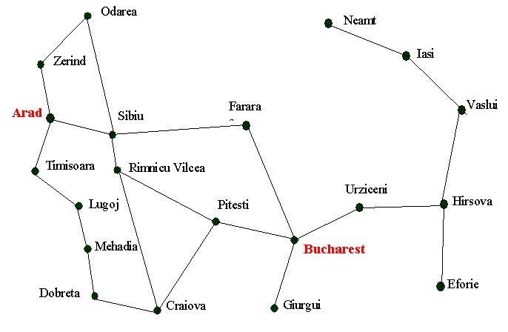

Assume you are currently in Arad, and we want to get to Bucharest.

The depth-first and breath first blind searches only differ in the order in which we expand the nodes, but, as we shall see, this can have a dramatic effect as to how well the search performs.

- Search for a path from Arad to Bucharest using the depth-first search technique.
- Search for a path from Arad to Bucharest using the breadth first search technique.
Note: Avoid paths that are repeating cyclically.

- Nodes visited in order: Arad – Zerind – Odarea – (backtrack) – Sibiu – Farara – Bucharest
DFS goes into the Zerind branch first, but Odarea is a dead end with no unvisited neighbors leading towards Bucharest. DFS backtracks to Arad and tries the next branch: Sibiu. From Sibiu, it goes deep into Farara, which connects directly to Bucharest, so the goat is reached.
DFS SOLUTION PATH: Arad Sibiu Farara Bucharest

- BFS explores all nodes at the current depth level before oving deeper. It expands level by level from Arad:
Level 0 (start): Arad
Level 1: Zerind, Sibiu, Timisoara
Level 2: Odarea (from Zerind), Farara, Rimnicu Vilcea (from Sibiu), Lugoj (from Timisoara)
Level 3: Bucharest (from Farara) GOAL FOUND
BFS guarantees the shortest path. It visits all Level 1 nodes (Zerind, Sibiu, Timisoara) before expanding to Level 2. At Level 2, Farara is discovered as a neighbor of Sibiu. BFS then expands Farara at Level 3 and finds Bucharest immediately. Because BFS explores all shorter paths first, this is guaranteed to be the shortest route in terms of number of cities visited.
BFS SOLUTION PATH: Arad Sibiu Farara Bucharest

