Concurrent Socket Server

Matthew Bosworth
Ty Newman

CNT 4504 – Computer Networks & Distributed Processing

Professor Scott Kelly

July 13, 2026

Introduction
The purpose of this project was to design, implement, and evaluate a concurrent (multi-threaded) socket server and to measure how concurrency changes the efficiency of a client-server system compared to the iterative server built in the previous assignment. In the iterative design, a single server process handles one client from start to finish before it can even accept the next connection. The concurrent design removes that bottleneck: the main server thread does nothing but accept incoming connections, and every accepted connection is immediately routed to its own worker thread, which processes the request in parallel with other clients already being served.

The goals of the project were threefold. First, we wanted to build a working concurrent server in Java that listens on a specified network port and correctly services six different system-information requests: the server’s date and time, its uptime, its current memory usage, its active network connections (netstat), its currently logged-in users, and its running processes. Second, we wanted to build a multi-threaded client capable of spawning many simultaneous client sessions (1, 5, 10, 15, 20, 25, and 100) against the server while recording the turn-around time of every individual request. Third, and most importantly, we wanted to collect and analyze that timing data to quantify exactly how much a concurrent architecture improves average turn-around time relative to an iterative one, and to identify the point at which even a concurrent server begins to degrade under load.

The remainder of this report is organized as follows. The Client-Server Setup and Configuration section describes the design of both programs and the design decisions behind them. The Testing and Data Collection section explains our testing methodology and presents the measured data for all six operations on both servers, including comparison charts. The Data Analysis section answers the assigned analysis questions using that data. Finally, the Conclusion and Lessons Learned sections summarize what the data demonstrates and what we took away from building the system.

Client-Server Setup and Configuration

Server Design
The server, ConcurrentServer.java, opens a ServerSocket on port 4998, a port chosen from the allowed range for the course servers. The main thread runs an infinite loop around the blocking accept() call. The critical design decision is what happens after accept() returns: rather than processing the request itself, the main thread wraps the new client socket in a ClientHandler object (which implements Runnable), starts a brand-new Java Thread to run it, and immediately loops back to accept(). This means the listening thread is never occupied by request processing, so a burst of simultaneous connections can all be accepted and dispatched to their own worker threads with essentially no queuing at the accept stage. Each worker thread is the ‘server instance’ the assignment describes: it is created for exactly one request, and when the request is finished, the thread terminates and is destroyed.

Inside each worker thread, the handler reads a single line from the client containing the operation number (1 through 6). A switch expression maps the number to the corresponding Linux command: date, uptime, free -h, netstat -tuln, who, and ps aux, respectively. The command is executed through Jaca’s ProcessBuilder with bash -c, with standard error redirected into standard output so any error text is also captured and returned. The handler reads the entire output of the command, sends it back to the client line by line, and then sends a special delimiter line, ##END##, so the client knows the response is complete. Using an explicit end-of-message delimiter was a deliberate design decision: responses like ps aux span many lines of unpredictable length, so the client cannot simply read one line or wait for the socket to close on a timeout. Finally, the handler closes the client socket in a finally block, guaranteeing cleanup even if an exception occurred, and the thread ends.

Client Design
The client, MultiThreadedClient.java, first prompts the user once for the server’s IP address and port. It then enters a menu loop offering the six operations plus an exit option and asks how many client sessions to spawn. For each run, it creates that many ClientTask threads simultaneously. Each ClientTask records a start timestamp, opens its own TCP socket to the server, sends the chosen operation number, reads the response until it sees the ##END## delimiter, and records its elapsed time as the turn-around time for that request. This measures exactly what the assignment defines: the time for the request to travel to the server, be processed, and return.

Two concurrency utilities coordinate the measurement. An AtomicLong safely accumulates the total turn-around time across all threads without race conditions, and a CountDownLatch makes the main thread wait until every client thread has finished before computing and printing the results: the individual turn-around times, the total turn-around time, and the average (total divided by the number of clients). A key property of this design is that the client program is identical whether it is talking to the iterative or the concurrent server, which makes the two data sets directly comparable; any difference in the measurements is attributable to the server architecture alone.

Configuration
Both programs were compiled and run on the course servers using simple shell scripts (run_server.sh and run_client.sh) that invoke javac followed by java. The server ran on course server 02a at 139.62.210.112, and the client ran on course server 01a, connecting over port 4998. Sessions on the servers were managed through the Termius SSH client.

Testing and Data Collection
Testing followed the same procedure used for the iterative server, so the results would be directly comparable. With the concurrent server running on server 02a, the client on server 01a was pointed at 139.62.210.112:4998. For each of the six operations, we ran the client with 1, 5, 10, 15, 20, and 25 simultaneous sessions, and additionally with 100 sessions to observe the server under heavy load. For every run, the client printed the turn-around time of each individual session, the total turn-around time, and the average turn-around time; the averages are the primary metric analyzed below. Basic functional testing was performed first: each operation was required by a single client, and the returned output was visually verified to match the output of the corresponding command run directly on the server.

The tables below summarize the average turn-around time (in milliseconds) collected for both servers. The iterative server was measured at 1 through 25 clients in the previous assignment; the concurrent server was measured at the same levels plus the 100-client load test.

Iterative Server – Average Turn-around Time (ms) by number of clients:
Operation | 1 | 5 | 10 | 15 | 20 | 25
Date and Time | 18.00 | 53.20 | 46.40 | 59.40 | 66.95 | 63.68
Uptime | 20.00 | 34.80 | 50.10 | 66.93 | 69.70 | 89.24
Memory Use | 22.00 | 32.20 | 49.20 | 60.27 | 70.95 | 78.36
Netstat | 21.00 | 34.60 | 49.20 | 64.80 | 73.70 | 96.80
Current Users | 23.00 | 47.20 | 58.10 | 73.60 | 87.20 | 111.36
Running Processes | 39.00 | 69.80 | 100.20 | 132.07 | 164.75 | 191.52

Concurrent Server – Average Turn-around Time (ms) by number of clients:
Operation | 1 | 5 | 10 | 15 | 20 | 25 | 100
Date and Time | 12.00 | 16.20 | 17.20 | 20.73 | 18.80 | 21.00 | 442.87
Uptime | 13.00 | 15.40 | 21.00 | 21.87 | 22.90 | 29.80 | 454.51
Memory Use | 11.00 | 17.20 | 18.10 | 21.13 | 26.10 | 26.28 | 362.58
Netstat | 13.00 | 12.80 | 19.50 | 23.33 | 24.70 | 27.68 | 410.64
Current Users | 17.00 | 18.00 | 22.60 | 26.53 | 29.95 | 31.52 | 468.79
Running Processes | 31.00 | 28.80 | 35.50 | 56.67 | 69.95 | 54.72 | 537.45

The following charts plot the data for each of the six operations. Each chart overlays the iterative server results from the previous assignment (red) with the concurrent server results from this assignment (blue) over the 1-25 client range where both were measured, so the two architectures can be compared directly on the same axes. A seventh chart shows the concurrent server alone across all six operations, including the 100-client load test.

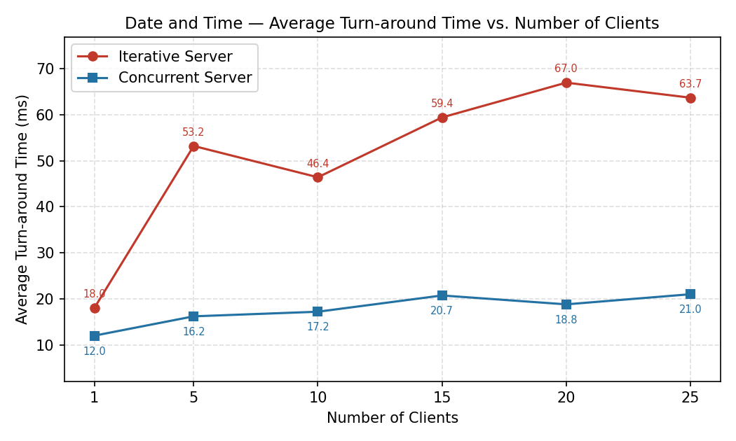
Figure 1. Date and Time – iterative vs concurrent average turn-around time.

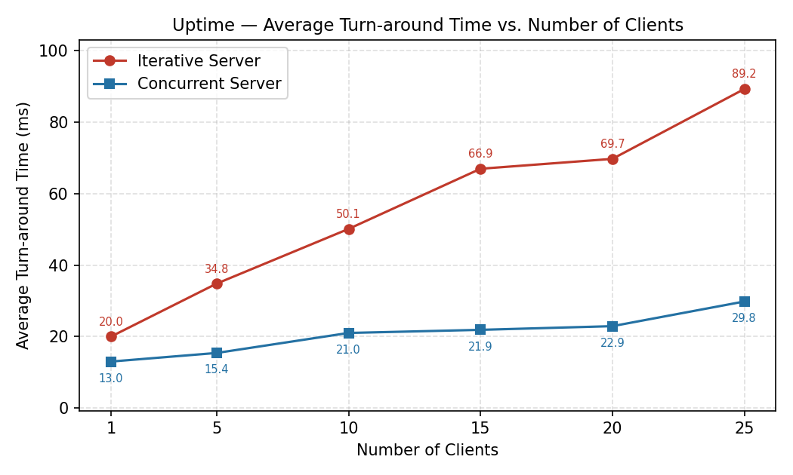
Figure 2. Uptime – iterative vs concurrent average turn-around time.

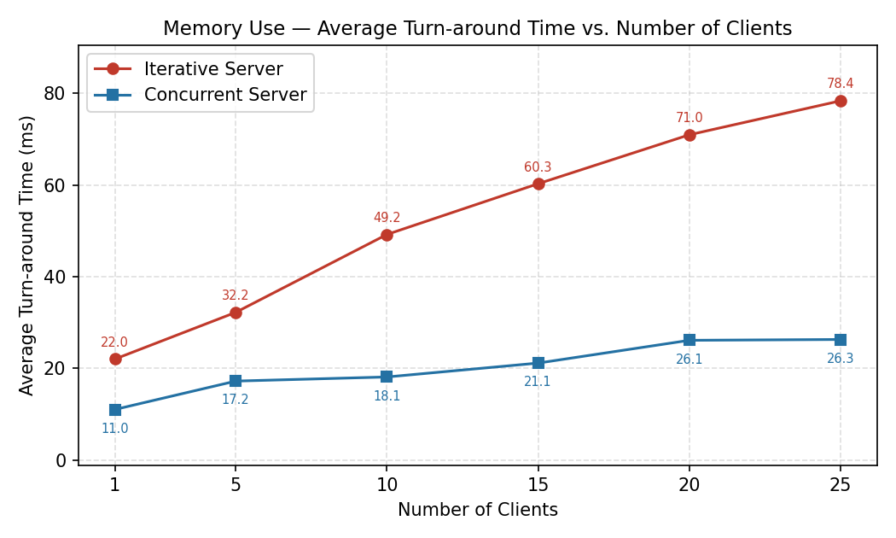

Figure 3. Memory Use – iterative vs concurrent average turn-around time.

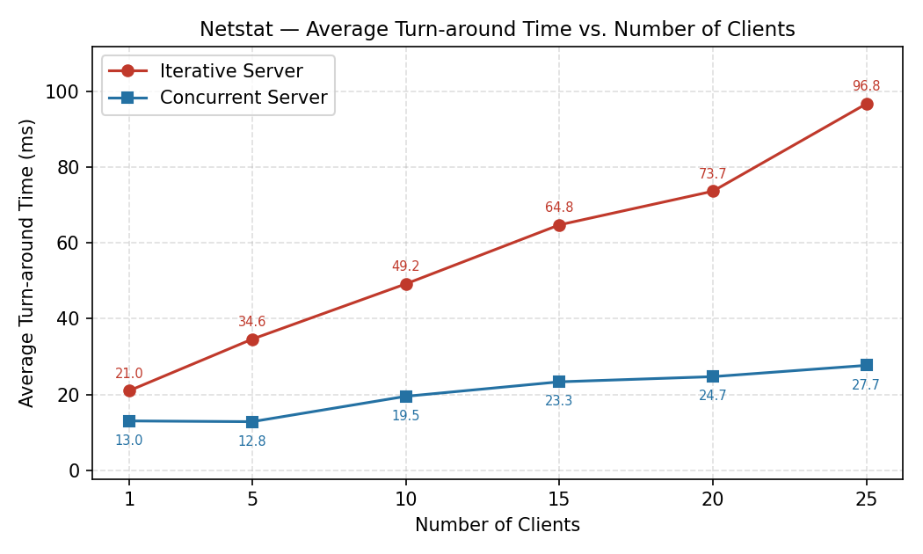
Figure 4. Netstat – iterative vs concurrent average turn-around time.

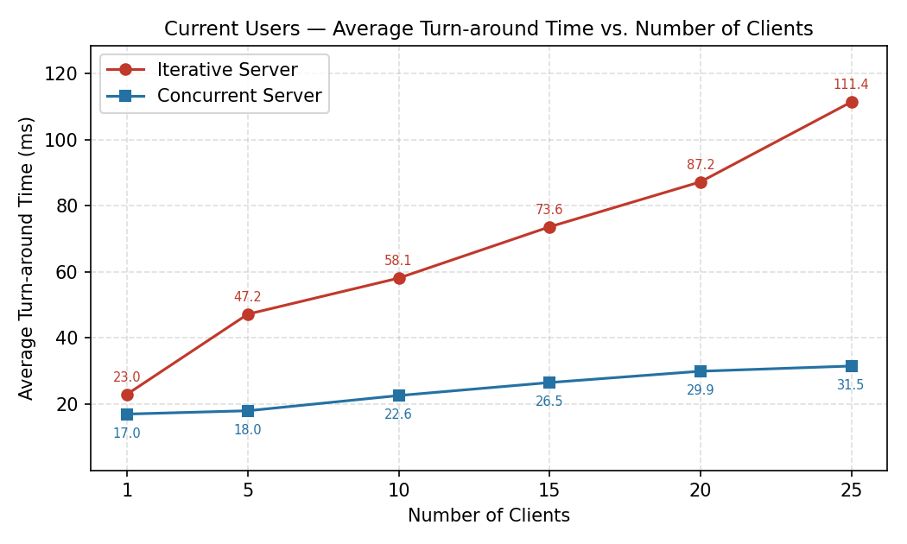

Figure 5. Current Users – iterative vs concurrent average turn-around time.

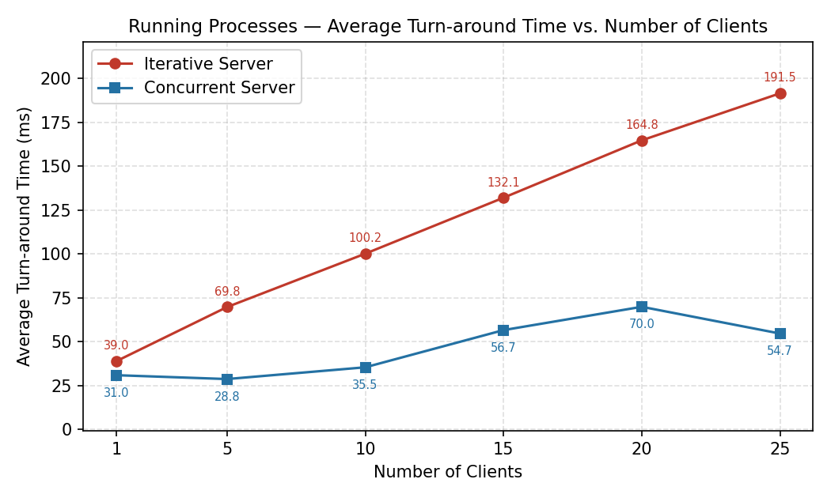

Figure 6. Running Processes – iterative vs concurrent average turn-around time.

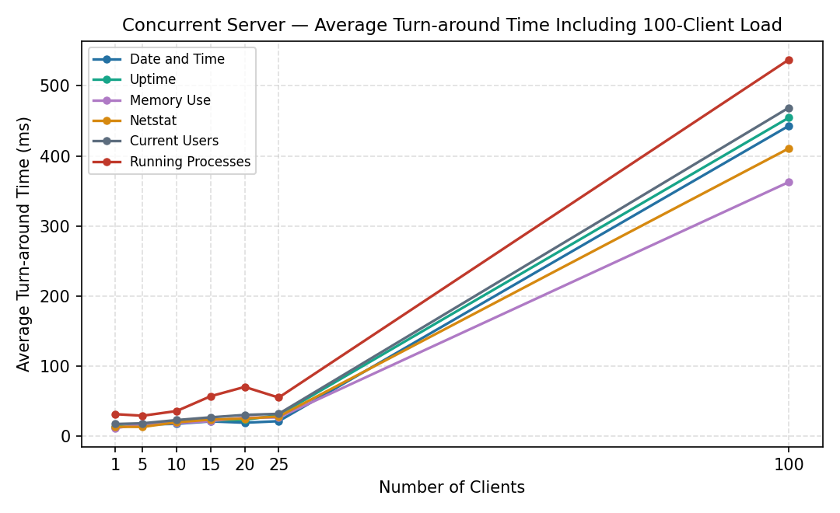

Figure 7. Concurrent server across all operations, including the 100-client load test.

Data Analysis

Effect of increasing clients on individual Turn-around Time
On the iterative server, increasing the number of clients has a direct and severe effect on individual turn-around times. Because clients are served strictly one at a time, each client’s measured time includes the processing time of every client ahead of it in line, so the later a client connects, the longer it waits. On the concurrent server, individual turn-around times are far less sensitive to the number of clients in the 1-25 range: because every client is served by its own thread in parallel, no client waits for another client’s request to finish. Individual times still rise modestly as clients are added, because all of the worker threads share the same CPU, memory, and network interface, and each thread also spawns an external Linux process to service its request. That contention grows with the number of simultaneous threads, which is why individual times creep upward rather than staying perfectly constant.

Effect of increasing clients on Average Turn-around Time
For the iterative server, the average turn-around time grows roughly linearly with the client count for every operation. For example, the Running processes operation averaged 39.00 ms with one client but 191.52 ms with 25, nearly a five-fold increase. For the concurrent server, the average stars remarkably flat over the same range: Date and Time only rose from 12.00 ms at one client to 21.00 ms at 25, and even the most expensive operation, Running Processes, rose from 31.00 ms to only 54.72 ms. Minor non-monotonic dips (such as Running Processes averaging less at 25 clients than at 20) are ordinary run-to-run variance on a shared machine and do not change the overall trend. The 100-client load test, however, shows that this flatness has a limit: averages jumped to roughly 360-540 ms across all operations. At the load, 100 threads each launching an external process simultaneously saturate the server’s CPU and process-creation capacity, so requests once again end up effectively waiting on one another, not in an accept queue, but in the operating system’s scheduler.

Contrast between the iterative and concurrent averages
Across every operation and every client count in the 1-25 range, the concurrent server’s average turn-around time is substantially lower than the iterative server’s, and the gap widens as clients increase. At 25 clients, the concurrent server was roughly three to four times faster on every operation: 21.00 ms vs 63.68 ms for Date and Time, 27.68 ms vs 96.80 ms for Netstat, 31.52ms vs 111.36 ms for Current Users, and 54.72 ms vs 191.52 ms for Running Processes. The shapes of the curves tell the story even more clearly than the raw numbers: the iterative curves climb steadily with load, while the concurrent curves are nearly horizontal. The concurrent server also outperformed at a single client (ex 12 ms vs 18 ms for Date and Time), though with one client, the two architectures are logically equivalent, so that gap reflects normal measurement variance and differing server conditions between test sessions rather than an architectural advantage.

When an iterative server makes sense
An iterative server is appropriate when the request rate is low, requests are short, and simultaneous connections are rare, for instance, an administrative or diagnostic service used by one person at a time, or an embedded device with very limited memory where the cost of creating threads is unacceptable. It is also attractive when simplicity and predictability matter more than throughout: with only one request in flight, there are no race conditions, no shared-state synchronization concerns, and resource usage is strictly bounded, which makes an iterative server easier to write, debug, and reason about. Finally, if requests must be processed strictly in arrival order, an iterative design provides that guarantee for free.

When a concurrent server makes sense
A concurrent server is the right choice whenever multiple clients are expected to connect at the same time and response latency matters, which describes virtually all production network services, such as web servers, database servers, and chat services. Our data shows why: at 25 simultaneous clients, the concurrent server delivered three to four times better average turn-around time, and each individual client’s experience was nearly as fast as if it were the only client connected. A concurrent design is especially beneficial when requests involve waiting (on I/O, on external processes, or on slow clients), because other threads can make progress while waiting. The caveat demonstrated by our 100-client test is that a naive thread-per-request server is waiting during that time. The caveat demonstrated by our 100-client test is that a naive thread-per-request server does not scale indefinitely; very high loads call for refinements such as a fixed-size thread pool that bounds resource consumption.

Conclusion

The data supports a clear conclusion: server architecture, not network speed or command cost, was the dominant factor in client turn-around time in this system. Simply changing the server from processing requests one at a time to processing them in parallels threads – with no change at all to the client – reduced average turn-around times at 25 clients by roughly 67% to 72% across all six operations and changed the scaling behavior from approximately linear growth to nearly flat. The experiment also demonstrated that concurrency is not free or unlimited: at 100 simultaneous clients, thread and process-creation overhead saturated the server and average times rose above both servers’ 25-client figures. The practical takeaway is that a thread-per-connection concurrent server is dramatically superior to an iterative server for realistic multi-client workloads, but a production system serving hundreds of simultaneous clients would need additional techniques, such as thread pooling, to maintain low latency at scale.

Lessons Learned

- Building and testing the concurrent server taught us several practical lessons beyond the headline result.
- Threading in Java is easy to start and harder to coordinate. Spawning a thread per connection required only a Runnable and a Thread, but correctly aggregating results across threads in the client required learning AtomicLong to avoid lost updates on the shared total, and CountDownLatch to make the main thread wait for all sessions to finish before printing results.
- Executing Linux commands from Java has subtleties. ProcessBuilder made running commands straightforward, but we learned to redirect the error stream into the output stream, so failures were visible to the client, and to fully read the process’s output before waiting for it to exit.
- Application-level protocols need explicit message boundaries. Because responses like ps aux are many lines long, the client had no built-in way to know when a response ended. Adding the ##END## delimiter was a small change that eliminated an entire class of hangs and truncated reads, and it taught us why real protocols define message framing.
- Measurement requires a controlled comparison. Keeping the client program byte-for-byte identical across the two assignments meant the iterative and concurrent data sets differed only in server architecture, which made the comparison in this report meaningful.
- Shared machines produce noisy data. Small anomalies reminded us that other users and background processes on the course servers affect individual runs, and that trends across many data points matter more than any single measurement.
- Finally, the 100-client test taught us that every architecture has a breaking point. Watching the concurrent server’s averages jump twentyfold at 100 clients made the cost of unbounded thread creation concrete in a way no textbook description could.

