一番

Pizzeria

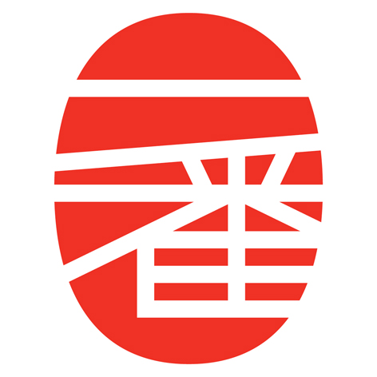

**Order Form**

≈Home≈Menu≈Order≈

First Name:

Last Name:

Phone Number:

E-mail:

Address (Delivery Only):

**Pizzas**

Pizza Size Small $8.99

Sauce Yes No

Cheese Yes No

Crust Flat Classic

Cheese Pizza + Toppings ($1/topping)

Pepperoni

Sliced Beef

Shitake Mushrooms

Jalapeño Peppers

Number Of Pizzas 0

**Specials**

Gyūdon 牛丼 Pie ($14.99) 0

Shitake 椎茸 Circle ($11.99) 0

**Salads**

Caesar Salad ($7.99) 0

Tilapia Salad ($7.99) 0

**Breadsticks**

Garlic Twists ($3.99) 0

Chinese Doughnuts ($3.99) 0

**Drinks**

Gourmet Cola ($3.99/L) 0

Umeshu ($14.99/L) 0

**Special Instructions**

Submit

[Ichiban Pizzeria](http://riegerm2.cse252.spikeshroud.com/week2/index.html)

Xiangbala Ave, Shangri-La

+1 (630) 222-4444

ichibanpizzeria@gmail.com

**Hours:** *11:00 - 24:00, Monday - Saturday*