**(sj)Tester Documentation**

Introduction:

The (sj)Tester software is a web-based, cross browser application that is intended for knowledge assessment of aircraft systems ground school.

The parenthetical “(sj)” denotes the phrase, “systems-justification.” *Testing* is the justification following the receipt of learning in order to discern an appropriate amount of knowledge retention.

Tasks:

This application provides for accomplishment of 3 tasks:

1. Test Creation and Modeling
2. Test Administration
3. Results Analysis.

Test Creation and Modeling

Instructor and administrators may create questions through a robust question / test meta-modeling tool. With this tool, questions can be presented to the student in a variety of ways. Tests can also be modeled to possess both a dichotomy of specific topic distribution and an element of randomization.

Test Administration

Instructors can select from an existing test model and generate a password-protected, limited-license test session. A limited license test is time-stamped upon generation and expires within 1 hour. Once a test is generated, the student can enter the selected password and proceed with testing provided that the time is within the limited-license window.

The testing area provides a basic set of tools for the student to utilize during testing. These features allow for tracking of un-answered questions as well as giving the student the option of marking a question they are unsure of or would like to return to for later review.

At the completion of the test, the student clicks a button for automatic grading and processing of results. A record of the student’s pass/fail result, missed questions and score is recorded in a database. The student will immediately be presented with a score and directed to review missed questions, should there be any. This meets the FAA testing requirement for training to proficiency.

Results Analysis

Instructors and Administrators access test records in a password-protected, instructor-only area. This area allows the following:

1. Viewing questions on created tests created by the logged in instructor.
2. Generating a test report for a student to view per-topic averages and to facilitate re-training, if needed.

The following features may be accessed by designated administrators only.

1. Viewing of all test scores within a specified time period (Year, Month, Quarter).
2. Ejection of a bad question and re-calculation of scores within a 24-hr period of creating the test.
3. Access to the question-modeling tool.
4. Access to the test-modeling tool.
5. Administrative feature for managing instructor access to the software.

Refer to appropriate section in this manual for expanded guidance on each feature.

Test Creation

(sj)Tester’s meta-modeling tool gives an option of creating 5 types of questions.

True/False: Two answers choices.

Multiple-Choice: 4 answer choices and 1 correct answer.

Multiple-Correct: 4 answer choices where 2 answers are correct and the final answer allows the student to select both correct answers (example: D. A and C are correct)

All-Correct: 4 answer choices where 3 answers are correct and the final answer allows the student to select all answers simultaneously (example: D. All of the above)

None-correct: 4 answer choices where 3 answer choices are incorrect and the final answer allows the student to select none of the previous. (example: D. None of the above)

Creating a question

From the instructor area, click the Questions Button under Admin Tasks.

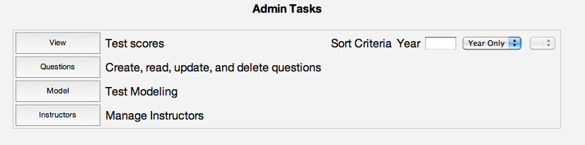

This will take you to the question modeling area.

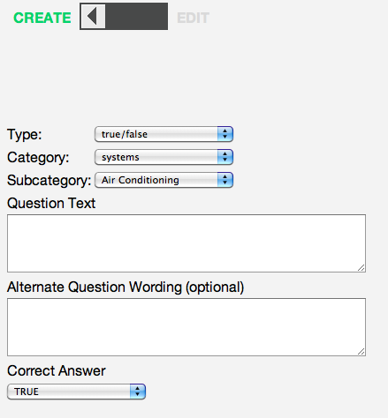

1. At the top of the question modeling area, the CREATE mode may be selected to input new questions. The EDIT mode may be used to modify an existing question within the database.

2. Select TYPE of question from the drop-down menu. (True/False, Multiple Choice, Multiple Correct, All Correct, None Correct). The answer fields presented will be specific to the type of question selected.

3. Select the subcategory, or system topic of the question (example: Stall Protection, Electrical, Fire Protection, etc)

4. Enter the Question Text and an optional question wording. The exact wording will be randomly selected at the time of test generation.

5. Enter the correct answer(s).

6. Enter the incorrect answer choices. The order of incorrect answer choices is insignificant. Answer choices will always be shuffled upon test generation.

7. Submit the question to the database.

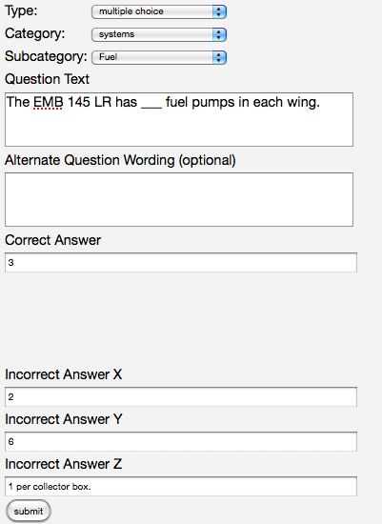

Figure - A question ready for submission to the database.

Viewing Questions.

To the right of the question-modeling tool, select the desired category and click View Questions. All existing questions for the selected topic will be presented.

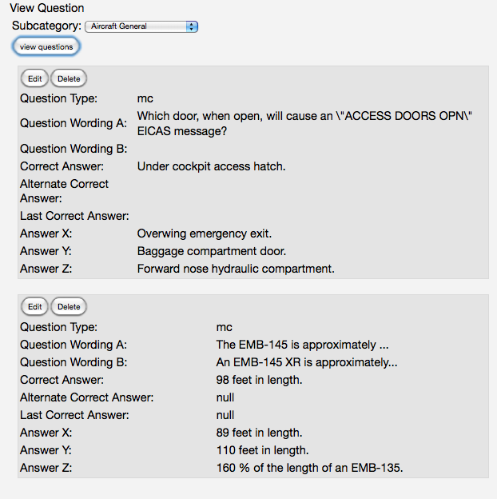

Figure - All questions for Aircraft General.

The question type can be identified by one of the following codes:

* tf : True/False
* mc: Multiple Choice
* c2: Multiple Correct
* ac: All Correct
* nc: None Correct

List:

Major areas:

* + Instructor Area
  + Modeling Area
  + Question Area
  + Test Area

Question Area.

* + Question types:
    - Multiple Choice (25 – 35 % All of the Above / None of the Above)
    - Multiple Correct
    - All Correct
    - None Correct
  + Viewing questions
  + Editing /Deleting existing questions