The primary research question that this thesis is concerned with is whether or not London can be accepted as being significantly statistically different from other areas in the United Kingdom, specifically Surrey and Sussex. It is the case, based on available data from John Beattie in *Crime and the Courts in England 1660-1800* and from the *Proceedings of the Old Bailey Online*, that in the majority of circumstances the data shows no distinction need be made whether a case was heard at the Old Bailey or in one of the Surrey and Sussex Quarter Sessions/Assizes. There are, however, certain exceptions which must be explored in which the data reveals serious discrepancies with the ways that individuals were handled or how the cases were resolved.

In three key statistical comparisons there are distinct differences between *Crime and the Courts in England 1660-1800* and *Proceedings of the Old Bailey Online*. The three chosen tests were Chi-Squared, Phi/Cramer’s V, and Kendall’s Tau. Chi-Squared was used to determine if a hypothesis could be possible or acceptable with regards to the data presented. Phi/Cramer’s V and Kendall’s Tau were follow-ups used to re-asses correlation strength and directionality respectively.

In all of these cases it appeared initially, using the Chi-Squared test, that there was not necessarily a difference between London and Surrey/Sussex. Each case came back as accepting of the hypothesis with a confidence greater than 99.9%. Since this was identical in both locations, it was initially not going to be explored since it continued to prove the thesis that London is not significantly statistically different from other areas in the United Kingdom, specifically Surrey and Sussex. Performing due diligence, however, highlighted the beginning of differences between some of the areas/hypotheses which seemed to have no difference.

The second step was to examine the same data using both Phi (φ), the Contingency coefficient, and Cramer’s V. In this case Cramer’s V, since the tables were two-by-two, was identical to Phi.[1] It was here that relationships, which certainly existed, were shown to be very weak, almost always the case for the Old Bailey, and then some degree of strong (moderately strong or strong) for Surrey/Sussex. This was the case for the three anomalies and warranted one more level of exploration.

Since these were square tables, it was appropriate to use a variant of Kendall’s Tau called Tau-B. The tables which stood out under Tau-B were the same ones which stood out under Phi. Tau-B, however, was used not just to confirm the findings from Phi, but also to determine some directionality. In both cases dealing with Homicide there was a negative directionality, while the case dealing with Infanticide indicated a positive directionality.

## Guilt when charged with Homicide pre-1740 and post-1740

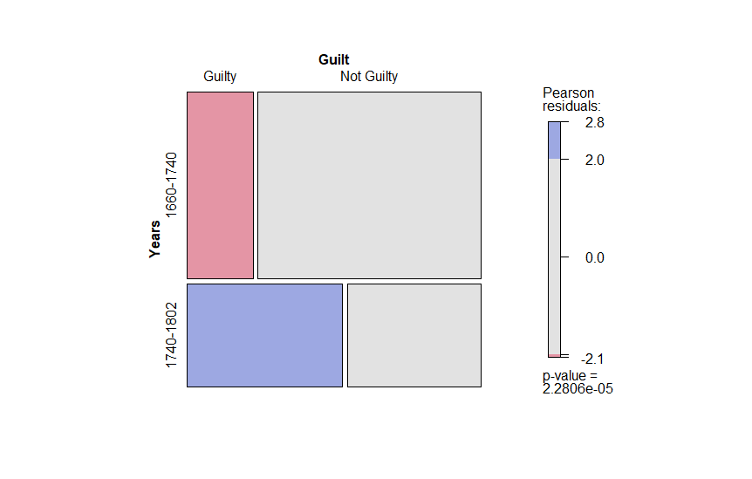

Figure : A mosaic representation of the Chi-Squared/Kendall's Tau-B Table of data

The first statistical anomaly was found with a working hypothesis that there is an association between being charged with Homicide and found guilty between 1660-1740 and 1740-1802 at the Old Bailey or in Surrey/Sussex.

## Guilt in Males charged with Homicide pre-1740 and post-1740

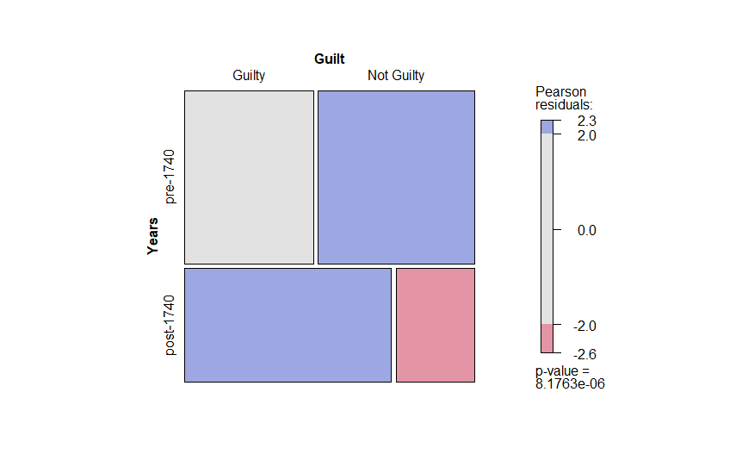

Figure : A mosaic representation of the Chi-Squared/Kendall's Tau-B Table of data

The second statistical anomaly is much like the first, except the role of gender was included to determine if it played any part. The anomaly was found with a working hypothesis that there is an association between males charged with homicide and found guilty pre-1740 and post-1740 at the Old Bailey or in Surrey/Sussex.

## Females Sentenced to Death for Infanticide between 1663-1802

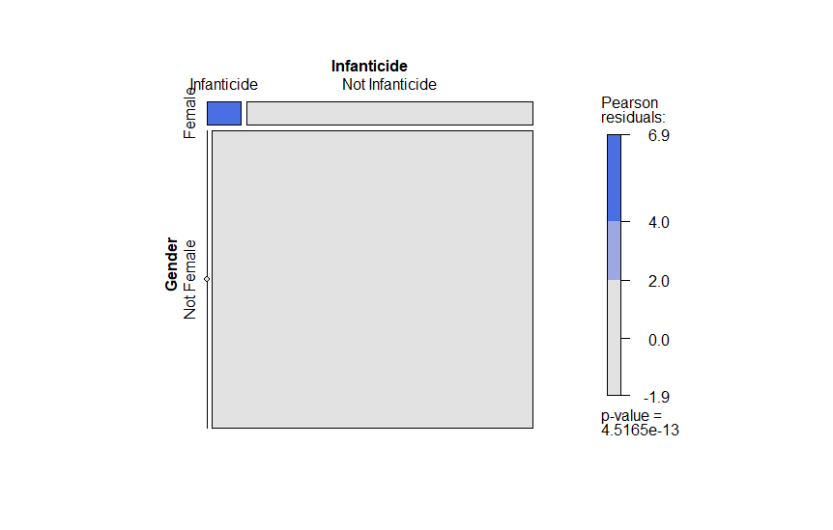

Figure : A mosaic representation of the Chi-Squared/Kendall's Tau-B Table of data

The third statistical anomaly was found with a working hypothesis that there is an association between being female and being sentenced to death for infanticide between 1663-1802 at the Old Bailey or in Surrey/Sussex.

1. http://uregina.ca/~gingrich/ch11a.pdf