* Text Classification and ROC Analysis
  + Performance Statistics:
    - 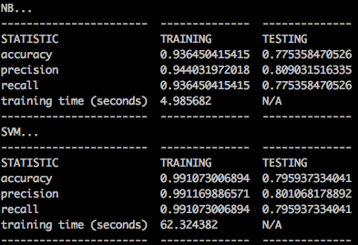
  + ROC Plot:
    - 
  + 2-3 Sentence Analysis:
    - Based on the performance statistics table above, the SVM classifier is slightly more accurate and has slightly higher recall, meaning that a higher fraction of positive instances are identified. Note that the SVM classifier takes more than 10 times as long to train all of the data. If we look at the pairwise comparisons in the ROC plot between the Naïve Bayes ROC plot vs the SVM ROC plot for each class, the ROC Naïve Bayes plot has a higher AUC than the SVM ROC plot for 3 out of 5 of the classes indicating that there is a strong likelihood that the SVM ROC plot often has better performance (though we don’t know the best threshold, theta, to use for the plot).