CMSC 350 – Project 4: Directed Graph

UML for written classes: 1

Test Plan: 2

Lessons Learned: 3

1. **UML**

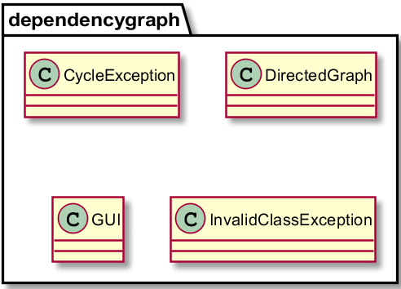

1. **Test Plan**
2. **Graph without cycles:**

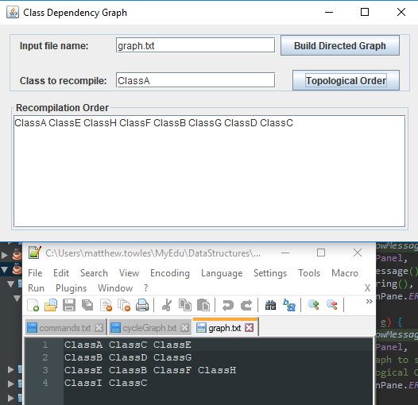

1. **Graph with cycles:**

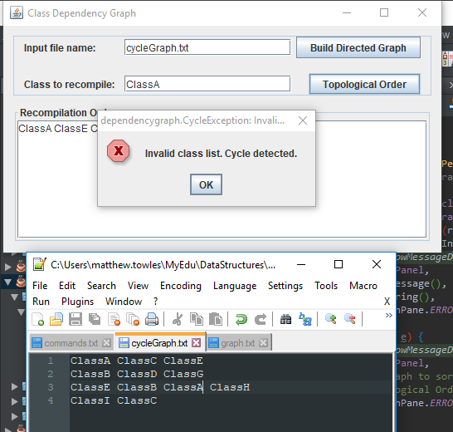

1. **Invalid file name:**

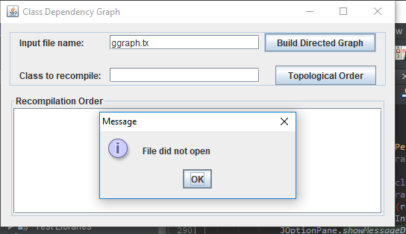

1. **Invalid class name:**

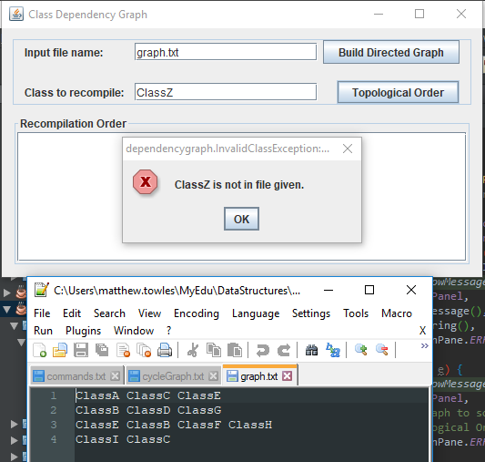

1. **Lessons Learned**