**CMSC 451 Homework 6**

1. Using Warshall’s algorithm, compute the reflexive-transitive closure of the relation below. Show the matrix after the reflexive closure and then after each pass of the outermost for loop that computes the transitive closure.

0 0 0 0 1

1 0 0 0 0

0 0 1 1 0

0 0 1 0 0

1 0 1 0 1

**A0 =**

**1** 0 0 0 1

1 **1** 0 0 0

0 0 1 1 0

0 0 1 **1** 0

1 0 1 0 1

**A1 =**

1 0 0 0 1

1 1 0 0 **1**

0 0 1 1 0

0 0 1 1 0

1 0 1 0 1

**A2 =**

1 0 0 0 1

1 1 0 0 1

0 0 1 1 0

0 0 1 1 0

1 0 1 0 1

**A3 =**

1 0 0 0 1

1 1 0 0 1

0 0 1 1 0

0 0 1 1 0

1 0 1 **1** 1

**A4 =**

1 0 0 0 1

1 1 0 0 1

0 0 1 1 0

0 0 1 1 0

1 0 1 1 1

**A5 =**

1 0 **1** **1** 1

1 1 **1** **1** 1

0 0 1 1 0

0 0 1 1 0

1 0 1 1 1

2. Using the matrix in the previous problem show the final result of executing Floyd’s algorithm on that matrix to produce a matrix containing path lengths.

Input:

0 0 0 0 1

1 0 0 0 0

0 0 1 1 0

0 0 1 0 0

1 0 1 0 1

Answer:

**0 ∞ 2 3 1**

**1 0 3 4 2**

**∞ ∞ 0 1 ∞**

**∞ ∞ 1 0 ∞**

**1 ∞ 1 2 0**

3. Show the graph that corresponds to the matrix in the first problem assuming the rows and columns correspond to the vertices a, b, c, d and e. Show its condensation graph, renaming its vertices. Determine any topological order of that graph and create an adjacency matrix with the vertices ordered in that topological order. Finally compute the reflexive-transitive closure of that matrix. What characteristic of that matrix indicates that it defines a total order?

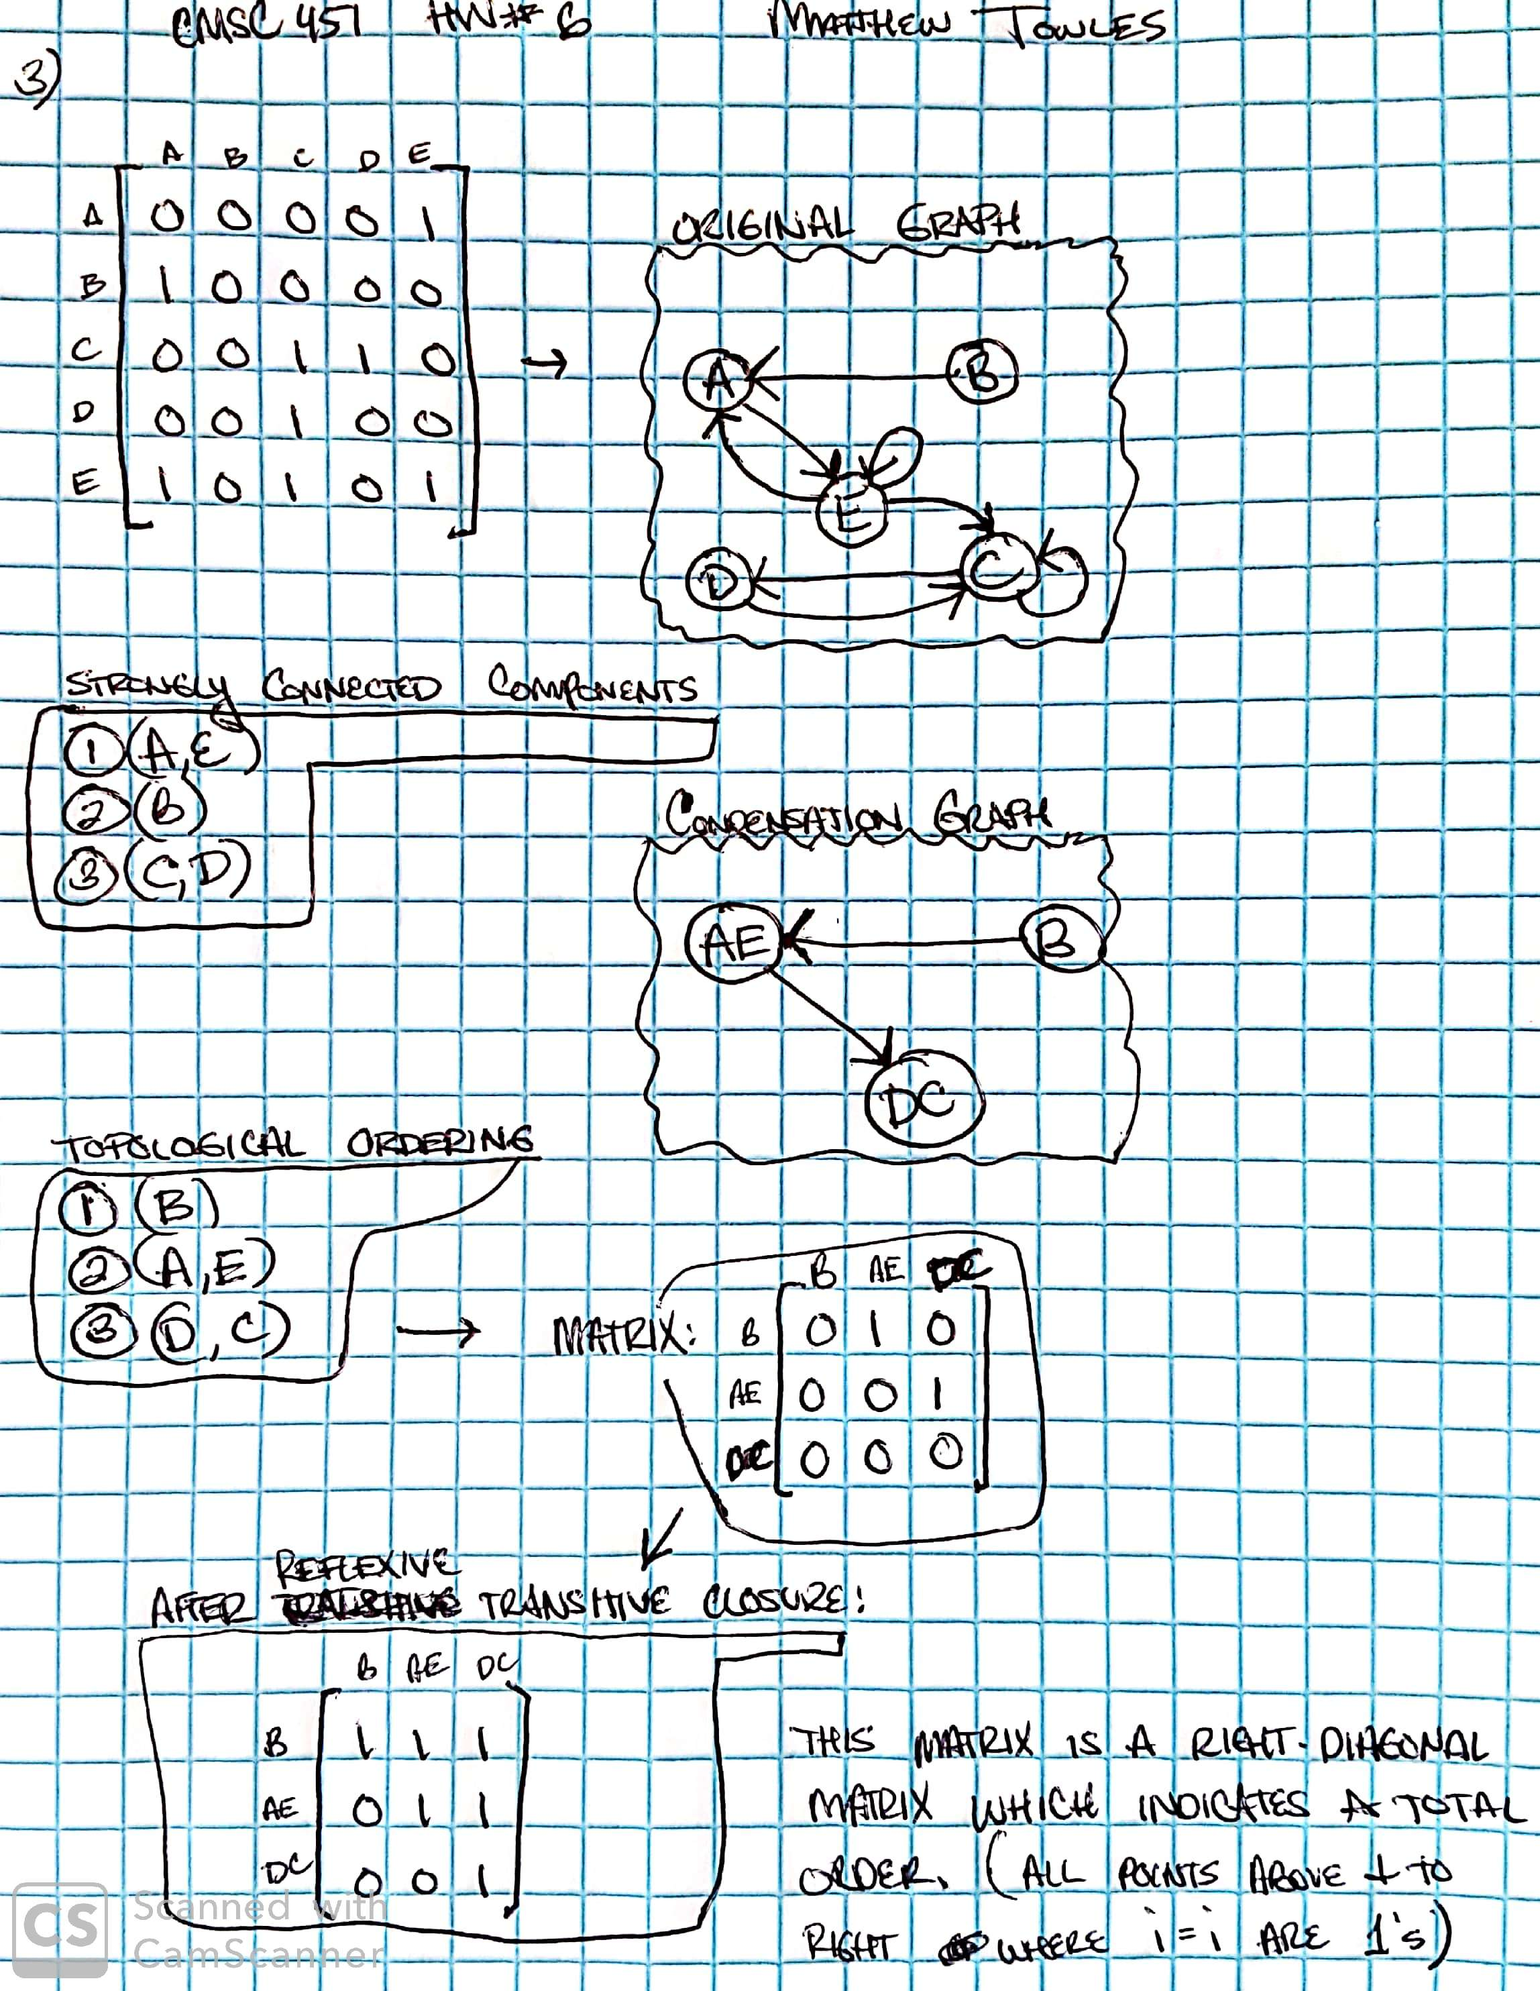

4. Using Floyd’s algorithm, compute the distance matrix for the weight directed graph defined by the following matrix:

0 4 ∞ 5

2 0 3 3

∞ 2 0 ∞

−2 ∞ −4 0

Show the intermediate matrices after each iteration of the outermost loop.

0 4 ∞ 5

2 0 3 3

∞ 2 0 ∞

-2 **2** -4 0

0 4 **7** 5

2 0 3 3

**4** 2 0 **5**

-2 2 -4 0

0 4 7 5

2 0 3 3

4 2 0 5

-2 **-2** -4 0

0 **3 1** 5

**1** 0 **-1** 3

**3** 2 0 5

-2 -2 -4 0

0 3 1 5

1 0 -1 3

3 2 0 5

-2 -2 -4 0