Final Project – Test Document 1

This document contains screenshots of the execution of the 4 algorithms using inputs from HW6 which are: N = 4 and the following reference string: 2 4 5 6 1 5 3 4 5 2 3 6 5 3 4 7 3 5 6

**FIFO**

*Beginning*

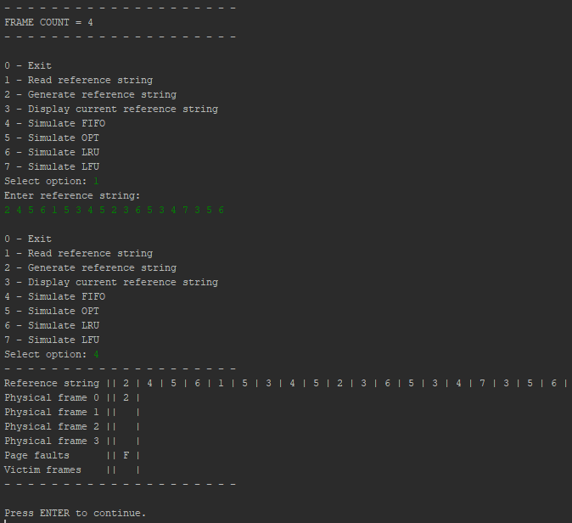

*Middle*

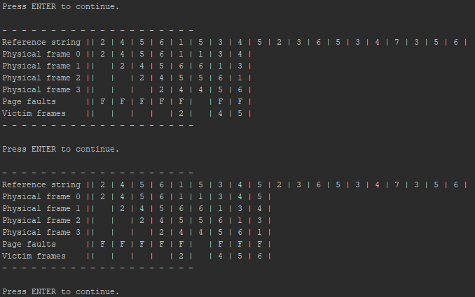

*End*

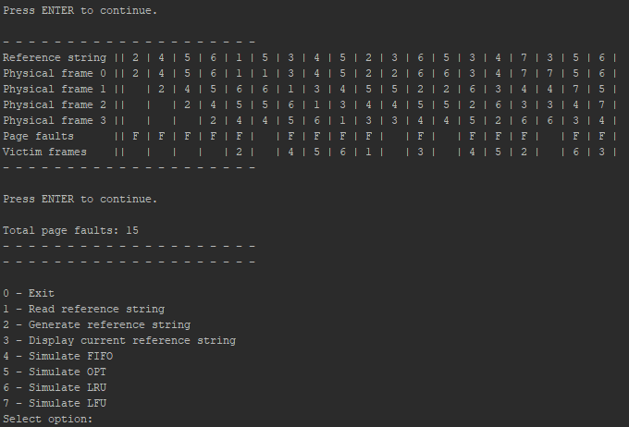

**OPT**

*Beginning*

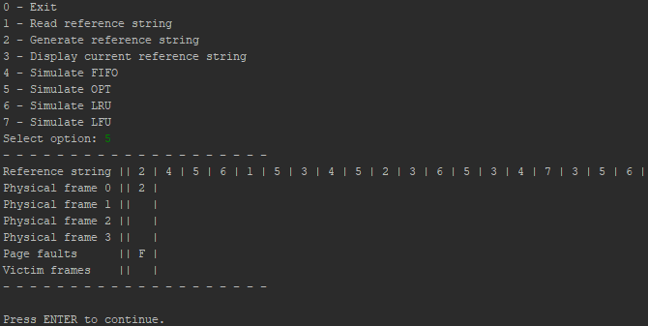

*Middle*

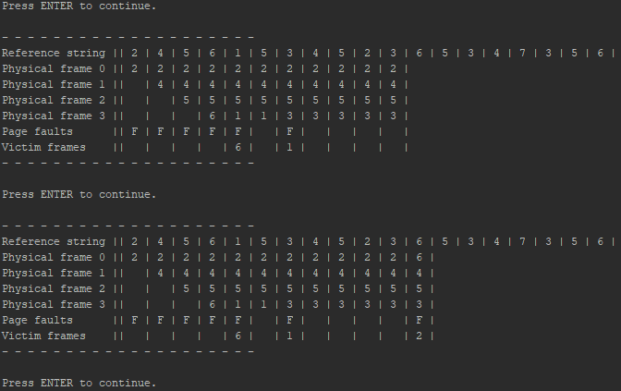

*End*

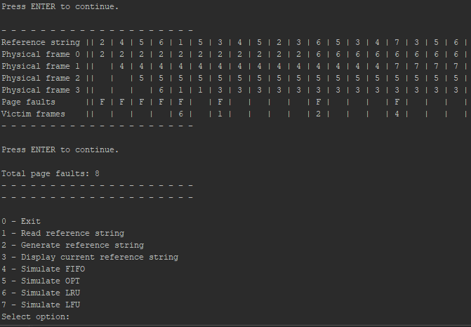

**LRU**

*Beginning*

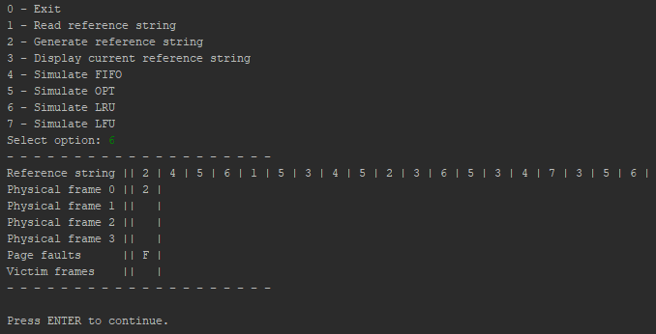

*Middle*

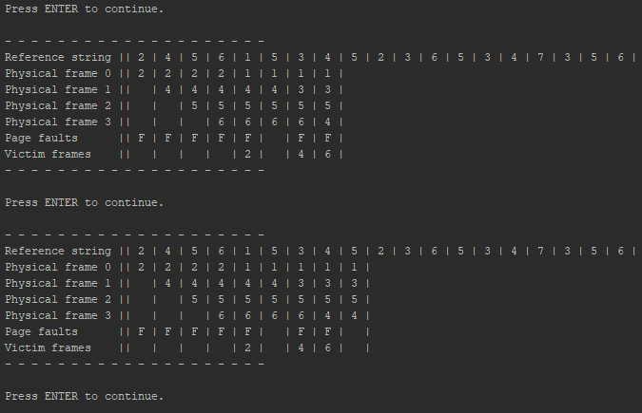

*End*

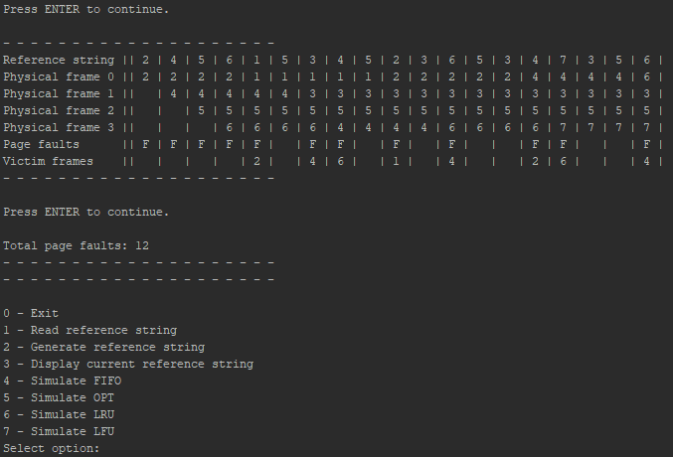

**LFU**

*Beginning*

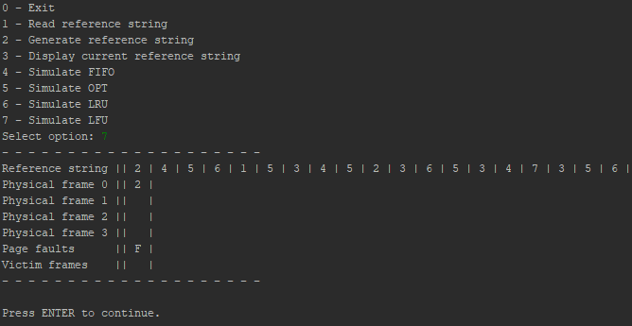

*Middle*

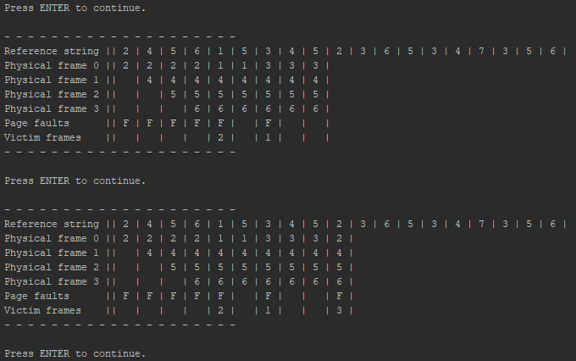

*End*

