Final Project – Test Document 2

This document contains screenshots of the execution of the 4 algorithms using N = 5 and the following reference string as inputs: 0 1 2 3 4 5 6 7 8 9 0 9 1 8 2 7 3 6 4 5

**FIFO**

*Beginning*

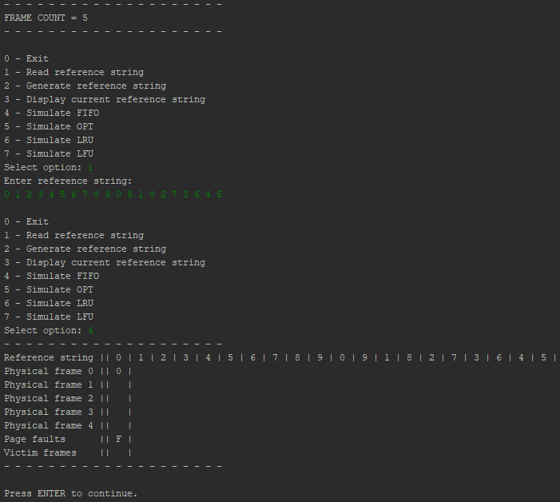

*Middle*

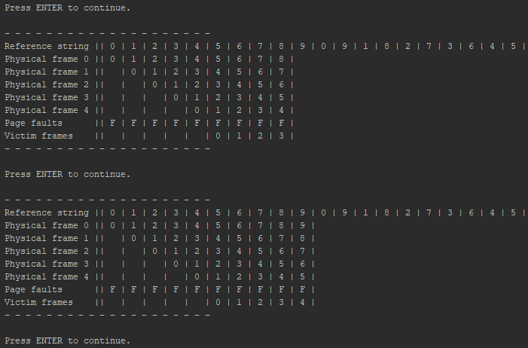

*End*

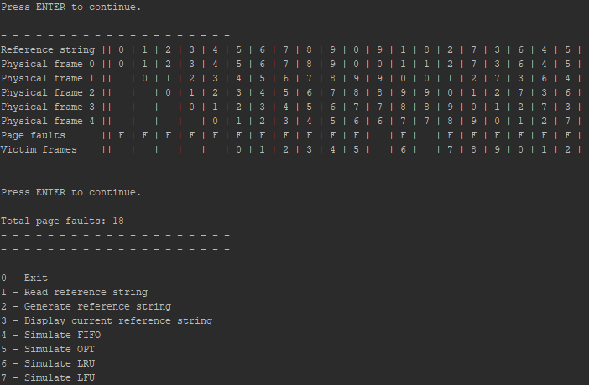

**OPT**

*Beginning*

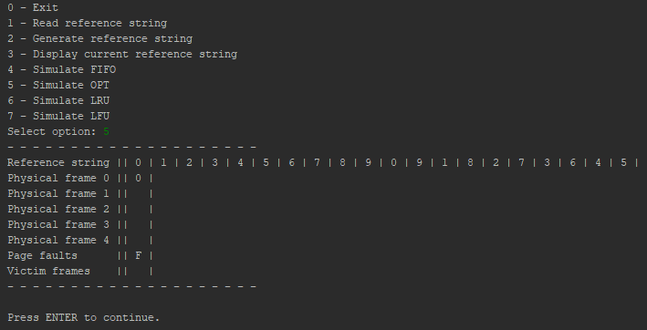

*Middle*

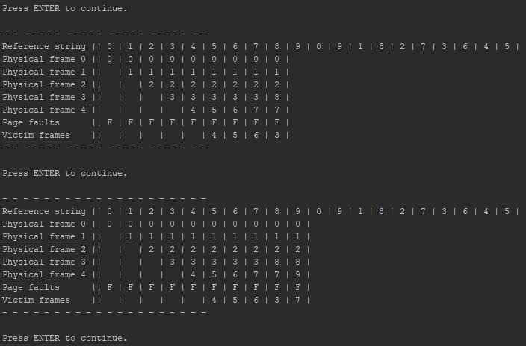

*End*

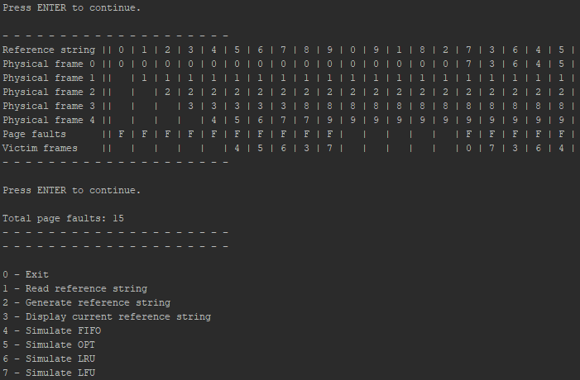

**LRU**

*Beginning*

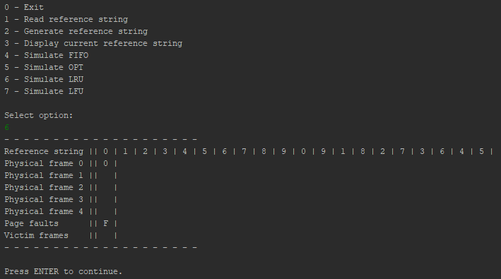

*Middle*

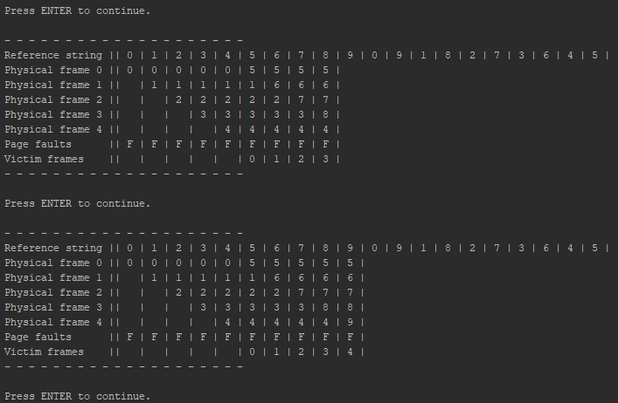

*End*

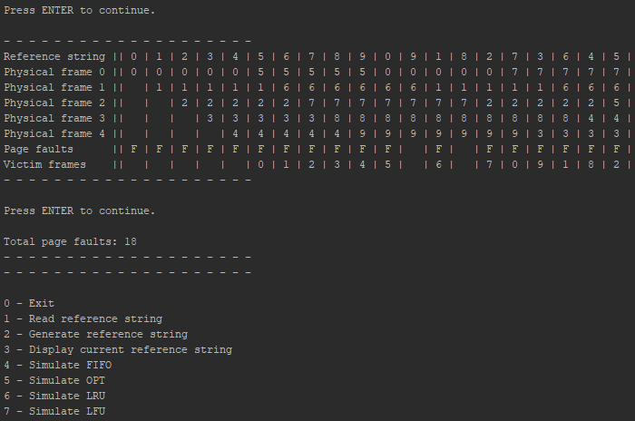

**LFU**

*Beginning*

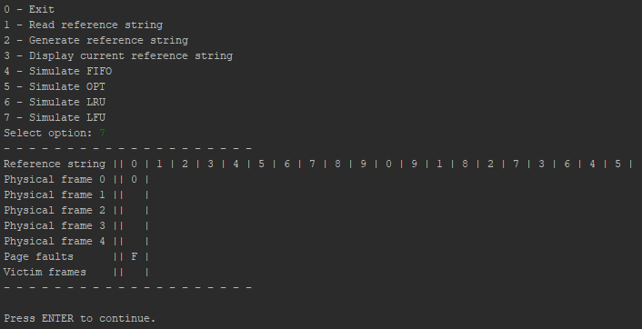

*Middle*

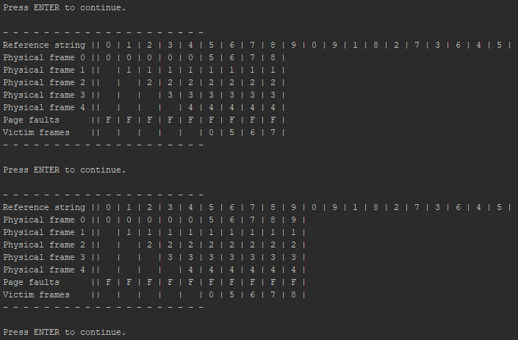

*End*

