Intermediate Programming – Project 1

This file contains three sections:

1. Overview and Explanation of Project
2. Test Case Table
3. Screenshots of Test Cases
4. Overview and Explanation of Project

This application takes a text file that has been specifically formatted for it as input and generates a summary of information from that input and gives it as output to the console. Further details and how the application works will be discussed in further detail.

As stated in the requirements, there are four classes:

* Employee.java – a class to represent an employee. The class has two fields: name (string) and salary (double) which is the monthly salary. The class has a constructor which requires two parameters to set the two fields. Four additional methods are in the class as well:
  + annualSalary() – calculates the salary for the year based on the (monthly) salary field.
  + toString() – overridden method from Object class. Returns a string representation of employee instance.
  + getName() and getSalary are getters for the fields
* Salesman.java – a subclass of Employee. Salesman has one additional field called annualSales which is the total dollar amount in sales made for the year. Two constants were created for Salesman for clarity: MAX_COMMISSION and COMMISSION_RATE. MAX_COMMISSION is the maximum dollar amount the Salesman can receive in a year. COMMISSION_RATE is the rate used in the calculation for the commission earned for a Salesman. The constructor calls the super class, Employee’s constructor and then also sets annualSales. The class has three other methods:
  + annualSalary() – Overridden from Employee. Adds commission to the annual salary.
  + getCommission() – calculated the commission earned by Salesman instance.
  + toString() – overridden from Employee. Calls Employee’s toString method and adds a line for annual sales.
* Executive.java – a subclass of Employee. Executive, much like the Salesman class overrides the same methods from Employee. Executive has one additional field called stockPrice which is the current stock price in dollars. If the stock price is greater than $50 then a bonus is applied to the Executive’s annual salary. Two constants belong to the Executive class called STOCK_PRICE_GOAL and BONUS. STOCK_PRICE_GOAL is 50, and so if exceeded the BONUS, 30,000, is applied. These were made for clarity and flexibility. The constructor uses the Employee constructor and also sets the stockPrice which is the third parameter. The annualSalary() method is overrideen from Employee in which the stock price is evaluated. If it is greater than 50 then the BONUS is added to the annual salary. The toString() method is also overriden as it calls the Employee toString() method and then adds the stock price as well.
* Salary.java – this class contains the main method of the application. The contents of the Salary class:
  + MAX_LINES – A constant. Maximum number of records for one year, which is 10 as stated in requirements.
  + YEAR1, YEAR2 – Both constants set to 2014 and 2015 as stated in requirements. Used for clarity rather than hard-coded year.
  + employees1 and employees2 – Two arrays of Employee objects that can each hold up to 10 (MAX_LINES) records. These are Employee[] arrays even though there are three potential types (Employee, Salesman, Executive.) This works as intended because the Salesman and Executive types are sublcasses of Employee and therefore are also Employee types as well. Just as every java object is an instance of the Object class as all classes implicity extend the Object class (are subclasses of it.)
  + employees1Count and employees2Count – both are ints initiated at 0. They will keep track of how many Employees have been added to each array, respectively. This is necessary since each employees array has space for 10 Employees. If only 3 were added to the array and the array is iterated, then it would iterate past the three and we would get a null pointer exception. By keeping track, we can dictate that any loop or iteration should stop based on employees1Count and employees2Count.
  + calcAverageSalary(Employee[] employees, int count) – calculates the average salary of all employees in first parameter. Second param, count, is either employees1Count or employees2Count so that we have a denominator to calculate the average. This is used to calculate the average salary for all employees for the year. It only works this way because of how we have organized the Employee arrays though. It could calculate the average of any array of Employees passed to it.
  + getAverageSalary(int year, double average) – returns a string message with the average salary and the year. Created to avoid code duplication.
  + getSummary(Employee[] employees, int count) – returns a string message by iterating through the array of Employees passed and calling each of their toString() methods while also adding information for each employee annual salary.
  + getHorizontalLine() – a separator to make the output more visually appealing and easier to see.
  + main method:
    - a scanner is created so that the user can input the name of the file to be read
    - user is prompted for the name of the file
    - fileName is a string where we capture user’s input
    - try block made in case file name is not found
    - a new scanner is made, this time to read the file itself
    - we loop with a while loop to evaluate each line of the file
    - we create an Employee object and save the first four pieces of data from the line since every line will have these first four pieces of data
    - then the type is checked since executive and salesman each have a fifth piece of data
    - the employee object is instantiated based on the type
    - it is then added to the appropriate employees array based on the year in the line of the file we are currently on
      * the correct count field is iterated as well to keep track of how many employees have been added to each array
    - The average salary is then calculated and saved for each year
    - Data is then displayed for the first year(2014) and then the second year(2015)
    - Lastly, there is a catch block which will only execute if the file the user input earlier is not found

All three test cases passed and executed as expected. The first test case simply used the example given in the requirements as this covered both years and all three types of employees. The other two test cases cover all years and types as well as test stock prices below, at, and above 50. All output is shown as whole dollars.

|  |  |  |  |
| --- | --- | --- | --- |
| 1. **Test case table** | | | |
| **Input** | **Expected Output** | **Actual Output** | **Pass?** |
| file: employees1.txt  actual input:  2014 Employee Smith,John 2000  2015 Salesman Jones,Bill 3000 100000  2014 Executive Bush,George 5000 55 | - - - - - - - - - - - - - - - - -  Average salary for 2014: $57000  - - - - - - - - - - - - - - - - -  Name: Smith,John  Monthly Salary: $2000  Annual Salary: $24000  Name: Bush,George  Monthly Salary: $5000  Stock Price: $55  Annual Salary: $90000  - - - - - - - - - - - - - - - - -  Average salary for 2015: $38000  - - - - - - - - - - - - - - - - -  Name: Jones,Bill  Monthly Salary: $3000  Annual Sales: $100000  Annual Salary: $38000 | - - - - - - - - - - - - - - - - -  Average salary for 2014: $57000  - - - - - - - - - - - - - - - - -  Name: Smith,John  Monthly Salary: $2000  Annual Salary: $24000  Name: Bush,George  Monthly Salary: $5000  Stock Price: $55  Annual Salary: $90000  - - - - - - - - - - - - - - - - -  Average salary for 2015: $38000  - - - - - - - - - - - - - - - - -  Name: Jones,Bill  Monthly Salary: $3000  Annual Sales: $100000  Annual Salary: $38000 | Yes |
| file: employees2.txt  actual input:  2015 Employee Towles,Matthew 200000  2014 Salesman Smith,Carl 3000 0  2014 Executive Bush,Will 22650 100  2014 Employee Baggins,Bilbo 123123  2015 Salesman Johnson,Bob 3000 9999  2015 Executive Bush,George 5000 50 | - - - - - - - - - - - - - - - - -  Average salary for 2014: $605092  - - - - - - - - - - - - - - - - -  Name: Smith,Carl  Monthly Salary: $3000  Annual Sales: $0  Annual Salary: $36000  Name: Bush,Will  Monthly Salary: $22650  Stock Price: $100  Annual Salary: $301800  Name: Baggins,Bilbo  Monthly Salary: $123123  Annual Salary: $1477476  - - - - - - - - - - - - - - - - -  Average salary for 2015: $832067  - - - - - - - - - - - - - - - - -  Name: Towles,Matthew  Monthly Salary: $200000  Annual Salary: $2400000  Name: Johnson,Bob  Monthly Salary: $3000  Annual Sales: $9999  Annual Salary: $36200  Name: Bush,George  Monthly Salary: $5000  Stock Price: $50  Annual Salary: $60000 | - - - - - - - - - - - - - - - - -  Average salary for 2014: $605092  - - - - - - - - - - - - - - - - -  Name: Smith,Carl  Monthly Salary: $3000  Annual Sales: $0  Annual Salary: $36000  Name: Bush,Will  Monthly Salary: $22650  Stock Price: $100  Annual Salary: $301800  Name: Baggins,Bilbo  Monthly Salary: $123123  Annual Salary: $1477476  - - - - - - - - - - - - - - - - -  Average salary for 2015: $832067  - - - - - - - - - - - - - - - - -  Name: Towles,Matthew  Monthly Salary: $200000  Annual Salary: $2400000  Name: Johnson,Bob  Monthly Salary: $3000  Annual Sales: $9999  Annual Salary: $36200  Name: Bush,George  Monthly Salary: $5000  Stock Price: $50  Annual Salary: $60000 | Yes |
| file: employees3.txt  actual input:  2014 Executive Bush,Will 666 0  2014 Employee Baggins,Bilbo 123123  2015 Salesman Johnson,Bob 0 9999  2015 Executive Bush,Will 22650 100  2015 Employee Baggins,Bilbo 123123  2014 Salesman Johnson,Bob 0 9999 | - - - - - - - - - - - - - - - - -  Average salary for 2014: $495223  - - - - - - - - - - - - - - - - -  Name: Bush,Will  Monthly Salary: $666  Stock Price: $0  Annual Salary: $7992  Name: Baggins,Bilbo  Monthly Salary: $123123  Annual Salary: $1477476  Name: Johnson,Bob  Monthly Salary: $0  Annual Sales: $9999  Annual Salary: $200  - - - - - - - - - - - - - - - - -  Average salary for 2015: $593159  - - - - - - - - - - - - - - - - -  Name: Johnson,Bob  Monthly Salary: $0  Annual Sales: $9999  Annual Salary: $200  Name: Bush,Will  Monthly Salary: $22650  Stock Price: $100  Annual Salary: $301800  Name: Baggins,Bilbo  Monthly Salary: $123123  Annual Salary: $1477476 | - - - - - - - - - - - - - - - - -  Average salary for 2014: $495223  - - - - - - - - - - - - - - - - -  Name: Bush,Will  Monthly Salary: $666  Stock Price: $0  Annual Salary: $7992  Name: Baggins,Bilbo  Monthly Salary: $123123  Annual Salary: $1477476  Name: Johnson,Bob  Monthly Salary: $0  Annual Sales: $9999  Annual Salary: $200  - - - - - - - - - - - - - - - - -  Average salary for 2015: $593159  - - - - - - - - - - - - - - - - -  Name: Johnson,Bob  Monthly Salary: $0  Annual Sales: $9999  Annual Salary: $200  Name: Bush,Will  Monthly Salary: $22650  Stock Price: $100  Annual Salary: $301800  Name: Baggins,Bilbo  Monthly Salary: $123123  Annual Salary: $1477476 | Yes |

1. Screenshots of Test Cases

Test Case 1:

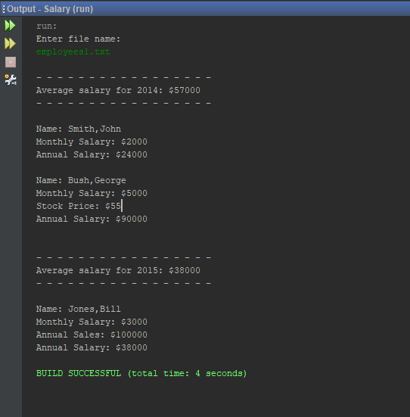

Test Case 2:

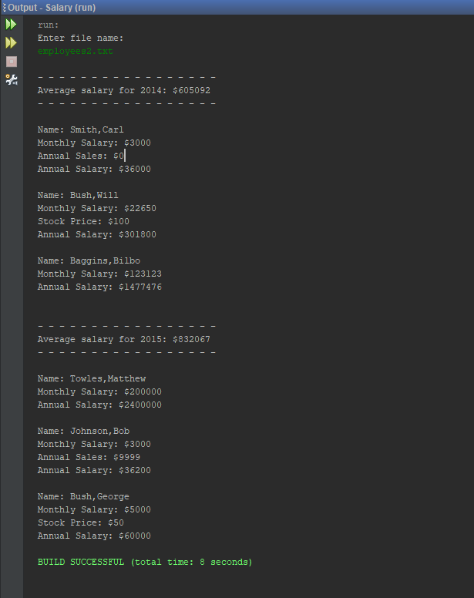

Test Case 3:

